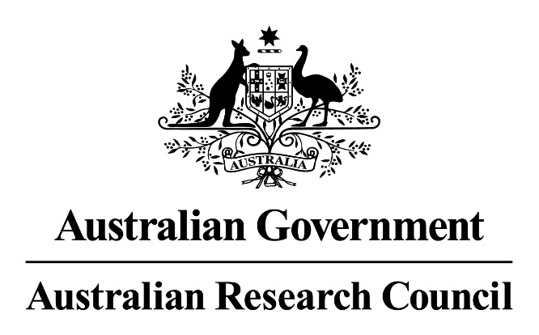

Evaluation of the Discovery Projects scheme

**Final report**

Australian Research Council

Program Evaluation Section

November 2020

Contents

Abbreviations and glossary 4

Executive summary 6

Key findings 7

Opportunities for improvement 9

Part One: Evaluation overview 13

1.1 Background 13

1.2 Authorisation and management 13

1.3 Reasons for the evaluation 14

1.4 Purpose and scope 14

1.5 Terms of reference 14

1.6 Evaluation questions 14

1.7 Evaluation methodology 15

1.8 ARC administrative data notes 17

Part Two: Discovery Projects scheme implementation 19

2.1 Origins of Discovery Projects 19

2.2 Overview of Discovery Projects scheme objectives and intended outcomes 20

2.3 Applications and funded projects 23

2.4 Success rates 23

2.5 Funding requested and awarded 24

2.6 Return rates 25

2.7 Participating organisation contributions 25

2.8 Fields of Research 26

2.9 Interdisciplinary research 33

2.10 Project completion and objectives achieved 34

Part Three: Effectiveness—Discovery Projects scheme objectives 37

3.1 Quantitative stakeholder views on effectiveness—overall scheme objectives 38

3.2 Supporting excellent basic and applied research by individuals and teams 40

3.3 Supporting excellent research training 49

3.4 Supporting national and international research collaboration 53

3.5 Enhancing the scale and focus of research in Australian Government priority areas 59

Part Four: Effectiveness—Discovery Projects scheme intended outcomes 63

4.1 Quantitative stakeholder views on effectiveness—overall scheme intended outcomes 64

4.2 Expanding Australia’s knowledge base and research capacity 68

4.3 Delivering economic, commercial, environmental, social and cultural benefits for Australia 73

4.4 Stakeholder feedback on potential improvements 77

Part Five: Appropriateness of the Discovery Projects scheme 79

5.1 Discovery Projects’ role within Australia’s research funding landscape 80

5.2 Discovery Projects scheme design 85

5.3 Appropriateness of Discovery Projects’ funding amount and duration 91

Appendix A: Opportunity One—Targeted advice, outreach and engagement (additional information) 98

Appendix B: Stakeholder feedback—executive summary 100

Appendix C: Survey sample 103

Appendix D: Success rates by Fields of Research 106

Appendix E: Translational benefits delivered through Discovery Projects 107

Appendix F: Research and development investment in Australia 108

# Abbreviations and glossary

|  |  |
| --- | --- |
| **ANZSRC** | Australian and New Zealand Standard Research Classification |
| **APD** | Australian Postdoctoral Fellowship |
| **APF** | Australian Professorial Fellowship |
| **Applied research** | Original work undertaken primarily to acquire new knowledge with a specific application in view. It is undertaken either to determine possible uses for the findings of basic research or to determine new ways of achieving some specific and predetermined objectives[1] |
| **ARC** | Australian Research Council |
| **ARF** | Australian Research Fellowship |
| **CGRGs** | Commonwealth Grants Rules and Guidelines |
| **DECRA** | Discovery Early Career Researcher Award |
| **DIA** | Discovery International Award |
| **DORA** | Discovery Outstanding Researcher Award |
| **DP** | Discovery Projects |
| **Early Career Researcher** | A researcher who has held a PhD or equivalent qualification for a period of less than or equal to five years at the time of their application |
| **ERA** | Excellence in Research for Australia |
| **Experimental development** | Systematic work, using existing knowledge gained from research or practical experience, which is directed to producing new materials, products, devices, policies, behaviours or outlooks; to installing new processes, systems and services; or to improving substantially those already produced or installed[2] |
| **FoR** | Field of Research |
| **FTE** | Full-Time Equivalent |
| **HASS** | Humanities, Arts and Social Sciences |
| **HDR** | Higher Degree by Research |
| **ICA** | International Collaboration Award |
| **IDR** | Interdisciplinary Research |
| **Mid-Career Researcher** | A researcher who has held a PhD or equivalent qualification for a period of between five and fifteen years at the time of their application |
| **NCGP** | National Competitive Grants Program |
| **NHMRC** | National Health and Medical Research Council |
| **PhD** | Doctor of Philosophy |
| **Pure basic research** | Experimental and theoretical work undertaken to acquire new knowledge without looking for long term benefits other than the advancement of knowledge[3] |
| **QEII** | Queen Elizabeth II Fellowship |
| **R&D** | Research and development |
| **Research trainee** | Throughout this report, research trainee is employed broadly, to refer to those engaging in Honours, Master’s, PhD or postdoctoral training. |
| **Return rate** | The amount of ARC funding awarded as a percentage of funding requested in successful applications |
| **RFCD** | Research Fields, Courses and Disciplines |
| **ROPE** | Research Opportunity and Performance Evidence |
| **RMS** | Research Management System |
| **SEO** | Socio-Economic Objective |
| **STEM** | Science, Technology, Engineering and Mathematics |
| **Strategic basic research** | Experimental and theoretical work undertaken to acquire new knowledge directed into specified broad areas in the expectation of practical discoveries. It provides the broad base of knowledge necessary for the solution of recognised practical problems[4] |
| **Success rate** | The number of funded projects as a percentage of applications submitted |

# Executive summary

Discovery Projects is the largest Australian Research Council (ARC) funding scheme, supporting 15,035 projects since its introduction in 2001, and constituting almost 40 per cent of all National Competitive Grants Program (NCGP) funding. The scheme supports excellent basic and applied research undertaken by individuals and teams.

This evaluation assessed the effectiveness and appropriateness of the Discovery Projects scheme. It focused on the scheme’s design and implementation, including its objectives and intended outcomes, its role within Australia’s overall research and innovation landscape, the administration and provision of funding, and the benefits of the research it supports. The evaluation drew upon ARC policy and program documents, data and information from the scheme’s inception to the 2020 round (DP20), as well as stakeholder surveys and interviews conducted by Kantar, Public Division. Discovery Projects had not previously been evaluated.

Stakeholder feedback and ARC data indicated that, overall, Discovery Projects is effective in achieving its objectives and intended outcomes, including:

* supporting excellent basic and applied research by individuals and teams through its competitive peer review process
* supporting excellent research training opportunities in high quality research environments
* fostering increased national and international research collaboration, particularly between scholars across institutional and national boundaries
* expanding Australia’s knowledge base and research capacity by supporting funding opportunities, open access research outputs and a sustainable research workforce
* delivering a diverse range of economic, commercial, environmental, social and cultural benefits to Australia.

Stakeholders generally considered the scheme’s design—including its objectives, intended outcomes and funding duration and amount—to be appropriate. They regarded Discovery Projects as a unique component of the Australian research funding landscape that complemented other sources of funding available to researchers, and emphasised the importance of its support for investigator-led, non-medical basic research.

However, the strength of stakeholder agreement on the scheme’s effectiveness and appropriateness varied with respect to specific objectives and intended outcomes. In qualitative feedback, some stakeholders expressed concerns or a lack of clarity about elements of the scheme, including perceived tensions between aspects of its design and views that some research and researchers were disadvantaged in assessment processes. The evaluation identified six opportunities to address stakeholder feedback and support improvements in the scheme’s performance:

1. Targeted advice, engagement and outreach
2. Improved facilitation of national and international collaboration
3. Improved Discovery Projects data collection
4. Potential options to provide aggregated feedback on Selection Advisory Committee assessments
5. Development of a Discovery Projects program logic
6. Ongoing monitoring and evaluation.

# Key findings

***Key Finding One: Discovery Projects is effective in achieving its objectives and intended outcomes***

Stakeholder feedback and ARC data indicated that Discovery Projects is broadly effective in achieving all objectives and intended outcomes listed in the DP21 Grant Guidelines. Stakeholders agreed most strongly about the effectiveness of the scheme’s support for excellent basic research, national research collaboration, research training, and expanding Australia’s knowledge base and research capacity.

***Key Finding Two: Discovery Projects’ scheme design is appropriate***

Overall, stakeholders regarded Discovery Projects’ objectives and intended outcomes as appropriate to achieve its policy intent. Survey and interview participants highlighted positive interrelationships between distinct elements of the scheme’s design, including the importance of its support for basic research in laying the foundations for applied research and the delivery of translational benefits. The majority of stakeholders also agreed that the scheme’s project funding amount and duration were appropriate to meet its objectives and intended outcomes.

***Key Finding Three: Discovery Projects plays a unique and important role within the Australian research funding landscape by supporting basic research***

Stakeholders regarded Discovery Projects as a unique component of the Australian research funding landscape that complemented other NCGP schemes and non-ARC sources of funding. While the scheme supports both basic and applied research, stakeholders emphasised the importance of its contribution to investigator-led, non-medical basic research conducted at Australian universities, in the context of the substantial focus on applied research in Australia’s broader research and development effort.

***Key Finding Four: Discovery Projects research supports diverse positive academic outcomes and translational benefits***

Discovery Projects supports a substantial body of openly accessible research outputs and contributes to national research capacity through the provision of funding, opportunities for the development of the research workforce, and enhancements to the scale and diversity of research in Australia. The majority of stakeholders considered the scheme effective in supporting economic, commercial, environmental, social and cultural benefits, and described a wide variety of translational outcomes delivered by their completed projects. However, some stakeholders noted difficulties anticipating long term benefits and articulating outcomes arising from basic research.

***Key Finding Five: Researchers completing funded projects recently and those collaborating internationally had more positive perceptions of Discovery Projects***

Researchers whose last completed project under the scheme was finalised in the past three years or involved international collaboration tended to be more positive about Discovery Projects’ effectiveness and appropriateness. This suggests that the scheme’s implementation may have improved over time and that international collaboration may enhance overall scheme performance. Additional research would be required to provide further insight into these findings.

***Key Finding Six: Some stakeholders were unclear or had concerns about elements of Discovery Projects***

Although stakeholders predominantly agreed that Discovery Projects was effective and appropriate, elements of the scheme’s objectives and intended outcomes, implementation and assessment processes were unclear or raised concerns for some. These included perceived tensions between the scheme’s support for basic research and the inclusion of applied research and translational benefits in its objectives and intended outcomes, as well as a lack of clarity about the role of the National Science and Research Priorities in scheme processes. Some stakeholders also expressed concerns that, in assessment processes: Humanities, Arts and Social Sciences research was disadvantaged in comparison to Science, Technology, Engineering and Mathematics research; experienced applicants were favoured over Early and Mid-Career Researchers; and economic benefits were preferred to social and cultural benefits.

***Key Finding Seven: Data limitations affect monitoring and evaluation of Discovery Projects***

While ARC systems support comprehensive, quality-assured data on Discovery Projects applications, data limitations affecting monitoring and evaluation of the scheme were identified. Changes to terminology, reporting processes and systems over time have made it difficult to establish consistent and comparable longitudinal datasets on some aspects of scheme performance. Further, there is a lack of alignment in some areas between the data collected within ARC systems and the scheme’s stated objectives and intended outcomes. The data collected in final reports were not sufficient to comprehensively assess the overall scale of research training delivered under the scheme. In addition, there are limitations inhibiting more detailed evaluation of the outcomes and achievements of Discovery Projects research beyond the intentions specified in applications.

# Opportunities for improvement

***Opportunity One: Targeted advice, engagement and outreach***

To raise stakeholder awareness, address concerns, and clarify issues highlighted in this evaluation, opportunities exist to reinforce the following messages in ARC engagement and outreach with researchers and research offices, and in advice to Discovery Projects applicants, assessors and Selection Advisory Committees (additional information on each point is provided in Appendix A):

* Discovery Projects funding is based on research excellence
* the proportion of funded projects involving basic research has increased
* Discovery Projects supports innovative research involving elements of risk when assessed as suitable through peer review
* basic research is important in supporting Australian Government research priorities and translational benefits
* addressing an Australian Government priority is not a requirement for funding
* there is no preference between applications that may deliver economic, commercial, environmental, social or cultural benefits
* overall, success rates for women, Early Career and Mid-Career Chief Investigators, and Humanities, Arts and Social Sciences research, are comparable to, or above, overall scheme success rates
* the ARC is committed to the competitive assessment of interdisciplinary research
* Discovery Projects funds four and five year applications when assessed as competitive through peer review.

***Opportunity Two: Improved facilitation of national and international collaboration***

Stakeholder feedback indicated the potential for research collaboration to bolster the overall effectiveness of Discovery Projects, and highlighted opportunities to reduce perceived barriers to national and international collaboration under the scheme. These include:

* reviewing the possibility of allowing all Partner Investigators—including international researchers—to submit a less intensive two page Curriculum Vitae with specific content requirements, rather than completing the entire Research Opportunity and Performance Evidence section of Discovery Projects application forms
* reinforcing, through outreach and engagement, the purpose and importance of the scheme’s Chief Investigator participation limits in ensuring researchers invest sufficient time and resources in funded projects; while noting that, provided Chief Investigator responsibilities are fulfilled, flexibility exists to contribute to additional research projects as unnamed researchers.

Ongoing monitoring of the scale of research collaboration between researchers and organisations may inform future assessment of the impact of these changes and support greater understanding of the benefits of national and international collaboration under the scheme.

***Opportunity Three: Improved Discovery Projects data collection***

Further strengthening Discovery Projects data collection, including greater alignment of data with the scheme’s objectives and intended outcomes, may support enhanced monitoring and assessment of scheme performance, in accordance with the Commonwealth Grants Rules and Guidelines.[5] Opportunities to improve data collection include:

* changing application forms to specify that research trainee data should include the total number of trainees to be supported through the project, and whether they will receive a Higher Degree by Research stipend and/or project support
* adjusting final report questions to include the total number of research trainees supported—to measure against data collected from applications, and support assessment of the overall scale of research training delivered under the scheme
* amending application forms to allow researchers to indicate whether their project will address an Australian Government priority area beyond the National Science and Research Priorities—to align with recent changes to the scheme’s objectives
* adjusting final reports to include response options in the Benefits section that cover all scheme intended outcomes—specifically, adding options to indicate whether a project contributed to expanding Australia’s knowledge base or delivered commercial benefits
* consider options to expand available funding data in relation to specific budget items, while ensuring researchers have the flexibility of a one-line budget and avoiding the creation of additional administrative burden for university research offices
* consider options to collect further data on the experiences of research trainees involved in research supported by Discovery Projects—potentially through short voluntary questionnaires or surveys—to provide further insight on the nature and effectiveness of research training under the scheme (this opportunity may be considered more broadly across the NCGP)
* improving consistency over time in data collection through applications, final reports and variation requests—to enhance the ARC’s ability to monitor and analyse the scheme’s performance over a longer timescale.

***Opportunity Four: Potential options to provide aggregated feedback on Selection Advisory Committee assessments***

Subject to consideration by the ARC of feasibility and appropriateness, there may be an opportunity to investigate the development of brief reports summarising overall issues, considerations and/or concerns emerging in Selection Advisory Committee deliberations during a Discovery Projects round. These reports would not comment on the outcomes of individual applications. However, they may enhance the transparency and consistency of assessment processes and support researchers in developing future applications.

Additional factors for consideration include the burden on Selection Advisory Committees, the potential value to applicants of aggregated feedback and the extent to which such reports may provide insights beyond existing advice, outreach and engagement. If this opportunity is pursued, it may also be considered more broadly across the NCGP.

***Opportunity Five: Development of a Discovery Projects program logic***

The development of a program logic for the Discovery Projects scheme may support enhanced implementation, monitoring and evaluation of the scheme. The Commonwealth Grants Rules and Guidelines highlight the importance of ‘robust planning and design’ in the administration of Australian Government grant opportunities by:

* establishing a rationale for grant opportunities—particularly what outcomes are expected and how these will be measured
* defining the operational objectives
* establishing performance and evaluation measures.[6]

While Discovery Projects has been in existence since 2001 and has undergone numerous changes over time, a program logic model has not been developed for the scheme. The development of such a model may assist in further clarifying Discovery Projects’ objectives and intended outcomes, including in relation to the intentions underpinning key terms, such as ‘research training’, ‘research capacity’, and the distinction between research ‘teams’ and ‘collaboration’. It may also inform effective ongoing resourcing and policy decisions, and provide greater assurance that the scheme’s design is appropriate.

***Opportunity Six: Ongoing monitoring and evaluation***

Continued monitoring of Discovery Projects against benchmarks established within this evaluation may contribute to ongoing assessment of the scheme’s performance and inform further improvements over time.

In addition to maintaining existing reporting processes, further areas for ongoing monitoring include:

* the proportion of applications submitted, funded projects and funding awarded, as well as success rates and return rates for:
  + basic and applied research
  + Humanities, Arts and Social Sciences and Science, Technology, Engineering and Mathematics research
* research trainee participation on projects, including the total and average number of research trainees identified on applications and funded projects, and the funding associated with HDR stipend requests
* Early and Mid-Career named researcher participation, including the proportion of Early and Mid-Career named researchers on applications and funded projects and success rates
* the number of research outputs generated by Discovery Projects, including the number of outputs per completed project and changes in traditional and non-traditional output types over time
* timeliness of final report submission, including the proportion of final reports being submitted on time and late.

Given the scheme’s significance to the NCGP, and to the broader Australian research funding landscape, a further evaluation of Discovery Projects in 2024–25 would provide a valuable opportunity to:

* analyse performance against benchmarks identified within this evaluation
* assess scheme objectives and intended outcomes using additional available data and following the development of a program logic model for the scheme
* analyse elements of the scheme that were introduced or changed too recently to be considered within the current evaluation.

# Part One: Evaluation overview

## Background

Discovery Projects is the largest Australian Research Council (ARC) funding scheme and one of the main means by which researchers interact with the ARC. It provides project funding for basic and applied research undertaken by individual researchers and teams. Discovery Projects offers between $30,000 and $500,000 per year for up to five years. As is the case across the entirety of the National Competitive Grants Program (NCGP), Discovery Projects allocates funding on the basis of research excellence as assessed through ARC selection processes.

The Discovery Program, including the Discovery Projects scheme, was part of an announcement in December 1999, when the Hon Dr David Kemp AC, then Minister for Education, Training and Youth Affairs, released *Knowledge and Innovation: A policy statement for research and research training*.[7] This policy statement set out the Howard Government’s vision for the future of higher education research in Australia, including the establishment of the NCGP.

The intent of the Discovery element of the NCGP was to ‘[recognise] the importance of Australia’s universities as major sources of fundamental research, dedicated to the creation of knowledge, within a wider framework that encourages links with users of the research’.[8]

The Discovery Projects scheme’s current objectives are to:

* support excellent basic and applied research and research training by individuals and teams
* support national and international research collaboration
* enhance the scale and focus of research in Australian Government priority areas.

The intended outcomes for the Discovery Projects scheme are:

* expanded knowledge base and research capacity in Australia
* economic, commercial, environmental, social and/or cultural benefits for Australia.

## Authorisation and management

This evaluation was authorised and undertaken in accordance with the *ARC Evaluation Strategy* and *Strategic Evaluation Plan*.[9] The evaluation was managed and conducted by the ARC Program Evaluation Section, which is part of the Corporate Services Branch and is independent from policy and program functions within the ARC’s organisational structure.

The Program Evaluation Section consulted with relevant ARC line areas to identify the priorities and issues addressed in the evaluation, seek advice on policy and program matters, and access policy and program data, documents and information.

The Program Evaluation Section engaged Kantar, Public Division to conduct independent survey and interview research with external stakeholders as an input into the evaluation. Kantar, Public Division’s stakeholder engagement services were procured under the whole-of-government Research, Evaluation and Data panel arrangement, administered by the Department of Social Services.

## Reasons for the evaluation

Discovery Projects has not been evaluated since it was introduced in 2001. Given its long running operation and its central role within the Australian Government’s overall investment in university research, it was important to assess the implementation of the scheme and its performance in supporting high quality research.

## Purpose and scope

The purpose of the evaluation was to assess the appropriateness and effectiveness of the Discovery Projects scheme with respect to its objectives and intended outcomes. The evaluation considered the scheme’s design and implementation, including its role within Australia’s overall research and innovation landscape, the administration and provision of funding under the scheme and the benefits of the research it supports. It considered all Discovery Projects rounds since the scheme’s commencement. The evaluation is intended to inform policy and program decision making—and possible improvements—in relation to the scheme and its future implementation.

## Terms of reference

The evaluation assessed:

1. the effectiveness of the Discovery Projects scheme—including the ARC’s implementation of the scheme and the outcomes of funded research—in supporting excellent basic and applied research and research training, enhancing research collaboration, expanding Australia’s research capacity and supporting research that benefits Australia
2. the appropriateness of the Discovery Projects scheme, including with respect to its design, the nature of the support it provides, and its role within the Australian Government’s overall investment in research and innovation.

## Evaluation questions

To address the terms of reference, the evaluation sought to answer the following questions, with reference to the scheme’s objectives and intended outcomes:

1. What has been the nature, scale and focus of research support under the Discovery Projects scheme, including in relation to:
   1. number of applications and funded projects, including success rates
   2. funding amounts, duration and return rates
   3. researchers, research trainees, and other individuals and teams
   4. national and international research collaboration
   5. fields of research and socioeconomic objectives
   6. basic and applied research
   7. completion and outcomes of research?
2. How effective has the Discovery Projects scheme been in achieving its objectives and intended outcomes, including in relation to:
   1. ARC implementation of the scheme, including application, assessment and post award processes
   2. the nature and value of the support provided
   3. supporting high quality research outcomes that provide benefits for research stakeholders and for Australia
   4. performing its role within the Australian research and innovation landscape?
3. How appropriate is the Discovery Projects scheme—including its objectives and intended outcomes—for achieving the intent of the Australian Government in relation to:
   1. the role of the scheme within the Government’s overall investment in research and innovation
   2. the design of the scheme
   3. the nature and value of the support provided
   4. supporting translational benefits for Australia by funding basic research?

## Evaluation methodology

The evaluation questions were addressed through analysis of the following sources of data and information:

* quantitative and qualitative program management data and information collected by the ARC (predominantly addressing evaluation question 1)
* qualitative and quantitative stakeholder feedback collected through surveys and interviews, conducted by Kantar, Public Division (predominantly addressing evaluation questions 2 and 3).

### ARC policy and program documents, data and information

A range of policy and program materials were used to inform the development of the evaluation and analysis presented in this report. These included publicly available sources such as the ARC’s Discovery Projects webpage, Grant Guidelines/Funding Rules and selection reports, as well as internal policy and program management documents such as scheme timelines, stakeholder engagement materials (such as presentations), applicant documentation (including applications, progress reports and final reports), internal ARC reviews and Ministerial submissions.

ARC program management data and information were sourced internally from the ARC’s Research Management System (RMS), final reports and archived records. Relevant policy and program staff within the ARC provided technical advice on the interpretation, complexities and caveats associated with the data and information. In particular, the Grant Policy and Data section extracted and provided quantitative data, including Discovery Projects application, assessment and outcome data. Quantitative and qualitative data arising from regular post award program management processes, including project reporting (variation requests and final reports), as well as information on funding agreements and other project management issues, were also employed.

The Program Evaluation section undertook evaluative analysis of the data to develop findings. This evaluation built upon existing data analysis undertaken internally by the ARC as a part of its regular program review and monitoring processes.

### Stakeholder surveys and interviews

The stakeholder engagement undertaken by Kantar, Public Division included the delivery of interviews and surveys, the collection and analysis of quantitative and qualitative data and reporting to the ARC on outcomes.[10] Policy and program staff in the ARC provided assistance with identifying participants and obtaining contact details. Kantar, Public Division de-identified all interview and survey responses, and destroyed stakeholder contact details upon completion of the services. The Program Evaluation section undertook a supplementary analysis of interview and survey stakeholder data.

#### Surveys

Surveys were undertaken to obtain a broad understanding of the views and experiences of researchers funded under the Discovery Projects scheme. Surveys were tailored and delivered to named researchers funded from DP02 onwards, including Chief Investigators, Partner Investigators and fellowship/award recipients. Invitations to complete the online survey were sent to all named researchers funded under Discovery Projects between DP02 and DP20, for whom the ARC had contact details. A total of n=19,615 invitations were sent; approximately 100 further named researchers did not have email addresses recorded on RMS.

The survey was open for 23 days and was completed by a total of n=3069 named researchers. This represents a response rate of approximately 16 per cent. A total of 215 automatic bounce backs and automatic replies were received. To ensure participation was voluntary, respondents were generally not forced to respond to survey questions. As such, the sample size differs between questions. Further information about the distribution of the survey sample by key demographic variables is provided in Appendix C. No weighting was applied to the sample. As such, responses slightly over represent researchers who had been awarded funding multiple times under the Discovery Projects scheme, and those currently or recently receiving funding.

Coding was undertaken to thematically group text-based responses to two open-ended questions from the survey. Due to the large sample collected, a representative subsample of n=1000 responses were selected for coding for Question Six and n=1012 for coding for Question Seven. To generate a sub-sample that was representative of all responses, these open-ended questions were analysed to ascertain the proportion of participants associated with disciplinary, basic/applied, international collaboration/non-collaboration and gender groupings. These proportions were then used to develop a sample frame where quotas for each subgrouping were filled through random selection. The remaining qualitative data generated by the surveys were examined through thematic analysis to identify, analyse and interpret common patterns of meaning across comments.

Throughout this report, differences between researcher sub-groups that reached statistical significance (at the 95 per cent confidence level) have been prioritised. With a total base size of n=3069 from a total population of 19,615 researchers, the overall margin of error for the quantitative survey is +/-1.6 per cent. However, as base sizes vary across questions, the margin of error for each question also varies. As mentioned earlier, for coded open-ended questions, Kantar, Public Division developed a representative subsample of n=1000 for Question Six, and n=1012 for Question Seven. For these questions the margin of error is approximately +/-3 per cent. Additional open-ended survey responses were read and categorised into common themes.

#### Interviews

In-depth interviews were undertaken with stakeholders possessing an in-depth understanding of the Discovery Projects scheme, and its strategic position within the broader research and innovation landscape. Interviews were tailored and delivered to the following Discovery Projects stakeholder groups:

* administering organisations, particularly research offices (n=24)
* peak bodies representing university cohorts (n=3).

Bespoke discussion guides were prepared for these different stakeholder groups through engagements between Kantar, Public Division and the ARC. Interviews with stakeholders lasted up to one hour and were primarily conducted over the telephone.[11] All recruitment and interviews were conducted in-house by Kantar, Public Division. Following engagements with stakeholders, interviewers prepared detailed notes against the discussion guide. Post-analysis was undertaken by the consultants through several workshops involving the interview team. These provided the foundation for a systematic distillation of the main themes across each section of the discussion guide, helping to assess patterns in responses across different stakeholder groups.

## ARC administrative data notes

The below textbox provides a summary of important information and historical changes to consider when interpreting ARC program data throughout the report.

**Data notes**

* Data are primarily presented based on scheme round funding commencement dates, which have been abbreviated (e.g. DP02 refers to the Discovery Projects round for funding commencing in 2002).
* Unless otherwise noted, application data have been generated to cover the period from the inaugural Discovery Projects round (DP02) to the most recently announced round at the time of drafting (DP20). Applications that were withdrawn have been excluded from data analysis.
* ARC administrative data from final reports have been generated as at 26 February 2020.
* Final reports from after DP14 have generally been excluded from analysis. A limited number of final reports have been submitted from later funding rounds, as most of these projects remain ongoing. While mandatory, final reports have not been submitted for all completed DP02–DP20 projects.
* Application and final report data generally rely upon researcher self-reporting.
* Data relating to projects and funding—including funded projects, total scheme funding, average project funding and return rates—have been generated on the basis of data at the time of Ministerial announcement.

**Historical changes**

* Between DP02 and DP11, Discovery Projects included specific provisions to support Early Career Researchers. From DP12 onwards, the Discovery Early Career Researcher Award (DECRA) scheme became the ARC’s primary source of support for this group.
* Between DP02 and DP11, the Discovery Projects scheme offered a range of fellowship opportunities supporting researchers at different career stages, including the Australian Professorial Fellowship (APF), the Australian Research Fellowship (ARF), the Queen Elizabeth II Fellowship (QEII) and the Australian Postdoctoral Fellowship (APD). Between DP12 and DP14, the scheme offered the Discovery Outstanding Researcher Award (DORA). Comparable fellowship and award opportunities have largely been transitioned into other NCGP schemes over time, with Discovery Projects currently emphasising the provision of project funding. These fellowship and award opportunities are included within the DP02–DP14 scheme data presented by this report.
* The Discovery Projects scheme’s priorities and policy objectives have also shifted over time. For instance, since DP03, the Discovery Projects scheme has included objectives relating to support for research priorities identified by the Australian Government. These have changed over the scheme’s history, and have included the National Research Priorities, the Strategic Research Priorities and the National Science and Research Priorities. The scheme has also had a greater focus on international collaboration since DP10, coinciding with the termination of the Linkage International scheme.

# Part Two: Discovery Projects scheme implementation



Part Two provides contextual material supporting the report’s evaluation of the effectiveness and appropriateness of the Discovery Projects scheme. The first half of Part Two sets out the historical context of Discovery Projects and provides a strategic overview of its objectives and intended outcomes. The second half examines ARC administrative data representing the nature, scale and focus of the scheme.

## Summary of findings

* Discovery Projects applications received, projects funded and funding requested by applicants declined from DP12 onwards. This primarily reflected the reallocation of ARC funding to the Discovery Early Career Researcher Award (DECRA) scheme; however, these trends continued over subsequent rounds.
* Total funding awarded fell by 25.6 per cent between DP11 and DP12 following the introduction of DECRA. Total funding then remained stable (at approximately $230,000,000–$250,000,000) until DP18, before rising in DP19 ($262,590,367) and DP20 ($284,952,924).
* From DP07 onwards, Discovery Projects success rates remained stable at approximately 20 per cent. Return rates increased from 50.8 per cent (DP12) to 73.6 per cent (DP20).
* The ratio of total participating organisation contributions to total ARC funding for successful Discovery Projects applications increased from $0.84:$1 in DP02 to $1.20:$1 in DP20.
* Science, Technology, Engineering and Mathematics (STEM) disciplines have been represented more strongly than Humanities, Arts and Social Sciences (HASS) disciplines in applications, funded projects and funding awarded, with Biology and Engineering being the most represented fields. However, success and return rates for HASS and STEM research have been comparable.
* The proportion of interdisciplinary applications and funded projects declined slightly from DP07 onwards. Success rates for interdisciplinary research were slightly lower than for non-interdisciplinary research.
* Final reports indicated that while most completed projects experienced interruptions affecting timely progress or completion, the vast majority fulfilled all of their project objectives.

## Origins of Discovery Projects

The introduction of the Discovery Projects scheme coincided with the establishment of the ARC as an independent Commonwealth entity under the *Australian Research Council Act 2001*. Discovery Projects broadly replaced the Large Research Grants and Research Fellowships schemes, which had previously been administered by the ARC as part of the National Board of Employment, Education and Training. The first Discovery Projects scheme round (DP02) opened in 2001, for project funding commencing in 2002.

The policy rationale behind the establishment of the ARC’s NCGP was articulated in *Knowledge and Innovation: A policy statement for research and research training* in December 1999. This document outlined the intent to divide the NCGP into two elements—the Discovery Program and the Linkage Program. The former was to focus on recognising ‘the importance of Australia’s universities as major sources of fundamental research, dedicated to the creation of knowledge, within a wider framework that encourages links with users of the research’. The latter emphasised ‘national and international collaboration necessary for Australian research to contribute to a strong and vibrant knowledge economy’ through ‘better collaboration with researchers in other universities and across the innovation system’.[12] The design of the NCGP reflected stakeholder feedback highlighting the ‘need to ensure the continued strength of basic research while encouraging more “application-oriented” research, in line with the greater emphasis placed on external linkages and collaboration’.[13]

*Knowledge and Innovation* outlined the Australian Government’s reasoning behind maintaining a balanced approach to its support for basic and applied research:

The Government believes that basic research serves as the foundation and catalyst to much commercial research and is a fundamental driver of innovation. The Government also recognises that our universities are the principal sites for basic research and that support for fundamental research must be sustained. At the same time, governments have responsibilities to address social needs in cost-effective ways. It is a legitimate expectation that public investment in research will pay social dividends through contributions to problem-solving as well as providing commercial opportunities.[14]

From its inception, the Discovery Projects scheme has been the central component of the Discovery Program, and pivotal to the broader NCGP. In total, the scheme received 67,890 applications and funded 15,035 projects between the DP02 and DP20 funding rounds, constituting 60 per cent of applications received and 54 per cent of projects funded under the NCGP. On average, the scheme received 3573 applications and funded 791 projects per year.

## Overview of Discovery Projects scheme objectives and intended outcomes

Under the Department of Finance’s *Commonwealth Grants Rules and Guidelines 2017* (CGRGs), Australian Government agencies are expected to adopt an ‘outcomes orientation’ in the administration of grants programs. This requires the development of ‘concise, unambiguous, and realistic’ operational objectives and an articulation of the ‘change [that] is expected as a result of a grant (the intended outcomes)’.[15] Accordingly, NCGP scheme objectives reflect ‘the specific result the ARC/Australian Government is trying to achieve within the scheme timeframe and with the available resources’, while intended outcomes refer to what the ‘ARC/Australian Government hopes to achieve if the objectives are accomplished’.[16] The CGRGs position the evaluation of performance against objectives and intended outcomes as a key component of grants administration. This is intended to ensure that grants support the achievement of Australian Government policy goals and deliver positive outcomes to the broader community. While commonly used within the context of Australian Government grants administration to map relationships between inputs, activities, outputs and expected outcomes, the Discovery Projects scheme does not currently have a program logic model.

This report uses the objectives and intended outcomes identified within the DP21 funding round to assess the performance of the Discovery Projects scheme. Reflecting the outcomes orientation required under the CGRGs, the DP21 Grant Guidelines introduced the distinction between ‘objectives’ and ‘intended outcomes’, where previous funding rounds employed only the terminology of ‘objectives’. Over time, Discovery Projects scheme objectives have consistently included support for high quality basic or fundamental research, research training, Australian Government research priorities, expanding Australia’s knowledge base and building research capacity. Research collaboration has also been a sustained focus, and direct reference to collaboration has been a component of the scheme’s objectives since DP10. While the themes identified within DP21 objectives and intended outcomes have generally been maintained throughout the scheme’s history, there have been shifts in terminology and focus. For example, reference to applied research was not expressly included in the scheme’s objectives until DP12. Data presented throughout this evaluation are interpreted in light of historical changes in Discovery Projects’ policy settings.

The following sections briefly outline key introductory information on Discovery Projects’ objectives and intended outcomes to support the more detailed discussion of the scheme’s effectiveness and appropriateness in Parts Three, Four and Five.

From inception, the central principle of Discovery Projects—and the NCGP as a whole—has been to support research on the basis of excellence. Competitive peer review underpins the scheme’s allocation of funding and its efforts to achieve all objectives and intended outcomes. Discovery Projects funds excellent investigator-led research in a diverse range of disciplinary and interdisciplinary fields, encompassing both basic and applied approaches. Compared to other NCGP schemes, it has a large pool of available funding, and relatively broad eligibility requirements.

### Objectives

#### Supporting excellent basic and applied research and research training by individuals and teams

#### As with all NCGP schemes, Discovery Projects applications are assessed by disciplinary experts according to assessment criteria specified within Grant Guidelines. As noted above, the initial policy rationale for the Discovery Program emphasised support for basic research. However, applied research has been eligible for Discovery Projects funding since inception, and has been included within scheme objectives from DP12 onwards.

#### Both individual researchers and research teams have been supported throughout the history of Discovery Projects. Key principles underpinning the assessment of researchers under all NCGP schemes, including Discovery Projects, are outlined in the ARC Research Opportunity and Performance Evidence (ROPE) Statement. The purpose of ROPE is ‘to enable evaluation of a researcher’s activities, outputs and achievements, in the context of career and life opportunities and experiences, including, where relevant, significant career interruptions.’[17]

#### Research training is critical to Australia’s performance in research and innovation, and to the delivery of positive academic and non-academic outcomes from scholarship.[18] Discovery Projects recognises the importance of continuing to invest in the future research workforce to support the development of excellent researchers capable of conducting excellent research. The scheme supports the delivery of training in high-quality research environments and provides stipend and project support for research trainees.

#### Supporting national and international research collaboration

National and international collaboration has been a central feature of recent Australian Government policy initiatives to improve Australian research and innovation.[19] Discovery Projects currently supports research conducted by national and international teams of university researchers, as well as collaboration between higher education institutions and business, government, community and other stakeholders. It complements the Linkage Program’s focus on supporting relationships between university researchers and end users by enabling the development of national and international collaborative networks primarily between scholars.

#### Enhancing the scale and focus of research in Australian Government priority areas

#### A range of Australian Government priorities exist within the national research and innovation landscape, commonly emphasising existing strengths, opportunities for further investment and/or areas of community need. For most of the scheme’s history, Discovery Projects has incorporated objectives relating to enhancing the ‘scale and focus’ of research in Australian Government priority areas. At present, the National Science and Research Priorities are the only priorities directly referenced within scheme documentation. These were intended to ‘focus government investment for science and research on the most important challenges’ and ‘help science and research efforts reflect the needs of industry, the economy and the community’.[20] Despite their inclusion in the objectives, it is not a requirement that Discovery Projects applications address a specific Australian Government priority.

### Intended outcomes

#### Expanded knowledge base and research capacity in Australia

#### As the ARC’s largest scheme, Discovery Projects represents a significant component of the Australian Government’s investment in university research. It is designed to contribute to an expanded knowledge base in Australia by supporting peer-reviewed scholarship in a wide range of disciplines, and encouraging broad dissemination and use of research outputs and data in accordance with the ARC Open Access Policy.[21] Through the fundamental knowledge base it supports, the scheme aims to assist a broad range of actors in academic, commercial, government, community and other settings.

#### The scheme’s contributions to Australia’s research capacity relate to the expansion of available expertise, opportunities for funding, and the development of a diverse and sustainable research workforce.[22] The ARC Research Workforce Statement, which traverses the entire NCGP—including Discovery Projects—outlines the agency’s commitment to the development of a sustainable Australian research workforce in order to build research capacity and maintain international competitiveness. Discovery Projects supports this intended outcome by providing opportunities to the Australian research workforce at all career stages.[23]

#### Economic, commercial, environmental, social and cultural benefits for Australia

#### In articulating the rationale for the establishment of the NCGP, Knowledge and Innovation envisaged the development of an ‘entrepreneurial’ research culture, focused on identifying ‘opportunities in new and emerging fields of research that will provide social, cultural and economic benefit’.[24] The Discovery Projects assessment criteria ask applicants to outline the benefits that will be delivered through funded research for Australia and international communities. This focus is intended to ensure public funding administered by the ARC through the scheme is returned in the form of clear and substantive economic, commercial, environmental, social and cultural benefits.

**********************************************************************************

The remainder of Part Two outlines trends in the nature, scale and focus of the Discovery Projects scheme in the DP02–DP20 funding rounds, primarily employing internal ARC program data from applications, funded projects and final reports. This information provides context for the evaluation of the scheme’s effectiveness in achieving its objectives (Part Three) and intended outcomes (Part Four), as well as its appropriateness (Part Five).

## Applications and funded projects

The number of applications submitted under the Discovery Projects scheme has fluctuated over time. The period between DP02 and DP11 saw a relatively sustained increase in application numbers, growing from 3077 to 4230. This trend was interrupted in DP12, with applications dropping by 16.2 per cent in a single year to 3544. This decrease coincided with the movement of the ARC’s primary mechanism of support for Early Career Researchers from Discovery Projects to the DECRA scheme. A further decline in application numbers occurred between DP18–DP20, with the scheme receiving an average of slightly fewer than 3000 applications per year throughout this period. This may have been influenced by ARC outreach efforts prior to these rounds encouraging university Research Offices to ensure that only high-quality applications are submitted for peer review, in order to reduce ARC administrative burden and improve success rates.

Figure 1: Applications submitted and funded, DP02–DP20

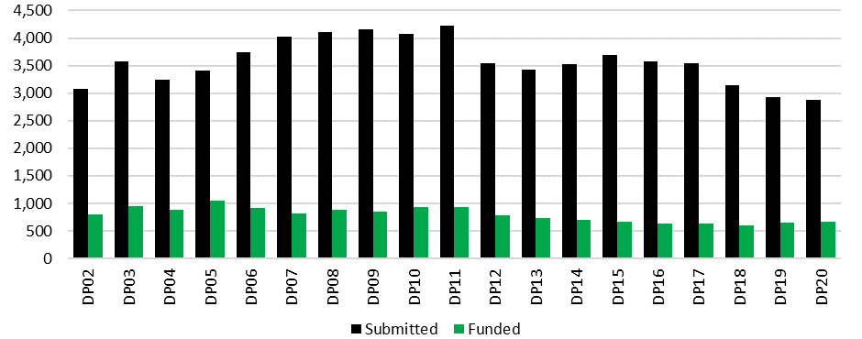

Source: ARC administrative data.

There was also a relatively steady decline in the number of projects funded under the scheme. After an initial period of growth in funded projects between DP02 and DP05 (from 792 to 1055 funded projects), the number of successful Discovery Projects applications gradually decreased, before settling somewhat in more recent rounds (an average of 639.7 projects funded in DP15–DP20). This amounted to a 37.4 per cent fall in the number of projects funded between DP05 and DP20. This decline is likely to reflect a range of factors, including the fall in application numbers, increased return rates for successful projects (see Section 2.6), and changes in the composition of the NCGP.

## Success rates

Success rates are defined as the number of projects funded as a percentage of applications submitted. These may be affected by a range of factors, including the number of applications received, the total funding available and the funding requested by applicants. After reaching a high of 30.9 per cent in DP05, the success rate for the Discovery Projects scheme remained relatively stable, at approximately 20 per cent from DP07–DP20.

Figure 2: Success rates, DP02–DP20

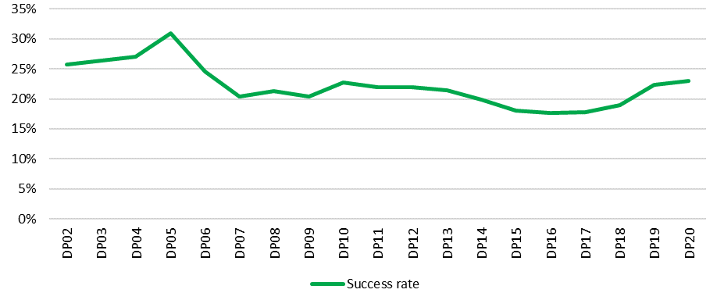

Source: ARC administrative data.

## Funding requested and awarded

Total funding requested under the Discovery Projects scheme more than doubled between DP02 ($1,014,313,394) and DP11 ($2,203,559,701), as a consequence of increases both in the number of applications submitted and the average amount requested per project, before declining substantially in DP12 ($1,822,442,555) with the introduction of DECRA. After rising between DP13 and DP15 (reaching $1,950,089,142), total funding requested again fell, reaching $1,641,948,285 in DP20.

Total funding awarded under the scheme followed somewhat similar trends, rising from $196,091,236 to $318,162,472 between DP02 and DP11 (with a peak of $325,575,289 in DP10). DP12 saw a 25.6 per cent fall in a single year (to $236,837,254), following the introduction of DECRA. Total funding then remained stable (at approximately $230,000,000– $250,000,000) until DP18, before rising in DP19 ($262,590,367) and DP20 ($284,952,924).

Figure 3: Total funding requested and awarded, DP02–DP20

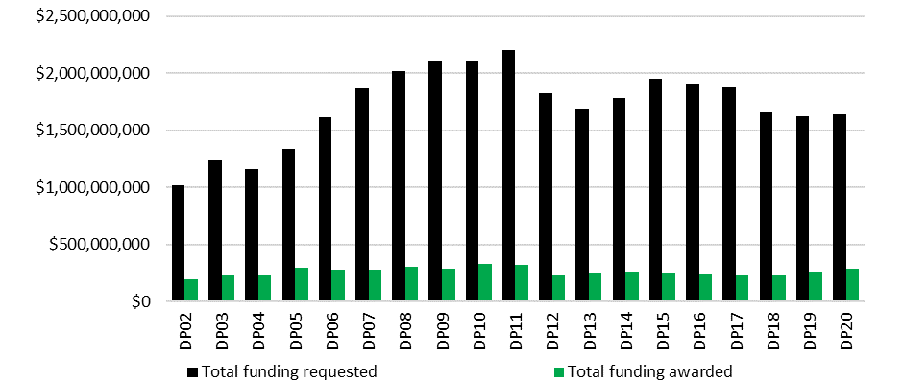

Source: ARC administrative data. *Note: Funding data reflect funding amounts at the time of announcement, and have not been adjusted for inflation.*



## Return rates

Budgets for successful applications are assessed as part of the ARC’s peer review processes. Figure 4: shows that the return rate for Discovery Projects (defined as the amount of ARC funding awarded as a percentage of funding requested in successful applications) was relatively stable between DP02 and DP12, averaging 56.7 per cent through this period. From DP13 onwards, the return rate steadily increased, peaking at 73.6 per cent in DP20.

Figure 4: Return rates, DP02–DP20

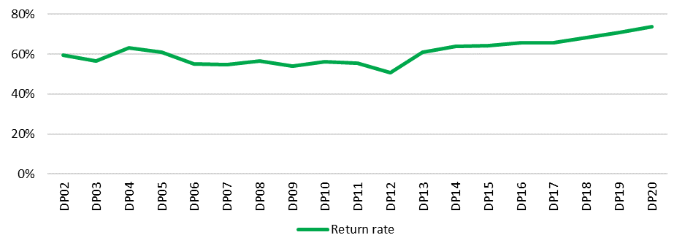

Source: ARC administrative data.

This increase may reflect several interacting factors. The declining number of funded projects has allowed a greater proportion of funding to be awarded to successful applicants. Between DP18 and DP20, there was also an increase in total funding announced under the scheme (Section 2.5). While Discovery Projects return rates increased in recent years, they remained relatively low compared to return rates under the Linkage Program.



## Participating organisation contributions

Cash and in-kind contributions from participating organisations constitute significant additional sources of support for research funded under the Discovery Projects scheme.[25] Between DP02 and DP20, participating organisation cash and in-kind contributions matched every $1 awarded through the scheme, with total combined contributions pledged on successful applications ($5,005,957,858) slightly exceeding total ARC funding ($4,999,362,564). The ratio of total contributions on successful applications to total ARC Discovery Projects funding increased over time from $0.84:$1 in DP02 to $1.20:$1 in DP20. From DP11 to DP20, over 70 per cent of contributions to funded projects were pledged by Administering Organisations.

Figure 5 traces total and average contributions associated with applications and funded projects between DP02 and DP20. Total contributions grew substantially between DP02 and DP11, before declining noticeably in DP12. This appears to correlate with a drop in overall applications and funding awarded under the scheme following the introduction of DECRA (see Sections 2.3 and 2.5). However, where overall application and funded project numbers continued to decline after DP12, total contributions broadly increased from DP12 to DP20, from $1,059,829,030 to $2,048,588,484 for applications and from $247,819,017 to $342,562,376 on funded projects. This is likely to reflect at least two factors. Firstly, there was growth in the average level of contributions per project from $249,049 to $712,533 on applications and $318,533 to $519,034 on funded projects from DP12 to DP20. Secondly, it may reflect the increase in the average number of participating organisations per project (see Section 3.4.2). Discovery Projects applications only recently began to directly distinguish between cash and in-kind contributions. In each round between DP16 and DP20, 85–90 per cent of contributions indicated within successful applications were in-kind.

Figure 5: Total and average contributions on applications and funded projects, DP02–DP20

**Figure 5 is a graph showing the total and average contributions pledged on applications and funded projects between DP02 and DP20. See text above graph for more information.
**

Source: ARC administrative data. *Note: Figures provided reflect planned contributions in applications. Contribution data have not been adjusted for inflation. Changes to the ARC’s collection of contribution data were introduced in DP15 to request both cash and in-kind contributions separately; previously, the ARC requested information about ‘non-ARC contributions’, which combined both cash and some types of in-kind contributions (e.g. university staff wages).*

## Fields of Research

### Applications, funded projects and funding

#### HASS and STEM

Using the Australian and New Zealand Standard Research Classification (ANZSRC) Field of Research (FoR) codes identified in Discovery Projects applications,[26] this section analyses the representation of different disciplines in research supported by the scheme. The primary 2-digit FoR codes[27] entered in applications have been used to assign projects to either HASS or STEM disciplines.[28]

As indicated in Figure 6, STEM disciplines have been represented more strongly than HASS disciplines in both applications and funded projects. The difference in composition has become slightly more pronounced over time, with STEM growing from approximately 70 per cent to 80 per cent of all applications and funded projects from DP02–DP20. This disparity is more pronounced within the context of total funding awarded, with STEM disciplines receiving no less than 75.2 per cent of funding (DP10), and up to 83.6 per cent of funding (DP20), per scheme round.

Figure 6: Proportion of applications, funded projects and total funding awarded by HASS/STEM, DP02–DP20

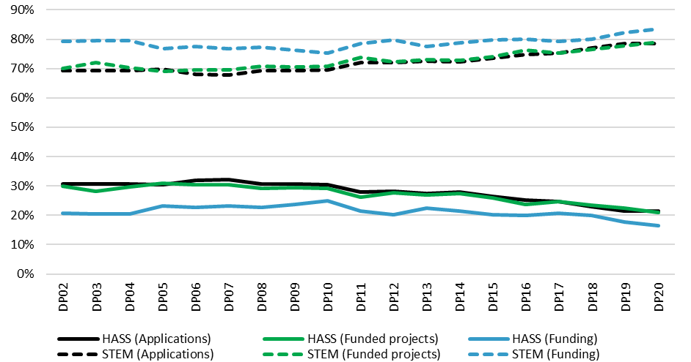

Source: ARC administrative data. *Note: STEM and HASS designations have been applied on the basis of primary 2-digit FoR code. Funding data reflect funding amounts at the time of announcement, and have not been adjusted for inflation.*

#### 2-digit Field of Research codes

Engineering and Biological Sciences were the dominant primary 2‑digit FoRs in Discovery Projects from DP02 to DP20, receiving approximately double the proportion of applications and funded projects compared to the next highest FoR. Built Environment and Design and Agricultural and Veterinary Sciences were the least represented FoR codes, each accounting for less than 1.2 per cent of all applications and funded projects over this period.

The two following figures identify the proportion of applications (Figure 7) and funded projects (Figure 8) associated with each primary 2-digit FoR code throughout all Discovery Projects scheme rounds between DP02 and DP20. In general, FoR representation was consistent between applications and funded projects. When ranked by total proportion from DP02 to DP20, nine of the top ten FoR codes appear for both applications and funded projects. These are Engineering, Biological Sciences, Information and Computing Sciences, Studies in Human Society, Chemical Sciences, Physical Sciences, Mathematical Sciences, Psychology and Cognitive Sciences, and Earth Sciences.

Figure 7: Proportion of applications by primary 2-digit FoR code, DP02–DP20

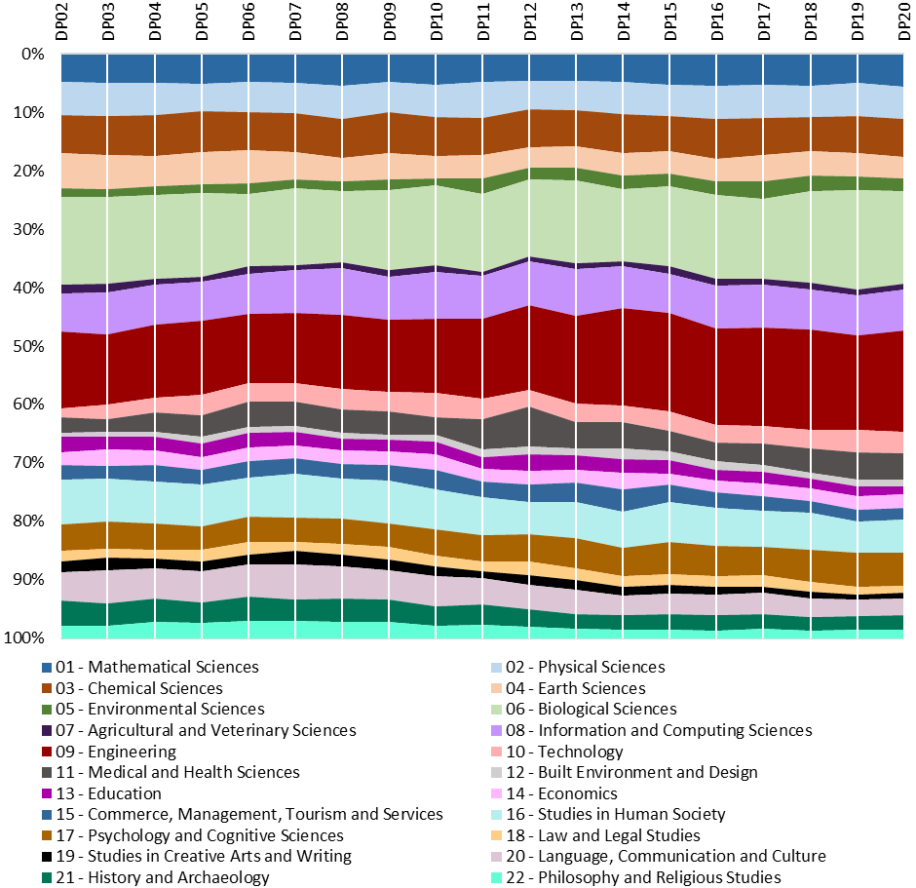

Source: ARC administrative data.

The representation of different FoR codes within Discovery Projects applications remained relatively stable over time, although some trends are evident. The proportion of Engineering applications submitted between DP02 and DP20 substantially increased. Conversely, the proportion of applications in the Language, Communication and Culture, and Earth Sciences FoRs decreased.

Figure 8 shows that among funded projects, there was also relative stability across FoRs. There was, again, a general trend towards a greater representation of Engineering research up until DP17, but with a slight decline over the three most recently announced funding rounds.

Figure 8: Proportion of funded projects by primary 2-digit FoR code, DP02–DP20

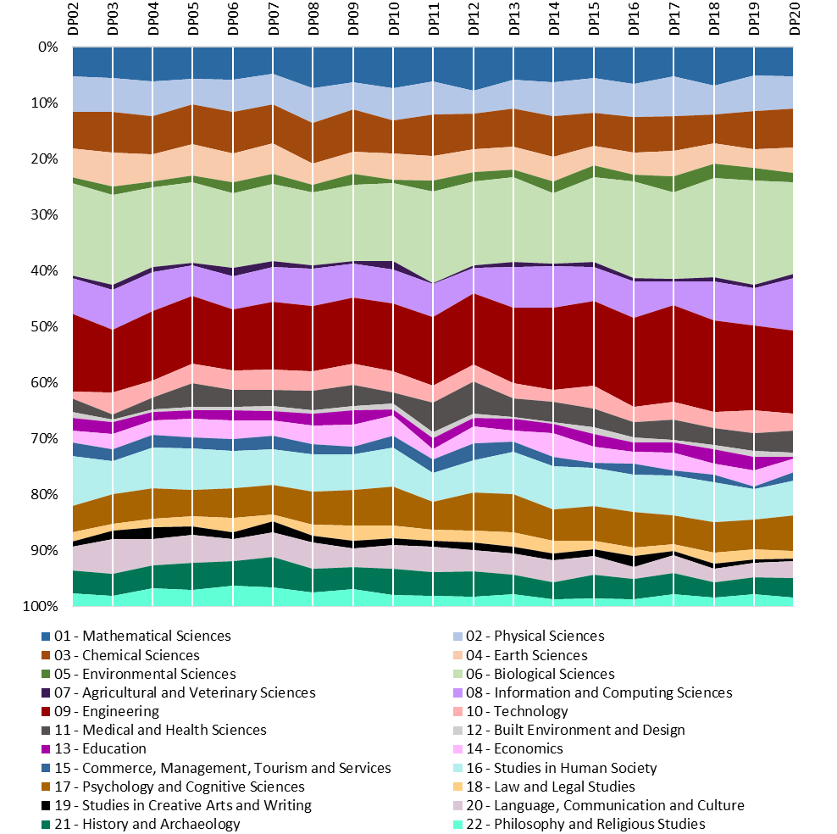

Source: ARC administrative data.

In terms of total funding awarded (Figure 9), Biological Sciences and Engineering were again the dominant primary 2-digit FoR codes between DP02 and DP20, receiving 17.2 per cent and 14.5 per cent of all funding respectively. Studies in Creative Arts (0.9 per cent), Agricultural and Veterinary Sciences (0.8 per cent) and Built Environment and Design (0.6 per cent) had the lowest average proportions of total funding. These figures are consistent with the relative proportion of funded projects addressing these FoRs.

Figure 9: Proportion of funding awarded by primary 2-digit FoR code, DP02–DP20

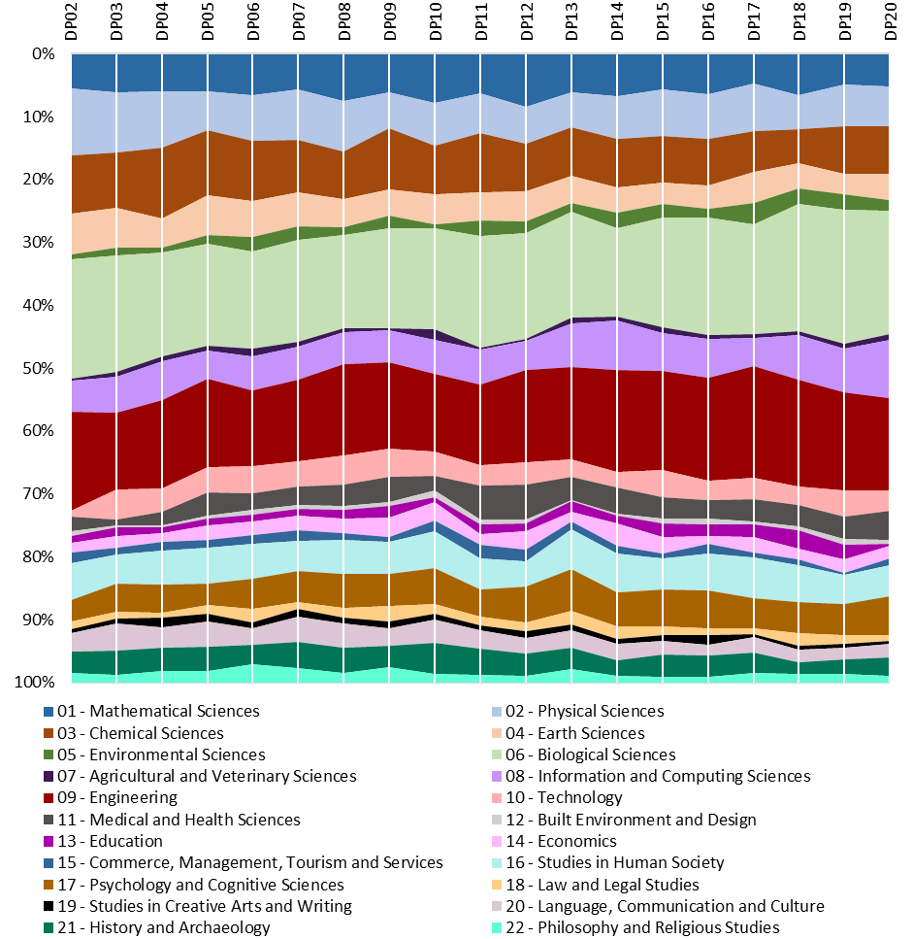

Source: ARC administrative data. *Funding data reflect funding amounts at the time of announcement, and have not been adjusted for inflation.*

Over time, the percentage of funding awarded to different FoRs has generally been consistent, although some changes are apparent. Chemical Sciences, Language, Communication and Culture, and Earth Sciences received a slightly diminishing proportion of total funding from DP04 onwards. The proportion of funding awarded to Medical and Health Sciences increased substantially in DP11 (5.4 per cent) and DP12 (5.5 per cent) from an average of 2.7 per cent in prior funding rounds. It subsequently moderated to an average of 3.7 per cent between DP13 and DP20.[29]

### Success and return rates

#### HASS and STEM

Despite divergent application, funded project and funding outcomes, Figure 10 shows that success rates for HASS and STEM disciplines have corresponded closely throughout the history of the Discovery Projects scheme. This result reflects ARC processes ensuring similar success rate results across different Selection Advisory Committee disciplinary panels. The return rate for funded HASS projects was generally slightly higher than for STEM, particularly during earlier Discovery Projects funding rounds. Between DP02 and DP20, the total return rate for HASS projects was 61.2 per cent, compared to 59.8 per cent for STEM. Disparities in the proportion of total funding awarded to STEM and HASS, as noted in Figure 6, do not reflect differences in return rates for these disciplinary areas.

Figure 10: Success and return rates by HASS/STEM, DP02–DP20

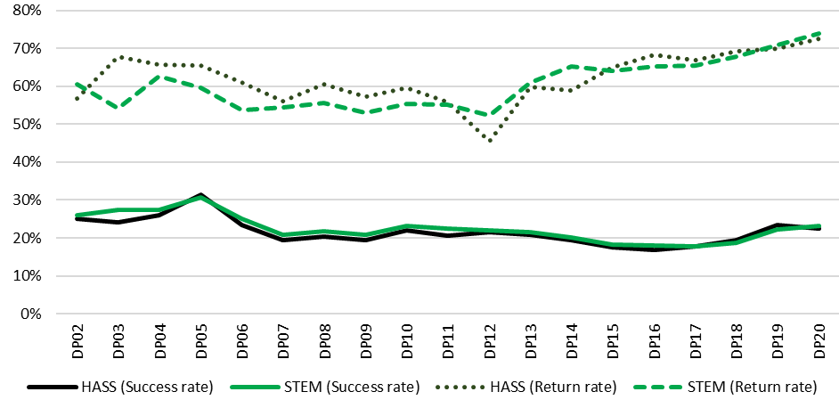

Source: ARC administrative data. *Note: STEM and HASS designations have been applied on the basis of primary 2-digit FoR code.*

Figure 11 maps average funding requested and awarded for HASS and STEM projects between DP02 and DP20. For both disciplinary areas, average funding requested and awarded gradually increased over time. However, in all Discovery Projects scheme rounds, successful STEM applications requested, and were awarded, substantially more average funding per project. Differences in funding requested are contributing to the overall skewing of scheme funding towards STEM. These findings potentially reflect disparities in research costs associated with HASS and STEM projects, notwithstanding significant differences in expenses between disciplines within these overarching areas.[30]

Figure 11: Average funding requested and awarded per project by HASS/STEM, DP02–DP20

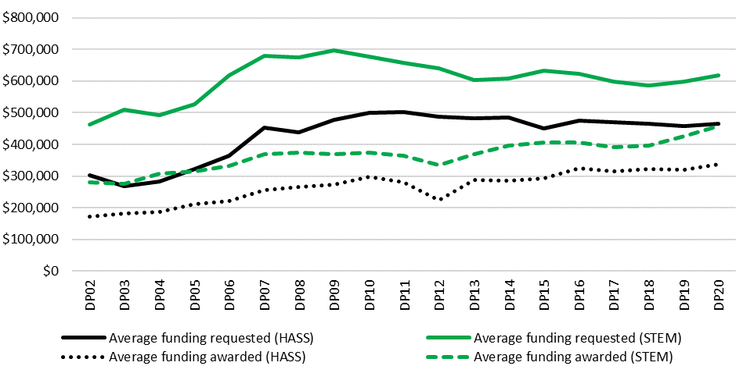

Source: ARC administrative data. *Note: STEM and HASS designations have been applied on the basis of primary 2-digit FoR code. Funding data reflect funding amounts at the time of announcement, and have not been adjusted for inflation. Funding requested data only includes successful applications.*

#### 2-digit Field of Research codes

Figure 12 depicts the six primary 2-digit FoRs with the highest overall success rates between DP02 and DP20. Three STEM (Mathematical Sciences, Psychology and Cognitive Sciences, and Biological Sciences) and three HASS (History and Archaeology, Economics, and Philosophy and Religious Studies) disciplines are represented. (See Appendix D for further detail on success rates by primary 2-digit FoR codes). Consistent with the data presented in Figure 10, no clear patterns relating to FoR success rates were apparent when analysed by HASS and STEM designations. Built Environment and Design (14.3 per cent) and Agricultural and Veterinary Sciences (14.8 per cent) had the lowest overall success rates from DP02 to DP20.

Figure 12: Success rates by primary 2-digit FoR code, DP02–DP20

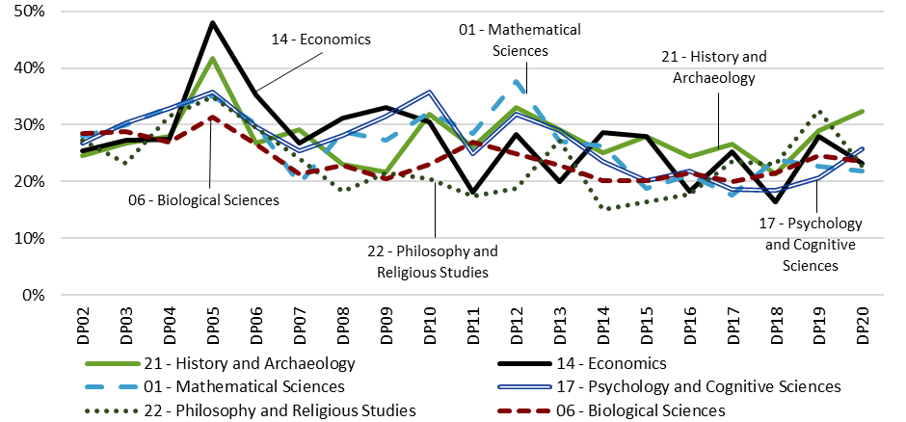

Source: ARC administrative data.

## Interdisciplinary research

The *ARC Statement of Support for Interdisciplinary Research* describes interdisciplinary research (IDR) as ‘research that traverses or transcends disciplinary boundaries and which synthesises(s) or integrate(s) methods and knowledge from multiple disciplinary domains’.[31] Previous research suggests that IDR may be disadvantaged within peer review processes. Applications within existing disciplinary boundaries may be easier to substantiate using pre-existing research literature, and the innovativeness associated with IDR may be regarded as presenting greater risk. Recruiting peer reviewers with expertise across multiple disciplinary domains also presents distinct challenges.[32] ARC mechanisms to support IDR include recruiting College of Experts peer reviewers with broad expertise, assigning IDR proposals across Selection Advisory Committee panels as needed to ensure they are assessed by experts with the required diversity of disciplinary knowledge, and ongoing monitoring and reporting.

This section employs two approaches to analyse the scale of IDR within Discovery Projects. Firstly, if the primary FoR code identified in an application has less than a 70 per cent weighting, the project has been deemed interdisciplinary in nature. This approach has been taken at both 2-digit and 4-digit FoR code levels. Secondly, applications from DP17 onwards have included a question directly asking researchers to specify whether they regard their work as interdisciplinary.

Figure 13 maps the proportion of interdisciplinary Discovery Projects applications and funded projects using these measures. A few features of the graph are notable:

* The level of IDR varies substantially depending on the metric used, with the 4-digit FoR and self-assignation measures suggesting considerably higher proportions than the 2-digit FoR code measure. The lower rate of interdisciplinary research recorded at the 2-digit FoR level reflects the more finely differentiated disciplinary divisions allowed for by 4-digit FoR codes.
* The 2-digit and 4-digit approaches both suggest that there was a slight decline in the proportion of IDR between DP07 and DP20.
* According to all three measures, the proportion of IDR applications was generally slightly higher than the proportion of IDR funded projects.

Figure 13: Interdisciplinary applications and funded projects, DP02–DP20

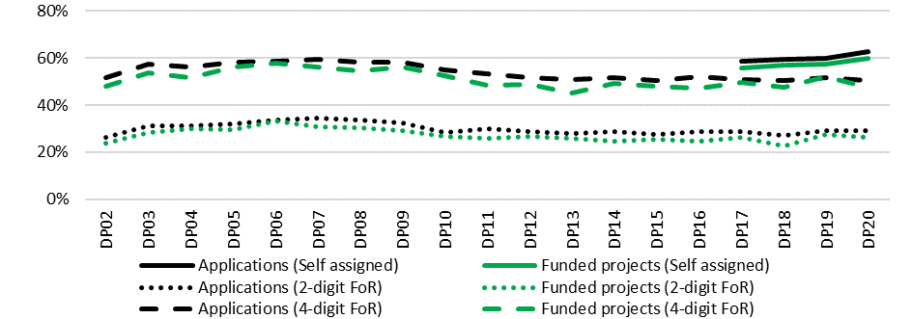

Source: ARC administrative data. *Note: Self-assigned data only available from DP17 onwards.*

Figure 14 tracks success rates for IDR and non-IDR between DP02 and DP20, using the measures identified above. All three approaches suggest that the success rate for non-IDR was consistently slightly higher than the success rate for IDR throughout the time period. This suggests that there may be scope for the ARC to further focus its advice to Discovery Projects assessors and Selection Advisory Committees as part of ongoing efforts to support IDR.

Figure 14: Success rates for IDR and non-IDR, DP02–DP20

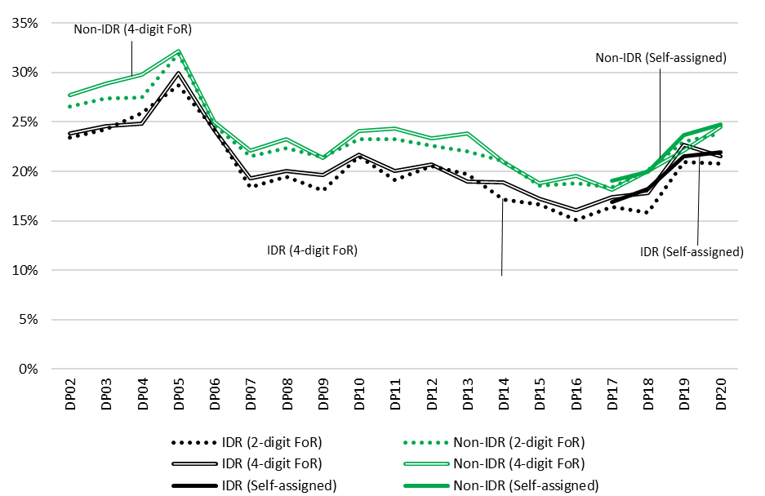

IDR (2-digit FoR)

Non-IDR (2-digit FoR)

Source: ARC administrative data. *Note: Self-assigned data only available from DP17 onwards.*

## Project completion and objectives achieved

Final reports address compliance with funding conditions specified within Grant Agreements and are used by the ARC to determine satisfactory project completion. This section analyses final report data to provide insight into project completion and the achievement of project objectives in research funded under Discovery Projects. It should be acknowledged that final reports have not been submitted for all funded projects. Further, data derived from these reports are generally based upon researcher self-reporting.

### Project completion

From DP02 to DP11, researchers were expected to submit final reports within six months of their final grant payment or the final approved carryover of funds. This period was lengthened to 12 months from DP12 onwards.

Figure 15 depicts available data on the proportion of submitted final reports classified as being on time or late by calendar year.[33]

Figure 15: Proportion of final reports submitted on-time and late by calendar year, 2015–2019

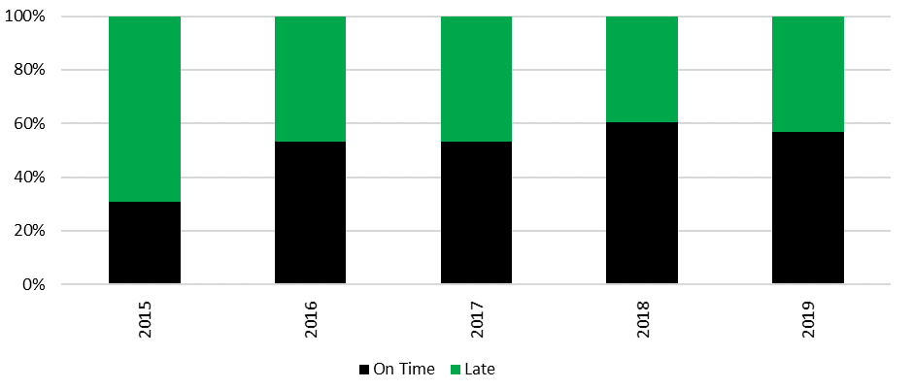

Source: ARC administrative data. *Note: Data periods relate to calendar years, rather than DP funding rounds. On time and late time statuses reflect earliest date of final report submission. Late status data relate to final reports submitted longer than 12 months after the final grant payment/approved carryover of funds; project variations to these dates are reflected within the data.*

Overall, a slight majority (53.0 per cent) of Discovery Projects final reports appear to have been submitted on time over the period documented. The data for 2015 were a noticeable outlier, within which a significant majority (69.3 per cent) of submitted final reports were late. However, as only final reports submitted in the second half of 2015 have been included, the data may not be representative of 2015 as a whole.

From late-2016 onwards, the ARC strengthened its mechanisms to encourage timely submission by more rigorously enforcing eligibility requirements requiring all named researchers on submitted applications to have met their obligations in relation to previously funded projects, including the submission of satisfactory final reports, by the grant opportunity closing date. Given the relatively recent introduction of this change, continued monitoring of these data may provide further insight into the impact of these mechanisms on the timely submission of Discovery Projects final reports.

### Factors affecting project progress or completion

Discovery Projects final reports ask whether there were factors affecting ‘the satisfactory and timely progress or completion of the project’. Researchers answering ‘Yes’ are prompted to provide a textual description of the nature of these interruptions. The majority of final reports submitted for successful projects between DP02 and DP14 answered the above question affirmatively, with the proportion gradually increasing over time, from 53.3 per cent in DP02 to 61.2 per cent in DP14.[34]

Analysis of a randomly selected sample of 100 of the 6303 open text descriptions available from final reports provided insight on the factors affecting the timely and satisfactory progress or completion of projects. The most commonly cited factors related to personnel arrangements, particularly the recruitment of postdoctoral researchers and Higher Degree by Research (HDR) candidates, movements between jobs, difficulties gaining access to necessary skills and expertise, and/or retirement. Family and personal matters were often specified, such as illness, periods of leave and caring responsibilities. Factors relating to the research process itself, including interruptions to data collection, unexpected delays to project timeframes and the impact of unanticipated preliminary findings, were also frequent.

A further theme commonly emphasised was the impact of not receiving the full sum of funding requested. Researchers described responding to this situation by reducing project scope, changing the research objectives originally specified, limiting the number of personnel involved, devoting less time to particular project stages and/or reducing the amount of research data collected.

### Project objectives achieved

Discovery Projects applicants must identify individual project objectives and, if awarded funding, report on the achievement of those objectives in final reports. Researchers may reframe project objectives during the course of their funding.

As shown in Figure 16, available final report data indicate that a high proportion of projects funded from DP02–DP14 were reported to have met all project objectives. The proportion of projects meeting no objectives was less than 5 per cent in DP02 and diminished over time from a very low baseline to a negligible level.

Figure 16: Proportion of project objectives met, DP02–DP14

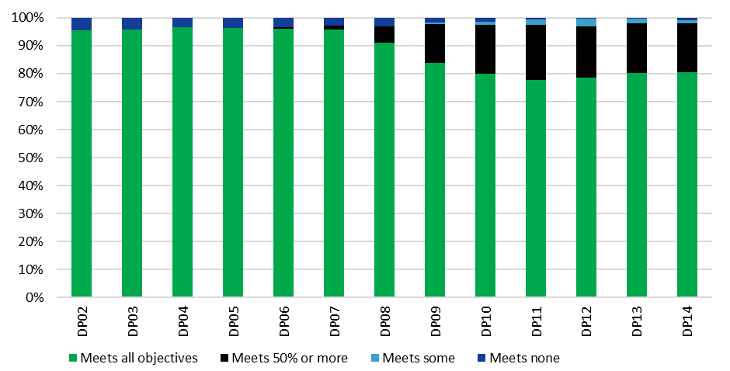

Source: ARC administrative data. *Note: DP15 onwards excluded due to limited data being available. Data provided relate to the objectives of individual projects, rather than the Discovery Projects scheme objectives. Early final reports requested a single overall indication of whether the research met its objectives; later final reports requested an indication of whether each individual objective had been met.*

The most noticeable features of Figure 16 are the decline in the proportion of research described as meeting all specified project objectives from DP07 (95.7 per cent) to DP11 (77.6 per cent), and the simultaneous rise in the proportion of research meeting 50 per cent or more of project objectives (from 1.5 per cent in DP07 to 17.4 per cent in DP14). These apparent changes are likely to reflect amendments to ARC reporting processes. Originally, Discovery Projects final reports asked, ‘Did the project meet its initial objectives or approved revised objectives?’, with researchers only able to provide a ‘Yes’ or ‘No’ response to describe the project as a whole. In later years, researchers were asked to respond against each individual project objective, allowing for more nuanced reporting.

# Part Three: Effectiveness—Discovery Projects scheme objectives

Part Three evaluates Discovery Projects’ effectiveness in achieving its objectives, as stated in the DP21 Grant Guidelines. Following an initial analysis of stakeholder perceptions of Discovery Projects’ performance in relation to its objectives overall, the scheme’s effectiveness is assessed in relation to individual elements of the objectives, as follows:

* supporting excellent basic and applied research by individuals and teams
* supporting excellent research training
* supporting national and international research collaboration
* enhancing the scale and focus of research in Australian Government priority areas.

Each section includes a discussion of the approach Discovery Projects employs to achieve the objective, a consideration of relevant internal ARC administrative data, and a discussion of key perspectives emerging from surveys and interviews with stakeholders.

## Summary of findings

* Stakeholder feedback and ARC data indicate that Discovery Projects is effective in achieving its objectives. Stakeholders regarded the scheme to be most effective in supporting basic research, national research collaboration and research training.
* Researchers whose last completed project under the scheme was finalised recently (2018 or later), or involved international collaboration, tended to be more positive overall about Discovery Projects’ effectiveness in meeting its objectives.

*Supporting excellent basic and applied research by individuals and teams*

* While the scheme supports both basic and applied research, the proportion of funded projects involving basic research increased over time. Success rates for basic research were consistently higher than for applied research, while return rates for both were generally similar.
* The average number of named researchers on funded projects steadily increased from 2.1 in DP02 to 3.2 in DP20. While male researchers accounted for over 75 per cent of the total number of named researchers, female researchers had higher success rates in recent funding rounds.
* Aboriginal and Torres Strait Islander researcher participation was low, but increased marginally from 0.2 per cent of all named researchers on funded projects in DP02 to 0.5 per cent in DP20.
* Stakeholders regarded the competitive peer review process as effective in underpinning the scheme’s support for excellent research conducted by individuals and teams. However, some stakeholders perceived HASS research to be disadvantaged in comparison to STEM research.

*Supporting excellent research training*

* Total research trainee numbers and Higher Degree by Research stipends increased slightly on funded projects between DP16 and DP20.
* Data are not currently collected on the total number of research trainees participating on projects under the scheme, or on actual stipend expenditure.
* Stakeholders commented that the scheme’s support for research training was valuable, but raised concerns that reductions in awarded project budgets impacted support for research training, and that typical grant durations did not align with Doctor of Philosophy (PhD) completion timeframes.

*Supporting national and international research collaboration*

* The average number of participating organisations increased on applications (from 1.4 to 2.3) and funded projects (from 1.5 to 2.4) from DP02 to DP20.
* International organisations constituted a growing proportion of participating organisations on applications (from 25.5 per cent to 33.0 per cent) and funded projects (from 30.0 per cent to   
  33.0 per cent) between DP11 and DP20. International higher education institutions were the most common participating organisation type outside of Australian universities.
* In line with its design and intent, the scheme primarily supports collaboration between national and international researchers.
* Qualitative stakeholder feedback included concerns that limiting researchers to two Chief Investigator roles disincentivised collaboration between Australian universities, and that administrative burdens impeded international Partner Investigator participation.

*Enhancing the scale and focus of research in Australian Government priority areas*

* The proportion of funded projects addressing the National Science and Research Priorities has declined compared to previous priorities. This is likely to reflect changes to the nature, number and breadth of the priorities, rather than the effectiveness of the scheme.
* Advanced Manufacturing, Environmental Change and Health have been the most frequently addressed National Science and Research Priorities; while Food, Soil and Water, and Resources have been addressed less frequently.
* Stakeholders expressed a degree of uncertainty about the role of the National Science and Research Priorities in Discovery Projects processes.



## Quantitative stakeholder views on effectiveness—overall scheme objectives

Researchers funded under Discovery Projects agreed that the ARC’s implementation of the scheme effectively supports the achievement of its objectives. Figure 17 shows researchers were most likely to either agree or strongly agree that the scheme effectively supports basic research (70 per cent), research collaboration within Australia (69 per cent) and internationally (63 per cent), as well as research training (67 per cent). The majority also agreed the scheme was effective in its support for applied research (57 per cent) and research in Australian Government priority areas (60 per cent). The proportion of respondents disagreeing or strongly disagreeing about the effectiveness of Discovery Projects in achieving scheme objectives was low.

Figure 17: Level of agreement that ARC implementation of Discovery Projects effectively supports scheme objectives

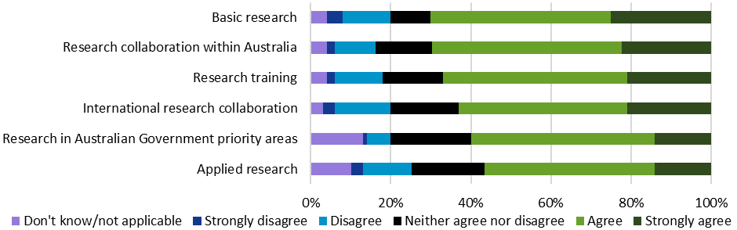

Source: Kantar, Public Division. *Note: (n=3018).*

Table 1 presents the proportion of researchers—grouped according to characteristics of their most recently completed project under the scheme—who agreed or strongly agreed that the ARC’s implementation of Discovery Projects effectively supports the achievement of scheme objectives.

Table 1: Proportion of researchers agreeing that ARC implementation of Discovery Projects effectively supports the achievement of scheme objectives, by most recently completed Discovery Projects research characteristics

|  |  |  |  |  |  |  |  |  |  |  |
| --- | --- | --- | --- | --- | --- | --- | --- | --- | --- | --- |
|  | Research Project Characteristics | | | | | | | | | |
| Objective | **STEM** | **HASS** | **Completed Project 2018 or later** | **Completed Project 2011– 2017** | **Completed Project 2010 or earlier** | **Basic** | **Applied** | **Basic and Applied Combined** | **International Collaboration** | **No International Collaboration** |
| Basic research | 72%  (+) | 67% | 75%  (+) | 66%  (–) | 61%  (–) | 73% | 62%  (–) | 70% | 72%  (+) | 65%  (–) |
| Research collaboration within Australia | 65%  (–) | 74%  (+) | 70% | 65% | 66% | 68% | 68% | 67% | 69% | 64% |
| Research training | 72%  (+) | 62%  (–) | 71%  (+) | 66% | 58%  (–) | 67% | 68% | 69% | 70%  (+) | 63%  (–) |
| International research collaboration | 61% | 61% | 67%  (+) | 55%  (–) | 53% | 63% | 54%  (–) | 61% | 69%  (+) | 44%  (–) |
| Research in Australian Government priority areas | 58%  (–) | 65%  (+) | 63% | 61% | 54% | 56%  (–) | 63% | 64%  (+) | 61% | 58% |
| Applied research | 54% | 59% | 59% | 57% | 43%  (–) | 46%  (–) | 69%  (+) | 62%  (+) | 58%  (+) | 51%  (–) |

Source: Kantar, Public Division. *Note: Percentage of survey respondents agreeing or strongly agreeing. Grey cells are significantly below the mean (–) while green cells are significantly above the mean (+), at the 95 per cent confidence level. Subgroups assigned on the basis of most recently completed project funded under the scheme. Table only includes participants with a completed project (n=2469); different numbers of survey participants responded to questions relating to research project characteristics.*

Researchers who had completed a project in the last three years were generally more positive about the scheme’s achievement of its objectives than those who had completed projects less recently. For instance, this group was more likely to agree or strongly agree that the scheme effectively supports basic research (75 per cent compared to 65 per cent), research training (71 per cent compared to 64 per cent) and international collaboration (67 per cent compared to 58 per cent). While this seems to indicate that stakeholders’ perceptions of the scheme’s effectiveness have become more positive over time, neither the feedback received nor an analysis of changes in the ARC’s implementation of the scheme support firm conclusions regarding specific elements that contributed to these results. It is also possible that the recency of the research and funding may have influenced some stakeholders’ perceptions and recollections. There may be value in seeking more detailed stakeholder perspectives on this issue in future to inform improvements that may further strengthen the scheme’s effectiveness.

Researchers whose most recently completed project involved international collaboration were also more likely to agree that Discovery Projects effectively achieved its objectives. Compared to researchers not collaborating internationally, they more often agreed or strongly agreed that the scheme effectively supports basic research (72 per cent compared to 65 per cent), applied research (58 per cent compared to 51 per cent), research training (70 per cent compared to 63 per cent) and, as may be expected, international collaboration (69 per cent compared to 44 per cent).

There was also variability by disciplinary area. Compared to participants completing projects in HASS fields, researchers from STEM fields were more likely to agree that the scheme effectively supported basic research (72 per cent compared to 67 per cent) and research training (72 per cent compared to 62 per cent). Researchers from HASS fields, alternatively, were more likely to positively perceive the scheme’s effectiveness in relation to national collaboration (74 per cent compared to 65 per cent) and research addressing Australian Government priority areas (65 per cent compared to 58 per cent). The latter finding contrasts somewhat with stakeholder feedback expressing concerns that the National Science and Research Priorities disproportionately emphasise STEM-related themes (see Section 5.2.2).

## Supporting excellent basic and applied research by individuals and teams

The fundamental principle underpinning the Discovery Projects scheme has been to support research on the basis of excellence, as assessed through a competitive peer review process. As noted in Part Two, while Discovery Projects is a pivotal component of the Australian Government’s support for basic research, it has also supported applied research since its inception. From DP12 onwards, the scheme’s objectives were broadened to explicitly reference support for both basic and applied approaches.

Elements of the current scheme design continue to reflect this particular balance of support for basic and applied research. For instance, compared to most schemes within the Linkage Program, current Discovery Projects assessment criteria place greater emphasis on fundamental research considerations such as ‘Investigator/Capability’ and ‘Project Quality and Innovation’, as opposed to ‘Benefit’, which may be difficult to anticipate within the context of basic research. Simultaneously, the scheme includes mechanisms to support applied research through opportunities to collaborate with research end users and assessment criteria relating to commercialisation.

### ARC data—excellent basic and applied research

While the ARC does not directly categorise projects as basic or applied research, analysis of the ANZSRC Socio-Economic Objective (SEO) codes assigned to Discovery Projects research provides insight into the balance of the scheme’s support for basic and applied approaches. SEO codes allow research ‘to be categorised according to […] intended purpose or outcome’, within five overarching ‘sectors’: Defence (A); Economic Development (B); Society (C); Environment (D); and Expanding Knowledge (E). More detailed SEO codes exist at 2-, 4- and 6-digit levels under these sectors.[35]

In Discovery Projects application forms, researchers are asked to specify up to three 6-digit SEO codes for their proposed research, and to assign a weighting to each.[36] The following analysis aggregates these 6-digit SEO codes within their overarching primary sector.[37] The analysis employs Expanding Knowledge as a proxy indicator for basic research, in accordance with the Australian Bureau of Statistics definition:

Expanding Knowledge is for the categorisation of R&D which does not have an identifiable socio-economic objective. This is usually the case for pure basic research or strategic basic research. [...] Applied research and experimental development, by definition, have an identified socio-economic objective and therefore should not be categorised in this sect*or.[38]*

It is important to note that Discovery Projects applicants frequently assign Expanding Knowledge to proposed research alongside other SEO sectors, reflecting that basic and applied research are not mutually exclusive, and indicating that the scheme supports projects combining elements of both.

The two figures below map the proportion of Discovery Projects applications (Figure 18) and funded projects (Figure 19) by primary SEO sector between DP02 and DP20. Between DP04 and DP10, Economic Development, Society and Expanding Knowledge were each the primary SEO sectors for approximately 25–30 per cent of applications and funded projects. From DP11 onwards, the proportion of research identifying Expanding Knowledge as the primary SEO sector substantially increased, exceeding 50 per cent of applications and funded projects in DP19 and DP20. Almost two-thirds of funded projects identified Expanding Knowledge as either a primary or non-primary SEO in DP19 and DP20. DP11–DP20 saw a relative decline in the Economic Development and Society primary sectors. Projects associated with the Environment sector remained steady at approximately 7–10 per cent of applications and funded projects between DP02 and DP20. Research relating to the Defence sector was uncommon. These results suggest that, over time, an increasing proportion of applications and funded projects under the scheme have included a focus on basic research.

Figure 18: Proportion of applications by primary SEO sector, DP02–DP20

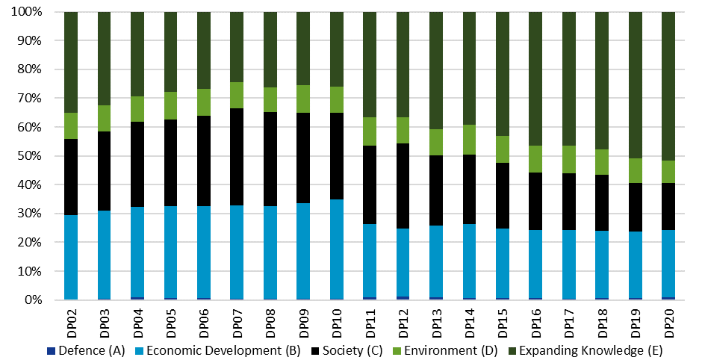

Source: ARC administrative data. *Note: Categories used reflect the 2008 ANZSRC.*

Figure 19: Proportion of funded projects by primary SEO sector, DP02–DP20

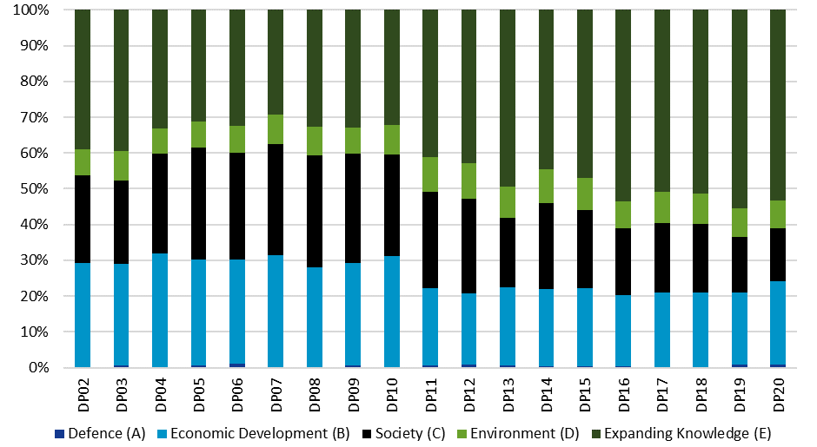

Source: ARC administrative data. *Note: Categories used reflect the 2008 ANZSRC.*

Figure 20 compares success and return rate results for projects with a primary Expanding Knowledge sector, and projects with any alternative primary SEO sector, to examine selection results associated with basic and applied research submitted under the Discovery Projects scheme. The total success rate for basic research (25.0 per cent) was higher than the success rate for applied research (20.3 per cent) between DP02 and DP20. Over this same time period, the total return rate for basic research closely paralleled results for applied research projects, with total return rates of 60.2 per cent and 59.9 per cent respectively.

Figure 20: Success/return rates for basic and applied research, DP02–DP20

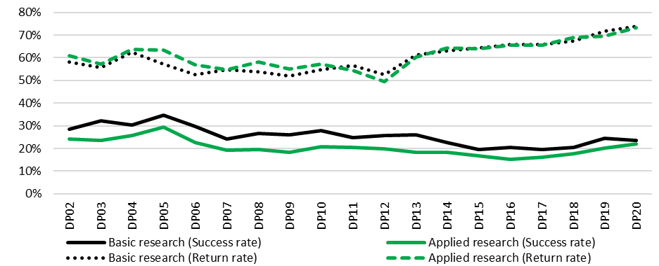

Source: ARC administrative data. *Note: Categories used reflect the 2008 ANZSRC. ‘Basic research’ includes projects with a primary Expanding Knowledge SEO sector; ‘Applied research’ includes projects with a primary Defence, Economic Development, Society or Environment SEO sector.*

These findings suggest that, in accordance with its objectives, Discovery Projects effectively supports a balance of basic and applied research, with the proportion of basic research (identified as projects with a primary Expanding Knowledge SEO sector) increasing over time. Consistent with researcher perceptions that the scheme supports basic research more effectively than applied research, applications associated with Expanding Knowledge have also had marginally higher success rates than research with other primary SEO sectors. The appropriateness of the scheme’s operation in these ways is discussed in Part 5.

### ARC data—individuals and teams

#### Named researchers

Between DP02 and DP11, the number of named researchers (including Chief Investigators, Partner Investigators, and award and fellowship recipients) on Discovery Projects applications grew steadily from 5951 to 10,106, as shown in Figure 21.[39] After briefly declining in DP12–DP13 (following the introduction of DECRA), the growth in named researcher participation on applications resumed, peaking in DP17 at 11,108. Over the past three announced funding rounds, however, this figure fell noticeably, reaching 9091 in DP20—the lowest number of named researchers on applications since DP07. This decline is likely to reflect the falling number of applications submitted in DP18–DP20. The number of named researchers on funded projects remained relatively static for most of the scheme’s history, hovering at close to 2000, albeit with a lower figure in DP02 (1644), spikes in DP05 (2314), DP10 (2357) and DP11 (2447), and values above 2000 in the two most recent rounds (2098 in DP19 and 2103 in DP20).

There has, however, been a sustained increase in the average number of named researchers per project. For applications, this figure grew from 1.9 to 3.2 named researchers between DP02 and DP20. For funded projects, the average number increased from 2.1 to 3.2 over the same time period. The proportion of funded projects involving more than one named researcher has also grown substantially, increasing from 53.5 per cent in DP02 to 86.8 per cent in DP20. These data suggest that, over time, Discovery Projects has been increasingly effective at fostering research involving team-based arrangements. It should be noted, however, that these figures underestimate the size of teams funded under the scheme, as ‘unnamed researchers’ (including research trainees, postdoctoral fellows and research assistants) are not captured.

Figure 21: Total/average named researchers on applications and funded projects, DP02–DP20

Figure 21 is a graph showing the total and average number of named researchers on Discovery Projects applications and funded projects between DP02 and DP20. See text above graph for more information.


Source: ARC administrative data. *Note: Data reflect number of named researchers identified within applications. Named researchers include Chief Investigators, Partner Investigators and fellowship recipients.*

#### Gender[40]

There was a steady increase in the average number of male named researchers on Discovery Projects applications (1.5 to 2.3) and funded projects (1.6 to 2.4) between DP02 and DP17, with a marginal fall over recent years. The average number of named female researchers was significantly lower, but increased over time (from 0.4 to 0.8 on applications and from 0.4 to 0.9 on funded projects between DP02 and DP20). Males accounted for over 75 per cent of the total number of named researchers on funded projects between DP02 and DP20.

Figure 22: Average number of named researchers on applications/funded projects and success rates by gender, DP02–DP20

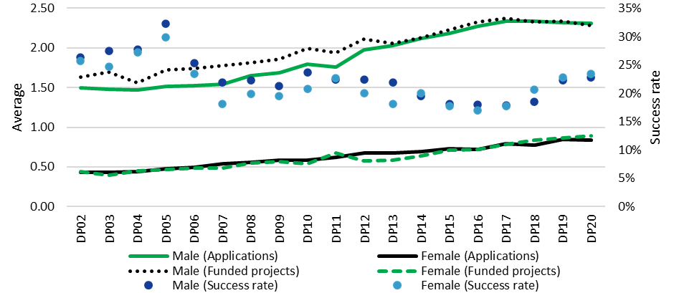

Source: ARC administrative data. *Note: Indeterminate and unknown gender figures have not been included due to low numbers. Data reflect number of named researchers identified within applications. Named researchers include Chief Investigators, Partner Investigators and fellowship recipients.*

Two factors should be taken into consideration when interpreting these data. Firstly, it is important to note that males continue to be overrepresented within the broader research workforce in Australia, as well as internationally. The ARC’s *Gender and the Research Workforce: Excellence in Research for Australia (ERA) 2018* report, for instance, found that males constituted 56 per cent of Australian higher education research staff, compared to 44 per cent for females. This disparity becomes more pronounced at senior employment levels.[41] Secondly, as indicated in Figure 22, while male named researchers had consistently higher success rates than their female counterparts until DP13, this disparity largely disappeared in recent years and, over the past three announced funding rounds, female named researchers had a slightly higher success rate.

#### Aboriginal and Torres Strait Islander researchers

Between DP02 and DP20, approximately 0.2 per cent of all named researchers on Discovery Projects applications and funded projects identified as having Aboriginal and/or Torres Strait Islander origin. This proportion increased marginally over time on both applications (reaching 0.3 per cent in DP19 and DP20) and funded projects (reaching 0.3 per cent in DP19 and 0.5 per cent in DP20),[42] but remains low compared to the proportion of Aboriginal and Torres Strait Islander researchers within the overall Australian academic population (1.3 per cent on a Full-Time Equivalent [FTE] basis).[43]

Figure 23: Proportion of named researchers identifying Aboriginal and/or Torres Strait Islander origin, DP02–DP20

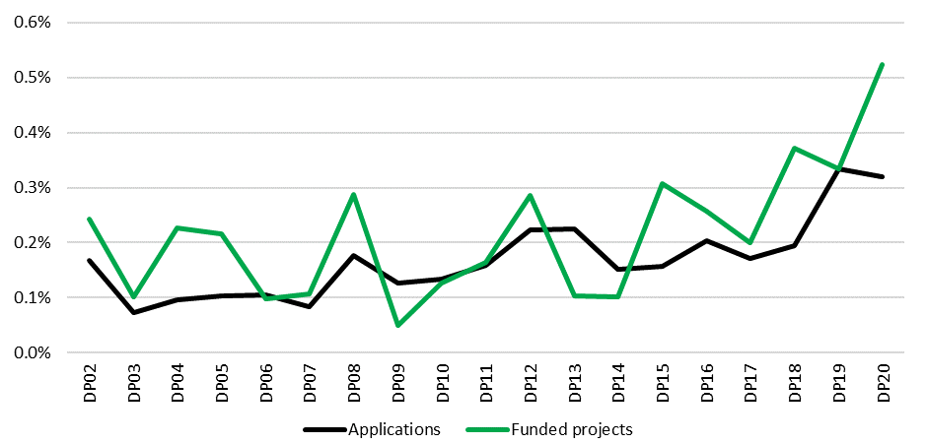

Source: ARC administrative data. *Note: Data reflect number of named researchers identified within applications. Named researchers include Chief Investigators, Partner Investigators and fellowship recipients. Aboriginal and Torres Strait Islander status data reflect researcher self-report.*

The total success rate for Aboriginal and Torres Strait Islander researchers named on Discovery Projects applications (28.2 per cent) exceeded the total success rate for all named researchers (22.2 per cent) between DP02 and DP20.

It is important to note that less than 50 per cent of researchers named on Discovery Projects applications indicated whether they have Aboriginal and/or Torres Strait Islander origin. Further, due to the low numbers, both the proportion of named researchers and their success rates were volatile from round to round. Nonetheless, these indications of increasing, but still low representation in the scheme should be considered in informing broader ongoing mechanisms to support Aboriginal and Torres Strait Islander researchers and research across the NCGP, under the ARC Statement of Support and Action Plan.[44]

### Qualitative stakeholder feedback on effectiveness

#### Supporting excellent research

Stakeholders regarded the effectiveness of Discovery Projects’ support for research excellence as being underpinned by the scheme’s competitive processes, including the use of rigorous peer review by disciplinary experts to direct funding to the highest quality applications in a ‘free market of ideas’.

(I)t is a very competitive environment, [but] we see [that] the projects that get funded are the projects that deserve funding – (University Research Office)

(I)n the actual administration of [the scheme], the peer review’s not perfect, but it is the best way of allocating scarce resources fairly that I’ve come across. There will always be, inherent in some, personal biases, but over a long period of time with change-over of personnel, it’s as good a process [as] we are going to get – (University Research Office)

While Discovery Projects’ approach to peer review was generally viewed as robust, and as effectively allocating funds on the basis of research excellence, some concerns were expressed. Stakeholders suggested that, within the context of an intensely competitive grant opportunity, peer reviewers’ capacity to consistently differentiate between applications of similar quality may be limited and could potentially be impacted by personal bias or ‘luck’. Researchers also expressed a desire for further feedback in relation to unsuccessful applications to support the development of higher quality future submissions, and for additional transparency in relation to Selection Advisory Committee deliberations.

I wouldn’t call it luck; there’s variance on the margins – (University Research Office)

Outcomes are somewhat capricious, depending on the luck of the reviewer draw – (Researcher)

The ARC rejoinder process could be improved so that applicants get a greater sense of the assessment panel’s views as well—mirroring the National Health and Medical Research Council (NHMRC) process where applicants receive reports from both expert assessors and the panel – (Peak Body)

Stakeholders also highlighted the significant administrative burden created by Discovery Projects’ selection processes when submitting applications (for researchers) and administering grants (for research offices). Respondents identified substantial opportunity costs relating to time and labour involved in engaging with the scheme—particularly within the context of success rates that they regarded as low. These concerns were emphasised by research office representatives from smaller universities, who highlighted larger institutions’ greater capacity to support Discovery Projects applications due to their additional resourcing.

That bureaucratic process is something that needs to be thought through because it is just ridiculous and surely unnecessary – (University Research Office)

It costs my organisation many thousands of dollars in time to put together a single application with low chances of success – (Researcher)

Do the maths: in any given round, all the unsuccessful grants together represent several hundred years of person-time, in their planning and writing and the many months of work gathering preliminary data – (Researcher)

The amount of time people put in is enormous—with a 15 per cent success rate it is a huge waste of effort – (University Research Office)

These perspectives are important to acknowledge as highlighting consequences of the rigour and complexity involved in Discovery Projects’ selection processes. However, similar application and peer review processes are employed across the NCGP and, as they are in many ways not specific to Discovery Projects, they are largely beyond the scope of this evaluation. These findings should be considered and addressed in ongoing reviews of NCGP-wide administrative processes undertaken by the ARC.

#### Supporting basic and applied research

Consistent with the initial policy rationale underpinning the development of the Discovery Program, qualitative feedback highlighted the effectiveness of the scheme’s support for investigator-led, curiosity-driven, blue sky research across broad disciplinary domains.

They tend to fund the best blue sky research that Australia does – (University Research Office)

Discovery Projects are prestigious because of [their] historical significance, and when you win one, you really are pushing the frontiers of knowledge – (University Research Office)

Survey data on researchers’ most recently completed project funded under the scheme suggested that more than half of Discovery Projects activity involved applied research (15 per cent) or a combination of basic and applied research (39 per cent). As discussed above, quantitative survey results also affirmed the scheme’s efficacy in supporting applied research, though with a lower level of participant agreement than for basic research (see Figure 17). Against this backdrop, qualitative stakeholder responses noted that the scheme’s support for basic research indirectly contributed to applied outcomes by expanding the fundamental knowledge base.

(T)he great discoveries and advances in human society have usually come from basic research, or basic pure research – (University Research Office)

Basic research is essential. It is the foundation for all other research and also for translation. The Discovery Projects scheme, and other ARC schemes, has sought to encourage and amplify translation, and my sense is that this is now something that recipients put a premium on – (Researcher)

Despite stakeholders’ overall emphasis on the effectiveness of Discovery Projects’ support for basic research, qualitative feedback included views that certain elements of the scheme’s design potentially impede the provision of funding opportunities to innovative, ‘blue sky’ proposals. The perceived importance of an established ‘track record’,[45] of grounding proposals in pre-existing bodies of knowledge or evidence, and of demonstrating feasibility to ensure competitiveness within peer review processes were sometimes thought to favour more conservative applications. The scheme’s focus on delivering economic, commercial, environmental, social and cultural benefits, and addressing Australian Government research priorities, also raised concerns about its compatibility with unrestricted, fundamental academic enquiry (see Section 5.2.2 and 5.2.3 for further discussion).[46]

High risk basic research is not supported. There is a clear expectation that the research will be applied within a few years. This is particularly evident in the 'benefit' section. An overhaul to shift the focus from incremental research to new fundamental basic research is needed. If this scheme is not going to support fundamental high risk research who in Australia is going to? – (Researcher)

The Discovery Projects scheme should support high risk, fundamental research much more strongly than it presently does. The problem is (a) the emphasis on National Priorities and (b) the ‘feasibility’ and ‘benefit’ assessment criteria. Proposals focused on the most fundamental work (and that of the greatest potential for disruptive/game-changing ideas) can never rate highly against more derivative, yet applied work – (Researcher)

The relatively small overall pot of money means that grants are inevitably biased towards the most applied projects with the most visible chances of success, which also tends to favour establish(ed) researchers with substantial track records. This also means that innovative basic research is very rarely funded, with the result that ARC funding is seen as not available for basic research – (Researcher)

It is important to note that the current Project Quality and Innovation assessment criterion requires Discovery Projects peer reviewers to assess applications with respect to the ‘novelty/originality and innovation of the proposed research’. It should also be acknowledged that innovative research is conducted by researchers across a range of career stages, and that elements of ‘risk’ may be characteristic of both basic and applied work.

Discovery Projects is designed to balance support for innovative research with mechanisms ensuring public funding is directed to excellent research and researchers, and to projects that will deliver positive outcomes within and beyond academia. As demonstrated earlier (Section 3.2.1), it appears that the balance of Discovery Projects’ funding has been shifting towards basic research over recent funding rounds. The appropriateness of this is discussed further in Part 5, in the context of the scheme’s role within the Australian Government’s overall investment in research and development (R&D). Nevertheless, in light of concerns expressed by stakeholders, it will be important for the ARC to continue to monitor the balance of the scheme’s support for basic and applied research, and to reiterate that due consideration should be given to innovative research in assessment processes.

#### Supporting individuals and teams of researchers

Qualitative stakeholder feedback was generally consistent with the view that Discovery Projects is ‘enabling excellent researchers to conduct excellent research’—both as individuals and as teams—as assessed through peer review processes.

The project drives the team to achieve a certain goal…you need the services of X, Y, Z, and these services may be overseas. The ARC wants to see the best research and the best possible team – (University Research Office)

I have been lucky enough to have received multiple Discovery Grants. These grants have been instrumental in my career progression, but more importantly in building a world leading team in my field of research...and have enabled the establishment of a network of interdisciplinary researchers who are now working together – (Researcher)

There were some concerns raised about whether the scheme was discouraging excellent junior researchers from participating on funded projects by emphasising ‘track record’ considerations within selection processes. These views are addressed in more detail in Section 4.2.3.

#### Supporting HASS and STEM research

As demonstrated in Section 2.8.1, Discovery Projects supports research from a broad range of disciplines, with all 22 2-digit FoR codes being represented in funded projects in every scheme round between DP02 and DP20. However, feedback from stakeholders included concerns that the Discovery Projects scheme more effectively supports STEM research than HASS research. These views are consistent with the differences in disciplinary representation on applications and funded projects noted earlier (see Section 2.8.1). Some stakeholders believed that HASS research was undervalued within Discovery Projects selection processes, while others suggested that HASS scholars were not applying in sufficient numbers.

And I think there is a perception, which I think is true, that the support provided to the humanities and social sciences is not as strong as it could be – (University Research Office)

These complaints are partially true, but the bigger problem is [HASS scholars] aren’t applying enough [relative to STEM scholars] and you can’t blame the ARC or the assessment panels for that – (University Research Office)

Although success rates have historically been essentially identical for HASS and STEM applications submitted under Discovery Projects (Section 2.8.2), the perception that STEM research is favoured within selection processes may potentially be discouraging HASS researchers from submitting applications. Stakeholder outreach and engagement activities highlighting the Discovery Projects scheme’s support for both HASS and STEM research may assist in redressing these concerns.

## Supporting excellent research training

Between DP02 and DP17, Discovery Projects scheme objectives specifically included support for research training in ‘high-quality research environments’. Since DP18, training has been incorporated into a broader objective focusing on supporting excellent research and research training. The scheme’s assessment criteria continue to reference the high quality and suitability of the training environment.

Discovery Projects application budgets may request PhD and/or Master’s by Research degree stipends, up to a specified value, to support Australian and international HDR students to participate in funded projects. Funding may also be used to support research activities undertaken by PhD, Master’s and Honours students that are directly related to the funded project. This includes domestic and international travel, as well as essential field research activities, such as technical or logistical support, travel and accommodation costs. Funding is not available for HDR HECS or HELP loan repayments, international student fees or professional development courses for research trainees.

Under the scheme’s Grant Guidelines, Chief Investigators may not undertake HDR study during the project activity period. The ARC integrates research training across the NCGP, rather than administering dedicated schemes within which HDR students may participate as Chief Investigators.

### ARC data—Research trainee participation

Recent Discovery Projects application forms request information about the number of PhD, Master’s and Honours FTE places that will be filled through proposed projects. Figure 24 presents data collected from this question for applications and funded projects between DP16 and DP20. Application forms do not clearly indicate whether figures provided should match the number of HDR stipends requested or the total number of students receiving project support.

Figure 24: Honours, Master’s and PhD FTE places on applications/funded projects, DP16–20

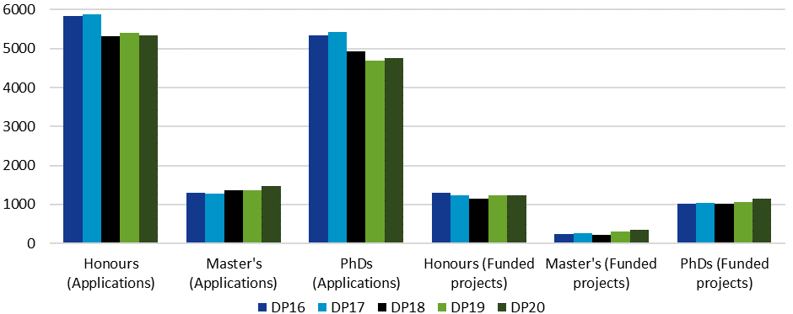

Source: ARC administrative data. *Note: Data reflect number of research trainee places identified within applications. Figures are provided on an FTE basis.* *Structured research trainee application data not available prior to DP16.*

An average of 11,943 FTE research trainee positions per funding round were specified on applications between DP16 and DP20—most of whom were either Honours students or PhD candidates. These outcomes are consistent with Department of Education, Skills and Employment data suggesting relatively low Master’s by Research enrolments in Australia.[47] Total research trainee positions on applications declined by 7.4 per cent over the time data were available, from 12,488 in DP16 to 11,564 in DP20. This decline primarily occurred in Honours and PhD positions, with Master’s places marginally increasing. However, the average number of research trainees per application increased over the time period from 3.5 in DP16 to 4.0 in DP20.

Over the same funding rounds, an average of 2657 research trainees were identified on all successful applications, growing slightly from 2563 in DP16 to 2727 in DP20. The number of Honours students identified on funded projects remained relatively steady, while the number of Master’s students (245 to 340) and PhD candidates (1008 to 1159) increased. The average number of research trainee positions per funded project remained relatively stable at 4.0.

As the data provided have been derived from applications, they should be interpreted as indications of expected research trainee participation. Given disparities between funding requested and funding awarded, and difficulties recruiting HDR students identified within final report data noted previously (see Section 2.10.2), the actual scale of research training delivered may not align with application data. At present, comparable research trainee data collected through final reports were only available from DP13 onwards.[48] These reports collect the number of research trainees participating by year, which inhibits an assessment of total training participation on completed projects. Capturing the total number of trainees supported over project life through final reports would allow for comparisons between anticipated research trainee participation on applications and actual outcomes achieved by completed projects, and enable more accurate monitoring and future evaluation of the scale of research training supported by the scheme as a whole.

### ARC data—HDR stipend funding

The total amount of funding requested for HDR stipends on applications and funded projects provides further insight into the scale of Discovery Projects’ support for research training. Figure 25 shows that the amount requested on applications appears to have declined slightly from DP16; however, given the relatively short timeframe covered by the available data, and the noticeable increase in funding requested in DP20 applications, further monitoring will be needed to determine whether this reflects an ongoing trend. The value of requested HDR stipends on funded projects remained relatively stable for most of the time period covered (hovering around $35.5–$35.9 million between DP16–DP19) but grew substantially in the most recently announced funding round ($41.7 million in DP20).

It is important to note that within ARC peer review processes, successful applications are allocated a one-line total budget, rather than being assigned funding amounts for specific items. This approach reflects the ARC’s desire to ensure flexibility in the utilisation of project funding. Subsequently, data on the amount of funding awarded for HDR stipends are not available. The ARC does not maintain records documenting actual expenditure from funded grants against specific budget items. Additionally, the allowable stipend funding specified within Discovery Projects Grant Guidelines has increased over time, which may account for part of the overall growth in stipend requests that occurred in DP20.

Figure 25: HDR stipend funding requested within applications (A) and funded projects (F), DP16–DP20

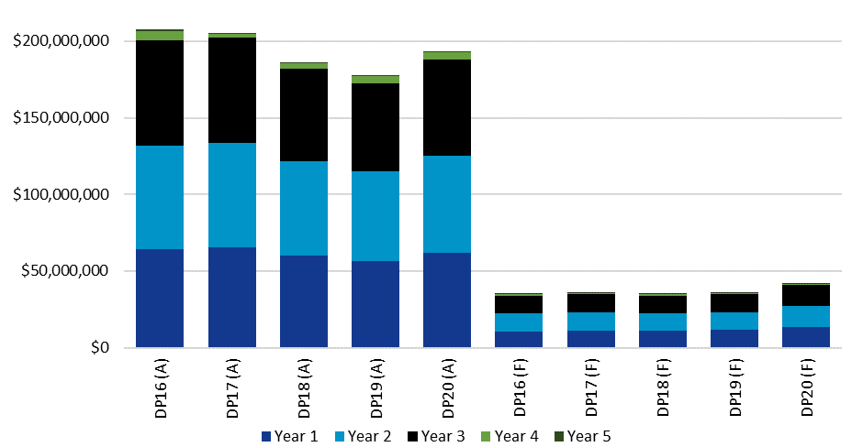

Source: ARC administrative data. *Note: Data reflect amount of funding requested for stipends within all applications (A) and within applications from funded projects (F). Funding data have not been adjusted for inflation. Structured HDR application data not available prior to DP16.*

Overall, ARC administrative data provide provisional evidence that, in terms of scale, Discovery Projects’ effectiveness in supporting research training has slightly increased over time, in terms of FTE positions and HDR stipend requests. However, ongoing monitoring will be needed to confidently support this conclusion, given the short duration of available data, the marginal nature of potential trends identified and the limitations of current final report data.

### Qualitative stakeholder feedback on effectiveness

Stakeholders regarded Discovery Projects as effectively supporting high quality research training. Research office representatives noted the alignment between this objective and outcomes being pursued by universities, and said they encouraged the inclusion of funding and support for HDR candidates on applications. Qualitative feedback highlighted Discovery Projects’ contribution to the ongoing development of future generations of Australian researchers through opportunities to collaborate with more experienced, leading scholars. The scheme’s inclusion of research trainees on significant projects was seen as effectively contributing to future research workforce capacity, and reciprocally supporting the effective delivery of basic and applied research.

Through that process [of including PhD students on Discovery Projects], people with more experience, or those who are more advanced in their careers, can help younger people to come into the system – (University Research Office)

I believe Discovery Projects are essential for the development of basic research and the training of researchers in Australia and I value the scheme very much – (Researcher)

Stakeholders also identified certain challenges. Firstly, reflecting on disparities between funding requested and awarded under Discovery Projects, some stakeholders noted that HDR stipends stipulated within applications may not eventuate. They believed that HDR scholarships were often regarded as ‘easy’ cuts when re-evaluating proposed project budgets. However, given the limitations in application and final report data relating to research trainees discussed above (Section 3.3.1), it is difficult to assess the extent to which the scheme’s return rates impact the scale of research training delivered.

Refrain from trimming budgets—they're seriously planned, and research training almost always suffers when they are cut – (Researcher)

The issue as far as I can see is that the ARC usually significantly cuts the requested budget, hindering the prospect of the project of making the desired impact. Similarly, the significantly cut budget generally leads to no HDR students being hired as part of the project – (Researcher) [49]

Secondly, the tendency to fund successful Discovery Projects applications for three years (Section 5.3.3) was highlighted by some stakeholders as creating a tension with the typical PhD candidature length. Given the time involved in identifying suitable doctoral students, some stakeholders noted that it was not uncommon for projects to conclude prior to HDRs completing their studies. Notwithstanding these comments, interview participants acknowledged that the scheme had generally been flexible in allowing for project extensions to support the completion of postgraduate study.

(The) provision of HDR stipends assists in research training and is very useful, but ARC funding rules for a three year Discovery Project do not align with postgraduate award conditions allowing for extension to 3.5 years – (Researcher)

Better support for HDR (students)—projects tend to (be) complete(d) before the student because of timelines! – (Researcher)

I have applied for two grants to receive five years funding and both times it was reduced to three years. I would have liked to have known why on both occasions. I was grateful for the funding but the two extra years would have helped with the PhD advertisement, selection, training and completion timeline – (Researcher)

A third concern expressed was that disallowing expenses associated with participation in training programs may limit opportunities to foster the development of skills needed to implement funded projects.

Sometimes it is not possible to predict the expertise needed when starting a project. Opportunities arise that may need expertise additional to what is available from the research team. Upskilling team members from research funding should be permissible – (Researcher)

Research training in Discovery Projects seems to be ad hoc. While applicants are advised to include Early Career Researchers as part of the team, that does not mean that they get actual training—the award of a Discovery Project would seem to assume that Early Career Researchers have already reached a level at which they no longer need 'training', just new research experience of working on a major project – (Researcher)

It is important to note that, as specified in Discovery Projects Grant Agreements, all project costs covered by ARC funding must directly relate to the completion of the funded project. Training activities may be supported if the researcher can clearly demonstrate that they are required for the purposes of project completion.

Overall, survey data collected for this evaluation highlighted the effectiveness of Discovery Projects’ support for research training. The areas of stakeholder concern identified within this section relating to grant duration, return rates and access to training programs can, however, usefully inform ongoing review and monitoring activities undertaken by the ARC. Enhancing the ARC’s data capabilities to more accurately assess the scale of the scheme’s support for HDR students, and highlighting the competitiveness of five year funding applications (see Section 5.3.4) within outreach and engagement activities, may offer avenues to begin addressing stakeholder concerns identified above.

## Supporting national and international research collaboration

Discovery Projects supports research collaboration between Australian and international researchers and organisations. The scheme’s Grant Guidelines allow Administering Organisations to collaborate on funded projects with Other Eligible Organisations (generally Australian universities) and Other Organisations (including international universities, as well as business, industry, government, community and not-for-profit organisations). The ARC expects participating organisations in Discovery Projects research to consider making cash and/or in-kind contributions to projects where feasible. However, unlike Linkage Program schemes that require partner organisation contributions, this is not mandatory (see Section 2.7).[50]

Discovery Projects employs a range of mechanisms to support international collaboration. For instance, the scheme currently provides project funding for international travel, field research costs (which may be incurred overseas), and access to international research and infrastructure facilities. Between DP10 and DP20, Discovery Projects granted International Collaboration Awards (ICAs), later renamed Discovery International Awards (DIAs), which contributed to international travel and associated costs. These awards were originally offered after the discontinuation of the Linkage International scheme and reflected a commitment to encouraging international engagement throughout the NCGP. DIAs were removed in DP21 as part of an ARC streamlining initiative, due to the presence of multiple eligible funding items supporting international travel. From DP02 to DP20, 63.8 per cent of successful applications indicated an intention to engage in some form of international collaboration.

### ARC data—researcher roles

Named researchers may participate in Discovery Projects as either Chief Investigators or Partner Investigators.[51] The definitions of these roles have shifted slightly over time. Both Chief Investigators and Partner Investigators must take significant intellectual responsibility for research funded under the scheme. In general, Chief Investigators are researchers who reside predominantly in Australia for the duration of the project and are employed by an Eligible Organisation (usually an Australian university).[52] Partner Investigators are named researchers who do not meet the eligibility requirements to be a Chief Investigator. Discovery Projects Partner Investigators are primarily academics associated with international universities, with a smaller number affiliated with Australian universities, business, government, community, not-for-profit and other national or international organisations.

There has consistently been a substantially higher number of Chief Investigators than Partner Investigators participating in Discovery Projects. The average number of Chief Investigators and Partner Investigators on applications and funded projects gradually increased over the course of the scheme’s history (albeit with a slight decline in the number of Partner Investigators in DP20). This steady increase potentially indicates that the scheme has been increasingly effective at enhancing the scale of collaboration between researchers over time.

Figure 26: Average number of named researchers on applications and funded projects by role, DP02–DP20

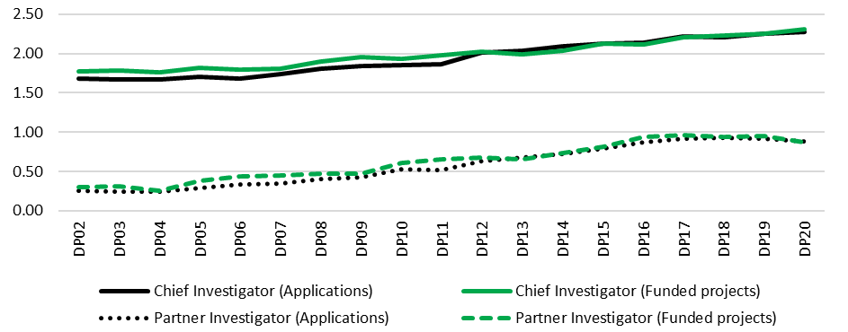

Source: ARC administrative data. *Note: Data reflect number of named researchers identified within applications. Named researchers include Chief Investigators, Partner Investigators and fellowship recipients.*

### ARC data—participating organisations

In addition to supporting collaboration between researchers, Discovery Projects also facilitates engagement across organisations. Figure 27 outlines the total and average number of participating organisations appearing on applications and funded projects between DP10 and DP20.[53] Total participating organisations identified within applications grew substantially over most of the time period (from 5832 in DP10 to 8011 in DP17), before declining over the following three funding rounds to 6450 in DP20—a fall of 19.5 per cent. Trends are less apparent within the context of funded projects, with participating organisation numbers fluctuating from approximately 1350 to 1550 over the time period (DP11 is an outlier at 1802). Trends in the average number of participating organisations per project have been more pronounced, with overall growth on both applications (1.4–2.3) and funded projects (1.5–2.4) between DP10 and DP19, before moderating slightly in DP20. This indicates that the scale of collaboration between participating organisations on individual projects has increased, and suggests that the scheme has been more effectively supporting the formation of research linkages between organisations over time.

Figure 27: Total/average number of participating organisations on applications/funded projects, DP10–DP20

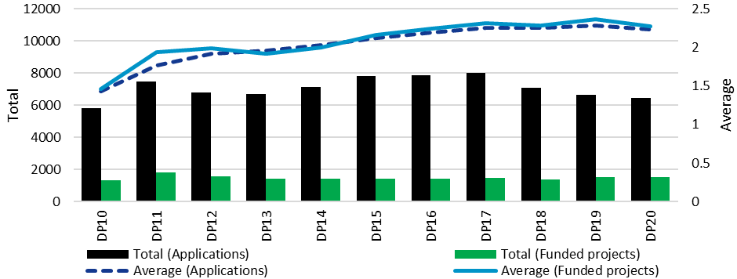

Source: ARC administrative data. *Note: Data include Administering Organisations, Other Eligible Organisations and Other Organisations, as defined within Discovery Program Grant Guidelines. Figures provided reflect planned participation in applications. Organisations appearing on more than one application per funding round have been counted multiple times. Data prior to DP10 not available.*

Figure 28 provides one view of international collaboration supported under Discovery Projects by disaggregating total and proportional participating organisation data according to Australian or international entity status. Between DP11 and DP20, international participating organisations were most commonly from the United States of America (listed on 38.4 per cent of successful applications involving at least one international organisation), the United Kingdom (24.6 per cent), Germany (10.1 per cent), Canada (7.7 per cent) and China (7.6 per cent).

Figure 28: Australian/international participating organisations on applications/funded projects, DP11–DP20

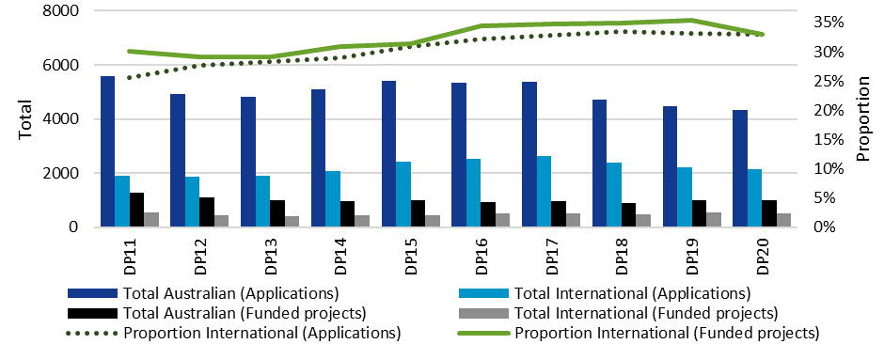

Source: ARC administrative data. *Note: Data include Administering Organisations, Other Eligible Organisations and Other Organisations, as defined within the Discovery Program Grant Guidelines. Figures provided reflect planned participation in applications. Organisations appearing on more than one application per funding round have been counted multiple times. Data prior to DP11 not available.*

Four insights are apparent within these data. Firstly, a significant majority of participating organisations appearing on both applications and funded projects were Australian; this result is understandable given the Australian entity status of Administering and Other Eligible Organisations. However, secondly, there was moderate growth in the proportionate representation of international organisations over time. Between DP11 and DP20, the percentage of participating organisations classified as international grew from 25.5 per cent to 33.0 per cent on applications, and 30.0 per cent to 33.0 per cent on funded projects (peaking in DP18 and DP19 respectively). Thirdly, there was a decline in participating organisations appearing on applications over the past three funding rounds, which involved both Australian and international organisations. Fourthly, after a slight decrease from DP11 to DP13, the total number of Australian and international participating organisations on funded projects generally remained stable up to DP20, fluctuating slightly over time without strong trends.

Figure 29 captures the spread of entity types participating as Other Organisations in projects funded under the scheme between DP11 and DP20.

Figure 29: Proportion of Other Organisations by entity type, DP11–DP20

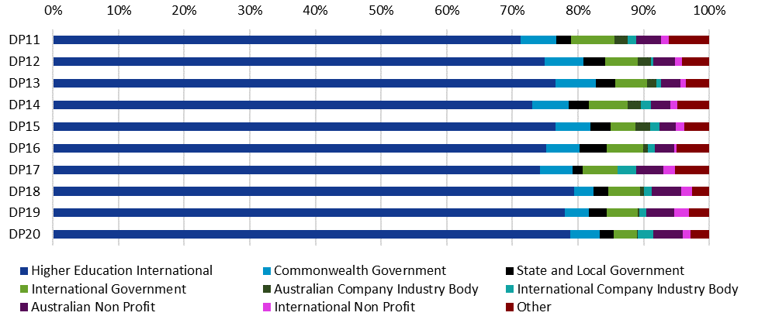

Source: ARC administrative data. *Note: Higher Education Funding Act organisations (Australian Universities participating as Administering or Other Eligible Organisations) have been excluded. Figures provided reflect planned participation in applications. Organisations appearing on more than one application per funding round have been counted multiple times. Data prior to DP11 not available.*

International higher education institutions were the most commonly represented entity type, constituting 70–80 per cent of Other Organisations in each funding round. Collectively, government organisations (Local, State, Commonwealth and International) represented the next highest proportion, at approximately 10–15 per cent in each round. These data suggest that Discovery Projects has been increasingly effective at fostering collaboration between Australian and international universities. However, it appears to have been supporting proportionally fewer engagements with government, business and non-profit stakeholders over time.

Consistent with the scheme’s objective to support excellent basic and applied research, these data show that collaboration supported under Discovery Projects primarily involves university researchers and higher education institutions, rather than the non-academic end users emphasised in the applied research focus of Linkage Program schemes. Consistent with findings presented on p. 56, Figure 29 also suggests there has been a slight increase in the proportion of international participating organisation on funded projects over time.

### Qualitative stakeholder feedback on effectiveness

As shown in Figure 17, most stakeholders surveyed regarded Discovery Projects as effectively supporting national and international research collaboration. Consistent with the fact that the scheme does not prioritise end user collaboration as actively as the ARC’s Linkage Program, qualitative responses highlighted the contributions to knowledge and innovation facilitated by the scheme’s support for collaboration between researchers.

In terms of national and internal collaboration you just have to (look at) the awarded grant proposals to see the amount of cross-institutional work undertaken. The bulk of our funded Discovery Projects will have international partners from overseas universities…It certainly achieves that – (University Research Office)

However, participants also discussed barriers to collaboration under the scheme. The ARC limits researchers to participating as Chief Investigators on up to two Discovery Projects grants at a time in order to ensure they invest sufficient time and resources in funded projects, to distribute opportunities to a variety of researchers, and to reduce administrative burdens associated with submitting and processing a high number of applications.[54] Stakeholder feedback identified this as a disincentive to Australian universities allowing their researchers to participate in non-lead Chief Investigator roles on collaborative projects involving another university as the Administering Organisation. They noted the preference of universities to appear as Administering Organisations on ARC projects in order to increase the total value of their competitive research grant income and, in turn, increase the proportion of funding they receive under Research Block Grant allocation formulae.[55]

There are some relatively arbitrary impediments to collaboration within Australia due to the identification of a single Administering Organisation. And given that all Australian universities are in competition for portions of block grants, it becomes important for universities to see themselves as having a large pool of ARC studies that they are the Administering Organisation for – (University Research Office)

I would suggest removing the two-bid limit (maybe make it two as Primary Chief Investigator). We are at a point now where university research offices require staff to lead bids and so I can't collaborate with others as they have the same rule. It's becoming a huge issue – (Researcher)

There's a dilemma—which I'm unsure how to resolve—in terms of collaboration between universities when Chief Investigators are limited to two grants. Each university would prefer that they are the Administering Organisation and encourage researchers to lead grants rather than collaborate on applications led by other universities. That said, I also support limits on the number of grants held in order to more widely distribute grant opportunities – (Researcher)

It should be noted that eligibility limits on the number of Discovery Projects researchers may simultaneously participate on do not apply to the Partner Investigator role or to participation as unnamed researchers. However, researchers may not participate as Partner Investigators if they are eligible to be Chief Investigators.

Qualitative feedback also included concerns about the potential for administrative barriers to impede collaboration with international researchers. Some obstacles were recognised as being beyond the ARC’s influence, such as Australian Government controls relating to export, defence and national security. However, some stakeholders expressed views that the complexity of Discovery Projects application forms and the burdens placed on researchers and research offices to facilitate collaboration were disincentives for international researchers. These concerns existed alongside comments about opportunities to support international Partner Investigators through Discovery Projects funding being limited.

Please cut the red tape or it just won't be worth it for international partners to collaborate on these projects – (Researcher)

Make it easier for overseas Partner Investigators to join projects. Currently collaborators have a lot of material to add to RMS which is disproportionate to the benefits most receive (minor support from the ARC). For university research offices to have to prepare contracts and budgets for low-level involvement by overseas Partner Investigators is not an efficient use of funds nor time – (Researcher)

At the moment we have to ask international Partner Investigators to collaborate with no hope of reward for their involvement – (Researcher)

(I)f researchers want to collaborate, the ARC doesn’t want Australian money to leave Australia—so you are collaborating with those who have funding from their own country…everyone’s got some funding in the game but there is no way of formalising that – (University Research Office)

Consistent with the practices of comparable research funding agencies internationally, the ARC only directly allocates funding to Australian Eligible Organisations, as specified within NCGP Grant Guidelines. Under the Discovery Projects scheme, opportunities exist for Australian researchers to seek funding to travel overseas to meet international collaborators, or to bring overseas collaborators to Australia.

Overall, Discovery Projects appears to effectively support research collaboration. Addressing barriers identified within this section may further enhance the scale and depth of national and international engagement facilitated by the scheme. It would be beneficial for outreach and engagement activities to further highlight opportunities provided by the scheme to support collaboration between researchers from Australian universities, without undermining the intent behind eligibility limits on the number of Chief Investigator roles that may simultaneously be held. There may also be opportunities to reduce the administrative burden confronted by international Partner Investigators by reducing the ROPE component of Discovery Projects application forms for this group to a two page Curriculum Vitae with specific content requirements.

## Enhancing the scale and focus of research in Australian Government priority areas

Discovery Projects scheme objectives specified an intent to enhance the scale and focus of research relating to the National Research Priorities from DP04 to DP14; the Strategic Research Priorities from DP15 to DP16; and the National Science and Research Priorities from DP18 to DP20. The specific priorities associated with each of these periods are summarised in Table 2. Discovery Projects does not include dedicated funding streams or targets for priority-related research, and addressing a priority has never been an eligibility requirement. This reflects the principles underlying the formation of the scheme, and the NCGP as a whole, which prioritise the allocation of funding to investigator-led research on the basis of peer-reviewed excellence.[56]

Table 2: Discovery Projects research priorities, DP04–DP20

|  |  |
| --- | --- |
| **Title and timing of priorities** | **Priority areas** |
| **National Research Priorities**  **(DP04–DP14)** | An environmentally sustainable Australia  Promoting and maintaining good health  Frontier technologies for building and transforming Australian industries  Safeguarding Australia |
| **Strategic Research Priorities**  **(DP15–DP16)** | Living with a changing environment  Promoting population health and wellbeing  Managing our food and water assets  Securing Australia’s place in a changing world  Lifting productivity and economic growth |
| **National Science and Research Priorities**  **(DP17–DP20)** | Food  Soil and water  Transport  Cybersecurity  Energy  Resources  Advanced manufacturing  Environmental change  Health |

In DP21, this scheme objective was reframed to reference ‘Australian Government priority areas’ more broadly. This change was introduced to acknowledge the breadth and diversity of research priorities identified by the Australian Government.[57] However, at present, the National Science and Research Priorities are the only priorities directly referenced within Discovery Projects assessment criteria.

DP21 application forms request an indication of whether proposed research falls within one of the National Science and Research Priorities; researchers may elect to not select a priority. Discovery Projects assessors are directed to consider whether the proposed research reflects a ‘potential contribution to capacity in the Australian Government’s National Science and Research Priorities and other priorities identified by Government’. This is currently a component of the ‘Benefit’ category within the scheme’s assessment criteria, which may also be addressed by demonstrating potential for the development of new or advanced knowledge, and/or the delivery of economic, commercial, environmental, social or cultural benefits for Australian and international communities.[58]

### ARC data—Australian Government research priorities

Figure 30 depicts the number and proportion of projects funded under the Discovery Projects scheme addressing at least one Australian Government priority from DP04 to DP20. The number of projects addressing a priority was somewhat shaped by the total number of projects funded under the scheme (see Section 2.3). A period of growth from DP04 to DP11 (from 515 to 842 funded projects) was followed by a decline from DP12 to DP20 (from 684 to 397 funded projects, reaching a low of 331 in DP18).

Figure 30: Funded projects addressing a research priority area, DP04–DP20

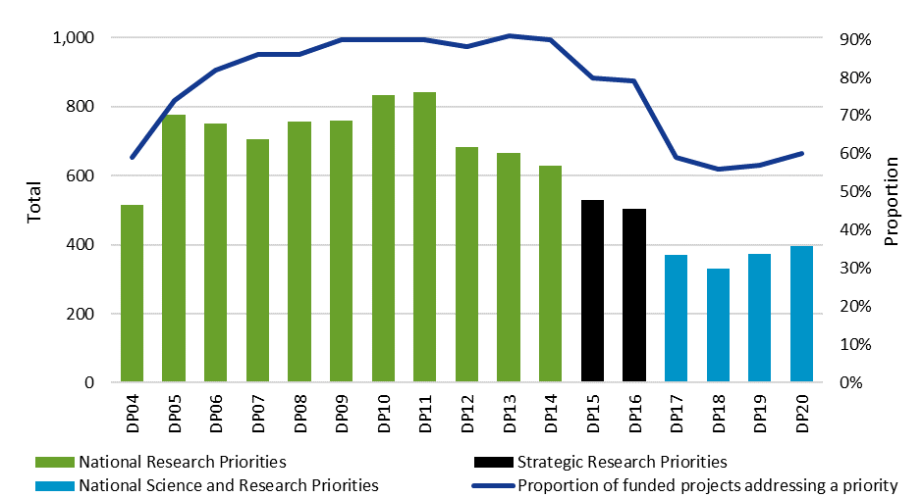

Source: ARC administrative data. *Note: Projects addressing one or more research priority are included within data.*

These figures were also influenced by changes in the relative frequency with which funded projects have addressed research priorities. Between DP06 and DP16—a period traversing the National Research Priorities and Strategic Research Priorities—the proportion of funded projects addressing at least one priority fluctuated from slightly below 80 per cent to slightly above 90 per cent. The proportion of funded projects addressing the National Science and Research Priorities has been noticeably lower. From DP17 to DP20, 56–60 per cent of funded projects related to at least one of these priorities. This is likely to reflect the nature of the current priorities, which highlight specific thematic focuses. The National Research Priorities and Strategic Research Priorities were, alternatively, characterised by greater thematic breadth and generality. Changes in the number, nature and scope of priorities over time make longitudinal analysis of Discovery Projects’ effectiveness against this objective challenging.

Figure 31 depicts the proportionate representation of the National Science and Research Priorities in funded projects from DP17 to DP20, excluding funded projects making no selection. Advanced Manufacturing was the most commonly selected area, accounting for approximately 28 per cent of priorities identified between DP17 and DP20. This may reflect the frequency with which the Advanced Manufacturing priority is addressed through Engineering research,[59] which, as noted in Part Two, has been a dominant FoR category within Discovery Projects. Environmental Change and Health were also strongly supported. Food, Resources, Soil and Water and Transport were the least represented priorities.

Figure 31: National Science and Research Priorities addressed within funded projects, DP17–DP20

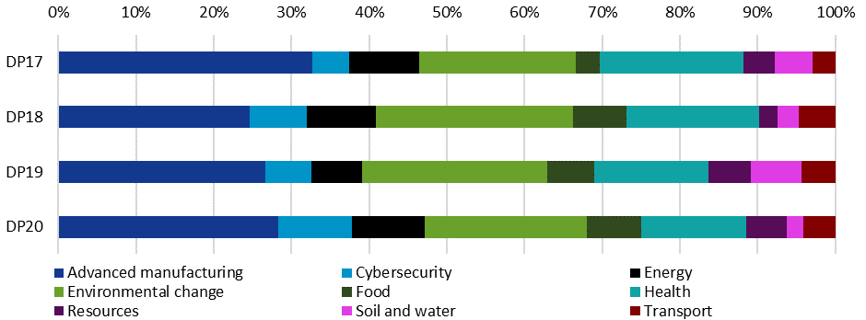

Source: ARC administrative data.

As the National Science and Research Priorities were only introduced in DP17, it is too early to assess outcomes or impacts arising from funded projects addressing these priorities. Similarly, there are not yet relevant data available to assess the effect of alterations to DP21 scheme objectives and assessment criteria on Discovery Projects’ support for Australian Government priorities.

### Qualitative stakeholder feedback on effectiveness

Discovery Projects was regarded by the majority of stakeholders as effectively enhancing priority-related research, as shown in Figure 17. Qualitative responses indicated that stakeholders understood Discovery Projects to be effectively balancing support for Australian Government priorities with the provision of opportunities for researcher-led projects. While the DP21 scheme objectives and assessment criteria reference Australian Government priorities more broadly, survey and interview participants focused on the National Science and Research Priorities. Some interview participants contended that the scheme’s reference to priorities established a framework that encouraged researchers to develop applications addressing significant issues facing Australia.

As an applied researcher…I was surprised at how willing and enthusiastic researchers are to do the right thing according to government priorities – (University Research Office)

Concerns expressed by stakeholders primarily related to the appropriateness of this objective, rather than the effectiveness of its implementation (see Section 5.2.2). However, in relation to the ARC’s implementation of Discovery Projects, some stakeholders expressed a lack of certainty about the status of the National Science and Research Priorities within the scheme’s selection processes. Several questioned whether addressing these priorities was an eligibility requirement to receive funding under the scheme.

It is unclear how the priority research areas are taken into consideration to judge if the grant will be awarded or not. Do grants have to fall within one of the priority research areas to be awarded that year? This seems not to be the case – (Researcher)

*Be clear in defining priority areas so applicants don't waste time applying when they won’t have a chance* – (Researcher)

*If pushing the Government's research priorities, then the ARC needs to say that upfront so that those not in those research priorities can save themselves the effort of applying* – (Researcher)

Some stakeholders suggested that a lack of certainty about the role of the priorities within Discovery Projects assessment processes may compel researchers to make a case that their proposed research addresses the priorities, which may be questionable and/or tangential. These practices have the potential to undermine both the meaningfulness of the scheme’s support for Australian Government priorities and the data collected by the ARC to measure the scale of its contribution in these areas.

I think it makes [applications] quite generic…It’s easy to make a case and people who are successful know how to write an argument [that will win funding] – (University Research Office)

Overall, I would suggest that the objective of addressing the Australian Government's research priorities is of secondary consideration during the assessment process […] almost anything can be tailored to meet them. I do not think that this is a bad thing, given my primary interest in the ARC's support for excellence in basic research in all disciplines – (Researcher)

Applicants either distort the focus of their research or are dissuaded from applying because they think they won't fit – (Researcher)

Researchers and research office representatives expressed a desire for greater clarity from the ARC about the role of Australian Government priorities in Discovery Projects processes, in order to enhance confidence that the effort associated with submitting applications in non-priority aligned research was not wasted. Providing further targeted information through scheme documentation and ARC outreach activities may be valuable in addressing these concerns.

# Part Four: Effectiveness—Discovery Projects scheme intended outcomes

Part Four evaluates the effectiveness of the Discovery Projects scheme in achieving its intended outcomes, as stated in the DP21 Grant Guidelines. It begins with an analysis of stakeholder perceptions of Discovery Projects’ overall effectiveness in achieving its intended outcomes, before providing a more detailed assessment of the scheme’s performance against the following:

* expanded knowledge base and research capacity in Australia
* economic, commercial, environmental, social and/or cultural benefits for Australia.

Both sections include an account of the approach Discovery Projects employs to achieve the intended outcome, a discussion of relevant internal ARC administrative data, and an analysis of feedback collected from surveys and interviews with stakeholders. Part Four concludes with a brief description of areas for potential improvement highlighted by stakeholders within qualitative survey responses.

Assessing the effectiveness of Discovery Projects against its intended outcomes involves significant methodological complexity, particularly given the scheme’s support for a diverse range of investigator-led basic and applied research. These outcomes are inherently broader and more disparate than the scheme’s objectives, and extend well beyond the context of academic benefits. Intended outcomes may accumulate long after funding associated with a specific grant has ended and, further, impacts are commonly generated through interactions between multiple stakeholders and organisations, rather than stemming immediately or directly from individual research projects. These potential methodological limitations are addressed where they arise throughout the analysis.

## Summary of findings

* Overall, stakeholders agreed that Discovery Projects is effective in achieving its intended outcomes. They more strongly agreed that it delivered an expanded knowledge base and research capacity than economic, commercial, environmental, social and cultural benefits.
* Researchers whose last completed project was finalised recently (2018 or later), or involved international collaboration, tended to be more positive in relation to both intended outcomes. Those whose projects involved HASS research tended to agree more strongly that the scheme delivered translational benefits than those whose projects involved STEM research.

#### Expanding Australia’s knowledge base and research capacity

* The average number of research outputs per completed project under the scheme declined between DP02 and DP14. This is likely to reflect broader changes within the university sector.
* In recent years, over 85 per cent of research outputs supported by Discovery Projects have been made openly accessible.
* ARC data show that the scheme has supported researchers across diverse career stages, with changes in composition over time. Between DP12 and DP20, the representation of Early Career Researchers declined on applications and funded projects, while the representation of Mid-Career Researchers fell on applications but remained relatively stable on funded projects. However, success rates for both groups were similar to overall scheme rates in recent rounds, except for Early Career Researchers in lead Chief Investigator roles.
* Stakeholders commented that Discovery Projects’ support for investigator-led basic and applied research effectively supported the expansion of Australia’s knowledge base. Comments also highlighted the knowledge, research training and equipment supported through the scheme as important contributions to expanding Australia’s research capacity.
* Stakeholder feedback included perceptions that Discovery Projects assessment processes may favour applicants with established academic careers and extensive track records, and disadvantage Early and Mid-Career Researchers.

#### Delivering economic, commercial, environmental, social and cultural benefits to Australia

* ARC data and survey responses indicated that research funded under Discovery Projects delivered a wide variety of translational benefits. Qualitative feedback included views that the scheme’s support for excellent basic research, an expanded knowledge base and research capacity effectively contributed to the delivery of such benefits.
* Survey participants identified social and cultural benefits more frequently than economic outcomes arising from their most recently completed project under the scheme. This conflicted with ARC final report data, which suggested a more common focus on economic benefits. Qualitative stakeholder feedback included concerns that Discovery Projects assessment processes undervalued social and cultural outcomes.
* Some stakeholders identified difficulties in addressing benefits in application and reporting processes, particularly in predicting outcomes arising from basic research, as well as long-term benefits that may not be apparent at the time of project completion.



## Quantitative stakeholder views on effectiveness—overall scheme intended outcomes

As documented in Figure 32, researchers surveyed generally agreed or strongly agreed that the ARC’s implementation of the Discovery Projects scheme effectively supports both an expanded Australian knowledge base and research capacity (81 per cent), and economic, commercial, environmental, social and/or cultural benefits (67 per cent). The stronger perception of effectiveness in relation to expanding Australia’s knowledge base and research capacity is likely to reflect the scheme’s significant focus on supporting basic research (see Section 3.2.1).

Figure 32: Level of agreement that ARC implementation of Discovery Projects effectively supports scheme intended outcomes

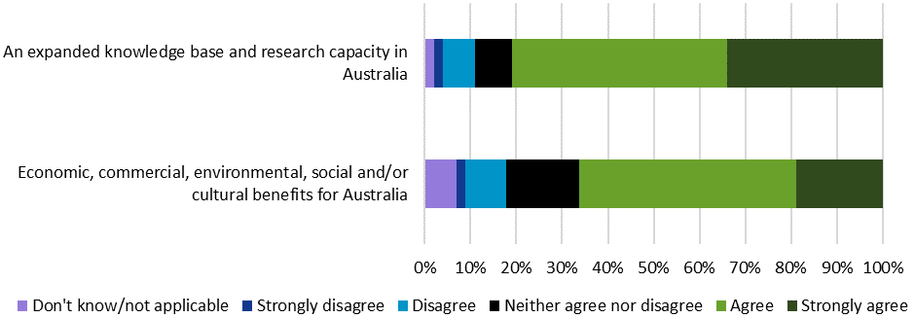

Source: Kantar, Public Division. *Note: (n=3030).*

Table 3 represents the percentage of researchers—grouped according to the characteristics of their most recently completed project under the scheme—who agreed or strongly agreed that the ARC’s implementation of Discovery Projects effectively supports the achievement of scheme intended outcomes.

Table 3: Proportion of researchers agreeing that ARC implementation of Discovery Projects effectively supports the achievement of scheme intended outcomes, by most recently completed Discovery Projects research characteristics

|  |  |  |  |  |  |  |  |  |  |  |
| --- | --- | --- | --- | --- | --- | --- | --- | --- | --- | --- |
|  | Research Project Characteristics | | | | | | | | | |
| Intended outcome | **STEM** | **HASS** | **Completed Project 2018 or later** | **Completed Project 2011– 2017** | **Completed Project 2010 or earlier** | **Basic** | **Applied** | **Basic and Applied Combined** | **International Collaboration** | **No International Collaboration** |
| An expanded knowledge base and research capacity in Australia | 81% | 81% | 85%  (+) | 78% | 72%  (–) | 79% | 82% | 82% | 82%  (+) | 77%  (–) |
| Economic, commercial, environmental, social and/or cultural benefits for Australia | 63%  (–) | 72%  (+) | 72%  (+) | 64% | 57%  (–) | 65% | 66% | 68% | 68%  (+) | 63% |

Source: Kantar, Public Division. *Note: Percentage of survey respondents agreeing or strongly agreeing. Grey cells are significantly below the mean (–) while green cells are significantly above the mean (+) at the 95 per cent confidence level. Researcher subgroups assigned on the basis of most recently completed project funded under the scheme. Table only includes participants with a completed project (n=2469); different numbers of survey participants responded to questions relating to research project characteristics.*

Perceptions were generally consistent between researcher groupings, although there were variances. Researchers completing a project in the past 3 years (85 per cent, compared to 77 per cent for earlier completions) and those engaging in international collaboration (82 per cent, compared to 77 per cent for those not collaborating internationally) were particularly likely to agree or strongly agree that the scheme was effective in expanding Australia’s knowledge base and research capacity.

These same groups were also more likely to highlight the effectiveness of the scheme in delivering translational benefits (72 per cent for those completing their research recently, compared to 62 per cent completing earlier; and 68 per cent for researchers collaborating internationally, compared to 63 per cent for those not collaborating internationally). This was also the case for HASS researchers (72 per cent, compared to 63 per cent for STEM researchers).

The more positive perceptions of researchers who had recently completed projects or engaged in international collaboration are consistent with findings on Discovery Projects scheme objectives presented in Section 3.1. As stated previously, these results may reflect improvements to scheme implementation over time, although further detailed stakeholder feedback would be needed in future to gain further insight into the factors contributing to these more positive views. The results may also suggest that the benefits of international collaboration contribute more broadly to the achievement of the scheme’s objectives and intended outcomes.

To further evaluate the extent to which Discovery Projects is effective in delivering its intended outcomes, survey respondents were asked to select up to three areas in which their most recently completed project under the scheme delivered the most substantial outcomes and/or benefits. Those who had ongoing projects, and had not completed a previous project under the scheme, were excluded from this question (approximately 20 per cent of survey participants). Figure 33 presents participants’ responses. Most researchers (80 per cent) selected an expanded knowledge base, followed by expanded research capacity (50 per cent). Smaller proportions of respondents identified social (19 per cent), cultural (13 per cent), environmental (12 per cent), economic (9 per cent) or commercial (4 per cent) benefits arising from their research.

Figure 33: Most substantial outcomes/benefits delivered from most recently completed project under Discovery Projects

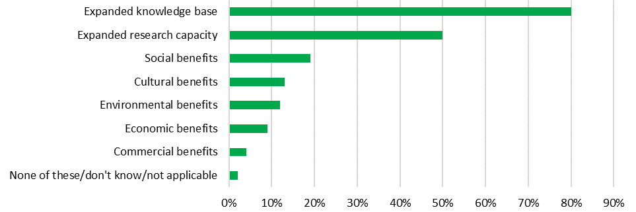

Source: Kantar, Public Division. *Note: Data include those who had been named a researcher on a completed Discovery Project and provided a response (n=2404). Participants had the option to select up to three items.*

As suggested in Part 3, Discovery Projects allocates funding to basic and applied research on the basis of research excellence. These survey results, emphasising positive academic outcomes more strongly than translational benefits, are consistent with the balance of Discovery Projects’ support towards basic research (see Section 3.2.1). In evaluating the scheme’s overall support for translational benefits, several qualifications are important. Firstly, while assessment criteria relating to the delivery of benefits to Australia have been present throughout the history of the scheme, this intended outcome was only introduced in DP21. There are, as such, methodological problems involved in evaluating benefits delivered against the current intended outcome. Further, it is still too early to assess the extent to which the introduction of this intended outcome will shape benefits and outcomes from research funded under Discovery Projects. Secondly, the researcher survey divided the second intended outcome into five distinct response categories, compared to two for the first intended outcome, which is likely to have reduced the proportion of respondents associating their research with each benefit area. Forty-seven per cent of respondents identified at least one translational benefit category.[60] Thirdly, these benefits and outcomes reflect researcher self-perception and cannot be verified due to the survey responses being non-identifiable. Further, the perceptions of benefit that informed participants’ responses may not have been entirely consistent. For instance, open text responses indicated variability in participants’ association of intellectual property outcomes such as patents with economic or commercial benefits.

Table 4 presents the proportion of researchers—again, grouped according to the characteristics of their most recently completed project under the scheme—identifying each of the most substantial outcome and benefit areas specified in Figure 33.

Table 4: Proportion of researchers identifying most substantial outcome and benefit areas delivered, by most recently completed Discovery Projects research characteristics

|  |  |  |  |  |  |  |  |  |  |  |
| --- | --- | --- | --- | --- | --- | --- | --- | --- | --- | --- |
|  | Research Project Characteristics | | | | | | | | | |
| Outcome/benefit area | **STEM** | **HASS** | **Completed Project 2018 or later** | **Completed Project 2011– 2017** | **Completed Project 2010 or earlier** | **Basic** | **Applied** | **Basic and Applied Combined** | **International Collaboration** | **No International Collaboration** |
| Expanded knowledge base | 82%  (+) | 76%  (–) | 83%  (+) | 78%  (–) | 75%  (–) | 87%  (+) | 66%  (–) | 78% | 82%  (+) | 77%  (–) |
| Expanded research capacity | 55%  (+) | 41%  (–) | 54%  (+) | 48% | 40%  (–) | 51% | 41%  (–) | 51% | 54%  (+) | 42%  (–) |
| Social benefits | 9%  (–) | 38%  (+) | 19% | 20% | 19% | 11%  (–) | 34%  (+) | 23%  (+) | 17%  (–) | 24%  (+) |
| Cultural benefits | 3%  (–) | 32%  (+) | 13% | 14% | 13% | 16%  (+) | 8%  (–) | 12% | 13% | 14% |
| Environmental benefits | 16%  (+) | 6%  (–) | 13% | 11% | 11% | 9%  (–) | 12% | 16%  (+) | 13% | 10% |
| Economic benefits | 8% | 12%  (+) | 10% | 8% | 6% | 3%  (–) | 16%  (+) | 12%  (+) | 9% | 9% |
| Commercial benefits | 6%  (+) | 2%  (–) | 4% | 5% | 6% | 2%  (–) | 7% | 7%  (+) | 4% | 5% |
| None | 1% | 1% | 1% | 1% | 1% | 1% | 2% | 1% | 1% | 1% |

Source: Kantar, Public Division. *Note: Percentage of survey respondents agreeing or strongly agreeing. Grey cells are significantly below the mean (–) while green cells are significantly above the mean (+) at the 95 per cent confidence level. Researcher subgroups assigned on the basis of most recently completed project funded under the scheme. Table only includes participants with a completed project (n=2469); different numbers of survey participants responded to questions relating to research project characteristics.*

A degree of variability emerged between researchers with different project characteristics, particularly in relation to delivering outcomes in the areas of expanding Australia’s knowledge base and research capacity. As may be anticipated, researchers whose projects focused on basic research more frequently selected options relating to the first scheme intended outcome (87 per cent for expanded knowledge base and 51 per cent for expanded research capacity, compared to 66 per cent and 41 per cent respectively for researchers whose projects focused on applied research). These categories were also more commonly identified by researchers whose projects were in STEM disciplines (82 per cent for expanded knowledge base and 55 per cent for expanded research capacity, compared to 76 per cent and 41 per cent respectively for those completing HASS research), researchers who had collaborated with international stakeholders (82 per cent for expanded knowledge base and 54 per cent for expanded research capacity, compared to 77 per cent and 42 per cent for those who did not collaborate internationally), and those who had completed their research in the past three years (83 per cent for expanded knowledge base and 54 per cent for expanded research capacity, compared to 77 per cent and 46 per cent for those completing their projects less recently).

The translational benefits selected by different researcher subgroups also varied. Researchers completing HASS projects were more likely to identify social, cultural and economic outcomes arising from their work, while those in STEM aligned more strongly with commercial and environmental benefits. This finding may reflect that, to an extent, certain disciplines may be more likely to produce specific kinds of benefits. Further variations were apparent in relation to type of research. Cultural benefits were associated with basic research more frequently than applied research, whereas positive commercial, economic, environmental and social outcomes were reported to arise more frequently from applied research. Researchers working on interdisciplinary projects tended to select social and cultural benefits more frequently than non-interdisciplinary researchers.

## Expanding Australia’s knowledge base and research capacity

Discovery Projects has consistently used assessment criteria relating to the advancement of knowledge and innovative research in order to directly support applications demonstrating a capacity to grow Australia’s knowledge base. The *ARC Open Access Policy*, which applies to the Discovery Projects scheme, and the NCGP more broadly, is a mechanism employed by the ARC to further foster this outcome. The policy generally requires research outputs to be ‘made openly accessible within a twelve-month period from the date of publication’, to ensure knowledge arising from this work is disseminated to other researchers and the broader community.[61]

The ARC does not specifically define the term ‘research capacity’; however, this phrase has been employed elsewhere to refer to ‘a process of developing sustainable abilities and skills enabling individuals and organisations to perform high quality research’.[62] Due to the scheme’s size and centrality within the NCGP, the breadth of its support for Australian university researchers and trainees, and its significance within the national research funding landscape (see Part Five), Discovery Projects contributes to Australia’s research capacity in diverse ways. It contributes to the resources invested in Australian research, shaping the quantity of projects undertaken, the scale of the research possible, and the breadth of disciplinary activity. The scheme also contributes to the pipeline of opportunities available to Australian researchers at diverse career stages, and the subsequent composition of the national research workforce.

### ARC data—research outputs

Research outputs arising from projects funded under Discovery Projects provide an indicative measure of the scheme’s contribution to expanding Australia’s knowledge base. The ARC adopts a broad definition of research outputs in its policies, assessment and reporting processes. This spans peer reviewed books, chapters, journal articles and conference presentations, as well as non-traditional research outputs, such as museum exhibitions, designs and creative works.[63]

Table 5 presents total research output numbers identified within Discovery Projects final reports between DP02 and DP14. For peer reviewed, published outputs, these figures include those that have been published or are in press, but not those that are forthcoming or submitted for consideration. Due to data limitations, the figures provided should be interpreted as a broad approximation of total outputs.[64]

Table 5: Total number of Discovery Projects research outputs by type, DP02–DP14

|  |  |  |
| --- | --- | --- |
| **Output type** | **Total** | **Proportion** |
| **Journal articles** | 98,059 | 50.1% |
| **Conference proceedings** | 65,807 | 33.6% |
| **Book chapters** | 14,889 | 7.6% |
| **Other academic outputs** | 8999 | 4.6% |
| **Books** | 4372 | 2.2% |
| **Major reviews** | 1645 | 0.8% |
| **Computer software** | 804 | 0.4% |
| **Creative works** | 541 | 0.3% |
| **Audio-visual recordings** | 521 | 0.3% |
| **Exhibition curatorships** | 103 | 0.1% |
| **Designs** | 85 | 0.04% |

Data source: ARC administrative data. *Note: Data from previous and current final report templates have been recategorised to allow for comparison. Data on major reviews not collected after DP10.*

Overall, journal articles (98,059) and conference presentations (65,807) were the most common outputs arising from research funded under the Discovery Projects scheme from DP02 to DP14. A substantial number of book chapters (14,889) and books (4372) were also identified. Over this period, the average number of journal articles produced per project remained relatively stable, at approximately 8.4–10.4 articles. However, the average number of all research outputs per completed project appears to have declined—most noticeably in relation to conference presentations.

When interpreting these findings, it should be noted that final report data may be less complete in more recent funding rounds, rendering longitudinal comparison challenging. It is also important to acknowledge that common research output types vary between disciplines, and may change over time. For instance, conference papers were historically a commonly accepted means of communication for researchers within certain disciplines (for example, engineering). This appears to be changing over time, with a growing focus on other research output types. The decline in average research output numbers may, as such, reflect broader changes in researcher behaviour, rather than the effectiveness of the Discovery Projects scheme. Further, the introduction of ERA has seen a significant increase in the quality of research conducted in Australian universities.[65] ERA processes emphasise that universities should focus on the quality of research outputs reported. Along with the removal of research publications data from the Higher Education Research Data Collection (HERDC) in 2016,[66] this has somewhat shifted the focus away from research output quantity.

Using project output quantities to assess the effectiveness of Discovery Projects in expanding Australia’s knowledge base is a limited methodology. The categories used in Table 5 include research outputs of differing scale, quality and impact, which cannot be assessed meaningfully on the basis of a quantitative count. Nonetheless, the numbers indicate the sizeable scale and diversity of the research outputs supported by Discovery Projects.

Analysis of approved Discovery Projects final reports submitted between November 2017 and February 2020 revealed that 85.5 per cent of research outputs supported by the scheme were reported by researchers as being openly accessible at the time of project completion.[67] This suggests that, in addition to fostering a substantial number of outputs, the scheme contributes to Australia’s knowledge base through the wide availability of these outputs.

### ARC data—career age

The distribution of Chief Investigators by career age provides a useful metric to assess the extent to which Discovery Projects contributes to expanding Australia’s research capacity by supporting researchers across diverse career stages. Career age is defined as the length of time between the conferral of a researcher’s first PhD and the application closing date for the funding round. Figure 34 and Figure 35, below, present the proportion of Chief Investigators on applications and funded projects respectively by career age from DP11 to DP20.[68] Overall, they show that the scheme supported researchers at a variety of career stages, with notable changes in composition over time.

Figure 34: Proportion of Chief Investigators on applications by career age (years), DP11–DP20

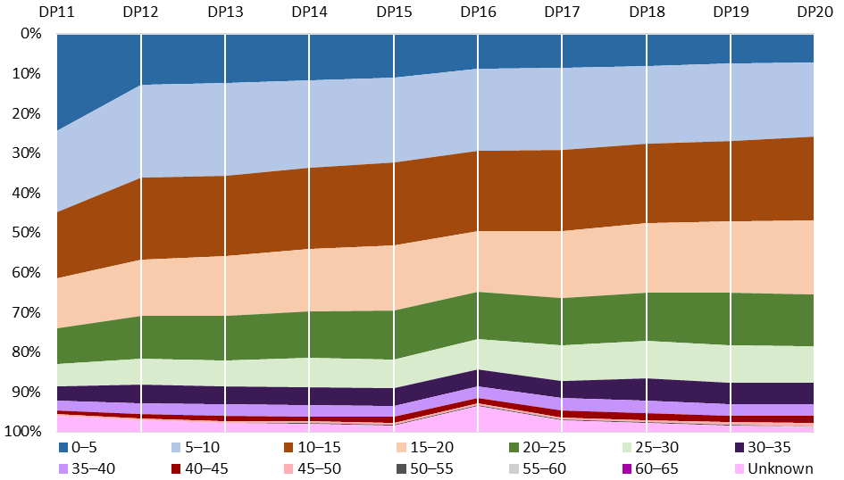

Source: ARC administrative data. *Note: Data reflect number of Chief Investigators identified within applications; figures do not take variations to project teams into account. Data presented in person participation terms—researchers named on multiple applications will appear more than once. Those with an exact career age of a factor of five appear in the higher bracket. Chief Investigators without a PhD not included within data. ‘Unknown’ career ages relate to researchers not specifying PhD conferral dates. Career ages have not been adjusted to reflect career interruptions. Data not available prior to DP11.*

Figure 35: Proportion of Chief Investigators on funded projects by career age (years), DP11–DP20

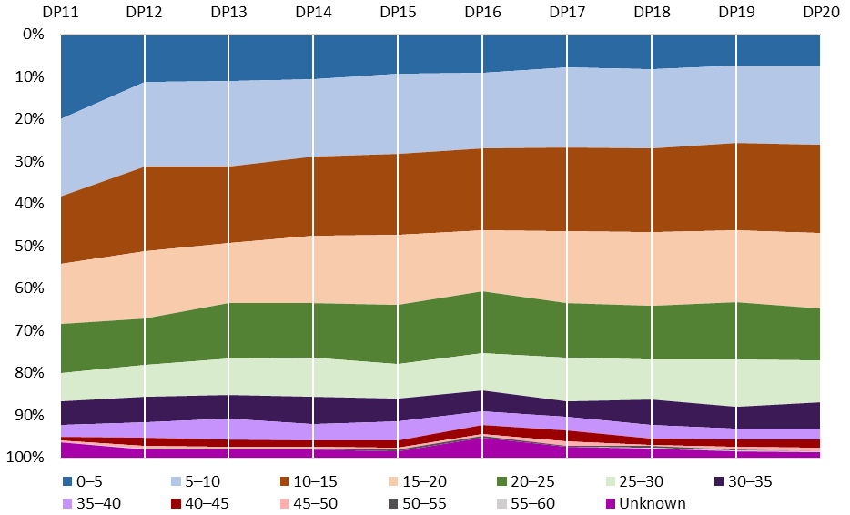

Source: ARC administrative data. *Note: Data reflect number of Chief Investigators identified within applications; figures do not take variations to project teams into account. Data presented in person participation terms—researchers named on multiple applications will appear more than once. Those with an exact career age of a factor of five appear in the higher bracket. Chief Investigators without a PhD not included within data. ‘Unknown’ career ages relate to researchers not specifying PhD conferral dates. Career ages have not been adjusted to reflect career interruptions. Data not available prior to DP11.*

The proportion of Early Career Researchers (with a career age of less than or equal to five years[69]) on Discovery Projects applications and funded projects approximately halved between DP11 and DP12. This fall occurred alongside the introduction of the DECRA scheme. However, on applications from DP12 onwards, the proportion of Early Career Researchers continued to decline from 12.9 per cent to 7.1 per cent in DP20; and from 11.3 per cent to 7.3 per cent for funded projects over the same period.

Between DP12 and DP20, the proportion of Chief Investigators defined as Mid-Career Researchers (with career ages of between five and fifteen years) fell gradually on applications (from approximately 44.0 per cent to 39.7 per cent), while remaining relatively stable on funded projects (fluctuating between 36.9 and 39.9 per cent). Over the same period, there was growth in the proportionate representation of Chief Investigators with a career age of 15–30 years, particularly on applications (from 31.5 per cent to 40.8 per cent), but also on funded projects (from 34.5 per cent to 40.1 per cent).

For both Early and Mid-Career Researchers, representation on applications was generally higher than on funded projects. This was reflected in Early and Mid-Career Researchers having lower total success rates than the scheme-wide success rate throughout the DP12–20 time period (18.5 per cent and 17.9 per cent respectively, compared to 20.0 for the scheme as a whole). However, in recent funding rounds, success rates for Early Career Researchers (21.6 per cent in DP19 and 23.7 per cent in DP20) and Mid-Career Researchers (22.1 per cent in DP19 and 23.3 per cent in DP20), were similar to overall scheme success rates (22.4 per cent in DP19 and 23.0 per cent in DP20)—and slightly higher in DP20. Conversely, it is important to acknowledge that success rates for applications with Early Career Researchers as the lead Chief Investigator were lower than the scheme average in DP19 (16.3 per cent) and DP20 (13.9 per cent).

The overall decline in the proportion of Early Career Researchers on funded projects in recent years appears to primarily reflect their declining proportionate representation as Chief Investigators on applications. This may suggest that the ARC’s implementation of the ROPE policy since 2014 has, in some respects, supported the scheme to effectively contribute to the expansion of Australia’s research capacity by ensuring opportunities are provided to those with less research experience. However, to address lower success rates for lead Chief Investigator Early Career Researchers, there may be value in reinforcing ROPE in advice to Discovery Projects assessors.

These findings should be interpreted in light of broader changes to the composition of the Australian research workforce over time. For instance, recent growth in the number of postgraduate research completions at Australian universities[70] is likely to mean that a greater proportion of the contemporary university research workforce would currently meet the ARC’s definition of Early or Mid-Career Researcher, compared to a decade ago. This growth has occurred alongside the decline in the representation of these groups appearing on applications and funded projects under the Discovery Projects scheme. Ongoing monitoring of participation and success rates by career age will be important to identify longer term trends and inform the effective implementation of the ROPE policy into the future.

### Qualitative stakeholder feedback on effectiveness

Qualitative feedback indicated that stakeholders perceived Discovery Projects’ effectiveness in expanding Australia’s knowledge base and research capacity to be underpinned by its support for research excellence across diverse disciplinary domains. The ‘investigator-led’ nature of the scheme was regarded as effectively fostering outcomes unlikely to have arisen via industry or philanthropic-supported research. While some suggested that the scheme’s performance in this regard could be further enhanced through greater resourcing, it is important to note that overall NCGP funding is primarily determined through Australian Government Budget processes and is beyond the scope of this evaluation.

The ARC is critical to expanding our knowledge base—it is about doing free form research in important areas that are going to be important in the future—so we need to keep resourcing that effectively – (University Research Office)

I feel the scheme achieves this [intended outcome] well, but outcomes would be improved with greater funding – (University Research Office)

Some participants highlighted the knowledge, research training and equipment supported through Discovery Projects as important contributions to expanding research capacity within higher education institutions, and other sectors more broadly.

This includes through the research training it provides, the knowledge that (it) supports (and) the research infrastructure that is often critical for industry partners or users, and that it provides bases on which businesses and other end users can engage with universities and their research – (Peak Body)

Stakeholder feedback included concerns that, despite the presence of ROPE, Discovery Projects assessment processes may favour applicants with established academic careers and extensive track records. Among the feedback were perceptions that only the most experienced researchers win grants, potentially undermining the breadth of support for Australia’s broader research workforce, and perpetuating a cycle within which the ‘winners keep winning’ Discovery Projects funding. Research offices suggested that such perceptions may discourage the inclusion of junior scholars on applications.

Early career researchers may be involved in writing the grant and activities associated in the grant; however (they) may not be named due to the years of experience required to get the grant – (University Research Office)

Mechanisms could be introduced to allow more opportunity for more junior researchers to be brought into the scheme – (Researcher)

To address these concerns, some participants expressed a desire for the scheme’s assessment criteria to more strongly prioritise project quality over investigator capability.

The weighting is too heavily skewed to track record and not enough to the project. Older successful researchers are funded for second rate projects and junior researchers with less track record are unable to obtain support for excellent projects – (Researcher)

The scheme is inherently too focused on rewarding 'successful' professors who have long publication records and high citations – (Researcher)

Less of an emphasis on track record of researchers and more emphasis on quality, value and significance of the research project – (Researcher)

These comments contrast with data presented in Section 4.2.2, which suggest that Early and Mid‑Career Researchers’ success rates in recent Discovery Projects funding rounds were competitive. Some of the feedback may reflect experiences with the scheme in earlier funding rounds and/or a lack of stakeholder awareness about recent improvements in success rates. Further outreach and engagement highlighting the opportunities presented to Early and Mid-Career Researchers under the scheme, and their recent success in selection processes, may be beneficial to address stakeholders’ perceptions and encourage greater participation by these groups.

## Delivering economic, commercial, environmental, social and cultural benefits for Australia

Prior to DP21, Discovery Projects did not have a scheme objective explicitly relating to the delivery of benefits to Australia. However, much of the activity historically supported by the scheme has been driven by the underlying imperative to deliver benefit through research excellence. Further, the capacity to deliver benefits to the Australian and/or international community has been a component of the assessment criteria for all Discovery Projects scheme rounds. The scheme currently allocates a weighting of 15 per cent to the ‘Benefit’ assessment criterion. The DP21 Grant Guidelines note that this may be addressed by demonstrating potential for new or advanced knowledge, a focus on Australian Government priorities (as noted in Section 3.5), and/or the delivery of economic, commercial, environmental, social and cultural benefits.

The National Interest Test was announced by the Australian Government in October 2018, requiring applicants to outline the extent to which their research will contribute to Australia’s national interest. All projects recommended for funding by the ARC in DP20 were assessed as satisfying the National Interest Test. While it is relevant in the context of stakeholder feedback discussed below, the National Interest Test is beyond the scope of this evaluation as it applies to all NCGP schemes.

### ARC data—benefits delivered by Discovery Projects

While Discovery Projects final reports have consistently included questions about benefits delivered through completed research, the specific information requested has changed over time.

In early Discovery Projects final reports (DP02–DP13), researchers were asked whether there were ‘identifiable national benefits’, including ‘economic, social, cultural and/or environmental contributions’, arising from their projects. Responses to this question were consistent between DP02 and DP13, with approximately 85 per cent of final reports recording affirmative answers (within a narrow range from around 83–87 per cent in each round).[71] This indicates that a substantial majority of research funded through the scheme over this period delivered some form of translational benefit.

Prior to DP14, final report forms did not request information about the specific benefits arising from projects. Since DP14, they have included a question asking whether the research ‘has produced or is likely to result in or lead to’ the following benefits: economic, social, cultural, environmental or increased research capacity. Respondents may select as many options as applicable. Figure 36 presents the relative frequency with which final reports indicated each benefit between DP14 and DP16, as a proportion of the total number of benefits selected within each funding round. It is difficult to compare these results with final report data from DP02 to DP13 as current report templates do not allow researchers to indicate that their projects delivered no benefits.

Figure 36: 'My research has produced or is likely to result in or lead to ...', DP14–DP16

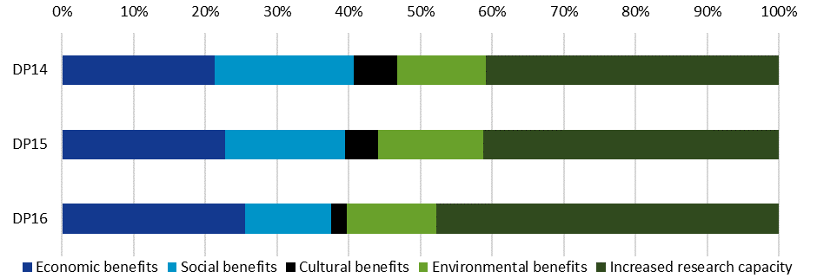

Source: ARC administrative data. *Note: Final reports have not been submitted for all funded projects. Data not available prior to DP14. Data from DP17 onwards have not been included due to the limited number of final reports submitted.*

Between DP14 and DP16, 40–50 per cent of benefits selected related to increased research capacity; significantly more than the other categories. Of the remaining options, economic benefits were most common, increasing slightly from 21.4 per cent (DP14) to 25.5 per cent (DP16) of selections. Social and cultural benefits were identified less frequently over time, together accounting for 25.4 per cent of benefits selected in DP14 final reports, but only 14.1 per cent in DP16 final reports. The proportion of responses identifying environmental benefits remained relatively static in a range from 12.3 per cent (DP14) to 14.7 per cent (DP15). Given the brevity of the period covered by the available data set, these findings should be interpreted as indicative.

Since DP14, final reports have also requested additional detail about the nature of actual or potential benefits arising from completed projects. The available response options are categorised under the broader categories in Figure 36. One or more options can be selected. Figure 37 presents the representation of each of these more detailed benefits as a proportion of all responses in final reports from DP14 to DP16.

Figure 37: 'In more detail, my research has produced or is likely to result in or lead to ...', DP14–DP16

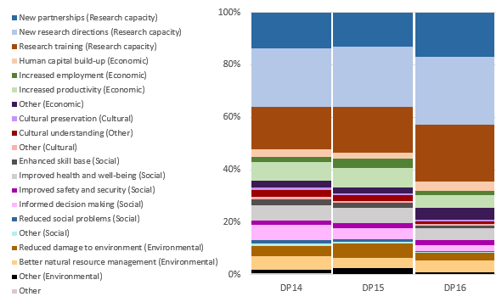

Source: ARC administrative data. *Note: Final reports have not been submitted for all funded projects. Data not available prior to DP14. Researchers are not able to indicate that completed projects delivered no benefits.*

The three most commonly selected options related to building research capacity; most frequently the development of ‘new research directions’, which was closely followed by ‘research training’ and the formation of ‘new partnerships’. In relation to economic benefits, ‘increasing productivity’ was selected most often. ‘Improved health and well-being’ was the most frequent response in the social benefit category and ‘cultural understanding’ was the most common cultural benefit. ‘Better natural resource management’ and ‘reduced damage to environment’ were the most frequently selected environmental benefits.

The strong representation of benefits relating to ‘research capacity’ is consistent with Discovery Projects’ allocation of funding on the basis of research excellence, and its unique role in supporting basic research within Australia’s research funding landscape (see Section 5.1.1). However, these results also highlight the diverse translational benefits supported by the scheme.

### Qualitative stakeholder feedback on effectiveness

Survey and interview participants identified benefits arising from Discovery Projects research across a variety of national and international domains. A sample of the benefits reported from survey participants’ most recently completed Discovery Projects grant is outlined in Appendix E. Interview participants discussed the effectiveness of the scheme in delivering translational outcomes, and highlighted interrelationships between these benefits and the expansion of Australia’s knowledge base and research capacity.

If I look at the start-up companies coming out of the university—vast majority of those come from our Discovery Projects – (University Research Office)

It supports the continuum of translation—and it is certainly excellent at translation from the perspective of academic discovery or knowledge – (University Research Office)

It can support areas that are really important, but not as economically attractive. I think that’s where the ARC scheme is really important because it looks at humanities, social sciences and areas that don’t obviously lead to tangible economic benefits – (University Research Office)

Stakeholder feedback included views that Discovery Projects’ contribution to expanding Australia’s knowledge base had the potential to deliver transformative, innovative benefits. However, with respect to the scheme’s support for basic research, some feedback noted that outcomes and benefits were often somewhat unpredictable, and frequently arose over extended time periods. Several stakeholders expressed difficulties anticipating benefit at the application stage. Others suggested that the extended timescale over which benefits accrued could mean that impact was difficult to meaningfully assess at the time of project completion (or final reporting), and that the ARC lacked mechanisms to track and acknowledge positive research outcomes arising after funding had ended.

Expected outcomes are too narrowly defined in terms of benefits to Australian society. Yes, in principle a good idea, but in practice such benefits cannot easily be identified before a project starts, and stated benefits could be overblown – (Researcher)

I have little doubt it delivers great practical benefit, but if you are funding pure basic research, you are not going to immediately see the benefit in terms of economic or social outcomes in year four—what you’ll see in year four are academic outputs which are increasing knowledge, which will lead to that benefit…So I can say I truly believe it is occurring, but if you ask for a specific example then I will find that hard to do – (University Research Office)

The benefits of the research, at least of the type of research that I pursue (a combination of basic and applied research), usually materialise beyond the completion of the final report – (Researcher)

Under current Discovery Projects processes, the ARC requests descriptions of ‘potential’ benefit in response to scheme assessment criteria, and asks for information in final reports about the benefits completed research ‘has produced or is likely to result in or lead to’. While these questions recognise the difficulties in anticipating and documenting research benefits, they are unlikely to capture the full breadth and scale of positive outcomes actually delivered as they rely, at least in part, on researchers’ expectations about the future. Because the data presented in Figure 36 and Figure 37 (pp. 74–75) are drawn from final reports, they are also limited in this regard as they combine both realised and anticipated benefits.

Some stakeholders expressed the belief that Discovery Projects was acknowledging certain research outcomes more effectively than others. It was suggested that the ARC’s administration of the scheme implicitly preferenced tangible, immediate benefits, particularly within economic or commercial domains, and undervalued positive social or cultural outcomes. Participants noted difficulties demonstrating an immediate ‘return on investment’ within the context of research more closely aligned with the delivery of social and cultural benefits.

There should be more value placed on cultural and social outcomes – (Researcher)

The ARC may need to give a higher weighting for benefit for particular areas of funding. E.g. an educational project is unlikely to lead to short-term economic benefits and indeed benefits may be almost impossible to be made tangible. It doesn't make the research any less valuable to society or the individual involved – (Researcher)

Creative thinking about benefits, especially intangible social and cultural benefits, will help to realise the value of humanities and social sciences research – (Researcher)

These perspectives somewhat align with final report data indicating that projects produced or were more likely to produce economic benefits than social and cultural benefits (Section 4.3.1). However, they contrast with quantitative survey responses in which researchers more commonly identified social and cultural benefits among the most substantial positive outcomes arising from their most recently completed project under the scheme (Section 4.1).

Divergent findings about the benefits delivered through Discovery Projects from final reports and survey responses potentially reflect multiple methodological considerations. For instance, whereas final reports are generally submitted within 12 months of project completion, survey responses may have been provided several years after grant funding ceased. These differing timescales have potentially shaped both the opportunity for particular kinds of benefits to have arisen, as well as researchers’ perspectives on the outcomes of their work. There were, further, differences in the categories used to arrange data relating to outcomes/benefits. ‘Commercial Benefits’ and ‘Expanding Knowledge’ (which was selected by an overwhelming majority of survey participants when reflecting on their most recently completed project [Figure 33]), were not options provided within final reports. Finally, significant differences in the nature of the samples arising from final reports and the evaluation survey should be acknowledged. Only one final report is submitted per completed project. The survey, alternatively, was distributed to named researchers funded under the scheme, meaning that some projects may be represented more than once within survey findings. While the vast majority of completed projects are represented within final report data, only 16 per cent of the named researchers surveyed responded to the questionnaire.

Given these inconsistencies, no definitive conclusion can be drawn about the balance of the kinds of translational benefits delivered by the scheme. These issues should be revisited in future monitoring and evaluation of Discovery Projects when additional final report data over longer timescales are available. To address stakeholder perceptions that social and cultural benefits are undervalued within Discovery Projects assessment processes, it may be beneficial for ARC advice, outreach and engagement, including with Discovery Projects peer reviewers, to clarify that there is no hierarchy of benefits in the design or implementation of the scheme.

Stakeholders’ comments regarding the challenges involved in assessing research benefits are relevant across the NCGP and may also usefully inform further consideration, beyond the scope of this evaluation, of the ARC’s broader approaches to supporting research impact.

## Stakeholder feedback on potential improvements

Survey participants were asked to identify aspects of the ARC’s implementation of Discovery Projects that could be improved to more effectively support the achievement of the scheme’s intended outcomes. Researchers expressed a variety of suggestions for improvement. While it appears that many participants reflected on the outcomes pursued by their individual project, their collective feedback provides important insights relevant to the scheme as a whole. Figure 38 provides a high-level summary of themes emerging from the coding of a representative sample of 1012 responses to this question.[72]

Figure 38: Potential areas of improvement to support the delivery of intended outcomes

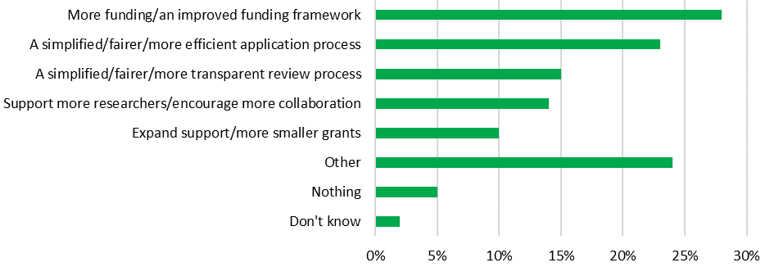

Source: Kantar, Public Division. *Note: A representative subsample of n=1012 survey responses to this question were coded.*

Participants most commonly raised issues related to funding (28 per cent), such as increasing the amount of funding available and/or implementing an ‘improved funding framework’. They also frequently expressed support for a simplified, fairer and more efficient application process (23 per cent), as well as potential improvements to Discovery Projects’ approach to peer review (15 per cent). Fourteen per cent of researchers described a desire for additional support for a greater diversity of researchers (including junior researchers), along with encouraging more collaboration. Finally, 10 per cent of participants mentioned supporting new areas of research, offering more grants and providing smaller grant options.

A number of these categories are beyond the scope of this evaluation as they relate to NCGP-wide matters (such as the application and peer review processes). However, these results echo findings elsewhere in the report highlighting the role of collaboration in the generation of positive outcomes, including the particular significance of international collaboration. They also reflect a degree of stakeholder interest in smaller grant options, which is discussed further in Section 5.3.2.

# Part Five: Appropriateness of the Discovery Projects scheme

Part Five examines the appropriateness of Discovery Projects. It considers the continued relevance and importance of the scheme in light of the current Australian Government policy context, the research funding landscape, and the suitability of the scheme’s design in response to identified needs.[73]

In evaluating the appropriateness of Discovery Projects, Part Five examines the scheme’s:

* position, role and importance within Australia’s research funding landscape
* design, including objectives and intended outcomes, as well as its approach to supporting translational benefits through basic research funding
* available funding amount and duration.

## Summary of findings

* Overall, stakeholders considered Discovery Projects’ role within the Australian research funding landscape, the scheme’s design, and the available funding amount and duration to be appropriate.

*Appropriateness of role within research funding landscape*

* Stakeholders predominantly agreed that Discovery Projects was a unique component of both the Australian research funding landscape and the broader NCGP, and that it complemented other sources of research funding.
* Researchers whose last completed project was finalised recently (2018 or later) tended to be more positive about the appropriateness of the scheme’s role.
* Qualitative feedback included views that the scheme overlapped with other funding sources in its support for applied research and research collaboration.
* Survey participants identified the scheme’s support for basic research as its most important contribution.
* Alternative funding opportunities were limited for many researchers who had been unsuccessful in a Discovery Projects grant round, highlighting the uniqueness and importance of the scheme.

*Appropriateness of scheme design*

* Over two-thirds of survey participants agreed that Discovery Projects’ objectives and intended outcomes were appropriate, and more than half agreed that its approach to supporting translational benefits through basic research funding was appropriate.
* Researchers whose last completed project was finalised recently (2018 or later) or involved international collaboration tended to be more positive about the appropriateness of the scheme’s design.
* While some stakeholders commented on the importance of the scheme’s contribution to the fundamental knowledge base in laying the intellectual foundations for applied research and translational benefits, others perceived tensions between its support for basic research and its focus on both Australian Government priorities and the delivery of translational benefits.

*Appropriateness of funding amount and duration*

* Between DP02 and DP20, the average amount of funding requested and awarded per project grew steadily.
* Most stakeholders affirmed the appropriateness of the scheme’s current funding range of $30,000–$500,000 per annum, although qualitative stakeholder feedback included arguments for lowering the minimum funding threshold.
* The majority of Discovery Projects grants have been funded for three years in all scheme rounds.
* While ARC administrative data indicated that applications seeking more than three years of funding generally had competitive success and return rates, stakeholder comments revealed a perception that longer projects would be subject to greater scrutiny during peer review.



## Discovery Projects’ role within Australia’s research funding landscape



The NCGP constitutes approximately eight per cent of the Australian Government’s investment in R&D. Discovery Projects is the ARC’s largest scheme, constituting almost 40 per cent of all NCGP funding announced since 2002. As discussed throughout this report, the scheme has provided support for both basic and applied research since its inception and, as noted in Section 3.2.1, has supported an increasing proportion of basic research over time. In this way, Discovery Projects plays a distinct role within Australia’s broader R&D effort, which is substantially weighted towards applied research, in terms of both government funding sources and economy-wide R&D expenditure. The proportion of higher education R&D expenditure directed to pure and strategic basic research has declined over time, and limited pure basic research occurs outside of university contexts in Australia. Further detail on Australia’s research funding landscape is provided in Appendix F.

### Quantitative stakeholder views—appropriateness of Discovery Projects’ role

Survey participants predominantly agreed that the Discovery Projects scheme’s role within the Australian research funding landscape was appropriate. As shown in Figure 39, approximately two-thirds of researchers believed that the scheme was unique compared to both other NCGP schemes (68 per cent) and within the broader funding landscape (64 per cent). Similar proportions agreed that Discovery Projects complemented other ARC schemes (69 per cent), and other available sources of research funding (64 per cent).

Figure 39: Position of Discovery Projects within the broader research funding landscape

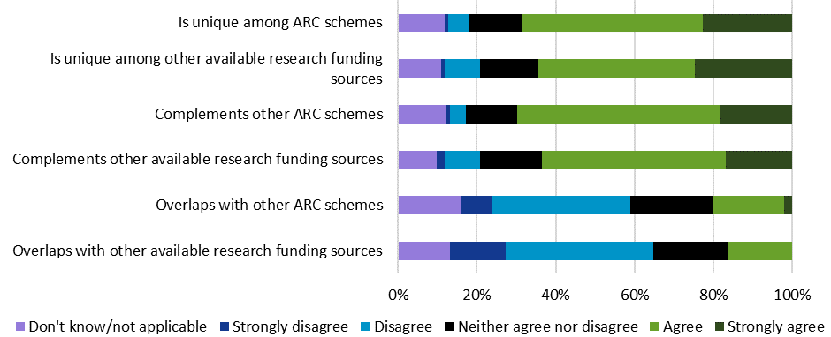

Source: Kantar, Public Division. *Note: (n=2992–3055).*

Conversely, approximately one-fifth (19 per cent) of survey participants agreed or strongly agreed that Discovery Projects overlapped with other ARC schemes and 17 per cent believed that it overlapped with other non-ARC funding sources. Qualitative responses provided some indication of the nature of perceived overlaps, including elements within both the broader NCGP and non-ARC funding sources supporting applied research, collaboration, and the expansion of Australia’s knowledge base and research capacity.

Table 6 presents the views of survey participants—grouped according to the characteristics of their most recently completed project under the scheme—on Discovery Projects’ position within the research funding landscape. Researchers who had completed their projects within the past three years were more likely to view the scheme’s role as unique in relation to both the NCGP (75 per cent, compared to 69 per cent of those completing less recently) and non-ARC funding sources (71 per cent, compared to 63 per cent of those completing less recently). Those completing a project in the past three years were also more likely to agree that Discovery Projects complements other ARC schemes (77 per cent, compared to 67 per cent of those completing less recently) and other available research funding sources (71 per cent, compared to 60 per cent of those completing less recently).

Table 6: Proportion of researchers agreeing about the position of Discovery Projects within the research funding landscape, by most recently completed Discovery Project characteristics

|  |  |  |  |  |  |  |  |  |  |  |
| --- | --- | --- | --- | --- | --- | --- | --- | --- | --- | --- |
|  | Research Project Characteristics | | | | | | | | | |
| Position within funding landscape | **STEM** | **HASS** | **Completed Project 2018 or later** | **Completed Project 2011– 2017** | **Completed Project 2010 or earlier** | **Basic** | **Applied** | **Basic and Applied Combined** | **International Collaboration** | **No International Collaboration** |
| Is unique among ARC schemes | 73% | 70% | 75%  (+) | 72% | 57%  (–) | 72% | 64%  (–) | 73% | 72% | 69% |
| Is unique among other available research funding sources | 68% | 67% | 71%  (+) | 66% | 51%  (–) | 67% | 60%  (–) | 70% | 67% | 66% |
| Complements other ARC schemes | 72% | 72% | 77%  (+) | 69% | 59%  (–) | 71% | 69% | 72% | 72% | 69% |
| Complements other available research funding sources | 67% | 64% | 71%  (+) | 62% | 52%  (–) | 65% | 63% | 66% | 68% | 60% |
| Overlaps with other ARC schemes | 20% | 22% | 20% | 23% | 19% | 20% | 24% | 21% | 21% | 22% |
| Overlaps with other available research funding sources | 18% | 19% | 17% | 19% | 19% | 17% | 22% | 17% | 17% | 19% |

Source: Kantar, Public Division. *Note: Percentage of survey respondents agreeing or strongly agreeing. Grey cells are significantly below the mean while green cells are significantly above the mean at the 95 per cent confidence level. Researcher subgroups assigned on the basis of most recently completed project funded under the scheme. Table only includes participants with a completed project (n=2469); different numbers of survey participants responded to questions relating to research project characteristics.*

Researchers whose most recently completed project involved basic research were more likely to agree that the scheme was unique (72 per cent compared to 64 per cent of those engaging in applied research), and 67 per cent regarded it as unique in relation to non-ARC funding sources (compared to 60 per cent of those engaging in applied research). These results reflect the distinctive role Discovery Projects plays in providing support for basic research (alongside applied research) within Australia’s research funding landscape.

### Quantitative stakeholder views—Discovery Projects’ most important contributions

From a list of options, survey participants were asked to identify what they regarded as Discovery Projects’ most important contributions to the national research funding landscape, with the opportunity to select up to three responses. Figure 40 shows that, while stakeholders recognised the significance of the scheme’s support for a broad range of scholarship, its contribution to basic research was regarded as especially important, being selected by more than half (55 per cent) of researchers surveyed. Participants were much less likely to select applied research (17 per cent).

Figure 40: Discovery Projects' most important contributions to the Australian research funding landscape

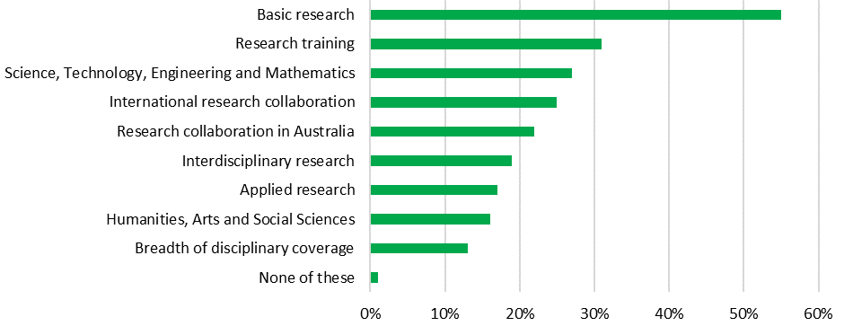

Source: Kantar, Public Division. *Note: (n=2827). Respondents able to select up to three options.*

Disaggregating these survey findings according to the characteristics of survey participants’ most recently completed project under the scheme revealed notable variations (Table 7). Not surprisingly, researchers whose most recently completed project involved basic research were more likely to identify basic research as one of the most important contributions of the scheme (73 per cent, compared to 30 per cent of those completing applied research, and 54 per cent of those whose most recent project involved a combination of the two). Similarly, researchers conducting non‑interdisciplinary projects more commonly included basic research among the scheme’s top contributions (64 per cent, compared to 54 per cent for those with interdisciplinary projects). STEM researchers were also more likely to identify basic research (68 per cent, compared to 41 per cent for HASS researchers), and less likely to include applied research in their top three contributions (15 per cent compared to 20 per cent for HASS researchers).

Table 7: Discovery Projects’ most important contributions to the research funding landscape, by most recently completed Discovery Projects research characteristics

|  |  |  |  |  |  |  |  |  |  |  |
| --- | --- | --- | --- | --- | --- | --- | --- | --- | --- | --- |
|  | Research Project Characteristics | | | | | | | | | |
| Contribution | **STEM** | **HASS** | **Completed Project 2018 or later** | **Completed Project 2011– 2017** | **Completed Project 2010 or earlier** | **Basic** | **Applied** | **Basic and Applied Combined** | **International Collaboration** | **No International Collaboration** |
| Basic research | 68%  (+) | 41%  (–) | 60% | 58% | 49%  (–) | 73%  (+) | 30%  (–) | 54%  (–) | 60% | 55% |
| Research training | 41%  (+) | 20%  (–) | 34% | 32% | 29% | 34% | 31% | 33% | 34% | 32% |
| Science, Technology, Engineering and Mathematics | 34%  (+) | 16%  (–) | 30%  (+) | 26% | 25% | 28% | 25% | 28% | 29% | 26% |
| International research collaboration | 24% | 22% | 27%  (+) | 22% | 16%  (–) | 26% | 16%  (–) | 24% | 31%  (+) | 9%  (–) |
| Research collaboration within Australia | 18%  (–) | 29%  (+) | 21% | 23% | 20% | 21% | 23% | 22% | 19%  (–) | 26%  (+) |
| Interdisciplinary research | 16%  (–) | 21%  (+) | 18% | 18% | 13% | 15%  (–) | 20% | 20% | 19% | 15% |
| Applied research | 15%  (–) | 20%  (+) | 16% | 17% | 18% | 6%  (–) | 43%  (+) | 19%  (+) | 16% | 19% |
| Humanities, Arts and Social Sciences | 4%  (–) | 40%  (+) | 17% | 17% | 19% | 16% | 16% | 17% | 15%  (–) | 21%  (+) |
| Breadth of disciplinary coverage | 13% | 15% | 14% | 13% | 11% | 13% | 11% | 14% | 13% | 15% |
| None of these | 1% | 2% | 1% | 2% | 2% | 1% | 2% | 2% | 1% | 2% |

Source: Kantar, Public Division. *Note: Percentage of survey respondents agreeing or strongly agreeing. Grey cells are significantly below the mean (–) while green cells are significantly above the mean (+) at the 95 per cent confidence level. Researcher subgroups assigned on the basis of most recently completed project funded under the scheme. Table only includes participants with a completed project (n=2469); different numbers of survey participants responded to questions relating to research project characteristics.*

National and international collaboration were regarded as important elements of the scheme’s contribution by 39 per cent of survey participants. The proportion of survey participants identifying international (25 per cent) and national (22 per cent) collaboration were similar. As could be expected, those whose most recently completed project involved international collaboration were more likely to identify that area as an important contribution (31 per cent) than those who did not collaborate internationally (9 per cent). There was also some variability between STEM and HASS researchers, with STEM researchers (18 per cent) being less likely than HASS researchers (29 per cent) to include collaboration within Australia as one of the scheme’s top contributions.

Participants also highlighted the scheme’s contributions to research training (31 per cent) and STEM disciplines (27 per cent). While more participants identified the importance of the scheme’s support for STEM than HASS, it should be acknowledged that STEM researchers were more strongly represented within the survey’s overall sample, and as named researchers on projects funded under the scheme. The results highlighting the importance of the scheme’s support for basic research may have been affected by the higher representation of participants who had completed projects in basic (44 per cent), as opposed to applied (15 per cent), research.[74]

### Quantitative stakeholder views—alternative funding sources

Survey participants who indicated they had been a named researcher on an unsuccessful Discovery Projects application (77 per cent of the those surveyed) were asked about alternative funding sources they had pursued after their most recent unsuccessful application.

As Figure 41 shows, 73 per cent of those researchers had made, or intended to make, a further attempt at raising funding to support their proposed research. Most commonly (43 per cent), this involved applying for another Discovery Projects funding round. A substantial number also applied or intended to apply for other ARC schemes (16 per cent) or international funding sources (15 per cent). Twenty-seven per cent indicated they had not sought or would not seek alternative funding for the project.

Figure 41: Other funding sources applied for after most recent unsuccessful Discovery Projects application

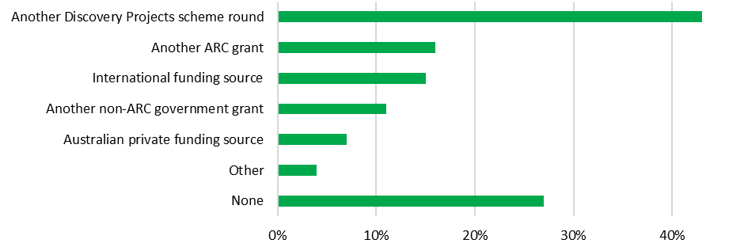

Source: Kantar, Public Division. *Note: Data includes those who had been named a researcher on an unsuccessful Discovery Projects application (n=2341).*

Sixty-three per cent of those who had sought (or intended to seek) alternative funding were successful, while 37 per cent were not. As Figure 42 shows, another Discovery Projects round (30 per cent) was the most common alternative source of funding received, followed by another ARC grant (13 per cent).

Figure 42: Other funding sources received after most recent unsuccessful Discovery Projects application

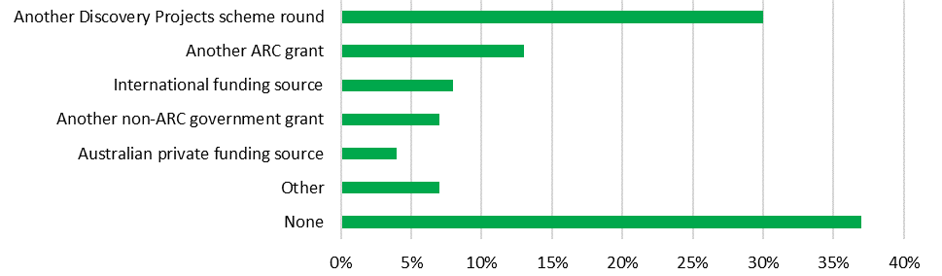

Source: Kantar, Public Division. *Note: Data includes those who had applied, or intended to apply, for alternative funding for their most recent unsuccessful Discovery Projects application (n=1681).*

Overall, in responses about funding sources they had both applied for and received, participants most frequently selected ‘Another Discovery Projects scheme round’ or ‘None’. This indicates that alternative funding opportunities may be limited for many researchers and appears to reinforce stakeholder perspectives that Discovery Projects occupies a unique role within the Australian research funding landscape. Alternative opportunities appeared to be particularly limited for those proposing research within HASS disciplines. Thirty-seven per cent responded that they had not sought, or would not seek, alternative funding for their project, compared to 23 per cent of STEM researchers. Statistically significant differences between participants proposing basic and applied research were not apparent, despite stakeholders’ emphasis on the importance of the scheme’s contribution to basic research (see Section 5.1.2).

## Discovery Projects scheme design

### Quantitative stakeholder views—appropriateness of Discovery Projects scheme objectives, intended outcomes and support for translational benefits through basic research funding

Overall, more than two-thirds of survey participants (68 per cent) agreed or strongly agreed that Discovery Projects’ objectives and intended outcomes are appropriate, given the scheme’s underlying policy intent. More than half (56 per cent) also agreed that the scheme’s approach to supporting translational benefits through basic research is appropriate; only 18 per cent either disagreed or strongly disagreed.

Figure 43: Level of agreement about the appropriateness of the Discovery Projects scheme’s objectives, intended outcomes and approach to delivering translational benefits

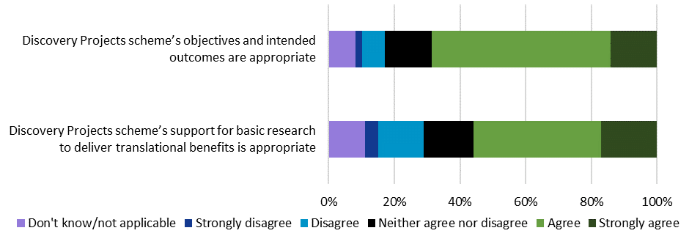

Source: Kantar, Public Division. *Note: (n=3044, 3042).*

Table 8 shows that responses were generally consistent when disaggregated by the characteristics of researchers’ mostly recently completed project under the scheme. Researchers completing their most recent project in the last three years were more likely to agree or strongly agree that the scheme’s objectives and intended outcomes are appropriate, compared to those who completed less recently (74 per cent, compared to 64 per cent respectively). Researchers whose most recently completed project involved international collaboration were also more likely to agree (71 per cent, compared to 63 per cent of those not involving international collaboration).

Table 8: Proportion of researchers agreeing about the appropriateness of the Discovery Projects scheme’s objectives, intended outcomes and approach to supporting translational benefits, by most recently completed Discovery Projects research characteristics

|  |  |  |  |  |  |  |  |  |  |  |
| --- | --- | --- | --- | --- | --- | --- | --- | --- | --- | --- |
|  | Research Project Characteristics | | | | | | | | | |
|  | **STEM** | **HASS** | **Completed Project 2018 or later** | **Completed Project 2011– 2017** | **Completed Project 2010 or earlier** | **Basic** | **Applied** | **Basic and Applied Combined** | **International Collaboration** | **No International Collaboration** |
| Discovery Projects scheme’s objectives and intended outcomes are appropriate | 69% | 70% | 74%  (+) | 65%  (–) | 60%  (–) | 67% | 69% | 70% | 71%  (+) | 63%  (–) |
| Discovery Projects scheme’s support for basic research to deliver translational benefits is appropriate | 57% | 53% | 61%  (+) | 53% | 40%  (–) | 56% | 47%  (–) | 58% | 57%  (+) | 51%  (–) |

Source: Kantar, Public Division. *Note: Percentage of survey respondents agreeing or strongly agreeing. Grey cells are significantly below the mean (–) while green cells are significantly above the mean (+) at the 95 per cent confidence level. Researcher subgroups assigned on the basis of most recently completed project funded under the scheme. Table only includes participants with a completed project (n=2469); different numbers of survey participants responded to questions relating to research project characteristics.*

The majority of survey participants whose most recently completed project involved basic (56 per cent) or a combination of basic and applied (58 per cent) research agreed that the scheme’s approach to supporting translational benefits through basic research is appropriate. Researchers completing applied projects agreed less frequently (47 per cent). However, for both groups, only low proportions disagreed or strongly disagreed (20 per cent of those completing basic research and 19 per cent completing applied research), indicating that most participants recognised the interdependence of basic and applied research in producing translational outcomes (see Section 5.2.3 for discussion).

### Qualitative stakeholder feedback—appropriateness of the Discovery Projects scheme’s objectives

Qualitative stakeholder comments affirmed the appropriateness of the Discovery Projects scheme’s objectives. Its support for excellent basic and applied research was understood to provide opportunities for new research directions and discoveries unlikely to have been supported through other funding mechanisms. Research office and peak body stakeholders highlighted the scheme’s importance as the most significant source of funding for investigator-led, non-medical basic research within Australia.

The fact is, that for many areas of research, it is the only source of funding to support really free academic research and really curiosity-driven research – (University Research Office)

I believe it is vital that it should continue...I recognise that without the Discovery Projects scheme being able to fund blue sky research ideas we would be severely hampered in ideas to feed into the applied research outcomes – (Researcher)

Discovery Projects’ objective to support research training was perceived as an appropriate contribution to developing the skills and experience of the Australian research workforce. Some feedback specifically emphasised Discovery Projects’ approach to supporting training within the context of high quality research environments to strengthen trainee development and foster intellectual engagement.

If you could have a research fellow funded for three years or a student undertake a PhD as part of a project team, it is much more impactful for them to be working on a funded project...It's important for an intellectual community...It's a very, very good way for them to get mentorship, to be engaged in the community and get involved in the outcomes as well. Having Discovery Projects available for students and research to work on is critical. I don't think there would be any other viable source in Australia at that type of scale – (University Research Office)

Participants also commented that the scheme’s objective to support national and international collaboration was appropriate for enhancing access to expertise, experience and resources within the context of funded research.

(I)n areas and universities where you may not have the largest team or a leading researcher in the field…you need to be able to draw on a range of people across the country who are leading in that area, that perhaps we were missing out on, so that the right teams are able to do big research projects – (University Research Office)

Research collaborations between many countries [is] very important – (Researcher)

Qualitative feedback regarding the appropriateness of the objective to enhance the scale and focus of research in Australian Government priority areas included more varied perspectives. Some stakeholders believed that the resourcing of ARC grants through government funding justified mechanisms encouraging researchers to address pressing issues confronting the Australian community. These participants tended to agree that the scheme’s current balance of support for priorities and ‘researcher-led’ projects was appropriate.

You can’t just be in a silo…Not just plugging away in your own little cubby hole doing your thing – (University Research Office)

It is appropriate that the ARC’s approach encourages applications that meet the intent of the Australian Government including in meeting national priorities but does not (nor should it) specifically direct funding to research in the Science and Research Priorities as a collective, nor to individual Science and Research Priorities – (Peak Body)

While the National Science and Research Priorities were developed in collaboration with a range of research, industry and government representatives,[75] some stakeholders described a desire for greater consultation with the Australian research community in the identification of future priorities. These comments often included concerns that the role of HASS disciplines in addressing significant issues confronting the nation were not sufficiently recognised within existing priorities.

Those priorities could be thought out more deeply, with input from a broader range of people – (University Research Office)

As someone who works across the humanities and social sciences, I find the National Science and Research Priorities very limited and limiting. [...] I think the ARC might devote some energy to enhancing the scale and focus of these areas – (Researcher)

Lots of research fields lying within social sciences (e.g. demographic trends, human mobility, human settlement, urban issues) are not recognised as national research priority areas – (Researcher)

It is important to note that the National Science and Research Priorities were determined by the Australian Government, and their content is beyond the scope of this evaluation. However, as described earlier (see Section 3.5), the Discovery Projects scheme objectives were amended in DP21 to refer to Australian Government priority areas more broadly, rather than the National Science and Research Priorities exclusively. Further outreach and engagement activities reinforcing the potential for applicants (and assessors) to refer to diverse Australian Government priorities under the scheme may be valuable. Changes to Discovery Projects application forms allowing researchers to indicate their intention to address priorities beyond the National Science and Research Priorities may also prove beneficial.

Other stakeholders perceived more general tensions between the presence of priorities determined by the Australian Government and the scheme’s objective to support basic research. Some regarded the priorities as impeding unconstrained intellectual enquiry, engagement with cutting-edge scholarship, and the transformative outcomes delivered through investigator-led, basic research.

Something that may not be a priority today, may be a priority tomorrow…the benefits might be next week, or they might be in 10 years. It is important not to pigeonhole [the grants] – (University Research Office)

I do not agree that the Australian Government should direct ARC Discovery Projects research to the Government of the Day's priority areas. There should be a separate scheme for this. The ARC Discovery Projects scheme is the only way Australians can pursue pure, curiosity-driven research. History has shown that many of our most profound innovations that have vastly increased the world's wealth and health have been the result of pure research – (Researcher)

I am quite critical about the national priorities being weighted so strongly. There is a good chance that excellent basic research gets overlooked and not funded because it doesn't respond to a current societal need and priority (as determined by the Government). If we had always thought this way, we would not have electronics as we know it, as the base research needed for it would never have been carried out in the first place. The current restrictions suffocate, to some extent, really innovative research – (Researcher)

As discussed earlier (see pp. 59), addressing an Australian Government priority is not a Discovery Projects eligibility requirement. While research priorities form one component of the ‘Benefit’ assessment criterion, benefit may be demonstrated in multiple ways; research priorities are not associated with a specific weighting. SEO data demonstrate that Discovery Projects’ support for basic research remains strong and has, in fact, increased in recent funding rounds (see Section 3.2.1). Further, the policy rationale underpinning the introduction of the National Science and Research Priorities expressly states that they can be addressed through either basic or applied research.[76] Reiterating these points in ongoing ARC advice, outreach and engagement may be useful in addressing stakeholder concerns and providing further clarity about the role of the priorities in Discovery Projects.

### Qualitative stakeholder feedback—appropriateness of Discovery Projects scheme intended outcomes

Stakeholders’ qualitative comments were predominantly positive about the appropriateness of Discovery Projects’ intended outcome to expand Australia’s knowledge base and research capacity. Their feedback on this intended outcome again highlighted the uniqueness and importance of the scheme in the Australian research funding landscape, including with reference to its support for basic research, building Australia’s international reputation, and generating research career opportunities.

Out of all schemes, this would be the most dangerous to stop…It is the bread and butter of all the other schemes and other research... (Removing Discovery Projects) would be a disaster, Australia isn’t investing enough as it is into basic research, this is a very rare and valuable scheme – (University Research Office)

It is critical to building Australia’s own stock of knowledge and contributing internationally, if the Australian Government wasn’t committed to funding that kind of research, we wouldn’t be a player on the international stage – (University Research Office)

In terms of human capital, it is about the fact that we need a vibrant research team. If there are no research opportunities in Australia, then they will get good jobs overseas and never come back. We need to bring them back to do exciting things, which is what the ARC does – (University Research Office)

Stakeholders were also invited to comment on the appropriateness of both Discovery Projects’ intended outcome to deliver economic, commercial, environmental, social and cultural benefits, and its approach to supporting translational benefits though basic research funding. Because substantially similar themes emerged in response to these questions, they are addressed together in the remainder of this section. Qualitative feedback in these areas often overlapped with perspectives about the scheme’s objective to support research addressing Australian Government priorities (see Section 5.2.2) and stakeholders’ positions on these issues were similarly varied.

Among those who considered Discovery Projects’ intended outcome of supporting translational benefits appropriate, some reiterated the principle that, being resourced through public funding, the scheme should deliver benefits to the broader community. Participants also made a range of arguments identifying basic research and support for the fundamental knowledge base as the foundations for applied research and all genuinely transformational innovation. Some commented that translational outcomes were realised through sustained investment over the medium-to-long term, and were often uncertain during the initial stages of research.

The research benefits the whole country in broader ways than just money—it provides enormous support to education in many direct and indirect ways. It creates a public environment where science is recognised as exciting, rewarding and important. It creates national pride and stimulates young people, so necessary for creating the workforce we need in a knowledge-based economy – (Researcher)

Basic research is essential, for its own sake. Sometimes the ‘translational benefits’ do not emerge until decades, even centuries, after the basic research has been performed. If you want innovation and good ideas that will benefit society, then you need to fund basic research, even where the link between the research and the future benefit is not immediately clear – (Researcher)

All translational outcomes start with basic research. There can be no applied outcomes without an excellent intellectual basis – (Researcher)

A vibrant essential research culture that can translate research for the national (and international) benefit fundamentally requires a solid, well-funded basic pool of research, research training and researchers – (Researcher)

World-leading fundamental research is usually the starting point for the most radical and game-changing translational benefits. For example, consider the development of wireless technology by the CSIRO – (Researcher)

Stakeholders who questioned the appropriateness of the scheme’s intended outcome to deliver translational benefits expressed a number of concerns. Some commented that the lack of immediate or predictable impacts stemming from basic research meant that it was not appropriate to focus on these types of benefits. Others went further, and suggested that the focus on translational outcomes reflected a reluctance to support basic research and the expansion of Australia’s knowledge base in lieu of direct opportunities for research application.

There is a clear expectation that the research will be applied within a few years. This is particularly evident in the 'benefit' section – (Researcher)

The scheme's objectives are themselves skewed in favour of functionalist socio‑economic objectives at the expense of disinterested basic research – (Researcher)

The language surrounding the ‘national benefit’ and ‘national interest’ sections implies a negativity towards fundamental basic research, which I don't think is intended. Often that sort of research does not have *immediate* applications of this nature, but the benefits are realised in the long run in all sorts of ways. I would like to be able to complete those sections more realistically – (Researcher)

Not all basic research can be translated, this is why it's basic research. If you want translational outcomes, you need to either fund applied projects, or provide specific funding to convert basic research into a translational outcome post-project. The benefit may not be seen for many years – (Researcher)

These responses should be interpreted in light of quantitative data presented earlier (see Section 5.2.1), indicating that the majority of stakeholders considered the Discovery Projects scheme’s objectives and intended outcomes, and its approach to supporting translational benefits through basic research funding, to be appropriate. Nonetheless, to address stakeholder concerns about tensions between these elements of the scheme’s design, there may be value in reiterating in ARC outreach and engagement that the scheme’s support for basic research has increased as a proportion in recent years (see Section 3.2.1), and that the scheme is designed to recognise the role of basic research in contributing to translational outcomes.

## Appropriateness of Discovery Projects’ funding amount and duration

This section evaluates the appropriateness of Discovery Projects’ available funding amount and funding duration in supporting the achievement of its objectives and intended outcomes. The analysis of both the scheme’s funding amount and funding duration considers ARC administrative data, overall perceptions of appropriateness from researchers surveyed, and qualitative feedback from stakeholders.

### ARC data—funding amount

The range of funding available to support individual projects under Discovery Projects has been relatively consistent over the course of the scheme’s history. The minimum funding amount available has shifted only once, increasing from $20,000 to $30,000 per annum from DP12 onwards. The presence of a minimum funding amount is intended to recognise the effort involved in preparing applications, the expectation that funded projects will achieve substantial outcomes and the capacity of universities to support smaller-scale research. The maximum amount available has remained at $500,000 per annum since the scheme’s inception. The wide funding range is intended to ensure Discovery Projects can support diverse research activities across a broad disciplinary spectrum.

Figure 44 shows that the average funding awarded to individual projects has steadily increased over the course of the scheme’s history from $247,590 in DP02 to $431,747 in DP20. This upward trajectory was briefly interrupted between DP10 and DP12; this dip may reflect the removal of fellowship opportunities and support for Early Career Researchers previously provided under the scheme. The sustained growth in the average amount of funding awarded to individual projects may reflect at least three factors. Firstly, the amount of funding requested within applications has steadily grown, from $329,644 in DP02 to $582,255 in DP21. This potentially relates to increases to the cost of conducting research, which have been documented elsewhere.[77] Secondly, as noted earlier (see Section 2.6), return rates rose substantially from DP12 onwards, meaning researchers have been receiving a greater proportion of funding requested. Thirdly, the size and scale of the projects for which researchers are requesting funding may have also increased.

Figure 44: Average funding requested/awarded per project, DP02–DP20

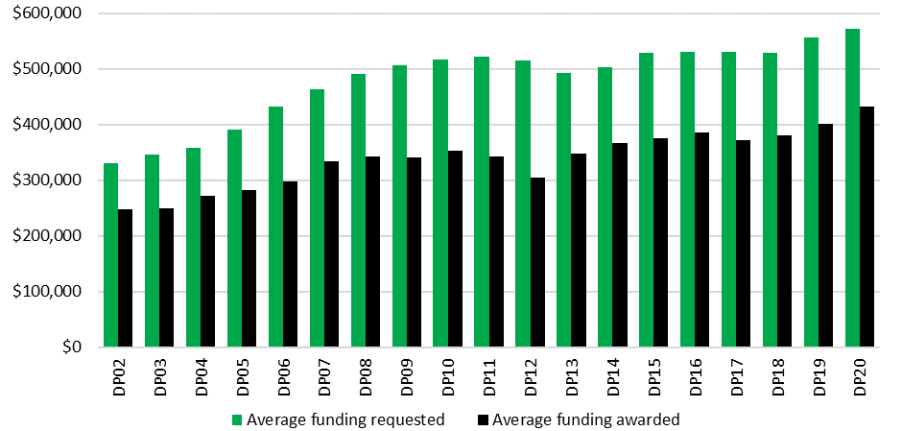

Source: ARC administrative data. *Note: Funding data reflect funding amounts at the time of announcement, and have not been adjusted for inflation. Average funding amounts reflect summed totals across all years of projects, rather than per annum amounts.*

### Stakeholder feedback—appropriateness of funding amount

Fifty-nine per cent of survey participants agreed or strongly agreed that funding amounts available through Discovery Projects are appropriate to support the achievement of the scheme’s objectives and intended outcomes, while 27 per cent disagreed or strongly disagreed.

Figure 45: Appropriateness of Discovery Projects scheme funding amount

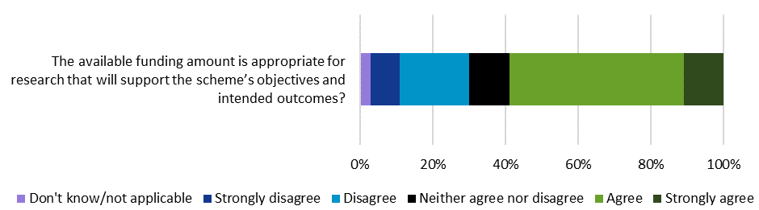

Source: Kantar, Public Division. *Note: (n=2976).*

When disaggregated according to the characteristics of researchers’ most recently completed project under the scheme, these results largely remained consistent. The only notable exception was that researchers completing STEM projects were less likely to agree or strongly agree (54 per cent) about the appropriateness of the funding amount than HASS researchers (65 per cent). This may reflect variations in costs for STEM and HASS research, with the former tending to be associated with higher funding requested per application under the scheme (see Section 2.8.2).

In qualitative feedback, a number of survey participants argued that there may be value in lowering minimum funding amounts offered under Discovery Projects. These perspectives were frequently expressed in respect of specific disciplinary domains, including the humanities, social sciences and mathematics, which were viewed as being able to deliver high quality, substantial research outcomes with less funding. Feedback also included suggestions that smaller grants had the potential to foster higher success rates and to diversify the research supported under the scheme.

Some disciplines would benefit from having smaller grants. For example, mathematical research is usually not organised in well-defined projects and not every project requires a post-doc – (Researcher)

For humanities and social sciences, more grants and smaller amounts funded for each grant – (Researcher)

Please consider funding a range of smaller grants—like $50k over three years as part of this scheme. I believe it would support more diversity, a greater range of projects and ultimately do a lot for Australian innovation – (Researcher)

It would probably be useful if there were more slightly smaller grants awarded, with a view to a greater percentage of applications being successful. The current success rates are low enough that a large majority of applicants are wasting a lot of time – (Researcher)

The themes highlighted in these responses align with the 2019 *Australian Government funding arrangements for non-NHMRC research* report, which noted that the ‘needs of researchers will differ across disciplines’ and ‘that different levels of funding are required to support these needs’. The report recommended the implementation of smaller scale funding options by the ARC to support greater flexibility within Australia’s research funding system.[78] In response to this review, the ARC noted that historic Discovery Projects data suggested a decline in the number of researchers seeking funding of less than $100,000, indicating the absence of widespread demand for smaller scale funding options.

Given overall support for the appropriateness of Discovery Projects’ existing funding range among survey respondents, further evidence would be needed to recommend specific changes. However, perspectives presented within this evaluation highlighting some stakeholder support for changes to the minimum funding threshold should be considered within future reviews of Discovery Projects’ funding provisions.

An additional matter highlighted by stakeholders concerned difficulties funding postdoctoral positions through the scheme. As demonstrated in Figure 44, the average amount of funding awarded for Discovery Projects grants has increased gradually over time, from slightly below $300,000 in DP06 to $431,747 in DP20. Stakeholders suggested that funding postdoctoral positions occupied too large a proportion of most Discovery Projects budgets, potentially diminishing the scheme’s contribution to the development of a sustainable Australian research workforce, and its subsequent research capacity.

The research budget allocated for Discovery Projects from the government is very low. Too many applications each year and successful applications end up with a fraction of the budget they have requested. One Discovery Project is not enough to hire a postdoctoral fellow in Australia – (Researcher)

The funding range is also too low to support postdoctoral fellows, and this greatly hampers research output as postdocs are a major contributor to Australian scientific publications. At current Group of Eight Enterprise Bargaining Agreement rates, a single postdoctoral fellow for three years would consume an entire ARC Discovery Projects budget with nothing left for travel, equipment, or maintenance. This mismatch in funding levels will eliminate the postdoc as a viable career path for young academics in Australia—Chief Investigators cannot afford them anymore. We are seeing many bright young graduates go overseas instead to seek postdoctoral positions – (Researcher)

The funding is not even enough to pay for a full-time postdoc. With no dedicated experienced person, it is difficult to achieve all the goals – (Researcher)

Stakeholder concerns about the capacity to support postdoctoral positions through Discovery Projects grants are important to acknowledge, particularly given data presented earlier suggesting that the proportionate representation of Early and Mid-Career Chief Investigators on applications and funded projects declined over time (see Section 4.2.2). While these are important considerations in evaluating Discovery Projects’ support for less experienced researchers, quantitative survey results showed that the scheme was predominantly regarded as effective in its support both for research training (see Section 3.1) and expanding Australia’s knowledge base and research capacity (see Section 4.1). As previously noted in relation to research training more broadly, the provision of a one-line budget for successful applications and the absence of records documenting grant expenditure against specific budget items limits the ARC’s ability to estimate the level of funding support for postdoctoral positions under Discovery Projects. Mechanisms to more effectively monitor how scheme funding is allocated and/or acquitted would allow the ARC to more accurately evaluate the scale of Discovery Projects’ support for postdoctorates over time.

### ARC data—funding duration

The duration of funding offered under NCGP schemes is determined in light of multiple factors, including total funding available, scheme objectives and intended outcomes, and the scale of the projects being funded. The duration of Discovery Projects funding has fluctuated somewhat over time. Between DP02 and DP11, the scheme offered funding for between one and five years. Between DP12 and DP14, it offered funding for up to three years, which was extended to up to five years from DP15 onwards.

In assessing the appropriateness of Discovery Projects’ funding duration it is important to consider that, on the one hand, the CGRGs encourage Australian Government entities to develop ‘longer term grant agreements, where appropriate’, in order to reduce costs associated with administering additional grant rounds and applications, and to achieve better value for public money.[79] Longer grants also allow for greater stability, providing researchers with the confidence to develop extended projects, potentially resulting in greater academic and translational impact. On the other hand, longer grants tend to be associated with higher costs per grant. Shorter funding durations may contribute to improved success rates, within the context of finite available funding.

While the scheme’s funding duration has changed over time, the average funding length for successful applications has remained relatively static, between a minimum of 3.0 years (DP12) and a maximum of 3.3 years (DP10). Figure 46 shows that the vast majority (at least 70 per cent) of successful applications were awarded funding for three years in all funding rounds. Further, it appears that individual project funding durations converged over time. In the past four funding rounds announced, 93–95 per cent of successful applications were offered support for three years, compared to 78 per cent of projects funded between DP02 and DP10. These differences may partly reflect the removal of fellowship opportunities from the scheme, which were typically funded over a five year duration;[80] approximately 150–200 fellowships were awarded per funding round during this period.

Figure 46: Funding duration for funded projects, DP02–DP20

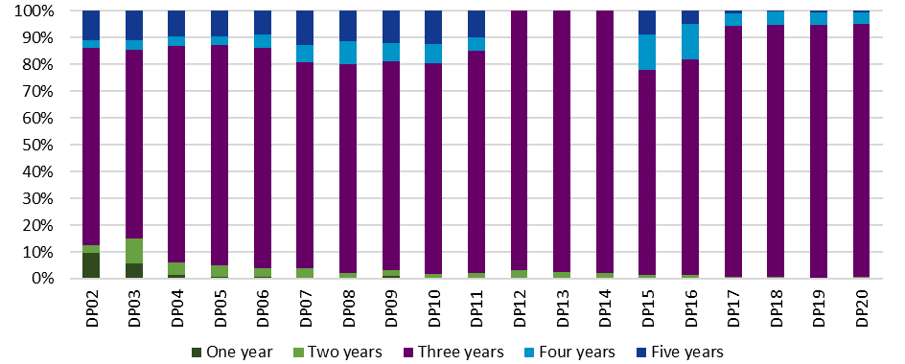

Source: ARC administrative data. *Note: Funding duration data reflect anticipated length of funding at the time of announcement.*

### Stakeholder feedback—appropriateness of funding duration

Seventy-five per cent of surveyed researchers agreed or strongly agreed that Discovery Projects’ funding duration was appropriate to support the achievement of the scheme’s objectives and intended outcomes. When responses were disaggregated by the characteristics of researchers’ most recently completed project under the scheme, no statistically significant differences emerged.

Figure 47: Appropriateness of Discovery Projects scheme funding duration

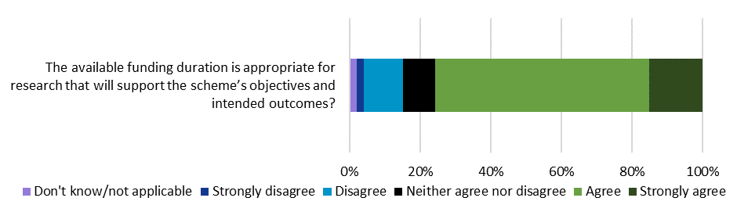

Source: Kantar, Public Division. *Note: (n=2976).*

As noted in greater detail previously (see Section 3.3.3), some stakeholders expressed concerns that the typical three year funding duration associated with research funded under Discovery Projects may not be appropriate to effectively support research training. These views were expressed in relation to difficulties recruiting HDR students (see Section 2.10.2) and the length of time associated with PhD completion (see Section 3.3.3). However, these concerns do not appear to be undermining stakeholders’ largely positive perceptions of the effectiveness of the scheme’s support for research training (see Section 3.1).

Some stakeholder comments revealed perceptions about the existence of an informal ‘unwritten rule’ that Discovery Projects only supported three year grants, despite the funding duration specified within scheme documentation. Feedback highlighted the belief that applications requesting four or five years of funding would be subjected to additional peer review scrutiny. While some acknowledged that longer studies had been funded, it appeared common to design proposals within the parameters of a three year period. Some regarded this as affecting the breadth and impact of research fundable under the scheme.

The other thing is that researchers have a choice to apply for between one and five years of funding for Discovery Projects—most choose three years as it is traditional, and they are less likely to get scrutiny for feasibility in the assessment process. The people who say the project should run longer, my response is maybe they should apply for four years – (University Research Office)

The maximum funding period available is five years, which in theory is a positive, but it is very rare for projects to be funded for longer than three years, I believe due to budget constraints. This means that in practice the limit is really three years, which contributes to the stop-start nature of some research programs and increases workload for researchers in terms of spending time putting in applications more frequently, with greater uncertainty – (Researcher)

Most researchers only apply for three years of funding—not because they don't have better five year projects or longer duration is not preferable. They do this because asking for more than three years is widely viewed as a ‘kiss of death’ for applications – (Researcher)

Such perceptions potentially contributed to low numbers of Discovery Projects applications and funded projects associated with longer funding durations (Figure 46). However, they are not strongly supported by ARC administrative data. As Figure 48 indicates, applications requesting five years of funding have generally had higher than average success rates—although the success rate for these applications has fallen slightly below average for three of the past four funding rounds. Notably, it appears that applications making one or two year funding requests have consistently had worse than average success rates.

Figure 48: Success rate by years of funding requested, DP02–DP20

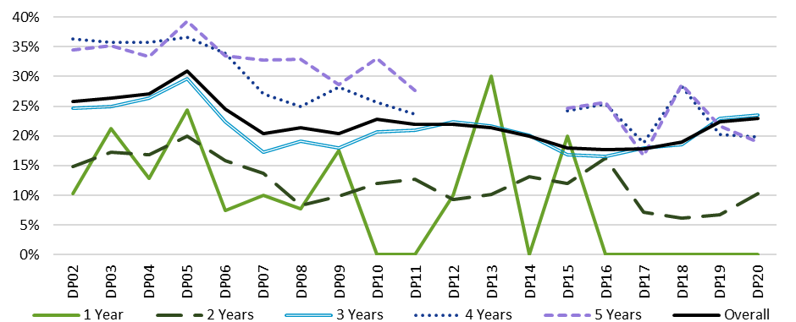

Source: ARC administrative data. *Note: Between DP12 and DP14, a maximum of three years of funding could be requested.*

Between DP02 and DP20, the average return rate per funding round for successful applications seeking five years of funding (51.1 per cent) was lower than the scheme-wide average (60.8 per cent), although a number of factors must be taken into account. Selection Advisory Committees may make recommendations on both the amount of funding awarded to successful applications and the number of years of funding allocated. Of successful applications requesting five years of funding over the course of the scheme’s history, 50.6 per cent received funding for a five year period, but 43.3 per cent received only three years of funding. Between DP02 and DP11, those requesting and receiving five years of funding had higher than average return rates; however, this trend reversed from DP15 to DP20. As would be anticipated, return rates for applications reduced to three years were well below the scheme average (ranging from 25.0 per cent to 43.3 per cent between DP02 and DP20).

It is important to acknowledge that, in general, Discovery Projects applications requesting higher funding amounts over all durations tend to have lower return rates. As five-year funding requests tend to also be above average, it is difficult to determine whether return rates for these applications reflect the funding duration or funding amount requested. Further, given the very low number of five-year applications and funded projects between DP17 and DP20, it is difficult to identify consistent return rate trends.

On balance, these data suggest that stakeholder perceptions of five year applications being significantly disadvantaged may be somewhat exaggerated. Providing further information through outreach and engagement activities on the relatively competitive success rates for five year applications, and the nuances evident in return rates, may help to address researchers’ concerns. There may also be opportunities, in advice to Discovery Projects peer reviewers, to reinforce the scheme’s openness to supporting longer applications where the applicant has justified the request for funding over a longer duration.

# Appendix A: Opportunity One—Targeted advice, outreach and engagement (additional information)

Opportunity One (p. 9) identifies messages that may potentially be reinforced in ARC engagement and outreach with researchers and research offices, and in advice to Discovery Projects applicants, assessors and Selection Advisory Committees. This appendix provides additional detail on each of these messages.

**Discovery Projects funding is based on research excellence**

*Issue:*The content of some feedback indicated that the fundamental importance of research excellence in the allocation of funding under Discovery Projects could be further reinforced (Sections 5.2.2 and 5.2.3).

*Justification:*From inception, the central principle of Discovery Projects—and the NCGP as a whole—has been to support research on the basis of research excellence. Competitive peer review underpins the scheme’s allocation of funding and its efforts to achieve all objectives and intended outcomes (Section 2.2).

**The proportion of funded projects involving basic research has increased**

*Issue:*Stakeholders regard Discovery Projects as a unique and important source of support for basic research within the Australian research funding landscape (Section 5.1.2). However, some feedback included concerns that Discovery Projects’ scheme design may favour applied research (Sections 5.2.2 and 5.2.3).

*Justification:*The proportion of Discovery Projects applications and funded projects involving basic research increased over time (Section 3.2.1). In addition, survey results showed that, quantitatively, stakeholders held overwhelmingly positive views about the effectiveness of the scheme’s support for basic research (Section 3.1).

**Discovery Projects supports innovative research involving elements of risk when assessed as suitable through peer review**

*Issue:*Some stakeholders commented that Discovery Projects was insufficiently supportive of innovative, potentially risky, basic research. These comments referred to the ‘feasibility’ assessment criteria, a perceived overemphasis on researcher track record, and the scheme’s focus on translational benefits and Australian Government priorities (Section 3.2.3).

*Justification:*Discovery Projects assessment criteria include the ‘novelty/originality and innovation of the proposed research’. The ARC seeks to support research that may involve elements of risk, while ensuring public funding is directed to excellent research and researchers, and projects that will deliver positive outcomes within and beyond academia (Section 3.2.3).

**Basic research is important in supporting Australian Government research priorities and translational benefits**

*Issue:*Survey and interview participants perceived conflicts between the scheme’s support for basic research, with its objective to expand the scale and focus of research in Australian Government priority areas and intended outcome to deliver translational benefits (Sections 5.2.2 and 5.2.3).

*Justification:*Discovery Projects recognises the importance of both basic and applied research in addressing Australian Government research priority areas (Section 5.2.2). The evaluation highlighted the pivotal role of basic research in the establishment of the intellectual foundations for applied research and translational outcomes (Section 5.2.3).

**Addressing an Australian Government priority is not a requirement for funding**

*Issue:*Stakeholders expressed uncertainty about the role of Australian Government research priorities in Discovery Projects processes. They commented that this may lead applicants to make tenuous links between their proposed research and the priorities (Section 3.5.2).

*Justification:*While researchers may respond to the ‘Benefit’ assessment criterion by referencing relevant priority areas, addressing an Australian Government research priority has never been a requirement for funding. This reflects the scheme’s focus on investigator-led research (Section 3.5.2).

**There is no preference between applications that may deliver economic, commercial, environmental, social or cultural benefits**

*Issue:*Stakeholders suggested that Discovery Projects assessment processes prioritised tangible, immediate economic and commercial benefits over social and cultural translational benefits (Section 4.3.2).

*Justification:*Discovery Projects does not preference particular kinds of benefit delivered through research, and recognises the diverse timescales over which positive translational outcomes may arise (Section 4.3.2). Research funded under Discovery Projects delivers a diverse range of positive outcomes (Sections 4.1 and 4.3).

**Overall, success rates for women, Early Career and Mid-Career Chief Investigators, and Humanities, Arts and Social Sciences (HASS) research, are comparable to, or above, total scheme success rates**

*Issue:* Representation of women researchers (Section 3.2.2), researchers with less experience (Section 4.2.2) and HASS research (Section 2.8.1) on Discovery Projects applications and funded projects was comparatively low. Stakeholder feedback included views that certain groups of researchers were disadvantaged in Discovery Projects peer review processes (Sections 3.2.3 and 4.2.3).

*Justification:*ARC administrative data show that success rates for women (Section 3.2.2) and Early and Mid-Career (Section 4.2.2) Chief Investigators overall were higher than scheme-wide success rates in DP20. However, Early Career Researcher lead Chief Investigators on Discovery Projects applications had success rates that were below scheme average, highlighting the need to continue to reinforce the ARC’s ROPE policy to assessors. Discovery Projects’ peer review processes (including the composition of Selection Advisory Committees) have consistently ensured comparable success rates for HASS and STEM research (Section 2.8.2).

**The ARC is committed to the competitive assessment of interdisciplinary research**

*Issue:*The proportion of interdisciplinary Discovery Projects applications and funded projects declined over time, and interdisciplinary projects had slightly lower success rates than non-interdisciplinary projects. This may reflect perceptions that interdisciplinary applications face greater challenges in peer review processes (Section 2.9).

*Justification:*The *ARC Statement of Support for Interdisciplinary Research* highlights the value of interdisciplinary research and articulates the ARC’s commitment to ensuring it is recognised appropriately in NCGP processes (including in Discovery Projects)(Section 2.9).

**Discovery Projects funds four and five year applications when assessed as competitive through peer review**

*Issue:* Some stakeholders expressed beliefs that applications requesting more than three years of funding are subjected to additional scrutiny in Discovery Projects peer review processes (Section 5.3.4). This may contribute to low numbers of four and five year funding applications (Section 5.3.3).

*Justification:* ARC administrative data suggest that applications requesting funding over four and five year durations have generally had competitive success rates. Return rates for applications seeking five years of funding have varied (Section 5.3.4).

# Appendix B: Stakeholder feedback—executive summary

*From the final report by Kantar, Public Division to the ARC on stakeholder engagement services conducted as an input to the evaluation.*

The Discovery Projects scheme provides funding for basic and applied research undertaken by individual researchers and teams. It is the largest Australian Research Council (ARC) funding scheme and plays a central role in the Australian Government’s overall investment in university research. The Discovery Projects scheme has not been evaluated since it commenced and was identified as a priority for evaluation by the ARC.

The ARC engaged Kantar, Public Division (Kantar) to collect stakeholder feedback on the scheme in order to support an evaluation of the effectiveness and appropriateness of Discovery Projects. These stakeholder engagements consisted of:

* interviews with a sample of 24 university research offices and three peak bodies
* a survey distributed to named researchers on projects funded under the scheme since its inception.

Overall, stakeholders found the implementation of the Discovery Projects scheme to be effective in meeting its objectives and delivering on its intended outcomes. The scheme’s role within the broader research funding landscape, its objectives and intended outcomes, and the value and nature of the support provided were regarded as appropriate. However, opportunities to improve were identified in several areas.

***Discovery Projects is effectively achieving its objectives***

* Stakeholders agreed that the Discovery Projects scheme is supporting excellent basic and applied research. It is considered to be one of the only schemes that funds basic, investigator-led, ‘blue-sky’ research within the Australian funding landscape. The competitive Discovery Projects application process was broadly regarded as effectively ensuring the best projects were funded.
* Stakeholders considered Discovery Projects to be supporting excellent research training for individuals and teams through three primary mechanisms:
  1. By funding excellent research, Discovery Projects provides opportunities for all researchers to train and develop,
  2. The ARC was seen to actively encourage the training and development of junior researchers by allowing funding to be utilised for PhD and Master’s stipends, and
  3. Supporting Higher Degree by Research (HDR) students to collaborate with experienced researchers at the forefront of their fields.

There were, however, concerns expressed that Discovery Projects was primarily a scheme for ‘experienced’ researchers. It should be noted that mechanisms previously employed to support early career researchers through Discovery Projects—including a dedicated funding stream and fellowship opportunities—have been transitioned to the ARC’s Discovery Early Career Researcher Award (DECRA) scheme.

* The Discovery Projects scheme was perceived to be effectively supporting national and international collaboration. Furthermore, many participants noted that the ability to collaborate with other institutions, both nationally and internationally, ultimately fostered better research. There were, however, concerns raised about contractual and administrative challenges in sharing projects between institutions domestically. While highly regarded, it was also felt there was potential to more effectively support international collaboration.
* Stakeholders broadly regarded Discovery Projects as effectively supporting the enhanced scale and focus of research in Australian Government priority areas. It was generally believed that the scheme design was encouraging the development of projects aligned to Australian Government priority areas without undermining support for investigator-initiated, blue sky research.

***Discovery Projects is effectively achieving its intended outcomes***

* Discovery Projects was regarded as effectively supporting an expanded knowledge base and research capacity by supporting high-quality researcher-led projects, as well as contributing to the development of the future research workforce through training. However, stakeholders noted these outcomes could be amplified by increasing the amount of available project funding. There was also a perception amongst some research offices and peak bodies that the scheme’s funding had not increased in line with the number of researchers applying for grants, meaning high-quality research proposals were often not able to be funded.
* The Discovery Projects scheme was viewed as supporting economic, commercial, environmental, social and cultural benefits for Australia. Research offices evidenced this through outcomes generated by a range of projects that have been funded by the scheme. It was generally recognised that Discovery Projects is somewhat unique in its support for projects delivering social and/or cultural benefits. It was, however, noted that the extent of any benefits supported by the scheme was often difficult to quantify (particularly for basic research projects) until well after a project had been completed. This was sometimes perceived to create a tension, with respondents believing the ARC was prioritising research with more direct, immediate or tangible outcomes. As a result, some participants expressed a desire for more freedom to pursue a broader range of benefits to Australia, within different timeframes.

***Discovery Projects objectives/intended outcomes, role and funding value/duration are appropriate***

* The objectives and intended outcomes of Discovery Projects were broadly regarded as appropriate. Stakeholders (researchers, research offices and peak bodies) highlighted the importance of the scheme in supporting basic research to develop the fundamental knowledge that underpins applied research, which in turn delivered benefits to Australia and Australian society. Furthermore, many supported the appropriateness of the scheme’s support for research training and collaboration in order to enhance Australia’s capacity to deliver excellent research and research outputs. Participants appreciated the appropriateness of priority areas for research, within the context of research funding being provided by the Australian Government.
* The Discovery Projects scheme was perceived to be playing an appropriate role within the funding landscape. It was regarded as unique in its support for investigator-led basic research, and as performing a critical function within Australia’s research and innovation sector. Stakeholders also broadly perceived the scheme to be supporting translational benefits through basic research—and considered this to be an appropriate role—as well as contributing to the national and international community through contributions to knowledge.
* The value and duration of the funding provided by the Discovery Projects scheme was broadly regarded as appropriate. Participants recognised that increasing the value of the grants without an increase in the overall funding pool would lead to fewer grants being awarded. Likewise, if the overall length of grants were to be increased, this could impact the total number of grants available. Participants raised concerns about potential impacts to the viability of funded projects due to disparities between funding requested and funding awarded for successful applications.

# Appendix C: Survey sample

Table 9: Survey sample profile—gender

|  |  |
| --- | --- |
| Gender | Percent of sample (%) |
| Male | 73 |
| Female | 27 |
| Unknown | <1 |

Source: ARC administrative data. Note: Table reflects ARC Research Management System (RMS) data as at February 2020.

Table 10: Survey sample profile—number of Discovery Projects applications

|  |  |
| --- | --- |
| Number of applications | Percent of sample (%) |
| 1 | 12 |
| 2 | 10 |
| 3 | 9 |
| 4 | 7 |
| 5 | 7 |
| 6 | 6 |
| 7 | 7 |
| 8 | 5 |
| 9 | 5 |
| 10 | 5 |
| 11 | 4 |
| 12 | 4 |
| 13 | 4 |
| 14 | 3 |
| 15 | 2 |
| 16 | 2 |
| 17 | 2 |
| 18 | 2 |
| 19 | 1 |
| 20+ | 4 |

Source: ARC administrative data. Note: Table reflects RMS data as at February 2020.

Table 11: Survey sample profile—current number of Discovery Projects funded projects

|  |  |
| --- | --- |
| Number of projects | Percent of sample (%) |
| 0 | 57 |
| 1 | 37 |
| 2  3 | 6  <1 |

Source: ARC administrative data. Note: Table reflects RMS data as at February 2020.

Table 12: Survey sample profile—number of successful Discovery Projects applications

|  |  |
| --- | --- |
| Number of successful applications | Percent of sample (%) |
| 1 | 44 |
| 2 | 20 |
| 3 | 11 |
| 4 | 8 |
| 5 | 6 |
| 6 | 4 |
| 7 | 3 |
| 8 | 2 |
| 9 | 1 |
| 10 | 1 |
| 11 | <1 |
| 12 | <1 |

Source: ARC administrative data. Note: Table reflects RMS data as at February 2020.

Table 13: Survey sample profile—research type

|  |  |
| --- | --- |
| Research type | Percent of sample (%) |
| Applied | 15 |
| Basic | 44 |
| Combination  Don’t Know/NA | 39  1 |

Source: Survey administered by Kantar, Public Division. Note: Data relates to self-identified research-type for the respondent’s most recently completed project. Respondents who had been successful in receiving funding, but had not completed their project at the time of data collection, are not represented (n=2439).

Table 14: Survey sample profile—Administering Organisations

|  |  |  |  |
| --- | --- | --- | --- |
| Administering Organisation | % of sample | Administering Organisation | % of sample |
| The University of New South Wales | 10 | **La Trobe University** | 2 |
| The University of Melbourne | 10 | **Swinburne University of Technology** | 2 |
| The University of Queensland | 9 | **James Cook University** | 1 |
| Monash University | 8 | **University of South Australia** | 1 |
| The University of Sydney | 8 | **The University of New England** | 1 |
| The Australian National University | 8 | **Australian Catholic University** | 1 |
| The University of Adelaide | 4 | **University of Canberra** | 1 |
| The University of Western Australia | 4 | **Murdoch University** | <1 |
| Macquarie University | 3 | **Victoria University** | <1 |
| University of Wollongong | 3 | **Charles Sturt University** | <1 |
| University of Technology Sydney | 3 | **Southern Cross University** | <1 |
| Griffith University | 3 | **Charles Darwin University** | <1 |
| Queensland University of Technology | 3 | **Federation University Australia** | <1 |
| Curtin University | 2 | **Edith Cowan University** | <1 |
| The University of Newcastle | 2 | **University of Southern Queensland** | <1 |
| Deakin University | 2 | **University of the Sunshine Coast** | <1 |
| University of Tasmania | 2 | **Central Queensland University** | <1 |
| Royal Melbourne Institute of Technology (RMIT University) | 2 | **Not Applicable** | 1 |
| Western Sydney University | 2 | **Don't know** | 1 |
| Flinders University | 2 | **Other** | <1 |

Source: Survey administered by Kantar, Public Division. Note: Data relates to the administering organisation for the respondent’s most recently completed project. Respondents who had been successful in receiving funding, but had not completed their project at the time of data collection, are not represented (n=2439).

Table 15: Survey sample profile—disciplines of research

|  |  |  |  |
| --- | --- | --- | --- |
| Discipline | Percent of sample (%) | Discipline | Percent of sample (%) |
| Biological Sciences | 13 | **Studies in Human Society** | 7 |
| Engineering | 12 | **History and Archaeology** | 6 |
| Physical Sciences | 8 | **Language, Communication and Culture** | 5 |
| Information and Computing Sciences | 5 | **Education** | 4 |
| Chemical Sciences | 5 | **Economics** | 3 |
| Earth Sciences | 5 | **Commerce, Management, Tourism and Services** | 2 |
| Psychology and Cognitive Sciences | 4 | **Law and Legal Studies** | 2 |
| Mathematical Sciences | 4 | **Philosophy and Religious Studies** | 2 |
| Environmental Sciences | 3 | **Built Environment and Design** | 1 |
| Medical and Health Sciences | 3 | **Studies in Creative Arts and Writing** | 1 |
| Technology | 1 | **Other (please specify)** | 2 |
| Agricultural and Veterinary Sciences | 1 | **Don't know** | 1 |
|  |  | **Not Applicable** | 1 |
| Science, Technology, Engineering and Mathematics (STEM) | **62** | **Humanities, Arts and Social Sciences (HASS)** | **34** |

Source: Survey administered by Kantar, Public Division. Note: Data relates to discipline for the respondent’s most recently completed project. Respondents who had been successful in receiving funding, but had not completed their project at the time of data collection, are not represented (n=2455).

# Appendix D: Success rates by Fields of Research

Table 16: Success rates by primary 2-digit Field of Research code, DP02–DP20

|  |  |  |  |  |  |  |  |  |  |  |  |  |  |  |  |  |  |  |  |
| --- | --- | --- | --- | --- | --- | --- | --- | --- | --- | --- | --- | --- | --- | --- | --- | --- | --- | --- | --- |
| **Row Labels** | **DP02** | **DP03** | **DP04** | **DP05** | **DP06** | **DP07** | **DP08** | **DP09** | **DP10** | **DP11** | **DP12** | **DP13** | **DP14** | **DP15** | **DP16** | **DP17** | **DP18** | **DP19** | **DP20** |
| 01 Mathematical Sciences | 28.0% | 29.9% | 33.1% | 35.1% | 30.2% | 19.7% | 28.8% | 27.3% | 32.2% | 28.4% | 37.7% | 27.0% | 26.3% | 18.9% | 21.2% | 17.6% | 24.0% | 22.8% | 21.9% |
| 02 Physical Sciences | 29.2% | 28.2% | 30.3% | 28.8% | 26.9% | 21.5% | 24.0% | 18.7% | 22.9% | 20.7% | 18.6% | 22.4% | 22.0% | 20.6% | 19.0% | 22.2% | 18.7% | 25.1% | 23.5% |
| 03 Chemical Sciences | 26.1% | 28.6% | 26.9% | 32.1% | 28.5% | 21.3% | 22.7% | 22.3% | 21.0% | 25.6% | 21.0% | 23.7% | 21.4% | 18.5% | 16.1% | 17.3% | 16.2% | 24.7% | 24.6% |
| 04 Earth Sciences | 21.8% | 27.3% | 24.7% | 31.6% | 22.1% | 23.8% | 21.0% | 17.6% | 26.9% | 24.3% | 25.8% | 23.6% | 22.5% | 16.2% | 18.2% | 18.5% | 16.8% | 18.8% | 28.8% |
| 05 Environmental Sciences | 17.8% | 29.8% | 20.0% | 22.2% | 26.5% | 24.6% | 15.9% | 20.3% | 13.0% | 17.3% | 19.1% | 13.2% | 19.0% | 16.5% | 9.5% | 16.8% | 17.9% | 19.7% | 17.5% |
| 06 Biological Sciences | 28.4% | 28.7% | 27.0% | 31.4% | 26.6% | 21.4% | 22.8% | 20.6% | 23.0% | 27.0% | 24.9% | 22.8% | 20.2% | 20.2% | 21.5% | 20.0% | 21.5% | 24.5% | 23.6% |
| 07 Agricultural and Veterinary Sciences | 8.2% | 15.4% | 20.6% | 13.3% | 26.5% | 25.7% | 12.5% | 8.3% | 30.4% | 6.3% | 9.4% | 20.0% | 12.1% | 12.2% | 6.7% | 8.1% | 12.1% | 14.3% | 17.9% |
| 08 Information and Computing Sciences | 25.0% | 26.1% | 28.1% | 25.9% | 21.4% | 17.2% | 18.0% | 16.7% | 16.8% | 17.9% | 13.6% | 19.4% | 20.5% | 16.1% | 16.3% | 10.5% | 19.5% | 22.0% | 31.0% |
| 09 Engineering | 27.2% | 24.9% | 26.5% | 29.3% | 22.2% | 20.4% | 19.7% | 19.5% | 22.0% | 19.6% | 19.2% | 19.1% | 17.6% | 16.3% | 17.0% | 18.4% | 18.0% | 20.8% | 19.6% |
| 10 Technology | 20.8% | 38.7% | 34.6% | 31.3% | 26.9% | 23.8% | 20.5% | 23.7% | 20.5% | 19.3% | 24.7% | 18.5% | 14.3% | 21.4% | 15.6% | 18.5% | 17.2% | 24.5% | 19.2% |
| 11 Medical and Health Sciences | 24.4% | 11.7% | 16.2% | 34.6% | 17.6% | 14.6% | 18.4% | 18.9% | 15.1% | 22.8% | 17.9% | 16.3% | 16.7% | 17.2% | 15.2% | 17.6% | 13.8% | 15.6% | 20.2% |
| 12 Built Environment and Design | 36.4% | 17.9% | 14.8% | 17.1% | 15.0% | 17.4% | 15.0% | 16.2% | 23.8% | 16.1% | 13.3% | 4.5% | 3.0% | 15.1% | 11.5% | 7.1% | 12.1% | 21.2% | 14.3% |
| 13 Education | 21.4% | 24.4% | 18.4% | 20.5% | 18.3% | 14.3% | 21.7% | 28.2% | 11.0% | 22.1% | 12.1% | 18.1% | 15.2% | 18.4% | 15.7% | 15.7% | 29.1% | 28.8% | 5.3% |
| 14 Economics | 25.4% | 27.3% | 27.5% | 47.9% | 35.3% | 26.7% | 31.3% | 33.0% | 30.6% | 18.1% | 28.2% | 20.0% | 28.7% | 27.9% | 18.3% | 25.3% | 16.4% | 27.9% | 23.2% |
| 15 Commerce, Management, Tourism and Services | 25.6% | 24.7% | 22.2% | 24.4% | 17.6% | 16.8% | 15.4% | 10.5% | 14.3% | 19.3% | 22.1% | 11.7% | 8.6% | 5.3% | 13.4% | 6.8% | 14.8% | 5.3% | 18.2% |
| 16 Studies in Human Society | 30.2% | 21.1% | 27.2% | 32.0% | 24.6% | 17.8% | 21.1% | 17.8% | 23.5% | 17.9% | 22.7% | 25.5% | 25.1% | 18.1% | 18.4% | 20.7% | 21.2% | 23.1% | 25.0% |
| 17 Psychology and Cognitive Sciences | 26.8% | 30.3% | 32.9% | 35.7% | 29.6% | 25.4% | 28.2% | 31.5% | 35.8% | 24.9% | 31.9% | 28.9% | 23.5% | 20.2% | 21.9% | 18.6% | 18.5% | 20.7% | 25.8% |
| 18 Law and Legal Studies | 24.1% | 22.2% | 26.7% | 29.7% | 31.2% | 18.0% | 22.7% | 28.6% | 27.6% | 24.7% | 20.5% | 27.1% | 22.9% | 14.7% | 14.1% | 11.4% | 21.8% | 26.2% | 29.0% |
| 19 Studies in Creative Arts and Writing | 12.5% | 18.4% | 33.3% | 24.6% | 16.4% | 16.3% | 13.3% | 13.8% | 15.7% | 19.1% | 17.5% | 15.5% | 15.1% | 16.7% | 26.0% | 14.3% | 14.7% | 16.7% | 10.3% |
| 20 Language, Communication and Culture | 22.1% | 28.7% | 24.4% | 30.0% | 17.6% | 15.0% | 18.3% | 13.4% | 19.2% | 22.8% | 20.1% | 20.0% | 24.6% | 17.2% | 10.1% | 15.3% | 15.0% | 21.0% | 24.4% |
| 21 History and Archaeology | 24.6% | 26.8% | 27.9% | 41.7% | 26.8% | 29.1% | 23.0% | 21.7% | 31.9% | 26.2% | 33.0% | 29.2% | 25.0% | 28.0% | 24.5% | 26.7% | 21.3% | 29.0% | 32.4% |
| 22 Philosophy and Religious Studies | 27.3% | 23.3% | 31.5% | 34.8% | 29.5% | 24.1% | 18.3% | 21.6% | 20.5% | 17.5% | 18.8% | 27.3% | 15.1% | 16.4% | 17.8% | 23.6% | 23.1% | 32.6% | 22.7% |

Source: ARC administrative data.

# Appendix E: Translational benefits delivered through Discovery Projects

Survey respondents articulated a range of overlapping economic, commercial, environmental, social and cultural benefits arising from their most recently completed project funded under the Discovery Projects scheme. These benefits were extremely diverse, as may be anticipated given the size of the scheme, the length of its operation and the disciplinary breadth covered. A systematic, comprehensive account of the full variety of outcomes stemming from Discovery Projects is beyond the scope of this evaluation. However, the below identifies a selection of just some of the significant benefits articulated by researchers funded under the scheme.

**Economic benefits:** thedevelopment of databases and econometric methodologies informing economic policy; improvements to information technology security; the development of skilled researchers for the commercial, government and community workforce; improvements to the development of urban infrastructure; better understanding of consumer psychology; the creation of ongoing partnerships between researchers and industry stakeholders; and the generation of new markets through the development of innovative technologies.

**Commercial benefits:** thedevelopment of enhanced production techniques and materials; the creation of new products for commercialisation; improvements to management practices relating to governance, risk and accounting; contributions to the development of start-up companies; the transfer of technical knowledge from researchers to business through workshops; the design and delivery of prototypes to commercial stakeholders; the creation and commercialisation of intellectual property; improved understanding of the impact of commercial activity on environment and heritage; enhanced approaches to business valuation; and the generation of technical knowledge contributing to efficient business practices.

**Environmental benefits:** improvements to agricultural adaptation to climate change; the development of data analytic techniques informing environmental policy; enhanced water security and water treatment technologies; the creation of more ecologically sustainable production techniques; contributions to the development of renewable energy technologies; improvements to pollution control; increasing community awareness and uptake of environmentally sustainable practices; more effective management of biodiversity; and improvements to environmental management policy development processes.

**Social benefits:** improvements to the monitoring and management of health conditions; enhanced curriculum models and learning outcomes within schooling contexts; improvements to road safety; more effective responses to childhood bullying; greater understanding of factors contributing to overeating and obesity; the development of innovative approaches to the management of problem drinking behaviour; the enhanced measurement and understanding of income inequality; increased social participation through technology; improved cross-cultural awareness within the context of policing; and enhanced data to support policies relating to mental health and suicide prevention.

**Cultural benefits:** improved cultural heritage management; enhanced ability to preserve material, historical and linguistic cultures; identification of economic opportunities and impact associated with cultural tourism; the development of publicly accessible historical and cultural databases; improvements to outreach and engagement activities with Aboriginal communities; the development of resources supporting inter-religious dialogue; greater understanding of the role of contemporary museums; guidance to support ethical practice within health provision; improvements to the culturally diverse negotiation of ecological management; and promoting educational engagements with Aboriginal communities.

# Appendix F: Research and development investment in Australia

### Australian Government funding for R&D

This appendix outlines key characteristics of national R&D[81] funding and expenditure. It supports the discussion of Discovery Projects’ role within the research funding landscape in Section 5.1. As shown in Figure 49, the ARC accounts for approximately eight per cent of total Australian Government investment in R&D and, alongside the NHMRC, represents one of the most significant competitive research grant funding sources available to Australian universities.

Figure 49: Australian Government investment in research and development, from Budget Estimates 2019–2020

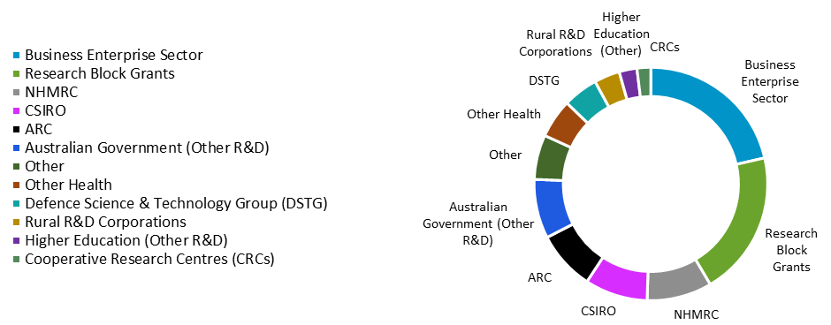

Source: Department of Industry, Science, Energy and Resources, 2019–20 Science, Research and Innovation Budget Tables. *Note: Figures reflect budget estimates for 2019–20. ‘NHMRC’ category combines university, government, MRI, hospital and other spending. ‘Other’ category combines other R&D, energy and the environment, rest of the world, other rural R&D and private non-profit spending. ‘Business Enterprise’ includes R&D tax incentives.*

### R&D expenditure in Australia

The majority of R&D expenditure in Australia—as determined by the location where research occurs, rather than the source of research funding—is currently associated with applied research and experimental development. Substantially lower levels of spending are directed towards pure and strategic basic research.

Figure 50 presents the distribution of Australian R&D expenditure by business, higher education, government and private non-profit stakeholders, according to research activity type. Business appears to be the largest contributor to R&D in Australia, and primarily focuses on experimental development[82] (59.7 per cent of business R&D expenditure) and applied research (31.9 per cent). Higher education institutions represent the next largest location for R&D expenditure. While the largest proportion of higher education R&D expenditure is in applied research (48.4 per cent), pure and strategic basic research represent a much higher proportion (together approximating 40.6 per cent) than in other locations. Indeed, the vast majority (slightly less than 90 per cent) of all expenditure on pure basic research in Australia occurs within higher education institutions. Higher education institutions are also the most significant location for strategic basic research (45.2 per cent of all strategic basic research expenditure), followed by business (27.5 per cent) and government (17.5 per cent). Research conducted within Australian and State and Territory Government contexts tends to prioritise applied and strategic basic research, with significantly lower expenditure overall than business and higher education institutions.

Figure 50: R&D expenditure in Australia by research location and research activity type, 2017–19

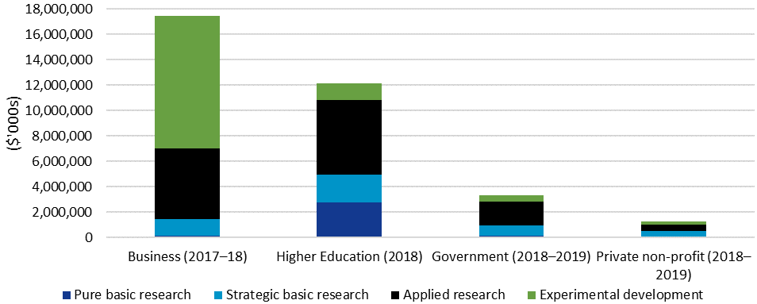

Source: ABS. *Note: Data derived from most recent ABS releases 8104.0, 8109.0 and 8111.0 available. Expenditure data presented on basis of location of research, rather than source of funding. Government category includes Australian, State and Territory Governments. Expenditure data have not been adjusted for inflation.*

Figure 51 presents university expenditure by research activity type from 1992–2018. Expenditure on all four research types has increased substantially over the past three decades; this is unsurprising, given figures have not been adjusted for inflation. However, there are noticeable differences in the rate of increase. Between 1992 and 2018, spending on applied research within universities increased by over a factor of ten—from $514,177,000 to $5,883,779,000. Over the same period, increases in both pure ($675,864,000 to $2,769,006,000) and strategic ($401,524,000 to $2,166,901,000) basic research were comparatively more moderate.

Figure 51: Australian higher education R&D expenditure by research type, 1992–2018

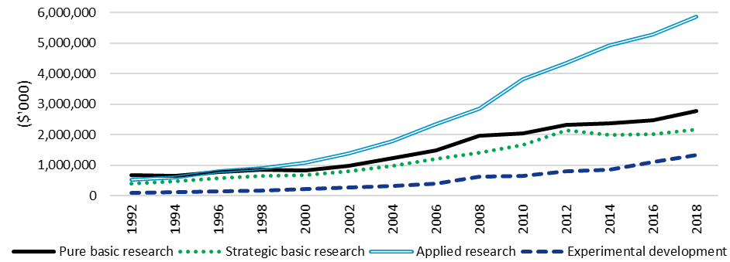

Source: ABS. *Note: Data derived from ABS release 8111.0. Expenditure data presented on basis of location of research, rather than source of funding. Expenditure data have not been adjusted for inflation.*

As shown in Figure 52, relative differences in rates of expenditure growth have had noticeable effects on the longitudinal composition of Australia’s university R&D spending. In 1992, pure and strategic basic research constituted over 60 per cent of all R&D spending within Australian higher education institutions. This figure fell over the past three decades to around 40 per cent in 2018. Over the same time period, spending on applied research increased from 30.3 per cent in 1992 to 48.4 per cent in 2018. These data indicate a proportional redistribution of expenditure away from basic research, and towards applied research, within Australian higher education institutions over the past three decades.

Figure 52: Australian higher education R&D expenditure by research type (proportion of spending), 1992–2018

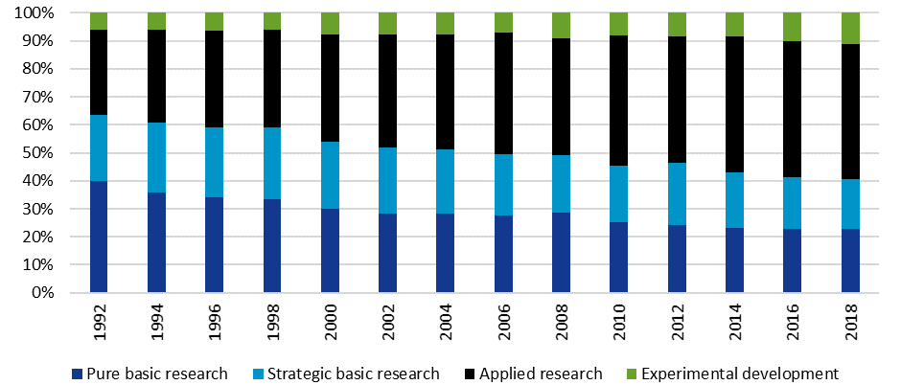

Source: ABS. *Note: Data derived from ABS release 8111.0. Expenditure data presented on basis of location of research, rather than source of funding. Expenditure data presented as a proportion of total higher education expenditure on R&D.*

1. www.abs.gov.au > Statistics > Technology & Innovation > ANZSRC—Research Classifications > Past & Future Releases > Australian and New Zealand Standard Research Classification (ANZSRC) 2008 > [Chapter 2—Types of Activity](https://www.abs.gov.au/AUSSTATS/abs@.nsf/Previousproducts/1297.0Main%20Features42008?opendocument&tabname=Summary&prodno=1297.0&issue=2008&num=&view=).
2. www.abs.gov.au > Statistics > Technology & Innovation > ANZSRC—Research Classifications > Past & Future Releases > Australian and New Zealand Standard Research Classification (ANZSRC) 2008 > [Chapter 2—Types of Activity](https://www.abs.gov.au/AUSSTATS/abs@.nsf/Previousproducts/1297.0Main%20Features42008?opendocument&tabname=Summary&prodno=1297.0&issue=2008&num=&view=).
3. www.abs.gov.au > Statistics > Technology & Innovation > ANZSRC—Research Classifications > Past & Future Releases > Australian and New Zealand Standard Research Classification (ANZSRC) 2008 > [Chapter 2—Types of Activity](https://www.abs.gov.au/AUSSTATS/abs@.nsf/Previousproducts/1297.0Main%20Features42008?opendocument&tabname=Summary&prodno=1297.0&issue=2008&num=&view=).
4. www.abs.gov.au > Statistics > Technology & Innovation > ANZSRC—Research Classifications > Past & Future Releases > Australian and New Zealand Standard Research Classification (ANZSRC) 2008 > [Chapter 2—Types of Activity](https://www.abs.gov.au/AUSSTATS/abs@.nsf/Previousproducts/1297.0Main%20Features42008?opendocument&tabname=Summary&prodno=1297.0&issue=2008&num=&view=).
5. Department of Finance (2017), *Commonwealth Grants Rules and Guidelines 2017*, p. 26, www.finance.gov.au > Government > Grants > Grants Policy Framework > [Commonwealth Grants Rules and Guidelines 2017](https://www.finance.gov.au/sites/default/files/2019-11/commonwealth-grants-rules-and-guidelines.pdf).
6. Department of Finance (2017), *Commonwealth Grants Rules and Guidelines 2017*, pp. 16–19, www.finance.gov.au > Government > Grants > Grants Policy Framework > [Commonwealth Grants Rules and Guidelines 2017](https://www.finance.gov.au/sites/default/files/2019-11/commonwealth-grants-rules-and-guidelines.pdf).
7. Kemp, D (1999), *Knowledge and innovation: a policy statement on research and research training*, Department of Education, Training and Youth Affairs, Canberra, www.voced.edu.au > Browse > Titles > [Knowledge and innovation: a policy statement on research and research training](https://www.voced.edu.au/content/ngv%3A41605).
8. Ibid, p. 12.
9. www.arc.gov.au > Policies & Strategies > Strategy > Evaluation > [ARC Evaluation Strategy](https://www.arc.gov.au/policies-strategies/strategy/evaluation/arc-evaluation-strategy).
10. An Executive Summary of Kantar, Public Division’s findings is presented in Appendix B.
11. One peak body interview was provided in written form.
12. Kemp, *Knowledge and innovation,* p. 12.
13. Ibid, p. 14.
14. Ibid, p. 14.
15. Department of Finance (2017), *Commonwealth Grants Rules and Guidelines 2017*, p. 26, www.finance.gov.au > Government > Grants > Grants Policy Framework > [Commonwealth Grants Rules and Guidelines 2017](https://www.finance.gov.au/sites/default/files/2019-11/commonwealth-grants-rules-and-guidelines.pdf).
16. Australian Research Council (2019), *Discovery Program Grant Guideline Changes 2019*, p. 2, www.grants.gov.au > Forecast Opportunities > DProg2019 > [Discovery Program Grant Guidelines Changes](https://www.grants.gov.au/?event=public.FO.show&FOUUID=9D5A301C-FF9F-8547-E68EF4E82698EFF6).
17. [www.arc.gov.au](http://www.arc.gov.au) > Policies & Strategies > Policy > [ARC Research Opportunity and Performance Evidence (ROPE) Statement](https://www.arc.gov.au/policies-strategies/policy/arc-research-opportunity-and-performance-evidence-rope-statement).
18. McGagh, J et al (2016), *Review of Australia’s Research Training System*, Report for the Australian Council of Learned Academies, p. vii, www.acola.org.au > Publications > Reports > [Research training system review](https://acola.org/research-training-system-review-saf13/).
19. Department of Industry, Innovation and Science (2017), *Australian Innovation System Report*, Canberra, pp. 16–17, www.industry.gov.au > About Us > Our Structure > Australian Innovation System Monitor > [Australian Innovation System Report 2017](https://www.industry.gov.au/data-and-publications/australian-innovation-system-report/australian-innovation-system-report-2017); Bell, J et al (2015), *Translating research for economic and social benefit: Country comparisons*, Report for the Australian Council of Learned Academies, www.acola.org.au > Publications > Reports > [Translating research for economic and social benefit – country comparisons](https://acola.org/research-social-economic-benefit-saf09/).
20. Australian Government (2015), ‘Science and Research Priorities’, www.industry.gov.au > Data and Publications > Science Policy and Engagement > [Science and Research Priorities](https://www.industry.gov.au/data-and-publications/science-and-research-priorities).
21. [www.arc.gov.au](http://www.arc.gov.au) > Policies & Strategies > [ARC Open Access Policy](https://www.arc.gov.au/policies-strategies/policy/arc-open-access-policy#:~:text=The%20ARC%20Open%20Access%20Policy%20applies%20to%20all,not%20include%20research%20data%20and%20research%20data%20outputs.).
22. [www.arc.gov.au](http://www.arc.gov.au) > Policies & Strategies > Policy > [ARC Research Workforce Statement](https://www.arc.gov.au/policies-strategies/strategy/arc-research-workforce-statement).
23. www.arc.gov.au > Policies & Strategies > Policy > [ARC Research Workforce Statement](https://www.arc.gov.au/policies-strategies/strategy/arc-research-workforce-statement).
24. Kemp, *Knowledge and Innovation,* pp. 4–5.
25. There are no eligibility requirements relating to contributions under the Discovery Projects scheme. Data includes Administering Organisations, Other Eligible Organisations and Other Organisations, as defined within the Discovery Program Grant Guidelines.
26. This evaluation employs the ANZSRC codes introduced in 2008. ARC data have not yet been re-categorised using the 2020 ANZSRC. The full list of FoR categories is available at www.abs.gov.au > Statistics > Technology & Innovation > ANZSRC—Research Classifications > Past & Future Releases > Australian and New Zealand Standard Research Classification (ANZSRC) 2008 > [Contents](https://www.abs.gov.au/AUSSTATS/abs@.nsf/Previousproducts/1297.0Contents12008?opendocument&tabname=Summary&prodno=1297.0&issue=2008&num=&view=). Prior to 2011, Research Fields, Courses and Disciplines (RFCD) was used in place of FoR codes for data collection by the ARC. RFCD codes from this period have been converted to corresponding FoR codes.
27. Applications ask researchers to provide up to three 6-digit FoR codes to describe their research. These responses have been rolled up to 2-digit FoR codes within the provided data. Where applications have multiple FoR codes, the primary code is designated according to the highest percentage weighting assigned. If two or more codes have the same weighting, the primary code has been selected randomly.
28. The STEM 2-digit FoRs are: Mathematical Sciences, Physical Sciences, Chemical Sciences, Earth Sciences, Environmental Sciences, Biological Sciences, Agricultural and Veterinary Sciences, Information and Computing Sciences, Engineering, Technology, Medical and Health Sciences and Psychology and Cognitive Sciences. The HASS 2-digit FoRs are: Built Environment and Design, Education, Economics, Commerce, Management, Tourism and Services, Studies in Human Society, Law and Legal Studies, Studies in Creative Arts and Writing, Language, Communication and Culture, History and Archaeology and Philosophy and Religious Studies.
29. The National Health and Medical Research Council (NHMRC) bears primary responsibility for administering grant programs supporting medical research within Australia. The ARC’s approach to medical and health research is outlined within the *ARC Medical Research Policy*, www.arc.gov.au > Policies & Strategies > Policy > [ARC Medical Research Policy](https://www.arc.gov.au/policies-strategies/policy/arc-medical-research-policy/arc-medical-research-policy-version-20181).
30. House of Representatives Standing Committee on Employment, Education and Training (2019), *Australian Government funding arrangements for non-NHMRC research*, Commonwealth of Australia, Canberra, pp. 23–26, www.aph.gov.au > Parliamentary Business > Committees > House Committees > Employment, Education and Training > Completed Inquiries and Reports > 45th Parliament > [Australian Government funding arrangements for non-NHMRC research](https://parlinfo.aph.gov.au/parlInfo/download/committees/reportrep/024212/toc_pdf/AustralianGovernmentFundingArrangementsfornon-NHMRCResearch.pdf;fileType=application%2Fpdf).
31. www.arc.gov.au > Policies & Strategies > Policy > [ARC Statement of Support for Interdisciplinary Research](https://www.arc.gov.au/policies-strategies/policy/arc-statement-support-interdisciplinary-research). Version 1.0 of this statement was released in 2016, followed by Version 1.1 in 2017.
32. Bromham, L et al (2016), ‘Interdisciplinary research has consistently lower funding success’, *Nature* vol. 534: 685–686; Langfeldt, L (2006), ‘The policy challenges of peer review: managing bias, conflict of interests and interdisciplinary assessments’, *Research Evaluation* vol 15, no. 1: 31–41.
33. Data on final report submission timing before July 2015 not available prior to the introduction of RMS 2.0; 2020 has been omitted due to the low number of reports submitted at the time of this report.
34. Due limited data availability, with many projects still ongoing, DP15 and onwards are excluded from this analysis.
35. www.abs.gov.au > Statistics > Technology & Innovation > ANZSRC—Research Classifications > Past & Future Releases > Australian and New Zealand Standard Research Classification (ANZSRC) 2008 > [Chapter 4—Socio-Economic Objectives](https://www.abs.gov.au/AUSSTATS/abs@.nsf/Previousproducts/1297.0Main%20Features62008?opendocument&tabname=Summary&prodno=1297.0&issue=2008&num=&view=).
36. The replacement of the Australian Standard Research Classification (ASRC) with the 2008 ANZSRC to classify ARC research from DP11 onwards introduced updated SEO categories. Sector-level headings generally remained unchanged but referred to ‘Expanding Knowledge’ instead of ‘Non-Oriented Research’. Data from applications initially lodged using ASRC categories have been updated to reflect the 2008 ANZSRC SEO classifications.
37. Where multiple sectors have been assigned the same weighting, the primary sector has been assigned randomly among these.
38. www.abs.gov.au > Statistics > Technology & Innovation > ANZSRC—Research Classifications > Past & Future Releases > Australian and New Zealand Standard Research Classification (ANZSRC) 2008 > [Chapter 4—Socio-Economic Objectives](https://www.abs.gov.au/AUSSTATS/abs@.nsf/Previousproducts/1297.0Main%20Features62008?opendocument&tabname=Summary&prodno=1297.0&issue=2008&num=&view=).
39. All figures relating to named researchers are provided in person participation terms. Researchers appearing on more than one application appear in data multiple times.
40. The terms ‘gender’, ‘female’ and ‘male’ are used in this report to ensure consistency with the terminology used in Discovery Projects application forms and ARC data and systems.
41. Australian Research Council (2019), *Gender and the Research Workforce: Excellence in Research for Australia (ERA) 2018,* Australian Research Council, Canberra,www.arc.gov.au > ERA > [Gender and the Research Workforce Report](https://dataportal.arc.gov.au/ERA/GenderWorkforceReport/2018/). See also Winslow, S and Davis, S (2016), ‘Gender inequality across the academic life course’, *Sociology Compass* vol. 10, no. 5: 404–416; UNESCO Institute for Statistics (2019), *Women in science*, Fact sheet no. 55, www.uis.unesco.org > Science, Technology & Innovation > Women In Science > [Women in Science—2019](http://uis.unesco.org/sites/default/files/documents/fs55-women-in-science-2019-en.pdf).
42. Figures provided in terms of person participations; researchers appearing on more than one application will be counted multiple times.
43. Department of Education, *Selected Higher Education Statistics—Staff 2019, Indigenous Summary*, www.education.gov.au > Higher Education > Higher Education Statistics > Staff Data > Selected Higher Education Statistics—2019 Staff Data > [2019 Staff Indigenous.](https://docs.education.gov.au/node/53178)
44. www.arc.gov.au > Policies & Strategies > Policy > [Statement of Support and Action Plan 2018–19: Aboriginal and Torres Strait Islander Researchers and Research](https://www.arc.gov.au/policies-strategies/policy/aboriginal-and-torres-strait-islander-researchers/arc-statement-support-and-action-plan-2018-2019-aboriginal-and-torres-strait-islander-researchers).
45. Despite the presence of the ARC’s ROPE policy, see p. 21.
46. The potential for ‘risky’ fundamental research proposals to be disadvantaged within publicly funded peer review processes was noted within a 2019 report commissioned by the NHMRC, specifically examining medical research contexts.
47. Department of Education, *2018 Student Summary, Section 2: All Students*, p. 2, www.education.gov.au > Higher Education > Higher Education Statistics > Student Data > Selected Higher Education Statistics—2018 Student Data > [018 Section 2 All students](https://docs.education.gov.au/system/files/doc/other/2018_section_2_-_all_students.pdf).
48. Final report trainee data from DP12 were also available; however, changes to the structure of final report trainee data from DP13 onwards meant these figures were not comparable.
49. It should be noted that changes to the budgets of funded projects are introduced within the context of Selection Advisory Committee processes.
50. Australian Research Council, *Discovery Projects Instructions to Applicants for funding commencing in 2021*, p. 24, www.grants.gov.au > Search > GO3193 > [GO Documents](https://www.grants.gov.au/?event=public.GO.show&GOUUID=A0D8A7AF-F1A8-6E4C-FE02E3BA72011F21&keyword=GO3193).
51. Fellowship recipients from early Discovery Projects funding rounds are incorporated into the Chief Investigator role within the context of ARC data.
52. Current Grant Guidelines state Chief Investigators must generally be employed by an Eligible Organisation on a 0.2 FTE basis as a minimum, or be the holder of an honorary academic appointment.
53. Participating organisations include Administering Organisations, Other Eligible Organisations and Other Organisations, as defined within the Discovery Program Grant Guidelines.
54. Project participation limits apply across the NCGP and differ between schemes and researcher roles. Chief Investigators may participate on two Discovery Program grants at a time, either: on two Discovery Projects grants; or on one Discovery Projects grant and one ARC Award/Fellowship. Centres of Excellence or Special Research Initiative Directors may concurrently participate on only one Discovery Program grant: either as Chief Investigator on one Discovery Projects grant or one ARC Award/Fellowship. See: [www.arc.gov.au](http://www.arc.gov.au) > Grants > Grant Application > [Eligibility Matters](https://www.arc.gov.au/grants/grant-application/eligibility-matters).
55. It should be noted that Eligible Organisations may claim a proportion of ARC grant funding on the basis of their collaborative agreement with Administering Organisations. More information on Research Block Grant allocation methodology is available at: [www.education.gov.au](http://www.education.gov.au) > Higher Education Research > View all Higher Education Research content > Research Block Grants > [Research Block Grants Calculation Methodology](https://www.education.gov.au/research-block-grants-new-arrangements-allocation-calculation-methodology).
56. Kemp, *Knowledge and Innovation*, p. 16.
57. Australian Research Council (2019), *Research Priorities in Australia*, www.arc.gov.au > About > Consultations > Closed Consultations > Implementation of the National Science and Research Priorities under the Australian Research Council’s National Competitive Grants Program > [Research Priorities in Australia](https://www.arc.gov.au/about-arc/consultations/national-science-and-research-priorities-review).
58. Prior to DP21, research priorities were referenced within the ‘Research quality and innovation’ assessment category.
59. As suggested within Discovery Program data generated as part of the 2019 review of the ARC’s implementation of the National Science and Research Priorities, p. 13, www.arc.gov.au > About > Consultations > Implementation of the National Science and Research Priorities under the Australian Research Council’s National Competitive Grants Program > [ARC Statistics—National Science and Research Priorities](https://www.arc.gov.au/about-arc/consultations/national-science-and-research-priorities-review).
60. Eighty-eight per cent of respondents selected at least one of the ‘Expanded knowledge base’ or ‘Expanded research capacity’ categories.
61. www.arc.gov.au > Policies & Strategies > Policy > [ARC Open Access Policy](https://www.arc.gov.au/policies-strategies/policy/arc-open-access-policy#:~:text=The%20ARC%20Open%20Access%20Policy%20applies%20to%20all,not%20include%20research%20data%20and%20research%20data%20outputs.).
62. Holden, L et al (2012), ‘Validation of the research capacity and culture (RCC) tool: Measuring RCC at individual, team and organisation levels’, *Australian Journal of Primary Health* vol 18, no. 1, pp. 62–67.
63. [www.arc.gov.au](http://www.arc.gov.au) > Policies & Strategies > Policy > [ARC Research Opportunity and Performance Evidence (ROPE) Statement](https://www.arc.gov.au/policies-strategies/policy/arc-research-opportunity-and-performance-evidence-rope-statement).
64. Final reports have not been submitted for all projects, researchers may not identify every relevant output, and outputs may be developed and/or published after final report submission.
65. Australian Research Council (2019), *State of Australian University Research 2018–19: ERA National Report,* Australian Research Council, Canberra,www.arc.gov.au > ERA > [ERA 2018 National Report](https://dataportal.arc.gov.au/ERA/NationalReport/2018/).
66. For more information on HERDC’s methodology, see www.education.gov.au > Higher Education Research > Research Block Grants > [Higher Education Research Data Collection (HERDC)](https://www.education.gov.au/higher-education-research-data-collection-herdc).
67. Data relate to approved final reports submitted between 23 November 2017 and 26 February 2020.
68. Given this intended outcome’s focus on growing research capacity in Australia, Partner Investigators, who are primarily international researchers within Discovery Projects, have been excluded from the data presented in this section.
69. In terms of determining eligibility for funding opportunities, time frames associated with Early or Mid-Career Researcher status may be extended, as outlined within the *ARC Policy Statement: Eligibility and Career Interruptions*, www.arc.gov.au > Policies & Strategies > Policy > [ARC Policy Statement: Eligibility and Career Interruptions](https://www.arc.gov.au/policies-strategies/policy/arc-policy-statement-eligibility-and-career-interruptions).
70. Department of Education, *Award course completions time series*, p. 2, www.education.gov.au > Higher Education > Higher Education Statistics > Student Data > Selected Higher Education Statistics—2018 Student Data > [Award course completions time series](https://www.education.gov.au/selected-higher-education-statistics-2018-student-data).
71. Final reports have not been submitted for all funded projects.
72. This question was selected for coding during the survey design stage. Coding was undertaken as part of the survey services provided by Kantar, Public Division.
73. Department of Health and Ageing (2012), *Evaluation of the mental health nurse incentive program*, www1.health.gov.au > For Consumers > Education and Prevention > Mental Health > Publications > Evaluation of the mental health nurse incentive program > Part B Evaluation Findings > [4.1 Assessment Scope](https://www1.health.gov.au/internet/publications/publishing.nsf/Content/mental-pubs-e-evalnurs-toc~mental-pubs-e-evalnurs-b~mental-pubs-e-evalnurs-b-4~mental-pubs-e-evalnurs-b-4-1).
74. 39 per cent of survey participants stated they engaged in a combination of both basic and applied approaches.
75. Australian Government (2015), ‘Fact Sheet—Science and Research Priorities’, p. 1, www.industry.gov.au > Data and Publications > Science Policy and Engagement > Science and Research Priorities > [Fact Sheet](https://www.industry.gov.au/sites/default/files/2018-10/science_and_research_priorities_2015.pdf?acsf_files_redirect).
76. Australian Government (2015), ‘Fact Sheet—Science and Research Priorities’, p. 1, www.industry.gov.au > Data and Publications > Science Policy and Engagement > Science and Research Priorities > [Fact Sheet](https://www.industry.gov.au/sites/default/files/2018-10/science_and_research_priorities_2015.pdf?acsf_files_redirect).
77. Leitner, K et al. (2011), *Analysis of the evolution of the costs of research—trends, drivers and impacts*, European Techno-Economic Policy Support Network.
78. House of Representatives Standing Committee on Employment, Education and Training (2019), *Australian Government funding arrangements for non-NHMRC research*, Commonwealth of Australia, pp. 23–26, www.aph.gov.au > Parliamentary Business > Committees > House Committees > Employment, Education and Training > Completed Inquiries and Reports > 45th Parliament > [Australian Government funding arrangements for non-NHMRC research](https://parlinfo.aph.gov.au/parlInfo/download/committees/reportrep/024212/toc_pdf/AustralianGovernmentFundingArrangementsfornon-NHMRCResearch.pdf;fileType=application%2Fpdf).
79. Department of Finance (2017), *Commonwealth Grants Rules and Guidelines 2017*, p. 27, www.finance.gov.au > Government > Grants > Grants Policy Framework > [Commonwealth Grants Rules and Guidelines 2017](https://www.finance.gov.au/sites/default/files/2019-11/commonwealth-grants-rules-and-guidelines.pdf).
80. Particularly the Australian Research Fellowships, Queen Elizabeth II Fellowships and Australian Professorial Fellowships, see p. 17)
81. R&D is defined as comprising ‘creative and systematic work undertaken in order to increase stock of knowledge—including knowledge of humankind, culture and society—and to devise new applications of knowledge’ and ‘covers three types of activity: basic research, applied research and experimental development’, Department of Industry, Science, Energy and Resources (2020), 2019–20 Science, Research and Innovation Budget Tables, www.industry.gov.au > Data and Publications > Research and Development (R&D) > [Science, Research and Innovation (SRI) Budget Tables](https://www.industry.gov.au/data-and-publications/science-research-and-innovation-sri-budget-tables).
82. The Australian and New Zealand Standard Research Classification (ANZSRC) defines experimental development as ‘systematic work, using existing knowledge gained from research or practical experience, which is directed to producing new materials, products, devices, policies, behaviours or outlooks; to installing new processes, systems and services; or to improving substantially those already produced or installed’, www.abs.gov.au > Statistics > Technology & Innovation > ANZSRC - Research Classifications > Past & Future Releases > Australian and New Zealand Standard Research Classification (ANZSRC) 2008 > [Chapter 2—Types of Activity](https://www.abs.gov.au/Ausstats/abs@.nsf/Previousproducts/1297.0Main%20Features42008?opendocument&tabname=Summary&prodno=1297.0&issue=2008&num=&view=).