

Evaluation of the Industrial Transformation Research Program process and priorities

Final report

Australian Research Council

Program Evaluation Section

June 2019

**Contents**

Abbreviations and glossary 3

Structure of this report 3

Executive summary 4

Background 5

The Industrial Transformation Research Program 5

Evaluation overview 6

Authorisation and management 6

Reasons for the evaluation 6

Purpose and scope 6

Terms of reference 7

Evaluation questions 7

Methodology 8

Key findings 10

ITRP objectives 10

ITRP support for industry focused research collaboration 10

ITRP support for industry focused research training 11

Engagement with Industry Growth Centres 11

ITRP fit with other Australian Government programs 11

ARC implementation of the ITRP process 12

Recommendations 12

Recommendation 1: Industrial Transformation Priorities 12

Recommendation 2: Information on HDR students and PDRs 13

Recommendation 3: Data and monitoring 13

Recommendation 4: Engagement, advice and outreach 13

APPENDIX 1: Analysis of ARC data and information 15

ITRP support for industry focused research collaboration 15

ITRP support for industry focused research training 20

Engagement with Industry Growth Centres 21

ITRP fit with other Australian Government programs 22

APPENDIX 2: Survey and interview findings report (ARTD Consultants) 27

# Abbreviations and glossary

| ARC | Australian Research Council |
| --- | --- |
| CEO | Chief Executive Officer |
| CI | Chief Investigator |
| CRC | Cooperative Research Centres |
| CRC-P | Cooperative Research Centres Projects |
| DIIS | Department of Industry, Innovation and Science |
| HDR | Higher degree by research |
| IGC / Growth Centres | Industry Growth Centres |
| ITRH / Research Hubs | Industrial Transformation Research Hubs |
| ITRP | Industrial Transformation Research Program |
| ITTC / Training Centres | Industrial Transformation Training Centres |
| NISA | National Innovation and Science Agenda |
| PDR | Postdoctoral researcher |
| PI | Partner Investigator |
| Return rate | The amount of ARC funding awarded as a percentage of funding requested in successful applications |
| RMS | Research Management System |
| Success rate | The number of funded projects as a percentage of applications submitted |

# Structure of this report

This report on the evaluation of the Industrial Transformation Research Program (ITRP) process and priorities is structured as follows:

* The main body provides information on the evaluation’s background, purpose, terms of reference, evaluation questions and methodology. It also presents the evaluation’s key findings and recommendations, informed by the analysis in Appendices 1 and 2.
* Appendix 1 presents analysis of ARC documents, data and information on the ITRP undertaken by the ARC Program Evaluation section.
* Appendix 2 presents analysis of ITRP stakeholder surveys and interviews undertaken by ARTD Consultants Pty Ltd.

# Executive summary

The Australian Research Council (ARC) Industrial Transformation Research Program (ITRP) supports collaboration between university researchers and industry to find solutions to industry problems and transform Australian industries. The ITRP consists of Industrial Transformation Research Hubs—supporting collaborative research that benefits industry partners—and Industrial Transformation Training Centres—supporting industry focused training for higher degree by research (HDR) students and postdoctoral researchers (PDR). It supports research in key growth areas (Industrial Transformation Priorities), which are consistent with the Government’s Industry Growth Centres initiative.

The ARC undertook an evaluation to assess the effectiveness and efficiency of ITRP processes and priorities in supporting industry focused research and research training, and its role and contribution among other relevant Australian Government programs. The evaluation focused primarily on the design, implementation and administration of the ITRP. It did not focus on the outcomes and benefits of funded research or research training. The evaluation drew upon ARC policy and program documents, data and information, as well as independent stakeholder survey and interview research conducted by ARTD Consultants Pty Ltd.

The evaluation found that, in general, ITRP stakeholders consider the scheme to be effective in supporting high quality, industry focused research collaboration and integrated research training. The ITRP has attracted the participation of increasing numbers of partner organisations over time, although different stakeholder groups had different perceptions of the nature of partner organisation involvement in various ITRP processes.

Stakeholders predominantly felt that the ITRP supports research training that is of high academic quality and applicable to industry skills. However, the evaluation found that ARC data collection processes do not currently support accurate reporting and monitoring of HDR and PDR training delivery under the ITRP.

Although stakeholders saw benefits in the scheme’s interaction with Industry Growth Centres, some expressed uncertainty about the Growth Centres’ role. Additionally, while most felt that the Industrial Transformation Priorities effectively focus research in key areas, some stakeholders perceived them to have gaps or be narrow. More broadly, the ITRP was generally considered to be unique, even though a majority of stakeholders perceived overlaps with other Australian Government programs.

Most stakeholders considered the ITRP process overall to be effective and efficient. Challenges they identified included negotiating and finalising partnership arrangements, application size and timeframes, and domestic student recruitment.

The evaluation makes four recommendations to the ARC to improve the effectiveness and efficiency of its implementation of the ITRP:

1. Consider revisions to improve the flexibility and clarity of the ITRP process with respect to the Industrial Transformation Priorities and the role of Industry Growth Centres
2. Collect additional data on HDR students and PDRs through Training Centre and Research Hub final reports
3. Consider using the metrics provided in this evaluation’s analysis as benchmarks to monitor performance of the ITRP and inform improvements
4. Address issues highlighted in this evaluation in ongoing ITRP stakeholder engagement, advice and outreach.

# Background

## The Industrial Transformation Research Program

The Industrial Transformation Research Program (ITRP)[1] supports collaboration between university researchers and industry to find solutions to industry problems and develop new products, processes and services to transform Australian industries. The ITRP consists of Industrial Transformation Research Hubs (ITRH, or Research Hubs)—providing funding for collaborative research that benefits industry partners—and Industrial Transformation Training Centres (ITTC, or Training Centres)—supporting partnerships to provide innovative higher degree by research and postdoctoral training for end-user focused research in industries vital to Australia’s future. ITRP funding is provided for research in key growth areas (Industrial Transformation Priorities), which are consistent with the Government’s Industry Growth Centres initiative.[2]

The Research Hub objectives are to:

* encourage collaborative R&D projects between universities and organisations outside the Australian higher education sector that will engage in cutting-edge research on new technologies to create economic, commercial and social transformation;
* leverage national and international investment in targeted industry sectors, including from industry and other research end-users; and
* drive growth, productivity and competitiveness within the Industrial Transformation Priorities.

The Training Centre objectives are to:

* support opportunities for HDR candidates and postdoctoral researchers to pursue industrial training;
* drive growth, productivity and competitiveness by linking to the relevant sectors;
* enhance competitive research collaboration between universities and organisations outside the Australian higher education sector; and
* strengthen the capabilities of industry and research end-users in identified Industrial Transformation Priority areas.[3]

The Industrial Transformation Training Priorities are subject to review from round to round, but have been aligned with the priority areas for the Industry Growth Centres initiative since its introduction in 2015. The current Industrial Transformation Priorities are:

* Advanced Manufacturing
* Cyber Security
* Food and Agribusiness
* Medical Technologies and Pharmaceuticals
* Mining Equipment, Technology and Services
* Oil, Gas and Energy Resources.

# Evaluation overview

## Authorisation and management

This evaluation was authorised and undertaken in accordance with the ARC Evaluation Strategy and Strategic Evaluation Plan.[4]

The evaluation was managed and conducted by the ARC Program Evaluation Section, which sits within the Corporate Services Branch and is independent from policy and program functions within the ARC organisational structure.

The Program Evaluation Section consulted with relevant ARC line areas to identify the priorities and issues addressed in the evaluation, seek advice on policy and program matters, and access policy and program data, documents and information.

The Program Evaluation Section engaged ARTD Consultants to conduct independent survey and interview research with external and internal stakeholders as an input to the evaluation. ARTD Consultants’ stakeholder engagement services were procured under the whole-of-government Research, Evaluation and Data panel arrangement, administered by the Department of Social Services.

## Reasons for the evaluation

Since its introduction in 2012, the ITRP has not been formally evaluated. This evaluation was therefore undertaken to assess the ITRP’s effectiveness in supporting research collaboration, translation and commercialisation—particularly to address industry issues—and its alignment with government innovation priorities. In that context, there is a need to assess the efficiency and effectiveness of the administration of the ITRP in supporting potentially complex collaborative research and research training arrangements. It is also important to assess the ITRP’s role and contribution to supporting industry focused research along with other programs such as Industry Growth Centres, Cooperative Research Centres (CRC), Cooperative Research Centres Projects (CRC-P) and the Global Innovation Linkages Program.

## Purpose and scope

The purpose of the evaluation was to provide evidence, and asses the effectiveness and efficiency of ITRP processes in meeting their objectives and supporting government priorities. The evaluation focused primarily on the design, implementation and administration of the ITRP. The evaluation’s scope included all ITRP activity since its introduction in 2012.

The evaluation did not focus on the outcomes of funded research or assess the effectiveness of the ITRP in supporting research that solves challenging industry issues, and driving growth, productivity and competitiveness. As the activities of the majority of funded Research Hubs and Training Centres are still underway, it was too early to assess the outcomes arising from completed research and research training under the ITRP.

The primary intended use of the evaluation is to inform whether any changes or improvements should be made to the implementation of ITRP processes and priorities by the ARC. The evaluation’s findings may also be useful for informing the university research sector (including researchers and research trainees), industry and other ITRP partner organisations about issues relevant to developing collaboration and applications under the ITRP, as well as establishing Research Hubs and Training Centres.

## Terms of reference

The evaluation’s terms of reference were to:

1. Assess the effectiveness and efficiency of ITRP scheme design, processes and administration in meeting the objectives of supporting industry focused collaborative research (through ITRH) and higher degree by research and postdoctoral training (through ITTC), as well as addressing issues involved in the management of potentially complex collaborative projects.
2. Assess the role and contribution of the ITRP in the broader context of Australian Government programs that support industry focused research, including its potential complementarity and overlaps with Industry Growth Centres, CRC, CRC-P and the Global Innovation Linkages Program.

## Evaluation questions

To address the terms of reference, the evaluation sought to answer the following questions:

1. Does the ITRP effectively support industry focused research collaboration?
   1. How many partner organisations have been involved?
   2. What types of partner organisations have been involved?
   3. How many collaborations were new and how many already existed?
   4. How much and what kind of contributions (cash/in kind) have partner organisations provided? What is the impact of different types of contributions on successful collaboration?
   5. How have partner organisations been involved in the development of ITRP applications and the design of programs and projects? Is expertise related to research translation and commercialisation typically included in program and project design?
2. Does the ITRP effectively support industry focused research training?
   1. How many higher degree by research (HDR) students and postdoctoral researchers (PDR) have been involved?
   2. What roles have HDR students and PDRs played in ITRP projects? What types of industry placements have they had?
   3. Why do HDR students and PDRs choose to be involved in the ITRP (as opposed to other opportunities for industry experience)?
   4. How have partner organisations been involved in the development and design of ITRP placements?
3. How effective is engagement with Industry Growth Centres as part of ITRP processes?
   1. How useful and important is the advice provided by Growth Centres to universities, researchers and partner organisations?
   2. Does it support opportunities for collaboration that may not otherwise occur, or that add to existing collaboration? What do these opportunities add?
   3. Does it support innovative research and the development of well targeted, industry focused projects?
   4. Does engagement with Growth Centres extend beyond the proposal stage? If so, in what form?
4. How well does the ITRP fit with other Australian Government programs that support industry focused research and innovation, including Growth Centres, CRC, CRC-P and the Global Innovation Linkages Program?
   1. Why do administering organisations and their partners seek support under the ITRP rather than other industry focused research schemes? Do they submit applications to multiple schemes?
   2. Do the Industrial Transformation Priorities (which match the areas of focus for the Growth Centres) effectively focus applications on key industry priority areas?
   3. Are there potential overlaps or inconsistencies between the ITRP and other industry focused research schemes?
5. How effective and efficient is the implementation of the ITRP process, and the associated advice provided by the ARC to ITRP applicants and other stakeholders, including in relation to:
   1. Establishing collaboration (for example, through project development, negotiation, and planning)
   2. Application and assessment processes
   3. Project implementation issues (for example, establishment, contracts, recruitment, intellectual property and commercialisation arrangements)?

## Methodology

The evaluation questions were addressed through analysis of the following sources of data and information:

* ARC policy and program documents, and quantitative and qualitative ARC program management data and information
* qualitative and quantitative stakeholder feedback collected through surveys and interviews conducted by ARTD Consultants.

### ARC policy and program documents, data and information

A range of ARC policy and program information and materials were used to inform the development of the evaluation and the analysis presented in this report. These included publicly available sources such as the ARC ITRP webpage,[5] grant guidelines and funding rules,[6] as well as internal policy and program management documents such as scheme timelines, stakeholder engagement materials (such as presentations), ITRH and ITTC progress and final reports, reports from ad hoc ITRH and ITTC reviews conducted by the ARC, and previous stakeholder feedback.

Program management data on the ITRP were sourced from the ARC’s Research Management System (RMS), and included application, outcome, funding, partner organisation and other data. Advice on interpretation, complexities and caveats associated with the data was provided by relevant policy and program owners and administrators within the ARC.

Detail on the analysis of ARC documents, data and information on the ITRP is provided in Appendix 1.

### Stakeholder surveys and interviews

The stakeholder engagement undertaken by ARTD Consultants included delivery of surveys and interviews, collection and analysis of quantitative and qualitative response data, and reporting to the ARC.

Surveys were tailored and delivered to the following ITRP stakeholder groups:

* research offices at universities involved with successful applications for ITRP funding
* Research Hub and Training Centre directors and managers involved with successful applications for ITRP funding
* Chief Investigators (CIs) involved with successful applications for ITRP funding
* Partner Investigators (PIs) involved with successful applications for ITRP funding
* higher degree by research (HDR) students and postdoctoral researchers (PDRs) who had undertaken research training within a Research Hub or Training Centre
* Industry Growth Centre representatives.

A total of 33 interviews were also held with members of the following ITRP stakeholder groups:

* university research office representatives (seven)
* Research Hub and Training Centre directors and managers (20 interviews representing ten Research Hubs and ten Training Centres)
* ARC representatives (two)
* Department of Industry, Innovation and Science (DIIS) representatives (two).

It is important to note that only research offices, directors, managers, CIs and PIs involved with successful ITRP applications were included in the surveys and interviews (although some of these stakeholders had also been involved in unsuccessful applications). This was largely due to the better availability of current contact details for successful stakeholders. This represents a limitation in the evaluation’s methodology, as stakeholders who had not been involved in successful applications may have provided very different responses.

Contact details for all stakeholder groups were provided confidentially to ARTD Consultants by the ARC. ARTD Consultants de-identified all survey and interview responses and destroyed all stakeholders’ contact details upon completion of the services.

Detail on the survey and interview methodology, analysis of the responses and the key findings identified by ARTD Consultants are provided in their final report to the ARC, in Appendix 2.

# Key findings

These findings are drawn from analysis of ARC documents, data and information on the ITRP (Appendix 1) and stakeholder survey and interview research conducted by ARTD Consultants (Appendix 2).

## ITRP objectives

1. In general, stakeholders agreed that the ITRP both fosters important research partnerships and supports research trainees to gain skills in industry priority areas.

## ITRP support for industry focused research collaboration

1. Overall, university and partner organisation stakeholders felt that the ITRP effectively supports industry focused research collaboration.
   * Perceived strengths included providing industry with access to research expertise and providing researchers with advice on industry needs.
   * Stakeholders generally felt that the ITRP supports high quality, reliable partnerships.
2. The number of partner organisations involved in funded Research Hubs and Training Centres has increased over time, indicating that the ITRP’s effectiveness in supporting collaboration may have improved as it has matured.
   * The average number of partner organisations has grown from 3.25 to 11 per Research Hub, and from 4.75 to 11.86 per Training Centre.
3. Consistent with the ITRP’s focus on industry issues, 75 per cent of all partner organisations have been from industry and business. The ITTC has had a slightly more diverse mix of partner organisation types than the ITRH.
4. International partner organisations have accounted for 16.4 per cent of all partner organisations in both Research Hubs and Training Centres.
5. In line with the different requirements of the ITRH and ITTC:
   * combined cash and in kind contributions from partner organisations have amounted to 154 per cent of the total funding requested from the ARC in successful ITRH applications and 92 per cent in successful ITTC applications
   * ITTC partner organisations’ average in kind contributions have been consistently higher in value than their cash contributions, while ITRH partner organisations’ cash and in kind contributions have tended to be more even.
6. Stakeholders reported that collaboration under the ITRP has most commonly been initiated through existing relationships. They also indicated that new collaborations were more common in Training Centres than in Research Hubs.
7. Stakeholder groups had differing perceptions of the ways partner organisations were involved in the development of ITRP applications.
   * 85 per cent of university stakeholders and only 60 per cent of PIs reported that partners were consulted in the development of the entire Research Hub or Training Centre research program.
   * 71 per cent of university stakeholders and only 30 per cent of PIs reported that partners were involved in consulting with Industry Growth Centres.
8. Half of director, manager and CI participants reported partner organisations dropping out during the life of the Research Hub or Training Centre.

## ITRP support for industry focused research training

1. Stakeholders predominantly felt that the ITRP performs well in supporting integrated research training that is of high academic quality and relevance, and is applicable to industry skills.
2. Current ARC data collection processes do not support accurate reporting on the total number of HDR students and PDRs involved over the life of each Research Hub and Training Centre.
   * Changes to ITRP reporting processes would support improved monitoring and evaluation of ITRP support for industry focused research training.
   * Further survey research with HDR students and PDRs in future may help the ARC to better understand employment and other outcomes for ITRP research trainees.
3. Many university and partner organisation stakeholders noted that recruitment of HDR students and PDRs was a challenge.
4. HDR students and PDRs expressed the view that more, higher quality research training opportunities through industry placements and skills development courses were required.
5. Stakeholder groups had differing perceptions of partner organisation involvement in the development of research training programs, with 85 per cent of university stakeholders and only 64 per cent of PIs reporting that partners were involved.

## Engagement with Industry Growth Centres

1. The benefits of Growth Centre engagement that stakeholders cited most commonly were identifying and enabling partnerships, support in the application and program design process, and the provision of market advice.
2. PIs felt Growth Centres were more useful for identifying university partners than university stakeholders felt they were for identifying industry partners.
3. While most stakeholders found Growth Centres easy to reach and responsive, some reported difficulties in contacting and engaging with them.
4. Stakeholders expressed some uncertainty and a need for greater clarity about the Growth Centres’ role in ITRP application and assessment processes.
   * The ARC has provided additional advice in the latest ITRP grant guidelines, but further stakeholder engagement on this issue may be valuable.
5. The majority of stakeholders reported that engagement with Growth Centres had extended beyond the Research Hub or Training Centre program development phase.
6. Growth Centre stakeholders felt that interaction between the ITRP and the Growth Centres supports both programs in achieving their objectives.

## ITRP fit with other Australian Government programs

1. Stakeholders generally perceived the ITRP to be unique in its support for integrated collaborative research and research training, and the scale of research collaboration supported. They perceived it to effectively complement other Australian Government programs.
2. Stakeholders had mixed views on whether the ITRP overlaps with other Australian Government programs, with just over half (54 per cent) agreeing that to some extent it does. The research did not clearly identify the nature of the perceived overlaps or test whether they exist.
3. Stakeholders generally felt that the Industrial Transformation Priorities (which align with the Industry Growth Centre priority areas) effectively focus applications on key industry priority areas, although some perceived them to have gaps or to be narrow.
   * It may be possible to revise elements of the ITRP’s design and guidelines to allow more flexibility in the Industrial Transformation Priorities and to clarify the Growth Centres’ role in the process.

## ARC implementation of the ITRP process

1. Overall, most stakeholders considered the ITRP process to be effective and efficient.
2. Stakeholders were mostly positive about the usefulness of the ARC’s advice and information at various stages of the ITRP process. However, some sources (for example, grant guidelines and associated documents) were clearly seen as more useful than others (ARC feedback on progress and final reports).
3. As identified by stakeholders:
   * challenging aspects of the application process included negotiation of partnership, intellectual property and commercialisation arrangements, the timeframes for the application process and the size of applications
   * challenging aspects of the establishment process included domestic student recruitment, along with negotiating, finalising and managing partnership, intellectual property and commercialisation arrangements.

# Recommendations

## Recommendation 1: Industrial Transformation Priorities

The ARC should **consider revisions to improve the flexibility and clarity of the ITRP process with respect to the Industrial Transformation Priorities and the role of Industry Growth Centres**.

Such revisions should seek to address stakeholder perceptions that the Industrial Transformation Priorities are narrow (finding 23), that the Industry Growth Centres’ role in the ITRP process is unclear (finding 18), and some reported difficulties in engagement with the Growth Centres (finding 17). They may include the following elements:

1. In the ITRP grant guidelines, retain the requirement for applications to address one or more of the Industrial Transformation Priorities.
2. Continue to include all Industry Growth Centre priority areas in the Industrial Transformation Priorities, but also consider the inclusion of additional priorities for each round—in consultation with appropriate stakeholders, including relevant ministers and DIIS.
3. Amend the ITRP guidelines to *require* applicants to engage with relevant industry experts (such as, but not exclusively, Growth Centres) to ensure the proposed research is targeted to support growth in the relevant Industrial Transformation Priority areas.
4. Amend the ITRH and ITTC assessment criteria to require applicants to describe the ways in which engagement with industry experts (such as, but not exclusively, Growth Centres) has ensured that the proposed research is targeted to support growth in the relevant Industrial Transformation Priority areas.
5. Ensure that industry expertise on ITRP Selection Advisory Committees covers any additional priority areas identified for each round.

The ARC should continue to work closely with DIIS and the Growth Centres in relation to their interaction with the ITRP and continue to emphasise the value of engagement with the Growth Centres in its ITRP advice and outreach activities.

## Recommendation 2: Information on HDR students and PDRs

The ARC should **collect additional data on HDR students and PDRs through Training Centre and Research Hub final reports**.

To support improved monitoring and evaluation of ITRP support for industry focused research training, this should include data on the total number of HDR students and PDRs who participated over the life of the Training Centre or Research Hub, the nature of their involvement, whether they completed their training, and whether they were supported by ARC funding, partner organisation contributions, or other sources.

In addition, the ARC may wish to consider undertaking further survey research with HDR students and PDRs in future to better understand employment outcomes for ITRP research trainees (finding 11).

## Recommendation 3: Data and monitoring

The ARC should **consider using the metrics provided in this evaluation’s analysis as benchmarks to monitor performance of the ITRP and inform improvements**.

Useful metrics from existing ARC data collections may include:

* number of partner organisations involved in funded projects (finding 3)
* types of partner organisations involved in funded projects (finding 4)
* international partner organisations involved in funded projects (finding 5)
* value of partner organisation cash and in kind contributions (finding 6).

## Recommendation 4: Engagement, advice and outreach

The ARC should **address issues highlighted in this evaluation in ongoing ITRP stakeholder engagement, advice and outreach**.

In particular, the evaluation’s findings can help to inform the ARC’s advice to stakeholders in particular areas, such as:

* finding the right partners, including the importance of managing expectations and the dimensions of collaboration involved under the ITRP (findings 8, 14)
* the views of HDR students and PDRs in relation to research training (finding 13)
* addressing key challenges in the ITRP application and establishment processes (findings 12 and 26).

In addition, there may be opportunities for the ARC to use regular and ongoing engagement mechanisms to seek further information and feedback from stakeholders on issues raised in this evaluation, such as:

* the initiation of collaboration under the ITRP (finding 7)
* issues in the retention of partner organisations (finding 9)
* the usefulness of ARC advice and information (including, for example, in relation to the role of Growth Centres in the process) (finding 18).

# APPENDIX 1: Analysis of ARC data and information

This appendix provides analysis of ARC documents, data and information on ITRP processes and priorities. It addresses a number of particular issues raised in the evaluation questions, but does not comprehensively address all of the evaluation questions. It is intended to complement—and should be read in conjunction with—the survey and interview findings report by ARTD Consultants, in Appendix 2.

The analysis presented here includes application, outcome, funding, partner organisation and other data from all ITRP rounds from the commencement of the scheme in 2012 to the most recently completed round in 2018. The 2019 round was underway but had not been completed at the time of this report’s preparation. Data from that round has therefore not been included, but the analysis does include reference to key program documents for that round as they are the most recent available.

The analysis involves data for both ITRP schemes (ITRH and ITTC), with ITRH rounds signified by an ‘H’ (for example, 2018 H) and ITTC rounds signified by a ‘C’ (for example, 2018 C). Further, two ITRH rounds were conducted for 2013, and are identified in the analysis as 2013 H1 and 2013 H2.

## ITRP support for industry focused research collaboration

### Applications and funding

Among ARC schemes, the ITRP provides relatively large scale support to a small number of projects. A total of 30 Research Hubs and 38 Training Centres have been funded under the ITRP since its inception.

As shown in Figure 1, the number of ITRP applications submitted has fluctuated between relatively small values, particularly in the ITRH. While ITRH applications peaked at 15 in the 2013 (round 2) and 2014 rounds, the number of ITTC applications has generally increased over time, with clearly more submitted in the 2016, 2017 and 2018 rounds (27, 26 and 28 applications, respectively).

Similarly, the number of funded projects has also fluctuated, with the ITRH peaking at seven projects in its second 2013 round and the ITTC reaching a peak of nine projects in its 2017 round. Success rates (the number of funded projects as a percentage of applications submitted) have also varied, ranging from 33 per cent (in 2012) to 60 per cent (in 2017) for the ITRH, and from 22 per cent (in 2016) to 54 per cent (in 2014) for the ITTC.

#### Figure 1: ITRP applications and success rates

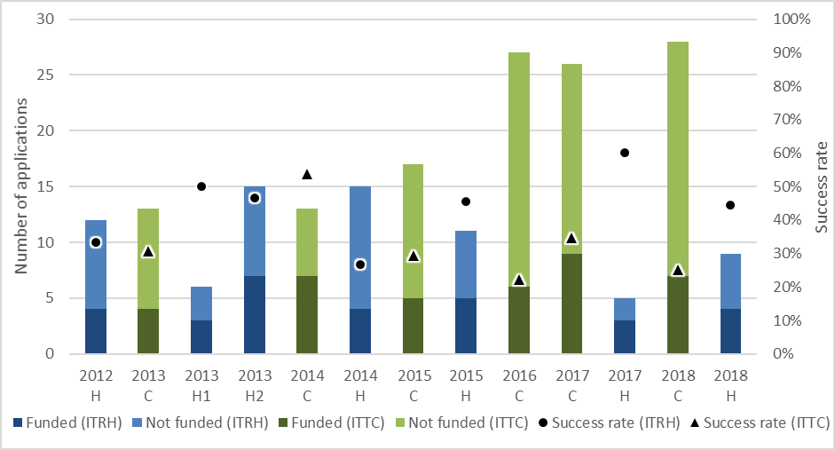Source: ARC data.

The total funding awarded in each ITRP round and the average funding awarded to each project have also fluctuated somewhat, as shown in Figure 2. For the ITRH, the pattern of total funding levels appears to broadly align with the number of funded projects, except in the 2014 round, when the average funding per project peaked at $4,670,467—over $1 million more than the average in every other ITRH round except 2018 ($4,492,975). Total ITTC funding increased in each round to 2017, when it jumped sharply to reach nearly $37 million, before dropping to its second highest total of just under $29 million in 2018. In line with changes in the ITTC funding rules, the average ITTC funding per project was notably lower in the 2013 and 2014 rounds (when the funding period was three years) than in the 2015-2018 rounds (when the funding period was four to five years).

#### Figure 2: Total and average funding awarded

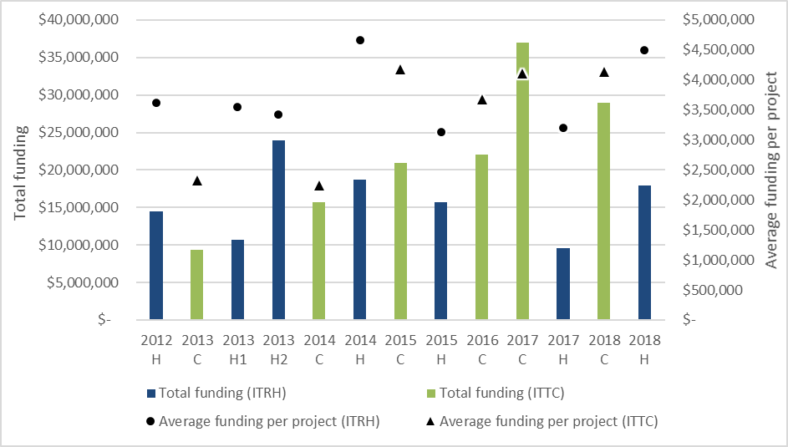Source: ARC data.

Given the relatively small numbers of ITRP applications and funded projects overall, it is difficult to identify many significant trends in these data. Furthermore, the focus, characteristics and operation of different Research Hubs and Training Centres vary greatly, creating additional challenges in attempting to draw clear conclusions from the data alone.

### Number of partner organisations

The ITRP is designed to support collaboration between university researchers and industry and other research end users. As shown in Figure 3, the number of partner organisations involved in funded projects has increased over time at both the scheme round and project (i.e. Research Hub or Training Centre) levels, which may indicate that the ITRP’s effectiveness in supporting collaboration has improved as it has matured—though not always consistently.

The number of ITRH partner organisations grew from 13 in the 2012 round to 44 in the 2018 round, and the ITTC saw an increase from 19 in the 2013 round to 83 in both 2017 and 2018, when it attracted considerably more partner organisations than the ITRH.

The average number of partner organisations per Research Hub grew from 3.25 in the 2012 round to 11 in 2018, although this was interrupted by declines in 2013 round 2 and 2014. The average per Training Centre grew steadily from 4.75 in 2013 to 11.86 in 2018.

#### Figure 3: Partner organisations (funded projects) – total and average per project

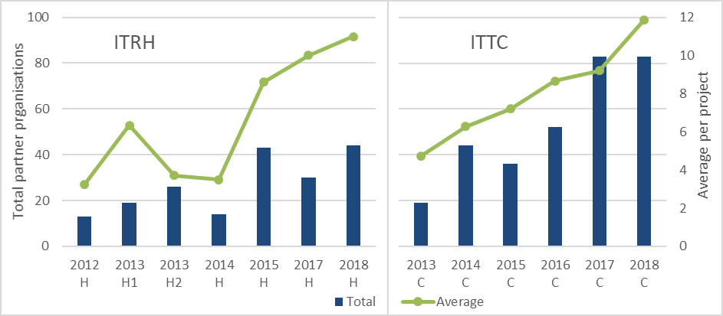Source: ARC data.

### Types of partner organisations

Figure 4 shows the types of partner organisations involved in the ITRP. Consistent with the ITRP’s focus on industry issues, 75 per cent have been from industry and business (identified as ‘Australian Company Industry Body’ and ‘International Company Industry Body’).

The ITTC has attracted a slightly more diverse mix of partner organisation types than the ITRH. In the ITRH, 81 per cent of partner organisations have been from industry and business, and 9 per cent have been government organisations (Commonwealth, State and Local, and International). By contrast, 72 per cent of ITTC partner organisations have been from industry and business, and 15 per cent have been government organisations. In both schemes, around five per cent have been non-profit organisations, and the remainder (‘Higher Education International’ and ‘Other’) have accounted for around 5 per cent of partner organisations in the ITRH and 9 per cent in the ITTC.[7]

#### Figure 4: Partner organisations by type (funded projects)

Figure 4 shows the total number and types of partner organisations involved in funded projects in each ITRH and ITTC round from 2012 to 2018.Source: ARC data.

Over the life of the ITRP to 2018 H and 2018 C, 16.4 per cent of partner organisations on funded projects have been international. The proportion has been the same in both the ITRH and the ITTC. While the total number of international organisations in the ITRH has fluctuated between rounds (from one in 2013 H1 to eight in 2018 H), the total number in the ITTC has increased quite consistently (from one in 2013 C to 20 in 2018 C).[8]

### Partner organisation contributions

Figure 5 shows the total partner organisation cash and in kind contributions for each ITRP round. As with the application and funding data discussed above, it is difficult to draw many clear conclusions from these data as they are based on a small number of considerably different Research Hubs and Training Centres. However, there are clear differences in the nature of the contributions that have been provided over the life of the ITRH (52 per cent cash, 48 per cent in kind) and the ITTC (26 per cent cash, 74 per cent in kind).[9]

These differences reflect distinct requirements of the two schemes. In the ITRH, the combined cash and in kind contributions from partner organisations must match or exceed the funding requested from the ARC. In addition, where any partner organisation has more than 100 employees, the combined partner organisation cash contributions must be at least 75 per cent of the funding requested from the ARC. The ITTC, in contrast, requires that cash and in kind contributions (along with the requested ARC funding) be sufficient to support all research projects described in the application, particularly those of HDRs and PDRs.[10]

It is interesting to note that the value of combined cash and in kind contributions from partner organisations has amounted to 154 per cent of the total funding requested from the ARC in successful ITRH applications and 92 per cent in successful ITTC applications.[11]

#### Figure 5: Total partner organisation contributions (funded projects)

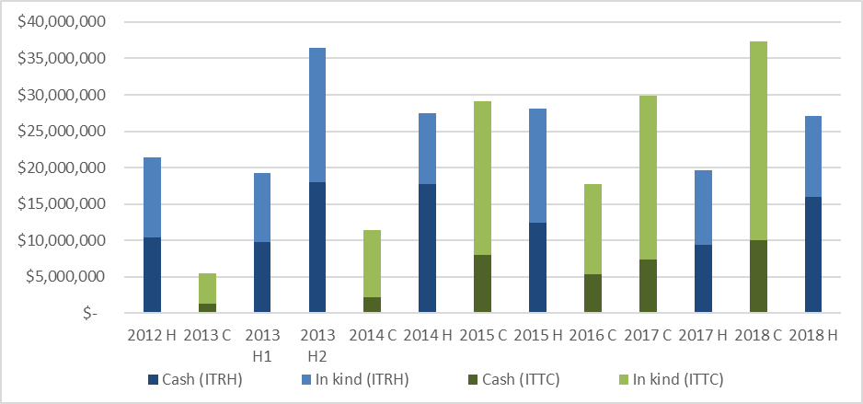Source: ARC data.

Figure 6 provides additional insights into the nature of partner organisation contributions at the funded project and individual partner organisation levels. In particular, it shows that, on average, Research Hubs have tended to attract higher value contributions than Training Centres, particularly in relation to cash contributions (consistent with the discussion above). It also shows that ITTC partner organisations’ average in kind contributions have been consistently higher than their cash contributions, but the balance between average ITRH partner organisations’ cash and in kind contributions has tended to be more even (with the exception of the 2014 round, in which one of the four funded projects involved a particularly low level of in kind contributions).[12]

#### Figure 6: Average partner organisation contributions (funded projects)

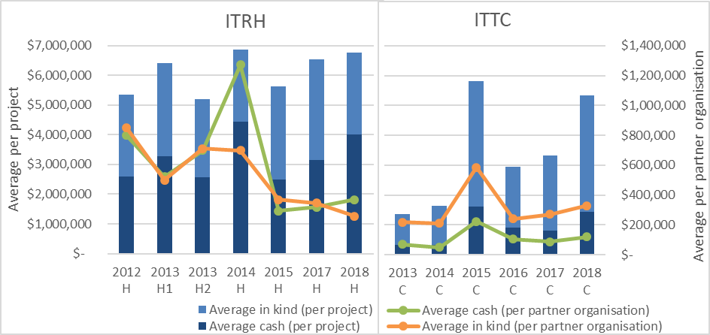Source: ARC data.

## ITRP support for industry focused research training

### Number of HDR students and PDRs involved

ARC data collections do not currently provide for accurate reporting on the total number of HDR students and PDRs involved over the life of each Research Hub and Training Centre. This is an especially important issue for monitoring the performance of the ITTC (which has an objective to ‘support opportunities for HDR candidates and postdoctoral researchers to pursue industrial training’), but is also relevant to the ITRH (which can support industrial research training, but does not have a specific objective to do so).

The funding rules and grant guidelines for all ITTC rounds since 2013 have reflected the intention that ARC funding for each Training Centre should support stipends for at least ten HDR candidates and salaries for at least three PDRs.[13] Since the 2016 ITTC round, applicants have been asked for how many HDR students and PDRs ARC funding was requested. Across the three subsequently completed ITTC rounds (2016 C, 2017 C and 2018 C), successful applications requested funding for an average of 12.2 HDR students and 3.9 PDRs.[14] However, these data do not indicate how many research trainees actually are (or have been) involved.

Training Centres and Research Hubs provide further information on their research training activities through annual progress reports to the ARC, which record their performance against agreed Key Performance Indicator (KPI) targets for each year (for example, number of HDR students enrolled at a Training Centre). Given that HDR students or PDRs may be enrolled or employed over multiple years, these annual reports cannot be used to provide reliable insights on levels of research training activity over the life of a Research Hub or Training Centre.

To enable ARTD Consultants to conduct surveys of HDR students and PDRs as part of this evaluation, the ARC sought contact details for ‘all current and past research trainees involved in’ each Research Hub and Training Centre. The data from Research Hubs and Training Centres that provided responses give a very rough indication of the scale of research training supported by the ITRP. As shown in Table 1. Research Hubs provided contact details for an average of 17 HDR students and seven PDRs, while the numbers for Training Centres were 15 and five, respectively.

Note that the ARC’s request did not ask Research Hubs and Training Centres to identify whether the contacts were current or past research trainees, or to elaborate on the nature of their involvement (that is, whether they were enrolled/employed, undertook placements, received mentoring, or were involved in other ways). Therefore, these numbers can only be considered as broadly indicative. Some insights into the number of research trainees who undertook placements are provided in the survey responses discussed in Appendix 2, indicating an average of five HDR and four PDR placements in Research Hubs, and six HDR and two PDR placements in Training Centres.[15]

#### Table 1: Average number of research trainees involved in Research Hubs and Training Centres

|  | ITRH | ITTC |
| --- | --- | --- |
| HDR | 16.6 | 15.0 |
| PDR | 7.4 | 4.9 |

Source: ARC data. *Note: Data derived from contact details provided to the ARC by Research Hubs (n=19) and Training Centres (n=14) to enable HDR and PDR surveys to be conducted by ARTD Consultants.*

To support improved monitoring and evaluation of ITRP support for industry focused research training, the ARC may wish to consider collecting further information through Training Centre and Research Hub final reports. This should include data on the total number of HDR students and PDRs who participated over the life of the Training Centre or Research Hub, the nature of their involvement (enrolled, employed, placement, mentoring or other involvement), whether they completed their training, and whether they were supported by ARC funding, partner organisation contributions, or other sources.

While the outcomes of ITRP funded research activity were outside the scope of this evaluation, the surveys conducted with HDR students and PDRs did ask whether they had completed their ITRP supported training, and if so, whether they were in further study or employment (and in which sector).[16] To better understand ITRP research trainees’ employment and other outcomes, and their perspectives on the value of participation in the ITRP, the ARC may wish to consider building upon these survey questions to inform more detailed and targeted surveys with HDR students and PDRs in future.

## Engagement with Industry Growth Centres

Stakeholder feedback indicated some uncertainty and a need for greater clarity regarding aspects of the Growth Centres’ role in the ITRP application and assessment processes, including whether they play an advocacy role or are involved in assessing applications.[17] The ITRP funding rules for funding commencing in 2018 did state that applications ‘may be subject to additional assessment, such as…consultation with the Industry Growth Centres’,[18] but they did not elaborate on what this entailed.

This lack of clarity has been addressed in the latest ITRP grant guidelines (for funding commencing in 2019), which provide the following advice regarding the provision of applications to Growth Centres during the assessment process:

*‘Applications may be provided to the relevant Industry Growth Centre, subject to any Conflicts of Interest. Applications will not be provided to the relevant Industry Growth Centre when that Growth Centre is listed as a Partner Organisation in an application. If asked, the Growth Centre provides comments to [the ARC] on the applications for the [Selection Advisory Committee]’s consideration.’*[19]

There may be value in the ARC seeking the views of ITRP stakeholders—through its regular engagement and outreach activities (for example, forums, induction sessions and feedback surveys)—on whether they perceive this advice to have clarified the role of the Growth Centres.

## ITRP fit with other Australian Government programs

### Industrial Transformation Priorities

The funding rules and grant guidelines for all ITRP rounds (except 2013 C) have required that applications address one or more of the Industrial Transformation Priorities in order to be eligible. Addressing the priorities has also been included within in the selection criteria for each round.[20]

The Industrial Transformation Priorities have changed a number of times over the life of the ITRP. These changes are detailed in Table 2, where the priorities for different ITRP rounds are grouped into six broad priority areas that have been used for the purposes of the analysis in this section. Initially, there were five priorities in the area of Food for 2012 H and 2013 C, and four priorities in Manufacturing were added for 2013 H1 and 2014 C. These were revised from 2013 H2 and 2015 C to include one Food priority and one Manufacturing priority, along with additional priorities in the areas of Oil and gas, Mining and Medical technology. Cyber security was added as a sixth priority for 2018 H and 2018 C.

#### Table 2: Industrial Transformation Priorities

| Priority area | ITRP rounds | Industrial Transformation Priorities |
| --- | --- | --- |
| Food | 2012 H; 2013 C | Future food storage; Food processing; Manufacturing capabilities; Product opportunities; Other food related research |
| 2013 H1; 2014 C | Future food storage; Food processing; Food manufacturing capabilities; Product opportunities; Other food related research |
| 2013 H2; 2014 H; 2015 C | Food and agriculture |
| 2015 H; 2016 C; 2017 C; 2017 H; 2018 C; 2018 H | Food and agribusiness |
| Manufacturing | 2013 H1; 2014 C | Product design and development; Manufacturing techniques; Defence manufacturing; Firm organisation and management |
| 2013 H2; 2014 H; 2015 C | Manufacturing |
| 2015 H; 2016 C; 2017 C; 2017 H; 2018 C; 2018 H | Advanced manufacturing |
| Oil and gas | 2013 H2; 2014 H; 2015 C | Oil and gas, including petroleum |
| 2015 H; 2016 C; 2017 C; 2017 H; 2018 C; 2018 H | Oil, gas and energy resources |
| Mining | 2013 H2; 2014 H; 2015 C | Mining and mining services |
| 2015 H; 2016 C; 2017 C; 2017 H; 2018 C; 2018 H | Mining equipment, technology and services |
| Medical technology | 2013 H2; 2014 H; 2015 C | Medical devices and biotechnology |
| 2015 H; 2016 C; 2017 C; 2017 H; 2018 C; 2018 H | Medical technologies and pharmaceuticals |
| Cyber security | 2018 C; 2018 H | Cyber Security |

While stakeholders who participated in interviews generally felt that the Industrial Transformation Priorities effectively focus applications on key industry priority areas, some perceived them to have gaps or to be narrow, or felt that under the ITRP some areas receive more focus than others.[21]

Figure 7 provides some insights into the extent to which the different priority areas have been addressed by funded projects in each ITRP round. It shows the average number of priorities addressed per funded project (y axis), and the proportion that each priority area represented in each round (colours within bars). For example, in 2015 H:

* funded projects addressed an average of 1.8 priorities
* three priority areas were addressed across all funded projects, with Manufacturing addressed most often (56 per cent of all instances), followed by Medical Technology (33 per cent) and Mining (11 per cent).

#### Figure 7: Industrial Transformation Priorities addressed per funded project (average)

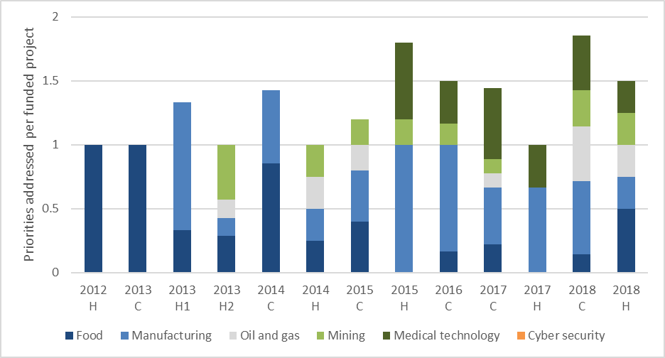Source: ARC data. *Note: Priority areas are as outlined in* *Table 2**. Where a project from 2012 H, 2013 H1, 2013 C or 2014 C addressed more than one priority in the areas of Food or Manufacturing, these have been consolidated. For example, a project in 2013 C addressing three different Food priorities would be counted as addressing only one priority (Food). A project in 2013 H1 addressing one Food priority and two Manufacturing priorities would be counted as addressing only two priorities (Food and Manufacturing).*

Overall, Manufacturing has been the most commonly addressed priority area, having been introduced early in the life of the ITRP and tending to remain comparatively prominent from round to round. This has been followed by Food, which was the only priority area for the first rounds of the ITRP, but has tended to feature less in more recent rounds. While Medical technology was included in the priorities for 2013 H2, 2014 H and 2015 C, it was not addressed in any funded projects in those rounds, but has been fairly consistently represented in subsequent rounds. Cyber security, which was introduced for 2018 H and 2018 C, has not yet been addressed in any funded project.

To provide a higher level picture, Figure 8 shows the priorities’ aggregate representation in applications and funded projects since the ITRP commenced. The proportions appear quite similar with respect to applications and funded projects—and for Mining (12 per cent) and Oil and gas (nine per cent), they are the same. This suggests that the level of focus on each priority has largely been driven by the content of the applications submitted. However, the success of research in different areas has varied somewhat. Manufacturing has been better represented in funded projects (35 per cent) than in applications (26 per cent), indicating that research in that area has fared relatively well in the ITRP process. Conversely, research in Medical technology (21 per cent in applications, 16 per cent in funded projects), Food (31 per cent in applications, 28 per cent in funded projects) and Cyber security (one per cent in applications, not yet addressed in any funded projects) has been less successful.

#### Figure 8: Overall representation of Industrial Transformation Priorities

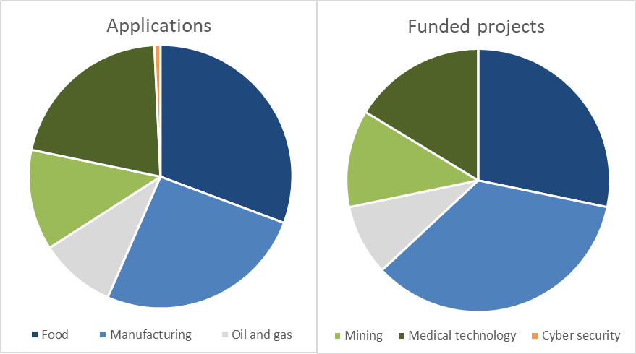Source: ARC data. *Note: Priority areas are as outlined in* *Table 2**. Priorities addressed in applications and funded projects have been counted as outlined in* *Figure 7* *and aggregated across all ITRP rounds to 2018 C and 2018 H.*

### Alignment of priorities with Industry Growth Centre priority areas

Beyond the role of the Growth Centres in the ITRP assessment process (discussed under ‘Engagement with Industry Growth Centres’, above), there is a level of ambiguity in the way the Growth Centres’ relationship to the Industrial Transformation Priorities is addressed.

The Industrial Transformation Priorities have aligned with (in fact, exactly matched) the Growth Centre priority areas since that initiative was introduced in 2015. This construction underpins the focus in the ITRP on engagement between applicants and Growth Centres to ensure support for research and research training in government identified priority areas. However, while addressing the Industrial Transformation Priorities is an ITRP eligibility requirement (as discussed above), engagement with the Growth Centres is not expressed as being mandatory. The most recent grant guidelines state that:

*‘The research and training programs of the proposed Research Hub or Training Centre must address one or more of the Industrial Transformation Priorities. Prior to applying, potential applicants are strongly encouraged to engage with the relevant industry growth centre.’*[22]

Engagement with the Growth Centres is then captured in an assessment criterion for both the ITRH (‘the extent to which the proposed Research Hub engages, and will continue to engage, meaningfully with the relevant Industry Growth Centre(s)’)[23] and the ITTC (‘the extent to which the proposed Training Centre will engage meaningfully with the relevant Industry Growth Centre(s)’).[24] It should also be noted that, despite being nearly identical, these criteria appear under different categories for the ITRH (‘Benefit’) and the ITTC (‘Feasibility and Commitment’).

While the importance of engagement with Growth Centres is also emphasised in other ARC advice (including through forums and other outreach activities), the Growth Centres initiative sits outside the ARC’s control and it is not possible for the ARC to enforce that engagement as part of the ITRP process. Indeed, some survey and interview participants—albeit a minority—reported difficulties in engaging with Growth Centres, including a lack of responsiveness.[25]

In light of these tensions, some revisions to the design of the ITRP process and priorities may be possible to help clarify the Growth Centres’ role and allow more flexibility to address concerns, discussed above, that the Industrial Transformation Priorities have gaps or are too narrow. For example, the ARC may wish to consider all or some elements of the following approach:

1. In the ITRP grant guidelines, retain the requirement for applications to address one or more of the Industrial Transformation Priorities.
2. Continue to include all Industry Growth Centre priority areas in the Industrial Transformation Priorities but also consider the inclusion of additional priorities beyond the scope of the Growth Centres for each round. These additional priorities should be identified in consultation with appropriate stakeholders, including relevant ministers and DIIS, to ensure consistency with the ITRP’s purpose of supporting industry growth in areas that are important to Australia.
3. Amend the ITRP guidelines so that rather than *strongly encouraging* potential applicants to engage with the relevant Growth Centres, they *require* applicants to engage with relevant industry experts (such as, but not exclusively, Growth Centres) to ensure the proposed research is targeted to support growth in the relevant Industrial Transformation Priority areas.
4. Amend the ITRH and ITTC assessment criteria so that rather than describing the extent to which a Research Hub or Training Centre will ‘engage meaningfully’ with the relevant Growth Centres, applicants are required to describe the ways in which engagement with industry experts (such as, but not exclusively, Growth Centres) has ensured that the proposed research is targeted to support growth in the relevant Industrial Transformation Priority areas.
5. Noting that ITRP Selection Advisory Committees include members with relevant industry expertise, the ARC would need to ensure this expertise covered any additional priority areas identified for each round.

These changes would provide extra flexibility and remove ambiguities associated with the ARC’s lack of control over the operation of the Growth Centres, while allowing the ITRP to continue to align with them. Given the important role of the Growth Centres in Australia’s innovation policy landscape, the ARC should continue to work closely with DIIS and the Growth Centres in relation to their interaction with the ITRP and continue to emphasise the value of engagement with the Growth Centres in its ITRP advice and outreach activities.

1. [www.arc.gov.au](http://www.arc.gov.au) > Grants > Linkage Program> [Industrial Transformation Research Program](https://www.arc.gov.au/grants/linkage-program/industrial-transformation-research-program).
2. [www.industry.gov.au](http://www.industry.gov.au) > Strategies for the future> [Industry Growth Centres](https://www.industry.gov.au/strategies-for-the-future/industry-growth-centres).
3. *Grant Guidelines for the Industrial Transformation Research Program (2018) for funding commencing in 2019*, available at [www.grants.gov.au](http://www.grants.gov.au) > [Forecast Opportunity View - ITRP2019](https://www.grants.gov.au/?event=public.FO.show&FOUUID=5B5652AD-FA06-3E4F-913E6DF3E7D79304). Note: analysis by ARTD Consultants (Appendix 2) addressed the objectives in ITRH and ITTC *Funding Rules for funding commencing in 2018*, available at [www.arc.gov.au](http://www.arc.gov.au) > Grants > Grant application > Funding Rules/Grant Guidelines > [Linkage Program Funding Rules/Grant Guidelines](https://www.arc.gov.au/grants/grant-application/funding-rulesgrant-guidelines/linkage-program-funding-rulesgrant-guidelines).
4. www.arc.gov.au > Policies & Strategies > Strategy > Evaluation > [ARC Evaluation Strategy](https://www.arc.gov.au/policies-strategies/strategy/evaluation/arc-evaluation-strategy).
5. www.arc.gov.au > Grants > Linkage Program > [Industrial Transformation Research Program](https://www.arc.gov.au/grants/linkage-program/industrial-transformation-research-program).
6. See [www.arc.gov.au](http://www.arc.gov.au) > Grants > Grant application > Funding Rules/Grant Guidelines > [Linkage Program Funding Rules/Grant Guidelines](https://www.arc.gov.au/grants/grant-application/funding-rulesgrant-guidelines/linkage-program-funding-rulesgrant-guidelines); and [www.grants.gov.au](http://www.grants.gov.au) > [Forecast Opportunity View - ITRP2019](https://www.grants.gov.au/?event=public.FO.show&FOUUID=5B5652AD-FA06-3E4F-913E6DF3E7D79304).
7. ARC data. Note: ITTC figures do not total 100 per cent due to rounding.
8. ARC data.
9. ARC data.
10. These requirements have been specified in the funding rules and grant guidelines for all ITRH and ITTC rounds. See [www.arc.gov.au](http://www.arc.gov.au) > Grants > Grant application > Funding Rules/Grant Guidelines > [Linkage Program Funding Rules/Grant Guidelines](https://www.arc.gov.au/grants/grant-application/funding-rulesgrant-guidelines/linkage-program-funding-rulesgrant-guidelines); and [www.grants.gov.au](http://www.grants.gov.au) > [Forecast Opportunity View - ITRP2019](https://www.grants.gov.au/?event=public.FO.show&FOUUID=5B5652AD-FA06-3E4F-913E6DF3E7D79304).
11. ARC data.
12. ARC data.
13. See [www.arc.gov.au](http://www.arc.gov.au) > Grants > Grant application > Funding Rules/Grant Guidelines > [Linkage Program Funding Rules/Grant Guidelines](https://www.arc.gov.au/grants/grant-application/funding-rulesgrant-guidelines/linkage-program-funding-rulesgrant-guidelines); and [www.grants.gov.au](http://www.grants.gov.au) > [Forecast Opportunity View - ITRP2019](https://www.grants.gov.au/?event=public.FO.show&FOUUID=5B5652AD-FA06-3E4F-913E6DF3E7D79304).
14. ARC data.
15. ARTD Consultants, Appendix 2, p. 15.
16. ARTD Consultants, Appendix 2, pp. 15-16.
17. ARTD Consultants, Appendix 2, pp. 18-19.
18. *Funding Rules for schemes under the Linkage Program (2017 edition)*, paragraphs B10.1.1 (for ITRP) and C11.1.1 (for ITTC). See [www.arc.gov.au](http://www.arc.gov.au) > Grants > Grant application > Funding Rules/Grant Guidelines > [Linkage Program Funding Rules/Grant Guidelines](https://www.arc.gov.au/grants/grant-application/funding-rulesgrant-guidelines/linkage-program-funding-rulesgrant-guidelines).
19. *Grant Guidelines for the Industrial Transformation Research Program (2018) for funding commencing in 2019*, paragraph 9.14.f. See [www.grants.gov.au](http://www.grants.gov.au) > [Forecast Opportunity View - ITRP2019](https://www.grants.gov.au/?event=public.FO.show&FOUUID=5B5652AD-FA06-3E4F-913E6DF3E7D79304).
20. See [www.arc.gov.au](http://www.arc.gov.au) > Grants > Grant application > Funding Rules/Grant Guidelines > [Linkage Program Funding Rules/Grant Guidelines](https://www.arc.gov.au/grants/grant-application/funding-rulesgrant-guidelines/linkage-program-funding-rulesgrant-guidelines); and [www.grants.gov.au](http://www.grants.gov.au) > [Forecast Opportunity View - ITRP2019](https://www.grants.gov.au/?event=public.FO.show&FOUUID=5B5652AD-FA06-3E4F-913E6DF3E7D79304).
21. ARTD Consultants, Appendix 2, pp. 26-27.
22. *Grant Guidelines for the Industrial Transformation Research Program (2018) for funding commencing in 2019*, paragraph 3.6. See [www.grants.gov.au](http://www.grants.gov.au) > [Forecast Opportunity View - ITRP2019](https://www.grants.gov.au/?event=public.FO.show&FOUUID=5B5652AD-FA06-3E4F-913E6DF3E7D79304).
23. Ibid, paragraph A5.1c.
24. Ibid, paragraph B5.1b.
25. ARTD Consultants, Appendix 2, pp. 18-19.