

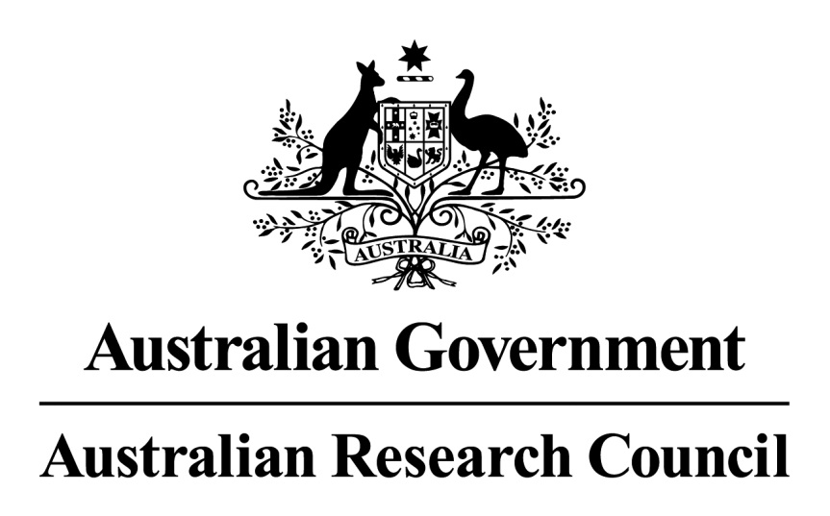

Open Access Policy

**Version: 2015.1**

**Issued: April 2015**

**Date for review: April 2017**

**Owner: Strategy Branch**

Contents

1. ARC Open Access Policy 3

2. Overview 3

3. Compliance Advice 3

4. Contact details 5

# 1. ARC Open Access Policy

The ARC Open Access Policy took effect from 1 January 2013.

Any publications arising from an ARC supported research Project must be deposited into an open access institutional repository within a twelve (12) month period from the date of publication.

In cases where researchers may not be able to meet the requirements because of current legal or contractual obligations, Final Reports must provide reasons why publications derived from a Project, Award, or Fellowship have not been deposited in an open access institutional repository within the twelve month period.

The Policy has been incorporated into all Funding Rules and Agreements released after 1 January 2013. The Policy does not apply retrospectively to pre-existing Funding Rules and Agreements.

# 2. Overview

The Australian Government makes a major investment in research to support its essential role in improving the wellbeing of our society. To maximise the benefits from research, publications resulting from research activities must be disseminated as broadly as possible to allow access by other researchers and the wider community.

The ARC acknowledges that researchers take into account a wide range of factors in deciding on the best outlets for publications arising from their research.

Such considerations include the status and reputation of a journal, book, publisher or conference, the peer review process of evaluating their research outputs, access by other stakeholders to their work, the likely impact of their work on users of research and the further dissemination and production of knowledge.

The ARC is committed to ensuring the widest possible dissemination of the research supported by ARC funding, in the most effective manner and at the earliest opportunity, taking into account any restrictions relating to intellectual property or culturally sensitive data.[1]

# 3. Compliance Advice

The ARC is aware that in many cases copyright and licensing arrangements are currently in place between authors, institutions and publishers. Where these copyright and licensing arrangements exist the ARC is cognisant of the fact that institutions and individuals will need to develop mechanisms to ensure compliance with the ARC’s policy that take into account agreements already in place between authors and publishers.

**Why does the ARC have an open access policy?**

* The overarching aim of the ARC’s Policy is to ensure that the findings of publicly funded research are made available to the wider public as soon as possible. Both the research community and the public gain from knowledge derived from ARC funded research, and both wish to derive maximum benefit from these outputs.
* This Policy brings the ARC further into line with the NHMRC and with other international research funding agencies such as those in the United States and the United Kingdom.

**When did the ARC Open Access Policy commence?**

* The Policy commenced on 1 January 2013. The first publications were not potentially due to be made available in an institutional repository until after 1 January 2014.
* The Policy has been incorporated into all Funding Rules and Agreements released after 1 January 2013.
* The Policy does not apply retrospectively to pre-existing Funding Rules and Agreements.

**Who is responsible for ensuring compliance with the Policy?**

* Compliance with the Policy is a matter for the Administering Institution to discuss with the ARC—the ARC will not routinely check compliance with individual Chief Investigators (CIs). The Chief Investigator (CI) on any given Project will be responsible for providing the publication metadata (including ARC Project ID, funder name, journal name, title, author list, volume, issue, page numbers) and, as and when it becomes available, the appropriate copy of the publication to the institutional repository (although this may be managed via the institutional research administration office). This is independent of the CI’s authorship role (first, last or middle) on a given paper.

**Which publications should be included in the institutional repository?**

* The Policy does not place restrictions on the types of publications that can be included in an institutional repository. The Administering Institution should assist researchers to identify and to capture appropriate information.
* In line with ARC Funding Rules, any material published in respect of an ARC-funded research activity must include acknowledgement of the ARC’s funding, including the ARC Project ID. Similarly, it is expected that any material published in respect of an ARC-funded research activity will be included in the institutional repository.
* Researchers should ensure that all publications are listed in the Final Report for each Project. If a publication cannot be included in the institutional repository, a justification for its non-inclusion must be provided in the Final Report.

**What information needs to be submitted to the institutional repository and when?**

* The ARC’s view is that publication metadata should include the ARC Project ID and list the ARC as the funding source, as well as other relevant information such as journal name, title, author list, volume, issue, page numbers, etc. This must be submitted to the institutional repository as soon as possible after the paper is accepted for publication, no matter when (or if) the paper itself will become openly accessible. Any future Funding Rules and Funding Agreements will include this requirement.
* The manuscript/journal article should be submitted to the institutional repository as soon as possible after the publication date. The repository manager will ensure that the manuscript/journal article is made available at a date that complies with the journal’s copyright transfer agreement.
* If the copyright transfer/licence agreement does not allow the manuscript/journal article to be made available within twelve months of the date of publication, it needs to be made available as soon as possible after that date. If the journal *never* allows the article to be made available, this information must be provided at the time of Final Report submission. Institutions may wish to use a publicly available ‘holding note’ to explain that copyright/licensing restrictions prevent inclusion of a particular article on the repository until a specific date.
* Institutional repositories should make publication metadata immediately available to the public upon publication—regardless of where the publication has been made freely available, if the publication is under embargo, or if the publication is never to be made available.

**Which version of the manuscript/journal article do I need to make available via the institutional repository?**

* There are numerous versions of the manuscript/journal article that can be made available via the institutional repository. Both the author’s version of the article (Word document) after peer-review, with revisions having been made and the publisher’s version (for example, journal version with final pagination and formatting) are acceptable under this policy.
* Publishers may have different policies regarding what version of a manuscript or article can be made available, and the timing of this availability. This information should be included in any copyright/licensing agreement.
* To find further information regarding which version of a paper can be uploaded to your institutional repository, consult your librarian or the SHERPA/RoMEO database of international publisher policies at http://www.sherpa.ac.uk/romeo/.

**If I publish my article in an Open Access publication or in an openly accessible digital database, for example PubMed Central or ArXiv, do I also need to submit the manuscript/article to my institutional repository?**

* No. If the print version (journal version) of the article is openly accessible via the publisher’s website or via a service, it is sufficient to just make the article metadata available in the institutional repository and provide a link to the site where the print version is available. However, Administering Institutions may require this of their researchers, and in that case it should also be submitted to your institutional repository.

**What do I do if my institution does not have an institutional repository?**

* If no institutional repository is immediately available to a Chief Investigator, this will need to be recorded in the Project’s Final Report.
* The ARC will then discuss the implementation of this policy with Administering Institutions that do not currently provide researchers with access to a repository.

# 4. Contact details

**Australian Research Council**

Phone: 02 6287 6600

[info@arc.gov.au](mailto:info@arc.gov.au)

www.arc.gov.au

Level 2, 11 Lancaster Place, Canberra Airport ACT 2609

GPO Box 2702, Canberra ACT 2601

| Version | Date Approved | Approved By | Brief Description |
| --- | --- | --- | --- |
| Version 2015.1 | 14/04/2015 | SMG endorsed | Replaces ARC Open Access Policy – Version 2013.1 |

1. Australian Code for the Responsible Conduct of Research, 2007, 4.4