SUPPORTINGDOCUMENTATION

ERA-SEER 2023 Technical Specifications

ISBN: 978-0-6484847-8-3

© Commonwealth of Australia 2022

P6#yIS1

All material presented in this publication is provided under a CC Attribution-NonCommercial- NoDerivatives 4.0 International (CC BY-NC-ND 4.0) licence [www.creativecommons.org >](https://creativecommons.org/) [Licenses > by-nc-nd/4.0](https://creativecommons.org/licenses/by-nc-nd/4.0/) with the exception of the Commonwealth Coat of Arms, the Australian Research Council (ARC) logo, images, signatures and where otherwise stated.

The details of the relevant licence conditions are available on the Creative Commons website as is the full legal code for the CC Attribution BY-NC-ND 4.0 licence, [www.creativecommons.org](https://creativecommons.org/licenses/by-nc-nd/4.0/legalcode) > licenses > by-nc-nd 4.0 legal code. Requests and enquiries regarding this licence should be addressed to ARC Legal Services on +61 2 6287 6600.

*Cover image: Blue Soap Bubbles . iStock.com /* [ThomasVogel](https://www.istockphoto.com/portfolio/ThomasVogel?mediatype=photography)*.*

Contents

Summary of changes from ERA 2018 to ERA 2023 4

1. ERA–SEER OVERVIEW 6

1.1 Purpose of the Technical Specifications 6

1.2 Structure of the Technical Specifications 6

1.3 Nature of ERA submissions 7

1.4 Role of SEER during submission 7

1.5 SEER institution user summary 7

1.6 Scope of the Technical Specifications 8

1.7 Disclaimer 9

1.8 Version control 9

1.9 Attachments 9

1.10 Related documents 9

2. SEER TECHNOLOGY PLATFORM 11

2.1 Summary 11

2.2 ERA submission process 12

2.2.1 Submission stage 12

2.2.2 Data integrity checking stage 13

2.2.3 Certification 13

2.3 ERA submission component 14

2.4 System security 15

2.5 International and special characters 15

2.6 Service availability 16

2.6.1 SEER 16

2.6.2 ERA Helpdesk 17

2.6.3 Institutional contact officers (ERA submission and repository) 17

2.7 Supported browsers 17

3. SUBMISSION DATA STRUCTURE 19

3.1 Institution submission 19

3.2 Researchers 21

3.2.1 Researcher 22

3.2.2 Discipline assignment 24

3.3 Research outputs 24

3.3.1 Traditional research outputs (general) 26

3.3.2 Book 31

3.3.3 Book chapter 32

3.3.3 Book outlet 33

3.3.5 Journal article 34

3.3.6 Conference publication 35

3.3.7 Non-traditional research outputs 38

3.3.8 Non-traditional research output types 43

3.4 Research Income 56

3.4.1 Australian competitive grant research income 56

3.4.2 Other public sector research income 58

3.4.3 Industry and other research income 59

3.4.4 CRC research income 60

3.5 ERA–SEER XML schema files 61

3.6 Codes 62

3.6.1 Language codes 62

3.6.2 Journal articles and unique output identifiers 62

4. INSTITUTIONALLY SUPPORTED REPOSITORY REQUIREMENTS 63

4.1 Research outputs 63

4.1.1 Technical specifications for research outputs 63

5. SYSTEM ENVIRONMENT 66

Appendix A: ERA–SEER 2023 Technology Pack Inventory 67

ERA–SEER 2023 Technical Specifications 67

ERA submission XML schemas 67

Submission examples 67

Schema definition documentation files 67

ERA 2023 Discipline Matrix 67

Code tables 67

Appendix B: Glossary of technical terms 68

# Summary of changes from ERA 2018 to ERA 2023

**Related to the ERA 2023 XML Schema more broadly**

* Research income changes
* Removal of “Has Aboriginal and Torres Strait Islander research” flag
* Removal of all reference to Australian Competitive Grants codes and code table
* Removal of Applied Measures
* Addition of “Indigenous Status (optional)” field to staff data
* Change to “Contains sensitive content” flag

**Specific to Researchers**

* Addition of “Indigenous Status (optional)” for researchers as optional field

*Indigenous status data elements based on Higher Education staff reporting requirements: item 316 Aboriginal and Torres Strait Islander code.*

**Specific to Research Income**

* Research income refers to the income data reported under the Higher Education Research Data Collection (HERDC), conducted by the Department of Education Skills and Employment (DESE). The HERDC Specifications and categories of income are referred to as Research and Development (R&D). For the purposes of the collection of this income data for ERA, the ERA documents and related ARC system refers to this as research income.
* The ACGR element no longer exists
* Research income is collected at the category level for Category 1 Australian Competitive Grant Research Income
* The proportion of grants within the reference period element no longer exists
* Research income is collected at the category level for Category 3 Industry and other Research Income

**Specific to Research Outputs**

* “Is culturally sensitive” flag has changed to “Contains sensitive content”
* Sensitive handling note flag containing predetermined response as well as “other” free text option
* Removal of Aboriginal and Torres Strait Islander Research flag due to inclusion of field of research “45 Indigenous Studies”

**Specific to Repositories**

* Removal of acceptable file types:
  + Microsoft PowerPoint (i.e. .ppt)
  + Microsoft Word documents with embedded macros (i.e. .docm)
  + Microsoft Excel files (i.e. .xls etc.)
* Advice on virus scanning on all repository files with an updated virus-scanner
* Update to communications between SEER and institutionally supported repositories

**Other**

* Removal of Applied Measures:
  + Plant breeder’s rights
  + Patents
  + Registered designs
  + Research commercialisation income
  + NHMRC endorsed guidelines
* Removal of peer review representative sample of output types for the 30% peer review sample

# 1. ERA–SEER OVERVIEW

## 1.1 Purpose of the Technical Specifications

TheseERA–SEER 2023 Technical Specifications (hereafter ‘Technical Specifications’) are for the use of eligible higher education providers (hereafter ‘institutions’) making submissions as part of Excellence in Research for Australia (ERA). The *ERA 2023 Submission Guidelines* set out the policies, rules and requirements for ERA submissions. These Technical Specifications build upon the *ERA 2023 Submission Guidelines* to provide technical instructions for institutions preparing and making ERA submissions.

The IT platform that supports the implementation of ERA is the System to evaluate the Excellence of Research (SEER). These Technical Specifications relate specifically to institutions’ interaction with SEER.

This document addresses:

* submission data requirements
* mechanisms of system interaction
* institutional repository requirements
* relevant technologies and security mechanisms related to interactions with the SEER platform.

## 1.2 Structure of the Technical Specifications

**Section** **1—ERA–SEER Overview**– outlines the purpose, structure, and scope of the document; the nature of ERA submissions; and the role of SEER during the ERA submission phase. It provides a SEER User Summary, sets out the target audience and includes a disclaimer.

It also provides information about version control, attachments, and related documents.

**Section 2—SEER Technology Platform**– outlines the ERA submission process and ERA submission components. It also addresses system security, international and special characters, service availability (including the ERA Helpdesk) and supported browsers.

**Section 3—Submis****sion Data Structure**– describes the submission data structures and the corresponding elements and attributes in the ERA–SEER submission XML schema.

**Section 4—Institutio****nally Supported Repository Requirements**– describes institutionally supported repository requirements, which are relevant for research outputs nominated for ERA peer review.

**Section 5—System Environment**– identifies the environment supporting ERA submissions.

**Appendix A**– briefly outlines the ERA–SEER Technology Pack Inventory.

**Appendix B**– contains a glossary of technical terms.

## 1.3 Nature of ERA submissions

Institutions are required to collate and package their submission in an XML data format when participating in ERA. Institutions must then submit the data to SEER via the ‘upload submission’ feature.

Research officers from institutions (see section 1.5) will also use SEER to validate submitted data and to access reports related to their submission(s). SEER allows subsequent uploads of revised submissions to support corrections of submitted data by replacing previous uploads prior to submission finalisation.

Institutions must prepare their ERA submissions using the following resources:

* ERA 2023 Submission Guidelines
* ERA – SEER 2023 Technology Pack (including ERA – SEER 2023 Technical Specifications)
* ERA 2023 Discipline Matrix
* Other supplementary information.

*The* ERA–SEER 2023 Technology Pack is a collection of electronic files intended to assist institutions preparing an ERA submission. The pack is available for download from the [ERA web pages](https://www.arc.gov.au/excellence-research-australia/era-2023) or [www.arc.gov.au](http://www.arc.gov.au) > [ERA](https://www.arc.gov.au/excellence-research-australia)> [ERA 2023](https://www.arc.gov.au/excellence-research-australia/era-2023). **Appendix A** of this document outlines the contents of the ERA – SEER 2023 Technology Pack.

## 1.4 Role of SEER during submission

During the submission phase, the role of SEER is to enable institutions to:

* upload and validate electronic ERA submissions via a well-defined XML data format
* upload explanatory statements that outline relevant contextual information about the institution’s research at a two-digit FoR level
* update institutional repository access information to support the ERA peer review process
* preview Units of Evaluation (UoE) based on their submission data
* create and view reports on their submissions
* finalise and certify submissions.

## 1.5 SEER institution user summary

The following are identified as institution users of SEER:

**ERA Research Office Staff**

This role has access to SEER to perform ERA Submissions. The ERA Research Office Delegate must assign this role.

**ERA Research Office Delegate**

The ARC assigns this role and will allow the institution user to perform the same functionality as ERA Research Office Staff, as well as the additional ability to approve the Research Office Staff role within their own institution. The ERA Research Office Delegate role will also be able to request the ARC to approve new ERA related role(s) for users within their institution. The approval of the roles other than ERA Research Office Staff will be actioned by appropriate ARC staff. The ERA Research Office Delegate can also remove all ERA roles from their staff with no approval required from the ARC.

**NOTE** – The ERA Research Office Delegate will not be able to assign RMS related roles to institutional staff unless the ERA Research Office Delegate also has ‘Research Office Delegate’ for RMS assigned to their profile.

**ERA Signatory**

This role is reserved for the Pro/Deputy Vice-Chancellor, Research (or equivalent). The role is responsible for finalising their institution’s ERA submission. This role must not be delegated. If this is an issue, institutions must contact the ARC to discuss before a change to this role can be approved in SEER.

**ERA Certifier**

This role is reserved for a Vice Chancellor (or equivalent). The role is responsible for certifying that all information in a submission is accurate and comprehensive. Certification takes the form of a signature, in digital form, of a submission Certification Statement by the Vice-Chancellor or equivalent of the institution. This role must not be delegated. If this is an issue, institutions must contact the ARC to discuss before a change to this role can be approved in SEER.

**Institution Repository Administrator**

This role is responsible for all repository items being digitally available as well as repository testing during the ERA submission process. The Institution Repository Administrator needs to also ensure that submitted links for each research output remain stable for the duration of an ERA submission process and associated ERA evaluation.

**Institution Outcome Viewer**

This role allows the user to view the UoE and the result of the ERA assessment after the public release of the results. This ‘view only’ role is only available at the completion of each ERA round.

## 1.6 Scope of the Technical Specifications

**In scope**

This document covers the following areas:

* data content and structures required for packaging an ERA submission
* institution system interfaces
* mechanisms of data transfer (including access to institutional repositories)
* system security
* SEER user interface availability and support procedures.

**Out of scope**

The following are out of scope for this document:

* policy matters and rules related to ERA submissions
* guides to underlying standards and technologies
* methods for aggregating/preparing submission information within institution IT systems
* ERA processes or workflows that are not directly supported by SEER
* SEER User guides.

**Target audience**

This detailed document is for a technical audience, specifically:

* institution IT staff
* institution research office staff
* third-party software developers (where applicable).

## 1.7 Disclaimer

These Technical Specifications provide information for interoperating with SEER. They are not intended to provide institutions with IT systems implementation instructions. Institutions are responsible for their respective systems development and data gathering to meet the requirements of these specifications. The Australian Government accepts no responsibility for any loss, damage, liability, or expense incurred by any institution resulting from any use of these Technical Specifications for any purpose.

## 1.8 Version control

Changes may be made to the ERA–SEER 2023 Technology Pack, including these Technical Specifications. The latest version can be found on the [ERA web pages](https://www.arc.gov.au/excellence-research-australia/era-2023) or [www.arc.gov.au](http://www.arc.gov.au) > [ERA](https://www.arc.gov.au/excellence-research-australia)> [ERA 2023](https://www.arc.gov.au/excellence-research-australia/era-2023). The ARC will inform institutions of any updated version of the Technical Specifications and/or the Technology Pack.

The ARC will use controlled versioning of the technical documentation.

**NOTE** – Minor revisions to the Technology Pack will not result in the reissuing of this document.

It is the responsibility of each institution to ensure that they use the latest version of these Technical Specifications.

## 1.9 Attachments

The ARC has distributed these Technical Specifications electronically within the ERA–SEER 2023 Technology Pack, which additionally includes:

* the ERA submission XML schema files (XSD)
* the ERA 2023 Discipline Matrix (MS Excel)
* SEER code (reference data) tables (TXT, CSV, XML).

Release notes are included with the ERA–SEER 2023 Technology Pack. These notes comprise instructions on how to open and use the packaged files as well as itemising changes between versions.

## 1.10 Related documents

Related external references include:

* W3C specifications (e.g. XML), see [www.w3.org](http://www.w3.org) > [Standards](https://www.w3.org/standards/) > [XML Technology](https://www.w3.org/standards/xml/)
* Australian Bureau of Statistics (2020), [Australian and New Zealand Standard Research Classification](https://www.abs.gov.au/statistics/classifications/australian-and-new-zealand-standard-research-classification-anzsrc/latest-release) (ANZSRC), Cat. No. 1297.0 ABS, Canberra
* Australian Bureau of Statistics (2016), [Australian Standard Classification of Languages](https://www.abs.gov.au/statistics/classifications/australian-standard-classification-languages-ascl/2016#overview) (ASCL), Cat. No. 1267.0 ABS, Canberra
* Australian Bureau of Statistics (2016), [Standard Australian Classification of Countries](https://www.abs.gov.au/statistics/classifications/standard-australian-classification-countries-sacc/2016) (SACC), Cat. No. 1269.0 ABS, Canberra
* Attorney-General’s Department, Australian Government [Protective Security Policy Framework](https://www.protectivesecurity.gov.au/)
* Attorney-General’s Department, Australian Government [Commonwealth of Australia Statutory Declaration](https://www.ag.gov.au/legal-system/publications/commonwealth-statutory-declaration-form)
* [RFC 2617–HTTP Authentication: Basic and Digest Access Authentication](http://www.faqs.org/rfcs/rfc2617.html)—[www.faqs.org](http://www.faqs.org) > Internet RFC Index > RFC 2601 - 2700 > [RFC 2617](http://www.faqs.org/rfcs/rfc2617.html).

The ARC may send other technical documentation to stakeholders to provide additional advice on integration with SEER if new issues or requirements arise. The ARC will post all documentation on the [ARC website](http://www.arc.gov.au/era-2018) [or](http://www.arc.gov.au/era/) [www.arc.gov.au](http://www.arc.gov.au) > [ERA](https://www.arc.gov.au/excellence-research-australia) > [ERA 2023](https://www.arc.gov.au/excellence-research-australia/era-2023)

# 2. SEER TECHNOLOGY PLATFORM

## 2.1 Summary

SEER is the information technology platform that serves to facilitate the implementation of the formal ERA process (described in the ERA 2023 Submission Guidelines). SEER is accessible via a web-based user interface and maintains the data and business logic relevant to the submission, assignment, evaluation and outcome reporting processes within ERA. See Figure 1 for a high-level overview of SEER and its interactions with external systems/users.

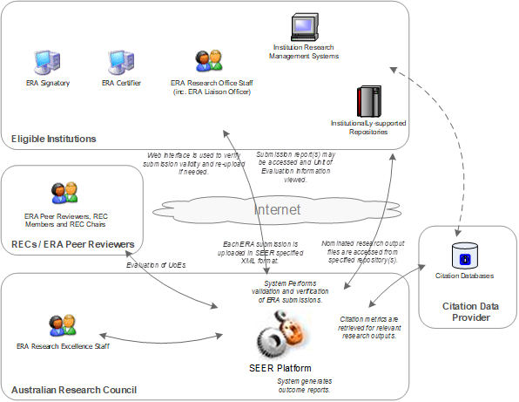

Figure SEER Functional Overview

SEER accepts submissions from institutions via an upload of XML encoded data. Institutions must collate and package their own submission data file(s) in compliance with the supplied ERA submission XML schemas. The SEER user interface serves to mediate the sequential flow of submission activities (including the provision of upload validation and verification results, viewing of UoE and subsequent submission reports) and electronic certification.

Institutions are required to nominate research outputs for peer review for those disciplines in which ERA peer review is an indicator. For ERA 2023, all research outputs nominated for peer review must be stored in an institutionally supported repository in digital form. Institutions must provide these research outputs with the link to an electronic copy in the repository, accessible through SEER as part of the XML submission file.

Key parties to the operation of the SEER platform include:

* ERA Institutions – Institutions eligible for participation in ERA as detailed in Appendix A of the *ERA 2023 Submission Guidelines*
* ERA Reviewers – Experts who undertake ERA evaluation activities as members of Research Evaluation Committees (RECs) or as ERA peer reviewers
* Citation Data Supplier – Commercial entity engaged by the ARC to provide citations reference data for citation disciplines
* Australian Research Council (ARC) – Australian Government statutory authority responsible for administering ERA.

## 2.2 ERA submission process

The ERA submission process has three stages (see Figure 2, ERA Process Overview). Each of these stages has a deadline that institutions must meet (see ERA 2023 Submission Guidelines, section 5). However, institutions may perform the tasks required for each stage prior to the deadline for that stage. Where an institution has completed the tasks required for one stage, it may proceed to the next stage without waiting for the stated start date for that subsequent stage.

The SEER supported processes that take place during each ERA submission stage are as follows:

### 2.2.1 Submission stage

**Upload**

* Each institution packages information about its own researchers and research items into a single XML document for all disciplines that conforms to the ERA submission XML schema. This XML file is then uploaded to SEER by logging onto (and interacting with) the SEER user interface.
* Institution users are also required to log on to SEER to upload explanatory statements and provide repository details.

**Validate**

* SEER scans the uploaded XML file for syntactic and semantic validity against ERA specified guidelines. Institution users view the results of validation for their submission on the SEER user interface. SEER will not accept a file with validation errors. Institutions must fix any validation errors and resubmit a valid XML file.

**Verify**

* Once a valid XML file has been submitted (that is, one with no validation errors), SEER verifies that the data contained in the file meets ERA business rules. SEER may return a file to an institution with verification errors or verification warnings. Institutions must fix verification errors before a submission can progress in SEER.
* The institution may decide not to fix verification warnings at that stage. However, the institution must acknowledge that it accepts the warning messages before it can progress to the next stage.
* Using the submission data from each institution, SEER creates UoEs for each four‑digit and two-digit FoR that meets or exceeds the low volume threshold.
* Using SEER, for peer review disciplines, the institution must also provide details of the repository domain and the authentication details referred to in the repository links of its XML file. The link to the research output file must be direct and not via a landing page. The institution is responsible for ensuring that SEER can access the research output marked as available for peer review using these authentication details.
* Institution users log on to the SEER user interface to view verification reports and UoEs based on the data in their submissions.

**Submit to ARC**

* Once an institution is satisfied that the data included in its submission is correct, the institution can then indicate to the ARC to start the data integrity checking stage. To do this, Research Officers must log on to SEER to submit the uploaded data to the ARC. At this stage, the submission will no longer be editable by the institution unless the ARC has sent it back to the institution.

### 2.2.2 Data integrity checking stage

**Verify**

* In this stage, the ARC will revisit all the warning messages accepted by the institution in the submission stage. If the ARC sees that there is a need for further clarification, it will contact the institution for more information. This may result in the ARC returning the submitted data to the institution for correction.
* The ARC undertakes further verification and integrity checking of the data contained in the submission. If any anomalies are detected (such as duplicate outputs), the ARC will return the submission to the institution with a list of changes to be corrected. Once the changes are resolved, the institution will be required to upload its submission once again, following the process outlined above in the submission stage.
* The ARC verifies (on an ad-hoc basis) the network accessibility of digital assets linked to submitted research outputs (as located in one or more institutionally supported digital repositories). However, the institution is responsible for ensuring that all repository items are accessible throughout the ERA process.
* Once the data integrity checking is complete, the ARC will accept the submission, which then allows the institution to finalise the submission.

**Finalise**

* Once both the ARC and the institution are satisfied that the data included in its submission is correct, the institution will be able to finalise its submission. The institution’s ERA Signatory (Pro/Deputy Vice-Chancellors, Research, or their equivalent) is required to log on to SEER to indicate that the institution’s submission, following the data integrity check, is valid. Finalisation of the submission following verification marks the end of Data Integrity Checking Stage.

### 2.2.3 Certification

* The institution ERA Certifier (Vice-Chancellor or equivalent) is required to log on to SEER to certify that the institution’s ERA submission is valid and finalised. Electronic certification of a finalised submission marks the end of Certification.

**NOTE** – Institutions may continue to use SEER after certification, but only to update authentication details of their existing repositories.

Figure 2 outlines the overall process of ERA 2023.

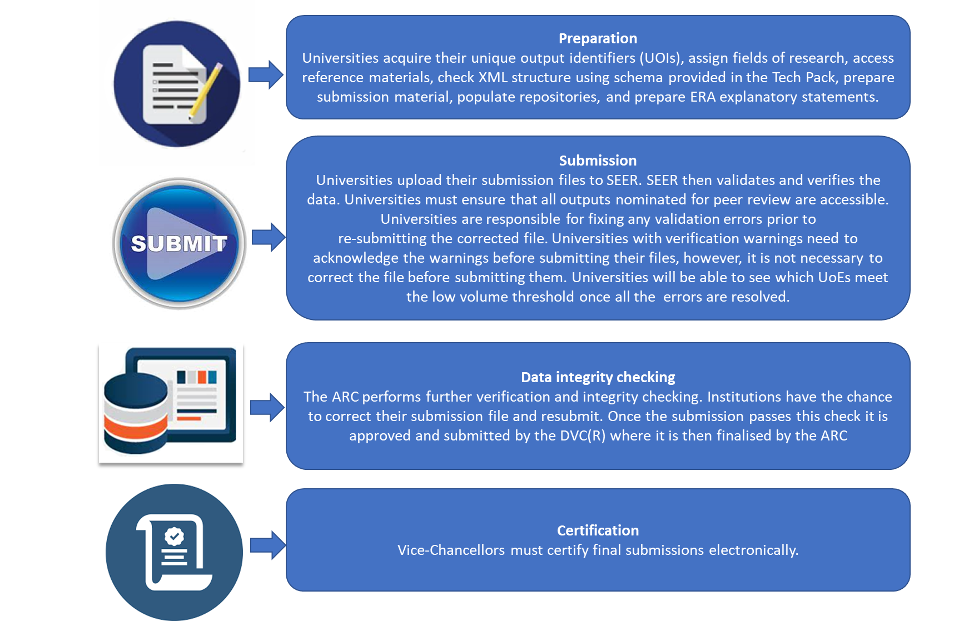

Figure ERA Process Overview

## 2.3 ERA submission component

The main components of an ERA submission (see section 5 of ERA 2023 Submission Guidelines) include:

* explanatory statements
* repository domains
* data on eligible researchers
* data on research outputs
* data on research income

All ERA submission data, apart from explanatory statements and repository domains (see below), must be packaged within an XML document that conforms to the ERA submission XML schema. This packaging requires the institution to use resources within the institution’s research support systems and to create the XML document for the institution. The institutions must implement this Extract, Transform, Load (ETL) process using their own system’s development resources. The ARC will not endorse the use of any research management system to support these processes.

Section 3 provides a conceptual description of the ERA submission XML schemas.

**NOTE** – Users should note that they cannot interactively edit XML data within the SEER system. Institutions may need to amend their XML file and resubmit their data several times during the submission process.

**Explanatory statements**

SEER provides a means through which the institution’s Research Officer(s) can upload an explanatory statement in machine-readable PDF for each eligible two-digit FoR. Each explanatory statement is limited to three pages[1]. Section 4.2 of the ERA 2023 Submission Guidelines provides more information on explanatory statements.

**Repository domains**

In ERA 2023, the repository domains will not be part of the XML file. The Institution Repository Manager can enter the repository domain and authentication method through SEER. Once an institution has uploaded the XML file, the URL for each research output nominated for peer review will be checked across the repository domains in the database. The SEER system will check any update to either the repository domain or the XML file. This crosscheck will be activated to ensure that the repository domains and authentication details match all repositories links. The repository domain(s) must match the links provided in the XML file before the submission can be successfully finalised.

**Note** – Adobe flash is no longer supported by SEER for university repositories. Institutions will need to have updated to more modern web standards such as HTML 5, SVG and JavaScript.

## 2.4 System security

SEER is only accessible to authenticated users. An institution’s ERA Research Office Delegate will have an individual user account (‘ERA Research Office Delegate’ account). A user account consists of a username and password combination, which is required to log on to SEER (via a web form login page). The Research Office Delegate is then responsible for creating supplementary user accounts within their institution’s SEER system. At a minimum, each institution must have one ERA Research Office staff, one Institution Repository Administrator, one ERA Signatory and one ERA Certifier (see section 1.5 for SEER institution user summaries). Each user account will be associated with only one institution and is only able to access data related to that institution.

User password security remains the responsibility of individual users. SEER user accounts are ongoing for the duration of the submission period, although the ARC may disable or revoke individual user accounts if concerns over system security or misuse arise.

All network communications with the SEER user interface are secured for confidentiality using the Secure Sockets Layer (SSL) protocol. Storage and processing of transactions within SEER is unsecured. SEER is not certified for processing transactions deemed ‘in-confidence’ or above by the Australian Government.

## 2.5 International and special characters

International and special characters are supported via the UTF- 8-character encoding standard for publication and outlet titles in research output metadata. UTF-8 is only required for internationalised research output metadata fields. There are no encoding requirements for research output files nominated for peer review.

Textual data that contains only 7-bit ASCII (i.e. Roman) characters will have the same encoding under both ASCII and UTF-8. This means that there are not likely to be any issues arising from systems that only support ASCII encoding. Similarly, there are not likely to be any issues converting from encodings that only support Roman characters for which a lossless conversion to ASCII exists. If systems that contain research output metadata use characters that do not exist in the ASCII character set, then issues may arise when converting these characters.

Data stored in systems that support other Unicode encodings (e.g. UTF-16) should not present any issues because a simple conversion from characters in these encodings into UTF-8 will exist. Research outputs with non-English language titles should list the title in the native script and then indicate the language of the title using the ABS classification code for the language. Institutions must provide an English translation of relevant titles to ensure that a research output is appropriately assigned to a peer reviewer. The XML schema defines all the attributes required to provide this information. UTF-8 characters are legal in all string values in the submission.

There is one restriction on text which is placed in XML attributes: no ‘<’ (less than/left angle bracket) or ‘>’ (greater than/right angle bracket) can be placed in the XML attribute text.

When inserting text into XML it is good practice to replace XML special characters with an XML entity reference, as per the following table (Table 1):

| **XML entity** | **symbol** | **meaning** |
| --- | --- | --- |
| &lt; | < | less than |
| &gt; | > | greater than |
| &amp; | & | ampersand |
| &apos; | ' | apostrophe |
| &quot | “ | quotation mark |

The entry below will generate an XML error:

<message text="if salary < 1000 then" />

To avoid this error, replace the "<" character with an **entity reference**:

<message text="if salary &lt; 1000 then" />

## 2.6 Service availability

### 2.6.1 SEER

SEER will operate 24 hours a day, seven days a week during the ERA submission period, except during scheduled maintenance periods (see below). The submission period is from Monday 6 March 2023 to Wednesday 3 May 2023. For dates specific to each ERA submission stage, please refer to section 1.5 of the ERA 2023 Submission Guidelines.

#### 2.6.1.1 Scheduled maintenance of SEER

A regular scheduled maintenance window for SEER will exist from 7:00am until 9:00am Canberra time on the first and third Thursday of each month, during which there may be disruptions to service. If the system must be offline for any additional maintenance period(s) then the ARC will advise participating institutions with 24 hours’ notice. Unfortunately, unscheduled maintenance is sometimes required to address unforeseen issues. In such cases, the ARC will advise participating institutions as soon as possible.

### 2.6.2 ERA Helpdesk

The ARC will provide helpdesk support for participating institutions before and during the ERA submission period during normal Canberra business hours. Institutions should direct queries regarding SEER to the ERA Helpdesk on (02) 6287 6755 or email [era@arc.gov.au](mailto:era@arc.gov.au)

### 2.6.3 Institutional contact officers (ERA submission and repository)

Institutions are required to provide the contact name and details of the Institution Repository Administrator with whom the ARC can speak regarding the institutionally supported repository, or the ERA peer review nominated research outputs within it. The ARC will liaise with the Institution Repository Administrator to resolve issues relating to access to research outputs during the following periods:

**During the submission period:**

* SEER may verify the accessibility of a research item within institutionally supported repositories via the individual links provided in the institution’s submission as they appear in the SEER user interface
* The institution should resolve any reported access problems within 48 hours.

**Following the submission period:**

* The institution will be required to ensure that research outputs nominated for ERA peer review are accessible through SEER, in accordance with how they appeared in the institution’s ERA submission
* The institution will be required to make its repository/ies accessible to SEER to assist with evaluation processes.

## 2.7 Supported browsers

| **Browser** | **Version** | **Platform** | **Level of Support** |
| --- | --- | --- | --- |
| Microsoft Edge | Current release. | Any version of Windows the stated Microsoft Edge versions are compatible with. | Fully Supported |
| Google Chrome | Current release. | Any operating system Chrome is compatible with. | Fully Supported |
| All other browsers and versions | ARC applications should work in any browser or version not fully supported, however as testing is restricted to those above, they will not be guaranteed to function. | | |
| Mobile Devices (tablets, mobile phones, etc.) | While ARC applications are not specifically designed for mobile devices, they should work if the device has internet connectivity and can run a browser. | | |

Institutions must configure web browsers to enable JavaScript, cookies and pop-up windows when accessing SEER.

# 3. SUBMISSION DATA STRUCTURE

This is a conceptual description of the submission data structures, the corresponding elements and attributes in the ERA–SEER submission XML schema.

Institutions must use an XML formatted document for packaging and submitting an ERA submission. The XML document must conform to the relevant ERA–SEER submission XML schema accompanying these Technical Specifications. XML schemas are available via ‘.xsd’ files in the ERA–SEER 2023 Technology Pack as outlined in **Appendix A**.

Please note that the concepts ‘Mandatory’ and ’Optional’ outlined below relate to the technical requirements of the XML schema structure. Please refer to the *ERA 2023 Submission Guidelines* for the policy requirements related to the submission of mandatory or optional data.

## 3.1 Institution submission

As outlined in Figure 3, the ERA submission data structure is broadly composed of:

* Researchers—metadata records about eligible researchers that the institution has identified as affiliated at the staff census date.
* Research outputs—metadata records for all submitted research outputs. That includes books, book chapters, journal articles, conference publications, original creative works, live performance of creative works, recorded or rendered creative works, curated or produced substantial public exhibitions and events, research reports for external bodies, and portfolios.

Institutions are not required to include evidence with their submission data; however, the institution must provide the ARC with the evidence when asked.

* Research income—metadata records for all submitted research income items. That includes:
  + - Australian Competitive Grants (Category 1)
    - Other Public Sector Research Income (Category 2)
    - Industry and Other Research Income (Category 3)
    - Cooperative Research Centre Research Income (Category 4).

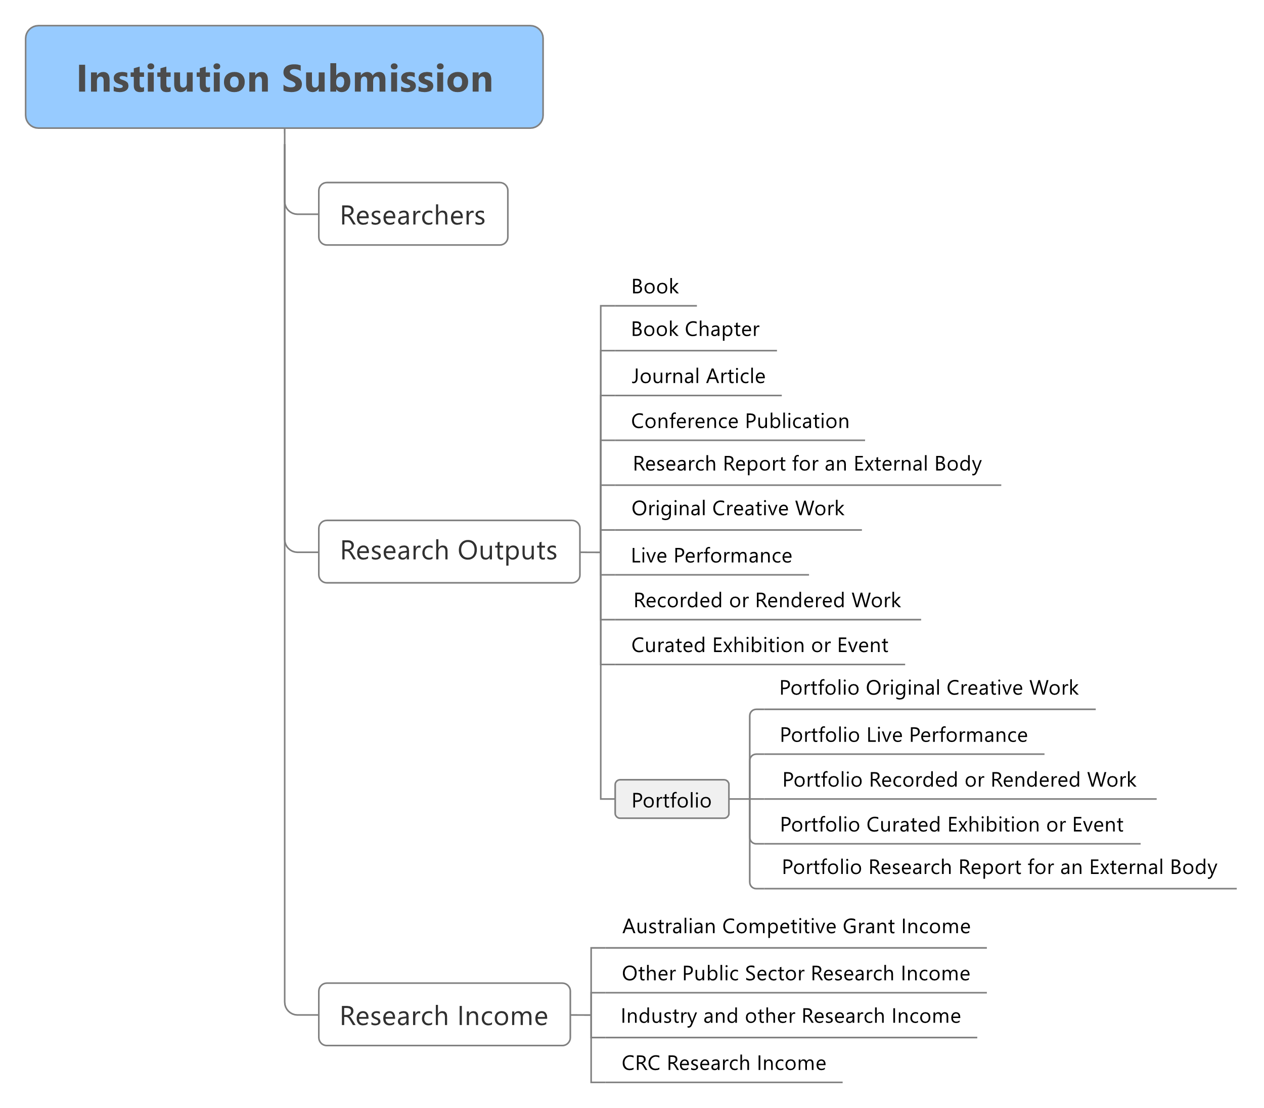

Figure Overview of Submission Data Structure

## 3.2 Researchers

The following data descriptions apply to the submission of all eligible researchers for the purposes of ERA. To determine the eligibility of a researcher for inclusion in ERA, please refer to section 4.3.1 of the ERA 2023 Submission Guidelines.

Figure 4 shows how the staff reference attribute provided for each eligible researcher corresponds to the same attribute provided for all the research outputs associated with that eligible researcher.

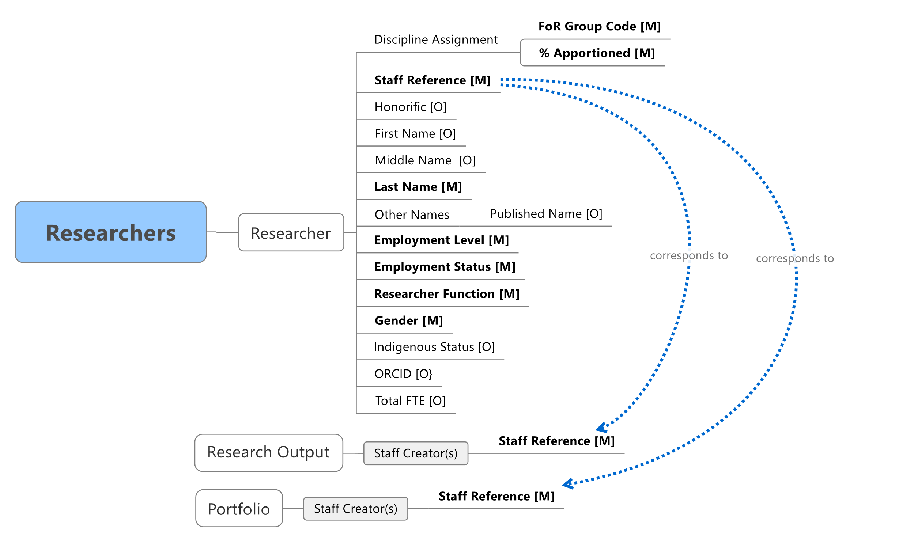

Figure Researchers Data Structure

### 3.2.1 Researcher

The following data items lie within the eligible researcher element of the ERA XML submission schema. Specific detail related to each data item, such as the field length, are in the ERA XML submission schema.

| **Concept Key** | **XML Schema Data Item** | **Description** |
| --- | --- | --- |
| Staff Reference | staffReference **[Mandatory]** | A unique reference given by the institution for each eligible researcher. |
| Honorific | honorific [Optional] | The preferred title of a researcher (e.g. Dr, Professor, etc.). |
| First Name | firstName [Optional] | The first or given name of a researcher. |
| Middle Name | middleName [Optional] | Any other given name(s) of a researcher that is not the researcher’s first name. |
| Last Name | lastName **[Mandatory]** | The last name, family name or surname of a researcher. |
| Other Names | otherNames [Optional] | Any other names under which the researcher has published research outputs. |
| Employment Status | employmentStatus **[Mandatory]** | The basis on which the researcher is affiliated to the institution.  Allowed values are:  1 = Employed  2 = Employed on a Casual Basis  3 = Other Employed |
| Employment Level | employmentLevel [Mandatory] | This is based on the Higher Education Staff Data Collection Element 408:  Allowed values are:  013 Level E  014 Level D  042 Level C  066 Level B  100 Level A  001 ‘Vice-Chancellor’  005 ‘Deputy Vice-Chancellor’  220 ‘Non-academic staff – senior executive’  201 ‘Level 1’  202 ‘Level 2’  203 ‘Level 3’  204 ‘Level 4’  205 ‘Level 5’  206 ‘Level 6’  207 ‘Level 7’  208 ‘Level 8’  209 ‘Level 9’  210 ‘Level 10’ |
| FTE | FTE [Optional] | The total FTE of a researcher within the institution. If the employment status is set to ‘Employed’, then SEER enforces this attribute. |
| Researcher Function | researcherFunction [Mandatory] | The employment status of the researcher, derived from Higher Education Staff Data Collection Element 412.  Allowed values are:  A. = Research only  B. = Teaching and Research  C.= Other Function |
| Gender | gender [Mandatory] | The gender of a researcher.  Allowed values are:  Male  Female  X (indeterminate/intersex/unspecified) |
| Indigenous | indigenousStatus [Optional] | Allowed values are:  2. Non-Indigenous – neither Aboriginal nor Torres Strait Islander origin  3. Of Aboriginal origin but not Torres Strait Islander  4. Of Torres Strait Islander but not Aboriginal  5. Both Aboriginal and Torres Strait islander Origin  9. No information |
| ORCID | orcid [Optional] | A Unique Digital identifier for each researcher issue by ORCID |
| Discipline Assignment | disciplineAssignment [Mandatory] | A collection of researcher FoRs with corresponding apportionment (see Discipline Assignment table below). |

### 3.2.2 Discipline assignment

The following attributes lie within the discipline assignment element. No fewer than one and up to three four-digit FoR codes must be assigned to an eligible researcher.

| **Concept Key** | **XML Schema Attribute** | **Description** |
| --- | --- | --- |
| FoR Group Code | forGroupCode **[Mandatory]** | The ANZSRC four-digit FoR code(s) (up to three) assigned to the researcher. |
| FoR Group % Apportionment | apportionment **[Mandatory]** | The percentage of the researcher’s affiliation to each FoR assigned to that researcher. The percentage of all FoR codes must equal 100. |

## 3.3 Research outputs

The data items in Figure 5 below apply to the submission of all eligible research outputs for the purposes of ERA. To determine the eligibility of a research output for inclusion in ERA, please refer to section 4.4 of theERA 2023 Submission Guidelines.

**NOTE** – For each research output across all types, the institution must provide the list of all creators named in the research output. However, where the research output consists of many creators, the institution must provide a list of all creators in the order that they appear on the publication, up to the last staff creator claimed by the institution. For example, if the research output has a thousand creators and the last staff creator submitted by the institution appears as creator number 250, the institution must provide the creator list showing 250 creators in the order that they appear on the publication.

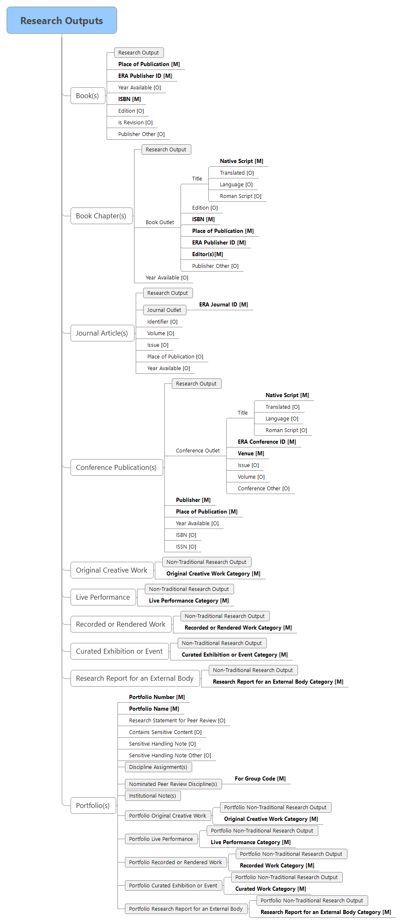

Figure Research Outputs Data Structure

### 3.3.1 Traditional research outputs (general)

The data structure in Figure 6 below applies to each eligible research output, irrespective of the research output type (i.e. book, book chapter, journal article, conference publication – full paper refereed).

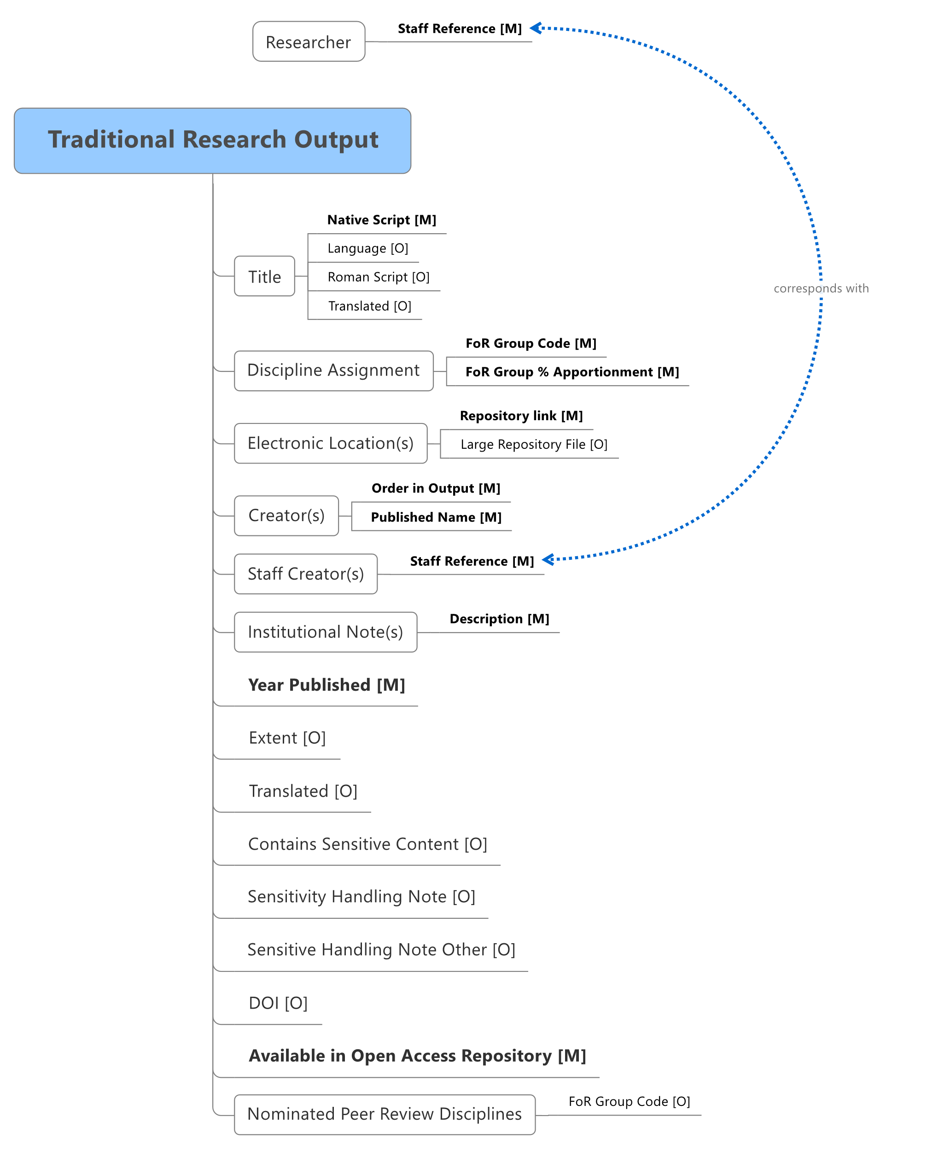

Figure Generic Traditional Research Output Data Structure

**NOTE** – For each research output across all types, the institution must provide the list of all creators named in the research output. However, where the research output consists of a large number of creators, the institution must provide a list of all creators in the order that they appear on the publication, up to the last staff creator claimed by the institution. For example, if the research output has a thousand creators and the last staff creator submitted by the institution appears as creator number 250, the institution must provide the creator list showing 250 creators in the order that they appear on the publication.

#### 3.3.1.1 Generic traditional research output element

The following data items lie within the generic traditional research output element. In addition to these generic data items, each traditional research output type will have its own specific data requirements.

| **Concept Key** | **XML Schema Data Item** | **Description** |
| --- | --- | --- |
| Title | title **[Mandatory]** | The title of the research output using complex format as specified in the Artifact Title. |
| Discipline Assignment | disciplineAssignment **[Mandatory]** | A collection of FoRs with corresponding apportionment of research output. |
| Creator(s) | creators **[Mandatory]** | The author(s) of the research output. The information details required for each Creator are specified in the Creator table. |
| Staff Creator(s) | staffCreators **[Mandatory]** | The staff Reference(s) associated with the research output. |
| Extent | extent [Optional] | The size or duration of the resource. |
| Year Published | yearPublished **[Mandatory]** | The four-digit calendar year in which the research output was published. |
| Available in Open Access Repository | availableInOpenAccessRepository  **[Mandatory]** | Indicates whether the research output is available in an open access institutional repository in line with the ARC Open Access Policy. |
| Translated | isTranslated [Optional] | Indicates that the research output submitted is a scholarly translation. |
| Nominated Peer Review Disciplines | nominatedPRDiscipline [Optional] | The FoR code(s) under which this research output should be peer reviewed. |
| Electronic Location(s) | electronicLocations [Optional] | The electronic location(s) of each research output. If the research output is marked as being available in the repository, then SEER enforces this attribute.  Required if nominated for ERA peer review. |
| Contains Sensitive Content | containsSensitiveContent [Optional] | Indicates that the research output requires special handling in the ERA peer review process because of the content. |
| Sensitive Handling Note | sensitiveNote [Optional] | The sensitive note outlines the appropriate handling of the sensitive research output(s).  If the research output has been marked as Contains Sensitive Content, then SEER enforces this attribute.  Allowed attributes are:   1. Indigenous/First Nations people should be aware that this output contains images, voices and/or names of deceased persons. 2. Indigenous/First Nations people should be aware that this output is about women’s business. 3. Indigenous/First Nations people should be aware that this output is about men’s business. 4. Assessors should be aware that this output contains content related to any of the following: violence, family or domestic violence, self-harm, sexual assault, suicide, family child removal, refugee experiences, war survivor experiences or other traumatic experiences that may be distressing or harmful to some people. 5. Assessors should be aware that this output contains content with explicit language, hate speech, nudity or sexuality, or drug use which may be confronting and potentially distressing to some people. |
| Sensitive Handling Note Other | sensitiveNoteOther [Optional] | Sensitivity note free text when predetermined answer is not suitable. |
| Institutional Submission Notes | institutionalNotes [Optional] | The Institutional Notes associated with the research output. |
| DOI | doi [Optional] | Identifier to uniquely identify objects. |

#### 3.3.1.2 Traditional research output discipline assignment

The following attributes lie within the discipline assignment element. No fewer than one and up to three four-digit FoR codes must be assigned to an eligible research output.

| **Concept Key** | **XML Schema Attribute** | **Description** |
| --- | --- | --- |
| FoR Group Code | forGroupCode **[Mandatory]** | The ANZSRC four-digit FoR code(s) (up to three) assigned to the research output. |
| FoR Group % Apportionment | apportionment **[Mandatory]** | The percentage of the research output’s affiliation to each FoR assigned to that research output. The percentage of all FoR codes must equal 100. |

#### 3.3.1.3 Traditional research output title (Artifact title)

The following attributes lie within the title element of the ERA XML submission schema.

| **Concept Key** | | **XML Schema Attribute** | **Description** |
| --- | --- | --- | --- |
| Native Script | | nativeScript **[Mandatory]** | The title of the research output. |
| Language | | language [Optional] | If the title is in a language other than English, then the language code should be determined using ABS 1267.0. |
| Roman Script | | romanScript [Optional] | Phonetic rendering of the full title in Roman characters, where the title of the output is in a foreign language, particularly if the title is in Non-roman characters. |
| Translated | translated [Optional] | The English translation of a research output Title, where the title in nativeScript is in a language other than English. | |

#### 3.3.1.4 Traditional research output electronic location

The following attributes lie within the electronic location element and are for research outputs that are nominated for ERA peer review and available in an institutionally supported repository.

| **Concept Key** | **XML Schema Attribute** | **Description** |
| --- | --- | --- |
| Repository link | repositoryLink **[Mandatory]** | The Uniform Resource Identifier (e.g. URL, Handle, etc.) that links to the research output. |
| Large Repository File | isLargeRepositoryFile [Optional] | Indicates whether the research output at this electronic location exceeds the recommended maximum size. Refer to section 4.1.1.4 below for more details.  This value defaults to FALSE. |

#### 3.3.1.5 Traditional research output creator

The following attributes lie within the creator element and describe the data requirement for the authors of the submitted research output.

| **Concept Key** | **XML Schema Attribute** | **Description** |
| --- | --- | --- |
| Order in the Output | orderInOutput **[Mandatory]** | The order in which the creator of the research output is listed on the research output. |
| Published name | publishedName **[Mandatory]** | The name (as published) of the creator, as listed on a research output (e.g. J. Block). All names on the output should be provided; not just those of staff researcher(s). |

#### 3.3.1.6 Traditional research output staff creator

The following attribute lies within the staff creator element. This staff reference attribute links the research output element with the researcher element.

| **Concept Key** | **XML Schema Attribute** | **Description** |
| --- | --- | --- |
| Staff Reference | staffReference **[Mandatory]** | A unique reference given by the institution to each eligible researcher. |

#### 3.3.1.7 Traditional research output institutional submission notes

The following attribute lies within the institutional submission notes element. For each research output, the institution may nominate up to two institutional submission notes. Where the research output is associated with error or warning message, the Institution Submission notes will be included in the XML snippet as part of the error and warning report.

| **Concept Key** | **XML Schema Attribute** | **Description** |
| --- | --- | --- |
| Institutional Notes Description | description **[Mandatory]** | The description of the institutional submission note within the institution that is associated with the research. |

### 3.3.2 Book

The following data items lie within the book element of the ERA XML submission schema. To determine the eligibility of a book for inclusion in ERA, please refer to section 4.4.8.1 of the ERA 2023 Submission Guidelines.

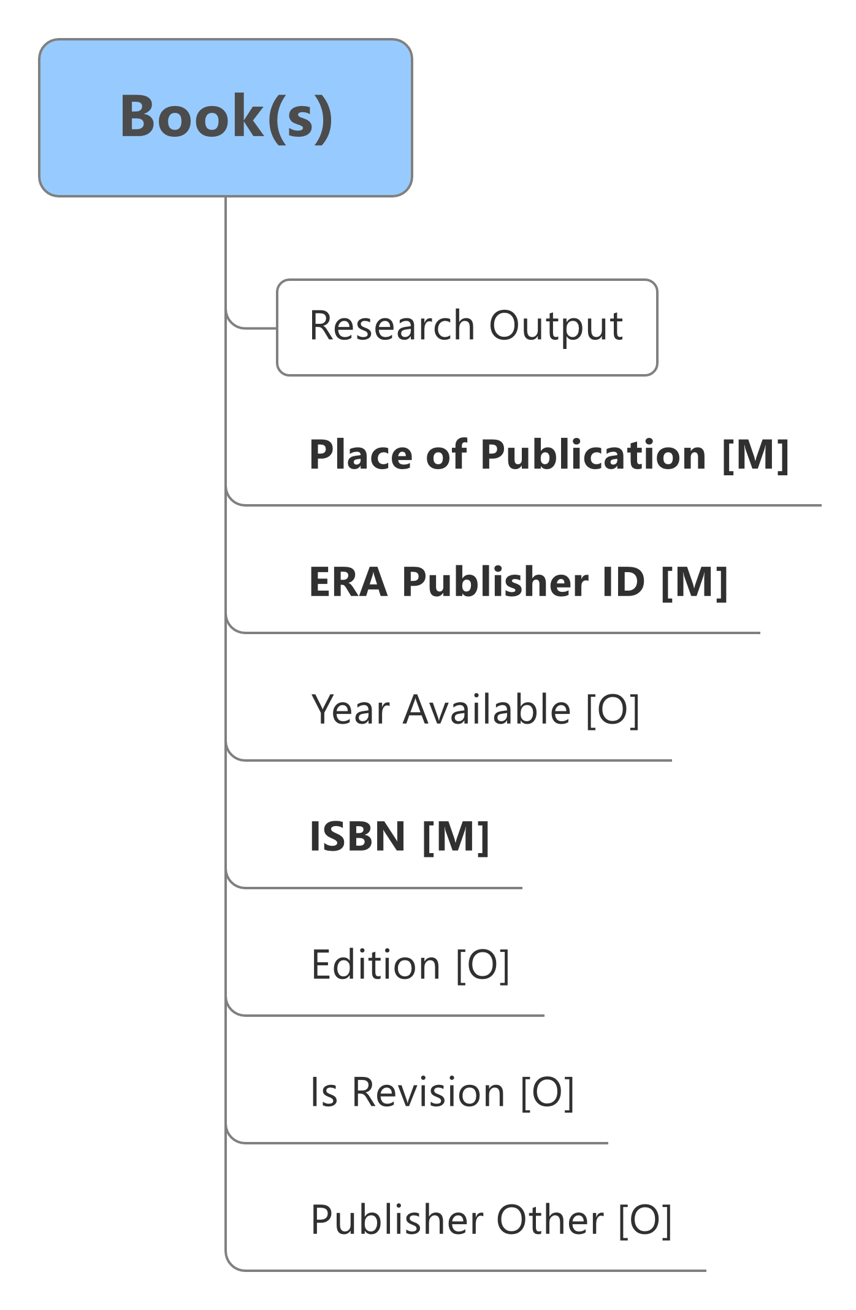

Figure Book Data Structure

| **Concept Key** | **XML Schema Data Items** | **Description** |
| --- | --- | --- |
| Is Revision | isRevision [Optional] | Distinguishes between the original and subsequent versions of a book submitted as a research output. This value defaults to FALSE. |
| Edition | edition [Optional] | The edition of the book. |
| ISBN | isbn [Mandatory] | The unique International Standard Book Number of the book. |
| ERA Publisher ID | eraPublisherId **[Mandatory]** | A unique identifier assigned by the ARC to a book publisher. |
| Place of Publication | placeOfPublication **[Mandatory]** | The location at which the research output was published. |
| Year Available | yearAvailable [Optional] | The four-digit calendar year in which the research output was first available (if different to the Year Published). |
| Publisher Other | publisherOther [Optional] | The name of the book publisher if the ARC has not assigned the book publisher a unique identifier. |

### 3.3.3 Book chapter

The following data items lie within the book chapter element of the ERA XML submission schema. To determine the eligibility of a book chapter for inclusion in ERA, please refer to section 4.4.8.2 of the ERA 2023 Submission Guidelines*.*

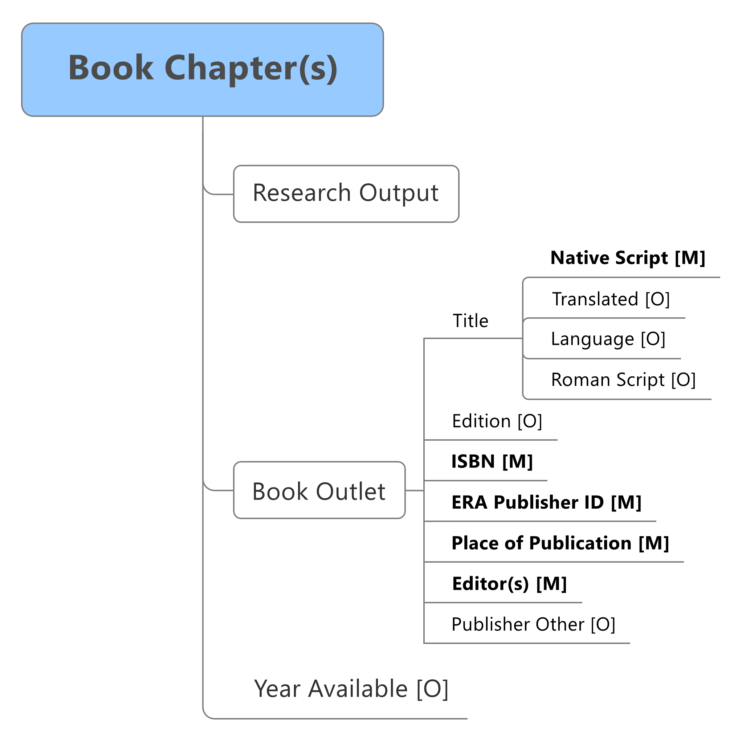

Figure Book Chapter Data Structure

| **Concept Key** | **XML Schema Data Item** | **Description** |
| --- | --- | --- |
| Book Outlet | bookOutlet **[Mandatory]** | Specific information regarding the book in which the book chapter was published (see Book Outlet table below). |
| Year Available | yearAvailable [Optional] | The four-digit calendar year in which the book was first available (if different to the Year Published). |

### 3.3.3 Book outlet

The following attributes lie within the book outlet element. The institution must provide the following book outlet attributes for each book chapter submitted as an eligible research output.

| **Concept Key** | **XML Schema Data Item** | **Description** |
| --- | --- | --- |
| Title | title **[Mandatory]** | The title of book in which the book chapter was published. |
| Edition | edition [Optional] | The edition of the book in which the book chapter was published. |
| ISBN | isbn **[Mandatory]** | The International Standard Book Number of the book in which the book chapter was published. |
| ERA Publisher ID | eraPublisherId **[Mandatory]** | A unique identifier assigned by the ARC to a book publisher. |
| Place of Publication | placeOfPublication **[Mandatory]** | The location at which the book was published. |
| Editor(s) | editor **[Mandatory]** | The name of the editor(s) of the book in which the book chapter was published. |
| Publisher Other | publisherOther [Optional] | The name of the book publisher if the ARC has not assigned the book publisher a unique identifier. |

### 3.3.5 Journal article

The following data items lie within the journal article element of the ERA XML submission schema. To determine the eligibility of a journal article for inclusion in ERA, please refer to section 4.4.8.3 of the ERA 2023 Submission Guidelines.

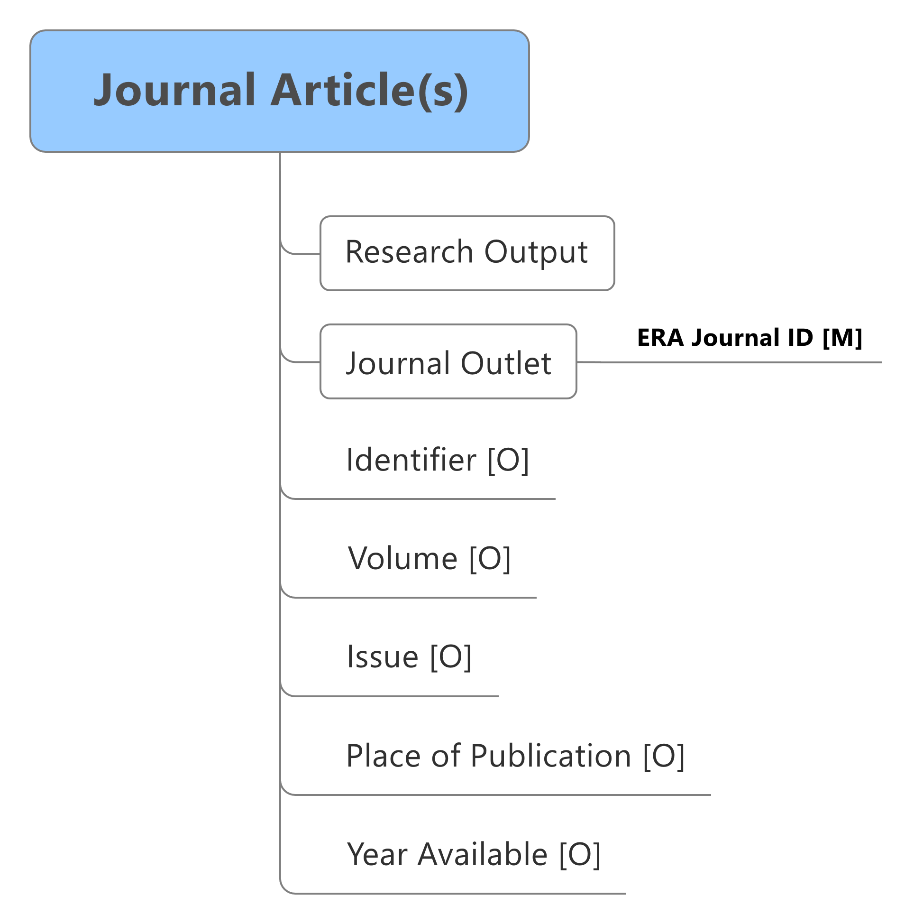

Figure Journal Article Data Structure

| **Concept Key** | **XML Schema Data Item** | **Description** |
| --- | --- | --- |
| Journal Outlet | journalOutlet **[Mandatory]** | The unique identifier assigned by the ARC to a journal. |
| Electronic Identifier | identifier [Optional] | The unique journal article output identifier provided by the citation data provider. |
| Volume | journalVolume [Optional] | The volume number of the journal. |
| Issue | journalIssue [Optional] | The issue number of the journal. |
| Place of Publication | placeOfPublication [Optional] | The location at which the journal article was published. |
| Year Available | yearAvailable [Optional] | The four-digit calendar year in which the journal article was first available (if different to the Year Published). |

#### 3.3.5.1 Journal outlet

The following mandatory attribute lies within the journal outlet element.

| **Concept Key** | **XML Schema Data Item** | **Description** |
| --- | --- | --- |
| ERA Journal ID | eraJournalid **[Mandatory]** | A unique identifier assigned by the ARC to a journal. |

### 3.3.6 Conference publication

The following data items lie within the conference publication element of the ERA XML submission schema. To determine the eligibility of a conference publication – full paper refereed for inclusion in ERA, please refer to section 4.4.8.4 of the ERA 2023 Submission Guidelines.

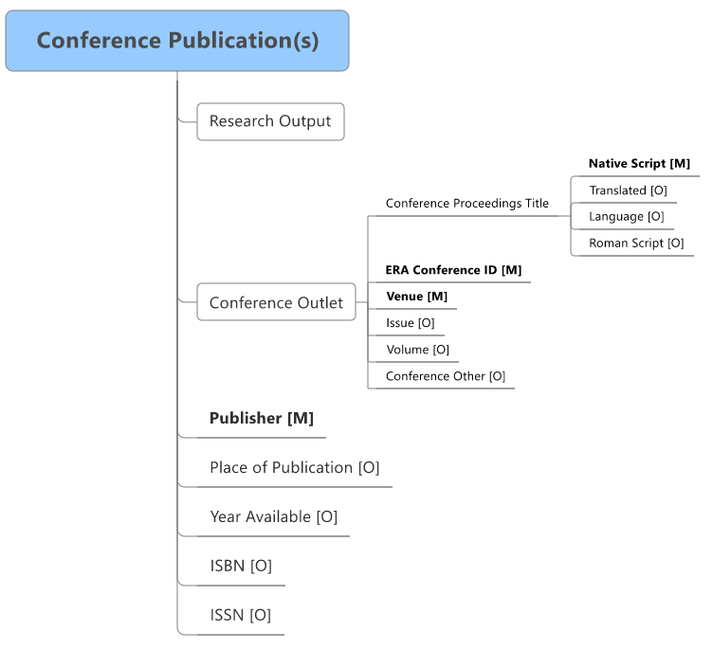

Figure Conference Publication Data Structure

| **Concept Key** | **XML Schema Data Item** | **Description** |
| --- | --- | --- |
| Conference Outlet | conferencePublicationOutlet **[Mandatory]** | Details submitted for the conference publication (see Conference Outlet element below). |
| Publisher | publisher **[Mandatory]** | The entity responsible for making the conference publication publicly available. |
| Place of Publication | placeOfPublication [Optional] | The location at which the conference proceedings were published. |
| Year Available | yearAvailable [Optional] | The four-digit calendar year in which the conference publication was first available (if different to the Year Published). |
| ISBN | isbn [Optional] | The International Standard Book Number assigned to the conference publication. |
| ISSN | issn [Optional] | The International Standard Serial Number assigned to the conference publication. |

#### 3.3.6.1 Conference outlet

The following data items lie within the conference outlet element.

| **Concept Key** | **XML Schema Data Item** | **Description** |
| --- | --- | --- |
| Conference Paper Title | title **[Mandatory]** | The name of the publication in which the conference is published. |
| ERA Conference ID | eraConferenceId **[Mandatory]** | A unique identifier assigned by the ARC to a conference series. |
| Venue | venue [Mandatory] | The venue name where the conference was held. |
| Issue | issue [Optional] | The issue number of the conference or the conference series publication. |
| Volume | volume [Optional] | The volume number of the conference or the conference series publication. |
| Conference Other | conferenceOther [Optional] | The name of the conference or the name of the conference series if the ARC has not assigned the conference a unique identifier. |

#### 3.3.6.2 Conference proceedings title

The following attributes lie within the title element of the ERA XML submission schema.

| **Concept Key** | **XML Schema Attribute** | **Description** |
| --- | --- | --- |
| Native Script | nativeScript **[Mandatory]** | The title of the research output. |
| Translated | translated [Optional] | The English translation of a research output Title, where the title in nativeScript is in a language other than English. |
| Language | language [Optional] | If the title is in a language other than English, then the language code should be determined using ABS 1267.0. |
| Roman Script | romanScript [Optional] | Phonetic rendering of the full title in Roman characters, where the title of the output is in a foreign language, particularly if the title is in non‑Roman characters. |

### 3.3.7 Non-traditional research outputs

The following generic data structure applies to the submission of non-traditional research output in the ERA XML submission schema. To determine the eligibility of a non-traditional research output for inclusion in ERA, please refer to section 4.4.9 of the ERA 2023 Submission Guidelines.

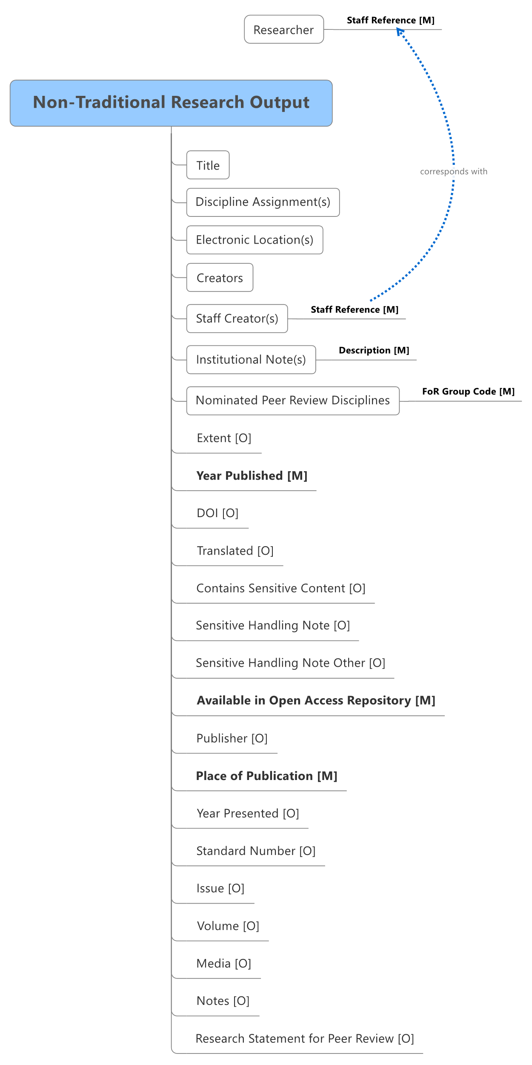

Figure Non-Traditional Research Output Data Structure

The following generic data items apply to the non-traditional research output attribute.

| **Concept Key** | **XML Schema Data Item** | **Description** |
| --- | --- | --- |
| Title | title **[Mandatory]** | The title of the non-traditional research output using complex format as specified in the Artifact Title. |
| Discipline Assignment | disciplineAssignment **[Mandatory]** | A collection of FoRs with corresponding apportionment of non-traditional research output. |
| Creators | creators **[Mandatory]** | The author(s) of the non-traditional research output. The information details required for each Creator is specified in the Creator table. |
| Staff Creator(s) | staffCreators **[Mandatory]** | A staff Reference(s) associated with the non‑traditional research output. |
| Extent | extent [Optional] | The size or duration of the resource. |
| Year Published | yearPublished **[Mandatory]** | The four-digit calendar year in which the non-traditional research output was published. |
| Translated | isTranslated [Optional] | Indicates that the research output submitted is a scholarly translation. |
| Nominated Peer Review Discipline | nominatedPRDiscipline [Optional] | The FoR codes(s) under which the non‑traditional research output should be peer reviewed. |
| Available in Open Access Repository | availableInOpenAccessRepository  **[Mandatory]** | Indicates whether the research output is available in an open access institutional repository in line with the ARC Open Access Policy. |
| Electronic Location(s) | electronicLocations [Optional] | The electronic location(s) of each non-traditional research output.  If the non-traditional research output is marked as being available in the repository, then SEER enforces this attribute.  Required if nominated for ERA peer review. |
| Contains Sensitive Content | containsSensitiveContent [Optional] | Indicates that the non-traditional research output requires special handling in the ERA peer review process because of the content. |
| Sensitive Handling Note | sensitiveNote [Optional] | The sensitive note outlines the appropriate handling of the sensitive non-traditional research output.  If the non-traditional research output has been marked as Contains Sensitive Content, then SEER enforces this attribute.  Allowed attributes are:   1. Indigenous/First Nations people should be aware that this output contains images, voices and/or names of deceased persons. 2. Indigenous/First Nations people should be aware that this output is about women’s business. 3. Indigenous/First Nations people should be aware that this output is about men’s business. 4. Assessors should be aware that this output contains content related to any of the following: violence, family or domestic violence, self-harm, sexual assault, suicide, family child removal, refugee experiences, war survivor experiences or other traumatic experiences that may be distressing or harmful to some people. 5. Assessors should be aware that this output contains content with explicit language, hate speech, nudity or sexuality, or drug use which may be confronting and potentially distressing to some people. |
| Sensitive Handling Note Other | sensitiveNoteOther [Optional] | Sensitivity note free text when predetermined answer is not suitable. |
| Institutional Submission Notes(s) | institutionalNotes[Optional] | The Institutional Notes(s) associated with the non-traditional research output. | |
| DOI | doi [Optional] | Identifier to uniquely identify objects. | |
| Publisher | publisher [Optional] | The entity responsible for making the non-traditional research output publicly available. | |
| Place of Publication | placeOfPublication [**Mandatory**] | The location at which the non-traditional research output was made publicly available (e.g. the venue at which the item was first presented). | |
| Year Presented | yearPresented [Optional] | The four-digit calendar year in which the non-traditional research output was presented (if different to the Year Published). | |
| Standard Number | standardNumber [Optional] | Reference number for the non-traditional research output (e.g. the International Standard Music Number (ISMN)). | |
| Issue | issue [Optional] | The issue number of the non-traditional research output. | |
| Volume | volume [Optional] | The volume number of the non-traditional research output. | |
| Media | media [Optional] | The medium or format of the non-traditional research output (e.g. interactive video installation, website). | |
| Notes | notes [Optional] | Any additional descriptive metadata for the non-traditional research output (e.g. venue name and type, venue commissioner, role of creator). | |
| Research Statement for Peer Review | researchStatement [Optional] | A statement identifying the research component of a non-traditional research output.  If the non-traditional research output has been made available for peer review, then SEER enforces this attribute. | |

#### 3.3.7.1 Non-traditional research output discipline assignment

The following attributes lie within the discipline assignment element. No fewer than one and up to three four-digit FoR codes must be assigned to an eligible non-traditional research output.

| **Concept Key** | **XML Schema Attribute** | **Description** |
| --- | --- | --- |
| FoR Group Code | forGroupCode **[Mandatory]** | The ANZSRC four-digit FoR code(s) (up to three) assigned to the non-traditional research output. |
| FoR Group % Apportionment | apportionment **[Mandatory]** | The percentage of the non-traditional research output’s affiliation to each FoR assigned to the non-traditional research output. The percentage of all FoR codes must equal 100. |

#### 3.3.7.2 Non-traditional research output title (Artifact title)

The following attributes lie within the title element of the ERA XML submission schema.

| **Concept Key** | **XML Schema Attribute** | **Description** |
| --- | --- | --- |
| Native Script | nativeScript **[Mandatory]** | The title of the non-traditional research output. |
| Language | language [Optional] | If the title is in a language other than English, then the language code should be determined using ABS 1267.0. |
| Roman Script | romanScript [Optional] | Phonetic rendering of the full title in Roman characters, where the title of the output is in a foreign language, particularly if the title is in non-Roman characters. |
| Translated | translated [Optional] | The English translation of a non-traditional research output Title, where the title in nativeScript is in a language other than English. |

#### 3.3.7.3 Non-traditional research output electronic location

The following attributes lie within the electronic location element and are for non-traditional research outputs that are nominated for ERA peer review and available in an institutionally supported repository.

| **Concept Key** | **XML Schema Attribute** | **Description** |
| --- | --- | --- |
| Repository link | repositoryLink **[Mandatory]** | The Uniform Resource Identifier (e.g. URL, Handle, etc.) that links to the non-traditional research output. |
| Large Repository File | isLargeRepositoryFile [Optional] | Indicates whether the non-traditional research output at this electronic location exceeds the recommended maximum size. Refer to section 4 below for more details.  This value defaults to FALSE. |

#### 3.3.7.4 Non-traditional research output creator

The following attributes lie within the creator element and describe the data requirement for the authors of the submitted non-traditional research output.

| **Concept Key** | **XML Schema Attribute** | **Description** |
| --- | --- | --- |
| Order in the Output | orderInOutput **[Mandatory]** | The order in which the creator is listed on a non-traditional research output. |
| Published name | publishedName **[Mandatory]** | The name (as published) of the creator, as listed on or within a non-traditional research output (e.g. J. Block). All names on the output should be provided; not just those of staff researcher(s). |

#### 3.3.7.5 Non-traditional research output staff creator

The following attribute lies within the staff creator element. This staff reference attribute links the non-traditional research output element with the research element.

| **Concept Key** | **XML Schema Attribute** | **Description** |
| --- | --- | --- |
| Staff Reference | staffReference **[Mandatory]** | A unique reference given by the institution to each eligible researcher. |

#### 3.3.7.6 Non-traditional research output institutional submission note(s)

The following attributes lie within the institutional submission note element. For each non-traditional research output, the institution may nominate up to two institutional submission notes.

| **Concept Key** | **XML Schema Attribute** | **Description** |
| --- | --- | --- |
| Institutional Description | description [Optional] | The full description of the institutional submission note within the institution that is associated with the research. |

### 3.3.8 Non-traditional research output types

The following categories apply to non-traditional output types, and have their own data requirements:

* original creative works
* live performance of creative works
* recorded or rendered works
* curated exhibition or event
* research report for an external body.

#### 3.3.8.1 Original creative works

The following attribute lies within the original creative works element.

| **Concept Key** | **XML Schema Attribute** | **Description** |
| --- | --- | --- |
| Creative work category | category **[Mandatory]** | Allowed values are:  1. = Visual artwork  2. = Design / Architectural work  3. = Textual work  4. = Other |

#### 3.3.8.2 Live performance of creative works

The following attribute lies within the live performance of creative works element.

| **Concept Key** | **XML Schema Attribute** | **Description** |
| --- | --- | --- |
| Live Performance Category | category **[Mandatory]** | Allowed values are:  1. = Music  2. = Play  3. = Dance  4. = Other |

#### 3.3.8.3 Recorded or rendered works

The following attribute lies within the recorded or rendered works element.

| **Concept Key** | **XML Schema Attribute** | **Description** |
| --- | --- | --- |
| Recorded Work Category | category **[Mandatory]** | Allowed values are:  1. = Film, video  2. = Performance  3. = Inter-arts  4. = Digital creative work  5. = Website/ web exhibition  6. = Other |

#### 3.3.8.4 Curated exhibition or event

The following attribute lies within the curated exhibition or event element.

| **Concept Key** | **XML Schema Attribute** | **Description** |
| --- | --- | --- |
| Curated Work Category | category **[Mandatory]** | Allowed values are:  1.= Web-based exhibition work  2.= Exhibition/event  3.= Festival  4.= Other |

#### 3.3.8.5 Research report for an external body

The following attribute lies within the research report for an external body element.

| **Concept Key** | **XML Schema Attribute** | **Description** |
| --- | --- | --- |
| Research report category | category **[Mandatory]** | Allowed values are:  1. = Public sector  2. = Industry  3. = Not for profit  4. = Other |

#### 3.3.8.6 Portfolio

The data structure outlined in Figure 12 below is specific to the data requirements within the portfolio element. Data requirements for the portfolio element are constructed separately within the schema to those of individual traditional or non-traditional research outputs not related to a parent portfolio.

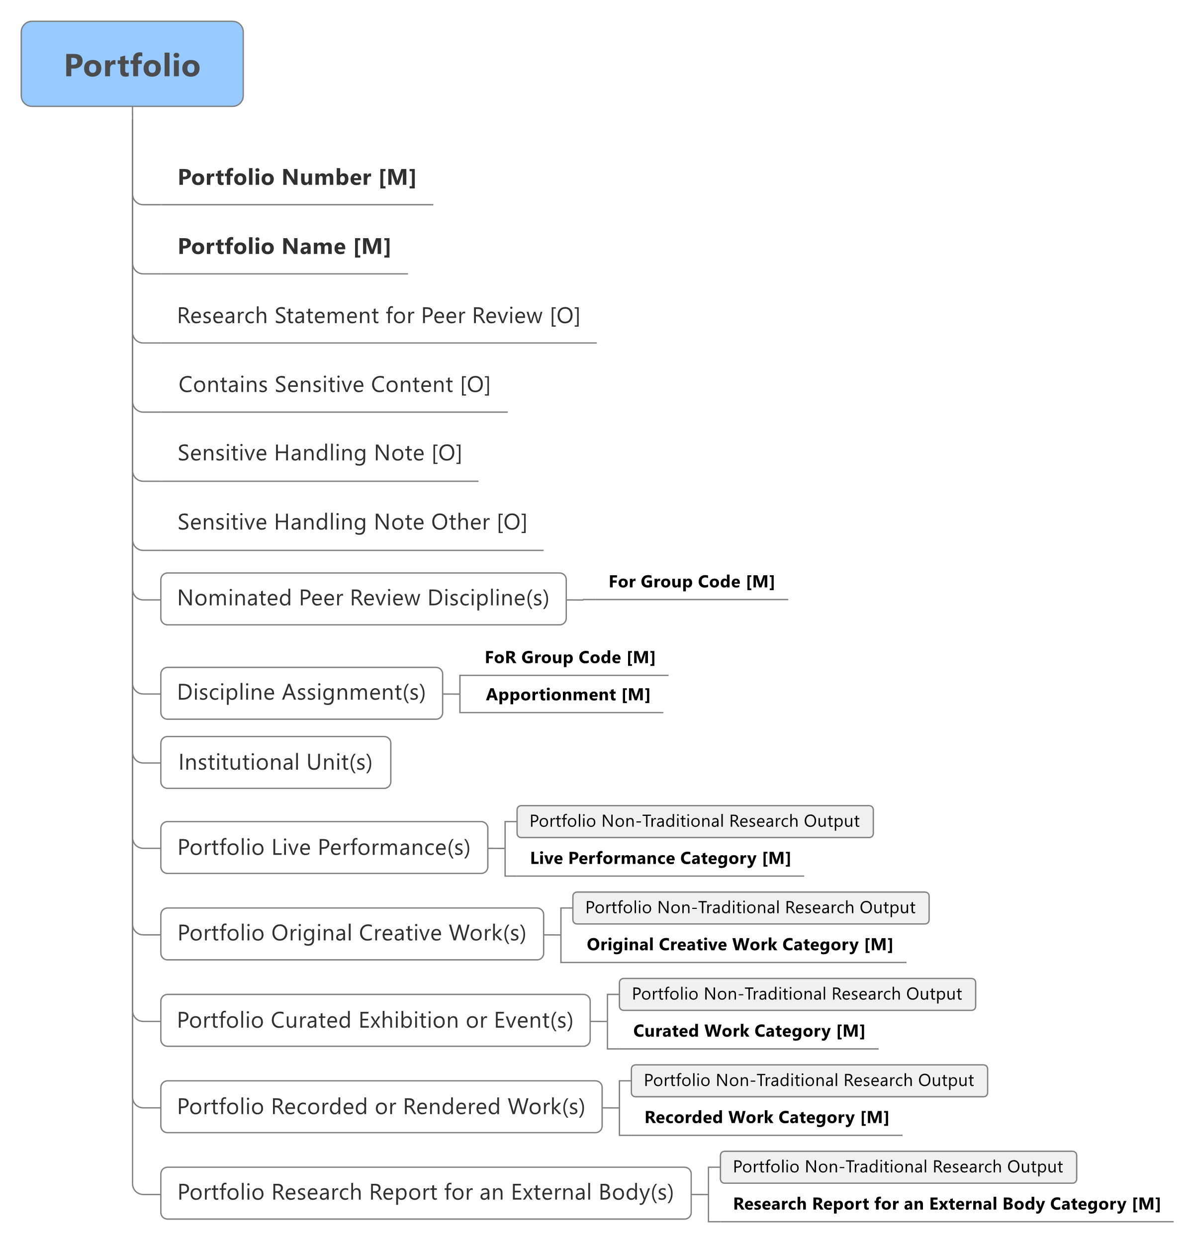

Figure 12 Portfolio Data Structure

The following data items lie within the generic portfolio element. In addition to these generic data items, each portfolio type will have its own specific data requirements.

| **Concept Key** | **XML Schema Attribute** | **Description** |
| --- | --- | --- |
| Portfolio Number | portfolioNumber **[Mandatory]** | The unique number assigned to each portfolio of individual works, constituting a single non‑traditional research output. |
| Portfolio Name | name **[Mandatory]** | The unique name given to a portfolio of individual works, constituting a single non-traditional research output. |
| Research Statement for Peer Review | researchStatement [Optional] | A statement identifying the research relevance of the collection of non-traditional research outputs within the portfolio.  If the portfolio is nominated for ERA peer review, then SEER enforces this attribute. |
| Contains Sensitive Content | containsSensitiveContent [Optional] | Indicates that the collection of work within the portfolio requires special handling in the ERA peer review process because of the content. |
| Sensitive Handling Note | sensitiveNote [Optional] | The sensitive note outlines the appropriate handling of the sensitive portfolio. If the portfolio has been marked as Contains Sensitive Content, then SEER enforces this attribute.  Allowed attributes are:   1. Indigenous/First Nations people should be aware that this output contains images, voices and/or names of deceased persons. 2. Indigenous/First Nations people should be aware that this output is about women’s business. 3. Indigenous/First Nations people should be aware that this output is about men’s business. 4. Assessors should be aware that this output contains content related to any of the following: violence, family or domestic violence, self-harm, sexual assault, suicide, family child removal, refugee experiences, war survivor experiences or other traumatic experiences that may be distressing or harmful to some people. 5. Assessors should be aware that this output contains content with explicit language, hate speech, nudity or sexuality, or drug use which may be confronting and potentially distressing to some people. |
| Sensitive Handling Note Other | sensitiveNoteOther [Optional] | Sensitivity note free text when predetermined answer is not suitable. |
| Nominated Peer Review Discipline | nominatedPRDiscipline [Optional] | The FoR code(s) under which the portfolio should be peer reviewed. |
| Discipline Assignment(s) | disciplineAssignment **[Mandatory]** | The collection of FoRs with corresponding apportionment related to the portfolio (see below). |
| Institutional Submission Note(s) | institutionalNote [Optional] | The Institutional Note(s) associated with the portfolio. |
| Portfolio Live Performance | portfolioLivePerformance [Optional] | The collection of attributes that lies within a Live Performance non-traditional research output within the portfolio (see below). |
| Portfolio Original Creative Work | portfolioOriginalCreativeWork  [Optional] | The collection of attributes that lies within an Original Creative Work non-traditional research output within the portfolio (see below). |
| Portfolio Curated Exhibition or Event | portfolioCuratedExhibitionOrEvent [Optional] | The collection of attributes that lies within a Curated Exhibition or Event non-traditional research output within the portfolio (see below). |
| Portfolio Recorded or Rendered Work | portfolioRecordedOrRenderedWork [Optional] | The collection of attributes that lies within a Recorded or Rendered Work non-traditional research output within the portfolio (see below). |
| Research Report for an External Body | portfolioResearchReportForExternalBody [Optional] | The collection of attributes that lies within a Research Report for an External Body non‑traditional research output within the portfolio (see below). |

##### 3.3.8.6.1 Portfolio discipline assignment

The following attributes lie within the discipline assignment element. No fewer than one and up to three four-digit FoR codes must be assigned to an eligible portfolio.

| **Concept Key** | **XML Schema Attribute** | **Description** |
| --- | --- | --- |
| FoR Group Code | forGroupCode **[Mandatory]** | The ANZSRC four-digit FoR code(s) (up to three) assigned to the portfolio. |
| FoR Group % Apportionment | apportionment **[Mandatory]** | The percentage of the portfolio’s affiliation to each FoR assigned to the portfolio. The percentage of all FoR codes must equal 100. |

##### 3.3.8.6.2 Non-traditional research outputs within a portfolio

The data structure outlined in Figure 13 below is specific to the data requirements for each individual non-traditional research output within a portfolio element.

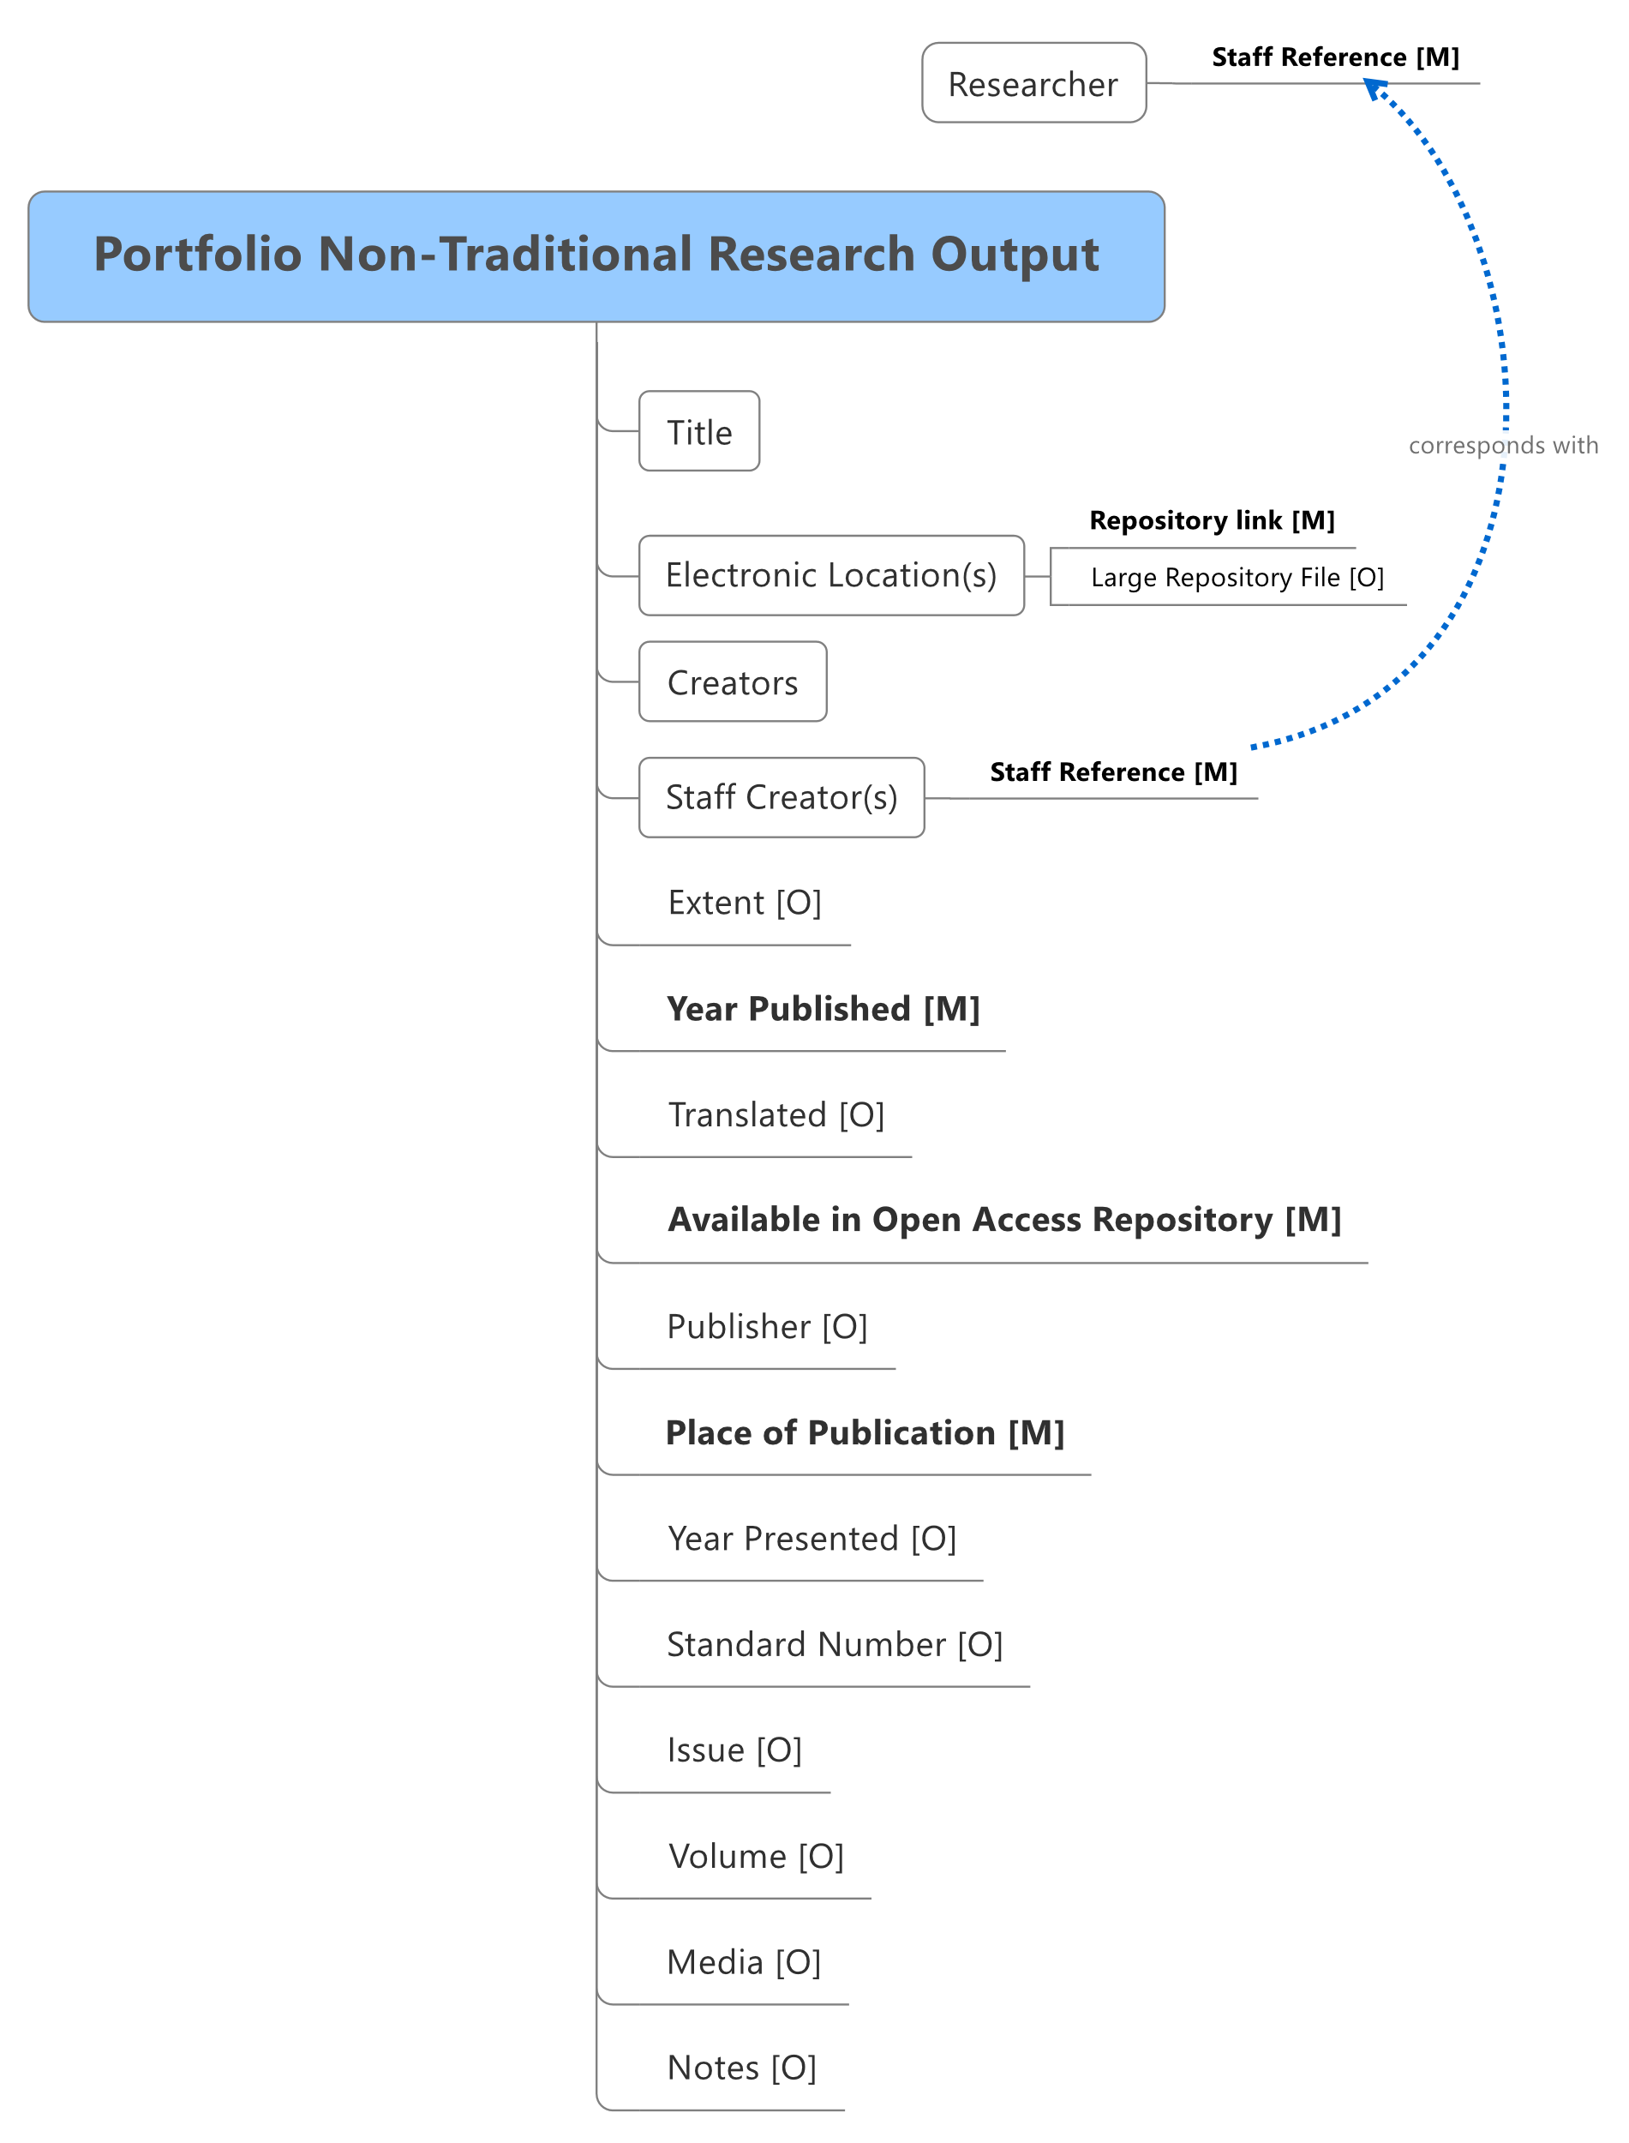

Figure Non-Traditional Research Output Data Structure within a Portfolio

The following data items apply to all non-traditional research outputs submitted as part of a portfolio.

| **Concept Key** | **XML Schema Data Item** | **Description** |
| --- | --- | --- |
| Title | title **[Mandatory]** | The title of the non-traditional research output using complex format as specified in the Artifact Title. |
| Creators | creators **[Mandatory]** | The author(s) of the non-traditional research output. The information details required for each Creator is specified in the Creator table. |
| Staff Creator(s) | staffCreators **[Mandatory]** | A staffReference(s) associated with the non-traditional research output. |
| Extent | extent [Optional] | The size or duration of the resource. |
| Year Published | yearPublished **[Mandatory]** | The four-digit calendar year in which the non-traditional research output was published. |
| Translated | isTranslated [Optional] | Indicates that the research output submitted is a scholarly translation. |
| Available in Open Access Repository | availableInOpenAccessRepository  **[Mandatory]** | Indicates whether the research output is available in an open access institutional repository in line with the ARC Open Access Policy. |
| Electronic Location(s) | electronicLocations [Optional] | The electronic location(s) of each non-traditional research output.  If the non-traditional research output is marked as being available in the repository, then SEER enforces this attribute.  Required if nominated for ERA peer review. |
| Publisher | publisher [Optional] | The entity responsible for making the non-traditional research output publicly available. |
| Place of Publication | placeOfPublication **[Mandatory]** | The location at which the non-traditional research output was made publicly available (e.g. the venue at which the item was first presented). |
| Year Presented | yearPresented [Optional] | The four-digit calendar year in which the non-traditional research output was presented (if different to the Year Published). |
| Standard Number | standardNumber [Optional] | Reference number for the non-traditional research output (e.g. the International Standard Music Number (ISMN)). |
| Issue | issue [Optional] | The issue number of the non-traditional research output. |
| Volume | volume [Optional] | The volume number of the non-traditional research output. |
| Media | media [Optional] | The medium or format of the non-traditional research output (e.g. interactive video installation, website). |
| Notes | notes [Optional] | Any additional descriptive metadata for the non-traditional research output (e.g. venue name and type, venue commissioner, role of creator). |

##### 3.3.8.6.3 Portfolio title (Artifact title)

The following attributes lie within the title element of the ERA XML submission schema.

| **Concept Key** | **XML Schema Attribute** | **Description** |
| --- | --- | --- |
| Native Script | nativeScript **[Mandatory]** | The title of the non-traditional research output. |
| Language | language [Optional] | If the title is in a language other than English, then the language code should be determined using ABS 1267.0. |
| Roman Script | romanScript [Optional] | Phonetic rendering of the full title in Roman characters, where the title of the output is in a foreign language, particularly if the title is in non-Roman characters. |
| Translated | translated [Optional] | The English translation of a non-traditional research output title, where the title in nativeScript is in a language other than English. |

##### 3.3.8.6.4 Portfolio electronic location

The following attributes lie within the electronic location element and are for individual non-traditional research outputs (within a portfolio of work which is nominated for ERA peer review), which are available in an institutionally supported repository.

| **Concept Key** | **XML Schema Attribute** | **Description** |
| --- | --- | --- |
| Repository link | repositoryLink **[Mandatory]** | The Uniform Resource Identifier (e.g. URL, Handle, DOI, etc.) that links to the NTRO. |
| Large Repository File | isLargeRepositoryFile [Optional] | Indicates whether the non-traditional research output at this electronic location exceeds the recommended maximum size. Refer to section 4 below for more details.  This value defaults to FALSE. |

##### 3.3.8.6.5 Portfolio creator

The following attributes lie within the creator element and describe the data requirement for the authors of the submitted non-traditional research output.

| **Concept Key** | **XML Schema Attribute** | **Description** |
| --- | --- | --- |
| Order in the Output | orderInOutput **[Mandatory]** | The order in which the creator is listed on a non-traditional research output. |
| Published name | publishedName **[Mandatory]** | The name (as published) of the creator, as listed on or within a non-traditional research output (e.g. J. Block). All names on the output should be provided; not just those of staff researcher(s). |

##### 3.3.8.6.6 Portfolio staff creator

The following attribute lies within the staff creator element. This staff reference attribute links the non-traditional research output element with the research element.

| **Concept Key** | **XML Schema Attribute** | **Description** |
| --- | --- | --- |
| Staff Reference | staffReference **[Mandatory]** | A unique reference given by the institution to each eligible researcher. |

##### 3.3.8.6.7 Portfolio original creative works

The following attribute lies within the portfolio original creative works element.

| **Concept Key** | **XML Schema Attribute** | **Description** |
| --- | --- | --- |
| Creative work category | category **[Mandatory]** | Allowed values are:  1. = Visual artwork  2. = Design / Architectural work  3. = Textual work  4. = Other |

##### 3.3.8.6.8 Portfolio live performance of creative works

The following attribute lies within the portfolio live performance of creative works element.

| **Concept Key** | **XML Schema Attribute** | **Description** |
| --- | --- | --- |
| Live Performance Category | category **[Mandatory]** | Allowed values are:  1. = Music  2. = Play  3. = Dance  4. = Other |

##### 3.3.8.6.9 Portfolio recorded or rendered works

The following attribute lies within the portfolio recorded or rendered works element.

| **Concept Key** | **XML Schema Attribute** | **Description** |
| --- | --- | --- |
| Recorded Work Category | category **[Mandatory]** | Allowed values are:  1. = Film, video  2. = Performance  3. = Inter-arts  4. = Digital creative work  5. = Website/ web exhibition  6. = Other |

##### 3.3.8.6.10 Portfolio curated exhibition or event

The following attribute lies within the portfolio curated exhibition or event element.

| **Concept Key** | **XML Schema Attribute** | **Description** |
| --- | --- | --- |
| Curated Work Category | category **[Mandatory]** | Allowed values are:  1. = Web-based exhibition work  2. = Exhibition/event  3. = Festival  4. = Other |

##### 3.3.8.6.11 Portfolio research report for an external body

The following attribute lies within the portfolio research report for an external body element.

| **Concept Key** | **XML Schema Attribute** | **Description** |
| --- | --- | --- |
| Research report category | category **[Mandatory]** | Allowed values are:  1. = Public sector  2. = Industry  3. = Not for profit  4. = Other |

## 3.4 Research Income

The data structure outlined in Figure 14 below is specific to the data requirements for research income. To determine the eligibility of research income for inclusion in ERA, please refer to section 4.5 of the ERA 2023 Submission Guidelines.

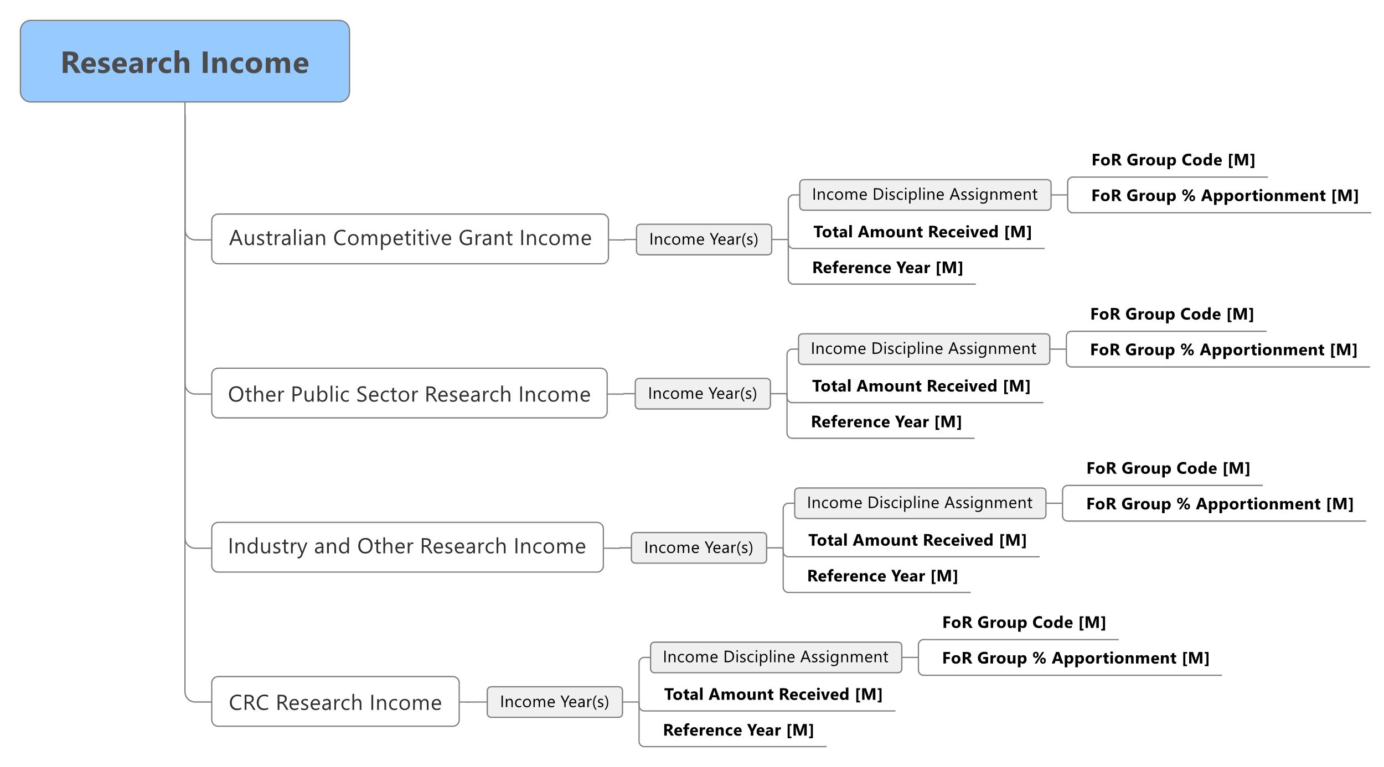

Figure Research Income Data Structure

The data submitted for all eligible research income should accord with that submitted by the institution as part of HERDC for each relevant year of the research income reference period. This is irrespective of the research income type (i.e. Australian Competitive Grant, Other public sector research income, Industry and other research income, CRC income). Refer to the XML submission schema for more detail, such as field length.

### 3.4.1 Australian competitive grant research income

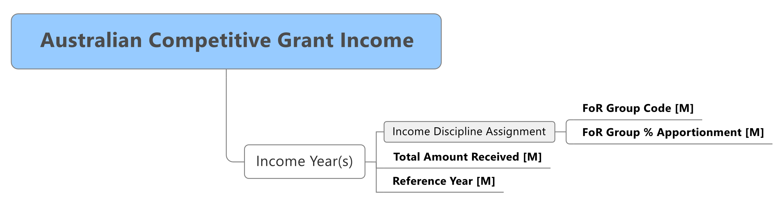

Figure Australian Competitive Grant Research Income Data Structure

The data requirements for Australian Competitive Grant research income are as follows:

| **Concept Key** | **XML Schema Data Item** | **Description** |
| --- | --- | --- |
| Income Years | incomeYears **[Mandatory]** | The collection of research income details for Australian Competitive Grants Research Income (see below). |
| Reference Year | referenceYear **[Mandatory]** | The four-digit calendar year. |

##### Income years

The following data items apply to the income years attribute.

| **Concept Key** | **XML Schema Data Item** | **Description** |
| --- | --- | --- |
| Income Discipline Assignment | incomeDisciplineAssignment **[Mandatory]** | The collection of FoRs associated with the research grant total and the apportionment of the research grant to those FoRs (see Income Discipline Assignment table). |
| Total Amount Received | totalAmountReceived **[Mandatory]** | The total amount of Australian Competitive Grant Research Income received within the reference year. |
| Reference Year | referenceYear **[Mandatory]** | The four-digit calendar year. |

##### Income discipline assignment

The following attributes apply to the discipline assignment for research income.

|  |  |  |
| --- | --- | --- |
| **Concept Key** | **XML Schema Data Item** | **Description** |
| FoR Group Code | forGroupCode **[Mandatory]** | The ANZSRC four-digit FoR code(s) (as many as are relevant) assigned to the research income. |
| FoR Group % Apportionment | apportionment **[Mandatory]** | The percentage of the total research grant received within an income year, disaggregated to the FoR code(s) assigned to the research income. The percentage of all FoR codes must be between 95 and 105, inclusively. |

### 3.4.2 Other public sector research income

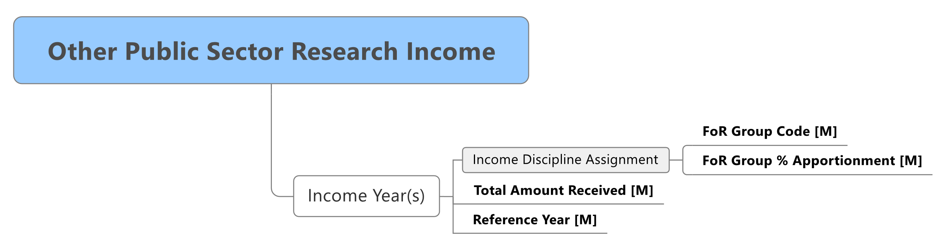

Figure Other Public Sector Research Income Data Structure

The data requirements for other public sector research income are as follows:

| **Concept Key** | **XML Schema Data Item** | **Description** |
| --- | --- | --- |
| Income Years | incomeYears **[Mandatory]** | The collection of research income details for Other Public Sector Research Income (see below). |

#### 3.4.2.1 Income years

The following data items apply to the income years element:

| **Concept Key** | **XML Schema Data Item** | **Description** |
| --- | --- | --- |
| Income Discipline Assignment | incomeDisciplineAssignment **[Mandatory]** | The collection of FoRs associated with the research income and corresponding apportionment of the Research income to those FoRs (see Income Discipline Assignment table). |
| Total Amount Received | totalAmountReceived **[Mandatory]** | The total amount of Other Public Sector Research Income received within the reference year. |
| Reference Year | referenceYear **[Mandatory]** | The four-digit calendar year. |

#### 3.4.2.2 Income discipline assignment

The following attributes apply to the discipline assignment for research income:

| **Concept Key** | **XML Schema Attribute** | **Description** |
| --- | --- | --- |
| FoR Group Code | forGroupCode **[Mandatory]** | The ANZSRC four-digit FoR code(s) (as many as are relevant) assigned to the research income. |
| FoR Group % Apportionment | apportionment **[Mandatory]** | The percentage of the total research income received within an income year, disaggregated to the FoR code(s) assigned to the research income. The percentage of all FoR codes must be between 95 and 105 inclusively. |

### 3.4.3 Industry and other research income

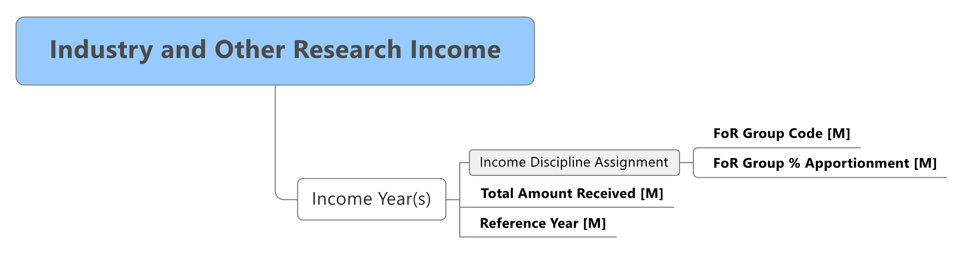Figure Industry and Other Research Income Data Structure

The data requirements for all industry and other research income are as follows:

| **Concept Key** | **XML Schema Data Item** | **Description** |
| --- | --- | --- |
| Income Years | incomeYears **[Mandatory]** | The collection of research income details for Industry and Other Research Income (see below). |

#### 3.4.3.1 Income years

The following data items apply to the income years attribute.

| **Concept Key** | **XML Schema Data Item** | **Description** |
| --- | --- | --- |
| Reference Year | referenceYear **[Mandatory]** | The four-digit calendar year. |
| Income Discipline Assignment | incomeDisciplineAssignment **[Mandatory]** | The collection of FoRs associated with the research income and the corresponding apportionment of the research income to those FoRs (see Income Discipline Assignment table). |
| Total Amount Received | totalAmountReceived **[Mandatory]** | The total amount of Industry and Other Research Income received within the reference year. |

#### 3.4.3.2 Income discipline assignment

The following attributes apply to the discipline assignment for research income:

| **Concept Key** | **XML Schema Data Item** | **Description** |
| --- | --- | --- |
| FoR Group Code | forGroupCode **[Mandatory]** | The ANZSRC four-digit FoR code(s) (as many as are relevant) assigned to the research income. |
| FoR Group % Apportionment | apportionment **[Mandatory]** | The percentage of the total research income received within an income year, disaggregated to the FoR code(s) assigned to the research income. The percentage of all FoR codes must be between 95 and 105 inclusively. |

### 3.4.4 CRC research income

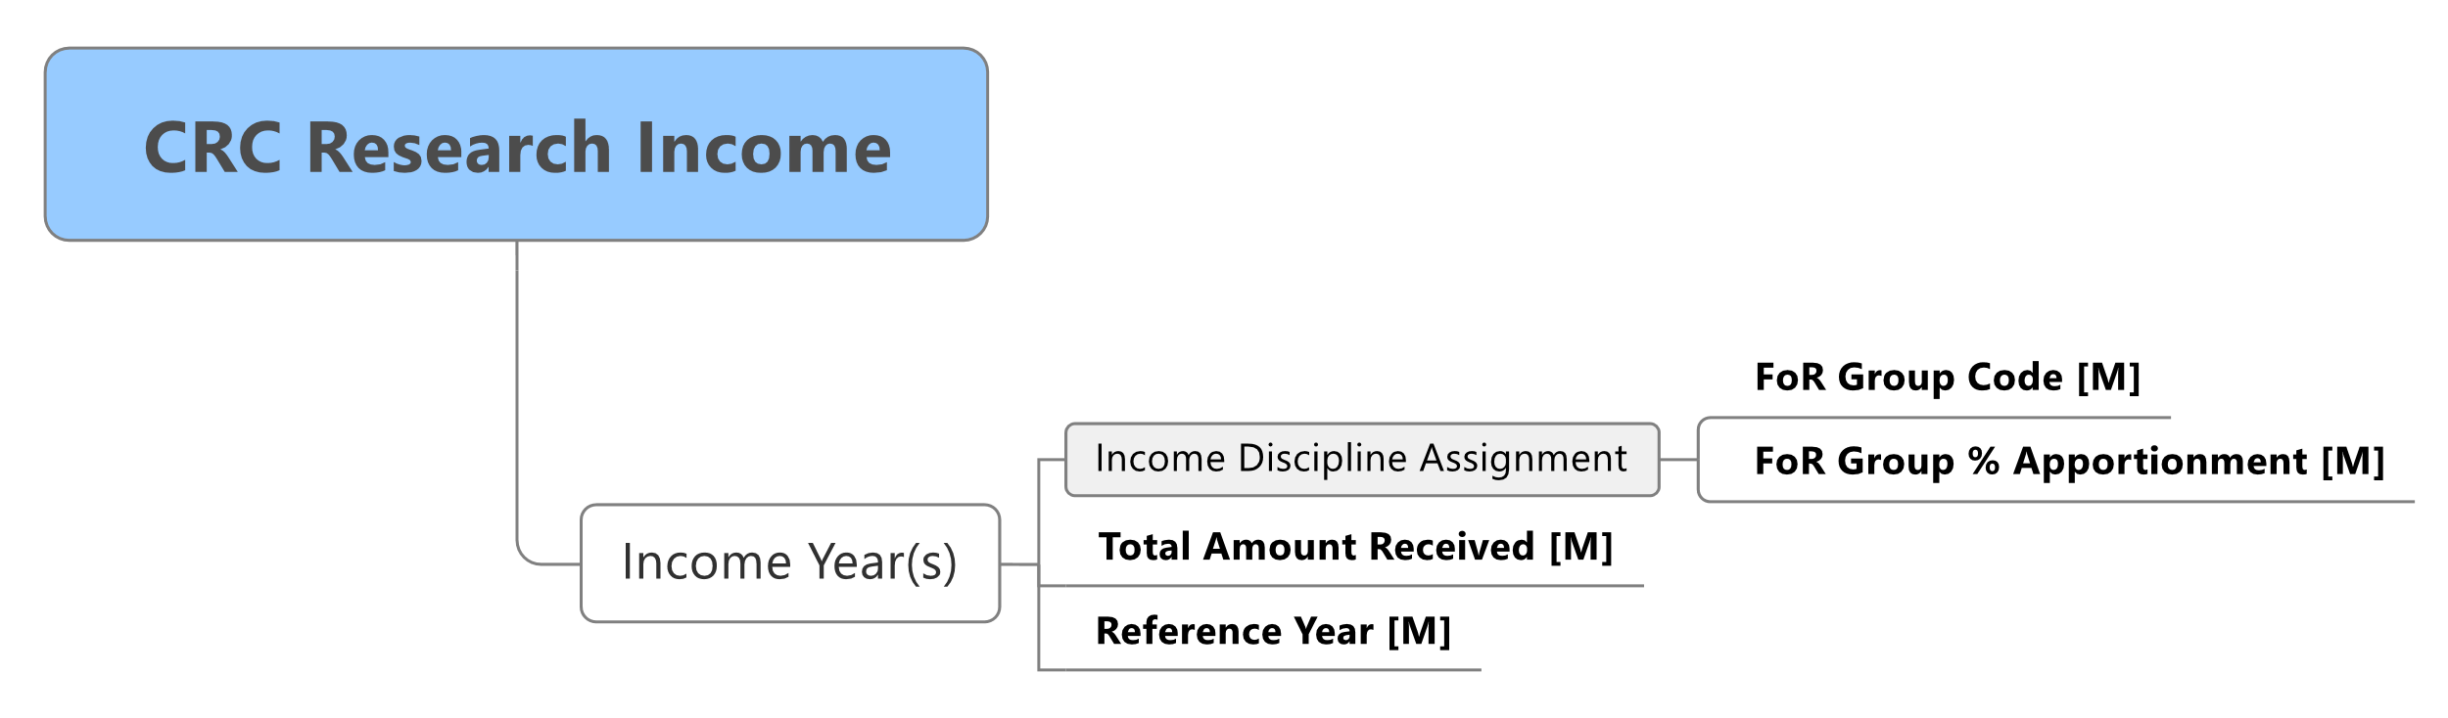

Figure CRC Research Income data structure

The following data requirements apply to CRC research income:

| **Concept Key** | **XML Schema Data Item** | **Description** |
| --- | --- | --- |
| Income Years | incomeYears **[Mandatory]** | The collection of research income details for CRC Research Income (see below). |

#### 3.4.4.1 Income years

The following data items apply to the income years attribute:

| **Concept Key** | **XML Schema Data Item** | **Description** |
| --- | --- | --- |
| Reference Year | referenceYear **[Mandatory]** | The four-digit calendar year. |
| Income Discipline Assignment | incomeDisciplineAssignment **[Mandatory]** | The collection of FoRs associated with the research income and the corresponding apportionment of the research income to those FoRs (see Income Discipline Assignment table). |
| Total Amount Received | totalAmountReceived **[Mandatory]** | The total amount of CRC Research Income received within the reference year. |

#### 3.4.4.2 Income discipline assignment

The following attributes apply to the discipline assignment for research income:

| **Concept Key** | **XML Schema Attribute** | **Description** |
| --- | --- | --- |
| FoR Group Code | forGroupCode **[Mandatory]** | The ANZSRC four-digit FoR code(s) (as many as are relevant) assigned to the research income. |
| FoR Group % Apportionment | Apportionment **[Mandatory]** | The percentage of the total research income received within an income year, disaggregated to the FoR code(s) assigned to the research income. The percentage of all FoR codes must be between 95 and 105 inclusively. |

## 3.5 ERA–SEER XML schema files

The ERA–SEER XML submission schema is provided in a number of files to subdivide the schema definition into modules. The XML submission schema files contain the definition of all the data elements that institutions can include in an ERA 2023 submission.

There is a brief description of the each of the SEER XML schema files below:

* seer.xsd—defines the ‘seer’ namespace and includes all the other ERA–SEER XML schema files as part of that namespace.
* researcher.xsd—defines the data elements used to specify eligible researchers.
* researchOutput.xsd—defines the data elements used to specify all eligible research output types.
* researchOutlet.xsd—defines the data elements used to specify all eligible research outlet types.
* researchIncome.xsd—defines the data elements used to specify eligible research income information.
* discipline.xsd—defines the data elements used to specify FoR and apportionments which are reused in data elements specified in the researcher, researchOutlet, and researchIncome schema files.
* artifactTitle.xsd—defines common data elements used to specify title metadata.
* type.xsd—defines common types and enumerations used in the other schema files to restrict attribute values and enforce validation of data rules.

## 3.6 Codes

Code (enumerated) values that are required for an institution’s submission have been included in the ERA–SEER 2023 Technology Pack.

### 3.6.1 Language codes

SEER uses the Australian Bureau of Statistics Australian Standard Classification of Languages (ASCL) to track languages. The ERA–SEER 2023 Technology Packprovides the code table of valid ASCL languages.

### 3.6.2 Journal articles and unique output identifiers

SEER requires the identification of submitted indexed journal articles by a unique output identifier supplied for each journal article by the citation data provider. Further information about the process of obtaining unique output identifiers for indexed journal articles will be available at the ERA website [www.arc.gov.au](http://www.arc.gov.au) > [ERA](https://www.arc.gov.au/excellence-research-australia) > [ERA 2023](https://www.arc.gov.au/excellence-research-australia/era-2023)

# 4. INSTITUTIONALLY SUPPORTED REPOSITORY REQUIREMENTS

ERA reviewers (ERA peer reviewers and members of the Research Evaluation Committees) will require access to institutionally supported repositories for the purposes of undertaking ERA peer review of research outputs. Reviewers will access institutionally supported repositories through SEER.

## 4.1 Research outputs

See section 4.4 of the ERA 2023 Submission Guidelinesfor the definition of research outputs.

A research output is nominated for ERA peer review with links to research outputs within a nominated institutionally supported repository. Institutions must store and reference their electronic research output files within their institutionally supported digital repositories. If needed, institutions can split large data files into two or more repository links. Research outputs that are not in digital form (such as artworks, or some books), should be scanned or videos made of the output that can be digitally stored. Electronic research output files accessed via SEER should conform to the requirements described in this document, guided by certain specifications and constraints. These include supported formats, file sizes and non-security related access issues outlined in more detail in the following chapter.

Please note that for ERA 2023, all research outputs nominated for peer review must be stored in an institutionally supported repository in digital form.

### 4.1.1 Technical specifications for research outputs

#### 4.1.1.1 Research output electronic location

Where a research output is available for peer review and is available within a repository, the research output must include a direct link to the research output files (no landing or metadata page is allowed for ERA 2023). Any nominated research output files may be formally viewed by ERA reviewers and other users authorised by the ARC.

URL-based automatic resolution of persistent identifiers or handles, such as Digital Object Identifiers (DOIs), via sites such as [dx.doi.org](https://dx.doi.org/) are suitable mechanisms for providing links as long as the link directly points to the actual research output file. Multiple electronic locations can be associated with a research output.

If it is necessary to preserve a specific file ordering for peer review, the institution must ensure that the links within the XML to those files are in the desired order. SEER will maintain the order of files as institutions submit them. The original filename of the research output will form part of the filename when the peer reviewer downloads it.

#### 4.1.1.2 Multiple institutionally supported repositories

An institution may have more than one institutionally supported repository for the purposes of ERA 2023 submission. The institution must enter all such repositories in SEER and confirm the access security method through SEER to each such repository accordingly. All the URLs in the XML file must correspond to one of the repositories entered in the system by the submitting institution.

#### 4.1.1.3 Supported formats

SEER supports all research output file types that can be rendered across the internet if these files conform to specified size constraints. Standard computer desktops may be configured with the required software to properly view the research output file. As a minimum, SEER will assume that standard desktops may be configured to properly display the following file types:

* Adobe PDF (i.e. .pdf)
* image (i.e. .gif, .jpg, .jpeg, .bmp, .png, .tif, etc.)
* Microsoft Word (i.e. .doc, .docx)
* text (i.e. .txt)
* popular video/audio format (i.e. .mp3, .mp4, .avi).

Research outputs with file types not identified in the list of supported formats (e.g. WAVE, AAC, and others) may still be included as part of an ERA submission upload. For these other formats, the ARC may contact the Repository Helpdesk (see section 4.1.1.6 below) to discuss the nature of the application required to access such files.

SEER will not accept:

* executable and script-based files (i.e. .exe, .bat, .sh)
* Microsoft PowerPoint (i.e. .ppt)
* Microsoft Word documents with embedded macros (i.e. .docm)
* Microsoft Excel files (i.e. .xls etc.)
* ZIP archives (i.e. .zip)
* compilation environment dependant files (i.e. .asp, .jsp, .cgi)
* Links that contain ‘callbacks’ and additional network transactions.

#### 4.1.1.4 Size limits

ARC staff and ERA reviewers may access the research output files stored in an institution’s digital repositories. SEER will relay these files to ARC staff and ERA reviewers.

Individual files in repositories for the purposes of ERA should be no greater than 200 MB. It is anticipated that the vast majority of research outputs will be under this limit and that many would be less than 200 MB in size. Research outputs that exceed the maximum size will need to be broken down into smaller files and named to allow them to be viewed in the correct order.

#### 4.1.1.5 HTTP ports

The ARC security rules only allow a small number of permissible TCP/IP ports as per the [*Australian Government Information Security Manual*](https://www.cyber.gov.au/acsc/view-all-content/ism) (ISM 2021). All communications between SEER and institutionally supported repositories must occur over HTTPS (Hypertext Transfer Protocol Secure) and with encryption supporting TLS 1.2 (Transport Layer Security version 1.2).

#### 4.1.1.6 Repository Service Availability and Helpdesk Arrangements

The ARC will liaise with institutions to ensure minimal unscheduled repository downtimes.

#### 4.1.1.7 Secure Digital Repositories and Authentication

All outputs must be publicly available (see 6.1 of the *ERA 2023 Submission Guidelines)*. However, not all outputs will be openly accessible due to copyright restrictions. Where the institution or the researcher is the copyright owner, or where the copyright owner has given express permission for the research output to be stored in an ‘open access’ repository, the research output should be stored in an ‘open access’ repository or in an ‘open access’ part of an institution’s ERA repository.

SEER requires read access to all objects within institutionally supported repositories to retrieve research output files to relay back to ARC staff and to ERA reviewers. Institutions are required to perform adequate virus scanning on all repository files with an updated virus-scanner, prior to making them available for upload by reviewers.

When accessing a ‘dark’ or otherwise ‘non-public’ institutionally supported repository, SEER’s preferred method of authentication is IP-Based Authentication. Institutionally supported repositories that are not able to support the IP-Based Authentication method are permitted to utilise Basic Authentication (RFC 2617).0F[2]

When utilising IP-Based Authentication to allow ERA access to dark repositories, please contact the ERA Helpdesk to obtain the IP addresses. These addresses are subject to change prior to SEER launch. The ARC will notify institutions granted the IP addresses of any change.

If utilising Basic Authentication, the ARC will require institutions to follow the below security rules when assigning a SEER user account:

* A special user account will be created for SEER, granting read access to all objects within the institutionally supported repository/repositories.
* Strong passphrases will be used – these must contain a combination of upper and lowercase characters, numbers and special characters (e.g. #, @, $).
* Passphrases must be a minimum of 14 characters, ideally as 4 random words.
* Passphrases should also not be constructed from song lyrics, movies, literature or any other publicly available material. Nor should they form a real sentence in a natural language nor be a list of categorised words.

All communications between SEER and institutionally supported repositories are required to employ X.509 certificates and TLS 1.2 to secure the communications.1F[3]

#### 4.1.1.8 Stability of Links

Institutions should endeavour to ensure that submitted repository links remain stable for the duration of an ERA submission process and associated ERA evaluation. As the ERA 2023 evaluation process involves remotely located ERA reviewers, it is a requirement that nominated links to institutionally supported repositories are available 24 hours per day, 7 days per week.

# 5. SYSTEM ENVIRONMENT

There is only one environment available to support the Excellence in Research for Australia (ERA) submissions. This is the System to Evaluation Excellence in Research ([SEER](https://seer.arc.gov.au/)), and is accessed at [https://seer.arc.gov.au.](https://seer.arc.gov.au/)

# Appendix A: ERA–SEER 2023 Technology Pack Inventory

## ERA–SEER 2023 Technical Specifications

The ERA–SEER 2023 Technology Packincludes the technical specifications.

## ERA submission XML schemas

The ERA submission XML schemas uniquely describe the data format allowed for submissions. They are available electronically in the *ERA–SEER 2023 Technology Pack* via the following files:

* seer.xsd
* researcher.xsd
* researchOutput.xsd
* researchOutlet.xsd
* researchIncome.xsd
* artifactTitle.xsd
* type.xsd
* discipline.xsd.

## Submission examples

Two sample submission files are included in the ERA–SEER 2023 Technology Pack.

## Schema definition documentation files

Schema Definition Documentation files describing the data elements contained within the schema files are in HTML format.

## ERA 2023 Discipline Matrix

The *ERA 2023 Discipline Matrix*, specifying which ERA indicators apply to which FoRs, is in a Microsoft Excel spreadsheet.

## Code tables

The code tables define enumerated fields (i.e. reference data) for use in submission XML documents. These are:

* eligible Australian Standard Classification of Languages (ASCL)
* eligible Standard Australian Classification of Countries

# Appendix B: Glossary of technical terms

See also Appendix B located in the ERA 2023 Submission Guidelines*.*

| **Term** | **Description** |
| --- | --- |
| 8-bit UCS/Unicode Transformation Format (UTF-8) | A variable-length character encoding for Unicode. It is able to represent any character in the Unicode standard. UTF-8 is the standard encoding method for email, web pages and XML documents. |
| Authorisation | Determining a user’s access to a resource. Authorisation usually relies on the user having been authenticated. |
| Basic Authentication | A standard HTTP authentication protocol supported by most browsers where username and password are transmitted as Base-64 encoded text. |
| Digital Object Identifier  (DOI) | DOI is a standard for persistently identifying a piece of intellectual property on a digital network and associating it with related data, the metadata, in a structured extensible way. DOIs can be resolved through the [DOI resolver](https://dx.doi.org/) at <https://dx.doi.org/>. |
| Handle System | Handle System enables a distributed computer system to store names, or handles, of digital resources and resolve those handles into the information necessary to locate, access, and otherwise make use of the resources. These associated values can be changed as needed to reflect the current state of the identified resource without changing the handle. This allows the name of the item to persist over changes of location and other current state information. There is an [overview of Handle System](https://www.rfc-editor.org/info/rfc3650) or [www.ietf.org](http://www.ietf.org/) > RFC Pages > RFC Index HTML > [RFC 3650](https://www.rfc-editor.org/info/rfc3650). |
| HyperText Transfer Protocol (HTTP) | An application layer protocol that provides a standard for web browsers and web servers to communicate. |
| HyperText Transfer Protocol (Secure) (HTTPS) | HTTP exchanged over an SSL encrypted session. |
| Internet Assigned Numbers Authority (IANA) | Of relevance to the ERA SEER is the registry of MIME types that may be found at [www.iana.org](https://www.iana.org/) > Protocol Assignment > [Media Types](https://www.iana.org/assignments/media-types/media-types.xhtml)[.](http://www.iana.org/assignments/media-types/)  This registry includes types from:  [RFC-2046](https://www.rfc-editor.org/info/rfc2046) or [www.ietf.org](http://www.ietf.org) > RFC Pages > RFC Index HTML > [RFC 2046](https://www.rfc-editor.org/info/rfc2046).  [RFC-1521](https://www.rfc-editor.org/info/rfc1521) or [www.ietf.org](http://www.ietf.org) > RFC Pages > RFC Index HTML > [RFC 1521](https://www.rfc-editor.org/info/rfc1521) and others. |
| Multipurpose Internet Mail Extensions (MIME) | Originally designed as a specification for formatting non-ASCII messages so that they can be sent via email. In addition, web browsers use MIME types to determine ‘helper’ applications or components that can be used to view the content.  [RFC-1341](https://www.rfc-editor.org/info/rfc1341) or [www.ietf.org](http://www.ietf.org) > RFC Pages > RFC Index HTML > [RFC 1341](https://www.rfc-editor.org/info/rfc1341). |
| System to Evaluate the Excellence of Research (SEER) | The information technology platform that supports ERA. |
| Transmission Control Protocol/Internet Protocol (TCP/IP) | A suite of protocols used to exchange information over the internet. |
| Transport Layer Security (TLS) | TLS is a cryptographic protocol that allows for end-to-end encrypted communications over a network. It is used in a variety of applications and builds on the deprecated Secure Socket Layer (SSL) protocol. |
| Uniform Resource Identifier (URI) | A standard syntax for the textual naming (identification) of resources that exist on the internet. Two concrete implementations of the URI syntax include the Uniform Resource Locator (URL) and the Uniform Resource Name (URN). A URL is a URI that defines how to retrieve a given resource over the internet (i.e. via a particular protocol such as HTTP). |
| Uniform Resource Locator (URL) | A global identifier for a network-retrievable document. |
| World Wide Web Consortium (W3C) | An international consortium of companies involved with developing standards for the internet and the web. |
| X.509 Certificate | An X.509 Certificate is a cryptography standard defining the format of public key certificates that are used in many Internet protocols including TLS and HTTPS. |
| XML | eXstensible Markup Language. A text-based specification used to promote interoperable exchange of data through standardised validation mechanisms and expression of data in a human-readable, self-describing manner. |

1. The third page is for institutions to explain the impacts of the COVID-19 pandemic on each eligible two-digit FoR.
2. RFC 2617–HTTP Authentication: Basic and Digest Access Authentication—[[www.faqs.org](http://www.faqs.org)](http://www.faqs.org/faqs/) > [Internet RFC Index](http://www.faqs.org/rfcs/) > RFC 2601 - 2700 > [RFC 2617](http://www.faqs.org/rfcs/rfc2617.html) .
3. The ARC will manage and control access to research outputs and will only allow ARC staff, Research Evaluation Committee (REC) members and ERA peer reviewers and other ARC authorised personnel access to research outputs that are stored in an institution’s repository for the purposes of ERA evaluation.