Final Reports Instructions – Second Release:

RMS user guide and Instructions

*For rounds funded in the following schemes:*

* Discovery Projects for funding commencing in 2014 - onwards
* Linkage Projects for funding commencing in 2014 - onwards
* Discovery Early Career Researcher Award for funding commencing in 2014 - onwards
* Australian Laureate Fellowship for funding commencing in 2012 - onwards
* Future Fellowships for funding commencing in 2013 - onwards
* Discovery Indigenous for funding commencing in 2014 - onwards
* Linkage Infrastructure, Equipment and Facilities for funding commencing in 2016 - onwards
* Centres of Excellence for funding commencing in 2011 - onwards
* Industrial Transformation Research Hubs for funding commencing in 2012 - onwards
* Industrial Transformation Training Centres for funding commencing in 2013 - onwards
* Linkage Learned Academies Special Projects for funding commencing in 2014 - onwards

*For all prior rounds, please refer to the* ***Final Report Instructions - First Release***

Table of contents

Submission of Final Reports: Information to note 3

When to submit a Final Report to the ARC 3

Final Report Extensions 3

Waive requests 3

Administration of Final Reports in RMS 3

Certification and accuracy of information 3

Updating of Final Reports once submitted to the ARC 4

Starting a Final Report in RMS 5

Searching for and editing a Final Report 5

Research Office Reports 5

If a Final Report is not appearing in RMS 5

Final Report state (status) 6

Completing the Final Reports Form Parts 6

Mandatory Questions 7

How to add multiple answers and remove answers within questions. 7

Part A – Project Details 9

Part B – Research Activities 11

Part C – Project Outputs 18

Part D – Project Outcomes 26

Part E – Research Impacts 28

Part F – Linkage Projects 30

Part F – Discovery Early Career Researcher Award 33

Part F – Future Fellowships 35

Part F – Australian Laureate Fellowships 37

Part F – Discovery Indigenous Award 39

Part F – Linkage, Infrastructure, Equipment and Facilities 40

Part F – ARC Centres of Excellence 42

Part F – Special Research Initiatives 46

Part F – Industrial Transformation Research Hubs 49

Part F – Industrial Transformation Training Centres 53

Part F – Learned Academies Special Projects 57

# Submission of Final Reports: Information to note

The Australian Research Council (ARC) requires that a Final Report be submitted for each ARC funded Project that has been completed. These instructions provide information to assist Research Office staff and Project participants in the completion and submission of ARC Final Reports in the Research Management System (RMS).

The Project Leader (first named participant) is responsible for the completion of the Final Report and its submission to the Administering Organisation’s Research Office. All *listed* active participants and Research Office staff have full edit access to the Final Report. Research Offices are responsible for the certification of the form and submission of Final Reports to the ARC.

If, after consulting this document, there are any queries regarding completing a Final Report form in RMS, please contact the Administering Organisation’s Research Office.

**Please note**: Paper copies of Final Reports will not be accepted by the ARC.

## When to submit a Final Report to the ARC

Final Reports are due twelve months after all ARC funding has been last expended. This includes expenditure of all funding paid and approved carryovers. The ARC calculates the Final Report due date based upon the Project’s end date provided by the Administering Organisation’s Research Office during the End of Year Reporting Process each year, or as a result of any Variation of Funding Agreement (Variation) changes (e.g. a Project suspension or Maternity leave). Final Reports must not be submitted prior to completion of the Project. Due dates for Final Reports can be found within the Project details in RMS.

## Final Report Extensions

Extensions for Final Reports can be requested via the Administrating Organisation’s Research Office. The request must note the Project ID and explain the extenuating circumstances. The Research Office can then submit the request to the ARC via an email.

**Please note:** the ARC will only accept requests for an extension to the Final Report due date if received from the Research Office of the Administering Organisation. Requests from researchers or other Participating Organisations will not be accepted.

## Waive requests

If there is a Project that may be eligible for the Final Report to be waived, email the Administrating Organisation’s Research Office with the Project ID and a justification as to why the request is being made. The Research Office can then submit the request to the ARC.

**Please note:** The ARC will only consider waive requests for Final Reports if no money was expended, the Project’s duration was less than 12 months or suitable justification is provided for the request. Requests to waive Final Reports due to lack of response for currently funded investigators will not be considered.

## Administration of Final Reports in RMS

Final Reports can only be accessed and managed through RMS. For general instructions on how to use RMS, please refer to the [RMS User Guide](http://www.arc.gov.au/rms-information) available on the ARC website.

## Certification and accuracy of information

Final Reports must be checked and certified by the Research Office Delegate, before they can be submitted to the ARC. Research Office Delegates are required to certify that the Project has complied with the relevant schemes Funding Rules/Grant Guidelines and Funding/Grant Agreements, and that all information provided within the Final Report is accurate and up to date.

Final Reports cannot be submitted to the ARC unless they have been certified by a Delegate. The ‘Submitted to Research Office (Valid)’ state will appear against each Report which is ready to be certified. Once certified, the state of Final Reports will appear as ‘Research Office Certified’ and can then be submitted to the ARC by Research Office staff.

The following prompt will appear once the ‘Certify Final Report’ button has been selected:

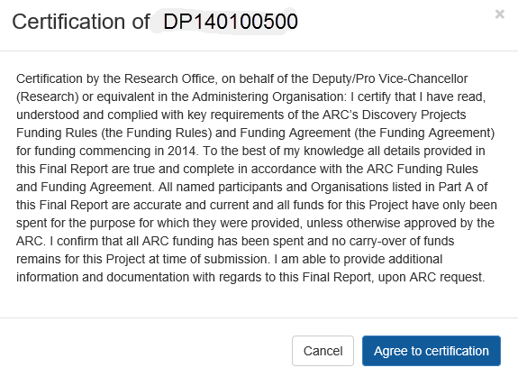

**Please note:** information collected in ARC Final Reports is used to determine whether Projects have reached satisfactory completion. Statistical information collected in Final Reports enables the ARC to account for public funding of research and to promote the value of research to the Australian community. As such, the ARC reserves the right to reject Final Reports, based on unsatisfactory completion, or to seek further clarification on information submitted or the lack thereof.

Please check that all of the information contained in the Final Report is accurate and that all required questions are completed as comprehensively as possible.

## Updating of Final Reports once submitted to the ARC

If Project Leader needs to edit a Final Report after submission, Research Offices can request that the Final Report is de-submitted back to them until it has been approved by the ARC. Once a report is assessed and approved by the ARC, the ARC will not allow edits to the report.

## Starting a Final Report in RMS

1. Login to [RMS](https://rms.arc.gov.au/RMS/ActionCentre/Account/Login?ReturnUrl=%2fRMS%2fActionCentre%2f).
2. In the *Applicant Project Management* section of the *Action Centre*, click on the ‘Final Reports’ tab.

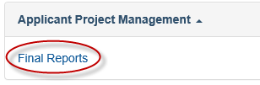

## Searching for and editing a Final Report

In the Final Reports tab, reports can be searched by selecting the relevant Scheme Round or Status from the allocated drop down lists or use the Search bar to search by Proposal/Title/Investigator/Organisation.

To edit a Final Report, click on ‘Edit’ under the Actions column of the Final Reports table. A Final Report may be edited by the Project participants and Research Office staff, however only the Project leader can submit it to the Research Office. Once it is submitted to the Research Office, only Research Office staff may edit the report. Once the Research Office has submitted the report to the ARC, it can be viewed but not edited by Project participants and Research Office staff.

## Research Office Reports

A report showing the data on the Final Reports can also be extracted by Research Office staff, via the ‘Research Office Report API Config’ link, located within the *Reports* tab of the Action centre. Instructions on how to use the API can be accessed via this link.

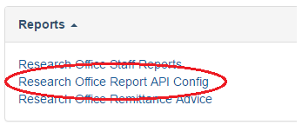

## If a Final Report is not appearing in RMS

If the Final Report for a project is not appearing in RMS, please first check if the scheme round is appearing in the ‘Scheme Round’ drop-down list. If it is not appearing, this is because the Scheme Round form has not yet been made available by the ARC.

***Please note:*** *This will not affect eligibility when applying for future grants as the ARC will be aware of the forms availability.*

## Final Report state (status)

The state of a Final Report relates to its progress status, and can be found on the second last column of the Final Reports tab. The states and their meanings are as follows:

| **State (status) type** | **Explanation** |
| --- | --- |
| **Draft** | The report has been created in RMS and is ready for editing. |
| **Ready to submit** | All the mandatory questions have been completed in draft. |
| **Submitted to Research Office** | The Final Report has been submitted to the Research Office (not all mandatory questions have been answered) |
| **Submitted to Research Office (Valid)** | The Final Report has been checked by the Research Office staff, all mandatory questions have been answered and the report is ready to be certified by the Research Office Delegate. |
| **Research Office Certified** | The Final Report has been certified by the Research Office Delegate and is ready to be submitted to the ARC by Research Office staff. |
| **Submitted to ARC** | The Research Office has submitted the Final Report to the ARC. |
| **Approved** | The Final Report has been assessed by the ARC and has been Approved. |
| **Waived** | The Final Report has been waived and is no longer required. |
| **Not required (Already on file)** | The Final Report has been submitted in a previous system and is no longer required. |

**Please note:** Unfortunately the ARC is unable to provide copies of Final Reports from previous systems such as GAMS. Research Offices were asked to take copies of any records they required before GAMS was shut down in 2012. Final Reports can no longer be extracted from this system. Final Reports submitted in RMS legacy, can be accessed via RMS.

## Completing the Final Reports Form Parts

Questions located in Part A to Part E of the Final Report are generic across all schemes. Part F of the report relates to scheme specific information and will have different questions that relate to the scheme. Note Part F does not appear for all schemes.

Note that the following instructions refer only to those Projects commencing from the scheme rounds as outlined below and onwards:

**DP14, LP14, DE14, FL12, FT13, IN14, LE16, CE11, IH12, IC13, LASP14**

Please refer to the [*Final Report Instructions - First Release*](https://www.arc.gov.au/grants-and-funding/grant-administration/final-report) for all schemes prior to those identified above to complete the Final Reports for previous rounds.

**Please note:** Within the heading of the form, the colour of the parts will be indicated as either red – meaning that they are incomplete and therefore invalid; or green – meaning that they are completed and valid.

To begin filling out the Final Report, click on the relevant form part at the top of the screen to navigate between form parts, beginning with Part A.

***Please remember to save regularly as you complete the form, using the ‘Save’ button located at the top right of the page.***

***The image of the 'Save' button.***

## Mandatory Questions

Some of the questions within the form are mandatory, meaning that they are required to be completed before the form part will validate. For these questions, the following warning will occur when there is an answer required before submitting the form:



## How to add multiple answers and remove answers within questions.

**Adding and removing multiple answers**

1. To enter multiple answer panels for a given question, select ‘Add Answer’ at the bottom of the question or the questions answer panel.



1. To remove an answer panel, select the cross ‘X’ in the top right of the answer panel for the answer that needs to be removed.

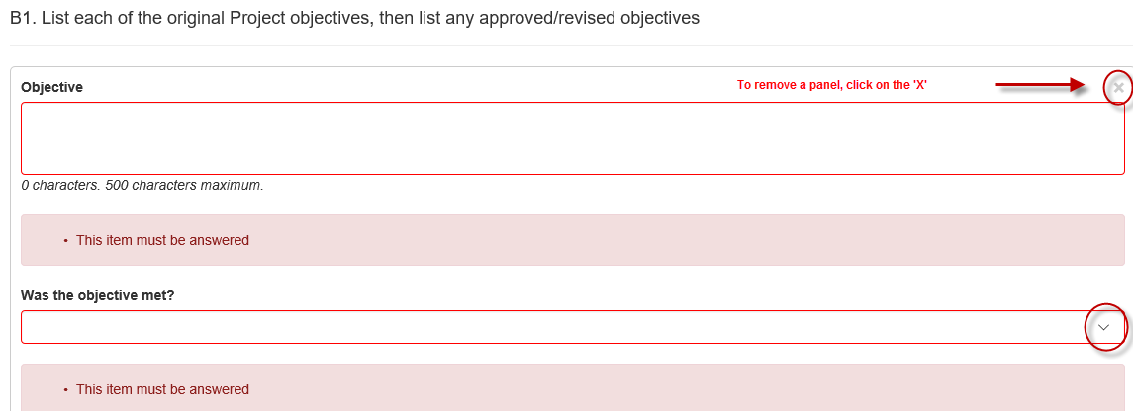

**Adding and removing an option**

1. To add, select the option from the drop-down menu or ‘search’ function and click ‘Add’.
2. To remove, select the ‘x’ beside the option that needs to be removed.

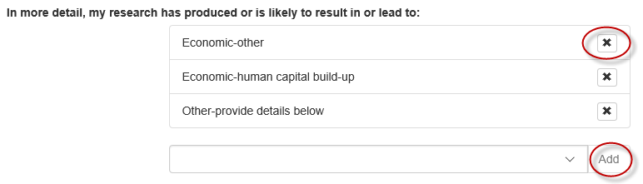

**Please note**: All options can only be added once. Click ‘Add’ otherwise the selection will be lost the next time ‘Save’ is hit.

# Part A – Project Details

**A1. Project summary** *(Auto-populated)*

This information is auto-populated from RMS and includes a basic summary of the Project including funded amount, years funded, FoR/SEO codes and priority areas. If there are any concerns regarding the information recorded within this section, please contact the Administering Organisation’s Research Office.

**Please Note:** Priority Areas will only populate for the following schemes:

* CE17 onwards
* IC15 onwards
* IH14 onwards
* DE16 onwards
* IN16 onwards
* DP16 onwards
* LA17 onwards
* LE16 onwards
* FL15 onwards
* LP15 onwards
* FT15 onwards
* SR18 onwards.

**A2. Named participants** *(Auto-populated)*

This information is auto-populated from RMS and will reflect the current status of all listed participants. If there are any concerns regarding the information recorded within this section, please contact the Administering Organisation’s Research Office. If a change is required, a Variation will have to be submitted.

**A3. Named organisation participants** *(Auto-populated)*

This information is auto-populated from RMS and will reflect the current status of all listed organisations. If there are any concerns regarding the information recorded within this section, please contact the Administering Organisation’s Research Office. If a change is required, a Variation will have to be submitted.

**A4. Total Participating Organisation Contributions** *(Auto-populated)*

This information is auto-populated from RMS and will reflect the contributions as currently listed within the Project. If there are any concerns regarding the information recorded within this section, please contact the Administering Organisation’s Research Office. If a change is required, a new Participating/Partner Organisation Agreed Contribution Report (POACR) will have to be submitted.

**A5. Total Partner Organisation Contributions** *(Auto-populated)*

This information is auto-populated from RMS and will reflect the contributions as currently listed within the Project. If there are any concerns regarding the information recorded within this section, please contact the Administering Organisation’s Research Office. If a change is required, a new POACR will have to be submitted.

**A6. Did you leverage additional funding for this Project?** *(Not Mandatory)*

This question is not mandatory and should only be answered if the answer is ‘Yes’.

Please note that any additional funding from named organisations on the Project cannot be added at this question. Additional funding from named organisation must be updated by submitting a revised POACR.

1. Manually type/insert the name of the organisation in which the additional funding was leveraged and select ‘Search’.
2. Once the name is found select the ‘Add’ button to add the appropriate organisation.

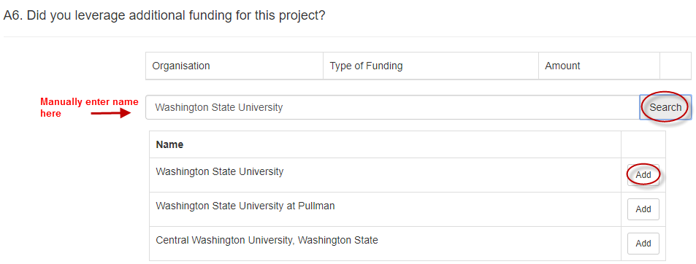

1. Select the ‘Cash’ or ‘In-kind’ funding type from the drop-down menu.
2. Insert ‘Amount’ of funding leveraged and click outside of the table to populate.

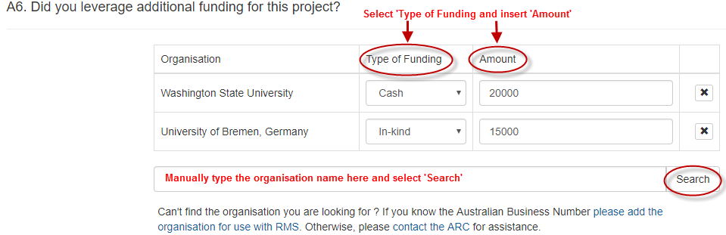

1. Repeat steps 1 to 4 to add additional organisations.

**A7. Provide a brief summary of the achievements of this research project for public release.** *(Mandatory)*

Provide a summary of no more than 750 characters (approximately 100 words). As this information may be posted on the ARC website as the outcomes of the research, please use suitable language understandable by non-experts and do not disclose any information here that is commercial-in-confidence or may compromise the researcher’s ability to translate the research, such as intellectual property. Avoid the use of acronyms, quotation marks and upper case characters.

# Part B – Research Activities

**B1. List each of the original Project objectives, then list any approved/revised objectives** *(Mandatory)*

Provide a written summary of no more than 500 characters, for each original Project Objective or approved/revised objective. For each objective provided, indicate whether the objective was ‘met’ or ‘not met’.

**IMPORTANT: Depending on the round, this question will have to be completed either via manual entry or it will be partially auto-populated. This question must be completed. Ensure objectives are added prior to completing this section of the form.**

**Manual Entry Instructions** *for the following schemes:*

*DP14, DP15, DE14, DE15, FT13, FT14, FL14, LE14, LE15, LP14, LP15, IN13, IN14, IN15*

1. Enter each objective as per the original proposal and select ‘yes’ or ‘no’ from the drop-down menu to indicate if the objective has been met or not met.

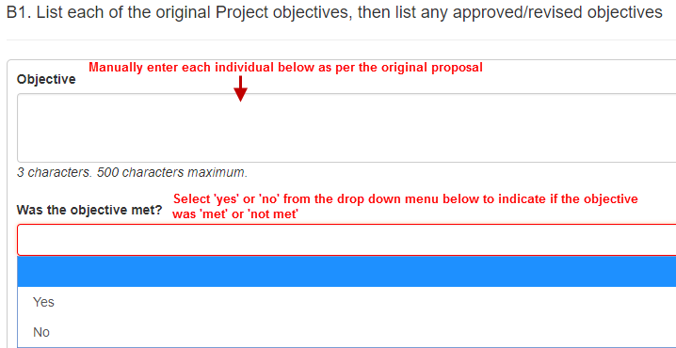

1. If yes, describe how the objective was met (maximum 500 characters)
2. If no, provide further justification detailing why the objective was not met (maximum 500 characters)
3. Repeat the above steps to add additional objectives and/or add revised objectives.

**Auto-populated Instructions**

*Scheme rounds from 2016 onwards will auto-populate the objectives as per the original proposal. Additional questions to be answered as detailed below*

1. Each objective as identified within the Project Proposal will auto-populate within this section. Select ‘yes’ or ‘no’ from the drop-down menu to indicate if the objective has been met or not met.

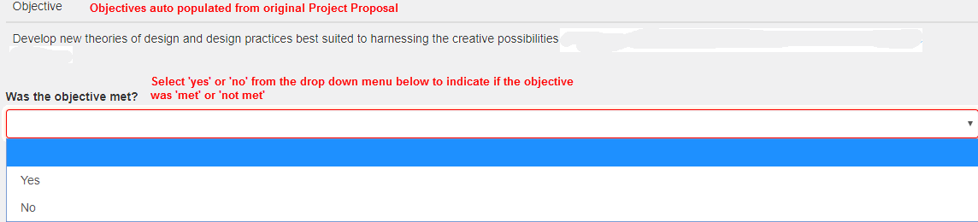

1. If yes, describe how the objective was met (maximum 500 characters)
2. If no, provide further justification detailing why the objective was not met (maximum 500 characters)
3. Repeat steps for each objective status.

**Please note:** In order to add a new or revised objective, please select ‘no’ against the objective not achieved and provide further details and justification of the revised objective/s. If an original objective was enhanced, please select ‘yes’ and provide further justification regarding the updated details.

**B2. Did anything affect the satisfactory and timely progress or completion of the Project? If yes, briefly describe the events that affected progress or completion.** *(Mandatory)*

A ‘Yes’ or ‘No’ answer is required. If ‘**Yes**’ is selected, provide a written summary of no more than 5000 characters, describing the events that affected the satisfactory and timely progress or completion of the Project. These events may include, but are not limited to:

* trouble finding PhD students/personnel required
* problems with salaried staff members
* illness of personnel/staff on the project
* problems which occurred with Partner Organisations
* delay in signing of Partner Organisation agreements
* personnel leaving the Project.

**Please note:** The ARC should have been informed of these changes and approval granted, prior to reporting them in the Final Reports. If the ARC was not previously notified and approval was not granted for these changes to occur, then a retrospective Variation may be sought from the Administering Organisation’s Research Office. Additionally, if these changes are not approved then the ARC may recover any funds that may be associated with these changes.

**B3. Did your research project involve collaboration with Australian organisations?** (*Mandatory*)

Select ‘Yes’ or ‘No’ from the drop-down box for each of the following options

* Within your organisation
* Other Australian university
* Australian government agency (Commonwealth, State or Local)
* Australian Industry
* Australian not-for-profit
* Other Australian organisation.

**B4. Did your research project involve collaboration with overseas organisations?** (*Mandatory*)

Select ‘Yes’ or ‘No’ from the drop-down menu for each of the following options

* Overseas university
* Overseas government agency
* Overseas industry
* Overseas not-for-profit
* Other overseas organisation.

**B5.** List any collaborations or partnerships the research involved or led to, other than those with investigatory or organisations listed in Part A of this Final Report. *(Not* *Mandatory*)

Please provide the name of the relevant organisation(s), which the Project led to collaborations or partnerships with. Also, provide the nature of collaboration, benefit of the collaboration and advise if this collaboration will continue past the life of the grant.

1. Select ‘Add Answer’ tab.
2. Enter the organisation name, or any part of the organisation name, and possible matches will be listed. (Additional organisation can be viewed by selecting ‘Next’ at the bottom of the selection list). Note that only one organisation can be selected at a time.
3. Select ‘Search’ and ‘Add’ the appropriate organisation from the list.

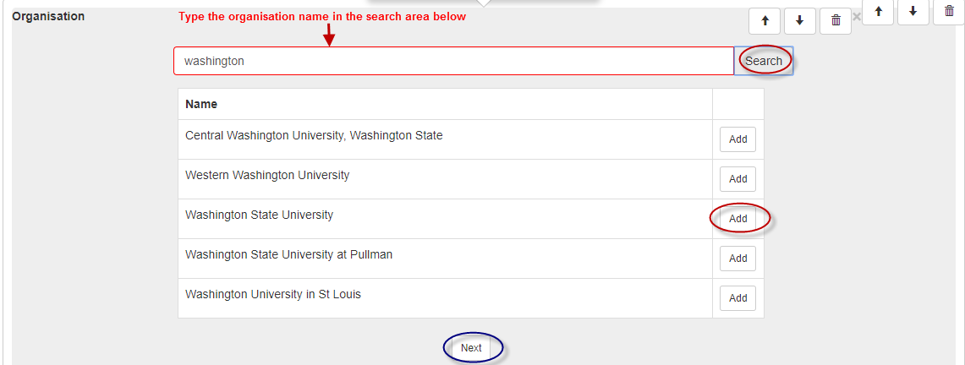

1. Select the nature of collaboration from the drop down menu and ‘Add’.

*(Multiple categories may be selected for each organisation).*

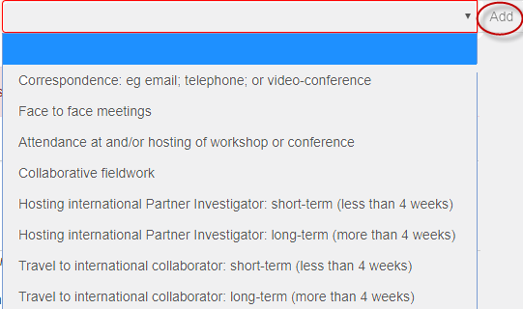

1. Provide a justification of a maximum of 1000 characters detailing the benefit of the collaboration.
2. Select ‘Yes’ or ‘No’ to identify if the collaboration continue past the life of the grant?
3. To add additional collaborations or partnerships, select ‘Add Answer’ and repeat steps 2 to 6.

**Please Note:** If the organisation does not exist in RMS, provide the details (full name, country and ABN - if Australian organisation) to the RMS Help Desk at [ARC-Systems@arc.gov.au](mailto:ARC-Systems@arc.gov.au) and the organisation will be added to RMS. Note that only one organisation can be selected.

**B6. Did you collaborate with researchers outside your own discipline during this Project?** (*Mandatory*)

A ‘Yes’ or ‘No’ answer is required. If ‘**Yes**’, manually enter the Field of Research (FOR) numerical code or enter the appropriate category code. Refer the link below to the Australian Bureau of Statistics for the FOR classifications.

[1297.0 - Australian and New Zealand Standard Research Classification (ANZSRC), 2008](http://www.abs.gov.au/Ausstats/abs@.nsf/Latestproducts/6BB427AB9696C225CA2574180004463E)

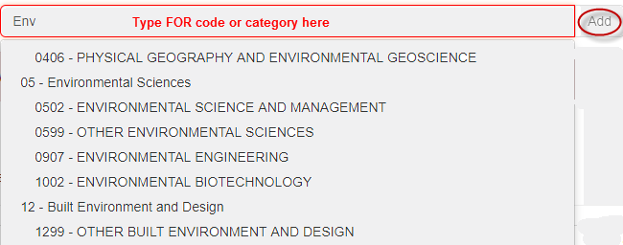

1. Select the appropriate code and ‘Add’.
2. To add additional categories, complete steps one and two.
3. If ‘No’ is selected, continue on to question B7.

**B7. How many research students and research personnel were funded by the ARC grant?** *(Mandatory)*

Enter the number of research students and personnel funded by the ARC grant. (*Refer below for definitions)*

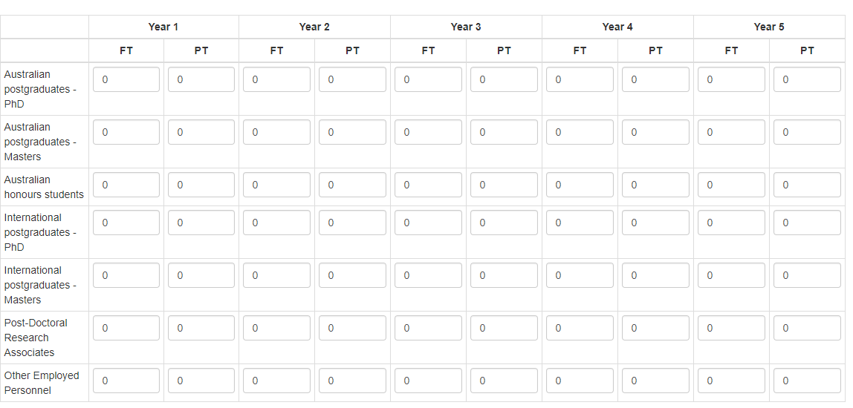

* *Australian Postgraduate and Honours* students supported by this project include; students enrolled at Australian higher education institutions whose postgraduate or honours research was assisted by the Project (for example, use of equipment funded under LIEF grants or supervision by Chief Investigators or Fellows on research related to the Project).
* *Overseas Postgraduate and Honours* students supported by this project include; students enrolled in overseas universities whose postgraduate or Honours research was assisted by ARC funding (for example, students who use equipment funded under the grant, or benefit from the Project funding).
* *Post-Doctoral Research Associates* supported by this project include; students who have a PhD or have been approved by the ARC as having a research degree or experience equivalent to the award of a PhD.
* *Other Employed Personnel* supported by this project include; research associate/assistants (full-time and part-time) funded by the Project, professional and/or technical officers and Industry Partner employees (other than named PIs) involved in the Project.

***Note: If a student/personnel is funded for 5 years, this should be reflected per year, per student/personnel***

**B8. What was the destination of PhD and Masters students funded by the ARC grant (within 12-months of the conclusion of their HDR Study)?** *(Not Mandatory)*

**Please note:** This question is not mandatory however, if there is an answer to B7, then B8 must be answered.

Insert the number of students against each of the categories as identified below (numerical answer only)

* Further study
* Industry
* Government
* University
* Other employed
* Unemployed
* Unknown.

**B9. Did your research project require the use of a national or international facility?** *(Mandatory)*

A 'Yes’ or ‘No’ answer is required. If ‘**Yes**’, select the name of the facility from the drop-down menu:

* CERN
* Synchrotron – Australia
* Synchrotron – Japan
* NCRIS funded facility
* LIGO
* Other (please enter name below).

If ‘Other’ is selected, insert the name of the facility (maximum 150 characters)

1. Was this access funded by the ARC?
2. If ‘Yes’, continue on to Part C – Research Outputs
3. If ‘No’, insert who funded access, if not the ARC (maximum 150 characters).

# Part C – Project Outputs

Investigators are requested to detail the project outputs achieved as a result of ARC funding including; research outputs (C1), data outputs (C2) and commercialisation outputs (C3 and C4).

RMS has the functionality to auto-populate outputs from Crossref to reduce the manual entry of outputs. This is available on the [Crossref website](http://search.crossref.org/) (http://search.crossref.org) by identifying outputs that have a Digital Object Identifier (DOI).

*Definition: A digital object identifier (DOI) is a unique alphanumeric string assigned by a registration agency (the International DOI Foundation) to identify content and provide a persistent link to its location on the Internet. The publisher assigns a DOI when articles are published and made available electronically.*

The table below reflects the output types accepted by the ARC, as auto-populated via Crossref. For outputs unable to be sourced from Crossref, manual entry will be required.

| **Accepted Research Output types from Crossref** | **Accepted Data Output types from Crossref** | **Unaccepted Research Output types from Crossref** |
| --- | --- | --- |
| Journal Article | Dataset | Book Section |
| Book Chapter |  | Book Track |
| Book |  | Book Part |
| Proceedings Article (Conference Papers appear as this type) |  | Book Set |
|  |  | Book Series |
|  |  | Edited Book |
|  |  | Reference Book |
|  |  | Monograph |
|  |  | Report |
|  |  | Journal |
|  |  | Journal Volume |
|  |  | Journal Issue |
|  |  | Reference Entry |
|  |  | Component |
|  |  | Report Series |
|  |  | Proceedings |
|  |  | Standard |
|  |  | Standard Series |
|  |  | Posted Content |
|  |  | Dissertation |
|  |  | Other |

**C1. Provide details of the research outputs produced by this Project** *(Mandatory)*

Details of research outputs may be provided in one of three formats:

1. Auto-populated DOI information that are already linked to the ARC DOI.
2. Auto-populate DOI number for those outputs with a DOI but are not linked to the ARC DOI.
3. Manual entry of outputs.

**Auto-populated DOI information that are already linked to the ARC DOI**

If the output has a DOI on Crossref and has been linked to the ARC DOI then they will appear automatically. To include the output to the report, select the ‘Add’ button, next to the relevant line.

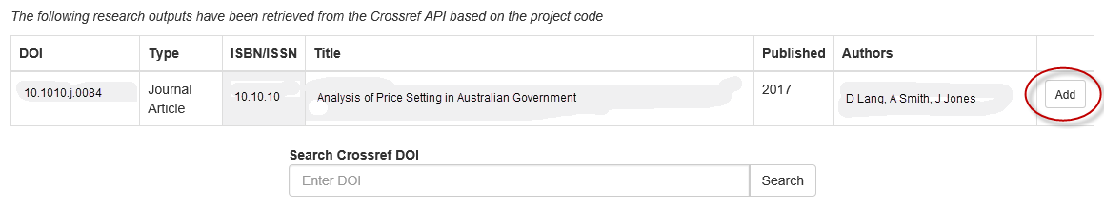

**Auto-populate DOI number for those outputs with a DOI but are not linked to the ARC DOI**

1. To manually locate a DOI number for population, insert the DOI number in the ‘*Search Crossref DOI’* field and select ‘Search’.



1. Select the relevant output from the list provided and select ‘Add’.

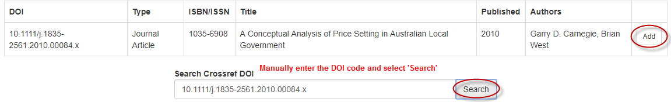

1. Once added, the DOI, Output category, ISBN/ISSN, Title, Year published and Authors will auto-populate. If the ISBN/ISSN does not auto-populate, this means that the entry from Crossref did not have this information. As this is a mandatory field, the entry will need to be updated in Crossref and then re-selected in RMS.
2. Select ‘Yes’ or ‘No’ from the drop down menu denoting if *the Research Output has been made Openly Accessible within a twelve (12) month period from the publication/release date*
3. If ‘**Yes**’ is selected, continue to add additional outputs if required or proceed to question C2.
4. If ‘**No**’ is selected, provide an explanation as to why the Research Output has not been made Openly Accessible within the twelve (12) months of the publication/release date.

Please note that ‘cost’ is not an acceptable reason.

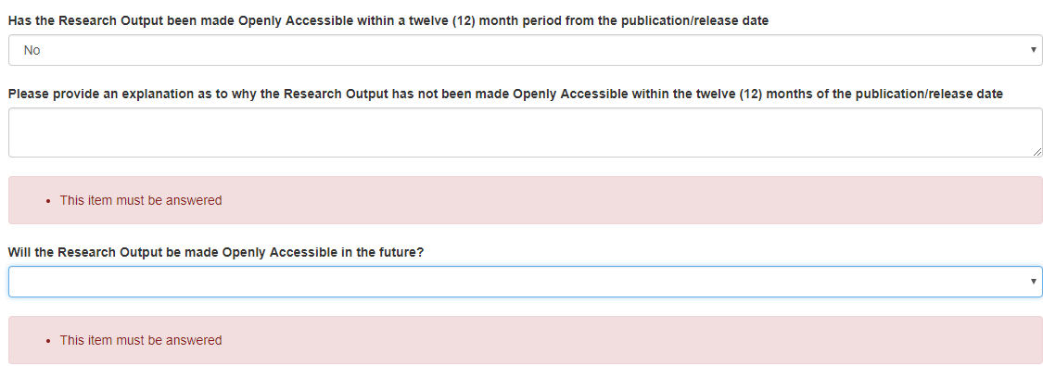

1. Select ‘Yes or ‘No’ from the drop-down list advising if the *Research Output will be made Openly Accessible in the future.*
2. If ‘**Yes**’, enter an expected date that the Research Output will be made ‘Openly Accessible’.
3. If ‘**No**’, provide an explanation as to why the Research Output will not be made Openly Accessible (please refer to the ARC's Open Access Policy).

**Manual entry of outputs**

If an output does not have a DOI, it will have to be added to the report manually. This will have to be repeated for each output that needs to be added to the report.

1. Select ‘Add Output’.
2. Insert the ‘DOI’ number and select the ‘Output category’ from the drop-down menu.

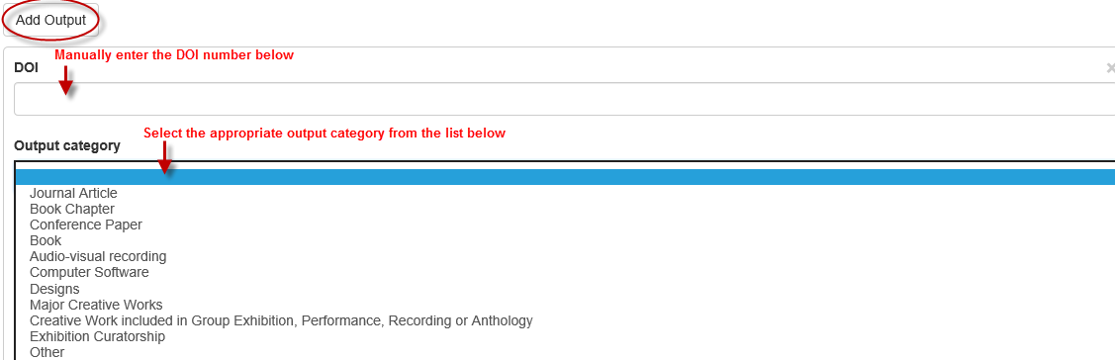

1. Enter the following fields to provide further detail regarding the output referenced:

* ISBN/ISSN identifier
* Title
* Year published/released
* Authors (Other named authors/contributors, contributors other than named participants).

1. Select ‘Yes’ or ‘No’ from the drop down menu denoting if *the Research Output has been made Openly Accessible within a twelve (12) month period from the publication/release date.*
2. If ‘**Yes**’ is selected, continue to add additional outputs if required or proceed to question C2.
3. If ‘**No**’ is selected, *Provide an explanation as to why the Research Output has not been made Openly Accessible within the twelve (12) months of the publication/release date.*

Please note that ‘cost is not an acceptable reason.

1. Select ‘Yes or ‘No’ from the drop-down, menu advising if the *Research Output will be made Openly Accessible in the future*.
2. If ‘Yes’, enter an expected date that the Research Output will be made ‘Openly Accessible’.
3. If ‘No’, provide an explanation as to why the Research Output will not be made Openly Accessible (please refer to the ARC's Open Access Policy).
4. To remove an output, select ‘x’ from the top right hand corner of output box.

**Please Note:** It is important to ensure that any academic outputs listed in the report were produced as a result of the Project itself and that they were not produced before the start date of the Project or from other funding. If an output listed was produced before the Project’s start date it will not be taken into consideration by the ARC and will request for these to be removed. The ARC will however, accept approximated dates to the closest possible day/month/year of publication or release for entry in RMS if an exact publication date is unknown.

Please note that outputs that have not been published as at the date of submitting the Final Report will not be accepted and the ARC will request for these to be removed.

**C2. Provide details of the data outputs produced by this Project** *(Mandatory)*

Details of research outputs may be provided in one of three formats:

1. Auto-populated DOI information that are already linked to the ARC DOI.
2. Auto-populate DOI number for those outputs with a DOI but are not linked to the ARC DOI.
3. Manual entry of outputs.

**Auto-populated dataset DOI information that are already linked to the ARC DOI**

If the data output has a DOI on Crossref and has been linked to the ARC DOI then they will appear automatically. To include the output to the report, select the ‘Add’ button, next to the relevant line.

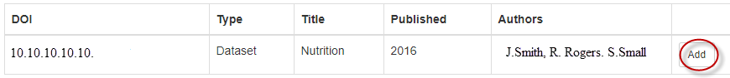

**Auto-populate dataset DOI number for those outputs with a DOI but are not linked to the ARC DOI**

1. To manually locate a dataset DOI number for population, insert the DOI number in the ‘*Search Crossref DOI’* field and select ‘Search’.



1. Select the relevant output from the list provided and select ‘Add’.
2. Once added, the dataset DOI, Type, Title, Published and Authors will auto-populate.

Search Crossref DOI by manually entering the number in the ‘Search box’ provided for auto-population of the data output.

**Manual Entry of Data Outputs**

Select ‘Add output’ and enter the following information to complete the output

* DOI number
* Output category (Dataset/Digital Data/Techniques/Algorithms/Software/Other)
* Title
* Year published/released
* Authors
* Has the Data Output been made Openly Accessible? Select ‘Yes’ or ‘No’ from the drop-down menu;

1. If ‘Yes’

* Enter the date the Data Output was made openly accessible.
* Enter where the Data Output was deposited.

1. If ‘No’

* Will the Data Output be made Openly Accessible in the Future?
* If ‘Yes’, enter the expected date that the Data Output will be made openly accessible and where the Data Output will be deposited.
* If ‘No’, provide an explanation as to why the Data Output will not be made Openly Accessible.

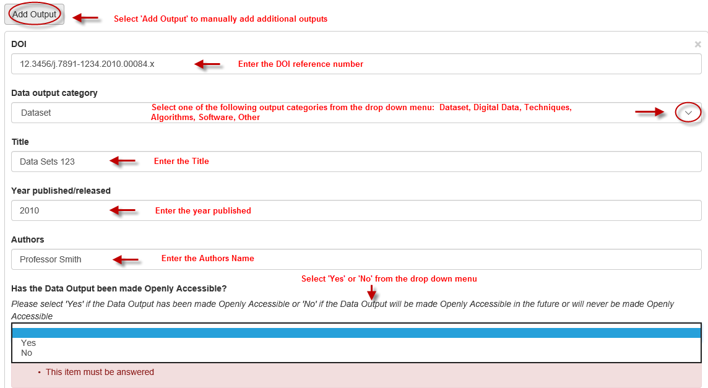

**C3. Number of commercial outputs produced during the project?**

This answer is auto-populated from the answers provided in C4.

**C4. Provide details of the commercial outputs produced by this Project** *(Mandatory)*

A Yes’ or ‘No’ answer is required for all the following questions from C4.1 - C5.

**C4.1 Invention Disclosures** *(Mandatory)*

Were any Invention Disclosures made by this Project? A Yes’ or ‘No’ answer is required. If '**Yes**', provide the number of Invention Disclosures in the text box provided.

**C4.2 Filed Patents** *(Mandatory)*

Were any Filed Patents made by this Project? A ‘Yes’ or ‘No’ answer is required. If '**Yes**' proceed to C4.2.2.

**C4.2.2 Provide details of any filed and/or pending patents**

Select the 'Add' button to see the fields to be completed. This must be done for each patent:

* Patent Title
* Patent Number
* Country (search for Country name and select 'Add', to add to the report)
* Application Date
* Patent Status (Filed/Pending)
* Listed on Source IP (Yes/No).

**C4.3 Plant breeders rights** *(Mandatory)*

Where there any Plant Breeder Rights acquired during this Project? A ‘Yes’ or ‘No’ answer is required. If '**Yes**' proceed to C4.3.2.

**C4.3.2 Provide details of any filed and/or pending patents**

Select the 'Add' button to see the fields to be completed. This must be done for each patent:

* Variety
* Application or certificate number
* Application Date
* Status (Filed/Certified Granted)
* Listed on Source IP (Yes/No).

**C4.4** **Registered Designs** *(Mandatory)*

Where any Registered Designs done by this Project? A ‘Yes’ or ‘No’ answer is required. If '**Yes**' proceed to C4.4.2.

**C4.4.2 Provide details of any registered designs**

Select ‘Add answer’ to populate the questions and answer the following:

* Article/Product Name
* Application Date (lodged)
* Status (Registered/Certified/Published/Lapsed/Other)
* Listed on Source IP (Yes/No).

**C4.5** **Integrated circuit design** *(Mandatory)*

Where any Integrated Designs done by this Project? A ‘Yes’ or ‘No’ answer is required. If '**Yes**' proceed to C4.5.2.

**C4.5.2 Provide details of any integrated circuit designs**

Select ‘Add answer’ to populate the questions and answer the following:

* Name
* Details
* Listed on Source IP (Yes/No).

**C4.6** **Other IP rights** *(Mandatory)*

Where any other IP rights produced by this Project? A ‘Yes’ or ‘No’ answer is required. If '**Yes**' proceed to C4.6.2.

**C4.6.2 Provide details of any other IP**

Select ‘Add answer’ to populate the Details.

**C4.7** **Licensed technologies** *(Mandatory)*

Where any Licensed Technologies executed by this Project? A ‘Yes’ or ‘No’ answer is required. If '**Yes**' please list the number of licensed technologies executed.

**C5. Did the intellectual property arrangements change during the course of the project?** *(Mandatory)*

A ‘Yes’ or ‘No’ answer is required. If ‘**Yes**’, provide details as to how the intellectual property arrangements changed during the Project and for what reasons? (Maximum 1000 characters).

# Part D – Project Outcomes

**D1. Briefly describe the most significant results, outcomes and benefits arising from the project. (This information is not for public release.)** *(Mandatory)*

Provide a written summary of no more than 1000 characters per question in the text box provided for each question as identified below, describing the significance, results, benefits, outcomes and impacts arising from the Project.

* Contributions to existing field
* Discoveries made
* Importance of research conducted
* New research direction identified
* Innovations, for example use of new, untested methods or theories.

**Please Note:** Do not include Academic outputs in this question. These should be included in Part C – Research outputs.

**D2. Briefly describe any other commercial outcomes from the Project** *(Not Mandatory)*

In the text box provided, please provide a written summary of no more than 1000 characters, describing any commercial products and revenue, spin off and start-up companies, benefits to partner organisations.

**D3. Provide details of any start-up/spin-out companies formed from this Project**

*(Not Mandatory)*

If ‘Yes’, enter the following details:

* Company/business name
* Australian Business Number (do not enter spaces)
* Year Established
* Number of current employees
* Company website/URL.

**D4. Have any of the investigators or their works won prizes, awards or other major tributes as a result of the research Project?** *(Mandatory)*

A ‘Yes’ or ‘No’ answer is required. If '**Yes**' proceed to D4.2.

**D4.2 Provide details of prizes, awards or major tributes by completing the following questions;**

* Award title / name
* Type of prize/award (select one of the following from the drop-down menu)
* Australian Government
* International Government
* No-government / Intergovernmental Organisation
* Peak body – Academies, Societies, etc.
* Industry and other private funding
* Researcher’s own institution
* Awarded to (select from drop-down menu and ‘Add’)
* Description / awarded by
* Date awarded

Select ‘Add Answer’ to enter additional awards.

**D5. What have you done to facilitate dissemination of the outcomes of your research?** *(Mandatory)*

From the drop-down menu, select the appropriate knowledge mobilisation event or activity and select ‘Add answer’.

* Media Coverage
* Press Release
* Project Relates Websites
* School Outreach
* Public Lectures/Forums
* Exhibitions
* Social Media
* Other.

1. If ‘Other’ is selected, please specify within the text box provided.
2. For Media release links, please provide a link to the relevant page in the text box provided.

# Part E – Research Impacts

**E1. Outline how the completed project has produced (or is expected to produce) significant new knowledge and/or innovative economic, commercial, environmental, social and/or cultural benefit to the Australian and international community.** *(Mandatory)*

Manually enter the Impact Statement as per the original proposal. For proposals that do not include a separate Impact Statement section, please draw on information from the Project Description that addresses intended impacts.

**Please note:** the Impact Statement will auto-populate for the following schemes and onwards: DP16, LP16, DE16, FL15, FT15, IN16, LE16

Select ‘Yes’ or ‘No’ from the drop down menu identifying if the original Impact has been revised? If yes, provide further detail in the text box provided regarding the revised Impact.

**E2. Provide details of the likely benefits arising from your research project** *(Mandatory)*

Please answer the following questions by selecting the relevant options from the drop-down menu. Select the appropriate category and ‘Add’. Multiple answers may be selected for these options.

**My Research has produced or is likely to result in or lead to** (Multi-select options)

* Economic benefits
* Social benefits
* Cultural benefits
* Environmental benefits
* Increased research capacity.

**In more detail, my research has produced or is likely to result in or lead to**. (Multi-select options)

* Economic-human capital build-up
* Economic –increased employment
* Economic-increased productivity
* Economic-other
* Social-informed decision making
* Social-enhanced skill base
* Social-improved health and well-being
* Social-improved safety and security
* Social-reduced social problems
* Social-other
* Cultural-cultural preservation
* Cultural-cultural understanding
* Cultural-other
* Environmental-better natural resource management
* Environmental-reduced damage to environment
* Environmental-other
* Research capacity-new partnerships
* Research capacity-new research directions
* Research capacity-research training
* Other-provide details below.

If ‘Other – provide details below’ is selected, please provide further details in the ‘Other benefits’ text box provided.

**I expect the benefit will be realised** (Single selection only)

* Already achieved
* Within five years
* More than five years.

**My research will benefit** (Multi-select option)

* Academic sector
* General public
* Government
* Not-for-profit/community organisations
* Schools
* Hospitals
* Private sector companies
* Professional & Industrial associations
* Galleries/libraries and museums sector
* Partner Organisations
* Other.

If ‘Other’ is selected from the options above, please specify whom the research will benefit.

# Part F – Linkage Projects

**F1. Briefly summarise the nature, extent and outcomes of the collaborative arrangements with the Partner Organisations listed in Part A.** (*Mandatory*)

This question is to be answered by the Researcher.

Please answer the following questions by completing the text box provided.

**Nature and extent of collaboration**

Provide a summary of no more than 1000 characters describing the nature and extent of the collaboration with the Partner Organisations listed in Part A. Describe the methods by which collaboration occurred (site visits, teleconferences, emails, etc.), how often it occurred, how it benefitted the Project and what outcomes were produced as a result of the collaborations.

**Ways the project fostered a greater understanding and appreciation of end-user needs and expectation**

Provide a written summary of no more than 1000 characters, describing the ways the Project fostered a greater understanding of industry needs and expectations. Describe what was learnt from the partnership and how the partnership shaped the research (for example, was research conducted based on the needs and expectations of the Partner Organisation(s)?

**Cooperative links between the higher education sector/industry/public sector users of research that resulted from the project, including employment opportunities**

Provide a written summary of no more than 1000 characters, providing details on any links that were formed between the Project and the higher education sector/industry/ public sector users.

This may include details on any new avenues of collaboration that were formed and how the research was used by higher education sector/industry/public sector users.

**F2. Briefly summarise the nature, extent and outcomes of the collaborative arrangements with the Administering Organisation.** *(Mandatory)*

All named Partner Organisations on the Project must complete this question.

**Who initiated the collaboration?**

Select either the Partner Organisation or Administering Organisation from the drop-down menu.

**Is this the first time that your organisation has participated as a Partner Organisation under the Linkage Projects scheme?**

Select ‘Yes’ or ‘No’ from the drop-down menu.

**Did this Project build on a previously established relationship or was it a new collaboration?**

Select ‘Existing relationship’ or ‘New Collaboration’ from the drop-down menu.

**Was it beneficial?**

Select one of the following options:

* Not beneficial
* Beneficial
* Very beneficial.

**Summarise the major outcomes from your perspective.**

Provide a text answer, summarising the major outcomes from the researcher’s perspective (5000 character maximum).

**Provide actual comments on intended or actual use of outcomes**

Provide a text answer, summarising intended and actual use of outcomes (5000 character maximum).

**What was the impact of the collaboration?**

Select an option/s from the drop-down menu provided and select ‘Add’. (Multi-select answer)

* Cultural
* Societal
* Economic
* Policy and public services
* No impact yet.

**What did you contribute?**

Select an option/s from the drop-down menu provided and select ‘Add’. (Multi-select answer)

* Leading or co-leading research projects
* General input or advice
* Planning Research
* Identification of research questions
* Dissemination of results
* Implementation of research results
* Increasing capacity through education and training
* Data collection
* Data Interpretation
* Other – If selected, provide further details in the text box provided.

**How have you used the results?**

Select an option/s from the drop-down menu provided and select ‘Add’. (Multi-select answer)

* Provide advice to decision makers
* Developed training
* Improved processes or services
* Developed products
* Other.

If ‘Other’, provide further details in the text box provided (maximum 200 characters).

**Will the collaboration be ongoing after the Project concludes?**

Select ‘Yes’ or ‘No’ from the drop down menu.

**Would you participate again in this scheme?** *(Mandatory)*

Select one of the following options from the drop-down menu:

* Yes
* No
* Unsure
* Not applicable.

**Why?**

Provide further detail.

# Part F – Discovery Early Career Researcher Award

**F1. Where, other than the Administering Organisation, did you undertake your research project?** *(Not Mandatory)*

Manually enter the name of the Organisation where the research was undertaken, other than the Administering Organisation, in the search box provided and select ‘Search’.

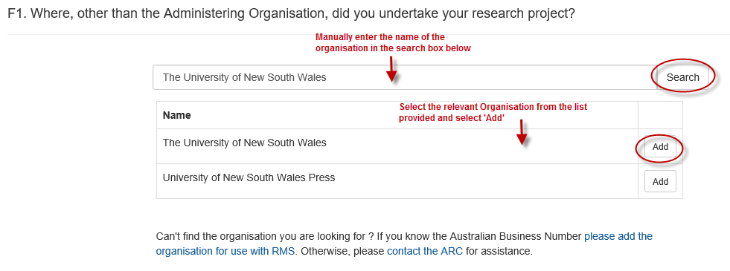

1. Select the appropriate organisation from the list provided and select ‘Add’.
2. Multiple options may be selected.
3. If an organisation cannot be found, add the Australian Business Number for use in RMS. Otherwise, please [contact](http://www.arc.gov.au/rms-information) the ARC helpdesk at [ARC-Systems@arc.gov.au](mailto:ARC-Systems@arc.gov.au) for assistance.

**F2. Employment post-project: When the Project finished, where did you go?***(Mandatory)*

From the list provided, please select an option to indicate where the DECRA was employed when the Project was completed.

* Employment – Administering Organisation
* Employment – Other University
* Employment – Other institution
* Employment – Industry/Private sector
* Employment – Industry/Collaborating partner on grant
* Employment – Government – State
* Employment – Government – Commonwealth
* Employment – NGO
* Not employed
* Employed Overseas – Please select from list of countries
* Other – Please provide details below.

If ‘Employed Overseas – Please select country/s by typing the country in the search box provided and ‘Add’.

If ‘Other’, provide further details in the text box provided (maximum 150 characters)

**F3. How did the fellowship increase research capacity?***(Mandatory)*

Please select the categories from the pre-populated list that best explains how the Fellowship increased research capacity. More than one category may be selected from the list. Select ‘Add’ to populate.

* Attracted domestic students
* Attracted international students
* Established new research team/lab
* Facilitated international partnerships
* Developed existing or emerging research strengths
* Advanced knowledge
* Developed or informed the development of new technology/products or processes
* Developed partnerships with the business/government or community sector
* Other.

If ‘Other’ is selected, provide a written summary of no more than 150 characters, explaining how the fellowship increased research capacity to conduct new research, new lab opportunities and new collaborations and/or links between academic institutions.

# Part F – Future Fellowships

**F1. Where did you undertake your research project?** *(Mandatory)*

Please select the organisation type from the pre-populated list that reflects:

* Where the Research was undertaken.
* The percentage of time spent at each organisation. (Do not use decimal points).
* More than one category may be selected from the list.

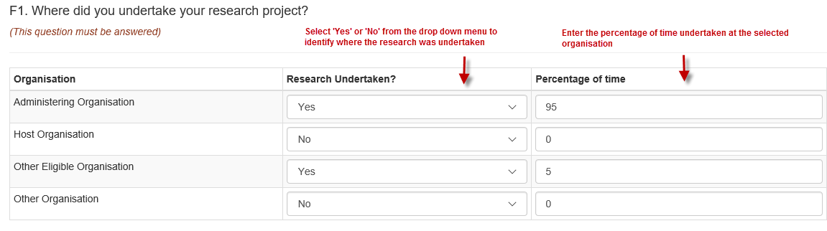

**F2. Employment post-project: When the Project finished, where did you go?** *(Mandatory)*

From the drop-down list provided, please select an option to indicate where the Future Fellowship was employed when the Project was completed.

* Employment – Administering Organisation
* Employment – Other University
* Employment – Other institution
* Employment – Industry/Private sector
* Employment – Industry/Collaborating partner on grant
* Employment – Government – State
* Employment – Government – Commonwealth
* Employment – NGO
* Not employed
* Employed Overseas – Please select from list of countries
* Other – Please provide details below.

If ‘Employed Overseas – Please select country/s by typing the country in the search box provided and ‘Add’.

If ‘Other’, provide further details in the text box provided (maximum 150 characters)

**F3. How did the fellowship increase research capacity?***(Mandatory)*

Please select the category/s from the pre-populated list that best explains how the Fellowship increased research capacity. More than one category may be selected from the list. Make sure to select ‘Add’ to populate.

* Attracted domestic students
* Attracted international students
* Established new research team/lab
* Facilitated international partnerships
* Developed existing or emerging research strengths
* Advanced knowledge
* Developed or informed the development of new technology/products or processes
* Developed partnerships with the business/government or community sector
* Other.

If ‘Other’ is selected, provide a written summary of no more than 150 characters, explaining how the fellowship increased research capacity to conduct new research, new lab opportunities and new collaborations and/or links between academic institutions.

# Part F – Australian Laureate Fellowships

**F1. Where did you undertake your research project?** *(Mandatory)*

Please select from the search list, where the Laureate undertook the research project, other than the Administering Organisation.

**F2. Employment post-project: When the Project finished, where did you go?** *(Mandatory)*

From the list provided, please select an option to indicate where the Australian Laureate Fellowship was employed when the Project was completed.

* Employment – Administering Organisation
* Employment – Other University
* Employment – Other institution
* Employment – Industry/Private sector
* Employment – Industry/Collaborating partner on grant
* Employment – Government – State
* Employment – Government – Commonwealth
* Employment – NGO
* Not employed
* Employed Overseas – Please select from list of countries
* Other – Please provide details below.

If ‘Employed Overseas – Please select country/s by typing the country in the search box provided and ‘Add’.

If ‘Other’, provide further details in the text box provided (maximum 150 characters)

**F3. For recipients of the Kathleen Fitzpatrick and Georgina Sweet awards: please provide details of activities undertaken and outcomes achieved with the additional funding provided?** *(Mandatory for Kathleen Fitzpatrick and Georgina Sweet Awardees)*

*Recipients of Kathleen Fitzpatrick and Georgina Sweet Australian Laureate Fellowships are provided with additional funding of up to $20,000 per annum (for five years) to undertake an ambassadorial role to promote women in research and to mentor early career researchers, particularly women, to encourage them to enter and establish careers in research in Australia.*

Please answer the following questions by completing the text box provided.

**What activities did you undertake as part of your ambassadorial role?**

Provide a written summary of no more than 1000 characters, describing the activities undertaken as part of the ambassadorial role after being awarded the named fellowship.

**What were the benefits to you of receiving the additional funding?**

Provide a written summary of no more than 1000 characters, describing the benefits of receiving the additional award funding.

**What benefits to woman in research and early career researchers were achieved through your activities?**

Provide a written summary of no more than 1000 characters, describing the additional benefits that the Fellowship provided to the Fellow’s career path. This may include any publications, collaborations, domestic and international exposure of the research, additional appointments etc.

**F4. How did the fellowship increase research capacity?** *(Mandatory)*

Please select the category/s from the pre-populated list that best explains how the Fellowship increased research capacity. More than one category may be selected from the list. Make sure to select ‘Add’ to populate.

* Attracted domestic students
* Attracted international students
* Established new research team/lab
* Facilitated international partnerships
* Developed existing or emerging research strengths
* Advanced knowledge
* Developed or informed the development of new technology/products or processes
* Developed partnerships with the business/government or community sector
* Other.

If ‘Other’ is selected, provide a written summary of no more than 150 characters, explaining how the fellowship increased research capacity to conduct new research, new lab opportunities and new collaborations and/or links between academic institutions.

# Part F – Discovery Indigenous Award

**F1. Where, other than the Administering Organisation, did you undertake your research project?** *(Not Mandatory)*

Manually enter the name of the Organisation where the research was undertaken, other than the Administering Organisation, in the search box provided and select ‘Search’.



1. Select the appropriate organisation from the list provided and select ‘Add’.
2. Multiple options may be selected.
3. If an organisation cannot be found, add the Australian Business Number for use in RMS. Otherwise, please [contact](http://www.arc.gov.au/rms-information) the ARC helpdesk for assistance.

**F2. Employment post-project: When the Project finished, where did you go?** *(Mandatory)*

From the list provided, please select an option to indicate where the DIA was employed when the Project was completed.

* Employment – Administering Organisation
* Employment – Other University
* Employment – Other institution
* Employment – Industry/Private sector
* Employment – Industry/Collaborating partner on grant
* Employment – Government – State
* Employment – Government – Commonwealth
* Employment – NGO
* Not employed
* Employed Overseas – Please select from list of countries
* Other – Please provide details below.

If ‘Employed Overseas – Please select country/s by typing the country in the search box provided and ‘Add’.

If ‘Other’, provide further details in the text box provided (maximum 150 characters).

# Part F – Linkage, Infrastructure, Equipment and Facilities

**F1. Does the organisation maintain a record of access to the facility or equipment by researchers?** *(Mandatory)*

A ‘Yes’ or ‘No’ answer is required. If ‘Yes’ is selected, provide a written summary of no more than 1000 characters, detailing who on the Project used the equipment, how often they used it and which outputs were influenced by/what outcomes resulted from the use of these facilities.

**F2.** What i**s the expected project life span of the infrastructure, equipment or facility?** *(Mandatory)*

Provide a written summary of no more than 1000 characters, detailing the expected life span of the infrastructure, equipment or facility.

**F3.** Briefly describe the research collaboration between the organisations listed in Part A, indicating how this collaboration was facilitated by the LIEF funding?*(Mandatory)*

Provide a written summary of no more than 1000 characters, describing how the collaboration between the organisations listed in Part A was facilitated by the Projects funding. Describing the methods by which collaboration occurred (site visits, teleconferences, emails, etc.), how often it occurred, how it benefitted the Project and what outcomes were produced as a result of the collaborations.

**F4.** Provide the breakdown of expenditure to purchase the equipment or establish the facility**.** *(Mandatory)*

Provide a breakdown of the expenditure on equipment and/or expenses involved in establishing the facility. For each item, please provide a description, the purchase price and any additional comments/information on the items.

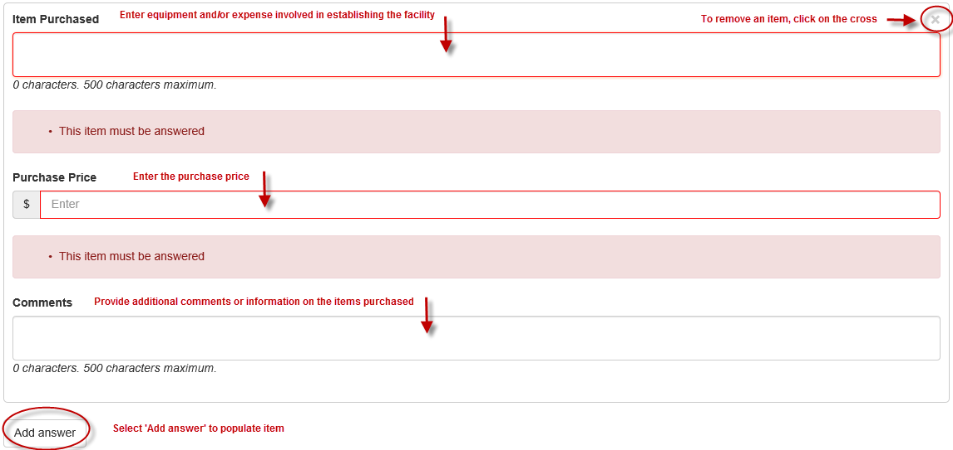

# Part F – ARC Centres of Excellence

**F1. Outline the top five benefits of conducting a research program through an ARC Centre of Excellence.** *(Mandatory)*

Provide a written summary of no more than 5000 characters, describing the top five benefits of conducting a research program through an ARC Centre of Excellence. Consider and compare the research undertaken as if it had been conducted through a series of individual grants instead.

**F2. Briefly summarise the nature, extent and outcomes of the collaborative arrangements with organisations listed in Part A. (For the Centre to complet**e) *(Mandatory)*

Please answer the following questions by completing the text box provided.

**Nature and extent of collaboration**

Provide a summary of no more than 1000 characters describing the nature and extent of the collaboration with the Participating Organisations listed in Part A. Describe the methods by which collaboration occurred (site visits, teleconferences, emails, etc.), how often it occurred, how it benefitted the Project and what outcomes were produced as a result of the collaborations.

**Benefits to the Centre, its research program and personnel through collaboration**

Provide a written summary of no more than 1000 characters, describing the benefits of the research program and personnel through collaboration during the Project and beyond if appropriate.

**F3. Briefly describe the nature, extent and outcomes of the collaborative arrangements with the Centre (For Participating Organisations to complete)** *(Mandatory)*

**Who initiated the collaboration?**

Select either the Participating Organisation or Administering Organisation from the drop-down menu:

* Participating Organisation
* Administering Organisation.

**Is this the first time that your organisation has participated as a Participating Organisation under the ARC Centres of Excellence Scheme?**

Select ‘Yes’ or ‘No’ from the drop-down menu.

**Did your organisations involvement in the Centre build on a previously established relationship or was it a new collaboration?**

Select one of the following options from the drop-down menu:

* Existing relationship
* New Collaboration.

**Was it beneficial?**

Select one of the following options:

* Not beneficial
* Beneficial
* Very beneficial.

**Summarise the major outcomes from your perspective**

Provide a written summary of no more than 5000 characters, describing the major outcomes of the Project and how they benefitted the Organisation.

**Provide actual comments on intended or actual use of outcomes**

Provide a written summary of no more than 5000 characters, describing the intended use of the outcomes.

**What did you contribute?**

Select an option/s from the drop-down menu provided and select ‘Add’. (Multi-select answer)

* Leading or co-leading research projects
* General input or advice
* Planning Research
* Identification of research questions
* Dissemination of results
* Implementation of research results
* Increasing capacity through education and training
* Data collection
* Data Interpretation
* Other – If selected, provide further details in the text box provided (maximum 200 characters).

**How have you used the results?**

Select an option/s from the drop-down menu provided and select ‘Add’. (Multi-select answer)

* Provide advice to decision makers
* Developed training
* Improved processes or services
* Developed products
* Other.

If ‘Other’, provide further details in the text box provided (maximum 200 characters).

**Will the collaboration be ongoing after the Centre concludes?**

Select ‘Yes’ or ‘No’ from the drop down menu.

**Would you participate again in this scheme?**

Select one of the following options from the drop-down menu **(***Mandatory)*

* Yes
* No
* Unsure
* Not applicable.

**Why?**

Provide further detail.

**F4. What was the employment outcome for postdoctoral researchers funded by the Centre (within 12 months of the conclusion of their Centre employment)?** *(Mandatory)*

Provide the employment outcome/destination of each postdoctoral researcher funded by the Project within 12 months of their Centre employment against the following categories.

* Employed by administering organisation
* Employed by other university
* Employed by other institution
* Employed by industry / private sector
* Employed by industry/collaborating partner on Centre
* Employed by state government
* Employed by Commonwealth Government
* Employed by NGO
* Employed overseas
* Not employed
* Other employed (please provide details in text box below if this option is answered).

**F5. Please list the gender breakdown of Centre personnel (total over period of ARC funding).** *(Mandatory)*

Insert the gender breakdown of Centre personnel employed on the Project against each position where relevant as per the list below.

* Chief Investigators (including Director)
* Partner Investigators
* Australian postgraduates – Honours students
* Australian postgraduates – Masters
* Australian postgraduates – PhD
* International postgraduates – Masters
* International postgraduates – PhD
* Australian postdoctoral researchers
* International postdoctoral researchers
* Other employed personnel (administration, technical etc.).

**F6. Did you collaborate with researchers and/or organisations in other countries?** *(Mandatory)*

A ‘Yes’ or ‘No’ answer is required. If ‘Yes’ is selected, please add the relevant country/s (if not Australia) by searching for the appropriate country/s and selecting ‘Add’. (Multiple answers allowed).

**F7. What was the nature of the international collaboration?** *(Mandatory)*

Provide a written summary of no more than 5000 characters, describing the nature of the international collaboration in the text box provided.

**F8. Please describe the most significant challenges in managing the ARC Centre of Excellence and the approaches used to resolve such challenges. (Multiple answers allowed)** *(Mandatory)*

Select ‘Add answer’ to populate questions.

**What was the challenge?**

Provide details of the challenge (maximum 500 characters).

**How was the challenge resolved?**

Provide a written summary of no more than 2000 characters, detailing how the challenge was resolved.

Select ‘Add answer’ to add additional challenges.

# Part F – Special Research Initiatives

**F1. Outline the top five benefits of conducting a research program through a Special Research Initiative** *(Mandatory)*

Provide a written summary of no more than 5000 characters, describing the top five benefits of conducting a research program through a Special Research Initiative. Consider and compare the research undertaken as if it had been conducted through a series of individual grants instead.

**F2. Did the Initiative allow the development of new collaborative arrangements? (For the Initiative to complete)** *(Mandatory)*

Please answer the following questions by completing the text box provided.

**Nature and extent of collaboration**

Provide a summary of no more than 1000 characters describing the nature and extent of the collaboration with the Participating Organisations listed in Part A. Describe the methods by which collaboration occurred (site visits, teleconferences, emails, etc.), how often it occurred, how it benefitted the Project and what outcomes were produced as a result of the collaborations.

**Benefits to the Initiative, its research program and personnel through collaboration**

Provide a written summary of no more than 1000 characters, describing the benefits of the research program and personnel through collaboration during the Project and beyond if appropriate.

**F3. Briefly describe the nature, extent and outcomes of the collaborative arrangements with the Initiative (For Participating Organisations to complete)** *(Mandatory)*

**Who initiated the collaboration?**

Select either the Participating Organisation or Administering Organisation from the drop-down menu.

* Participating Organisation
* Administering Organisation.

**Is this the first time that your organisation has participated as a Participating Organisation under the Special Research Initiatives Scheme?**

Select ‘Yes’ or ‘No’ from the drop-down menu.

**Did your organisations involvement in the Initiative build on a previously established relationship or was it a new collaboration?**

Select one of the following options from the drop-down menu:

* Existing relationship
* New Collaboration.

**Was it beneficial?** Select one of the following options:

* Not beneficial
* Beneficial
* Very beneficial.

**Summarise the major outcomes from your perspective**

Provide a written summary of no more than 5000 characters, describing the major outcomes of the Project and how they benefitted the Organisation.

**Provide actual comments on intended or actual use of outcomes**

Provide a written summary of no more than 5000 characters, describing the intended use of the outcomes.

**What did you contribute?** Select an option/s from the drop-down menu provided and select ‘Add’. (Multi-select answer)

* Leading or co-leading research projects
* General input or advice
* Planning Research
* Identification of research questions
* Dissemination of results
* Implementation of research results
* Increasing capacity through education and training
* Data collection
* Data Interpretation
* Other – If selected, provide further details in the text box provided (maximum 200 characters).

**How have you used the results?**

Select an option/s from the drop-down menu provided and select ‘Add’. (Multi-select answer)

* Provide advice to decision makers
* Developed training
* Improved processes or services
* Developed products
* Other.

If ‘Other’, provide further details in the text box provided (maximum 200 characters).

**Will the collaboration be ongoing after the Initiative concludes?**

Select ‘Yes’ or ‘No’ from the drop down menu.

**Would you participate again in this scheme?**

Select one of the following options from the drop-down menu **(***Mandatory)*

* Yes
* No
* Unsure
* Not applicable.

**Why?**

Provide further detail.

**F4. Please list the gender breakdown of Initiative personnel (total over period of ARC funding).** (*Mandatory)*

Insert the gender breakdown of Centre personnel employed on the Project against each position where relevant as per the list below.

* Chief Investigators (including Director)
* Partner Investigators
* Australian postgraduates – Honours students
* Australian postgraduates – Masters
* Australian postgraduates – PhD
* International postgraduates – Masters
* International postgraduates – PhD
* Australian postdoctoral researchers
* International postdoctoral researchers
* Other employed personnel (administration, technical etc.).

**F5. Did you collaborate with researchers and/or organisations in other countries?** *(Mandatory)*

A ‘Yes’ or ‘No’ answer is required. If ‘Yes’ is selected, please add the relevant country/s (if not Australia) by searching for the appropriate country/s and selecting ‘Add’. (Multiple answers allowed).

**F6. What was the nature of the international collaboration?** *(Mandatory)*

Provide a written summary of no more than 5000 characters, describing the nature of the international collaboration in the text box provided.

**F7. Please describe the most significant challenges in managing the Initiative and the approaches used to resolve such challenges.** (Multiple answers allowed) *(Mandatory)*

Select ‘Add answer’ to populate questions.

**What was the challenge?**

Provide details of the challenge (maximum 500 characters).

**How was the challenge resolved?**

Provide a written summary of no more than 2000 characters, detailing how the challenge was resolved.

Select ‘Add answer’ to add additional challenges.

**F8. Please attach up to two case studies of the outcomes and impact of the Initiative’s research program** *(Mandatory)*

Please attach a PDF document with a maximum of four (4) pages, detailing the outcomes and impact of up to two (2) case studies under the Initiatives research program.

# Part F – Industrial Transformation Research Hubs

**F1. Outline the top five benefits of conducting a research program through an Industrial Transformation Hub.** *(Mandatory)*

Provide a written summary of no more than 5000 characters, describing the top five benefits of conducting a research program through an Industrial Transformation Research Hub. Consider and compare the research undertaken as if it had been conducted through a series of individual grants instead.

**F2. Briefly summarise the nature, extent and outcomes of the collaborative arrangements with organisations listed in Part A**. *(For the Research Hub to complete) (Mandatory)*

Please answer the following questions by completing the text box provided.

**Nature and extent of collaboration**

Provide a summary of no more than 1000 characters describing the nature and extent of the collaboration with the Participating Organisations listed in Part A. Describe the methods by which collaboration occurred (site visits, teleconferences, emails, etc.), how often it occurred, how it benefitted the Project and what outcomes were produced as a result of the collaborations.

**Benefits to the Research Hub, its research program and personnel through collaboration**

Provide a written summary of no more than 1000 characters, describing the benefits of the research program and personnel through collaboration during the Project and beyond if appropriate.

**Ways the Research Hub fostered a greater understanding and appreciation of end-user needs and expectations**

Provide a summary of no more than 1000 characters describing ways the Research Hub fostered a greater understanding and appreciation of end-user needs and expectations.

**Cooperative links between the higher education sector/industry/public sector users of research that resulted from the Research Hub, including employment**

Provide a summary of no more than 1000 characters describing the cooperative links between the higher education sector/industry/public sector users of research that resulted from the Research Hub, including employment.

**F3. Briefly summarise the nature, extent and outcomes of the collaborative arrangements with the Research Hub** *(For Participating Organisations to complete) (Mandatory)*

**Who initiated the collaboration?**

Select either the Participating Organisation or Administering Organisation from the drop-down menu:

* Participating Organisation
* Administering Organisation.

**Is this the first time that your organisation has been a participating organisation under the Industrial Transformation Research Hubs Scheme?**

Select ‘Yes’ or ‘No’ from the drop-down menu.

**Did this Project build on a previously established relationship or was it a new collaboration?**

Select one of the following options from the drop-down menu:

* Existing relationship
* New Collaboration.

**Was it beneficial?**

Select one of the following options:

* Not beneficial
* Beneficial
* Very beneficial.

**Summarise the major outcomes from your perspective.**

Provide a written summary of no more than 5000 characters, describing the major outcomes of the Project and how they benefitted the Organisation.

**Provide actual comments on intended or actual use of outcomes**

Provide a written summary of no more than 5000 characters, describing the intended use of the outcomes.

**What did you contribute?**

Select an option/s from the drop-down menu provided and select ‘Add’. (Multi-select answer)

* Leading or co-leading research projects
* General input or advice
* Planning Research
* Identification of research questions
* Dissemination of results
* Implementation of research results
* Increasing capacity through education and training
* Data collection
* Data Interpretation
* Other – If selected, provide further details in the text box provided (maximum 200 characters).

**How have you used the results?**

Select an option/s from the drop-down menu provided and select ‘Add’. (Multi-select answer)

* Provide advice to decision makers
* Developed training
* Improved processes or services
* Developed products
* Other.

If ‘Other’, provide further details in the text box provided (maximum 200 characters).

**Will the collaboration be ongoing after the Initiative concludes?**

Select ‘Yes’ or ‘No’ from the drop down menu.

**Would you participate again in this scheme?**

Select one of the following options from the drop-down menu:

* Yes
* No
* Unsure
* Not applicable.

**Why?**

Provide further detail.

**F4. What was the employment outcome for postdoctoral researchers funded by the Research Hub (within 12 months of the conclusion of their Research Hub employment)?** *(Mandatory)*

Provide the employment outcome/destination of postdoctoral researchers funded by the Project within 12 months of their Research Hub employment against the following categories. (Enter a number for each category);

* Employed by administering organisation
* Employed by other university
* Employed by other institution
* Employed by industry / private sector
* Employed by industry/collaborating partner on Centre
* Employed by state government
* Employed by Commonwealth Government
* Employed by NGO
* Employed overseas
* Not employed
* Other employed (please provide details in text box below if this option is answered).

**F5. Please list the gender breakdown of Research Hub personnel (total over period of ARC funding).** (*Mandatory)*

Insert the gender breakdown of Centre personnel employed on the Project against each position where relevant as per the list below.

* Chief Investigators (including Director)
* Partner Investigators
* Australian postgraduates – Honours students
* Australian postgraduates – Masters
* Australian postgraduates – PhD
* International postgraduates – Masters
* International postgraduates – PhD
* Australian postdoctoral researchers
* International postdoctoral researchers
* Other employed personnel (administration, technical etc.).

**F6. Did you collaborate with researchers and/or organisations in other countries?** *(Mandatory)*

A ‘Yes’ or ‘No’ answer is required. If ‘Yes’ is selected, please add the relevant country/s (if not Australia) by searching for the appropriate country/s and selecting ‘Add’. (Multiple answers allowed).

**F7. What was the nature of the international collaboration?** *(Mandatory)*

Provide a written summary of no more than 5000 characters, describing the nature of the international collaboration in the text box provided.

**F8. Please describe the most significant challenges in managing the Research Hub and the approaches used to resolve such challenges.** *(Multiple answers allowed) (Mandatory)*

Select ‘Add answer’ to populate questions.

**What was the challenge?**

Provide details of the challenge (maximum 500 characters).

**How was the challenge resolved?**

Provide a written summary of no more than 2000 characters, detailing how the challenge was resolved.

Select ‘Add answer’ to add additional challenges.

# Part F – Industrial Transformation Training Centres

**F1. Outline the top five benefits of conducting a research program through an Industrial Transformation Training Centre.** *(Mandatory)*

Provide a written summary of no more than 5000 characters, describing the top five benefits of conducting a research program through an Industrial Transformation Training Centre. Consider and compare the research undertaken as if it had been conducted through a series of individual grants instead.

**F2. Briefly summarise the nature, extent and outcomes of the collaborative arrangements with organisations listed in Part A. (For the Training Centre to complete)** *(Mandatory)*

Please answer the following questions by completing the text box provided.

**Nature and extent of collaboration**

Provide a summary of no more than 1000 characters describing the nature and extent of the collaboration with the Participating Organisations listed in Part A. Describe the methods by which collaboration occurred (site visits, teleconferences, emails, etc.), how often it occurred, how it benefitted the Project and what outcomes were produced as a result of the collaborations.

**Benefits to the Training Centre, its research program and personnel**

Provide a written summary of no more than 1000 characters, describing the benefits of the research program and personnel through collaboration during the Project and beyond if appropriate.

**Ways the Training Centre fostered a greater understanding and appreciation of end-user needs and expectations**

Provide a summary of no more than 1000 characters describing ways the Training Centre fostered a greater understanding and appreciation of end-user needs and expectations.

**Cooperative links between the higher education sector/industry/public sector users of research that resulted from the Training Centre, including employment.**

Provide a summary of no more than 1000 characters describing the cooperative links between the higher education sector/industry/public sector users of research that resulted from the Training Centre, including employment.

**F3. Briefly summarise the nature, extent and outcomes of the collaborative arrangements with the Training Centre (For Participating Organisations to complete)** *(Mandatory)*

**Who initiated the collaboration?**

Select either the Participating Organisation or Administering Organisation from the drop-down menu:

* Participating Organisation
* Administering Organisation.

**Is this the first time that your organisation has been a participating organisation under the Industrial Transformation Training Centres Scheme?**

Select ‘Yes’ or ‘No’ from the drop-down menu.

**Did this Project build on a previously established relationship or was it a new collaboration?**

Select one of the following options from the drop-down menu:

* Existing relationship
* New Collaboration.

**Was it beneficial?** Select one of the following options:

* Not beneficial
* Beneficial
* Very beneficial.

**Summarise the major outcomes from your perspective**

Provide a written summary of no more than 5000 characters, describing the major outcomes of the Project and how they benefitted the Organisation.

**Provide comments on intended or actual use of outcomes**

Provide a written summary of no more than 5000 characters, describing the intended use of the outcomes.

**What did you contribute?**

Select an option/s from the drop-down menu provided and select ‘Add’. (Multi-select answer)

* Leading or co-leading research projects
* General input or advice
* Planning Research
* Identification of research questions
* Dissemination of results
* Implementation of research results
* Increasing capacity through education and training
* Data collection
* Data Interpretation
* Other – If selected, provide further details in the text box provided (maximum 200 characters).

**How have you used the results?**

Select an option/s from the drop-down menu provided and select ‘Add’. (Multi-select answer)

* Provide advice to decision makers
* Developed training
* Improved processes or services
* Developed products
* Other.

If ‘Other’, provide further details in the text box provided (maximum 200 characters).

**Will the collaboration be ongoing after the Project concludes?**

Select ‘Yes’ or ‘No’ from the drop down menu.

**Would you participate again in this scheme?**

Select one of the following options from the drop-down menu:

* Yes
* No
* Unsure
* Not applicable.

**Why?**

Provide further detail.

**F4. What was the employment outcome for postdoctoral researchers funded by the Training Centre (within 12 months of the conclusion of their Training Centre employment)?** (*Mandatory)*

Provide the employment outcome/destination of each postdoctoral researcher funded by the Project within 12 months of their Centre employment against the following categories.

* Employed by administering organisation
* Employed by other university
* Employed by other institution
* Employed by industry / private sector
* Employed by industry/collaborating partner on Centre
* Employed by state government
* Employed by Commonwealth Government
* Employed by NGO
* Employed overseas
* Not employed
* Other employed (please provide details in text box below if this option is answered).

**F5. Please list the gender breakdown of Training Centre personnel (total over period of ARC funding)** (*Mandatory)*

Insert the gender breakdown of Centre personnel employed on the Project against each position where relevant as per the list below.

* Chief Investigators (including Director)
* Partner Investigators
* Australian postgraduates – Honours students
* Australian postgraduates – Masters
* Australian postgraduates – PhD
* International postgraduates – Masters
* International postgraduates – PhD
* Australian postdoctoral researchers
* International postdoctoral researchers
* Other employed personnel (administration, technical etc.).

**F6. Did you collaborate with researchers and/or organisations in other countries?** *(Mandatory)*

A ‘Yes’ or ‘No’ answer is required. If ‘Yes’ is selected, please add the relevant country/s (if not Australia) by searching for the appropriate country/s and selecting ‘Add’. (Multiple answers allowed).

**F7. What was the nature of the international collaboration?** *(Mandatory)*

Provide a written summary of no more than 5000 characters, describing the nature of the international collaboration in the text box provided.

**F8. What were the benefits and challenges of industry placements?** *(Mandatory)*

Provide examples of no more than 5000 characters, describing the benefits and challenges of industry placements in the text box provided.

**F9. Please describe the most significant challenges in managing the Research Hub and the approaches used to resolve such challenges.** (Multiple answers allowed) *(Mandatory)*

Select ‘Add answer’ to populate questions.

**What was the challenge?**

Provide details of the challenge (maximum 500 characters).

**How was the challenge resolved?**

Provide a written summary of no more than 2000 characters, detailing how the challenge was resolved.

Select ‘Add answer’ to add additional challenges.

# Part F – Learned Academies Special Projects

**F1. Did the Project involve collaboration between Academies?** *(Mandatory)*

A ‘Yes’ or ‘No’ answer is required. If ‘Yes’ is selected, please add the relevant Academies by searching for the appropriate Academy/s and selecting ‘Add’. (Multiple answers allowed). Only add organisations that were eligible organisations for Learned Academies Special Projects.

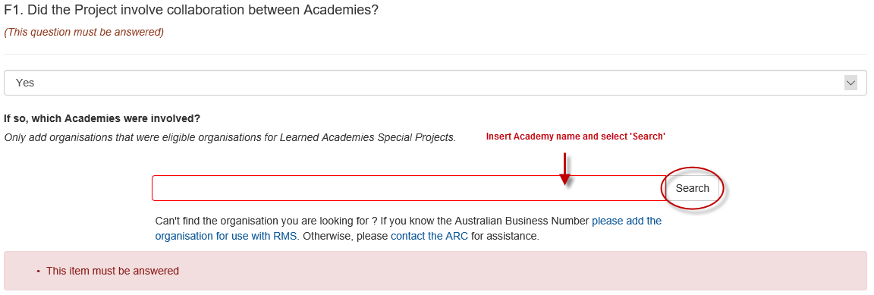

**F2. Where the Project involved collaboration between Academies, describe the benefits of this collaboration.** (*Not Mandatory)*

In the text box provided, please provide a written summary of no more than 5000 characters, describing the benefits of the collaboration.

**F3. Where the Project did NOT involve collaboration between Academies, what could be done differently to encourage and enable collaboration in future?** (*Not Mandatory)*

In the text box provided, please provide a written summary of no more than 5000 characters, describing what could have been done differently to enable future collaborations?

**F4. Please describe the most significant benefits which arose from managing the Project.** (*Mandatory)*

In the text box provided, please provide a written summary of no more than 5000 characters, describing the most significant benefits which arose from managing the Project.

**F5. Please describe the most significant challenges in managing the Project and the approaches used to resolve such challenges.**

Select ‘Add answer’ to populate questions.

**What was the challenge?**

Provide details of the challenge (maximum 500 characters).

**How was the challenge resolved?**

Provide a written summary of no more than 2000 characters, detailing how the challenge was resolved.

Select ‘Add answer’ to add additional challenges.

**F6. If a report, policy document, or other document was released as an outcome of the Project, please attach a copy of the document.**

Using the ‘Browse’ function, select the appropriate PDF file of no more than four (4) pages to be attached and select ‘Upload’.

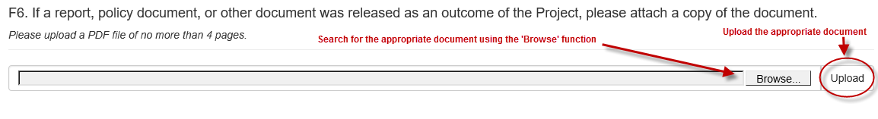

**F7. If applicable, outline the process used to disseminate the research outcomes of the Project to feed into policy development.** *(Not Mandatory)*

Provide a written summary of no more than 2000 characters, outlining the process used to disseminate the research outcomes of the Project to feed into policy development.

**F8. What were the benefits and challenges of this dissemination process?**

(Not mandatory however, if F7 was answered, F8 is to be completed)

Provide a written summary of no more than 2000 characters, detailing the benefits and challenges of the dissemination process.