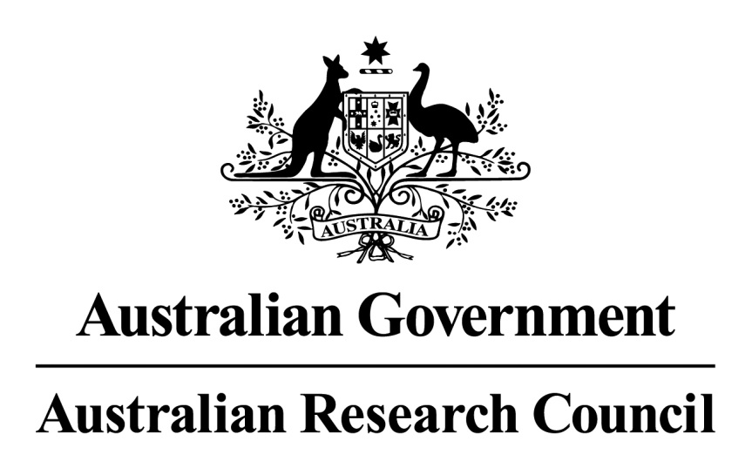

Research Workforce Statement

Purpose
This policy statement articulates the Australian Research Council’s (ARC) commitment and contribution to a strong and sustainable Australian research workforce.

Context
The ARC is a Commonwealth entity within the Australian Government that funds research and researchers under the National Competitive Grants Program (NCGP). The NCGP comprises a range of complementary schemes to support researchers at different career stages, build Australia’s research capability, expand and enhance research networks and collaborations, and develop hubs and centres of research excellence.

Under the NCGP, Discovery Program schemes support fundamental research, vital to the national innovation system, to develop new ideas, create jobs, foster international collaboration, achieve economic growth and benefit Australia. The Linkage Program schemes facilitate national and international research partnerships between higher education, business, industry, government and community organisations to achieve common goals and secure the benefits of research for Australia.

The ARC supports and facilitates research training and career opportunities for the highest quality Australian and international researchers. Funding is provided on a competitive basis and is predicated on supporting excellence, at whatever stage that occurs in a researcher’s career or research, including for new, next stage or divergent projects. Every proposal submitted to each scheme round is assessed through an extensive peer review process to identify the preeminent research and researchers in the round.

The ARC’s support for the research workforce is one element of a broader framework. There is significant engagement by key stakeholders, including the higher education and innovation sectors, government and the learned academies in planning for, and supporting, Australia’s research workforce. A key driver of the framework is to inform capacity building across the Australian research workforce, including amongst underrepresented groups such as women and Aboriginal and Torres Strait Islander researchers, to maintain and grow Australia’s competitiveness.

The global dimension of the research workforce is well established, with governments, industry and the education sectors worldwide focusing on attracting and retaining excellent researchers, participating in global initiatives and encouraging their researchers to collaborate with other researchers around the world.

Implementation
NCGP schemes support the research workforce, including through targeted schemes, for:
- higher degree by research students (all NCGP schemes), and honours students (Discovery Indigenous scheme only)
- early-career researchers
- mid-career researchers
- world-class researchers and research leaders
- research support staff.
In particular, the ARC seeks to support diversity in the research workforce, including:
- women in research under all NCGP schemes
- researchers returning after a career break or with non-traditional research careers
- Aboriginal and Torres Strait Islander researchers.

NCGP support is delivered by funding directly or indirectly:
- higher education organisations
- government organisations
- businesses
- community organisations.

Principles
The ARC seeks to support a strong and sustainable research workforce through:

Excellence
Funding the highest-quality eligible researchers, research and research students in science, technology, engineering and mathematics (STEM), and humanities, arts and social sciences
(HASS) disciplines through a competitive peer review process.

Participation
Supporting participation in the research workforce by researchers at all career stages and from under-represented groups, by:
- funding eligible researchers at different career stages through all schemes, including fellowships and awards
- funding Aboriginal and Torres Strait Islander researchers for projects and fellowships across all disciplines (excluding medical research)
- utilising eligibility and assessment criteria to support researchers at particular career stages and in under-represented groups
- providing fair access to ARC funding for all eligible researchers and promoting diversity, inclusion and equity principles.

Flexibility
Providing a framework which gives researchers flexibility in shaping their careers, by:
- utilising eligibility processes and grant conditions that allow for career life balance
- facilitating opportunities for researchers from diverse career and research backgrounds to access NCGP funding
- structuring NCGP schemes, eligibility and assessment processes, and grant conditions to encourage researchers to work with industry/end-user organisations and support movement between sectors
- utilising funding mechanisms which offer a wide range of support, including individual salaries through fellowships and awards, higher degree by research student stipends, research project costs, access to infrastructure, and establishment of centres, networks and hubs.

Capacity
Providing support mechanisms to attract and retain the highest quality researchers, by:
- enabling the conduct of research and research training in high quality and supportive research environments
- encouraging mentoring of early and mid-career researchers
- promoting mentoring of women researchers, including through the ambassadorial role of the Kathleen Fitzpatrick and Georgina Sweet Australian Laureate Fellowships
- fostering domestic and international collaboration
- facilitating access to infrastructure.

Evaluation
Monitoring the outcomes of ARC mechanisms for strengthening the Australian research workforce and committing to a process of continuous improvement.

Further information

Further documentation is on the ARC website and includes the: ARC Research Opportunity and Performance Evidence (ROPE) Statement, Gender Equality Statement; Eligibility and Career Interruptions Statement, ARC Early Career Researchers Statement of Support, grant guidelines and agreements for NCGP schemes and international support information.

