

Research Outputs in RMS
User Guide for Maintaining Research Outputs in your RMS Profile

Updated September 2021 (Version 6)

Contents
Overview 3
Part 1 – How to import Research Outputs from ORCID 4
1.1 Link your ORCID account with your RMS account 4
1.2 Import Research Outputs from ORCID 5
1.3 Retrieval Criteria for ORCID 7
1.2 Invalid Research Outputs 7
Part 2 – How to import Research Outputs using DOI 8
2.1 Import Research Outputs from DOI 8
Part 3 – How to import Research Outputs using BibTeX 9
3.1 Import Research Outputs from BibTeX 9
Part 4 – How to manually add Research Outputs 10
4.1 Manually add a Research Output 10
4.1.1 Add Unspecified Citation 11
4.1.2 How to Add Preprints or Comparable Resources 11
4.2 Edit a manually added Research Output 13
4.2.1 Manually add Editor(s) to a Research Output 13
Part 5 – Adding Details to Research Outputs 14
5.1 Add details to ORCID, DOI, BibTeX & manually-created outputs 14
Part 6 – Searching, Sorting and Maintaining your Research Outputs 15
6.1 Searching and Sorting Research Outputs 15
6.1.1 Sorting Research Outputs 15
6.1.2 Updating ORCID Outputs 16
6.2 Soft-deleting and Reviving Research Outputs 17
6.2.1 Soft-Deleting Individual Research Outputs 17
6.2.2 Reviving Individual Research Outputs. 17
6.2.3 Bulk Delete 18
6.2.4 Bulk Revive 19
6.3 Previewing the Research Outputs PDF 19
Part 7 - Permanently Delete Research Outputs 21
7.1 Permanently Delete Individual Research Outputs 21
7.2 Bulk ‘Permanently Delete’ Research Outputs 21
Part 8 – Citation Handling and Rendering 23
8.1 Citation Handling in RMS 23
8.2 Rendering of BibTeX Citations 24
Appendix 25

Overview

As part of the Australian Research Council’s (ARC’s) commitment to implement efficient processes to automate and streamline the collection of researcher information, the ARC has built functionality within the Research Management System (RMS) to allow researchers and Research Office Staff to list research outputs against a user’s RMS profile. Through this, the ARC aims to reduce the burden of repeated manual entry of research outputs (‘works’) in the grant application process.
Researchers can add outputs to their RMS profile through any of the following methods:
- Link an RMS account with an ORCID (Open Researcher and Contributor ID) account and import the research outputs from the Works section of the user’s ORCID profile;
- Add a research output citation by using a valid Digital Object Identifier (DOI);
- Upload a BibTeX file to RMS and perform a bulk upload of the research outputs contained within it; or
- Manually create an individual record per research output within the RMS user profile.
Once the research outputs have been added to the user’s RMS profile, they can be added to the research outputs questions of the Personnel and Research Opportunity and Performance Evidence (ROPE) section of an application form.
The ARC strongly recommends that prospective applicants import/update their outputs and confirm that the outputs will render correctly in PDF before starting an ARC research application.
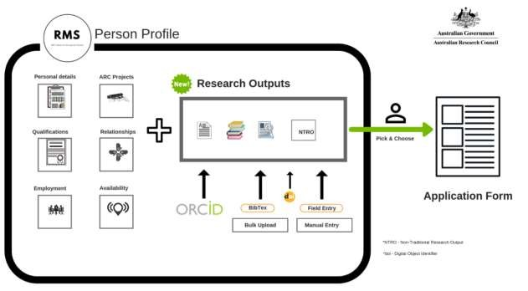

Part 1 – How to import Research Outputs from ORCID

ORCID (Open Researcher and Contributor ID) is an open, non-profit, community-driven effort to create and maintain a registry of unique researcher identifiers and a transparent method of linking research activities and outputs to these identifiers.

1.1 Link your ORCID account with your RMS account
Note: Only the user is able to authenticate their ORCID account and provide access to the ARC to read their limited-access information. Once the authentication has occurred, Researchers and Research Office Staff are able to import the outputs into a user’s profile.
- Navigate to the RMS Login page: https://rms.arc.gov.au
- From the Person Profile section, Select Personal Details
- Under the ORCID ID section of the Personal Details page, Select the Create or Connect your ORCID ID button


- A new window will open, allowing the user to sign in to their ORCID account or to register for a new ORCID account.
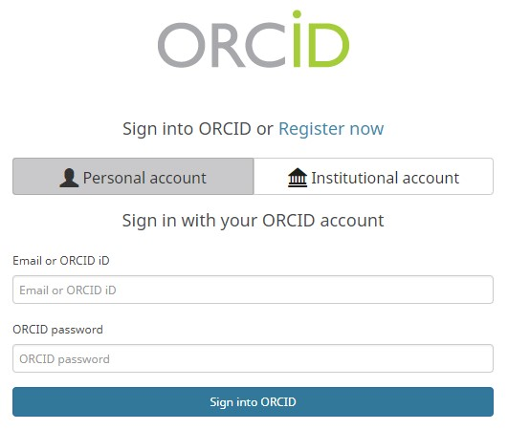

- Once the user has entered their account details, a message will prompt the user to authorise RMS to read their limited-access information.
The same function is available on the Research Output page in a user’s RMS profile.

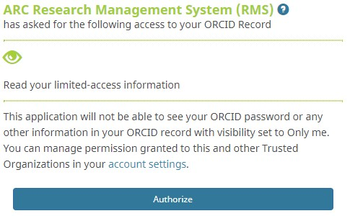

- Once the user has authorised, RMS will confirm and the user can close the window.


1.2 Import Research Outputs from ORCID
Note: The ARC recommends that researchers check their ORCID “Works” section before importing, and where necessary and possible edit the citation text and ensure the records are correct and appropriate, and nominate a preferred citation source for each work item.

- Navigate to the RMS Login page: https://rms.arc.gov.au
- From the Person Profile section, select Research Outputs
- Select the ‘Populate from ORCID’ button
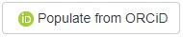

Note: If the user has not yet linked their ORCID account to their RMS Account, RMS will prompt them to do so at this stage. Further to this, if the user had previously linked their ORCID account to the RMS account, but had not yet authorised the ARC to read the limited access information, then RMS will prompt the user to do this.
- The following information panel will appear.
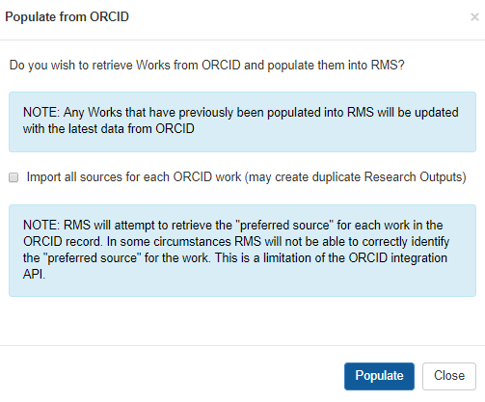
Note: By default, if the user does not tick the ‘all sources’ option, RMS will only import the nominated “preferred source” citation from ORCID, provided the user has indicated a preferred source for each works item.
If works item/s have multiple citation sources and the user has not indicated a preferred source and does not tick the ‘all sources’ option, RMS will import one random citation for each work.
- Click ‘Populate’ button
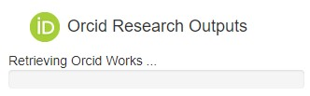
- The retrieved Research Outputs will display on the screen.

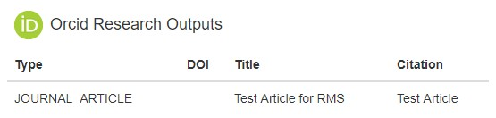

- If the user subsequently removes their ORCID ID from ‘Personal Details’ the outputs already imported from ORCID will remain in their RMS profile.

1.3 Retrieval Criteria for ORCID
RMS will only retrieve items in the Works section of the user’s ORCID profile if they have the following:
- A visibility setting of ‘Everyone’ and ‘Trusted Parties’, and
- Either a citation or a DOI (or both).
RMS will only retrieve the following information for each item that meets the above criteria:
- Category (Book Chapter, Refereed Journal Article etc.)
  - Users should check that the category is correct – if not correct, the user can update it in their RMS profile by selecting the ‘Additional Details’ button next to the output.
- Only the citation data from the nominated preferred source, if the user has indicated this in ORCID. (Depending on the Source, the user may or may not be able to edit the citation text.)
Note: RMS will NOT retrieve the title field from ORCID; the output’s title must be included in the citation text
Note: Citation is not mandatory within ORCID. If an ORCID Research Output does not contain a citation but does contain a DOI, RMS will use the DOI to make a reasonable attempt to recover this information using available resources (Crossref/Crosscite)

1.2 Invalid Research Outputs
Invalid Research Outputs are included in the import, but will display in red text on the Manage Outputs screen so that users can easily identify them – the user must correct the data at the source and refresh their outputs list in RMS, or use the DOI Reference if it is available. Alternatively, the user can enter the output manually into RMS.

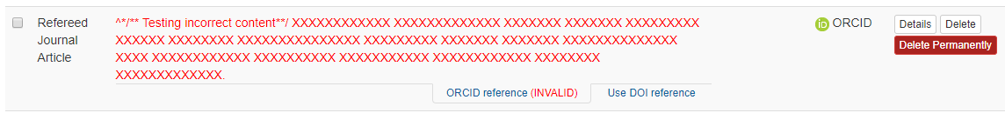
Note: Invalid citations will NOT render into the PDF, nor will they populate into the research application.

Part 2 – How to import Research Outputs using DOI

A digital object identifier (DOI) is a unique alphanumeric string assigned by a registration agency (the International DOI Foundation) to identify content and provide a persistent link to its location on the Internet. The publisher assigns a DOI when your article is published and made available electronically.
RMS users can import research output information by entering a DOI, and RMS will automatically harvest metadata for that output.

2.1 Import Research Outputs from DOI
- Navigate to the RMS Login page: https://rms.arc.gov.au
- From the Person Profile section, select Research Outputs

- Select the ‘Add by DOI’ button

- A Text Input screen will open. Enter a valid DOI and click the ‘Add’ button.
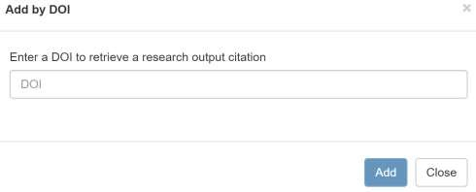
- RMS will import the Research Output to the User’s Profile. To refresh the DOI Research Output click on the ‘DOI reference [Refresh]’ tab below the record.


Part 3 – How to import Research Outputs using BibTeX

BibTeX is a list of references, formatted in a specific way. Many citation database providers, such as ORCID, EndNote and Scopus, enable the bulk download of research outputs into a single file in BibTeX format. Further information on accessing BibTeX files is available on the providers’ websites.

3.1 Import Research Outputs from BibTeX
- Navigate to the RMS Login page: https://rms.arc.gov.au
- From the Person Profile section, select Research Outputs
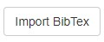
- Select the ‘Import BibTeX’ button

- A file input screen will open. Choose the file that you wish to import, the BibTeX file extension is .bib
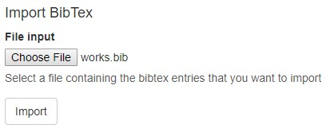
NOTE: Please refer to Appendix for further information on BibTeX fields.
- Click on ‘Import’ button. All of the records contained within the BibTeX file will import into the user’s profile.

Part 4 – How to manually add Research Outputs

4.1 Manually add a Research Output
- Navigate to the RMS Login page: https://rms.arc.gov.au
- From the Person Profile section, select Research Outputs
- Select the ‘Add Manually’ button
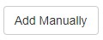

- A form is available for users to enter Research Outputs. First, select the Type of Research Output and the form will update to show the fields relevant to the Research Output Type.
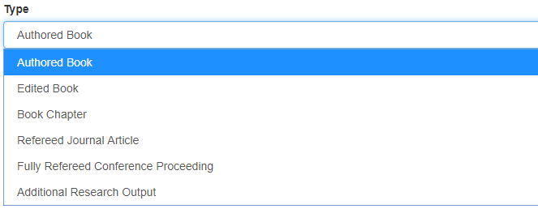
- The Title Format has two available formats: (1) Text (English Unicode) and (2) LaTeX.
The Text format displays the Research Output Title ‘as is’ entered by the User.

The LaTeX format only supports BibTeX subsets of Latex citation formats (ORCID with BibTeX, DOI import or RMS with LaTeX Title Format). In list views and edit screens RMS will not render LaTeX formatting.

Example of mathematical formula enclosed in $ rendered into the PDF.

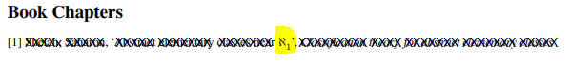

Note: Valid LaTeX formatting will render correctly in the application PDF in most circumstances. (See Part 7 for more details on rendering BibTeX citations.)

- Once the fields have been populated, click the ‘Save’ button to close the window and save the information to the user’s Research Outputs list.

4.1.1 Add Unspecified Citation
NOTE: Unspecified citation format only possible for the ‘Additional Research Output’ type
- To add an Unspecified Citation type select Additional Research Output, then select ‘Yes’ under ‘Free Form Citation’.
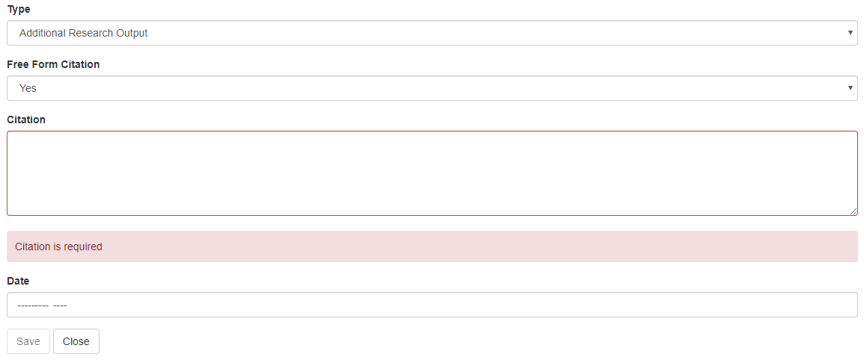
- Enter relevant text and date (Month and Year). The citation text will allow up to 4000 characters. Click ‘Save’.
- The citation will display in the Manage Outputs list.
Note: Only the citation text will display in the RMS outputs list or render into the PDF. To have the date display, include it within the citation text.

4.1.2 How to Add Preprints or Comparable Resources
Note: A preprint or comparable resource format is only possible for the ‘Additional Research Output’ type.
- To add a preprint or comparable resource select ‘Additional Research Output’, then select ‘Yes’ under ‘Free Form Citation’.
- Enter relevant text and date (Month and Year). The citation text will allow up to 4000 characters.
- The preprint or comparable resource should be explicitly identified [PREPRINT OR COMPARABLE]. Click ‘Save’.
- The citation will display in the Manage Outputs list.
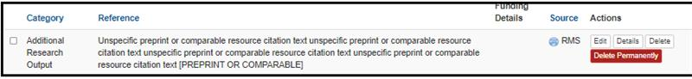
Note: Only the citation text will display in the RMS outputs list or render into the PDF. To have the date display, include it within the citation text.
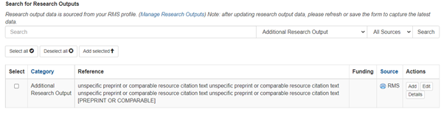
- Once included the citation will appear in the Additional Research Outputs list in the application as below.
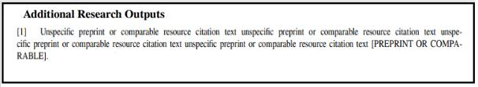

4.2 Edit a manually added Research Output
- Navigate to the RMS Login page: https://rms.arc.gov.au
- From the Person Profile section, select Research Outputs
- Against the Research Output that you wish to edit, click on the ‘Edit’ button
- Make the required edits and click the ‘Save’ button
Note: Not all the fields available in manual entry will render into the application PDF, and not all fields are relevant to each output category. The ARC is applying the Harvard Author-Date style to format outputs into the PDF. (The Style Manual for Authors, Editors and Printers Sixth Edition page 188 has details.)
The Notes field renders into the application PDF for the ‘Additional Research Outputs’ Category. Although it is not available for ‘Unspecified Outputs’.

4.2.1 Manually add Editor(s) to a Research Output
- Navigate to the RMS Login page: https://rms.arc.gov.au
- From the Person Profile section, select Research Outputs
- Against the Book Chapter or Fully Refereed Conference Proceeding Research Output that you wish to edit, click the ‘Edit’ button
- Click the ‘Add+’ button and add the editor
- Click the ‘Add+’ button again for each additional editor
- Click ‘Save’

Note: A structured Editor(s) field has been introduced to allow the user to specify editors of an authored book or refereed conference proceeding in the same structure with authors. The existing unstructured editor information will be displayed as read-only text. This information will remain until the user chooses to update editor information in the structured format, the existing unstructured editor(s) information will then be replaced with the new structure format.
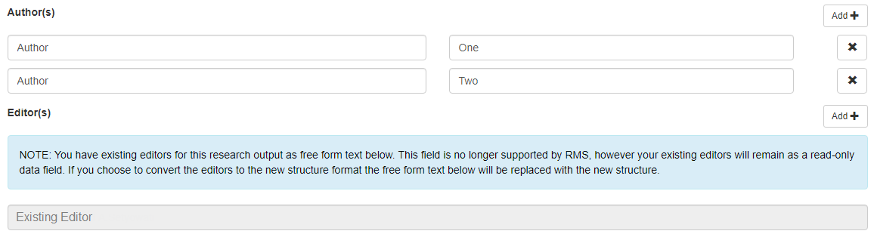

Part 5 – Adding Details to Research Outputs

5.1 Add details to ORCID, DOI, BibTeX & manually-created outputs
- Navigate to the RMS Login page: https://rms.arc.gov.au
- From the Person Profile section, select Research Outputs
- Against the Research Output that you wish to add details to, click the ‘Details’ button
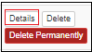
- The following information can be added/edited against the output:
  - Category – is automatically assigned to each output when importing from ORCID, DOI or BibTeX. If it is not correct, the user can update it in this section.
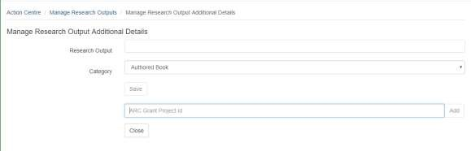
  - ARC Grants - If the Research Output originated from an ARC Grant, list the details of that grant here.
  - Enter the Project ID and click the Add button.
    - The Add button will only activate when the project Id matches a valid ARC project ID format, including pre-2001 projects. Do not enter any other text.
  - Enter the ‘year from’ and ‘year to’.
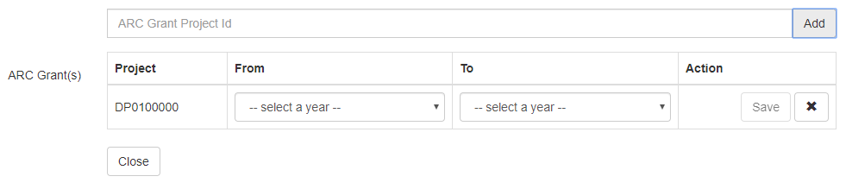
- Save and click on the ‘Close’ button.

Part 6 – Searching, Sorting and Maintaining your Research Outputs

6.1 Searching and Sorting Research Outputs
- Users can search for Research Outputs in several ways, text search, filters or a combination of both.
- Text search: Use the ‘Search’ field to enter text strings, for example from the title or the author’s name.

- Use the drop down lists for Category, Source or State to filter outputs.
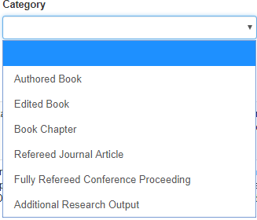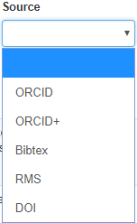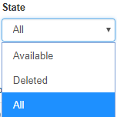
- Or use a combination of text search and filters.
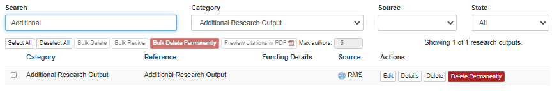

6.1.1 Sorting Research Outputs
- In Manage Research Outputs, users can sort outputs by clicking on the column headings (Category, Reference or Source) to alpha-sort the full list of outputs. Alternatively, use the search and filter options, and then sort within a smaller list of results.
- From the default sort order (as imported/entered), click once to alpha-sort ascending, second click will reverse this to alpha-sort descending, third click will return to the default order.
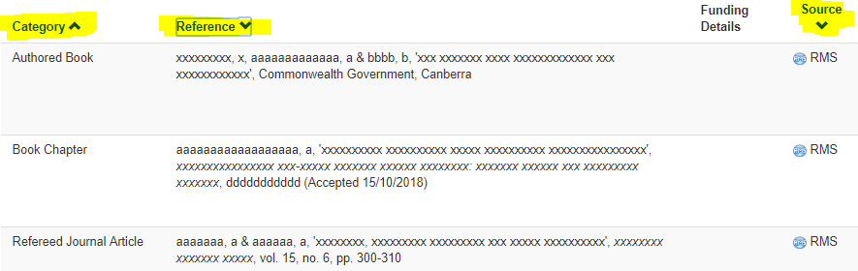

- In the example above, Category is in ascending order; Reference and Source are in descending order. The direction of the arrow next to the column heading indicates the sort order.

6.1.2 Updating ORCID Outputs
Users can convert an existing ORCID record output to ORCID+.
ORCID records will display with tabs below each record. If ORCID is the only source, the tab will show as ‘ORCID reference’. If a DOI exists for the output, a tab ‘Use DOI reference’ will display beneath the output - the user can click on this tab and the output details will refresh from Crossref or Crosscite.

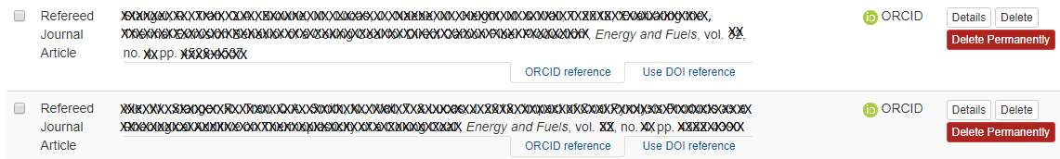
If the user clicks the ‘Use DOI reference’ tab, the record will refresh with additional details and include the DOI reference. The tabs will toggle to ‘Use ORCID Reference’ and DOI reference (Refresh). The source column will also show as ORCID+.
The user can change the source back to ORCID by clicking the ‘Use ORCID reference’ tab.

6.2 Soft-deleting and Reviving Research Outputs
Users can soft-delete (hide) Research Outputs from view by setting their state to ‘Deleted’ or revive them back to ‘Available’. Only ‘Available’ Outputs will populate into a research application.
Users can use the search and filter options to find and select individual or multiple outputs to soft-delete or revive.
Note: When you refresh (re-import) ORCID, DOI or BiBTeX data into RMS, existing outputs with a state of ‘Deleted’ will update if there are changes at the source. However, the state will remain as ‘Deleted’.

6.2.1 Soft-Deleting Individual Research Outputs
- Navigate to the RMS Login page: https://rms.arc.gov.au
- From the Person Profile section, select Research Outputs
- Against the Research Output that you wish to soft-delete or hide, select the ‘Delete’ button.
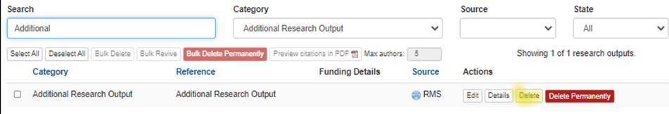

- A confirmation screen will open. Click the ‘OK’ button to confirm that you wish to delete the research output.
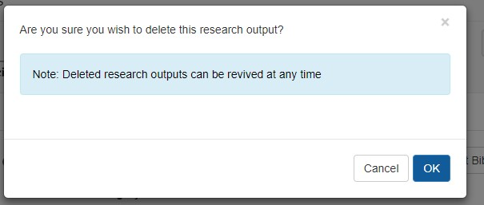
- Select ‘Deleted’ from the State filter to view deleted outputs.

6.2.2 Reviving Individual Research Outputs.
- Navigate to the RMS Login page: https://rms.arc.gov.au
- From the Person Profile section, select Research Outputs
- Under the Search filters at the top, select ‘Deleted’ from the State. This will list any Research Outputs marked as ‘Deleted’.
- Against the Research Output that you wish to revive, select the ‘Revive’ button.
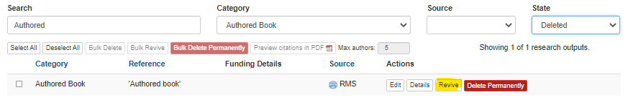
- A confirmation screen will open. Click the ‘OK’ button to confirm that you wish to revive the research output.
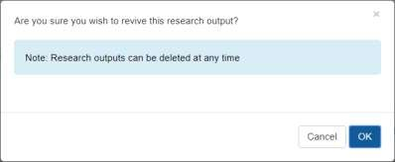
- The revived Research Output will display as ‘Available’.

6.2.3 Bulk Delete
- Navigate to the RMS Login page: https://rms.arc.gov.au
- From the Person Profile section, select Research Outputs
- To Bulk Delete, select the State Filter to ‘Available’.
- Tick the box next to the Outputs you wish to delete, or use the ‘Select All’ or ‘Deselect All’ buttons.
- Once the user has selected output/s, the ‘Bulk Delete’ button will be available.
Note: If the user sets the State filter to ‘All’ and ticks both ‘Available’ and ‘Deleted’ outputs, or uses ‘Select All’, the ‘Bulk’ buttons will not activate.
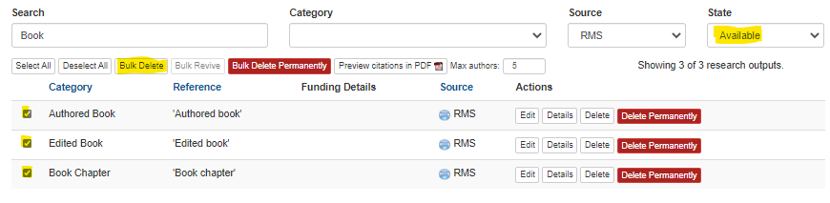
- A confirmation screen will open. Click the ‘OK’ button to confirm that you wish to revive the research outputs.
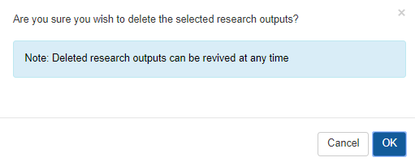
- The user can view deleted outputs by selecting ‘Deleted’ from the State filter.

6.2.4 Bulk Revive
- Navigate to the RMS Login page: https://rms.arc.gov.au
- From the Person Profile section, select Research Outputs
- To Bulk Revive, select the State Filter to ‘Deleted’.
- Tick the box next to the Outputs you wish to revive, or use the ‘Select All’ or ‘Deselect All’ buttons.
- Once the user has selected output/s, the ‘Bulk Revive’ button will be available.
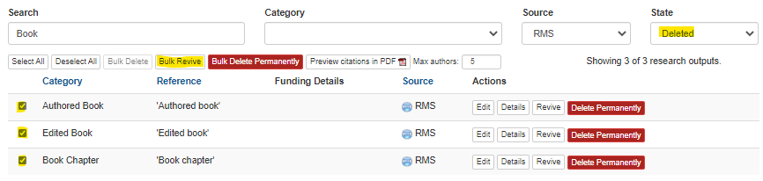
- A confirmation screen will open. Click the ‘OK’ button to confirm that you wish to revive the research outputs.
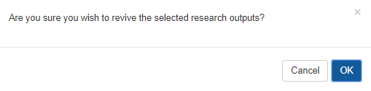
- The revived Research Outputs will display as ‘Available’.

6.3 Previewing the Research Outputs PDF
PDF preview is available within the Manage Research Outputs screen of the user profile by selecting one or more Research Outputs, and entering the maximum number of Authors to display and clicking the PDF button. The ARC recommends users check how their Research Outputs will render into the PDF before adding them to a research proposal.
- Select the outputs you wish to review in PDF, and then click the ‘Preview citations in PDF’ button. (The button is only available if at least one output is selected.)

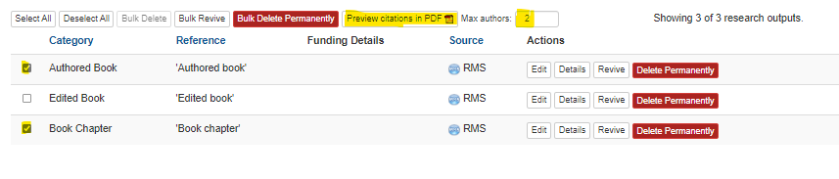

- The Maximum Authors defaults to 5. The minimum is 1.

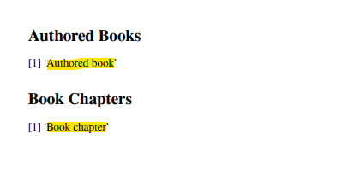
Notes on outputs rendering into PDF:
- Mathematical symbols will render correctly in the PDF when enclosed by $ signs.
- Author names will display the same as the source data for all authors, and limited to the number of ‘Max Authors’ selected.
- Invalid citations (showing as red text in RMS) will not render into the PDF.
- Research Output numbering restarts for each category.

Part 7 - Permanently Delete Research Outputs

It is possible for a user to remove Research Outputs from their RMS account permanently. Users will find this particularly useful where an import process has included duplicates or inaccurate works. It may be easier to permanently delete the outputs, correct them at source (if possible) then re-import.
Using the search and select functions described in Part 6, the user can find and select one, many or all of their outputs to permanently delete from their profile, and then click the “Delete Permanently” button. Unlike the ‘soft-delete’ option, outputs can be in any state (Available, Deleted, All) for the ‘Delete Permanently’ option.

7.1 Permanently Delete Individual Research Outputs
- Navigate to the RMS Login page: https://rms.arc.gov.au
- From the Person Profile section, select Research Outputs.
- Against the Research Output that you wish to delete permanently, select the ‘Delete Permanently’ button.
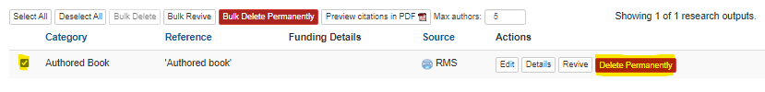
- A confirmation screen will open. Click the ‘OK’ button to confirm that you wish to ‘permanently delete’ the research output.
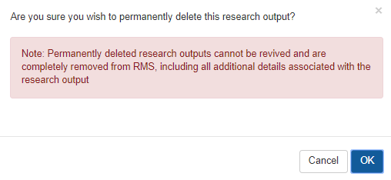
- Clicking ‘OK’ will completely remove the Research Output from the user’s profile.

7.2 Bulk ‘Permanently Delete’ Research Outputs
- Navigate to the RMS Login page: https://rms.arc.gov.au
- From the Person Profile section, select Research Outputs
- Tick the box next to the Research Outputs you wish to delete or use the ‘Select All’ or ‘Deselect All’ buttons.
- Once the user has selected output/s, the ‘Bulk Delete’ button will be available.
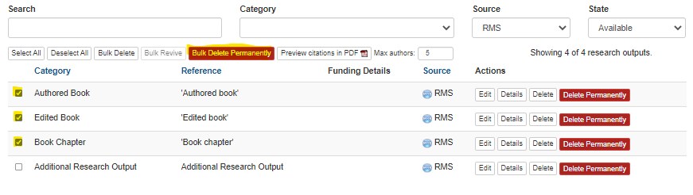
- A confirmation screen will open. Click the ‘OK’ button to confirm that you wish to ‘permanently delete’ the selected Research Outputs.
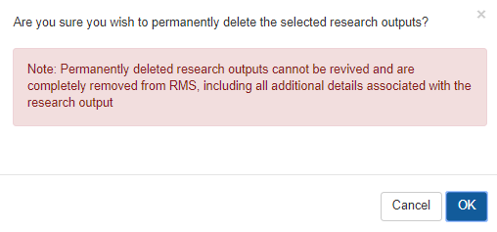
- Clicking ‘OK’ will completely remove the outputs from the user’s profile.

Part 8 – Citation Handling and Rendering

8.1 Citation Handling in RMS
RMS collects Research Outputs from various sources (ORCID, BibTeX files, DOI providers and manually entered Research Outputs). Each of these sources can potentially include citations in various formats.
Note: RMS will not correctly render MathML mark-up in citations
The citation formats can be broken into three groups:
- BibTeX;
- RMS-compatible formats; and
- Text based formats that RMS cannot understand.

BibTeX and RMS-compatible formats will render in a Harvard Citation format. Text based formats will be rendered ‘As is’.
RMS allows entering of Custom citations via ORCID by choosing ‘Unspecified’ citation format and then entering a formatted citation in the citation field. RMS will render these ‘As is’.
Note: Not all fields available in ORCID, BibTeX or DOI are included in the HARVARD format. For example, ISSN/ISBN are not included.
Below is a breakdown of these groupings:
Source: ORCID
BibTeX | BibTeX
RIS | RMS Compatible
APA | Text Based
Chicago | Text Based
Harvard | Text Based
IEEE | Text Based
Vancouver | Text Based
Unspecified | Text Based
Source: BibTeX import
BibTeX | BibTeX
Source: DOI Import
BibTeX | BibTeX
Source: Manual RMS
BibTeX with Text Title | BibTeX
BibTeX with LaTeX Title | BibTeX

8.2 Rendering of BibTeX Citations
LaTeX is a typesetting mark-up language used to create formatted documents. Originally, BibTeX was created as a way to create bibliographies in LaTeX documents.
This means that BibTeX citations often include LaTeX mark-up for adding formatting or displaying formula or other symbols that normal ASCII characters cannot represent.
The generated Application PDF will correctly render LaTeX mark-up in most scenarios. The ARC strongly recommends using the “Preview citations PDF” option in “Manage Research Outputs” to verify that all Research Output citations will render correctly in the Application PDF before adding them to the ROPE question in the Application.
LaTeX mark-up will not render correctly in the generated Application PDF when the mark-up relies on a BibTeX preamble that defines new LaTeX commands.

RMS will not render LaTeX mark-up in the Research Output list and edit screens (include online Application forms) except for mathematical symbols that are enclosed within $ characters.

RMS may not correctly render characters from some Non-English languages in the generated application PDF. The ARC recommends citations that can be expressed using the Times New Roman font or similar.
Some BibTeX citations may import into RMS but display as raw BibTeX in RMS list and edit screens. This can occur when the citation key in the BibTeX contains any of the following characters:
',', '{', '}', ' ', '='.
In this case, RMS will not correctly parse the BibTeX citation and these Research Outputs will not be available for selection in the Application Form.

Appendix

BiBTeX Field | Limited to Citation Types | Description
author |  | The name(s) of the author(s) (in the case of more than one author, separated by and)
editor |  | The name(s) of the editor(s) (in the case of more than one author, separated by and)
year |  | The year of publication (or, if unpublished, the year of creation)
title |  | The title of the work
journal |  | The journal or magazine the work was published in
booktitle |  | The title of the book, if only part of it is being cited
edition |  | The edition of a book, long or short form (such as "1st", “2”, “First" or "Second")
volume |  | The volume of a journal or multi-volume book
number |  | The "(issue) number" of a journal, magazine, or tech-report, if applicable
article-number |  | The "article number" of a journal, magazine, or tech-report, if applicable
publisher | Authored Book  Edited Book  Book Chapter | The publisher's name
address | Authored Book  Edited Book  Book Chapter | Publisher's address (usually just the city, but can be the full address for lesser-known publishers)
pages |  | Page numbers, separated either by commas or double-hyphens.
doi |  | Digital Object Identifier
media | Additional Research Output | Media type of work
note | Additional Research Output | Miscellaneous extra information

