Part A. Research Office HERDC staff User Guide
Complete Form
Log into SEER using your email and password. Ensure you have the Research Office HERDC staff member role assigned to your profile. After your ARC user account is set up, you can check your HERDC role by contacting the SEER helpdesk on (02) 6287 6789 during Canberra business hours or email arc-systems@arc.gov.au

Within the Action Centre (the home page), locate Research Office Data Collection Management.
Click on the “Form” button next to the appropriate Collection Round.
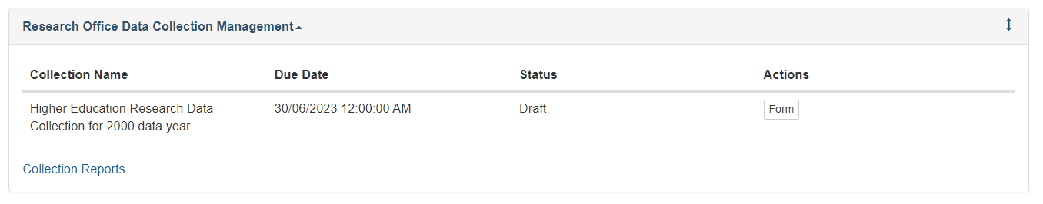
Note: remember to save the form regularly to ensure data is not lost.
Input Part A. Contact Details
Enter the Higher Education Provider and the contact details of the administrator responsible for completing the form.
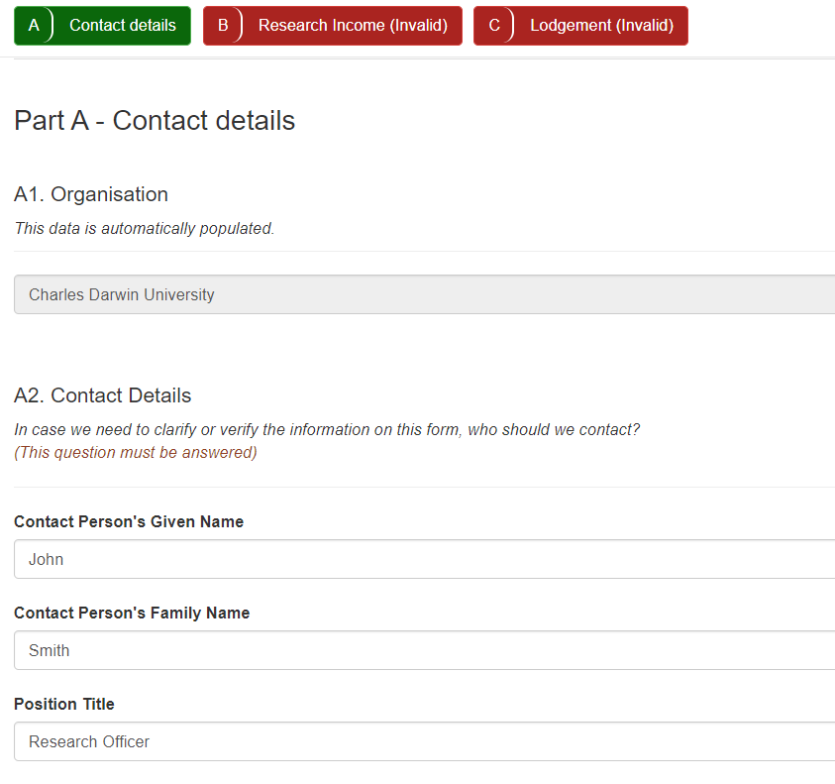

Input Part B. Research Income
Enter the eligible research income for each sub-category of Categories 1, 2, 3 and 4 in accordance with the HERDC specifications and any supplementary advice issued by the department. The form does not accept decimals places. Income for each sub-category should therefore be rounded to the nearest dollar.
Category totals are automatically calculated.
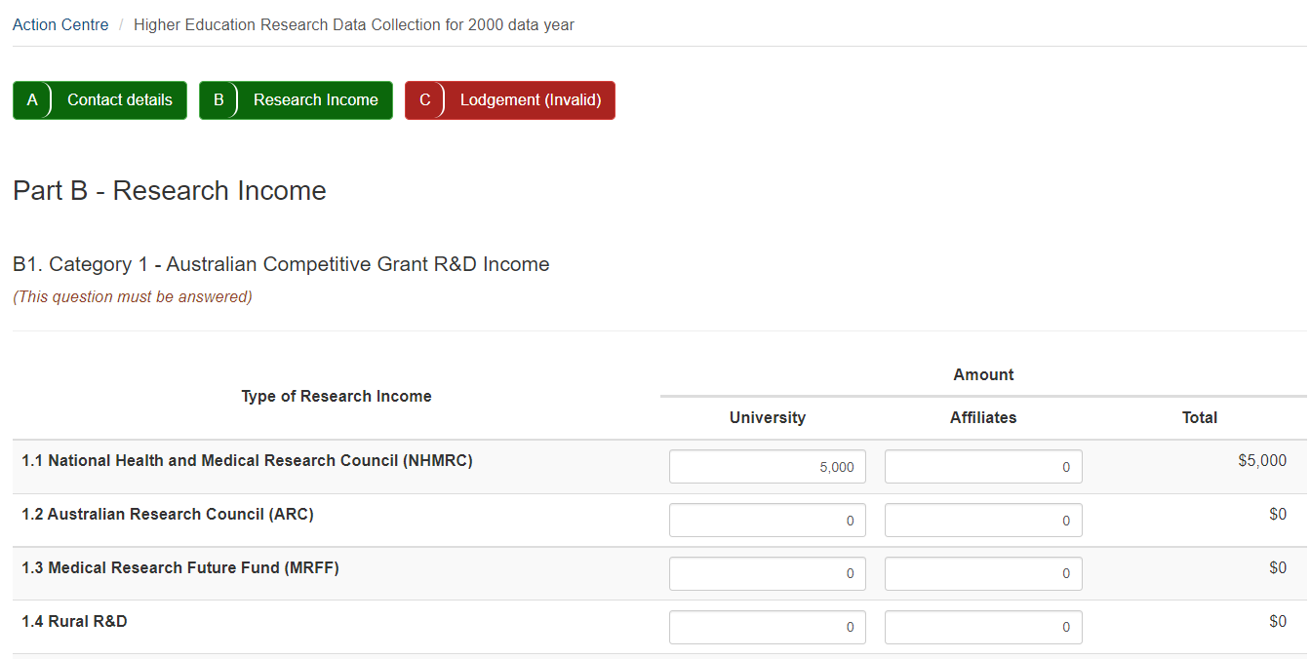

Input Part C. Lodgement
Enter the details for the submission and upload the audit report.
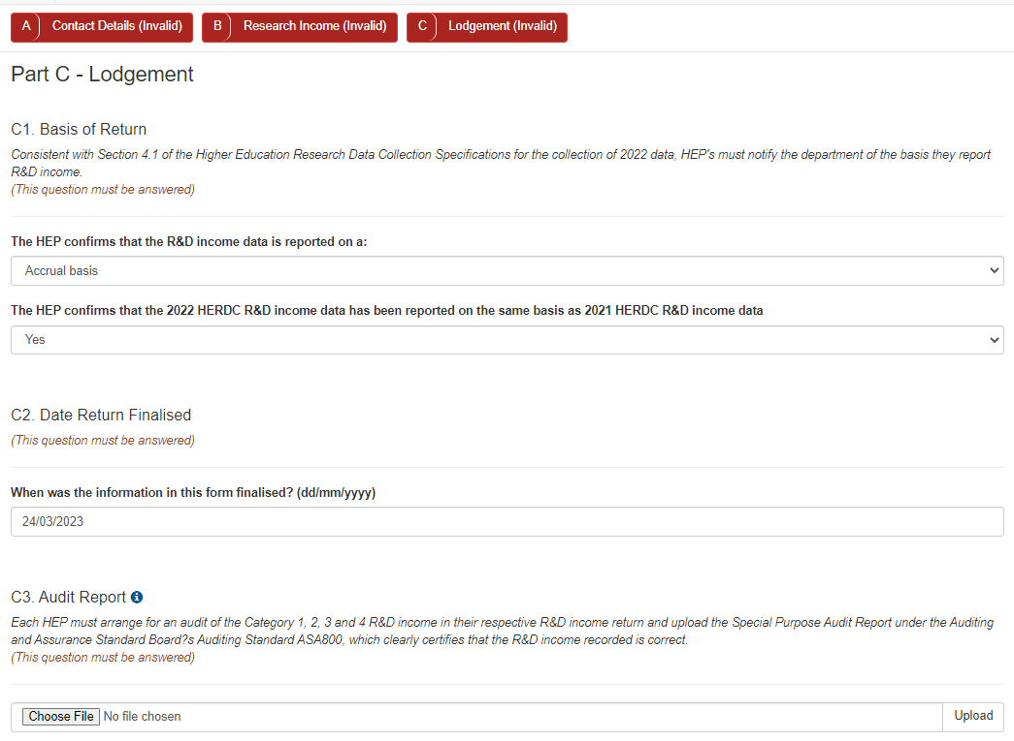

Submit to Certifier
Once the research income data and other required information is entered correctly, all parts (A, B, C) will be coloured green. This indicates that the form is valid. Remember to save the form.
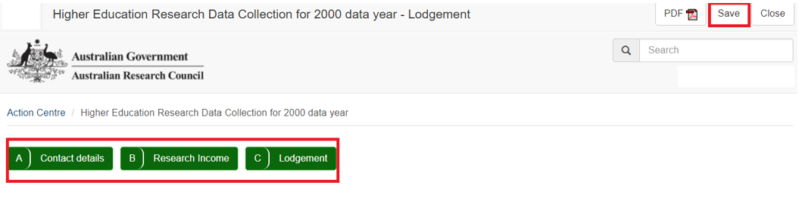
Select the PDF button to export a report of the draft form to confirm details.
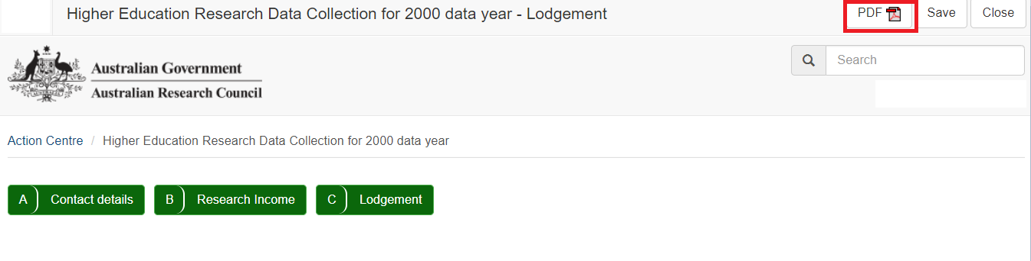
Return to action centre and select Submit to Certifier.
Note: this action does not send an email notification to the HERDC Certifier.
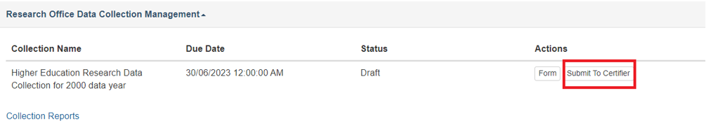
Once your Vice Chancellor has certified the form, return to action centre and select submit to the ARC.
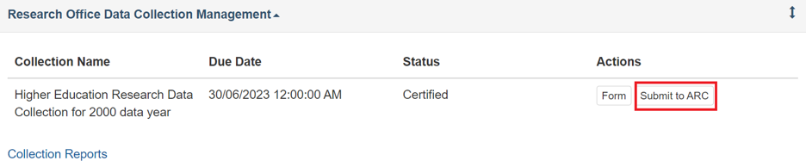
This step completes the process.

Part B. HERDC Certifier User Guide
View and Certify form
Log into SEER using your ARC user account email and password. Ensure you have the HERDC Certifier role assigned to your profile. You can check this by contacting the SEER helpdesk on (02) 6287 6789 during Canberra business hours or email arc-systems@arc.gov.au

Within the Action Centre (the home page), locate Research Office Data Collection Management.
Click on the “Form” button next to the appropriate Collection Round.
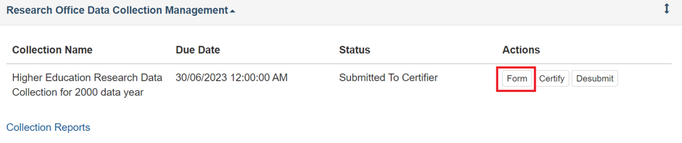
This will take you to the completed form to review the details. You can view the data on the screen navigating through each part of the form or use the PDF export to view the entire form at once.
Note: the data is not able to be changed, this view is read only.
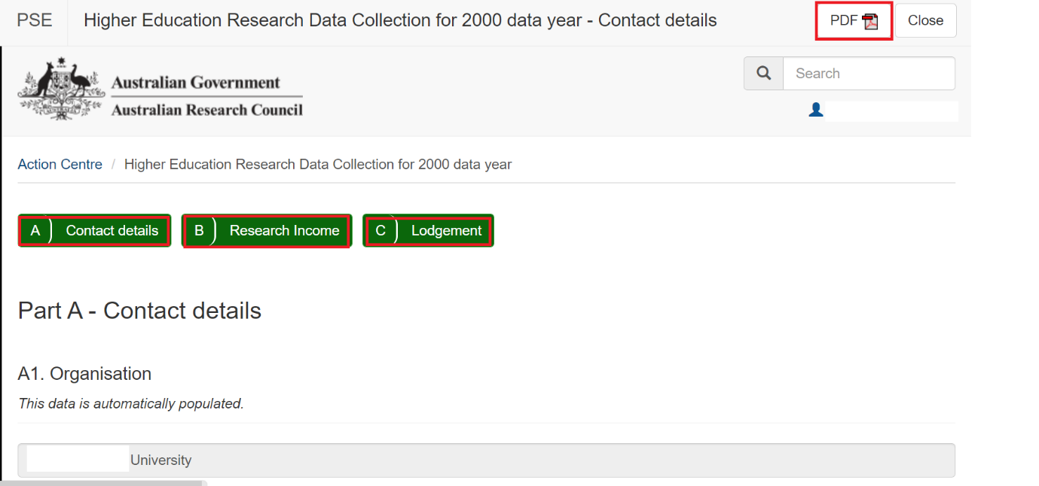
If the data requires modification, return to the action centre and select de-submit. This will return the form to a draft status and the Research Office HERDC Staff user can then log in and make changes to the form and re-submit for certification.
Note: this action does not send an email notification.
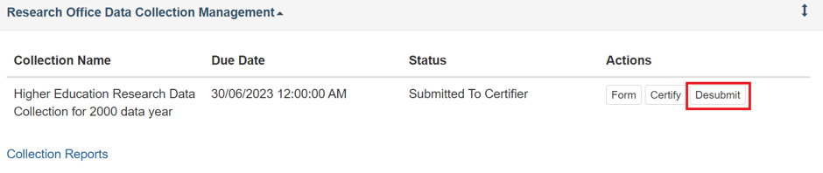
If the data is ready to certify, select certify.
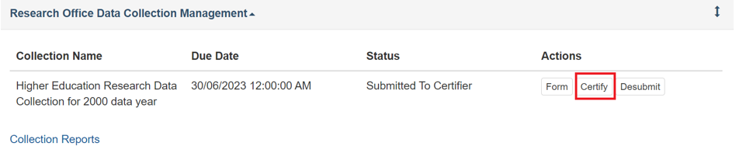
A pop up box will appear with specific certification text that must be accepted. This text, along with the time and date of the certification will appear in the downloadable PDF.
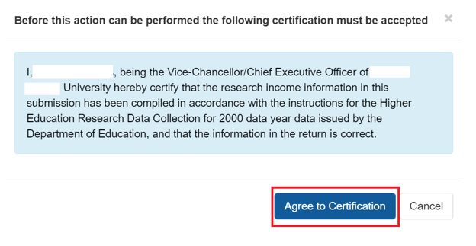
Once accepted, there will be one final option to certify or cancel.
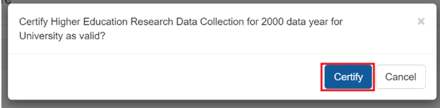
Once the form has been certified, the Research Office HERDC Staff user can log in and submit the form to the ARC.
Note: this action does not send an email notification to the Research Office HERDC Staff.
This concludes the process of submitting the HERDC Return.

Part C. View form, status and comments (all users)
Collection Reports
To view the form and download the PDF at any time, select collection reports.
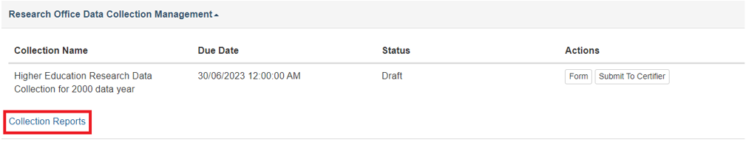
Select the relevant round and phase to view your submission, its status and select form to view the data and export the PDF.
Note: the phase will either be main or corrections. Unless the Department of Education is notified in writing, the corrections phase will reflect a copy of the original submission.
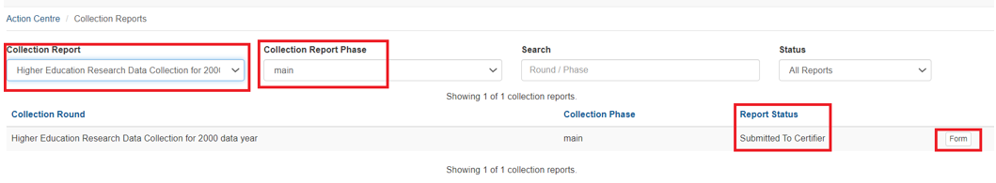
Any comments made by the ARC against a university submission will also appear here. Select feedback to view the comment.
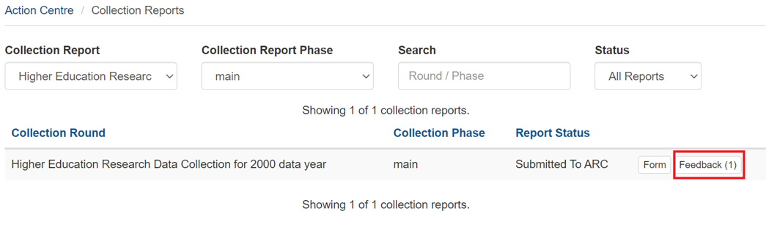
This will allow you to view the time, date, and text in the comment. Click view for further details.
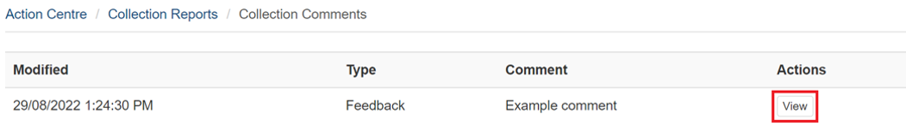
A pop-up box will appear with the full comment. 