

*College of Experts Nominations 2024*

Instructions to Applicants

for

College of Experts members

commencing in 2024

Version 1. Release date: 18 April 2023

Contents

1. Matters to note before completing the Nomination form 3

1.1 Your RMS User Profile 3

1.2 Accuracy of Information 3

1.3 Key Dates 3

1.4 Research Office 3

1.5 Nomination Certification 3

2. Creating a new Nomination in RMS 4

3. Completing the Nomination Form 4

Part A – Personal Details 5

Part B – Qualifications and Experiences 5

Part C – Selection Criteria 7

Part D – Referees 8

Part E – Nominating Organisation 8

4. Submitting the Nomination to the Research Office 9

5. Submitting the Nomination as a self-employed nominee 10

Certification Letter 11

**Australian Research Council  
*College of Experts***

**Instructions to Applicants**  
**Commencing in 2024**

The *College of Experts Nominations – Instructions to Applicants for College of Experts commencing in 2024* (hereafter referred to as the Instructions) provides information to applicants on how to complete and submit a College of Experts Nomination for 2024 (CN24) form in the ARC Research Management System (RMS).

# 

# **Matters to note before completing the Nomination form**

For general instructions on how to use RMS, refer to the [RMS User Management Guide](https://www.arc.gov.au/grants/rms-information) available on the ARC website.

## Your RMS User Profile

Ensure the Personal Details, Qualifications and Employment sections of your RMS Personal Profile contain up-to-date information, as some of these details will be auto-populated into the Nomination form.

## Accuracy of Information

Check carefully that all information contained in the Nomination form is accurate prior to submission as changes cannot be made once the nomination has been submitted.

## Key Dates

Refer to the [Grants Calendar](https://www.arc.gov.au/funding-research/grants-calendar) page on the ARC website for key dates. Nominations for the ARC College of Experts commencing in 2024 can be submitted up until 5.00pm (AEST), **Thursday 1 June 2023**.

## Direct your Queries to the Research Office

For a nominee who is affiliated with a higher education institution, please contact your Research Office in the first instance if you have any queries regarding nominations to the ARC College of Experts, including questions on how to complete the Nomination form. The Research Office should be able to answer any questions you might have and can seek clarification from the ARC if necessary. For other nominees, please contact the ARC directly. You can find the ARC’s contact details in the *ARC College of Experts 2024 Nomination Kit.*

## Nomination Certification

The Nomination form must be certified and submitted online through RMS by an authorised officer of the Administering Organisation.

The authorised officer must have the role of ‘Research Office Delegate’ in RMS. Only the Administering Organisation can certify and submit Nominations online.

For self-nominating individuals, see submitting the nomination as a self-employed nominee.

# **Creating a new Nomination in RMS**

To create a new Nomination:

* Login to [RMS](https://rms.arc.gov.au/)

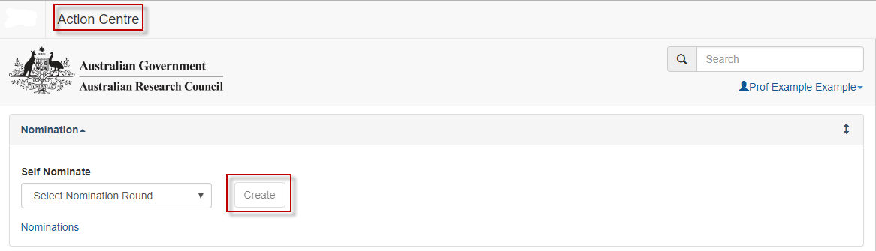

* Select **ARC College of Experts Nominations for 2024** from the drop-down list and click on ‘Create Draft Nomination’.

# **Completing the Nomination Form**

There are five Parts (A-E) in the CN24 Nomination form:

1. Personal Details
2. Qualifications and Experiences
3. Selection Criteria
4. Referees
5. Nominating Organisation

When the nomination has been created the form parts will be displayed at the top of the screen. Note that initially the colour of these parts will be **red**, indicating that the part is incomplete (invalid). When the Nomination part(s) have been completed they will become **green** (valid).



Click on the relevant form part at the top of the screen to navigate between form parts (Part A to Part E).

Click on Part A to start completing the Nomination form.

**The image of the 'Save' button.It is important to periodically save all changes.** The ‘Save’ button is located at the top of the page next to the Adobe PDF file icon:

**Note:** In many cases, further help text is provided within the form to assist you in completing questions.

### Part A – Personal Details

**A1 Personal Details**

* This section is automatically populated from the Personal Details section of your RMS profile. To ensure the information is current and accurate, go to your profile and check that your personal details are up to date.

**A2 Current appointment (s) / position (s)**

(This question must be answered)

* Do you have any current appointment(s) / position(s)? You can add multiple answers.

**A3 Profile link from organisations website**

* Please provide a web address for your current biographical profile.
* This is not mandatory; however, if available, the link will assist the selection process.

**A4 Research across multiple sectors: who have you conducted research and/or activities with beyond your current sector?**

(This question must be answered)

* Please include research and/or other activities which have included participants beyond academia or your current organisation, if currently in a Publicly Funded Research Agency.

### Part B – Qualifications and Experiences

**B1 Qualifications**

* This section is automatically populated from the Personal Details section of your RMS profile. To ensure the information is current and accurate, go to your profile and check that your personal details are up to date.

**B2 Committee and assessor experience (including ARC/NHMRC or similar international positions)**

* Please include details of any committee or assessor experience, in reverse chronological order.

**B3 Expertise Text**

* This section is automatically populated from the Personal Details section of your RMS profile. To ensure the information is current and accurate, go to your profile and check that your personal details are up to date.

**B4 Select up to ten 6-digit Field of Research (FoR) codes for the above  
 expertise**

* This question will populate with your 2020 FoR Codes.
* This section is automatically populated from the Personal Details section of your RMS profile. To ensure the information is current and accurate, go to your profile and check that your personal details are up to date.
* If you have more than ten FoR codes listed in your profile all will be imported to your nomination form. You will then need to select the ten most relevant FoR codes based on your expertise text.
* Note that you must select a primary FoR code in the 2020 list.
* If you need to return to your RMS profile to update your information, you can do so by clicking on the ‘Manage Expertise and Fields of Research’ link in the question. Once you have updated your information in your RMS profile will need to save and close your nomination form in order for the information to update. When re-opened the updated information should appear in your Nomination form.

### Part C – Selection Criteria

In this section all questions are mandatory.

**C1 Research Excellence**

* Include details about your nationally and internationally recognised research achievements and expertise.
* If applicable, include details of your ability to attract grants from competitive granting bodies - nominees should be at the forefront of research in their area.

**C2 Specialist disciplinary expertise and generalist discipline knowledge**

* Include details about your specialist expertise in a relevant disciplinary research area and general disciplinary knowledge in two or more discipline areas.
* Also describe your general disciplinary knowledge in two or more discipline areas and include the relevant 4-digit research codes.

**C3 Research standing, reputation and roles**

* Include details that outline your demonstrated high level of involvement in institutional/organisation roles and professional organisations as a research leader.

**C4 Organisational and/or administrative leadership skills**

* Include details about your administrative experience and leadership, committee/team skills such as forward planning skills, advocacy skills and skills in the management of research; personal qualities of fairness, impartiality, integrity and the ability to work effectively under tight timeframes.

**C5 Relevant experience**

* Include details about your relevant experience working in or collaborating with industry, public sector organisations, community groups and/or other non-academic organisations.

### Part D – Referees

**D1**

**Provide details of three referees who can comment on your performance against the selection criteria. One referee must be your current or most recent supervisor, and at least two referees should be Australian based.**

(This question must be answered)

### Part E – Nominating Organisation

**E1 Nominating Organisation**

(This question must be answered)

**E2 Nominator Name**

(This question must be answered)

**E3 Nominator Email Address**

(This question must be answered)

**E4 Nominator Employment Position**

(This question must be answered)

**E5 Nominator Phone Number**  (Please provide the mobile phone number for the Nominator)

(This question must be answered)

**E6 Letter of Certification**

* If self-employed, a letter of certification will need to be uploaded, confirming that all details in the nomination are correct and comply with the ARC’s requirements.
* For nominees from an Eligible Organisation, the Research Office will certify the nomination when submitting the nomination to the ARC through RMS. A letter will not be required.

# **Submitting the Nomination to the Research Office**

* Once all form components of the Nomination are completed and saved, the Nomination header should be validated and have changed from red (invalid) to green (valid).



* When you are ready to submit the Nomination Form to the Research Office, return to the Nominations page and click on ‘Submit to Research Office’.

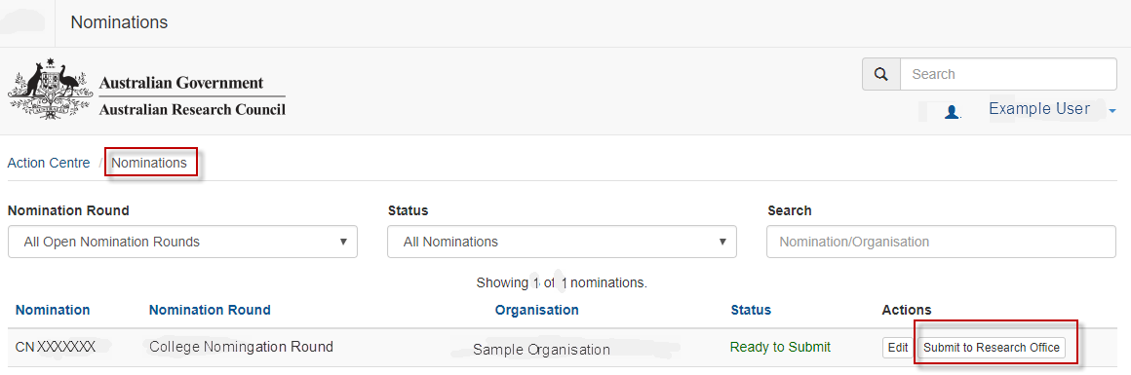

**Note:** Check carefully that all of the information contained in the Nomination form is accurate prior to submission. Research Offices may impose their own internal deadlines on researchers to submit Nominations.

* Nominees and Research Office staff who wish to generate a PDF so that they can keep a hard copy of the submitted Nomination may generate a PDF by selecting the PDF icon next to the ‘Save’ button (top right).

**The image of 'Save' button.**

# **Submitting the Nomination as a self-employed nominee**

* As a self-employed nominee you will need to ensure the details of your RMS Personal Profile are up to date.
* Ensure that your Administering Organisation is up to date:
  + To update your Administering Organisation, select the organisation that is to be the administrator of the account. This is usually the organisation that a person is affiliated with.

**Note:** Where a nominee is not affiliated with an organisation on the list the nominee must select the Australian Research Council as the Administrating Organisation.

* As a self-employed nominee, you will need to complete Part E with your own details.
* Self-employed nominees, and those being nominated by an organisation that is not an Eligible Organisation, will need to upload a certification letter. A template is provided at Attachment A.
* Once all components of the Nomination form are completed and saved, the Nomination header should be validated and have changed from red (invalid) to green (valid).



* Nominees who wish to keep a copy of the Nomination may generate a PDF by selecting the PDF icon next to the ‘Save’ button (top right).

**The image of 'Save' button.**

* Once the form is complete, you will be able to submit the form to the ARC from the Action Centre.

**Attachment A**

## Certification Letter for Self-employed Nominees

I, [insert name], certify that:

1. I have read, understood and complied with the 2024 College of Experts Nomination Instructions to Applicants and to the best of my knowledge all details provided in this form are true and complete;
2. I agree that if my nomination is successful, I will be available to fulfil the requirements of the membership of the ARC College of Experts; and
3. the Privacy Notice appearing at the top of this form has been drawn to my attention.

**Certification Letter for Nominees from Eligible Organisations**

I, [insert name and position title] of [insert name of eligible organisation], certify that:

1. I have read, understood and complied with the 2024 College of Experts Nomination, Instructions to Applicants and to the best of my knowledge all details provided in this form are true and complete.
2. I approve and support this nomination; and
3. agree that if this nominee is successful, the nominee will be available to fulfil the requirements of the membership of the ARC College of Experts.

To the best of my knowledge, the Privacy Notice appearing at the top of this form has been drawn to the attention of the nominee whose personal details have been provided in this form.