Variations of ARC Agreement:Research Office instructions for completing and submitting a Variation and/or POACR

**Table of contents**

**ARC Post Award** 4

**Submission of Variations: Information to note** 4

Navigating to the Project Details page 5

How to Start a variation in RMS 7

Add a variation request line 8

Remove a variation request line 9

Re-order multiple request lines 9

Deleting a variation request 10

Feedback Comments and Special Conditions 10

Finding a variation request 11

**Variation Request Types** 12

Allowance Variations 12

Allowance – Maternity/Parental leave 12

Budget Variations 12

Budget – Change Notification 12

Organisation Variations 15

Organisations – Add/Update 15

Organisations – Withdraw 15

Personnel Variations 16

Person – Add/Update 16

Person – Additional Appointments 18

Person – Defer Commencement 18

Person – Suspension 19

Person – Withdraw 20

Project Variations 21

Project – Defer Commencement 21

Project – End Date 22

Project – Full Relinquishment 22

Project – Partial Relinquishment 24

Project – Salary Conversion 24

Project – Salary Relinquishment 25

Project – Suspension 26

Project – Scope 27

Project – Transfer 28

Variations submitted outside of RMS 30

Project – Transfer Corrections 30

EoYR - Expenditure Correction 30

Project – Asset Relocation 31

Person – Add/update (that cannot be done in RMS) 32

Partner/Participating Organisation Agreed Contribution Report (POACR) 33

Creating a POACR in RMS 33

Search for a POACR in RMS 35

**Appendix A – ARC Variations – Supporting Documentation** 36

Supporting documents for variations submitted via RMS 36

Supporting documents for variations submitted outside of RMS 39

Transfer Correction 39

EoYR Correction 39

New Chief Investigator added to the Project 39

**Appendix B – ARC Variations – How to** 40

Allowance Variations 40

Allowance – Maternity/Parental leave 40

Budget Variations 41

Budget – Change Notification 41

Organisation Variations 42

Organisation – Add/Update 42

Organisation – Withdraw 43

Personnel Variations 44

Person – Add/Update 44

Updating an Affiliated Organisation in an investigators RMS profile: 45

Person – Additional Appointments 46

Person – Defer Commencement 47

Person – Suspension 48

Person – Withdraw 49

Project Variations 50

Project – Defer Commencement 50

Project – End date 51

Project – Full Relinquishment 52

Project – Partial Relinquishment 53

Project – Salary Conversion 54

Project – Salary Relinquishment 55

Project – Scope Change 56

Project – Suspension 57

Project – Transfer 58

**Appendix C – Calculating new End Dates due to FTE changes and suspensions** 60

# **ARC Post Award**

The Australian Research Council (ARC) Post Award team provides assistance, support and advice for ARC funded projects. For questions relating to funded projects, contact Post Award through the details provided below. Please provide the project ID and/or scheme year so that the team can provide specific advice.

All queries must come through the University Research Office (RO), as the agreement is between the ARC and the Administering Organisation and advice to the Chief Investigator (CI) needs to be provided in the context of the Administering Organisation’s own policy and procedures. If you are unable to answer a CI’s question, please reach out to the ARC Post Award team.

|  |  |  |
| --- | --- | --- |
| **Area** | **Contact details** |  |
| ARC Post Award | Email | [ARC-PostAward@arc.gov.au](mailto:ARC-PostAward@arc.gov.au) |
| Phone | (02) 6287 6600 |
| ARC RMS Support | Email | [ARC-systems@arc.gov.au](mailto:ARC-systems@arc.gov.au) |
| Phone | (02) 6287 6789 |

# **Submission of Variations: Information to note**

As a requirement of the ARC Grant Agreement, the Administering Organisation must ensure that a variation is submitted for certain changes to ARC Projects. Variations are submitted to the ARC via the Research Management System (RMS), by the Administering Organisation. For more information please refer to the relevant ARC Grant Guidelines and ARC Grant Agreement for the year in which the grant was funded.

A list of the documentation/agreement required for variations can be found in Appendix A. The ARC may request additional documentation if needed.

For a variation to be assessed, the following conditions must be met:

1. The variation must be submitted by the Administering Organisation via RMS.
2. The Administering Organisation must retain approvals and evidence that all relevant parties have been notified and confirm the changes.
3. Agreement from Participating Organisations must be from an authorised delegate.
4. A Partner or Other Organisation agreement may be submitted by the Partner Investigator (PI) on behalf of their organisation, provided the PI has the appropriate internal delegation for that Organisation. It is up to the Administering Organisation to ensure the PI holds this authority.
5. Host Organisation agreement may be submitted by the principle contact on behalf of their organisation, provided they have the appropriate internal delegation.

## Navigating to the Project Details page

Information related to a project is accessible in RMS through its Project Details page. Financial information, variations, end of year reports and special conditions of funding can be found on this page.

1. Login to [RMS](https://rms.arc.gov.au/RMS/ActionCentre/Account/Login?ReturnUrl=%2fRMS%2fActionCentre%2f). The home page is called the Action Centre.
2. In the Action Centre, under the heading ‘Research Office Project Management’, click on 'Research Office Projects'.

1. Search for the relevant Project by filtering on the Scheme, Scheme Round or Status drop down lists. Alternatively, use the Search bar to look up the Project ID, Project Title or First Investigator (ensuring there are no spaces before or after number).

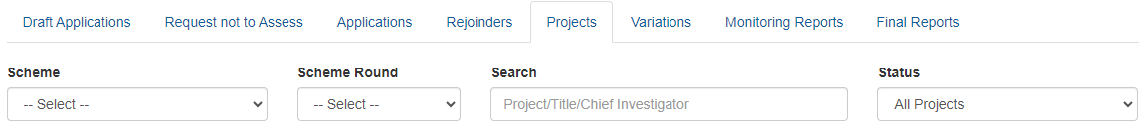

1. Once you have found the relevant project, click on the **'Details'** button to open the Project file.

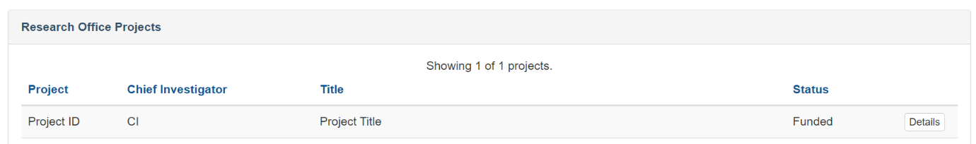

1. This will take you to the Project Details page as seen below.

## How to Start a variation in RMS

This section provides general instructions for submitting a variation to a project in RMS.

Please remember to **save regularly** as you complete the form, by using the 'Save' button located at the bottom left of the page.

For guidance on specific variation types please see “Variation Request Types” below.

1. Once in the Project details, select the 'Variations' tab and click on the 'Create Variation' button.



**Tip**: Once created, each variation is assigned an individual seven-digit code, which can be viewed under the 'Code' column.

## Add a variation request line

A single variation may need more than one variation type. For example, if a CI is moving to another University which is not already listed on the project, the variation will require a variation type - Person- Add/Update and variation type - Organisation- Add/ Update.

Following these steps to add each line of the variation:

1. Select the appropriate variation type from the 'Add Project Variation' drop-down menu, as shown below.

1. Fill in all mandatory fields, as required (referring to the specific [variation request types](https://australianresearchcouncil.sharepoint.com/sites/ProgramsBranch/Shared%20Documents/Post%20Award/Administration%20-%20Postaward/2022%20Post%20Award%20Information/Work%20Instructions/HYPERLINK#_Feedback_Comments) instructions later in this document).
2. Click 'Add'.
3. Repeat steps a) through c) to add additional lines for each variation line, saving as you go.
4. Complete justification field outlining “WHY” the changes are being requested (up to 500 words).

1. The justification field is mandatory and should be completed with all variations. The information provided here should be clear, concise, and include:
   * What the requested changes/actions are.
   * The personnel/organisations involved.
   * “WHY” the changes/actions are needed.

Justification should address the impact on the project and how these are being managed to meet project objectives.

**Tip:** This is a text box only and will not accommodate attachments, graphics or hyperlinks. If the request includes confidential information, it can be excluded from this field and should only be included within the supporting documents, if appropriate.

1. Add any required attachment:



Select the ‘Choose File’ button and select the document from your computer, then click on the upload button to attach the relevant supporting documentation. Please refer to Appendix A to see which variations require attachments.

**Tip:** Multiple files can be attached by saving them to a ‘zipped’ file. This zipped file can then be attached to the Variation or by scanning them as one document before attaching.

1. Once completed click ‘Save’ and then, ‘Submit to ARC’ at the bottom of the page. You cannot make changes once you have submitted to the ARC, however the ARC can return the variation to you if requested.

**Tip:** If you need to make changes before submitting the variation (remove or reorder etc), see following instructions before hitting Submit.

## Remove a variation request line

1. 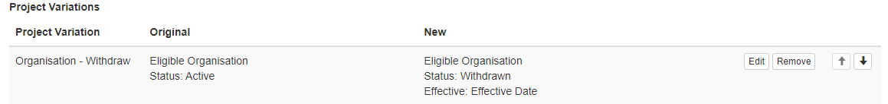Click the ‘Remove’ button, located on the right side of the relevant line to remove a request line from the variation.
2. A confirmation box will appear asking you whether you are sure you wish to remove this project variation. Click 'OK'.
3. Repeat as necessary for any lines to be removed.
4. Once completed click ‘Save’ and then ‘Submit to ARC’ at the bottom of the page.

## Re-order multiple request lines

1. Within the variation request, select the request line to be moved and click the up or down arrows, located on the right side of the relevant line. This will allow you to re-order the requested lines, which may be important for some variation types.

For example, when submitting a Project – Transfer variation, you must put the Transfer line first. Or with a Maternity/ Parental Leave variation, you must put the Maternity/ Parental Leave line first, then any period of Suspension, then an End Date Change.

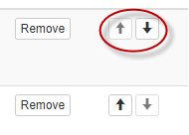

1. Repeat as necessary for any lines to be moved.
2. Once completed, hit ‘Save’ and then ‘Submit to ARC’.

## Deleting a variation request

Variations may be deleted following the instructions below.

1. Open the variation that you want to delete.
2. Select the 'Remove' button located within each request line (the justification does not need to be deleted).

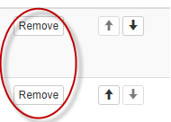

1. Once each line is removed, click ‘Save’ then ‘Close’ the variation. This will return you to the variation tab within the Project file.
2. Once in the variation tab of the Project file, click the 'Delete' button.



1. A warning will then pop up, confirming that you are happy to delete the variation by selecting 'Yes'.

**IMPORTANT: Once you have selected ‘Yes’ – this cannot be undone.**

## Feedback Comments and Special Conditions

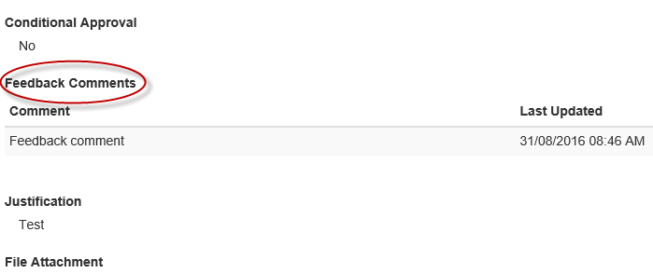If there is an issue with the variation, ARC will either decline the variation or return it to the Research Office. The ARC will include a feedback comment explaining why the variation was returned and/or declined. If the Administering Organisation proceeds with the variation request, the comment must be actioned and/or responded to when resubmitted to the ARC.

Feedback may also be included in feedback comments to indicate any special conditions the ARC may have placed on the approval. Special conditions are indicated when the 'Conditional' column is populated with 'Yes'.

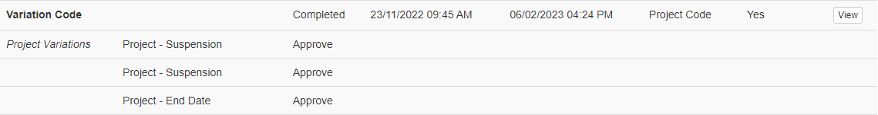

## Finding a variation request

There are several ways to find a variation in RMS.

1. Use the global search box at the top right of your screen to search by the Project ID. The search results will display relevant items to that project including Variations, Applications, Final Reports, and End of Year Reports (EoYR). Scroll down to Variations to locate the variation you need.

1. Use the search box to search by the individual variation ‘Code’.

Completed variations, may be viewed by clicking on the 'View' button.

Draft Variations can be edited by clicking on the 'Edit' button, as shown below.

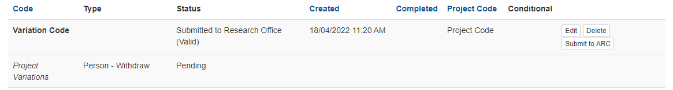

# **Variation Request Types**

## Allowance Variations

### Allowance – Maternity/Parental leave

For Allowance – Maternity/Parental leave variation to be used there must be a provision for maternity/parental leave in the relevant ARC Grant Agreement. If there is no provision in the ARC Agreement, the participant will not be eligible for paid leave from the ARC.

The leave allowance rate is calculated based the funding year the leave commences and the salary funding provided in that funding year. The budgeted funding year the leave falls into is estimated using the reported FTE and approved suspensions for that project.

For example: a DECRA with allowance provisions is also entitled to four weeks leave under the provisions of their university employment, a variation may be submitted.

If the DECRA has worked three years at 0.5 FTE, they may claim four weeks of allowance calculated from Year 2 of funding as they will have only worked one and a half years (1 FTE equivalent).

Allowance in this example calculates as (**Year 2 Salary** / 52) * 4, this figure will be rounded to the nearest whole dollar.

The funding year the leave commences from is determined using the Fellowship end date calculator, see Appendix C.

**Tip:** Review the relevant Agreement for claimable allowance

|  |  |  |
| --- | --- | --- |
| **Variation Type** | **Lines needed for the variation** | **Required attachments** |
| Maternity/Parental Leave | *Allowance – Maternity/Parental Leave  *Project – End Date  If relevant:  *Project/Person – Suspension  *Person – Add/Update | *HR Certification from Administering Organisation  *Confirmation from Project Leader (if not taking the leave) |

*For ARC to assess a Maternity/Parental leave variation you must include: submission of the following:*Please refer to Appendix B of these instructions for a ‘how to’ guide in RMS.

## Budget Variations

### Budget – Change Notification

A *Budget Change* variation is requested when significant funding is being moved across line items for the purpose of completing the Project. All requested items must be eligible as specified in the relevant ARC Grant Agreement and [Funding Rules/Grant Guidelines](https://www.arc.gov.au/manage-your-grant/funding-rulesgrant-guidelines). The ARC has developed a general list of non-allowable items across the ARC schemes ([Variation to a Funding Agreement](https://www.arc.gov.au/manage-your-grant)). Note: the document is a general indicator of non-allowable items and some items will not be relevant for some schemes/rounds.

**When would a variation be required?**

A variation is required if funding is being spent differently from what was outlined in the original proposal and the intention of the expenditure is different, For example:

* + When funds could not be spent on an item and is being repurposed in another budget category for other activity (eg: Travel to Personnel)
  + When the approved funding amount is less than the requested funding amount and the budget needs to be adjusted/ re-allocated (this may also require a Scope Change).
  + When funds are not used in one year and need to be moved to a later year (note: funds can only be moved forward, not backwards)

**When would a variation not be required?**

A variation is not required if funding is being spent differently from what was outlined in the original proposal but is within the same budget category, For example:

* + a Research Associate was budgeted but now a Research Assistant or PhD/HDR will undertake those tasks
  + a conference in Melbourne has been replaced by a conference in Perth
  + a type of software was initially budgeted but now a better/updated version is available so that version will be purchased instead
  + budget changes in timing with field work, due to natural disasters or change of environmental circumstances.
  + movement of funds from one year to another for the same budget item (i.e. budget carried over from one year to the next).

**Some examples of acceptable budget changes**

* + moving funding between high-level budget categories such as personnel, travel, maintenance, equipment, other, workshops (as allowable within the relevant ARC Grant Agreement)
  + from domestic to international travel
  + Reallocation of the budget due to a reduction in approved grant funding (this may also involve a *Project – Scope Change*)
  + movement of funds from one year to another for a different budget item.

**When would a variation not be approved?**

A *Budget Change* variation will not be approved if funding is being spent differently from what was outlined in the original proposal and the request is:

* + asking for items that are not allowed (as per the ARC Agreements)
  + approving the change would push the allowable item over the limits (i.e. travel or teaching relief)
  + the request is asking to purchase an item at the end of the project, not for the benefit of the project, but for another project, or just so the University doesn’t lose the funds (for example – buying $50,000 worth of computers with only 1 month to go to the end of the project)
  + asking for future years funding (that have not been paid yet) to be brought forward (i.e. funds to be brought forward from year 3 to year 1, in the first year of funding).

**Special Conditions**

Changes to funds linked to special conditions, such as International Collaboration Awards or Discovery International Awards (ICA’s or DIA’s) or Teaching Relief may be requested, however they are still required to abide by the conditions as outlined in the ARC Agreement. If the request is not in line with the original intention of the funding or will push the funding amounts over the allowable limits, or is requesting the use of non-allowable items (i.e. converting ICA/DIA’s to travel funding for non-collaboration), then the request will be declined.

**Travel – economy to business class**

Travel may also be upgraded from “economy” to “economy” business/business class if a medical certificate covering the travel period is provided to the HR area and certified by the Administering Organisation. Medical certificates that are dated far in advance of the travel are normally not acceptable, unless the condition is on-going or lifelong (i.e. a disability or chronic illness). Medical certificates for a specific period in the past to cover a specific injury (a medical certificate for 6 weeks for a broken arm) would not be acceptable.

**Salary Conversions**

If salary funds are paid from a salary line or named position (Fellowship/Award salary positions), then a *Project – Salary Conversion* variation type should be submitted. If a salary is funded from project funds only (i.e. student stipends in a DP), then a *Budget Change* variation type should be submitted instead.

If you are unsure if a position is funded from salary or project funds, try entering in a *Project – Salary Conversion* line. If the dropdown menu does not allow you to select the person/position, then it is funded through project funds.

**Tip:** The year in a Budget Change will refer to funding year rather than calendar year. Affected budgets should be reported based on when the activity was proposed to take place per the Project’s proposal and original application.

*For ARC to assess a Budget Change variation, you must include:*

|  |  |  |
| --- | --- | --- |
| **Variation Type** | **Lines needed for the variation** | **Required attachments** |
| Budget Change Notifications | *Budget – Change Notification  If relevant:  *Project – Scope Change | *No attachment – Details submitted within the Variation. |

Please refer to Appendix B of these instruction for a ‘how to’ guide in RMS.

## Organisation Variations

All changes to Participating Organisations must be reported to the ARC via a variation. All organisations must meet the eligibility criteria specified in the relevant Agreement and [Funding Rules/Grant Guidelines](https://www.arc.gov.au/manage-your-grant/funding-rulesgrant-guidelines), and should benefit the project.

### Organisations – Add/Update

Organisation – Add/Update is used when:

* adding a new organisation to a project, possibly due to the movement or addition of investigators
* changing the role of the organisation on the project (used during a transfer)
* adding an organisation due to a name change (this is combined with an Organisation – Withdraw variation).

*For ARC to assess an Organisation – Add/Update variation, you must include:*

|  |  |  |
| --- | --- | --- |
| **Variation Type** | **Lines needed for the variation** | **Required attachments** |
| Organisation Add/Update | *Organisation – Add/Update  *Person – Add/Update  If relevant:  *Organisation – Withdraw  *Person – Withdraw | * Written confirmation from Organisation  *Revised POACR (as required) |

Please refer to Appendix B of these instruction for a ‘how to’ guide in RMS.

### Organisations – Withdraw

All changes to Participating Organisations must be reported to the ARC via a variation. If an organisation is to be withdrawn from a project, this must be reported to the ARC via a variation. Organisations are commonly withdrawn due to the movement of investigators as well as changes in contributions and research direction.

Organisation – Withdraw is used when:

* removing an existing organisation from a project, possibly due to the movement/withdrawal of investigators or transfer of project, or if the organisation no longer wants to participate
* removing an organisation due to a name change (this is combined with an Organisation - add/update).

|  |  |  |
| --- | --- | --- |
| **Variation Type** | **Lines needed for the variation** | **Required attachments** |
| Organisation Withdraw | *Organisation - Withdraw  If relevant:  * Person – Add/Update  *Organisation – Add/Update  *Person – Withdraw  *Project Transfer | * Written confirmation from Organisation  *Revised POACR (as required) |

*For ARC to assess an Organisation - Withdraw variation, you must include:*  
 Please refer to Appendix B of these instruction for a ‘how to’ guide in RMS.

## Personnel Variations

All changes to named participants must be reported to the ARC. All existing and new participants must meet the eligibility criteria as specified in the relevant ARC Agreement and [Funding Rules/Grant Guidelines](https://www.arc.gov.au/manage-your-grant/funding-rulesgrant-guidelines).

RMS profiles must be updated by Investigators to ensure all their details are correct before a variation is created (this includes all COI questions and employment history). New Investigators cannot be added to a project until the ARC is notified of their RMS profile details.

### Person – Add/Update

Each request must include the person’s updated and affiliated organisation as a separate variation line in RMS relevant to the project.

If an Administering Organisation does not administer the RMS account of a Participant, you will need to submit an email request to the ARC to add them to the variation. See Supporting documents for variations submitted outside of RMS

Sometimes a Participant’s affiliated organisation is not be the same as the organisation that administers a participant’s RMS account. For example: an investigator may be employed at two universities, their RMS account administered by one, and their participation on the project is affiliated to the second university. In this example, both Universities should be listed as employers in their RMS profile. The second university will be unable to select the participant and must request that the ARC do this in their behalf.

Person – Add/Update is used when:

* adding a new investigator to a project (may need additional variation line type to add their Participating Organisation if the organisation isn’t already on the project)
* changing the role of the investigator on the project (from a Chief Investigator to Partner Investigator)
* changing the FTE of an investigator for Fellowships (not required for DP, LP, LE, IN)
* changing the organisation affiliation for an investigator on the project (may need additional variation line type to add/update/remove the original participating organisation).

**Tip:** As Discovery Projects (DP) are awarded on the qualifications of the CI’s and the specific team listed in the application the ARC will decline a request for new investigator to be added to a DP project without exceptional circumstances.

*For ARC to assess a Person – Add/Update variation, you must include:*

|  |  |  |
| --- | --- | --- |
| **Variation Type** | **Lines needed for the variation** | **Required attachments** |
| New Chief Investigator | *Person – Add/Update  If relevant:  *Organisation – Add/Update  *Organisation – Withdraw  *Project Transfer  *Allowance – Maternity/Parental Leave | *CV of new personnel (2 pages maximum)  * Written confirmation from affiliated organisation |
| New Partner Investigator | *Person – Add/Update  *Organisation – Add/Update  If relevant:  Organisation – Withdraw | *CV of new personnel (2 pages maximum)  *Agreement from affiliated organisation |
| New Director (CE/ ITRP) | **Please refer to the grant agreement and consult with the ARC major investments team before proceeding with this VFA.**  *Person – Add/Update (for incoming Director)  Person – withdraw (if necessary) for outgoing Director  *Organisation – Add/Update (or) Organisation – Withdraw (if necessary) | *Documentation and justification as advised by Major Investments team. |
| New COO  (Note ITRP Business Managers may use the role COO to be added to the Project). | *Person – Add/Update  *Organisation – Add/Update | *CV of new personnel  * Justification for selection of candidate. |
| PDRA/PGR appointment (Laureate Schemes prior to FL18 only) | *Person – Add/Update  *Person – Withdraw (if relevant) | \***No attachment** - Details submitted within the Variation. |

Please refer to Appendix B of these instructions for a ‘how to’ guide in RMS.

Please refer to Appendix C for guidance on calculating new End Dates due to FTE changes.

### Person – Additional Appointments

This variation type is only for participants who hold ARC Fellowships or Awards.

As Fellowships/Awards are research intensive positions, any additional appointments should be justified and significantly benefit the Fellow/Awardees career. Requests for additional appointments must also comply with the relevant scheme specific ARC Agreements.

If the additional appointment is for an administrative role at a University (e.g. Dean or Head of School), it would be expected that their ARC salary is relinquished to match the FTE amount spent on the position, unless it was deemed to be a short-term emergency appointment (i.e. four weeks due to a death or sudden illness of the person who holds the position) and approved by the ARC Post Award Delegate.

**Tip:** The ARC will not accept requests to convert the Fellowship/Award to part time and extend the end date for the purposes of holding an administrative position at the Administration Organisation.

*For ARC to assess an Additional Appointment notification variation, you must include:*

|  |  |  |
| --- | --- | --- |
| **Variation Type** | **Lines needed for the variation** | **Required attachments** |
| Additional Appointment Notification | *Person – Additional Appointment  If relevant:  *Person – Add/Update  *Project – End Date  *Project – Salary Relinquishment  *Project – Suspension | \***No attachment** - Details submitted within the Variation. |

Please refer to Appendix B of these instruction for a ‘how to’ guide in RMS.

### Person – Defer Commencement

The commencement of some non-named salaried participants (i.e. Post Graduate Researcher/Post-Doctoral Research Associate/Higher Degree by Research) can be deferred beyond the start date of the project. Although it is allowed, there are strict limits on when and for how long a deferment maybe requested. The request can also only be made for named participants. Please refer to the relevant ARC Agreement for guidance on whether the start date falls within the allowable period or the limit on when a request maybe submitted.

Person – Defer Commencement is used when:

* a PDRA/PGR/HDR position (named and funded) on an ARC grant is moving to Australia or is on approved leave (i.e. maternity/ parental /personal leave) and they cannot commence by the commencement date, as defined in the ARC Agreement.

**Tip:** If a sole investigator wishes to defer the commencement of a project, then a *Project – Defer Commencement* should be requested, not a *Person – Defer Commencement*.

**Tip:** Due to the deferred start date, the term of a PGR, named on Australian Laureate Fellowships, may be extended beyond the completion date of the project, for the purpose of meeting PhD requirements. However, a PGR can only receive funding for a maximum period of up to four years as the ARC will not provide additional funding to cover any extension to the study period of the award and the final end date of the project cannot be more than 8 years from the project commencement.

*For ARC to assess a Person – Defer Commencement variation, you must include:*

|  |  |  |
| --- | --- | --- |
| **Variation Type** | **Lines needed for the variation** | **Required attachments** |
| Person – Defer Commencement | *Person – Defer Commencement | \***No attachment** - Details submitted within the Variation. |

Please refer to Appendix B of these instructions for a ‘how to’ guide in RMS.

### Person – Suspension

If a salaried participant (Fellow/Awardee) is required to step away from the project for a period (usually more than four weeks), for exceptional circumstances, but the project will continue in their absence, they may request a *Person – Suspension*.

Person – Suspension is used when a Fellow/Awardee takes leave for:

* Maternity/Parental leave
* to take care of a family member
* to undertake an exceptional career opportunity
* medical reasons.

A *Person – Suspension* request will only be considered if it meets the following criteria:

* the project will continue in their absence by other named participants.
* the suspension is for a salaried position only (Fellow/Award) or named student position (PDRA/PGR).
* the suspension is allowable, as per the ARC Agreements (*noting that there are limits on how long suspensions may be requested for – please see the relevant ARC Agreement for limits*).
* the suspension has been fully justified, including the exceptional circumstances to approve the suspension.

*For ARC to assess a Person – Suspension variation, you must include:*

|  |  |  |
| --- | --- | --- |
| **Variation Type** | **Lines needed for the variation** | **Required attachments** |
| Person – Suspension | *Person – Suspension  If relevant:  *Person – Add/Update  *Project – End Date | \***No attachment** - Details submitted within the Variation. |

Please refer to Appendix B of these instructions for a ‘how to’ guide in RMS.

### Person – Withdraw

If an investigator is to be withdrawn from a project, this must be reported to the ARC via a variation.

Person – Withdraw is used when:

* due to the withdrawal of organisations, the project is transferred the investigator no longer wants to participate or becomes ineligible to remain on the project
* researcher is over project eligibility limits.

Up to 500 words should be entered into the justification outlining the reason for removing the person. This should be the ‘WHY’ for the request. For Industrial Transformation Research Program (ITRP), Centres of Excellence (CoE), and Special Research Initiative Excellence in Antarctic Science (SRIEAS), you must explain how the impact of the withdrawal will be managed.

*For ARC to assess a Person – Withdrawal variation, you must include:*

|  |  |  |
| --- | --- | --- |
| **Variation Type** | **Lines needed for the variation** | **Required attachments** |
| Person – Withdraw | *Person – Withdraw  If relevant:  *Organisation – Withdraw  *Person – Add/Update | * Written confirmation from personnel to be removed  If Person – Withdraw is related to the death of the Participant, please contact ARC for advice. |

**Tip:** The ARC Grant Agreement states there must be one original CI on the project to continue the research. If a project is being conducted by a sole CI and they wish to withdraw from the project, the project will need to be relinquished.

Please refer to Appendix B of these instructions for a ‘how to’ guide in RMS.

## Project Variations

Project variations affect duration, administration, and funding of an awarded project. Changes must meet the eligibility criteria as specified in the relevant ARC Agreement and [Funding Rules/Grant Guidelines](https://www.arc.gov.au/manage-your-grant/funding-rulesgrant-guidelines). If a project variation is a financial variation, the ARC Post Award team will seek verification of the data entered if it isn’t provided in the justification.

### Project – Defer Commencement

A project defer commencement request must occur before the final date of commencement, as specified in the relevant ARC Grant Agreement. There are strict limits on when and for how long a deferment may be requested. No ARC funds can be spent on the project until the new commencement date. Please refer to the relevant ARC Agreement for guidance on whether the start date falls within the allowable period or the limit on when a request maybe submitted.

For advice on deferring the commencement of Industrial Transformation Research Program (ITRP) and Centres of Excellence (CoE), please consult with the ARC Major Investment team.

Project – Defer Commencement is used when:

* Participating Organisation Agreements are yet to been signed by all named participating organisations.
* a Fellow/Awardee is on maternity leave or other approved leave.
* eligibility limits will be breached if the Project commences (noting there are limits on extensions for this reason).
* the project was transferred before it commenced, delaying the start date.

**Tip**: A *Project – End date* is NOT required for this type of request as it is already included in the *Project – Defer Commencement* line.

*For ARC to assess a Project – Defer Commencement variation, you must include:*

|  |  |  |
| --- | --- | --- |
| **Variation Type** | **Lines needed for the variation** | **Required attachments** |
| Project – Defer Commencement | Project – Defer Commencement | \***No attachment** - Details submitted within the Variation. |

Please refer to Appendix B of these instructions for a ‘how to’ guide in RMS.

### Project – End Date

Project Activity Period Ends when the ARC funded project activity is completed and all Grant Funds are spent. Once ARC funds are fully expended, the ARC considers the project to be completed and the end date should match this activity. Requests to extend the end date beyond this time will not be approved.

The ARC generally allows up to three years’ extension on most schemes beyond the original project end date (providing there is project funds available) (excluding any approved extensions). End dates requested beyond this are not approved without sufficient justification.

For further advice on Project – End Dates for Industrial Transformation Research Program (ITRP) and Centres of Excellence (CoE) and Special Research Initiative Excellence in Antarctic Science (SRIEAS), please consult with the ARC Major Investment team.

A **Project - End Date variation** request will only be considered if it meets the following criteria:

* The request directly relates to a change in the project that impacts spending e.g. maternity/paternity leave, suspension, part-time conversion, deferred commencement, requesting a financial carryover outside of the EoYR process, or to meet an eligibility requirement (if allowed in the relevant ARC Agreement).
* If the Project end date needs to be changed for the purposes of submitting a Final Report, written confirmation must be provided, confirming that the project has ended (including the actual end date) and that all the ARC funds have been expended. This action will confirm that all remaining funds from the change of the end date will be recovered by the ARC.
* A project end date cannot be brought forward to be less than the ARC granted funding period. Should the project conclude before the original end date of the funding period, funds may be relinquished by the ARC.
* A project that has entered its final year and seeks extension outside of the EoYR process.

Project – End Date is used when:

* extending an end date due to a change in FTE, approved leave, suspension or request carryover of funds
* reducing the length of a project due to all funds being spent
* complying with ARC eligibility requirements
* extending the end date due to a force majeure event or pandemic such as COVID-19 that impacts the performance of the project.

*For ARC to assess a Project – End date variation, you must include:*

|  |  |  |
| --- | --- | --- |
| **Variation Type** | **Lines needed for the variation** | **Required attachments** |
| End Date | Project – End Date  If relevant:  *Person – Add/Update  *Project - Suspension | \***No attachment** - Details submitted within the Variation. |

Please refer to Appendix B of these instructions for a ‘how to’ guide in RMS.

Please refer to Appendix C for guidance on calculating new End Dates due to FTE changes.

### Project – Full Relinquishment

If there are residual funds at the completion of a project, the residual funding must be returned to the ARC, or a project has not commenced and the Administering Organisation is now relinquishing the grant, a *Project – Full Relinquishment* variation is required to return all remaining funds to the ARC.

For a project to be relinquished, full expenditure figures (to date) must be included within the justification. Universities are not to include project expenditure after the agreed relinquished date, but may include committed costs (i.e. outstanding invoices).

Administering Organisations should ensure that they have acquitted all funds prior to submitting a *Project – Full Relinquishment* request, as the ARC will not reimburse the recovered funds.

Project – Full Relinquishment is used when:

* a Fellow/Awardee does not take up the grant or leaves before completion
* the investigators do not meet the eligibility criteria to hold the grant
* contract negotiations fail and the project is not eligible to commence (Linkage Program)
* there is a serious breach or integrity misconduct issue and ARC recovers all funding.

**Tip:** If the request for relinquishment is only for a specific amount but the project is still ongoing, a *Project – Partial Relinquishment* variation should be requested. A *Project – Full Relinquishment* variation should only be requested where the project is returning all remaining funds to the ARC and the project will end.

**Considerations of the Agreement when submitting a Full Relinquishment**

* do not include salary commitments after the project has been relinquished as expenditure
* all figures reported to the ARC must include **ALL** spent and unspent funds, regardless of their location. This includes funds that are not located at the Administering Organisation, and/or funds that are currently credited to another account code such as salaries, instead of the project itself
* The ‘Indexed Amount’ column will not appear for all future years.

*For ARC to assess a Project – Full Relinquishment variation, you must include:*

|  |  |  |
| --- | --- | --- |
| **Variation Type** | **Lines needed for the variation** | **Required attachments** |
| Full Relinquishment | Project – Full Relinquishment | \***No attachment** - Details submitted within the Variation. |

Please refer to Appendix B of these instructions for a ‘how to’ guide in RMS.

### Project – Partial Relinquishment

On occasion, some funds need to be returned to the ARC, while the project is still ongoing (i.e. has not come to an end). If this happens, a *Project – Partial Relinquishment* variation will have to be completed.

For a project to be partially relinquished, only the funding years are being relinquished must be completed. To relinquish the funds, you must enter the amount that is to remain on the project only and the ARC will recover the difference.

**Tip:** If the request is for the full amount or the Project has come to an end, a *Project – Full Relinquishment* variation should be requested instead. If the amount to be recovered is only for the salary component of a Fellowship/Award, a *Project – Salary Relinquishment* variation should be used.

Project – Partial Relinquishment is used when:

* relinquishing funding under special condition cannot be used for their original purpose and are not approved to be used for another purpose by the ARC
* recovering ARC funds due to a serious breach or misconduct.

**Considerations to observe when submitting a Partial Relinquishment**

* Is this the correct type of relinquishment variation to be used?
* The ‘Indexed Amount’ column will not appear for all future years.

*For ARC to assess a Project – Partial Relinquishment variation, you must include:*

|  |  |  |
| --- | --- | --- |
| **Variation Type** | **Lines needed for the variation** | **Required attachments** |
| Partial Relinquishment | *Project – Partial Relinquishment | \***No attachment** - Details submitted within the Variation. |

Please refer to Appendix B of these instructions for a ‘how to’ guide in RMS.

### Project – Salary Conversion

ARC may allow the conversion of identified salary funds for a Fellowship/Award to be converted to project funds to be used for other purposes.

For salary funds to be converted, the full amount of salary spent must be included within the request and you must also note the amount that is to remain on the salary, not the amount to be converted to project funds.

**Tip:** When entering in the amount to convert, you will see the amount listed under the project funds adjusting. This will represent the new split between the salary and project funds.

**Considerations when submitting a Salary Conversion**

* Is this the correct type of variation to be used? If the salary is already funded through project funds, then a *Budget Change* variation should be requested.
* The ‘Indexed Amount’ column will not appear for all future years.

Project – Salary Conversion is used when:

* converting Fellow/Award salary to Project funds
* converting a salary that was awarded to a named position (i.e. PDRA/PGR) and the position remined vacant.

*For ARC to assess a Project – Salary Conversion variation, you must include:*

|  |  |  |
| --- | --- | --- |
| **Variation Type** | **Lines needed for the variation** | **Required attachments** |
| Salary Conversion | *Project – Salary Conversion  If relevant:  *Project – Scope | \***No attachment** - Details submitted within the Variation. |

Please refer to Appendix B of these instructions for a ‘how to’ guide in RMS.

### Project – Salary Relinquishment

On occasions, salary funds have to be returned to the ARC, however the project is still ongoing (i.e. has not come to an end). If this happens, a *Project – Salary Relinquishment* variation must be completed.

For salary funds to be relinquished, the full amount to be relinquished must be included within the request, and you must also confirm the amount that is to remain on the project – not the amount to be recovered by the ARC.

**Tip:** If the request is for the full amount or the project has come to an end, a *Project – Full Relinquishment* variation should be requested. If the amount to be recovered is not for the salary component of a Fellowship/Award, a *Project – Partial Relinquishment* variation should be used.

**Considerations when submitting a Salary Relinquishment**

* Is this the correct type of relinquishment variation to be used? If there are projects to be relinquished, then this is not the correct Variation to use, you should use *Project – Full Relinquishment*.
* The ‘Indexed Amount’ column will not appear for all future years.

Project – Salary Relinquishment is used when:

* relinquishing Fellow/Award salary due to an additional appointment
* relinquishing a salary that was awarded to a named position (i.e. PDRA/PGR) and the position remained vacant.

*For ARC to assess a Project – Salary Relinquishment variation, you must include:*

|  |  |  |
| --- | --- | --- |
| **Variation Type** | **Lines needed for the variation** | **Required attachments** |
| Salary Relinquishment | *Project – Salary Relinquishment | \***No attachment** - Details submitted within the Variation. |

Please refer to Appendix B of these instructions for a ‘how to’ guide in RMS.

### Project – Suspension

A *Project – Suspension* is normally requested when, for example due to exceptional circumstances, no one can work on the project (usually for 4 weeks or more).

Project – Suspension is used when:

* serious illness, care for family member or maternity leave (usually for a sole CI grants and Fellowships) impacts project progression
* exceptional career opportunity arises (usually for a sole CI grants and Fellowships)
* delays in transferring an ARC grant
* restrictions in fieldwork resulting in ability to access the site or would result in danger to the researcher, such as natural disaster or political unrest
* default of Partner Organisations.

The ARC Agreement may have different requirements and limitations on suspensions for each scheme. It is advised that participants make themselves aware of these limitations when requesting long or multiple suspension requests.

When suspending a project (as opposed to the person) ARC funding cannot be spent during the suspension period. If funding is planned to be spent while a Fellowship is suspended (for example, a student hired on the Project intends to continue to work while the DECRA recipient is on maternity leave), a *Person – Suspension* must be requested.

**Tip:** *Project – Suspensions* cannot be requested to delay the commencement of a project. If a project has not commenced, a *Project - Defer Commencement* variation must be submitted.

*For ARC to assess a Project – Suspension variation, you must include:*

|  |  |  |
| --- | --- | --- |
| **Variation Type** | **Lines needed for the variation** | **Required attachments** |
| Project – Suspension | *Project – Suspension  *Project – End date | \***No attachment** - Details submitted within the Variation. |

Please refer to Appendix B of these instructions for a ‘how to’ guide in RMS.

### Project – Scope

A *Project – Scope Change* variation is used if there is a significant change in the projects scope, e.g. the direction of the project is changing significantly from the original proposal (due to personnel, budget, research field availability, equipment availability etc).

As the ARC Agreements have strict guidelines as to how the ARC will allow its funds to be used, it is important to consider if the changes will impact on how the originally funded project will be affected and if the scope change will drastically change the project moving forward.

For Industrial Transformation Research Program (ITRP) and Centres of Excellence (CoE) and large scale Special Research Initiatives (SRI), it is imperative that you consult with the ARC Major Investments team prior to submitting a request.

Project – Scope is used when:

* scope changes are made due to the approved project budget being less than requested and does not allow for all aims to be completed. With the removal of some funded activities, the researchers can seek other funds, but must avoid Commonwealth overlap
* events such as natural disasters inhibit a component of the research from being undertaken by the current project.

**Tip:** the ARC will not approve *Project – Scope* changes if they are being requested in order to meet a Partner Organisation’s requirements (i.e. contract research).

**Tip:** Scope change variations for Industrial Transformation Research Program (ITRP) and Centres of Excellence (CoE) and large scale Special Research Initiatives (SRI) must be discussed with the ARC major investments team prior to submission.

*For ARC to assess a Project – Scope variation, you must include:*

|  |  |  |
| --- | --- | --- |
| **Variation Type** | **Lines needed for the variation** | **Required attachments** |
| Scope | *Project – Scope  If relevant:  *Budget – Change Notification | \***No attachment** - Details submitted within the Variation. |

Please refer to Appendix B of these instructions for a ‘how to’ guide in RMS.

### Project – Transfer

A *Project – Transfer* may be requested if the project is still active and there are ARC funds still available for expenditure, and if all parties agree to the transfer.

Project – Transfer is used when:

* the Project Lead changes institutions and wants to take the grant with them
* there is a change in Project Lead and the Project moves to the new leader’s employing institution.

For a project to be transferred, the new organisation must be listed as an Eligible Organisation as specified in the relevant ARC Agreement. If they are not listed, they will not be able to become the Administering Organisation for the project.

**Tip:** If not already in place, an ARC Agreement will also have to be accepted in RMS, prior to the organisation being able to become the new Administering Organisation.

Transfer requests must always be fully justified and outline the reason for the transfer, how it will benefit the project and what (if any) affect it will have on any students or employees involved in the project. Transfer requests are also expected to have the agreement of all parties listed on the project.

Requests for Fellowship/Awardee transfers will also require additional justification from the DVCR (or their delegate) from the receiving Administering Organisation. This justification should outline the exceptional reasons for the transfer, how the new research environment will benefit the Fellow/Awardee.

All ARC funds must be declared before the transfer. By not declaring all ARC funds at the Administering Organisation will be in breach of the ARC Agreement and may be considered as fraudulent activity.

When calculating the transfer amount, the following MUST be adhered to:

* the total amount that the project was allocated for all years up to and including the current year must be included, not just the amount that the organisation has received so far
* future years’ allocation will not appear in the ‘Total Allocated’ column as this will be transferred automatically and the relinquishing Administering Organisation cannot claim this funding as expenditure
* if the project had previously been transferred, only the amount paid to the relinquishing Administering Organisation will appear in the ‘Total Allocated’ column
* full expenditure figures (to date) must be included within the request. Do not include salary commitments after the project has been transferred as expenditure
* all figures reported to the ARC must include ALL spent and unspent funds, regardless of their location. This includes funds that are not located at the Administering Organisation, and/or funds that are currently credited to another account code such as salaries, instead of the project itself
* only leave accumulated during the Fellowship/Awardee, can be paid out from the on-costs. Leave accumulated before or outside the Fellowship/Award (i.e. in another appointment) cannot be charged to the project
* the last year’s EoYR should be confirmed with the transfer amount, so that the transfer amount is not less than the amount previously reported as spent in the EoYRs

Transfers cannot be requested if all ARC funds have been spent.

*For ARC to assess a Project – Transfer variation, you must include:*

|  |  |  |
| --- | --- | --- |
| **Variation Type** | **Lines needed for the variation** | **Required attachments** |
| Transfer | *Project – Transfer request  *Organisation – Withdraw (or) Organisation – Add/Update  *Person – Add/Update  If relevant:  *Project – Defer Commencement  *Project Suspension / End date | * Written confirmation from receiving Administering Organisation  * Written confirmation from all named Organisations (excluding Host Organisations) |
| Transfers – Fellowships only | * Written confirmation from receiving Administering Organisation  * Written confirmation from all named Organisations (excluding Host Organisations)  *Letter of justification and research environment statement from receiving Administering Organisation DVCR (or their delegate) |

Please refer to Appendix B of these instructions for a ‘how to’ guide in RMS.

## Variations submitted outside of RMS

### Project – Transfer Corrections

If the amount previously reported during a transfer was incorrect, a *Project – Transfer Correction* may be requested.

Project - Transfer Correction is used when:

* there are additional funds to be transferred to the new Administering Organisation that were not included in the original transfer (i.e. funds located at another organisation on the grant)
* there are funds to be returned to the previous Administering Organisation as costs associated with the project were not identified at the time of transfer.

*For ARC to assess a Project – Transfer Correction variation, you must include:*

|  |  |  |
| --- | --- | --- |
| **Variation Type** | **Lines needed for the variation** | **Required attachments** |
| Transfer Correction | *Approval from the Administering Organisation/s  *Details of the correct transfer amount to be transferred | * Written confirmation from both current and previous Administering Organisation on the effective changes to the funding received  *Details of the correct amount to be transferred  *Justification as to why the information was reported incorrectly |

For these variations, Research Offices must email the relevant details/documentation to the Post Award email for processing as outlined in Appendix A of these instructions.

### EoYR - Expenditure Correction

If the amount previously reported during an EoYR was incorrect, an *EoYR Correction* may be requested.

EoYR – Expenditure Correction is used when:

* funds were incorrectly reported during a previous EoYR, resulting in carryover figures being incorrect.

*For ARC to assess a Project – EoYR Correction variation, you must include:*

|  |  |  |
| --- | --- | --- |
| **Variation Type** | **Lines needed for the variation** | **Required attachments** |
| EoYR corrections | *Email ARC Post Award Team | * Details of the correct amount for each year to be corrected (see example table in Appendix A)  *Justification as to why the information was reported incorrectly |

For these variations, Research Offices must email the relevant details/documentation to the Post Award mailbox for processing as outlined in Appendix A of these instructions.

### Project – Asset Relocation

Assets purchased with ARC Funding must be purchased for the exclusive purposes of the project for the duration of the 'Project Activity Period'. It is expected that unless otherwise approved by the ARC, the ownership of any Asset purchased wholly or partly with the funding shall be vested in the Administering Organisation, located on its campus and listed in its assets register unless:

* it was specified in the original proposal as being located at another organisation
* the project is terminated
* the project is transferred to another organisation.

If an organisation would like to relocate an asset to another location, such as another university on the grant, and the project is not transferring, a variation must be submitted to the ARC for approval.

This variation type is commonly used when the distribution of ARC funded equipment is being relocated to another organisation listed on the project.

*For ARC to* *assess an Asset – Relocation variation, you must include:*

|  |  |  |
| --- | --- | --- |
| Variation Type | Lines needed for the variation | Required attachments |
| Asset Relocation | *Asset Relocation  If relevant:  *Budget Change | *Confirmation from all named Organisations (excluding the Administering Organisation) regarding the new arrangements |

### Person – Add/update (that cannot be done in RMS)

There are some instances when an RO cannot add or change a new investigator on a project. In this instance, the ARC staff will need to create the variation. For example, if you are adding a researcher from an Other Organisation.

Person – Add/update (outside of RMS) is used when:

* adding a new investigator to a project
* change the role of the investigator on the project (from a Chief Investigator to Partner Investigator)
* change the FTE of an investigator (commonly used in Fellowships)
* change the organisation affiliation for an investigator on the project.

RMS profiles should be updated by Investigators to ensure all their details are correct before the variation can be processed, including their Affiliation, Non-Australian Research and COI questions.

Each request must include their updated and relevant affiliated organisation, relevant to the project. Noting that the Administering Organisation for the project may not be the same Administering Organisation on the researcher’s profile. For example: an investigator may be employed at two universities and their RMS account administered by one, however they are participating on the project as it is connected to the second university.

New Investigators cannot be added to a project until the ARC is notified via email of the following:

* Their RMS profile details (email address affiliated with their RMS account)
* If the person is being added, the request needs to list their full name, role, affiliated organisation on the project, FTE the investigator is working on the project and the effective date the addition/change happened. The effective dates should match the dates the organisation is being added/updated (if relevant).
* Sufficient justification should be provided in the email outlining “**WHY”** the person is requesting to be added to the project.

For these variations, Research Offices must email the relevant details/documentation to the Post Award mailbox for processing as outlined in Appendix A of these instructions.

## Partner/Participating Organisation Agreed Contribution Report (POACR)

All Administering Organisations are required to enter agreed Cash and In-Kind Contributions in RMS after it has signed a written agreement with all named Participating Organisations listed on the Project.

An updated POACR is required with the addition and/or withdrawal of a Participating Organisation. Before entering the contribution, please refer to the ARC Agreements for each year’s organisation contribution requirements.

Information drawn from the most recently approved POACRs are then used to confirm the contribution amounts for the Project, to ensure the eligibility is being adhered to (Linkage Program).

Should a POACR be required due to financial contribution changes throughout a project, a POACR will need to be approved prior to submitting the ARC Final Report as the information is auto populated into the Final Report.

### Creating a POACR in RMS

**IMPORTANT:** Please **do not** create a POACR for a new organisations contribution, until the ARC has **approved the addition of the new organisation**. The POACR will **only** populate with the organisations listed on the Project. If the POACR has been created in error, it can be deleted.

To create a POACR in RMS, you must do the following:

1. In RMS, search for the Project that a POACR needs to be created for.
2. Select the ‘Reports’ tab within the Project and press the *Create New Partner Organisations Agreed Contribution Report* button.

1. Click *Create Report* when ‘Create a new Partner Organisation Agreed Contribution report appears.Graphical user interface, text, application, email

   Description automatically generated
2. Once selected, a DRAFT report will appear on the list.
3. Click the *Form* button located next to the report that you want to update.



1. Enter each Organisation’s cash and in-kind contributions in the Updated Contributions section in the lower half of the screen (in white). As information is populated, the Updated Contribution Totals will then automatically update the totals.

**Please Note:** Only the original funded years will appear in the table. Funds should be entered against the years as they were awarded, regardless of if there was a deferred commencement. If contributions were provided after the original funded years, they may be entered into the last year of the table.

**Please Note:** The years in the POACR refer to funding year rather than calendar year. Funds should be entered against the year the activity is intended to take place regardless of periods of deferred commencements or suspensions. Should additional contributions be provided after the original funding years, they may be entered into the last year of the table.

1. Click *Save* when all contributions have been entered and *Close* the screen.
2. The POACR is now ready to be certified. Click the Certify button on the right of the report.



1. A new Certify Partner Organisation Agreed Contribution Report for the Project ID pop-up window will appear, asking to certify the Partner Organisation Contributions.
2. Click *Agree to certification* to certify the contributions or *Cancel* to go back to the form.

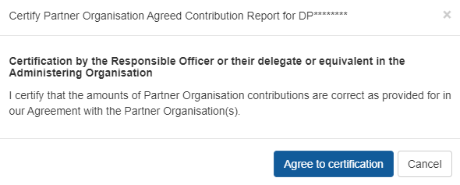

1. Following certification there will be option on the Reports page *Submit to ARC* or *Decertify* the contributions, to edit the form.
2. Click *Submit to ARC* to submit POACR to the ARC.



Once a POACR has been submitted to the ARC in RMS, the ARC will then review the report. The Research Office may request the POACR be un-submitted or may be un-submitted by the ARC to seek further information. This will update the POACR’s status to ‘Ready to Submit’.

Once the report has been returned to the Administering Organisation, the POACR can then be adjusted accordingly and resubmitted back to the ARC by following steps h) to l) above. Once approved by the ARC the status will appear as ‘Accepted’.

### Search for a POACR in RMS

Once a POACR has been created in RMS, it can be located via the Project Reports tab:

1. In the Research Office Project Management section of the Action Centre, click on Research Office Project Reports.

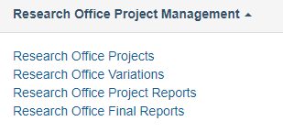

1. Search for the relevant Project by selecting the ‘Partner Organisation Agreed Contribution Report (POACR)’ from the *Report* drop down list.
2. Then filter on the *Scheme, Scheme Round or Status* drop down lists*.* Alternatively, the *Search* bar can be used to search on the Project ID, Project Title or First Investigator.

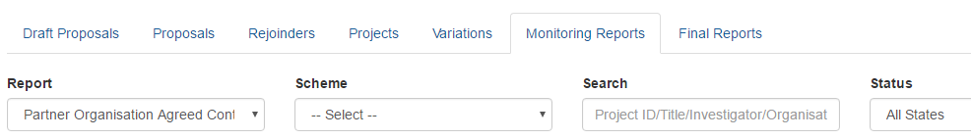

1. Upon finding the Project, click on ‘Form’ under Research Office Projects



# 

# **Appendix A – ARC Variations – Supporting Documentation**

Justification for variations must be communicated in the justification field. Some variations submitted to the ARC may also require additional evidence/approvals from participants on the project.

If these are required, they will be listed below. Multiple files can be compressed in a zipped folder and uploaded as one file such as when the ARC requests additional documentation.

The ARC will consider all variations that are submitted to the ARC, as approved, and certified by the Administering Organisation and Project Leader. Additional approvals are not required unless requested by the ARC.

## Supporting documents for variations submitted via RMS

| **Variation** | **Attachment** | **May include variation** |
| --- | --- | --- |
| **Allowance – Maternity / Parental Leave** | * HR Certification from Administering Organisation * Confirmation from Project Leader   (if not the Project Leader) | Project/Person – Suspension  Project – End Date  Person – Add/Update |
| **Budget – Change Notification** |  | Project – Scope Change |
| **Organisation – Add/Update** | * Written confirmation from Organisation | Organisation – Withdraw  Person – Withdraw  Person – Add/Update |
| **Organisation – Withdraw** | * Written confirmation from Organisation | Organisation – Add/Update  Person – Withdraw  Person – Add/Update  Project – Transfer |
| **Person – Add/Update** | **If an Investigator (CI or PI) is new to the project**   * CV of new person personnel (2 pages maximum) * Employment History completed in User Profile * Conflict of Interest completed in User Profile * Written confirmation from Affiliated/Partner Investigator’s Organisation (if relevant)   **If a Director (CE/ITRP) is new to the project**   * Documentation as advised by Major Investments team   **If a COO is new to the project**   * CV of new personnel * Justification for selection   **Role change:**  Chief/Partner Investigator;   * Written confirmation from relevant personnel * Written confirmation from Partner Investigator’s Organisation (if relevant)   **Postgraduate Researcher or Postdoctoral Research Associate:**   * None   **Affiliation change:**  Organisation is in the project   * Written confirmation from person changing   **Organisation is new to the project**   * Written confirmation from person and organisation   **FTE change:**   * FL/FT/DE required * DP if reducing to less than 0.2FTE | Project – Transfer  Person – Withdraw  Organisation – Withdraw  Organisation – Add/Update  Allowance – Maternity / Parental Leave  Person – Withdraw (required) specific to CE/ITRP |
| **Person – Additional**  **Appointment Notification** |  | Person – Add/Update  Project – End date  Project – Salary Relinquishment  Project - Suspension |
| **Person – Defer Commencement** |  | Person – Add/Update |
| **Person – Suspension** |  | Project – End Date  Person – Add/Update |
| **Person – Withdraw** | * Written confirmation from person removed | Organisation – Withdraw  Person – Add/Update |
| **Project – Defer Commencement** |  |  |
| **Project – End Date** |  | Person – Add/Update  Project – Suspension |
| **Project – Full Relinquishment** |  |  |
| **Project – Partial**  **Relinquishment** |  |  |
| **Project – Salary Conversion** |  | Project – Scope |
| **Project – Salary**  **Relinquishment** |  |  |
| **Project – Scope** |  | Budget – Change Notification |
| **Project – Suspension** |  | Project – End date |
| **Project – Transfer** | * Written confirmation from receiving Administering Organisation * Written confirmation from all named Organizations (excluding Host Organisations) * Fellowships only – Letter of justification and research environment statement | Organisation – Withdrawal  Organisation – Add/Update  Person – Add/Update  Project – Defer Commencement  Project – Suspension  Project – End Date |
| **Project – Transfer Correction** | **Requested by Research Offices via email only.**   * Written confirmation from both current and previous Administering Organisation * Details of the correct amount to be transferred * Justification as to why the information was reported incorrectly |  |
| **EoYR – Expenditure**  **Correction** | * Requested by Research Offices via email only * Details of the correct amount for each year to be corrected * Justification as to why the information was reported incorrectly |  |

## Supporting documents for variations submitted outside of RMS

Some variations are not able to be submitted to the ARC via RMS. These include:

* Transfer Corrections
* EoYR Corrections
* Asset Transfer
* the addition of new investigator (if their RMS account is not administered by the Research Office).

For these variations, Research Offices must email the relevant details/documentation to the Post Award mailbox for processing as outlined below.

### Transfer Correction

* Agreement from the current and previous Administering Organisation agreeing to the new funded amounts paid to each Organisation. This should include effective changes to project funding and salary funding (where applicable) received.
* Details of the correct transfer amount to be transferred
* A statement as to why the information was reported incorrectly

### EoYR Correction

* Details of the correct expenditure amount for each year of the Project using the table below
* A statement as to why the information was reported incorrectly

**Example of EoYR correction table:**

|  |  |  |  |  |  |
| --- | --- | --- | --- | --- | --- |
| **Reporting Year** | **Indexed amount funded** | **Original Expenditure reported to ARC** | **Revised Expenditure** | **Revised Carryover balance** | **RO Comments** |
| **2020** | $100,000 | $80,000 | $80,000 | $20,000 | Amount correctly reported – no changes |
| **2021** | $100,000 | $60,000 | $50,000 | $70,000 | Salary incorrectly charged; amount adjusted |
| **2022** | $100,000 | $30,000 | $20,000 | $150,000 | Salary incorrectly charged; amount adjusted |
| **TOTAL** | **$300,000** | **$170,000** | **$150,000** |  |  |

### New Chief Investigator added to the Project

*Only to be used for when an investigators RMS account is not administered by the Administering Organisation*

* CV of new personnel (up to 2 pages)

# **Appendix B – ARC Variations – How to**

## Allowance Variations

### Allowance – Maternity/Parental leave

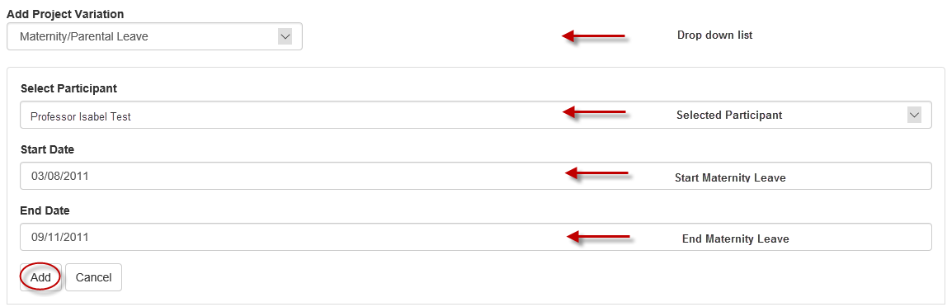

1. Select *Maternity/Parental Leave* from the ‘Add Project Variation’ drop-down menu.
2. Select the participant who the maternity/parental leave is being applied for, from the ‘Select Participant’ drop-down.
3. Enter the intended maternity/parental leave start and end dates into the appropriate fields.
4. Select ‘Add’
5. Provide details of the leave in the Justification box (up to 500 words).
6. Select the ‘Choose File’ button and then press ‘**Upload’** to attach the relevant documentation for the entire request, noting that it can only be one attachment.
7. ‘Save’ and ‘Close’ the request
8. Check the variation details and submit to the ARC.

Back to Allowance – Maternity/Parental leave

## Budget Variations

### Budget – Change Notification

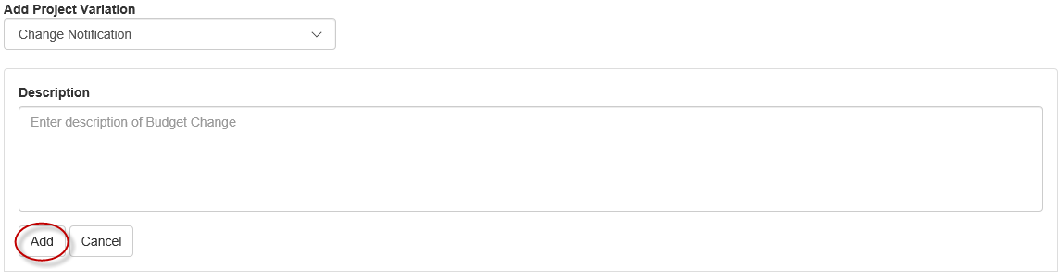

1. Select *Change Notification* under the Budget heading from the ‘Add Project Variation’ drop-down.
2. Enter a description of the proposed budget item changes, including amounts and location/years, using the format $X from [current budget item category] Year X to [new budget item category] Year Y Note: “year” refers to funding year, not calendar year.

i.e. “$15,000 from Year 2 Travel to Year 3 Other”

1. Select ‘Add’
2. Provide details of the budget changes in the Justification box (up to 500 words).
3. Documentation is not required for this type of variation, unless requested by the ARC.
4. ‘Save’ and ‘Close’ the request.
5. Check the variation details and submit to the ARC.

Back to Budget – Change Notification

## Organisation Variations

### Organisation – Add/Update

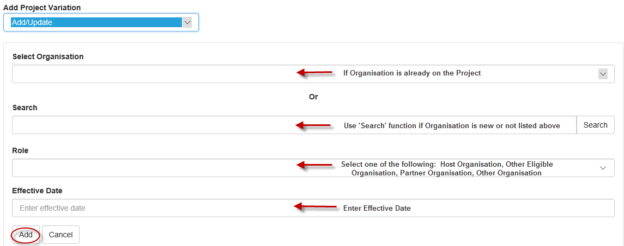

1. Select *Add/Update* from the ‘Organisation’ category within the ‘Add Project Variation’ drop-down.
2. Using the ‘Select Organisation’ drop-down, select the organisation that you intend on updating on the project. Alternatively, if the organisation is not already on the project, you may search for the organisation’s name using the search functions.
3. Select the organisation role from the ‘Role’ drop-down.

**Please note:** Only Universities which are considered eligible organisations can be added to projects as an ‘Other Eligible Organisation’. Please refer to the general eligibility requirements for organisations as defined in the relevant ARC Agreement.

1. Provide the date that this is to take effect in the ‘Effective Date’ box as per the Agreement by the New Organisation.
2. Select ‘Add’
3. Provide details of why the new organisation is to be added in the Justification box (up to 500 words).
4. Select the ‘Choose File’ button and then press ‘**Upload’** to attach the relevant documentation for the entire request, noting that it can only be one attachment.
5. ‘Save’ and ‘Close’ the request.
6. Check the variation details and submit to the ARC.

**If an organisation cannot be found in RMS, the Research Office will need to collect the relevant information from the Organisation and follow the below links to add the Organisations in RMS.**

To Request an International Organisation for RMS use this link:

[https://rms.arc.gov.au/RMS/Organisation/Manage/CreatePendingOrg](https://aus01.safelinks.protection.outlook.com/?url=https%3A%2F%2Frms.arc.gov.au%2FRMS%2FOrganisation%2FManage%2FCreatePendingOrg&data=05%7C01%7CHolly.Gordon%40arc.gov.au%7C002ab56ddc834c27168708db1dc1a818%7Cc75dbeeca1a549b48a3ac54972b1ce77%7C0%7C0%7C638136489826823598%7CUnknown%7CTWFpbGZsb3d8eyJWIjoiMC4wLjAwMDAiLCJQIjoiV2luMzIiLCJBTiI6Ik1haWwiLCJXVCI6Mn0%3D%7C3000%7C%7C%7C&sdata=VyoyvKHVx3e1lSnhG6bLrnU2b5zBRYh9qBy7aYolNoU%3D&reserved=0)

Please translate the organisation name into English if applicable.

To add Australian Organisations with an ABN in to RMS use this link:

[https://rms.arc.gov.au/RMS/Organisation/Manage/AddOrganisation](https://aus01.safelinks.protection.outlook.com/?url=https%3A%2F%2Frms.arc.gov.au%2FRMS%2FOrganisation%2FManage%2FAddOrganisation&data=05%7C01%7CHolly.Gordon%40arc.gov.au%7C002ab56ddc834c27168708db1dc1a818%7Cc75dbeeca1a549b48a3ac54972b1ce77%7C0%7C0%7C638136489826823598%7CUnknown%7CTWFpbGZsb3d8eyJWIjoiMC4wLjAwMDAiLCJQIjoiV2luMzIiLCJBTiI6Ik1haWwiLCJXVCI6Mn0%3D%7C3000%7C%7C%7C&sdata=g1WKMkywSGq97gchC2zc9xyMk7I%2BkZwBceRCTGG5NpY%3D&reserved=0)

**Note:** The only organisations RMS Support will create manually are Australian organisations without an ABN, small community groups etc. In this instance, please contact ARC helpdesk with all the details of the organisation: email [ARC-Systems@arc.gov.au](mailto:ARC-Systems@arc.gov.au)

Back to Organisation – Add/Update

### Organisation – Withdraw

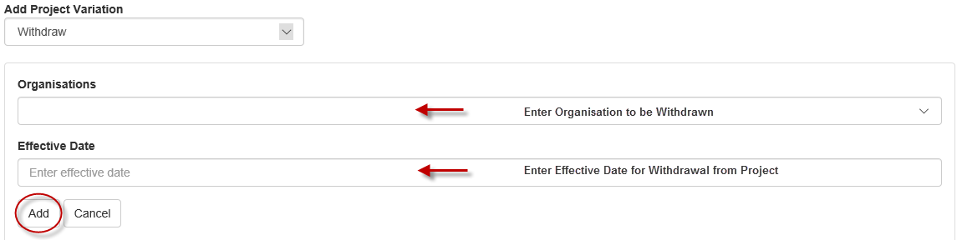

1. Select *Withdraw* from the ‘Organisation’ category within the ‘Add Project Variation’ drop-down.
2. Using the ‘Organisations’ drop-down, select the organisation that you intend to withdraw from the Project.
3. Provide the date that this is to take effect in the ‘Effective Date’ field as per the written agreement by the organisation.
4. Select ‘Add’
5. Provide details of why the organisation is being removed in the Justification box (up to 500 words).
6. Select the ‘Choose File’ button and then press ‘**Upload’** to attach the relevant documentation for the entire request, noting that it can only be one attachment.
7. ‘Save’ and ‘Close’ the request.
8. Check the variation details and submit to the ARC.

Back to Organisation – Withdraw

## Personnel Variations

### Person – Add/Update

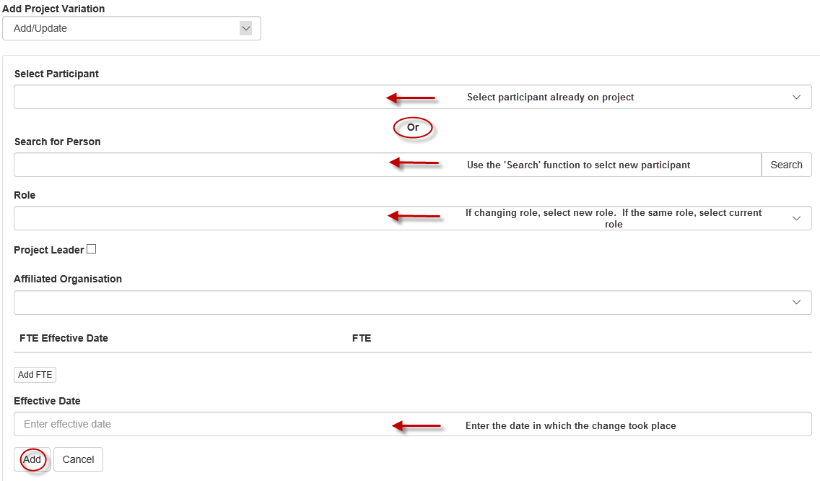

1. Select *Add/Update* from the ‘Person’ category within the ‘Add Project Variation’ drop-down.
2. Using the ‘Select Participant drop-down, select the organisation that you intend on updating on the project. Alternatively, if the person is not already on the project, you may search for their name using the search functions.
3. Select the Participant role from the ‘Role’ drop-down menu.
4. Select the Affiliated Organisation from the ‘Role’ drop-down, relevant to this person’s role on the Project. If the Organisation does not appear, please refer to the ‘Updating Affiliated Organisation’ instructions.
5. Select ‘Add FTE’ and enter the FTE fraction and effective date. Noting that multiple dates may be entered in this field by selecting the ‘Add FTE’ button each time to add in a new FTE fraction, if required. **Note**: The system has a minimum 0.1 FTE. Please add a note in the Justification field if it is lower than this.
6. Provide the date that this is to take effect in the ‘Effective Date’ box. This should reflect the date in which the change took place.
7. Select ‘Add’
8. Provide details on why the person is being added to the project in the Justification box (up to 500 words).
9. Select the ‘Choose File’ button and then press ‘**Upload’** to attach the relevant documentation for the entire request, noting that it can only be one attachment. (Note – documentation is not required for notifying a PDRA/PGR placement)
10. ‘Save’ and ‘Close’ the request.
11. Check the variation details and submit to the ARC.

Back to Person – Add/Update

## Updating an Affiliated Organisation in an investigators RMS profile:

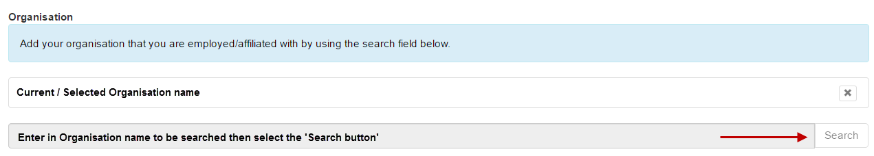

1. Look up the person's profile in RMS, by searching their name under the Mange Users link in the RMS Activity Centre.
2. Once you have selected the person, select the link to Employment History.
3. Select the relevant organisation that you want to edit.
4. Scroll to the bottom of the page and remove the Organisation name from the base of the screen by using the ‘x’ button.
5. Search for the Organisation’s name by typing in the Organisation’s name in the last row and selecting the ‘Search’ button.
6. Once the correct name is found, it can be selected by using the ‘Select’ button.
7. ‘Save’ and ‘Close’ the record. The profile will then be updated and the name will appear in the dropdown menu in the Variation.

**Tip:** If you cannot see the person’s profile, please contact either the researcher or ARC Helpdesk at [ARC-Systems@arc.gov.au](mailto:ARC-Systems@arc.gov.au) to fix this issue.

### Person – Additional Appointments

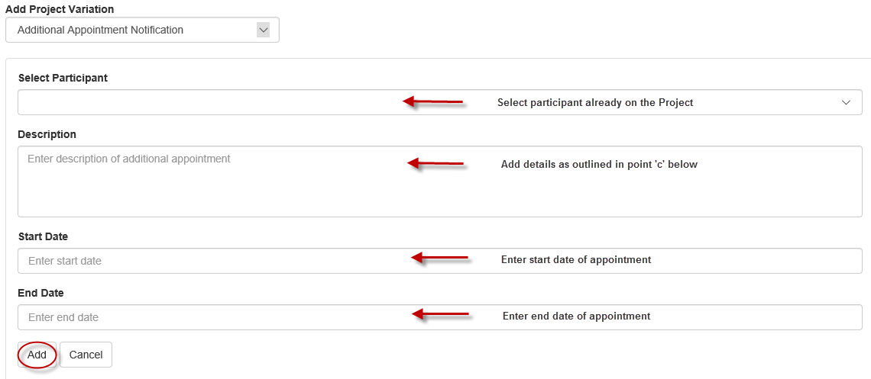

1. Select *Additional Appointment Notification* from the ‘Add Project Variation’ drop-down.
2. Using the ‘Select Participant’ drop-down select the participant for whom is requesting the additional appointment notification.
3. Provide a description of the additional appointment, ensuring that the additional information is provided, where possible:

* What organisation the additional appointment will be located at.
* What activities the participant will engage in.
* How much the participant will be remunerated.
* The new FTE for the Project and Appointment.

1. Enter the intended appointment start and end dates into the appropriate fields.
2. Select ‘Add’
3. Provide details on how this additional appointment will enhance the project in the Justification box (up to 500 words).
4. Documentation is not required for this type of variation, unless requested by the ARC.
5. ‘Save’ and ‘Close’ the request.
6. Check the variation details and submit to the ARC.

**Please note:** the additional appointment start and end dates cannot be entered in RMS outside of the start and end dates of the Project.

Back to Person – Additional Appointments

### Person – Defer Commencement

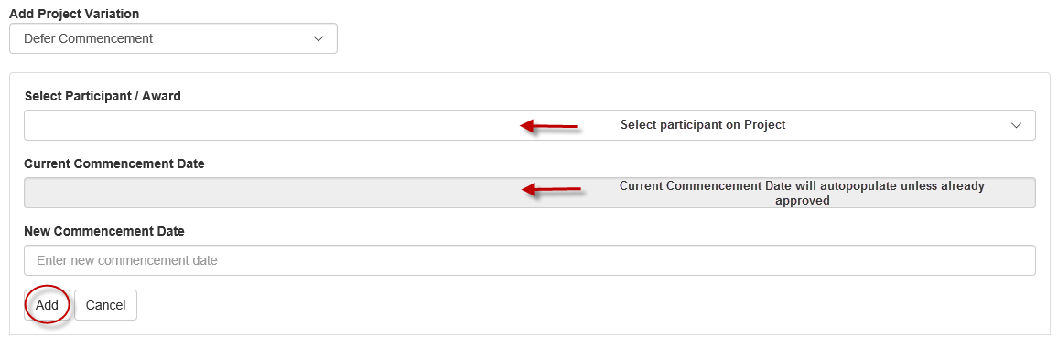

1. Select *Defer Commencement* from the ‘Person’ category within the ‘Add Project Variation’ drop-down.
2. Using the ‘Select Participant/Award’ drop-down select the participant/role for whom you need to defer the commencement.
3. Provide the revised commencement date into the ‘New Commencement Date’ field.
4. Select ‘Add’.
5. Provide details of the deferment in the Justification box (up to 500 words).
6. Documentation is not required for this type of variation, unless requested by the ARC.
7. ‘Save’ and ‘Close’ the request.
8. Check the variation details and submit to the ARC.

Back to Person – Defer Commencement

### Person – Suspension

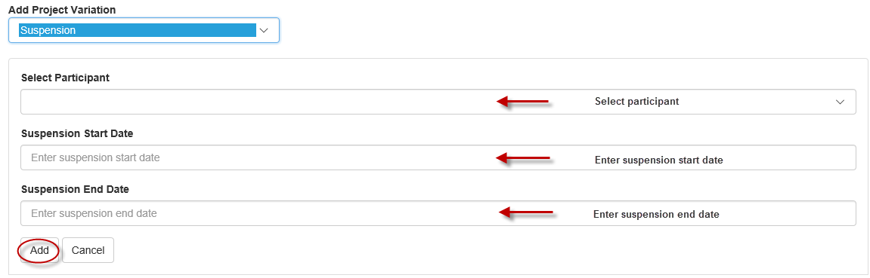

1. Select *Suspension* from the ‘Person’ category within the ‘Add Project Variation’ drop-down.
2. Select the relevant participant from the drop down menu.
3. Enter the intended suspension start and end dates into the appropriate fields.
4. Select ‘Add’.
5. Provide details of the suspension in the Justification box (up to 500 words).
6. Documentation is not required for this type of variation, unless requested by the ARC.
7. ‘Save’ and ‘Close’ the request.
8. Check the variation details and submit to the ARC.

Back to Person – Suspension

### Person – Withdraw

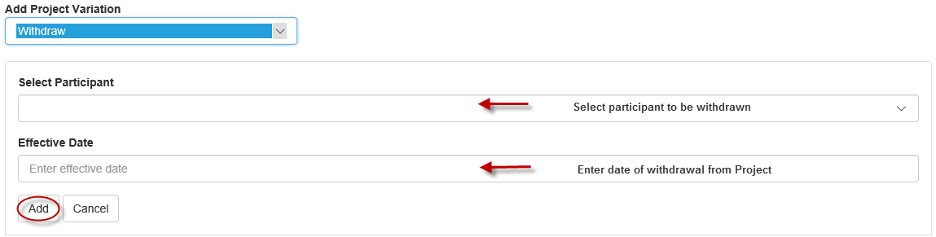

1. Select *Withdraw* from the ‘Person’ category within the ‘Add Project Variation’ drop-down.
2. Using the ‘Select Participant’ drop-down, select the participants that you intend to withdraw from the Project.

Provide the date that this is to take effect in the ‘Effective Date’ field. The effective date should match the date the person is being removed.

1. Select ‘Add’.
2. Provide details of why the person is being withdrawn in the Justification box (up to 500 words).
3. Select the ‘Choose File’ button and then press ‘**Upload’** to attach the relevant documentation for the entire request, noting that it can only be one attachment.
4. ‘Save’ and ‘Close’ the request.
5. Check the variation details and submit to the ARC.

Back to Person – Withdraw

## Project Variations

### Project – Defer Commencement

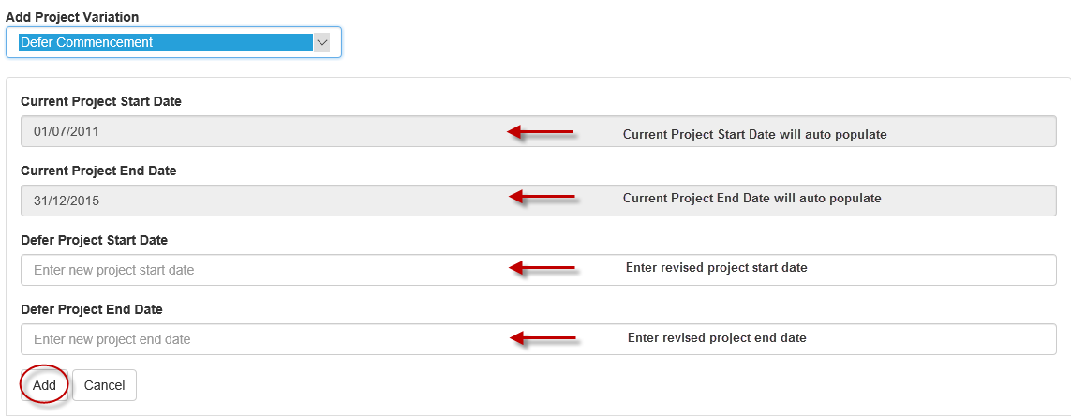

1. Select *Defer Commencement* from the ‘Project’ category of the ‘Add Project Variation’ drop-down.
2. Provide the new start date in the ‘Defer Project Start Date’ field. Provide the new end date in the ‘Defer Project End Date’ field­- ensuring the correct project duration.
3. Select ‘Add’.
4. Provide details on why the project is to be deferred in the Justification box (up to 500 words).
5. Documentation is not required for this type of variation, unless requested by the ARC.
6. ‘Save’ and ‘Close’ the request.
7. Check the variation details and submit to the ARC.

**Please note:** the deferred start date must not be before the intended date of funding commencement, as indicated in the warning text which appears if the dates are entered incorrectly.

Back to Project – Defer Commencement

### Project – End date

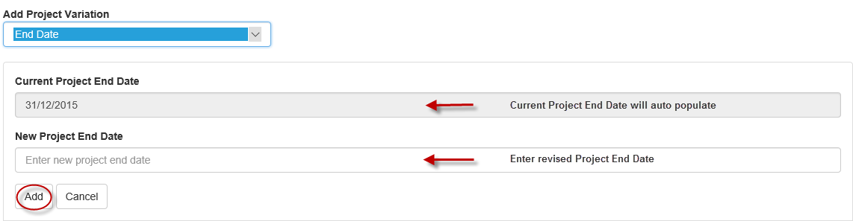

1. Select *End Date* from the ‘Add Project Variation’ drop-down.
2. Provide a revised Project end date in the field provided.
3. Select ‘Add’.
4. Provide details on why the project date is to be changed in the Justification box (up to 500 words).

**If this is for an eligibility reason, please state this in the Justification**.

1. Documentation is not required for this type of variation, unless requested by the ARC.
2. ‘Save’ and ‘Close’ the request.
3. Check the variation details and submit to the ARC.

Please refer to Appendix C for guidance on calculating new End Dates due to FTE changes.

Back to Project – End date

### Project – Full Relinquishment

The year in the variation line will refer to funding year rather than calendar year. For data entry purposes, spending must be reported against funding year rather than calendar year such that a prior year’s funding is exhausted before the following year’s funding can be reported as spent.

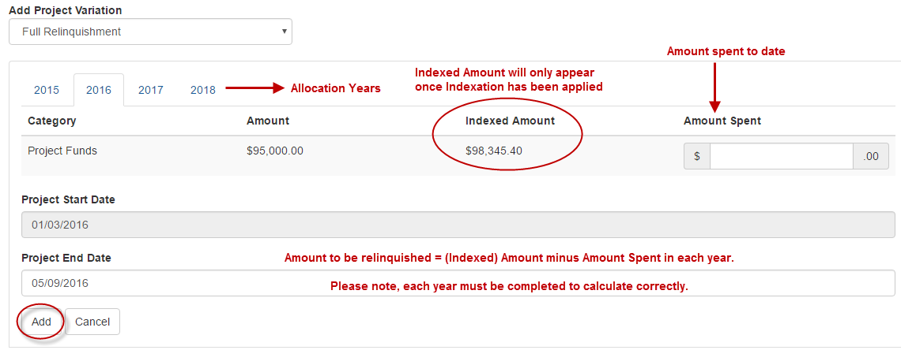

1. Select *Full Relinquishment* from the ‘Add Project Variation’ drop-down.
2. For each year of original allocation, enter the full amount of Project and Salary (if applicable) funding that has been spent to date in the ‘New Amount’ column provided. This Variation type requires that an amount be entered into all ‘New Amount’ fields, for each year. Amount spent for previous years must show as fully expended before moving on to the next year.

**NOTE:** **Amounts are against the funding year not based on actual expenditure as per the EOYR**

1. Provide a revised Project end date in the field provided.
2. Select ‘Add’.
3. Provide details on the relinquishment in the Justification box (up to 500 words).

Also include in the justification what the Administering Organisation has as the Relinquishment amount and give a breakdown of Project Funds and Salary for the period 1/01/YY to the transfer date.

1. Documentation is not required for this type of variation, unless requested by the ARC.
2. ‘Save’ and ‘Close’ the request.
3. Check the variation details and submit to the ARC.

Back to Project – Full Relinquishment

### Project – Partial Relinquishment

The year in the variation line will refer to funding year rather than calendar year. For data entry purposes, spending must be reported against funding year rather than calendar year such that a prior year’s funding is exhausted before the following year’s funding can be reported as spent.

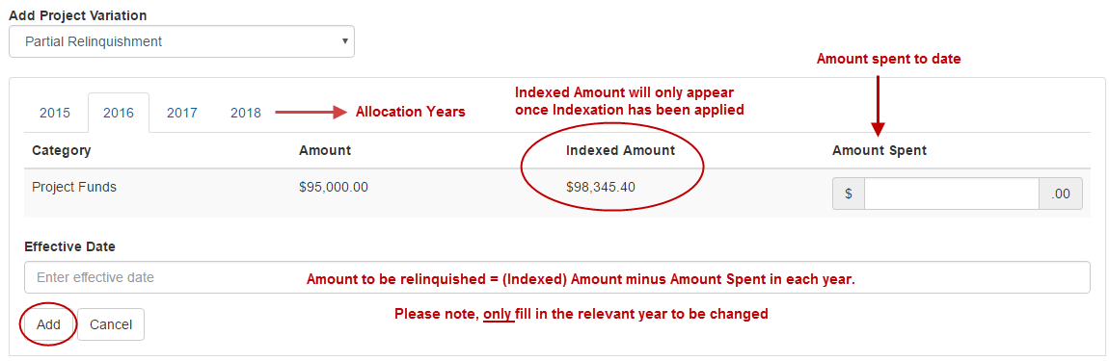

1. Select *Partial* *Relinquishment* from the ‘Add Project Variation’ drop-down.
2. For each year, enter the amount of Project and/or Salary funding that has been spent to date in the ‘New Amount’ column provided.
3. Provide the date that this is to take effect in the ‘Effective Date’ box.
4. Select ‘Add’.
5. Provide details on the relinquishment in the Justification box (up to 500 words).
6. Documentation is not required for this type of variation, unless requested by the ARC.
7. Save and Close the request’.
8. Check the variation details and submit to the ARC.

Back to Project – Partial Relinquishment

### Project – Salary Conversion

The year in the variation line will refer to funding year rather than calendar year. For data entry purposes, spending must be reported against funding year rather than calendar year such that a prior year’s funding is exhausted before the following year’s funding can be reported as spent.

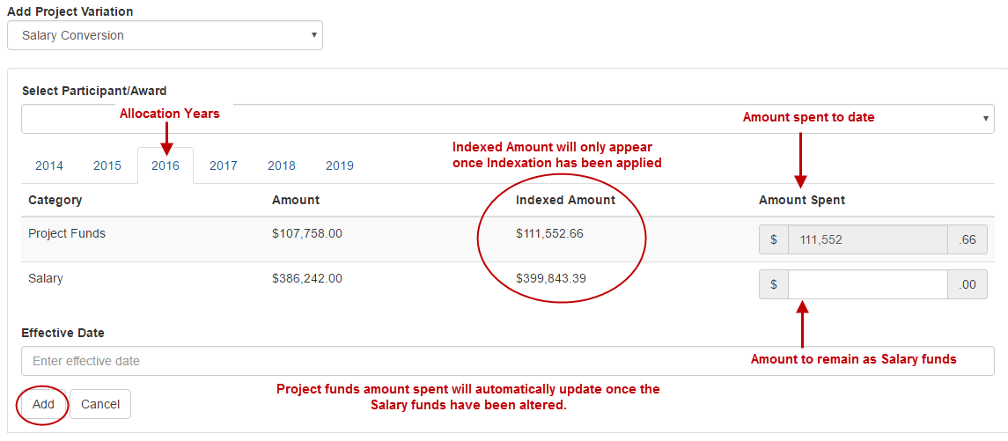

1. Select *Salary Conversion* from the ‘Add Project Variation’ drop-down.
2. Select the participant for which the salary is being converted, from the ‘Select Participant/Award’ drop-down.
3. For each year, calculate the remaining funds that are to be held as Salary, by subtracting the amount to be converted from the Salary ‘Indexed Amount’, as shown in the above example. This will automatically calculate the new ‘Project Funds’ as shown in the above example.
4. Provide the date that this is to take effect in the ‘Effective Date’ box.
5. Select ‘Add’.
6. Provide details on the conversion in the Justification box (up to 500 words).
7. Documentation is not required for this type of variation, unless requested by the ARC.
8. ‘Save’ and ‘Close’ the request.
9. Check the variation details and submit to the ARC.

Back to Project – Salary Conversion

### Project – Salary Relinquishment

The year in the variation line will refer to funding year rather than calendar year. For data entry purposes, spending must be reported against funding year rather than calendar year such that a prior year’s funding is exhausted before the following year’s funding can be reported as spent.

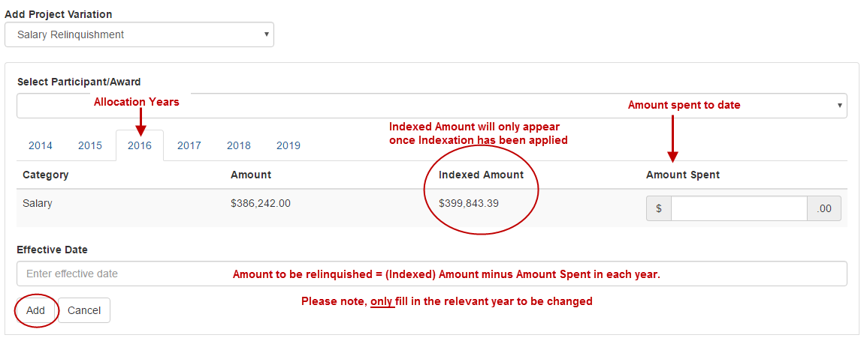

1. Select *Salary Relinquishment* from the ‘Add Project Variation’ drop-down.
2. Select the participant for which the salary is being relinquished, from the ‘Select Participant/Award’ drop-down.
3. For each year, enter the amount of salary funding that has been expended in ‘New Amount’ column provided.
4. Provide the date that this is to take effect in the ‘Effective Date’ box.
5. Select ‘Add’.
6. Provide details of the relinquishment in the Justification box (up to 500 words).
7. Documentation is not required for this type of variation, unless requested by the ARC.
8. ‘Save’ and ‘Close’ the request.
9. Check the variation details and submit to the ARC

**Please note:** the effective date must not fall outside of the start and end dates of the Project.

Back to Project – Salary Relinquishment

### Project – Scope Change

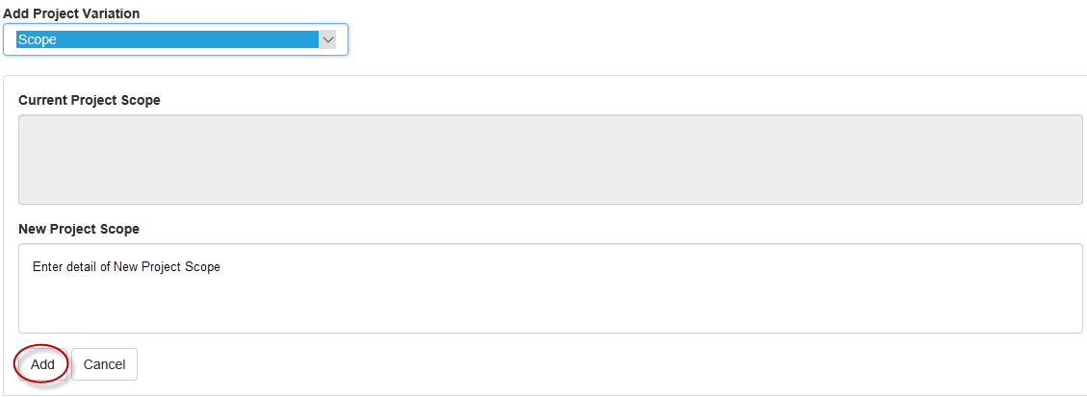

1. Select *Scope* from the ‘Add Project Variation’ drop-down.
2. Provide a revised scope in the ‘New Project Scope’ field provided.
3. Select ‘Add’.
4. Provide details of the scope change in the Justification box (up to 500 words).
5. Documentation is not required for this type of variation, unless requested by the ARC.
6. ‘Save’ and ‘Close’ the request.
7. Check the variation details and submit to the ARC.

**Please note:** Currently the scope changes will not appear anywhere on the project details tab. You will only know if the scope has changed when you are entering in a new Variation.

Back to Project – Scope Change

### Project – Suspension

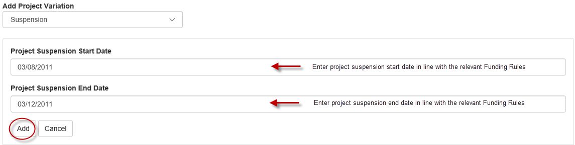

1. Select *Suspension* from the ‘Add Project Variation’ drop-down.
2. Enter the intended suspension start and end dates into the appropriate fields.
3. Select ‘Add’.
4. Provide details of the suspension in the Justification box (up to 500 words).
5. Documentation is not required for this type of variation, unless requested by the ARC.
6. ‘Save’ and ‘Close’ the request.
7. Check the variation details and submit to the ARC

**Please note:** the suspension start date entered must not be outside the start and end dates of the Project. If the suspension results in the Project end date being changed, this will also have to be either added to the Variation request, or requested separately via another Variation.

Back to Project – Suspension

### Project – Transfer

The year in the variation line will refer to funding year rather than calendar year. For data entry purposes, spending must be reported against funding year rather than calendar year such that a prior year’s funding is exhausted before the following year’s funding can be reported as spent.

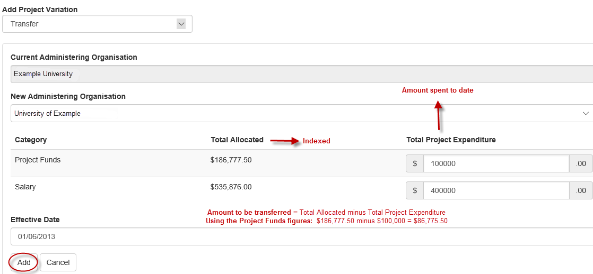

1. Select *Transfer* from the ‘Add Project Variation’ drop-down.
2. Select the Organisation which the Project is being transferred to in the ‘New Administering Organisation’ drop-down.
3. Update or Withdraw the original Administering Organisation, by changing its role or withdrawn it from the Project.
4. Provide the **total Project and/or Salary expenditure to date**, via the ‘Total Project Expenditure’ column. Note, the transfer amount will be calculated by subtracting the reported expenditure from the allocated amount.
5. Provide the date that this is to take effect in the ‘Effective Date’ box.
6. Select ‘Add’.
7. Provide details of the transfer in the Justification box (up to 500 words).

Also include in the justification what the Administering Organisation “has as the transfer amount and give a breakdown of Project Funds and Salary for the 2023 End of Year Reporting period”/”has spent as at the effective transfer date for reconciliation of spend reported to the ARC.”.

1. Select the ‘Choose File’ button and then press ‘**Upload’** to attach the relevant documentation for the entire request, noting that it can only be one attachment.
2. ‘Save’ and ‘Close’ the request.
3. Check the variation details and submit to the ARC.

**Please note:** the ‘transfer’ variation should be listed as the first request and the ‘Add/update Organisation’ or ‘Withdraw Organisation’ variation should be listed second. The arrows on the right side of the screen can be used to change the order of the requests.

Back to Project – Transfer

# **Appendix C – Calculating new End Dates due to FTE changes and suspensions**

The ARC uses a calculator which has been provided to Research Offices to determine new End Dates based on FTE changes and suspensions.

The ARC acknowledges that some Research Offices may calculate End Dates differently and there can be discrepancies due to different calculations. Generally, if the new End Date has a variance of a few days a from the ARC’s calculations, this will be accepted. If there are greater variances, the ARC will contact the Research Office to establish why there is such a difference.

**Tip:** The ARC calculates dates (including effective dates) as inclusive

– – – – – – – – – – – – –