­­

**Progress Report Instructions**

**RMS user guide and Instructions**

*For rounds funded in the following schemes:*

* Centres of Excellence for funding commencing in 2017 - onwards
* Industrial Transformation Research Hubs for funding commencing in 2017 – onwards
* Industrial Transformation Training Centres for funding commencing in 2017 – onwards
* Special Research Initiative Program for funding commencing in 2020 R1

Contents

Progress Reports: Information to note 4

When to submit a Progress Report to the ARC 4

Progress Report Extensions 4

Waiver requests 4

Administration of Progress Reports in RMS 4

Certification and accuracy of information 5

Updating of Progress Report once submitted to the ARC 5

Accessing Reports 6

Starting a Progress Report in RMS 6

Director or COO/BM 6

Research Office Staff 7

Mandatory fields 8

How to add multiple answers and remove answers within questions. 8

Adding and removing multiple answers 8

Adding and removing an option 8

Uploading a file 9

Completing the Progress Reports Form Parts 9

Saving the Report 10

ARC Comments fields 10

Progress Report status 11

Return to Research Office 11

Part A – Project Themes 12

A1 Themes 12

Part B – Themes 13

B1 Theme 13

B2 Theme Review 13

B3 Theme Updates 17

Part C – Governance 18

C1 Governance Plans 18

C2 Personnel Demographics 20

What are gender demographics among Programs personnel? 20

What are gender demographics among student personnel? 20

Part D – Highlights / Case Studies 22

D1 Highlights 22

D2 Case Studies 23

Part E – Partner Contributions 24

Part F – Key Performance Indicators 25

General Key Performance Indicators – Traditional and Non-traditional outputs 26

F1. Number of traditional outputs 26

F2. Non-traditional Research Outputs 26

Centres of Excellence specific Key Performance Indicators 27

F3. Number of workshops/conferences held/offered by the Centre 27

F4. Number of training held/offered by the Centre 27

F5. Number of Postgraduate commenced and completed 28

F6. Number of additional researchers working on Centre research 29

F7. Number of government, industry and business community briefings 29

F8. Number of new organisations collaborating with, or involved in, the Centre 30

F9. Number of female research personnel 30

ITRP Key Performance Indicators 31

F3. Number of visits to the project (>1 week) 31

F4. Number of government, industry and business community briefings 31

F5. Number and nature of commentaries about the project’s achievements 32

F6. Additional funding secured attributable to project’s engagement activities ($) 33

ITRP scheme specific Key Performance Indicators 34

Research Hubs 34

Training Centres 35

Part G – Outreach 36

G1 Describe the Centre's Outreach Strategy 36

G2 Grant Outreach 36

G3 Provide a summary of Program’s Top 10 outreach 37

Part H – Lodgment of Publication 39

Part I – Annual Report 41

Submitting a Form 42

Director or COO/BM 42

Research Office Staff 44

# Progress Reports: Information to note

The Australian Research Council (ARC) requires a Progress Report be submitted for each ARC funded project through the Centres of Excellence (CE), Industry Transformation Research Program (ITRP) and Special Research Initiative Program 2020 Round 1 (SR20 R1) schemes.

These instructions provide information to assist Research Office (RO) staff and Project participants in the completion and submission of ARC Progress Reports in the Research Management System (RMS).

The Director with the assistance of the Chief Operating Officer (COO)/Business Manager (BM) are responsible for the completion of the Progress Report and its submission to the Administering Organisation’s (AO) Research Office. The Director, COO/BM and Research Office staff all have full edit access to the Progress Report. The Research Office Delegate is responsible for the certification of the form and submission of Progress Reports to the ARC.

If, after consulting this document, there are any queries regarding completing the Progress Report form in RMS, please contact the Administering Organisation’s Research Office.

***Please note:*** *Paper copies or any other electronic format of the Progress Report will not be accepted by the ARC.*

When to submit a Progress Report to the ARC

Progress Reports are due to the ARC by 31 March each year. Due to delayed release of Annual/Progress Report in RMS, **2024 reports will be due 30 June 2025**.

Progress Report Extensions

Extensions for Progress Reports must be requested and approved by the ARC via the Administering Organisation’s Research Office. The request must note the Project ID and explain the extenuating circumstances. All requests for extensions must be made in writing to ARC Post Award by emailing [ARC-Postaward@arc.gov.au](mailto:ARC-Postaward@arc.gov.au) before the due date.

***Please note:*** *the ARC will only accept requests for an extension to the Progress Report due date if received from the Research Office of the Administering Organisation. Requests from researchers or other Participating Organisations will not be accepted.*

Waiver requests

If there is a Project that may be eligible for the Progress Report to be waived, email the Administering Organisation’s Research Office with the Project ID and a justification as to why the request is being made. All requests to waive a Progress Report must be made in writing to ARC Post Award by emailing [ARC-Postaward@arc.gov.au](mailto:ARC-Postaward@arc.gov.au) before the due date.

***Please note:*** *The ARC will only consider a waiver request for a full Progress Report will be if the project is still within the establishment phase or within the final six (6) months of the project end date.*

Administration of Progress Reports in RMS

Progress Reports can only be accessed and managed through RMS. For general instructions on how to use RMS, please refer to the [RMS User Guide](http://www.arc.gov.au/rms-information) available on the ARC website.

All requests for RO Delegate access must be made in writing to ARC Post Award by emailing [ARC-Postaward@arc.gov.au](mailto:ARC-Postaward@arc.gov.au).

For any RMS access issues, please contact the ARC RMS Helpdesk at [ARC-Systems@arc.gov.au](mailto:ARC-Systems@arc.gov.au).

***Note:****RMS is compatible with the latest versions of Google Chrome and Microsoft Edge. Compatibility with different browsers or older versions of Google Chrome and Microsoft Edge is not guaranteed.*

Certification and accuracy of information

Progress Reports must be checked and certified by the Research Office Delegate, before they can be submitted to the ARC. The Research Office Delegates is required to certify that the report is complete and that all information provided within the Progress Report is accurate and up to date.

The ‘Submitted to Research Office (Valid)’ state will appear against each Report which is ready to be certified. Once certified, the state of Progress Reports will appear as ‘Research Office Certified’ and can then be submitted to the ARC by Research Office staff.

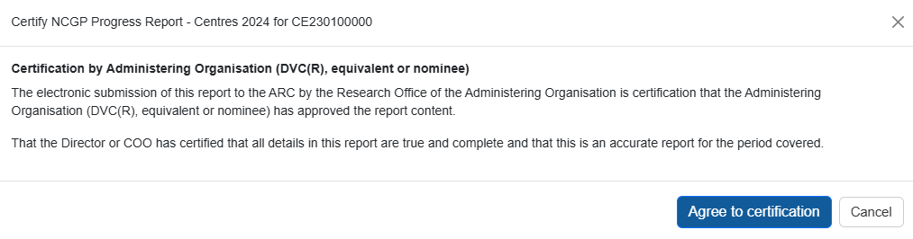The following prompt will appear once the ‘Certify Progress Report’ button has been selected:

***Please note:*** *information collected in the Progress Report is used to determine whether the Project is progressing towards satisfactory completion. Statistical information collected in Progress Reports enables the ARC to account for public funding of research and to promote the value of research to the Australian community. As such, the ARC reserves the right to reject Progress Reports to seek further clarification on information submitted or the lack thereof.*

Please check that all information contained in the Progress Report is accurate and that all required questions are completed as comprehensively as possible.

Updating of Progress Report once submitted to the ARC

If a Director and/or COO/BM needs to edit a Progress Report after submission, Research Offices can request that the Progress Report is de-submitted back to them up until it has been approved by the ARC. Once a report is assessed and approved by the ARC, the ARC will not allow edits to the report.

### Accessing Reports

To access a Progress Report in RMS you must be Research Office (RO) Staff or have an approved role in a project.

Project roles with access to the Progress Report are:

* Centre Director
* Hub Director
* Training Centre Director
* Chief Operating Officer (COO)
  + This role is a system title that captures roles such as Business Manager and COO

Starting a Progress Report in RMS

Director or COO/BM

1. Login to [RMS](https://rms.arc.gov.au/RMS/ActionCentre/Account/Login?ReturnUrl=%2fRMS%2fActionCentre%2f).
2. In the *ARC Applicant Project Management* section of *Action Centre*, click on ‘Project Reports’.

**Searching for and editing Reports**

1. Click the ‘Report’ drop-down and select the relevant form (either ‘NCGP Progress Report – Centres’ or ‘NCGP Progress Report ITRP’ followed by the reporting year)

1. In the filtered search results click ‘Form’ to edit the report for the desired project.

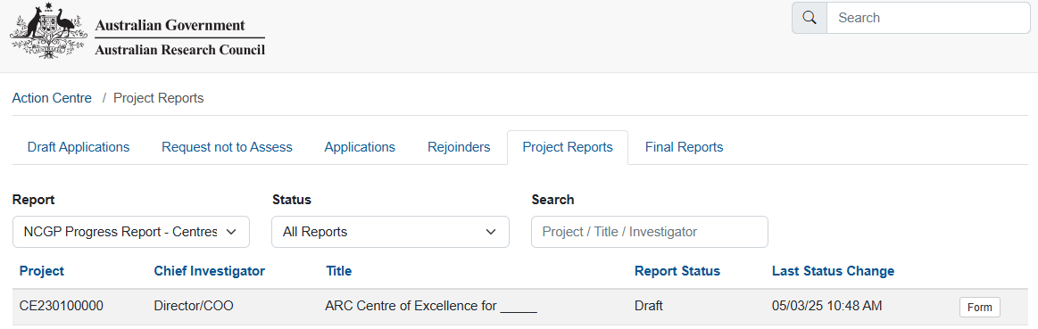

Research Office Staff

1. Login to [RMS](https://rms.arc.gov.au/RMS/ActionCentre/Account/Login?ReturnUrl=%2fRMS%2fActionCentre%2f).
2. In the *ARC Research Office Project Management* section of *Action Centre*, click on ‘Research Office Project Reports’

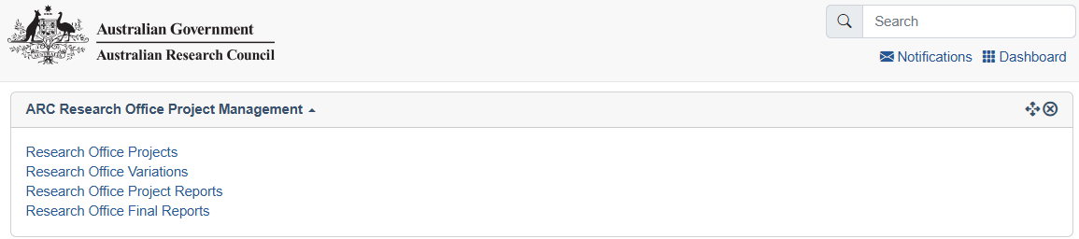

**Searching for and editing Reports**

1. Click the ‘Report’ drop-down and select the relevant form (either ‘NCGP Progress Report – Centres’ or ‘NCGP Progress Report ITRP’. The reporting year is indicated on the name of the form)

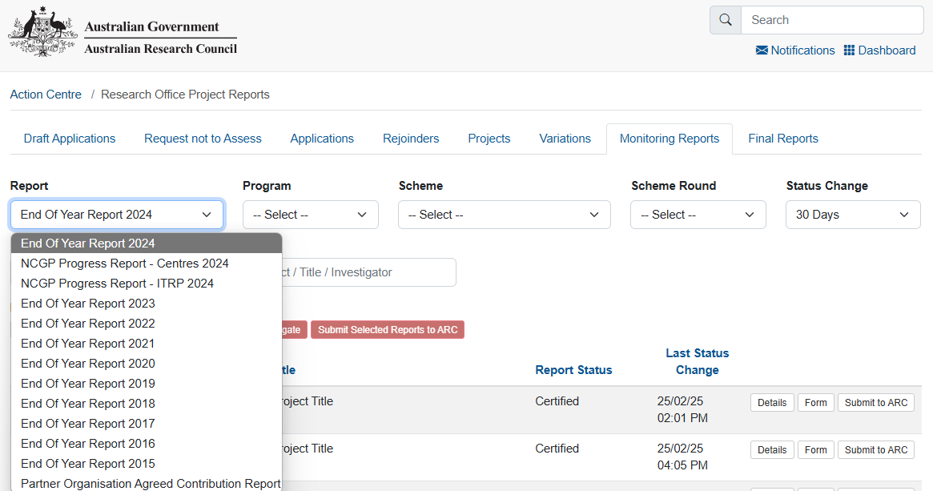

1. In the filtered search results click ‘Form’ to edit the report for the desired project.

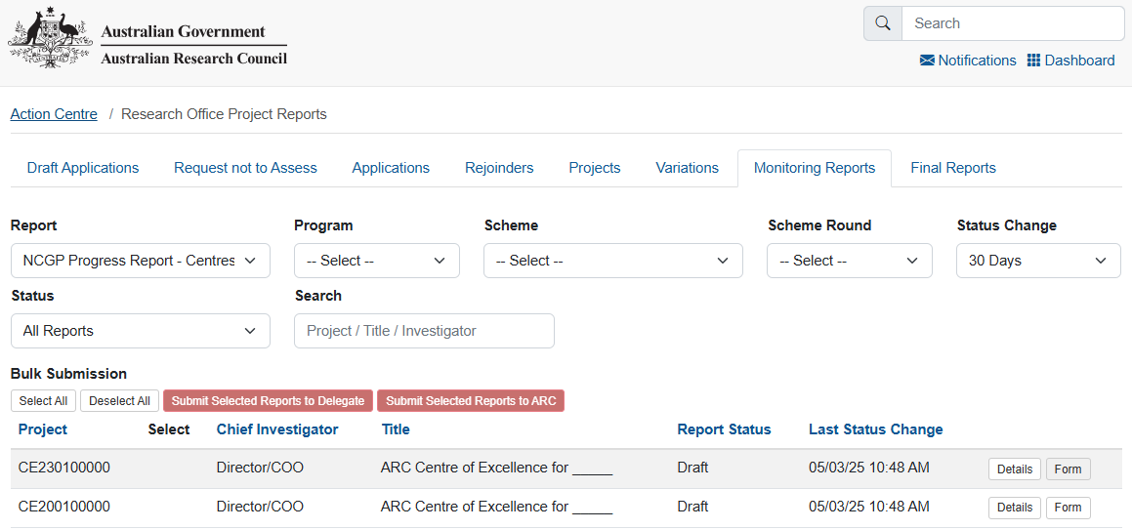

Mandatory fields

Several fields in the Report are mandatory and must be completed before the Progress Report can be certified and submitted to the ARC. The required fields are explained in detail, later in this document.

How to add multiple answers and remove answers within questions.

Adding and removing multiple answers

1. To enter multiple answer panels for a given question, select ‘Add Answer’ at the bottom of the question or the questions answer panel.

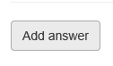

1. To remove an answer panel, select the cross ‘X’ in the top right of the answer panel for the answer that needs to be removed.

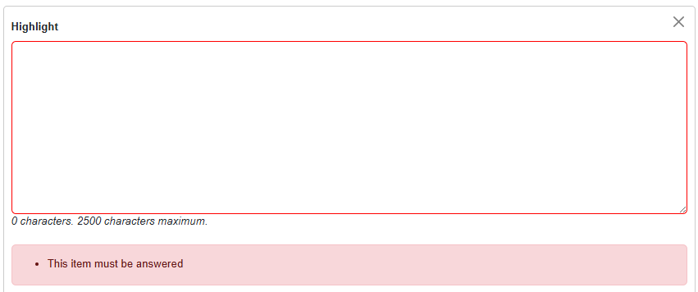

Adding and removing an option

1. To add, select the option from the drop-down menu or ‘search’ function and click ‘Add’.
2. To remove, select the ‘x’ beside the option that needs to be removed.

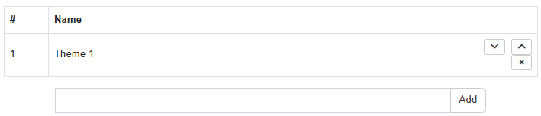

**Please note:** All options can only be added once. Click ‘Add’ otherwise the selection will be lost the next time ‘Save’ is hit.

Uploading a file

1. Click ‘Choose File’ and select a file to upload

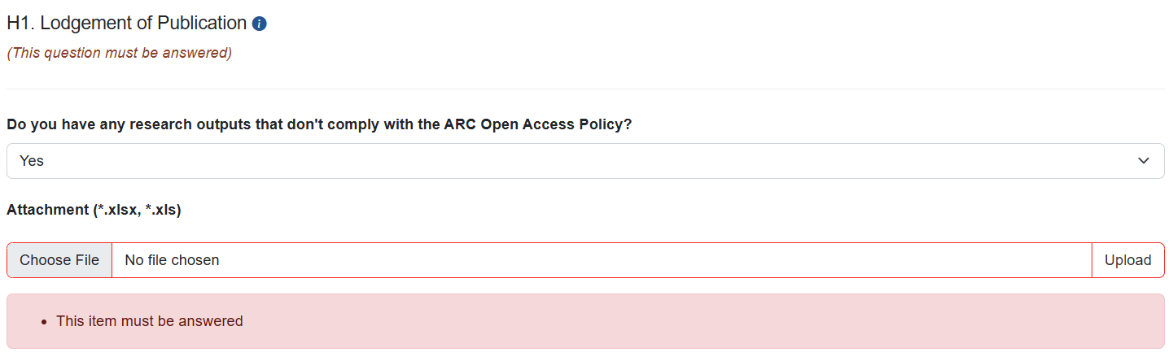

1. Click ‘Upload’ to upload the file

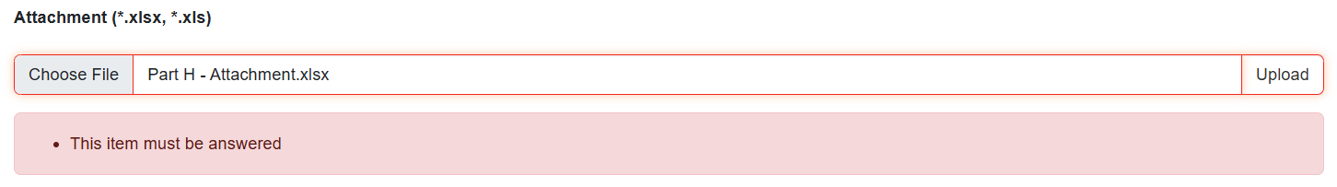

1. Click ‘Save’ at the top right of the page to ensure this is uploaded.

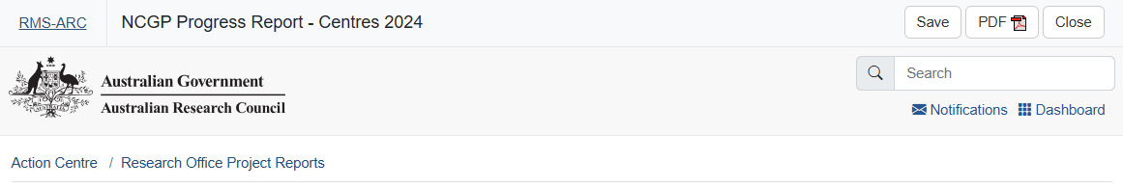

1. When completed correctly the file will appear under the upload field as a downloadable hyperlink.

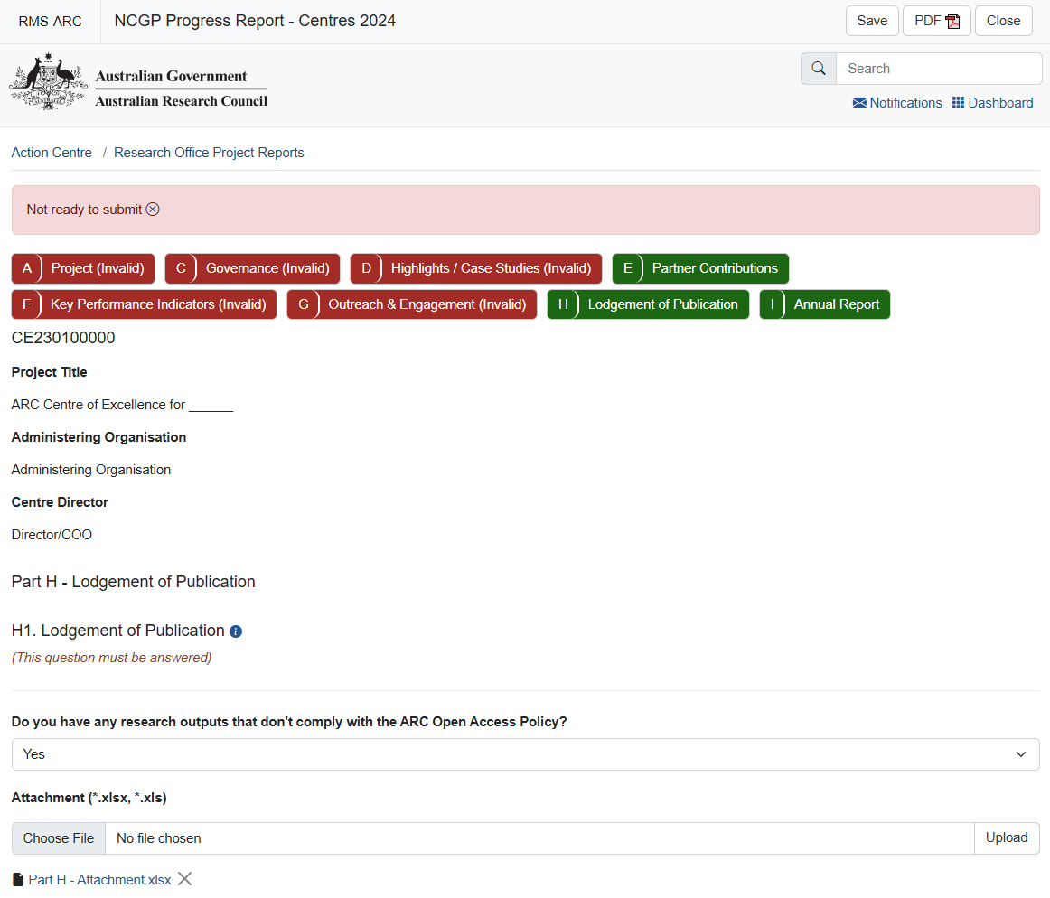

**Removing an upload**

a) Clicking the ‘X’ and saving removes an upload.



b) You may also replace an uploaded document by following the above steps from a) to d). Only one file may be uploaded.

Completing the Progress Reports Form Parts

To begin filling out the Progress Report, click on the relevant form part at the top of the screen to navigate between form parts, beginning with Part A.

**Please note:** Within the heading of the form, the colour of the parts will be indicated as either red – meaning that they are incomplete and therefore invalid; or green – meaning that they are completed and valid.

***Please remember to save regularly as you complete the form, using the ‘Save’ button located at the top right of the page.***

Saving the Report

All changes to the Report must be manually saved (no automatic saving). Should a user attempt to navigate away from the page with unsaved changes, a prompt will appear on the browser. The ‘Save’ button can be found at the top right of the page.



NOTE: Should your browser remain idle for an extended period, RMS will automatically log you out and your work will not be saved. Ensure you save your work on a regular basis.

ARC Comments fields

‘ARC Comments’ fields have been included in each Part of the Progress Report form to enable ARC staff to query any issues and provide instruction on any corrections required prior to approving the Progress Report. Should the Progress Report be returned to the RO, please refer to this section for comments from the ARC.

Progress Report status

The progress of a report through the approval process can be tracked by status, which can be found when accessing a form.

Your view can be filtered based on status, by choosing a status from the ‘Status’ drop-down.

The status and their meanings are as follows:

|  |  |
| --- | --- |
| **Status type** | **Explanation** |
| **Draft** | Either nothing has been entered, or not all mandatory fields have been completed |
| **Ready to Submit** | All mandatory information has been entered, and the Progress Report is ready to be submitted to the RO |
| **Returned to Research Office** | The ARC has returned the Progress Report to the RO to be amended |
| **Submitted to RO Delegate** | The Progress Report has been submitted to the RO Delegate and is waiting to be certified |
| **Certified** | The RO Delegate has certified the Progress Report, and it is now ready to be submitted to the ARC |
| **Resubmitted to ARC** | The Progress Report has been resubmitted to the ARC and is ready to be reassessed |
| **Submitted to ARC** | The Progress Report has been submitted to the ARC and is ready to be assessed |
| **Accepted** | The ARC has assessed and accepted the Progress Report |
| **Waived** | The ARC has waived the requirement for this Progress Report |

Return to Research Office

There is no notification or automated email system in RMS for these Progress Reports. ARC Post Award will email the project Director and RO advising of a Report’s desubmission and the resubmission due date. The email indicated in RMS will be used to notify the project Director.

# Part A – Project Themes

Enter the name of each Theme associated with this grant (as per your application and/or approved variation by ARC). Each Theme entered will create a new form part in Part B for this reporting period.

Theme names cannot be edited, ensure they are typed correctly when creating. A Theme will need to be deleted to update the name, therefore any information entered in Part B will be lost.

Your project application may have called a Theme a:

* Research Program
* Project
* Core Project
* Centre Theme
* Workstream

For the purpose of completing this section of the Progress Report, these terms are interchangeable.

## A1 Themes

1. Add a Theme by entering the theme name in the text field and clicking the ‘Add’ button.



*A minimum of 1 Theme is required*

Once a Theme is added, it will be included in Part B drop-down selection at the top of the page.

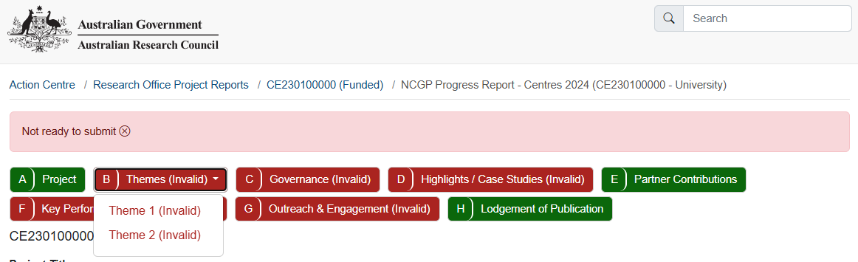

Once all Themes are added, you may continue to Part B – Themes.

# Part B – Themes

This section captures information related to the progress of Themes over the reporting period. New Themes may be reported and justified to meet scheme and funding objectives. For each entry in Part A, set questions in Part B will need to be answered. Use the drop-down to select a Theme and respond to the questions.



## B1 Theme

***Theme Name***

This section is auto-populated from responses in Part A.

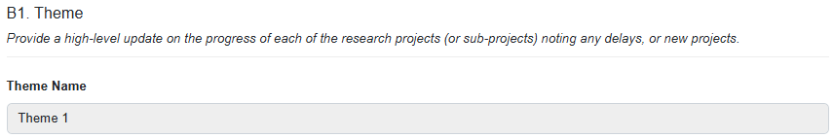

## B2 Theme Review

***Was this Theme listed in your application?*** *(Mandatory)*

1. Select “Yes” or “No” from the drop-down box.

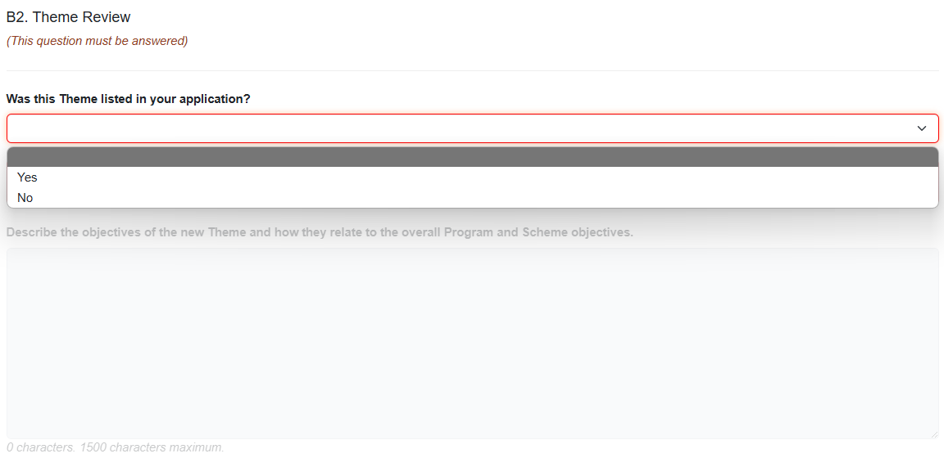

***If ‘No’***

* 1. Describe the objectives of the new Theme and how they relate to the overall Program and Scheme objectives.

A Theme that is not listed in the original application must describe its relation to Program and Scheme Objectives.

* 1. Select “Yes” or “No” from the drop-down menu of ***Has this theme been approved through a formal variation?***

**Please note:** On acceptance of the Progress Report the ARC Comments section will advise if a variation will be required to be submitted, or if it has been accepted as part of the acceptance of the Progress Report.

* 1. A screenshot of a computer

     AI-generated content may be incorrect.Indicate the status of the Theme in relation to the delivery of the Program.

The progress of delivery of a Theme is reported using a stop-light system:

|  |  |
| --- | --- |
| Status | Stop light |
| On track | Green light |
| Delayed | Yellow light |
| At risk | Red light |
| Completed | n/a |

Where a Theme is identified as ‘Delayed’ or ‘At risk’, further information is required to be provided in question B3.

A Theme that is identified as ‘On track’ or ‘Completed’ can save the progress on the form before continuing to Part C – Governance.

***If ‘Yes’ to*** ***‘Was this Theme listed in your application?’***

Click the drop-down and respond Yes or No to *‘****Is this Theme still applicable to this grant?****’*

***If ‘No’***

* 1. **A screenshot of a computer

     AI-generated content may be incorrect.**Explain why the Theme is no longer part of the Program in the following text box.
  2. Save the progress on the report before proceeding to Part C – Governance.

***If ‘Yes’ to ‘Is this Theme still applicable to this grant?’***

* 1. Indicate the status of the Theme in relation to the delivery of the PrograA screenshot of a computer

     AI-generated content may be incorrect.m.

The progress of delivery of a Theme is reported using a stop-light system:

|  |  |
| --- | --- |
| Status | Stop light |
| On track | Green light |
| Delayed | Yellow light |
| At risk | Red light |
| Completed | n/a |

Where a Theme is identified as ‘Delayed’ or ‘At risk’, further information is required to be provided in question B3.

A Theme that is identified as ‘On track’ or ‘Completed’ can continue to other questions on the form. Ensure to save the progress on the report before continuing to Part C – Governance.

## B3 Theme Updates

***Describe the changes and/or issues. Why were they important to the Program?***

This section is required if a Theme is ‘Delayed’ or ‘At risk’ in B2.

1. Click ‘Add answer’

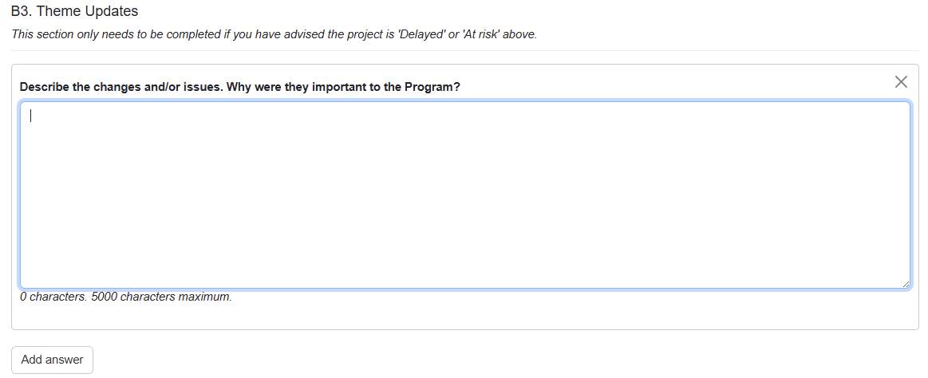

***Describe the changes and/or issues. Why were they important to the Program***



For issues and risks, include any mitigation strategies implemented and provide a self-assessment of the effectiveness of these strategies in managing the issue.

Multiple issues/changes may be identified for a single Theme and described individually using the ‘Add Answer’ button to add additional text boxes. Mitigation strategies and a self-assessment on effectiveness may be provided.

Where the status of a Theme is either ‘On track’ or ‘Completed’, the ARC does not need to be notified of any issues or risks, and this section will be greyed out.

Once this is completed, ensure you are save the form before continuing to Part C – Governance.

**ARC Comment section**

An ARC comment may be used to advise whether a scope change variation would be required for any ‘new’ Themes.

New themes that have not been requested in a formal variation will have a comment here from the ARC stating whether a formal variation is required.

# Part C – Governance

Once a project has commenced, we expect that the governance, policies and procedures required by the grant agreement are in place. This section is used to notify the ARC of any reviews and changes. There is no requirement to provide copies of these documents as part of the Progress Report.

As part of the ARC Grant Agreement, all CE/ITRP Programs are required to have strong governance, policies and procedures in place from the commencement of the Program. These governance, policies and procedures are to be reviewed on a regular basis.

At any stage, the ARC may request to see any, or all of your governance, policies or procedure documents relating to the ARC Grant Agreement.

## C1 Governance Plans

***Have you completed any reviews of your governance, policies or procedures during the reporting period?***

1. Respond ‘Yes’ or ‘No’ from the drop-down box.

1. Select which of the following have been reviewed by clicking on the adjacent checkbox:

* Operational Plan
* Strategic Plan
* Structure & Governance Plan
* Gender Equality & Diversity Plan
* Mentoring & Professional Development Plan(s)
* Translation Plan
* Data Management Plan
* Budget Plan
* Advisory Committees Structure(s)
* Other

When selecting ‘Other’ please state what governance, policy or procedure has been reviewed.

1. Click the drop-down and respond Yes or No to **“Have any governance, policies or procedures been updated?”**

***If ‘Yes’***

* 1. Select which of the following have been updated by clicking on the adjacent checkbox:
  + Operational Plan
  + Strategic Plan
  + Structure & Governance Plan
  + Gender Equality & Diversity Plan
  + Mentoring & Professional Development Plan(s)
  + Translation Plan
  + Data Management Plan
  + Budget Plan
  + Advisory Committees Structure(s)
  + Other
  1. When selecting ‘Other’ please state what governance, policy or procedure has been reviewed.

***If ‘No’***

There is no requirement to report updates to governance, policy or procedure.

For example, this may occur when a review has been undertaken for a policy however it was found that it is still applicable, and no updates were made.

***If ‘No’ to “Have you completed any reviews of your governance, policies or procedures during the reporting period?”***

When a project is already established and has commenced, we expect that plans and policies required by the agreements are in place. Where no reviews have taken place, there is no requirement to report an update implemented in the reporting period.

There is no requirement to provide copies of these documents as part of the Progress Report.

## C2 Personnel Demographics

Since 2016*, the ARC has collected data on researchers who identify as Female, Male, Indeterminate/Intersex, or Unspecified.

The matrix should reflect the Full Time Equivalent program personnel across the reporting period.

Complete the table using FTE figures. Up to 2 decimal places may be entered. You may estimate the total FTE.

### What are gender demographics among Programs personnel?

Programs personnel are personnel employed and working to support activity of the project including contractors, full and part time employees.

Where personnel have changed roles through the year, report them against the role they performed majority of their duties as during the reporting period. Please provide detail in the Additional Comments section.

### What are gender demographics among student personnel?

Where students have advanced their level of study (e.g. completed undergrad and commenced honours) through the year, report them against the highest degree during the reporting period.

**How many of Program personnel, to your knowledge, would identify as Culturally or Linguistically Diverse?**

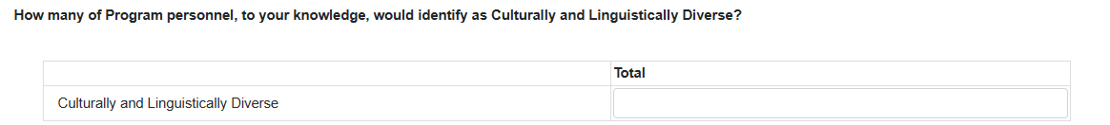

This question is not tied to an FTE. Please provide the head count of personnel who would identify as culturally or linguistically diverse.

Ensure to save your progress on this form before proceeding to Part D – Highlights / Case Studies.

# Part D – Highlights / Case Studies

A highlight may be a story of a success or unintended positive impact by the Project. This could include anything from PhD completions, researcher promotion, research awards, project recognition, onboarding a new partner.

A case study is defined for this report as an example of the project having a demonstrable benefit. Anything from commercialising a product or process; making a significant scientific discovery; achieving a societal benefit; providing evidence to inform government policy; improving economic outcomes for industry; etc.

An Executive Summary must be provided for each case study provided to the ARC which may be used in the ARC Annual Report and/or media releases.

Highlights and case studies are mandatory for all Centres of Excellence projects. With highlights being mandatory and case studies optional for all ITRP and SRI projects.

Centres of Excellence must provide at least 1 highlight and at least 2 case studies in this section.

Although ITRP or SRI projects are not required to provide a case study. Please consider the option as an opportunity to present the impact of the research through the reporting period.

**TIP:** Ensure to save this form frequently so that your progress is not lost.

## D1 Highlights

1. Click ‘Add answer’ to show the text box needed to complete this section.

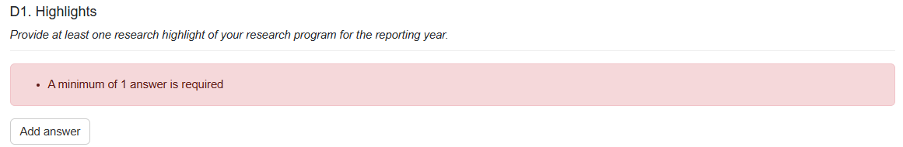

1. A PDF may be uploaded as supporting documentation. See instructions for uploading above.

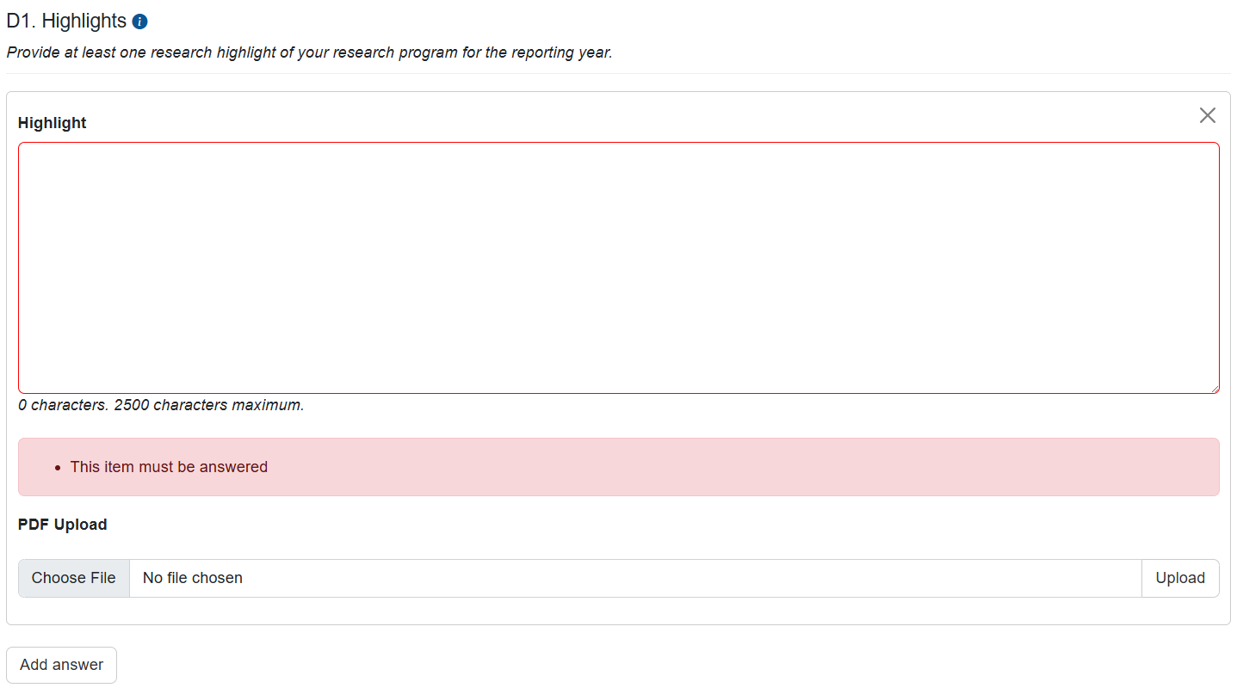

## D2 Case Studies

1. Click ‘Add answer’ to show the text boxes required to complete this section

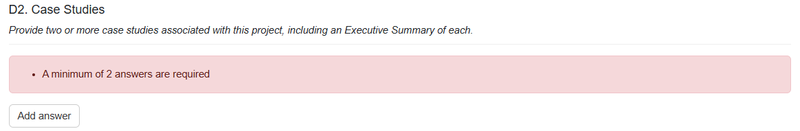

1. A PDF of a case study may be provided as supporting documentation. See instructions for uploading above. A screenshot of a computer

   AI-generated content may be incorrect.

Centres of Excellence’s must provide 2 or more case studies associated with this project, including an Executive Summary of each. Until 2 Executive Summaries have been provided, this section will flag as invalid.

Your full case study can be uploaded, or you can provide a URL link. See instructions for uploading above.

Describe how your project was involved in your examples.

The ‘Executive Summary’ should not be a copy paste of text from the attached case study.

# Part E – Partner Contributions

Your RO will be familiar with a Partner Organisation Agreement Contribution Report (POCAR), if you have any questions regarding this section, please contact your RO.

POACR’s refer to the original funded years rather than calendar year. Funds should be entered against the year the activity is intended to take place regardless of periods of deferred commencements or suspensions. Should additional contributions be provided after the original funding years, they may be entered into the last year of the table.

If your Partner Contributions require updating, please report in the ‘Updated Contributions’ table. Acceptance of the Progress Report will update the project POACR.

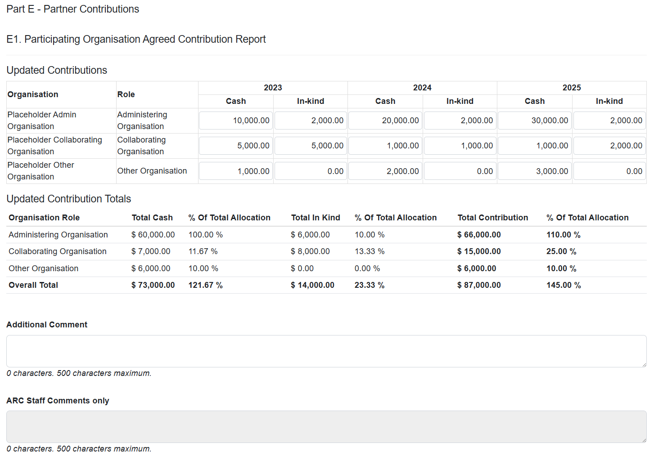

Current Organisational Contributions are displayed at the bottom of the page.

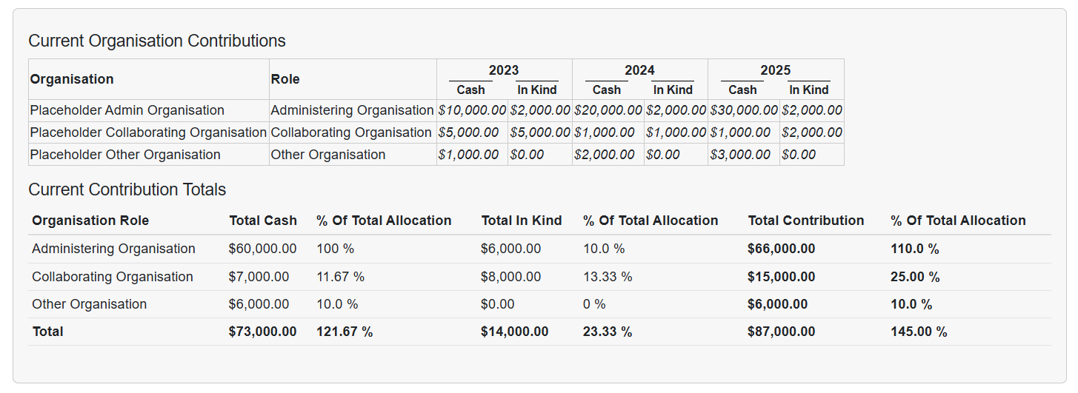

Ensure to save this form frequently so that your progress is not lost.

# Part F – Key Performance Indicators

Key Performance Indicators (KPIs) are a set of quantifiable measures that are used to monitor and provide indicative progress of research outcomes.

Common KPI measures have been identified and included in the Progress Report form.

Where KPI measures have previously been approved by the ARC:

* Approved KPIs that are not in Part F and included in the published Annual Report provided in Part I require an Additional Comment prompting ARC to check the published Annual Report.
* Approved KPIs that are not in Part F should be reported in the Additional Comment section.
* A target from an approved KPI that has not been met must be indicated in the Additional Comment section.
* A target from an approved KPI that has been exceeded does not require additional comment to indicate it has been met.
* Where a KPI is included in the form but not part of the Project’s approved KPIs, these are not assessed. You must enter a 0 and indicate these were not included in approved KPIs in the ‘Additional Comment’ section. See screenshots provided for each section for more information.

Qualitative measures should be provided in the Additional Comment section to provide context to quantitative measures in the category.

All tables are mandatory and only accept positive integers and will automatically remove characters that are not numbers (e.g. spaces, commas).

**TIP:** Ensure to save this form frequently so that your progress is not lost.

See below, screenshots for example responses.

## General Key Performance Indicators – Traditional and Non-traditional outputs

The number of outputs would be expected to increase over time and should reflect the body of work being developed. The types of outputs can be discipline and industry and/or other sector relevant and be of the highest quality.

The quality of research outputs may be quantified through a variety of measures including impact factors, peer review of outputs, citation analysis, and awards or prizes (if applicable).

Qualitative measures should be indicated in as an Additional Comment.

### F1. Number of traditional outputs

### F2. Non-traditional Research Outputs

## Centres of Excellence specific Key Performance Indicators

### F3. Number of workshops/conferences held/offered by the Centre

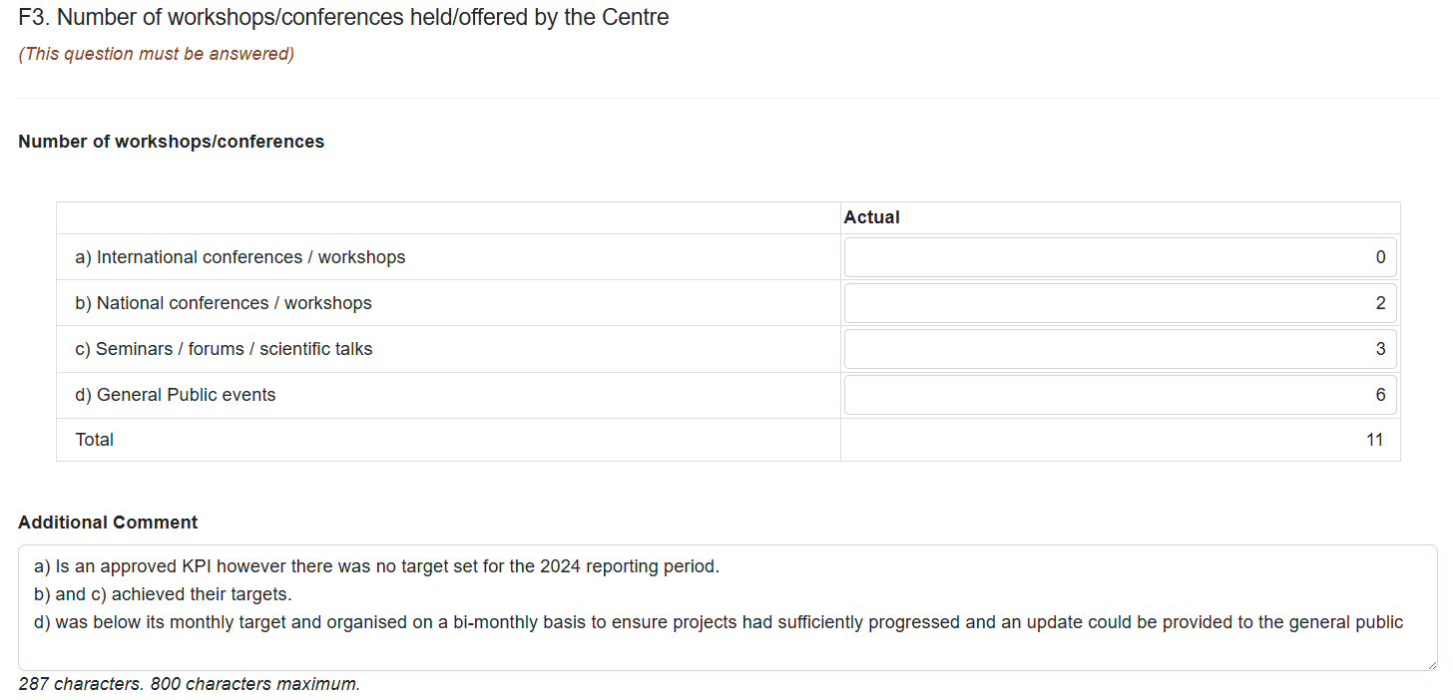

### F4. Number of training held/offered by the Centre

Training courses listed here should be over and above the standard professional development courses offered by participating institutions. The training should directly relate to the operation and objectives of the Centre and align with future workforce skills requirements.

### F5. Number of Postgraduate commenced and completed

These measures should report commencements and completions in 2024 only.

All students are expected to complete within the duration of the Centre. Acknowledging a general timeframe of 3.5 years for completion of a PhD, completions are not normally anticipated in the first three years of the Centre.

1. **Number of Postgraduate commenced** A screenshot of a computer

   AI-generated content may be incorrect.
2. **Number of Postgraduate completed**

### F6. Number of additional researchers working on Centre research

This refers to the number of research personnel recruited each year and should include all Centre research personnel who are not participating as a CI or PI. Students listed should be supervised by Centre researchers.

### F7. Number of government, industry and business community briefings

These targets demonstrate the Centre’s level of engagement with external stakeholders and the public, and ability to message the Centre’s research ideas. The ARC expects students/trainees to be involved in public talks. A screenshot of a computer

### F8. Number of new organisations collaborating with, or involved in, the Centre

Centres are expected to leverage new partnerships throughout the duration of the grant. Include the number of new Participating Organisations, as well as organisations with which the Centre establishes a new collaborative relationship. A screenshot of a computer

### 

### F9. Number of female research personnel

Provide the current number of female research personnel at the Centre.

## ITRP Key Performance Indicators

### F3. Number of visits to the project (>1 week)

This KPI will provide a measurement of the significant visits to the Investment. These visits can result from inviting a person(s) to attend or requests to visit the. This category does not include short visits, for example attending a single event such as a launch, presentation, or a mentoring session. However, if their stay for these events is extended to participate in research activities for one week or greater, this can be included. A screenshot of a computer

F4. Number of government, industry and business community briefings

The targets in this category are intended to demonstrate the level of engagement with external stakeholders and decision makers. The ARC expects that all students and Postdoctoral Fellows have opportunities to be involved in public talks. The targets in this category should be additional to the targets listed for workshops/conferences, and can include both invitations to speak at events, as well as - hosted events. A screenshot of a computer

### F5. Number and nature of commentaries about the project’s achievements

The ARC expects the Research Hub or Training Centre to appear as a separate entity within the Administering Organisation. This includes promoting research outcomes and events through its own website, social media, and articles. This KPI provides a measurement on how the Research Hub or Training Centre is raising its profile. A media release is defined as a factual based statement that informs people about an event, research outcome or other happenings. Social media examples include Twitter, Facebook, Instagram, and LinkedIn. Measurements of social media can include retweets, followers, or likes. Articles can include news stories, interviews, or bulletins.

### F6. Additional funding secured attributable to project’s engagement activities ($)

This category demonstrates that the Training Centre or Research Hub is providing a good return on investment. This is important for planning beyond the ARC funding of the Research Hub or Training Centre. This category can include additional funding secured above the commitments of the original Partner Organisations as listed in the application, or as additional funding secured from new partners (cash or in-kind commitments). However, the latter is not the sole measure of success and new Partner Organisations should be carefully considered against the remit of the research program.

Discuss Part E – Partner Contributions with your central Research Office to determine if a revised Contribution report can be included as part of the Progress Report and to reflect the response to *a) Additional contributions from Partner Organisation*.

Where revised contributions have previously been accepted by the ARC *a) Additional contributions from Partner Organisation*

## ITRP scheme specific Key Performance Indicators

## Research Hubs

### Number of mentoring programs (formal/informal) that Research Hub participants and staff are engaged with

This category includes formal and informal mentoring programs. Where possible, each student or postdoctoral fellow should have both an academic and industry mentor throughout the funding period. Please note that a mentor is additional to a supervisor. Mentoring programs listed should involve experienced personnel as mentors. Mentees may be Research Hub participants at any career stage. Programs listed can include Research Hub development/ leadership/ induction programs for Research Hub researchers, students, postdoctoral researchers, new staff, external stakeholders, end-users etc. Programs should include all personnel (including the Director).

### Number of postdoctoral fellows placed in Partner Organisations

This category demonstrates how the Research Hub will ensure ARC funded postdoctoral fellows will be integrated into the research program and involved with Partner Organisations over the life of the project. It is expected that there will be opportunities for postdoctoral fellows to be placed with Partner Organisations.

### Number of Higher Degree Researcher (HDR) students placed in Partner Organisations

This category demonstrates how the Research Hub will ensure ARC funded HDR students will be integrated into the research program and involved with Partner Organisations over the life of the project. It is expected that there will be opportunities for HDR students to be placed with Partner Organisations.

## Training Centres

### Number of Industry Centre Higher Degree Research (ICHDR) postgraduate students enrolled at the Training Centre

This category should include the number of ICHDRs funded by the ARC and should demonstrate how the Training Centre will ensure ARC funded ICHDR students will be integrated into the research program over the life of the project.

### Number of Industry Centre Postdoctoral (ICPD)s enrolled at the Training Centre

This category should include the number of ICPDs funded by the ARC and should demonstrate how the Training Centre will ensure ARC funded postdoctoral fellows will be integrated into the research program over the life of the project.

### Number of placements to Partner Organisations

The ARC encourages all ARC funded ICHDRs and ICPDs to spend considerable time conducting research outside of the higher education sector with a Partner Organisation (i.e., a year or more over the life of the project). Indicate whether the number of postdoctoral fellows who will be placed in Partner Organisations are either full-time or part-time per year. If the number is zero, please indicate this. The arrangements can be listed as a block of time or an FTE commitment.

### Number of professional short courses/workshops programs attended by Training Centre participants and staff.

Some examples are:

• Engaging with media

• Public speaking

• How to write a grant application, applying for a job and interview training.

• Gender equality and diversity

• Cultural awareness and ethics training

The ARC expects that Training Centres actively participate in several professional development courses, beyond what is offered at the university. Indicate the number of professional short courses/workshop programs that are available for Training Centre participants and staff.

Once Part F is completed for an ITRP or SRI, the form is complete and all parts are valid, the report may be submitted (See Submitting a Form).

# Part G – Outreach

**CE only**

## G1 Describe the Centre's Outreach Strategy

Where unchanged from previous years and/or has been previously provided to the ARC or stated as part of the ‘Glossy’ Annual Report, it may be copy/pasted here.

## G2 Grant Outreach

1. Provide total number of outreach activities conducted by the Centre in reporting period.

## G3 Provide a summary of Program’s Top 10 outreach

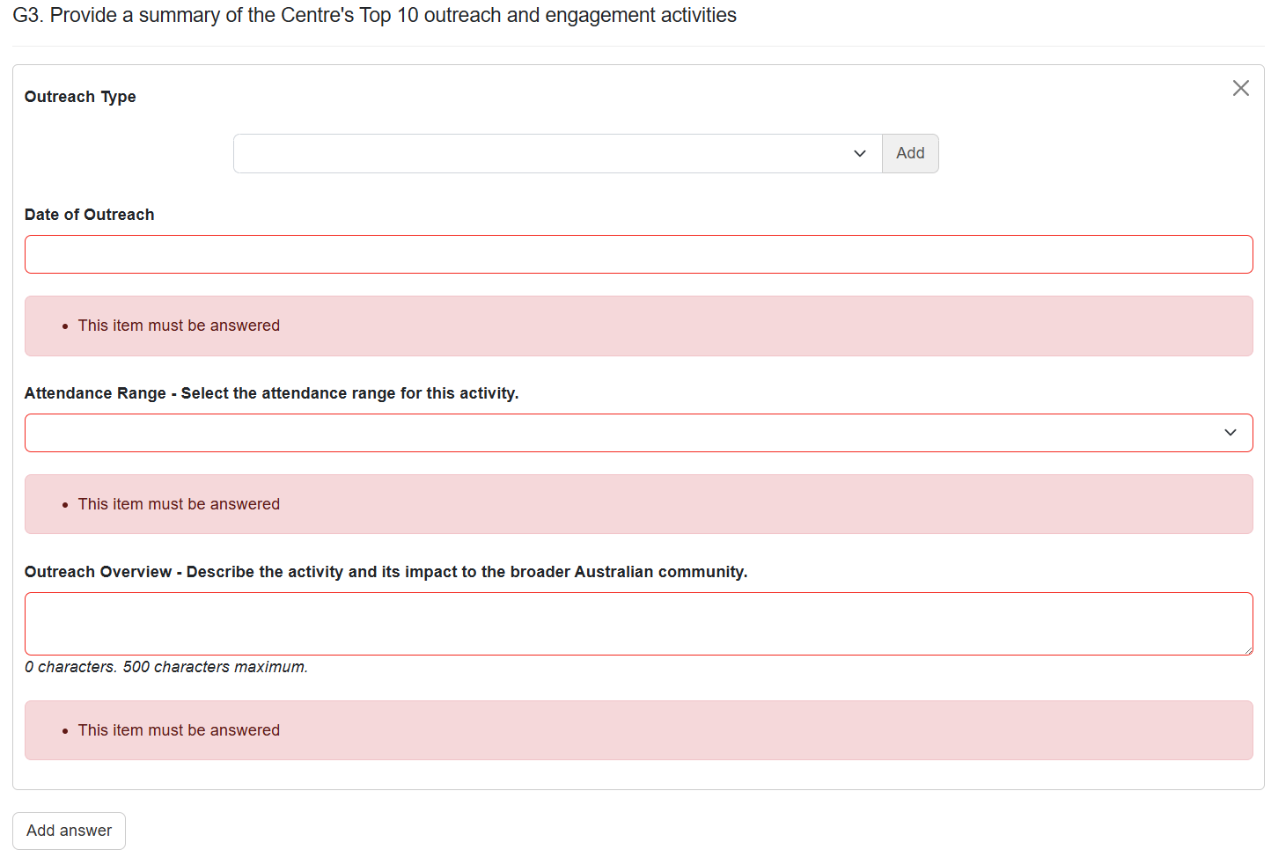

1. Click ‘Add answer’ to add a response to an outreach activity. Click ‘Add answer’ multiple times to provide the required number of summaries.

When there are less than 10 outreach activities completed in the reporting period, all activities must complete a summary.

No more than 10 activities can be described in this section.

**Outreach Type**

Multiple types may be attributed to an activity. The following may be selected:

* Conference
* Congress
* Forum
* Mentoring
* Round Table
* Scientific talks
* Seminar
* Summit
* Symposium
* Training
* Visitors
* Workshop

1. Select the activity type and click ‘Add’.
2. Repeat as required, adding types where an activity has multiple types that are suitable

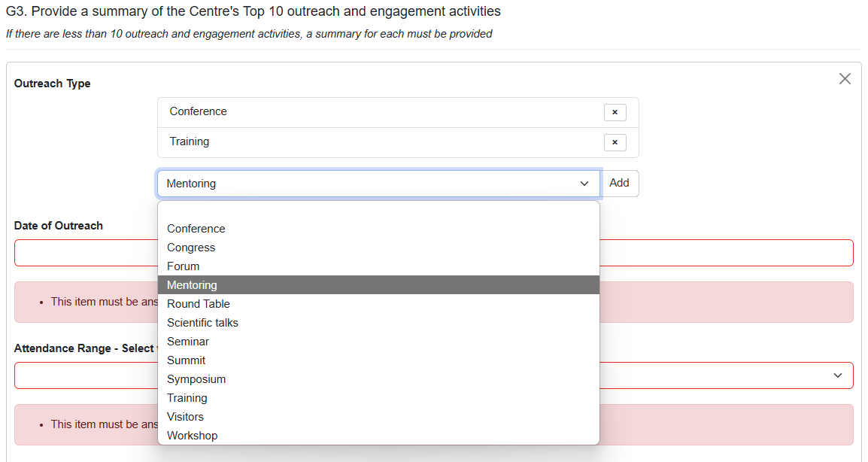

1. Click ‘X’ to remove a type that is not required.

**Date of Outreach**

You may only select dates in the 2024 calendar year.

**Attendance Range**

The following ranges may be selected:

* <25
* 26-50
* 51-75
* 76-100
* 101-150
* 151-200
* 201-300
* >300

**Outreach Overview**

Describe the activity and its impact to the broader Australian community.

# Part H – Lodgment of Publication

**CE only**

ARC Open Access Policy applies to all Research Outputs that come from ARC Funded Research, and their Metadata. Any Research Outputs arising from an ARC research project must be made accessible within 12 months from the date of publication.

Provide a list of publications (with justification) as to why they are not compliant with ARC Open Access Policy as an attachment below.

Note: The template for non-lodgement is provided on the ARC website and available here: [Annual Reporting Responsibilities of ARC Centres of Excellence](https://www.arc.gov.au/manage-your-grant/annual-reporting-responsibilities-arc-centres-excellence).

You may also click the ‘i’ under the question header to reveal a link to the same webpage above.

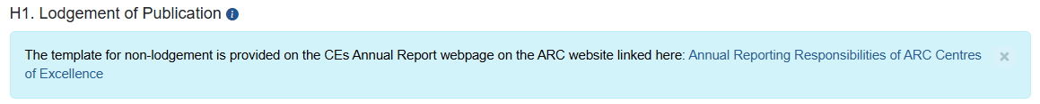

1. Click the drop-down to respond Yes or No to “Do you have any research outputs that don’t comply with the ARC Open Access Policy?”

**For a response of ‘Yes’**

1. Click ‘Choose File’ and select a file to upload A screenshot of a computer

   AI-generated content may be incorrect.
2. Click ‘Upload’ to upload the file.

1. Click ‘Save’ at the top right of the page to ensure this is uploaded.



1. When done correctly the file will appear as a downloadable hyperlink.



# Part I – Annual Report

**CE only**

ARC Grant Agreement requires each CE to produce an Annual Report. Please provide a link or upload a copy of your Annual Report for this reporting period.

When the Annual Report is publicly available on you Centre’s website, a link to the Annual Report may be provided here.

# Submitting a Form

When all parts of the form are Green, the Report is ready to be submitted to the research office and its status will update to ‘Ready to Submit’.

Director or COO/BM

1. Login to [RMS](https://rms.arc.gov.au/RMS/ActionCentre/Account/Login?ReturnUrl=%2fRMS%2fActionCentre%2f).
2. In the *ARC Applicant Project Management* section of *Action Centre*, click on ‘Project Reports’.

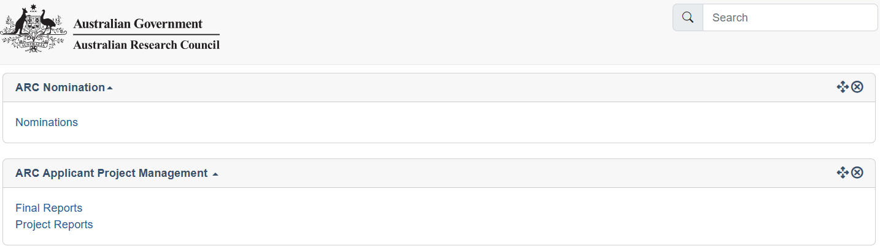

1. Click the ‘Report’ drop-down and select the relevant form (either ‘NCGP Progress Report – Centres’ or ‘NCGP Progress Report ITRP’ followed by the reporting year)

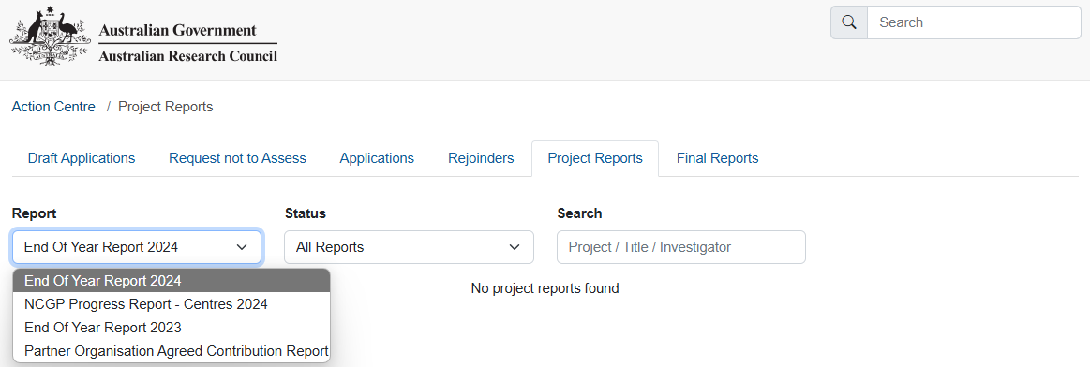

1. In the filtered search results click ‘Submit to RO’ to edit the report for the desired project.

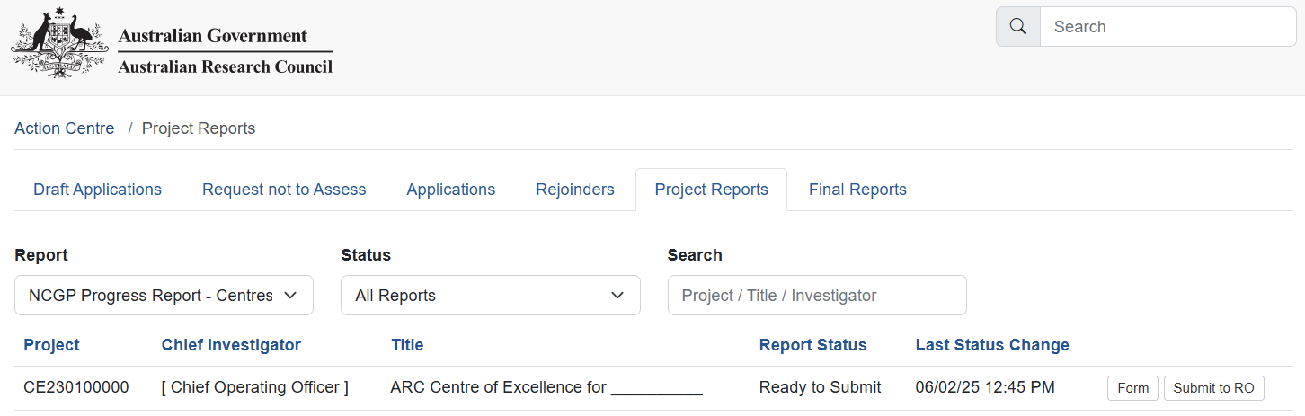

1. Click ‘Submit to RO’ in the following prompt to submit the report to your Research Office

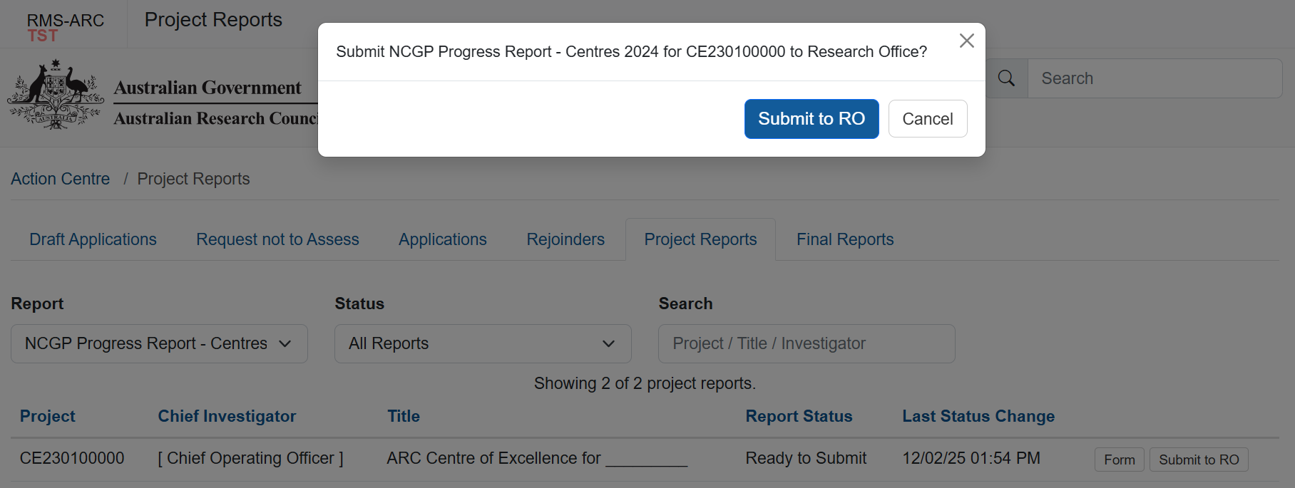

Once submitted to research office, the status will update to ‘Submitted to Research Office’.

Research Office Staff

1. Login to [RMS](https://rms.arc.gov.au/RMS/ActionCentre/Account/Login?ReturnUrl=%2fRMS%2fActionCentre%2f).
2. In the *ARC Research Office Project Management* section of *Action Centre*, click on ‘Research Office Project Reports’



**Searching for and editing Reports**

1. Click the ‘Report’ drop-down and select the relevant form (either ‘NCGP Progress Report – Centres’ or ‘NCGP Progress Report ITRP’. The reporting year is indicated on the name of the form)



1. In the filtered search results click ‘Submit to RO Delegate’ to send the report to the RO Delegate for Certification.

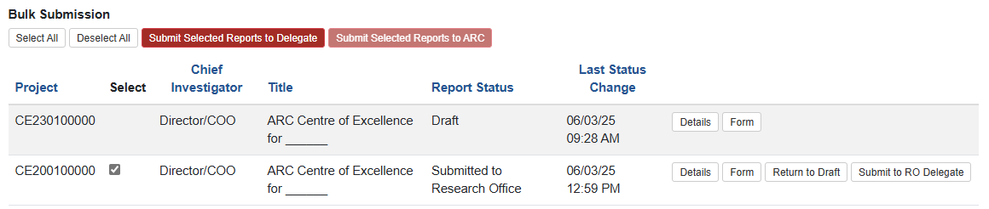

You may use the ‘Select All’ and ‘Submit Selected Reports to Delegate’ buttons to bulk submit forms that are ready to be certified by the RO Delegate. These forms will have a status of ‘Submitted to Research Office’

You may also select individually using the check box against the project code.

1. Click through the prompts to send to the RO Delegate.

**Prompt when submitting individually**.

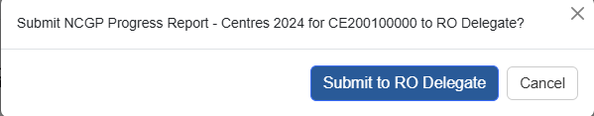

**Prompt when submitting using the bulk submit function**.

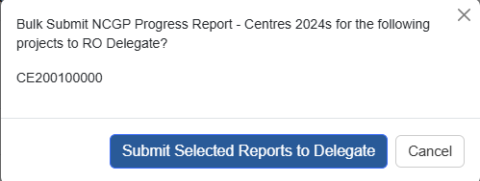

**Certifying as RO Delegate**

1. Login to [RMS](https://rms.arc.gov.au/RMS/ActionCentre/Account/Login?ReturnUrl=%2fRMS%2fActionCentre%2f).
2. In the *ARC Research Office Project Management* section of *Action Centre*, click on ‘Research Office Project Reports’



**Searching for and editing Reports**

1. Click the ‘Report’ drop-down and select the relevant form (either ‘NCGP Progress Report – Centres’ or ‘NCGP Progress Report ITRP’. The reporting year is indicated on the name of the form)



1. In the filtered search results click ‘Submit to RO Delegate’ to send the report to the RO Delegate for Certification.

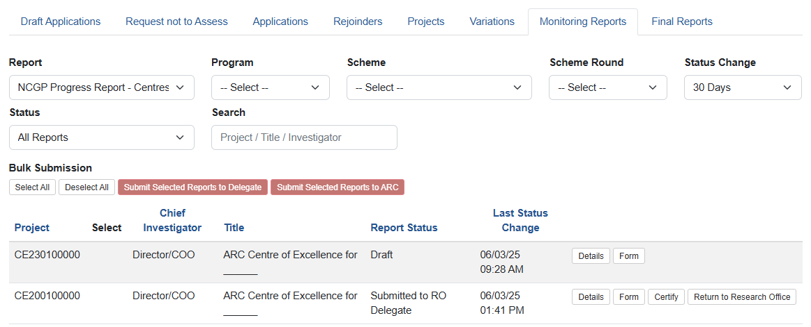

Bulk certification is unavailable.

1. Click through the prompts to Agree to certification.



1. Once certified, the Progress Report can be submitted to the ARC. Follow the prompts to submit the form to the ARC.

You may use the ‘Select All’ and ‘Submit Selected Reports to ARC’ buttons to bulk submit forms that have a status of ‘Certified’.

You may also select individually using the check box against the project code.

**Prompt when submitting individually**.

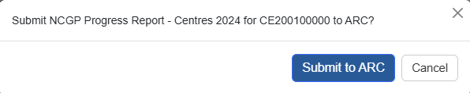

**Prompt when submitting using the bulk submit function**.

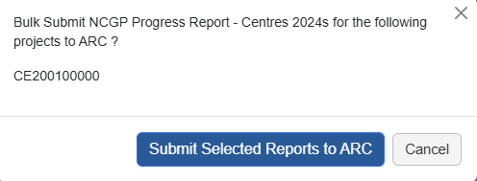

Once submitted to the ARC, the Report’s status will update to ‘Submitted to ARC’.

