# RMS: How to use Grant Agreement functionality

## Introduction

This is a guide for Research Office Signatories on how to use the Grant Agreement functionality within the Australian Research Council’s Research (ARC) Management System (RMS).

Grant Agreements and Grant Offers will be provided to Research Offices through RMS. The Grant Agreement and Grant Offers will then be accepted through RMS by a user with the role type, Research Office Signatory. The Grant Agreement and Grant Offers will then be accepted by an ARC Delegate and the associated projects will be created for payment of funding.

Use your email address and password to login to [RMS](https://rms.arc.gov.au/). If you don’t have a user account, contact members of your university’s research office.

RMS is compatible with the latest versions of Google Chrome and Microsoft Edge. The ARC cannot guarantee compatibility with other browsers or older versions of Google Chrome or Microsoft Edge.

## Terminology

**Grant Agreement**means the agreement entered into by the ARC and an Administering Organisation when an Application from that organisation is approved for funding. Accepting the Grant Agreement in RMS accepts the terms and conditions set out within the Agreement, it does not accept the Grant Offers made against it.

**Grant Offer** means the offer of funding made against an individual project. Grant Offers are accepted on a project level and cannot be accepted until the overarching Grant Agreement has been accepted by a Research Office Signatory.

**Deed of Variation** means there has been a change to the original Grant Agreement that was accepted via RMS during the original announcement period and new clauses need to be accepted for a scheme and/or project to continue.

# PART 1—Research Office (RO) Signatory

Grant Agreements and Grant Offers can be viewed by any user within your organisation with RO Staff access. However, to accept the Grant Agreement and Grant Offers, a user from your organisation, who has the authority to enter into an agreement with the ARC, must be given RO Signatory access. Only a user with RO Signatory access can accept the Grant Agreement and Grant Offers within RMS.

# PART 2— New Project Announcement Instructions

## 2.1—Accessing the Grant Agreement

* Login to [RMS](https://rms.arc.gov.au/)
* Enter your email address and your password. Click on the login button.
* Click on Grant Offers under the Announcement Management section of the RMS Action Centre.

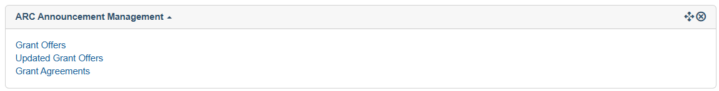

**Figure 1 – Grant Offers link under Announcement Management**

* From the drop-down options, select either the Scheme Round or Pending from the State Filter for which Grant Agreement you wish to view.



* The history of Grant Agreements for that scheme round will appear.

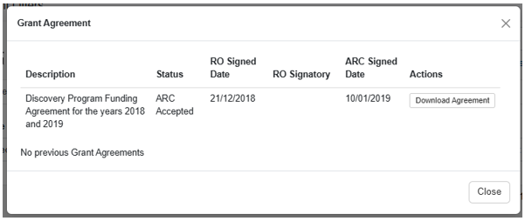

* Before accepting the agreement, click on Download Agreement to download a Microsoft Word version of the Grant Agreement for your review.

**Figure 2 – Grant Offers screen for a scheme round**

## 2.2—Accepting the Grant Agreement and Grant Offers

* Once you have read the Grant Agreement and agree to the conditions set out within it, accept the Grant Agreement by clicking on the Accept button.

**Figure 3 – Grant Agreement acceptance button**

* A screenshot of a message

  AI-generated content may be incorrect.Upon clicking this button, the following message will appear:

**Figure 4 – Grant Agreement Acceptance Message**

* Click OK to Accept the Grant Agreement.
* Once the Grant Agreement has been accepted, a list of projects will appear with the Grant Offer state appearing as Pending under Grant Offers.

**Figure 5 – Grant Offers List**

* If you wish to view additional information on a given project, click on the Details button to open the Project Details screen for that project.
* To accept the Grant offer for all projects, click on Mark all as Accepted button.
* To accept the Grant offer for a single project, select the Accept check box.
* To decline the Grant offer for a single project, select the Decline check box. When declining a project, you will be required to enter a reason for declining.

**NOTE:**Grant Offers should only be declined if the project is not going to be accepted by any organisation. Projects that will immediately be transferred to another organisation should be accepted prior to submitting a Variation to the Grant Agreement through the ARC’s Post Award team.

* Once all the check boxes have been selected, click on the Submit Selected button.
* The Grant Agreement and Grant Offers will subsequently be accepted by the ARC and the ARC’s Post Award team will arrange payments.

# Deeds of Variation Instructions

Due to the way Deeds of Variations are created, the order in which the document is executed changes slightly.

## 3.1—Accessing the Deeds of Variation

* Login to [RMS](https://rms.arc.gov.au/)
* Enter your email address and your password. Click on the login button.
* Click on Grant Agreements under the Announcement Management section of the RMS Action Centre.



* Click History under Scheme Rounds

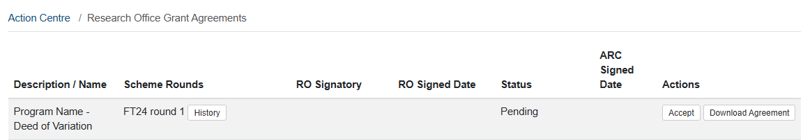

**History** allows a user to download a copy of the previous and updated agreements. You will also be able to view the RO signatory for previous versions and updated versions (once the updated version is signed by the RO signatory).

* Before accepting the agreement, click on Download Agreement to download a Microsoft Word version of the Grant Agreement for your review

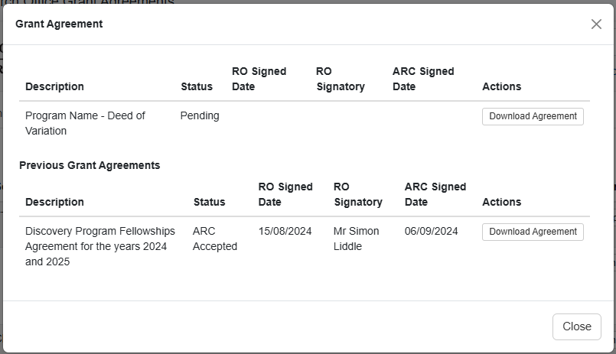

* Click Close.



## 3.2—Accepting the Deed of Variation

* Once you have read the Deed of Variation and agree to the conditions set out within it, accept the Deed of Variation by clicking on the Accept button.



* Click OK to Accept the Deed of Variation.

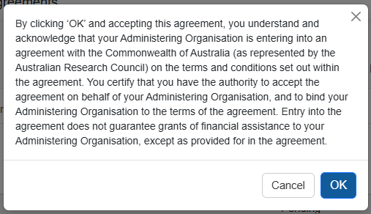

* Once accepted, the status will update to ‘Research Office Accepted’.

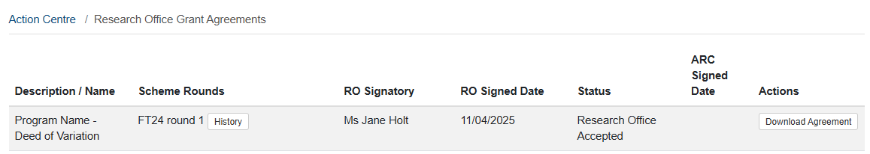

* Clicking ‘History’ will display the RO signatory, the RO signed date and will display the date signed by the ARC (once signed by the ARC).

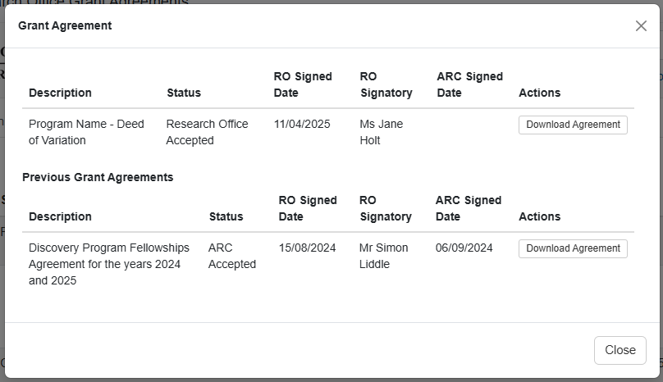

* You will be required to reaccept all projects that are listed under the original Grant Agreement and subsequent Deeds of Variation. Complete the same process as Figure 5.