# How to complete the Assurance Questionnaire

1. Log into RMS
2. Navigate to ARC Process Management
3. Select [Organisation Tasks]

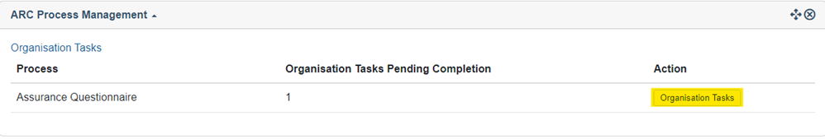

1. Select [Complete Form]. The Assurance Questionnaire will open for the Admin Organisation to complete.

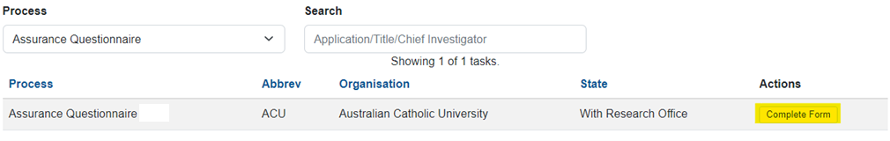

1. Submit to [RO Delegate]

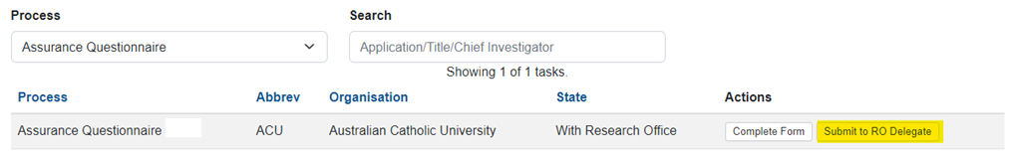

1. The RO Delegate will then [Certify and Submit to ARC]. This completes the Assurance Questionnaire for that Admin Organisation. Noting that the RO Delegate can return it to the Research Office if changes are required to the form prior to submitting to the ARC.

1. Once submitted you can access the completed form by following steps 1-2 then click “View” button.