**How to access and interpret your scores and assessment feedback**

**Why is the ARC releasing scores and assessment to all applicants for all NCGP schemes?**

The ARC trialled the release of assessor scores and rankings to unsuccessful applicants with the Industry Fellowship Program schemes in April and May 2023. This aimed to provide applicants with useful feedback to identify areas for improvement in future applications. Following positive feedback from the sector about the value of receiving such information, the ARC has made the decision to release the scores, rankings and assessments from peer review to all applicants for all NGCP schemes announced from March 2024.

1. **I was an applicant to a National Competitive Grant Program (NCGP) scheme.   
   How do I access my scores?**

Assessment scores, rankings and detailed assessments are available to eligible applicants for all NCGP schemes when funding outcomes are announced.

To access your assessment scores and feedback:

* Log into RMS
* Navigate to ‘'Applications’

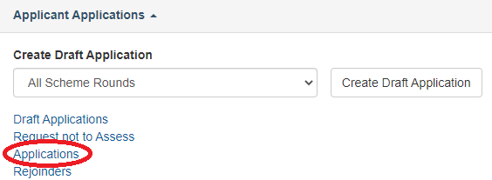

* Select the relevant Scheme Round from the ‘Scheme Round’ drop down box

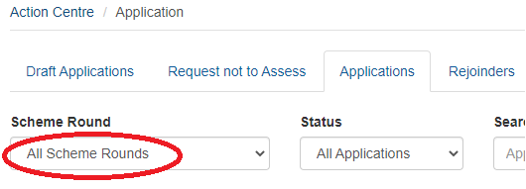

* Click on ‘Details’ for the relevant application

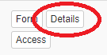

* Select the ‘Feedback’ tab



1. **Who can access the assessment scores and feedback?**

All participants on an eligible application can view their assessment scores and rankings in RMS. Research Offices will also be able to view this information.

1. **How do I interpret the assessment scores and rankings?**

The following glossary will help you to understand your assessment scores and feedback:

|  |  |
| --- | --- |
| **Term** | **Meaning** |
| Application Panel | This refers to the discipline panel for the application. For most schemes there are 4 to 5 discipline panels. For schemes that have a single multidisciplinary panel this will be indicated as ‘Combined’. |
| Application Panel Rank | This refers to the initial rank of the application in the Selection Meeting and is a combination of the Detailed and General Assessor scores. For schemes that do not have a combined panel this rank is within the Discipline panel only (not the rank of all applications submitted). |
| Application Panel Rating | This refers to the overall application rating using both General and Detailed application scores. (Noting the panel structure comments above) |
| Rank | This refers to the relative rank each Assessor gave to this application within the pool of applications they assessed. |
| Carriage 1 indicator | This indicates if the General Assessor was Carriage 1 (the lead General Assessor for the application). |
| Weighted Rating | The overall rating from each Assessor determined by the scores they gave to each individual Assessment Criterion and weighted on the basis of the Scheme Assessment Criteria. The scale of scores is from A to E and this rating is not normalised. |
| Normalised Weighted Rating | Each General Assessor scores on an A to E scale. For schemes with a significant volume of applications General Assessor scores may be normalised to reduce marking bias. |
| DAATSIA | This refers to the Discovery Australian Aboriginal and Torres Strait Islander Award (DAATSIA) candidate in the Discovery Indigenous scheme only. |
| Average Rating | This rating applies to a DAATSIA candidate in the Discovery Indigenous scheme only. Both the General and Detailed Assessors will score the DAATSIA between 1 to 100. The average rating is calculated by summing each of the General and Detailed Assessor’s score and then dividing by the total number of those Assessors. |

1. **Can I identify the Detailed Assessors and General Assessors who assessed my application?**

The Detailed Assessors and the General Assessors are de-identified and assigned a letter (A, B, C etc) or number (1, 2, 3 etc). You can also see which General Assessor was Carriage 1 for your application. Carriage 1 is the General Assessor with expertise that has the closest alignment to the area of your application.

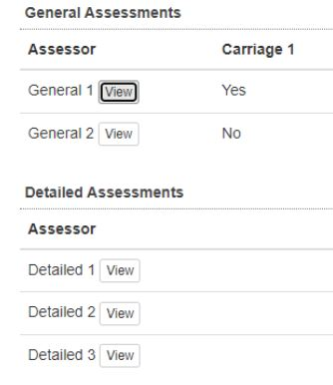

1. **There is a difference between my Detailed Assessor and my General Assessor scores. Why is this so?**

The key difference between a Detailed Assessor and a General Assessor is the number of applications that they assess within a scheme round. A Detailed Assessor will typically assess 1 to 5 applications, while a General Assessor will usually assess many more. For example, in the Discovery Project Scheme, a General Assessor may assess between 35 to 120 applications (depending upon the discipline panel).

Assessing a larger number of applications means that a General Assessor is able to assess the relative quality of an application within a scheme round, which may result in different scores from a Detailed Assessor who only assesses 1 to 5 applications. Also, in schemes which use normalisation, General Assessor Weighted Ratings are converted to Normalised Weighted Ratings to reduce marking bias. This may also result in scores that differ from those awarded by a Detailed Assessor.

1. **My application was found to be ineligible. Am I able to see my assessment scores?**

Scores, rankings and assessments are displayed in RMS only for eligible applications. Scores, rankings and assessments will not display for any application found to be ineligible.

1. **My application was successful. Am I able to see my assessment scores and feedback?**

Assessment scores, rankings and detailed assessments are available to eligible applicants for all NCGP schemes when funding outcomes are announced.

1. **How long will the assessment scores and feedback be viewable in RMS?**

Scores, rankings and detailed assessments will remain permanently in RMS for eligible applicants, so you may view them at any time.

1. **Has the appeals process changed due to the release of assessment scores and feedback?**

The appeals process has not changed. The ARC must receive an appeal within 30 days of the notification date to the Administering Organisation of application outcomes.

Appeals can only be made against administrative process issues. Appeals cannot be made against committee decisions or assessor ratings and comments.

1. **Will the Feedback API report for Research Offices show the scores and assessments?**

The Feedback API report run by Research Offices has remained unchanged. Therefore, it will still provide the banding feedback but not the assessment scores.

In addition - a new API has been created called the ‘Outcome And Assessment Data’. This new API will allow Research Offices to access assessment data.

1. **How does the Selection Advisory Committee (SAC) meeting operate?**

An overview of the peer review assessment process is available on the [ARC website.](https://www.arc.gov.au/funding-research/peer-review) The SAC meetings consider applications that, following assessment by the Detailed and General Assessors, are the most highly ranked and likely to be funded. The SAC will also consider applications in the ‘uncertainty band’ or ‘discussion band’, which are applications that may be funded, and any other application flagged for discussion either by a SAC member or by the ARC.

The discussion of an application is initiated by Carriage 1, who provides a brief summary and outlines the strengths and weaknesses of the application and whether they support the application for funding. The other carriages provide their views followed by any other SAC members. A budget is also proposed and agreed for each application that is supported for funding. Detailed information on the assessment process, including the SAC meetings, for the different schemes can be found in the relevant [Assessor Handbook](https://www.arc.gov.au/funding-research/peer-review/assessor-resources).