# How create and submit Conflict of Interest Declaration

## Introduction

This is a guide for Research Office staff on how to create, certify and submit Conflict of Interest (COI)declarations per project within the Australian Research Council’s (ARC) Research Management System (RMS).

As per clause 10 of Grant Agreements, each Administering Organisation needs to ensure that Declaring Researchers declare Actual, Potential and Perceived Conflicts of Interest (including any material change to a previously declared Actual, Potential and Perceived Conflict of Interests) to the ARC prior to the commencement of each Project.

Prior to submitting a COI Declaration to the ARC, you will be required to work with the Project Lead CI, Director and/or Chief Operating Officer and/or Business Manager, Other Eligible Organisations to collate all the Declaring Researchers COI in relation to the Project itself. If a Declaring Researcher has a COI to declare, please complete the excel template provided by the ARC.

Whether a Declaring Researcher has a COI to declare or not, the Administering Organisation is required to complete a COI Declaration within RMS.

COI Declarations can be created and submitted by the Research Office through RMS by a user with the role type, Research Office Delegate. The COI declaration will then be accepted by an ARC Post Award staff member.

Use your email address and password to login to [RMS](https://rms.arc.gov.au/). If you don’t have a user account, contact members of your university’s research office.

RMS is compatible with the latest versions of Google Chrome and Microsoft Edge. The ARC cannot guarantee compatibility with other browsers or older versions of Google Chrome or Microsoft Edge.

## Terminology

**Declaring Researcher** means all named Chief Investigators (from all organisations) on a Project.

## Creating a COI Declaration per project

As the COI Declaration is project based, the Research Office will need to create a COI Declaration from within each project manually.

* Login to [RMS](https://rms.arc.gov.au/)
* Enter your email address, password and MFA. Click on the login button.
* Navigate to Action Centre
* Go to *ARC Research Office Project Management*
* Select *Research Office Project*

* From the drop-down options, select either the Scheme and/or Scheme Round from within the Projects tab to assist with filtering out the Administering Organisations active projects.

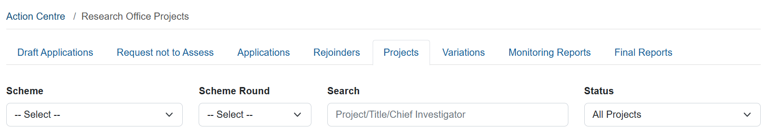

* Once you have the required *Scheme* and/or *Scheme Round*, select the Project you wish to complete the COI Declaration for.
* Within the Project information, select *Reports* from the ribbons across the top
* This will provide you with a list of Reports created and/or submitted and accepted by the ARC in relation to this particular project.

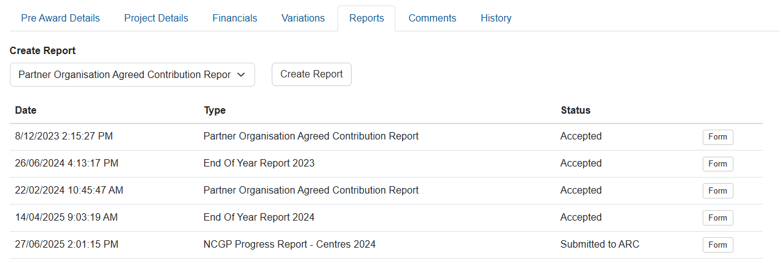

* To create the COI Declaration form, select *NCGP Conflict of Interest Report* from the drop down and click *Create Report*.

* A prompt will appear to ask if you wish to Create a new NCGP Conflict of Interest Report for this Project. Click *Create Report*

Project ID

* Once created, the Draft COI Declaration form will appear at the bottom of the Reports list.

## Completing the COI Declaration form

* Once you have created the COI Declaration form for a Project, click on *Form*

* For the Project, answer *Yes* or *No* to “Do any of the researchers on this project have any Conflict of Interest to declare”? Yes/No
* If no, the Attachment functionality will disappear, and you have completed filling out the declaration

* If yes, you will be required to upload a the completed excel template that the ARC provided

* Click on *Choose File*, select the file from your folder structure, click *Open*. The file will be listed against *Choose File*

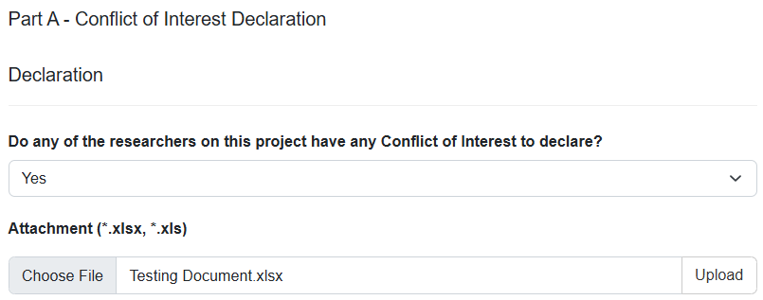

* Once you have the appropriate file, click *Upload*

**Note:** an Excel format is the only format that will be accepted. If you try to upload a document that is not .xlsx or .xls you will receive the following alert:

* Once you have uploaded the declaration you have completed the form. Now to certify and submit to ARC.

## Certification and Submission of the COI Declaration form

Once a Projects COI Declaration is ready to be certified and submitted to ARC, there are two ways the Research Office can certify and submit. They are:

Option 1: From within the *Reports* tab of the project itself or

Option 2: From within the *Research Office Project Reports – Monitoring Reports* tab

Option 2 will allow for bulk submission once the COI Declaration report is certified.

## Option 1: From within the *Reports* tab of each Project

* Return to the Reports tab of the Project, you will see the status of the NCGP Conflict of Interest Report has changed to *Ready to Submit*

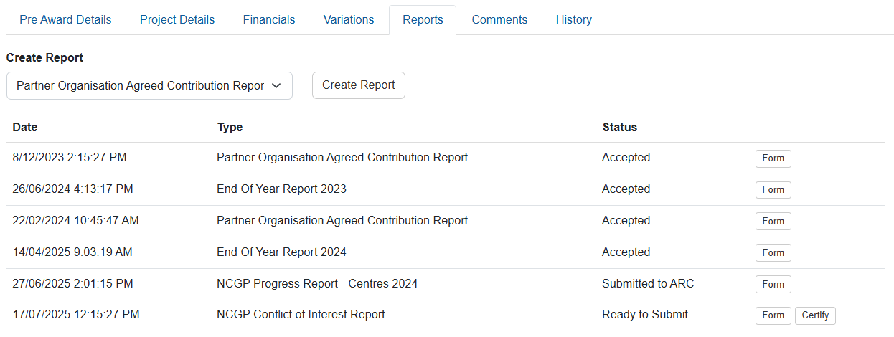

* Prior to submission to the ARC, the Research Office needs to certify that the information that is being submitted is true and accurate to the best of their knowledge.
* To certify the COI Declaration, click *Certify*



* A certification message will appear. Once you have read, understood and comply with the certification, click *Agree to certification*

* Once you have Agreed to certification, the Status of the COI Declaration will change to *Certified*.

* When you are ready to submit the COI Declaration click, *Submit to ARC*

* Once you click on Submit to ARC the below pop up will appear. Click, Submit to ARC

Project ID

* Once you have clicked on *Submit to ARC* the status of the COI Declaration form will change to *Submitted to ARC*.

## Option 2: From within the *Research Office Project Reports* – *Monitoring Reports* tab

Option 2 is beneficial when you have a few COI Declarations to certify and submit.

* Navigate to Action Centre
* Go to *ARC Research Office Project Management*
* Select *Research Office Project Reports*

* This will take you to *Monitoring Reports.* Once in *Monitoring Reports* select *NCGP Conflict of Interest Report* from the *Report* dropdown menu. Keep all the other filters clear.
* You will see a list of all the COI forms that have been created.
* Click on *Certify* for each of the COI Declarations you wish to certify.

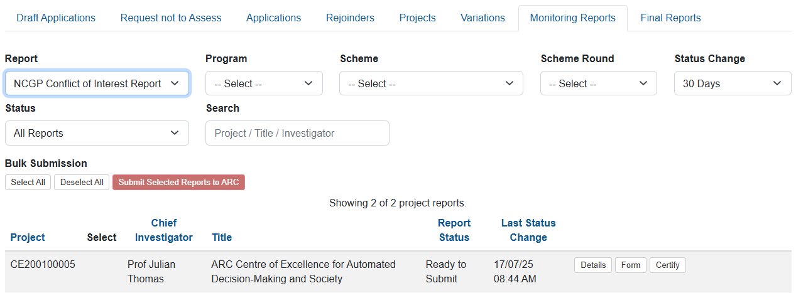

* A certification message will appear. Once you have read, understood and comply with the certification, click *Agree to certification*

* Once you have certified all the COI Declarations you can choose one of two options to Submit to ARC.
  + Individually *Submit to ARC* (same process as mentioned above)
  + *Select All – Submit Selected Reports to ARC*
* If you choose to *Select All – Submit Selected Reports to ARC* this will submit everything at once to the ARC.
* Click on *Select All*

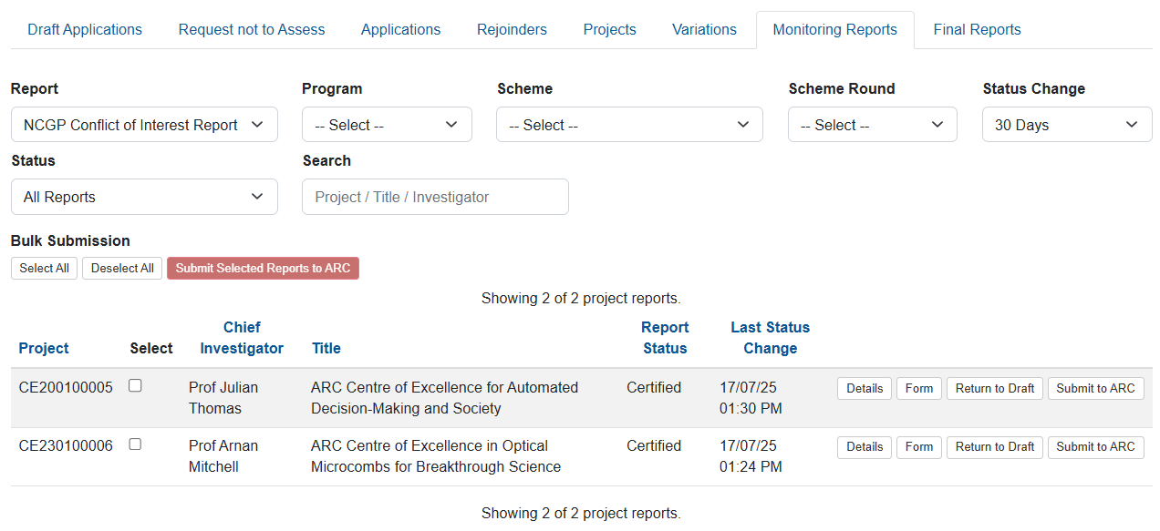

* Once you click *Select All* every certified COI Declaration will have a blue tick next to the Project ID

* Now, click on *Submit Selected Reports to ARC*

* The difference on this occasion is the prompt will provide you with a list of Projects you are bulk submitting COI Declarations for (instead of the individual Project).
* Click on *Submit Selected Reports to ARC*

* Once you have clicked on *Submit to ARC* the status of the COI Declaration form will change to *Submitted to ARC* for all the Projects.