# How complete and submit Nature of Employment Report

## Introduction

This is a guide for Research Office staff on how to complete and submit the Nature of Employment Report per project within the Australian Research Council’s (ARC) Research Management System (RMS).

As per ARC Grant Agreements, each Administering Organisation needs to ensure that a Nature of Employment Report is submitted within three (3) months of each project end date to the ARC.

The Nature of Employment Report requires data on Declaring Researchers across the lifecycle of the project. The Nature Employment Report will be open as soon as a project is created in RMS by the ARC. We encourage yearly input of information into this report to ensure the workload at the completion of the project is reduced for all.

Project years are calculated from the RMS reported Project Start Date and Project End Date. If a variation is submitted and approved to change / extend the Project End Date, the form will automatically update to reflect the new total number of years. Therefore, if the project is 3.5 years in duration, the report will have 4 Years of reporting required. The final year may only cover a partial year.

Note: When a project is created in RMS, the Nature of Employment Report will default to the number of years the project is awarded. Eg: ARC Centre of Excellence will have 7 years, Australian Laurate Program will have 5 years, Discovery Project will have the number of years awarded (ranging from 3 years to 5 years).

Prior to submitting a Nature of Employment Report to the ARC, you will be required to work with the Project Lead CI, Director and/or Chief Operating Officer and/or Business Manager, Other Eligible Organisations to collate all the Declaring Researchers Nature of Employment information in relation to the Project itself.

We understand that Researchers employment status will change over the lifecycle of a project and possibly within each reporting year. To complete this report, please indicate the employment status that accurately reflects most of the reporting year. Eg: 7 months as Ongoing part-time and 5 months as Ongoing casual, you will reflect 1 in Ongoing part-time.

Should a project be relinquished without spending any of the ARC funds, the Nature of Employment Report may be waived. To request a waiver of the Nature of Employment Report, please contact ARC Post Award on [arc-postaward@arc.gov.au](mailto:arc-postaward@arc.gov.au)

Use your email address and password to login to [RMS](https://rms.arc.gov.au/). If you don’t have a user account, contact members of your university’s research office.

RMS is compatible with the latest versions of Google Chrome and Microsoft Edge. The ARC cannot guarantee compatibility with other browsers or older versions of Google Chrome or Microsoft Edge.

## Terminology

**Declaring Researcher** means all named Chief Investigators (from all organisations) on a Project and unless otherwise directed by Us, all researcher positions budgeted for in the Grant Funds (including postdoctoral and research assistant positions).

**Nature of Employment** means, in respect of Declaring Researcher:

* + total count of Declaring Researchers;
  + employment status;
  + gender;
  + seniority; and
  + any other matters notified by Us to You from time to time.

## Accessing the Nature of Employment Report

Nature of Employment Reports can be accessed in two different ways:

1. Within each individual project; or
2. Via *Research Office Project* Reports

## Option 1: Within each individual project

* Login to [RMS](https://rms.arc.gov.au/)
* Enter your email address, password and MFA. Click on the login button.
* Navigate to Action Centre
* Go to *ARC Research Office Project Management*
* Select *Research Office Project*

* From the drop-down options, select either the Scheme and/or Scheme Round from within the Projects tab to assist with filtering out the Administering Organisations active projects.

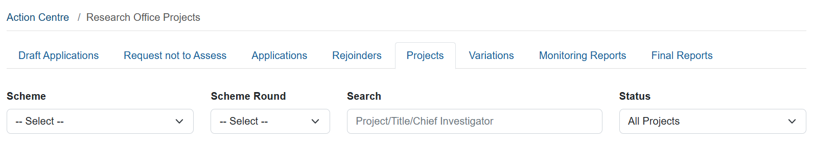

* Once you have the required *Scheme* and/or *Scheme Round*, select the Project you wish to complete the Nature of Employment Report for.
* Within the Project information, select *Reports* from the ribbons across the top
* This will provide you with a list of Reports created and/or submitted and accepted by the ARC in relation to this particular project.

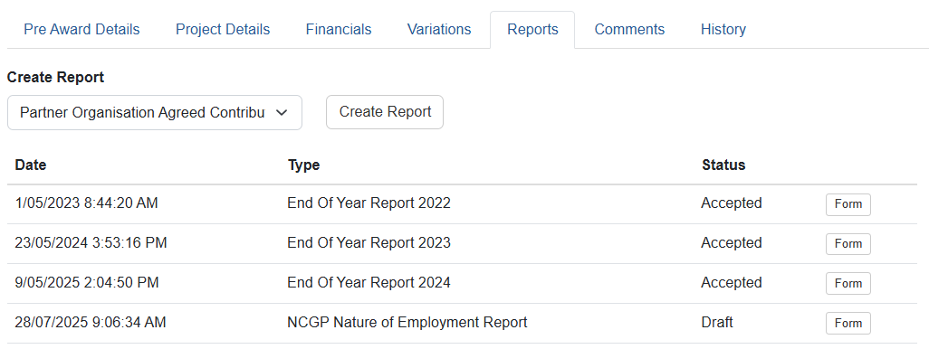

## Option 2: From within the *Research Office Project Reports* – *Monitoring Reports* tab

Option 2 is beneficial when you have a few Nature of Employment Reports you wish to complete.

* Login to [RMS](https://rms.arc.gov.au/)
* Enter your email address, password and MFA. Click on the login button.
* Navigate to Action Centre
* Go to *ARC Research Office Project Management*
* Select *Research Office Project Reports*

* This will take you to *Monitoring Reports.* Once in *Monitoring Reports* select *NCGP Nature of Employment Report* from the *Report* dropdown menu. Keep all the other filters clear.
* You will see a list of all the Nature of Employment Reports for all the Projects your Organisation administers.

No matter which option you choose to navigate to the Nature of Employment Report, the completion of the report will follow the same process.

## Completing the Nature of Employment Report form

Each question within the Nature of Employment Report is independent. The report is to be filled out on number of personnel, not FTE. Therefore, if you have five Chief Investigators and one Research Associate in Year 1 of the project, each question will total six for that year. It does not matter if three of the five Chief Investigators are working on the project at a 0.2 FTE.

* Once you have found the Nature of Employment Report for the corresponding Project, click on *Form*

Option 1:

Option 2:

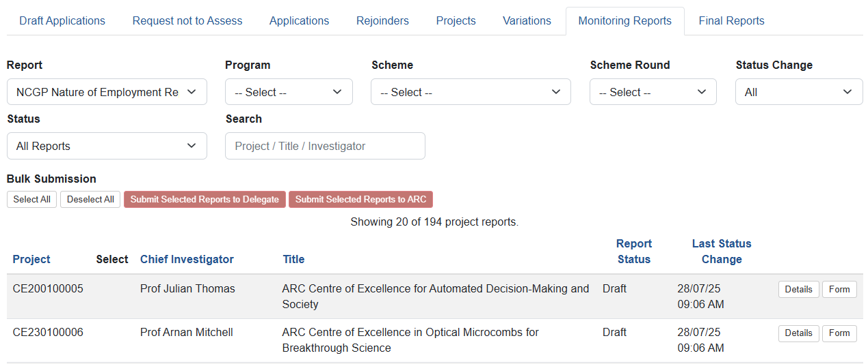

**Note:** All columns and rows of the below tables will require a number. If the category has zero personnel attached to it, please put a 0 in the box.

Part A – Nature of Employment

For the purpose of these questions, please specify the relevant count of Declaring Researchers employed during each period for the purposes of the Project.

Part B – Level of Employment

Level of employment will be categorised via the Higher Education Worker Levels for Academic and Professional employees

* As you complete each table the notification of *All items must be answered* will disappear and the below *Ready to submit* will appear.

* Ensure you click on *Save* prior to closing out of the Report.

## Certification and Submission of the Nature of Employment Report form

Once a Projects Nature of Employment Report is ready to be certified and submitted to ARC, there are two ways the Research Office can certify and submit. They are:

Option 1: From within the *Reports* tab of the project itself or

Option 2: From within the *Research Office Project Reports – Monitoring Reports* tab

Option 2 will allow for bulk submission once the COI Declaration report is certified.

## Option 1: From within the *Reports* tab of each Project

* Return to the Reports tab of the Project, you will see the status of the NCGP Nature of Employment Report has changed to *Ready to Submit*

* Prior to submission to the ARC, the Research Office needs to submit the report to the RO Delegate. Click *Submit to RO Delegate.*

* Click on *Submit to RO Delegate* once the pop up appears.

* This will change the status of the Report to *Submitted to RO Delegate.*

* From here only those with RO Delegate RMS log in rights can submit the Nature of Employment Report to ARC. Click on *Certify.*

* A certification message will appear. Once you have read, understood and comply with the certification, click *Agree to certification*

* Once you have Agreed to certification, the Status of the Nature of Employment will change to *Certified*.

* When you are ready to submit the Nature of Employment click, *Submit to ARC.*

* Once you click on Submit to ARC the below pop up will appear. Click, Submit to ARC

Project ID

* Once you have clicked on *Submit to ARC* the status of the Nature of Employment form will change to *Submitted to ARC*.

## Option 2: From within the *Research Office Project Reports* – *Monitoring Reports* tab

Option 2 is beneficial when you have a few Nature of Employment Reports to certify and submit.

* Navigate to Action Centre
* Go to *ARC Research Office Project Management*
* Select *Research Office Project Reports*

* This will take you to *Monitoring Reports.* Once in *Monitoring Reports* select *NCGP Nature of Employment Report* from the *Report* dropdown menu.

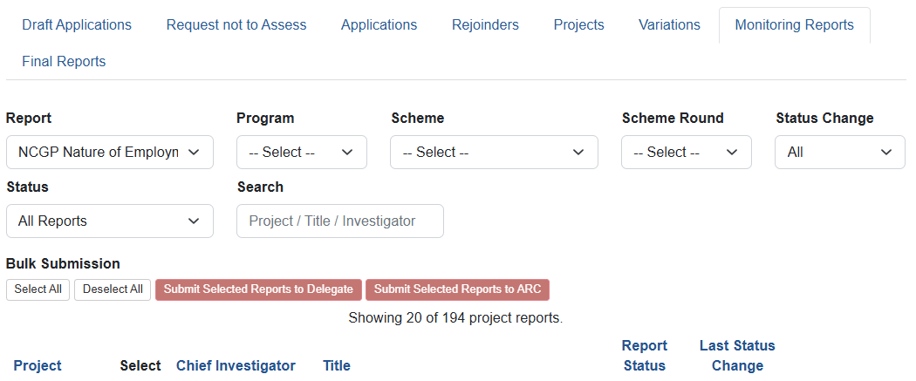

* This will provide you with a full list of Projects. Try using the other filter options to reduce the number of Projects you are searching through. Suggestion: Filter *Status* to *Ready to Submit*

* Click on *Submit to RO Delegate*

* Click on *Submit to RO Delegate* once the pop up appears.

* This will change the status of the Report to *Submitted to RO Delegate.*
* Change the *Status* filter to *Submitted to RO Delegate.* Click on *Certify* for each of the Nature of Employment Report you wish to certify.

* A certification message will appear. Once you have read, understood and comply with the certification, click *Agree to certification*

* Change the *Status* filter to *Certified.*
* Once you have certified all the Nature of Employment you can choose one of two options to Submit to ARC.
  + Individually *Submit to ARC* (same process as mentioned above)
  + *Select All – Submit Selected Reports to ARC*
* If you choose to *Select All – Submit Selected Reports to ARC* this will submit everything at once to the ARC.
* Click on *Select All*

* Once you click *Select All* every certified Nature of Employment will have a blue tick next to the Project ID

* Now, click on *Submit Selected Reports to ARC*

* The difference on this occasion is the prompt will provide you with a list of Projects you are bulk submitting Nature of Employment Report for (instead of the individual Project).
* Click on *Submit Selected Reports to ARC*

* Once you have clicked on *Submit to ARC* the status of the Nature of Employment Report form will change to *Submitted to ARC* for all the Projects.