
Research Management System
(RMS)
User Guide – Requesting and Maintaining an RMS User Account
Contents
Introduction 2
Key Points 2
PART 1 – Requesting a New RMS account 3
1.2 Submitting new account request 3
1.2 Verify your email address 5
1.3 Approval or rejection of your account request 6
PART 2 Completing / Maintaining Your Person Profile 7
2.1 Personal Details 8
2.1.1 Transferring your RMS account to a different Organisation 11
2.2 Expertise and Fields of Research 11
2.3 Qualifications 13
2.4 Employment History 14
2.5 Assessor Availability 15
2.6 Current ARC Projects 17
2.7 Research Outputs 17
PART 3 – Login, Navigation and Troubleshooting 17
3.1 Login to RMS 17
3.2 Requesting a Password Reset 17
3.3 Unlocking your account 20
3.3.1 Password troubleshooting 20
3.4 RMS navigation 21
3.5 Multi-factor Authentication 21
3.5.1 MFA Settings using Mobile App 22
3.5.2 Setting up MFA in RMS using Desktop extension 23
3.5.3 Manual Entry of MFA 25
3.5.4 Scanning QR code for MFA 25
3.5.5 FAQs 25

Introduction
The Research Management System (RMS) is a web-based application to manage grant programs for the ARC and its government partners. Each agency can utilise functions such as: submissions, assignment and assessment, rejoinders, announcement, grant offers/acceptance, and post-award activities such as grant variations and project reporting.
More detailed information on other agencies utilising RMS is available on the Research Grant Services page of the ARC Website.

Accessing RMS
The web address to access RMS is dependent on the agency or program that you are needing to interact with.
- ARC (NCGP) RMS instance - https://rms.arc.gov.au
- DESE (NCRIS) RMS instance - https://dese.researchgrants.gov.au
- ONI (NISDRG) RMS instance - https://rmsoni.researchgrants.gov.au
- Defence (NISDRG) RMS Instance - https://defence.researchgrants.gov.au
NOTE: you only need one account to access RMS, regardless of agency or program you are accessing, however you will require specific roles for each version/instance of RMS.

Key Points
    - RMS is compatible with the latest versions of Google Chrome and Microsoft Edge. The Australian Research Council (ARC) cannot guarantee compatibility with other browsers or older versions of Google Chrome or Microsoft Edge.
    - Your email address that you registered with is used to log in to RMS.
    - RMS security requirements comply with the Australian Cyber Security Centre (ACSC) cyber security strategies and require Multi-factor Authentication (MFA).
    - This will be mandatory for ARC and Research Office Staff (privileged users) and optional for other users (non-privileged users). All RMS users will be able to set up MFA or opt out themselves.
    - Your password must be a minimum length of 14 characters and must contain at least three of the following categories:
  - lowercase alphabetic characters (a-z)
  - uppercase alphabetic characters (A-Z)
  - numeric characters (0-9)
  - special characters (!@#$%&/=?.,:;\-)
- You can only reset your password once every 24 hours. If you cannot remember your new password, you will have to wait 24 hours before trying again. However, the RMS Support team can override this if required.
    - You must change your RMS password every 12 months. If you do not change your password within the 12 months, your RMS account will be suspended. Your account can be unlocked by requesting a Password Reset from any RMS Login Page or by contacting RMS Support. You do not need a new account when you change employment. Under Personal Details, you can change the Administration Organisation for your account or update your email address at any time. Alternatively, you can ask RMS Support to update your account.
    - All navigation in RMS originates from the RMS main menu page, known as the ‘Action Centre’.
    - Please note that all screenshots provided within this document have been obtained through the ARC instance of RMS and therefore differences may be evident between instances.

PART 1 – Requesting a New RMS account

NOTE: If you have ever been a participant on an ARC research application or acted as an assessor for the ARC, you will already have an RMS account. Please note your account may be inactive if you have not accessed it recently. If unsure, please contact RMS Support.
In addition, you do not need a new account when you change employment– See section 2.1.1 to transfer your account.

1.2 Submitting new account request
    - Navigate to the relevant RMS instance Login page using the links as listed above:
    - Click on Request New Account
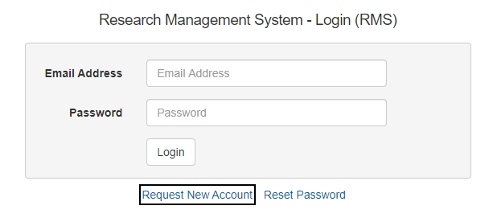
Figure 1.0 - RMS Login page

- The Register New User screen has two sections, Personal Details and Current Employment details (which are separated by a Recaptcha verification).
Personal details:
- Title
- First Name
- Second Name (not mandatory)
- Family Name
- Gender
- Date of Birth (not mandatory)
- Email
- Confirm email
- Organisation (Admin Organisation/Research Office/Lead Agent): This refers to the organisation that will administer your account. If one of the listed organisations employs you, or you are affiliated with it, select it to administer your RMS account.
  - If you are not affiliated with an available organisation within the list, please select the Australian Research Council to administer your account. You can update the Administration Organisation later if required. Alternatively, contact RMS Support for advice.
Note: Research office staff at the administering Organisation can view your details and are required to review all account requests.

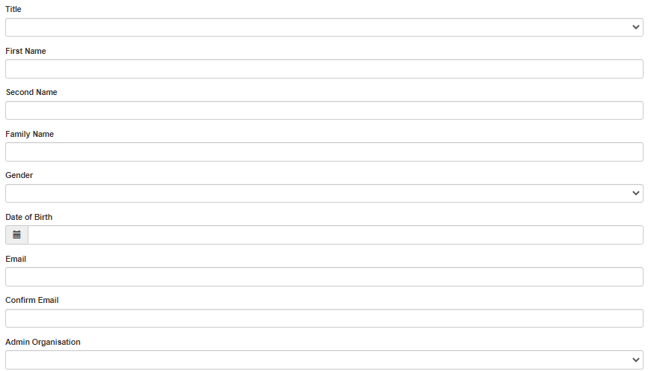
Figure 1.1 - New user account details – Personal
Recaptcha:
- You will need to verify the Recaptcha before you can submit
- You should complete all details first before verifying, or the verification may expire.
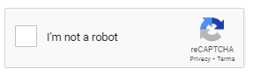
Figure 1.2 - New user account details – Recaptcha

Current Employment details:
- If you are currently unemployed, check the Unemployed box as this will disable the employment fields.
- Description (e.g. Director, Lecturer, Research Fellow etc)
- Department
- Contract Type: Contract or Permanent
- Employment Type: Full time or Part time (For Contract and Employment type, select the most applicable)
- Start Date
- End Date (leave this blank for current ongoing employment, or enter a future date for fixed term contracts)
- Organisation:
Enter your employers name in the available field, click search and select your organisation from the search results. You can also search for it by using the organisation’s ABN or entering part of the name (ABN search is more reliable). If your organisation is not listed in RMS, click the here link (see Figure 1.4) in the pop-up message to add the name of your organisation, or contact RMS Support and ask for it to be added to RMS.
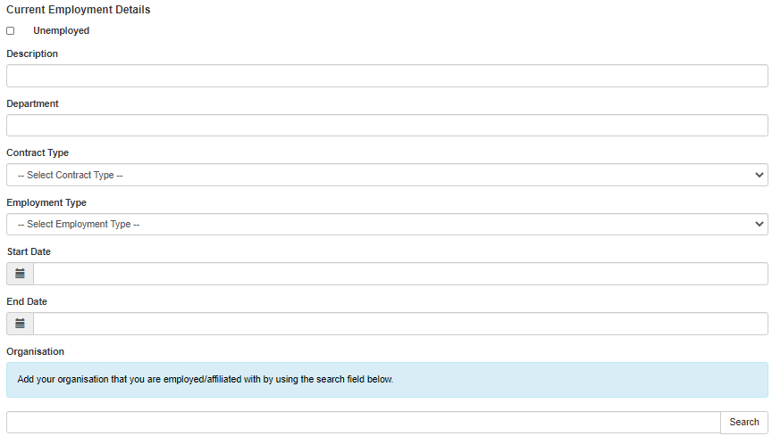
Figure 1.3 - New user account details – Current Employment Details

Figure 1.4 - Request to add organisation – Current Employment Details (continued)

    - Once details are complete and you have verified using the Recaptcha - Click Register
    - A notification screen will appear advising that your request has been successfully submitted.
Figure 1.5 - Confirmation that request is successful

1.2 Verify your email address
    - After you have Registered, RMS will send you an automatic email with a link to verify your email address: Click here to validate your email address
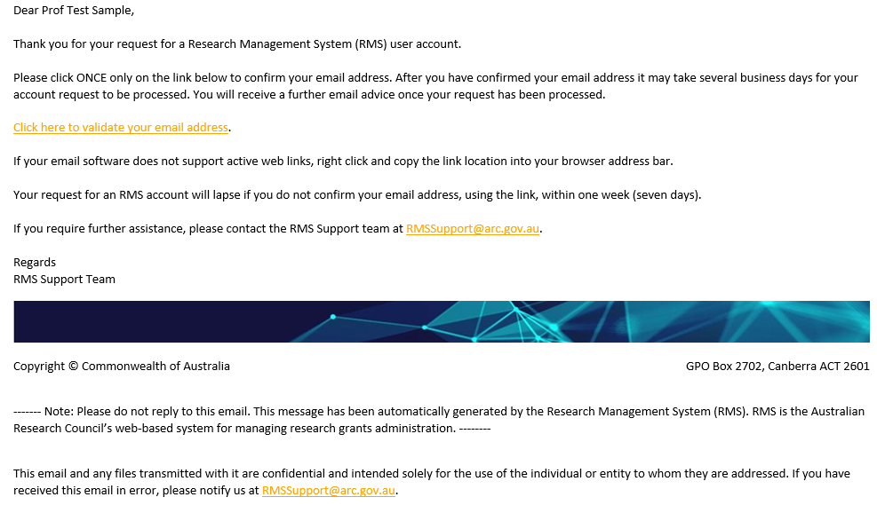
Figure 1.6 - Validation email for new account requests


Figure 1.7 - Confirmation of email verification

- Following email verification, if you requested via ARC-RMS and selected a research organisation to administer your account, the request will first go to that organisation’s research office to endorse. If the research office endorses your request, it will then come to the RMS Support team for final approval. Requests from other RMS Agents come direct to the ARC for approval.

NOTE: Your account does not exist until the ARC has approved it. You cannot log on or request a password before your account is approved.
It may take several business days for the Research Office and/or the RMS Support Team to process and approve the account request.

1.3 Approval or rejection of your account request
    - If the ARC approves your account request, RMS will send a second automatic email with a link to set your password:
    - To setup your initial login details in RMS, click here.
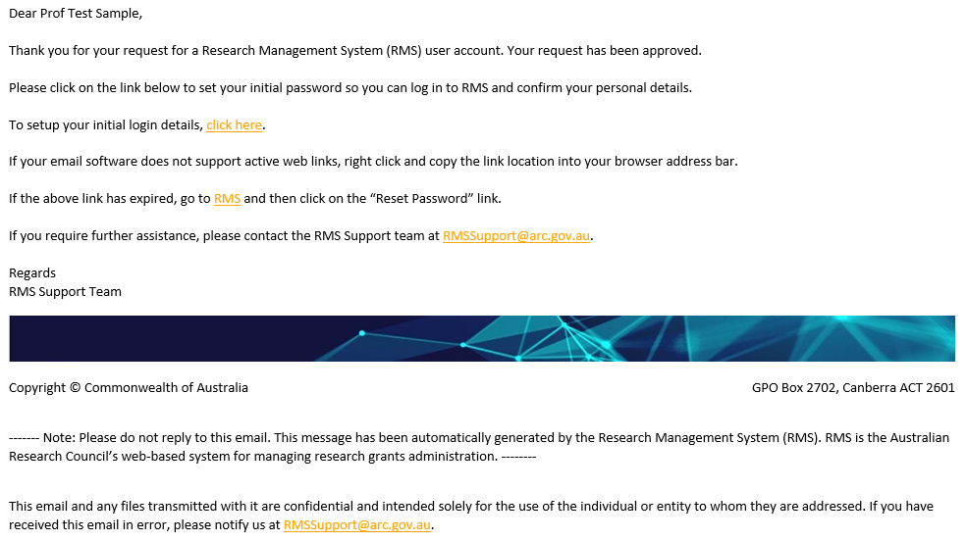
Figure 1.8 - Example of account approval email

  - Please note the password requirements when creating your new password.
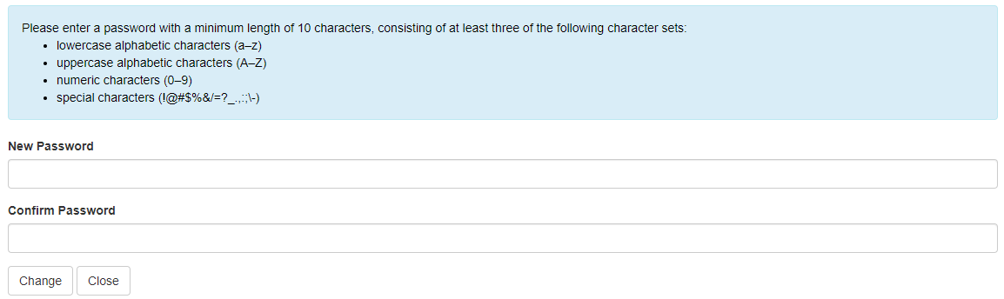
Figure 1.9 - Set Password Screen
Note: Once you have set your initial password, it is important to log onto RMS and complete your Person Profile, especially if you are applying for grant funding. See Part 2.

If either the research office or the ARC rejects your account request, RMS will send an automatic email with a reason for the rejection. The most common rejection reason is a pre-existing account. If required, contact RMS Support for assistance to update and access your existing account. You do not need a new account when you change employment or to access a different agency.

PART 2 Completing / Maintaining Your Person Profile
All users should periodically check their profile and update/add information where applicable.
The information contained in your RMS profile is used not only for statistical reporting but also to:
        - populate personal, employment and qualifications information into applications,
        - determine eligibility (if you are an applicant); and
        - match your expertise to applications if you are an assessor.
Note: Not all fields are mandatory in the client profile, but some will become mandatory if you apply for a grant as they are used populate the grant application and to determine eligibility.

2.1 Personal Details
First, select Personal Details from the Person Profile menu
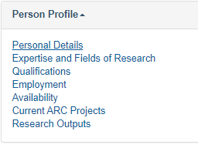
Figure 2.0 - Person Profile options

The information you entered at registration is here and can be updated if necessary.
Additional Fields to complete:
    - Phone Number
    - Alternate Phone Number
    - Country of Birth – start typing country name then select from the displayed list.
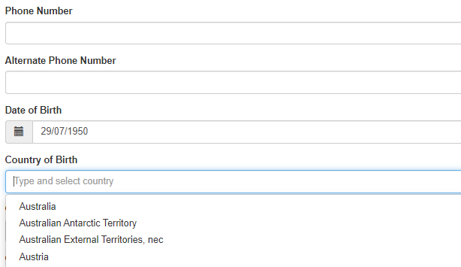
Figure 2.1 – Personal details

ORCID Id: For Information on connecting your ORCID Id please see the separate guide: Research Outputs in RMS—Instructions for adding Research Outputs to your RMS Profile available on the RMS Information page of the ARC Website.
The following fields collect additional demographics required for reporting purposes and information that may be used to verify that you meet the specific eligibility requirements of the grant program you are applying for.
    - Gender – select from the list.
    - Indigenous Status (mandatory) – select from the list
    - Citizenship (mandatory) – multiple entries are allowed. Start typing the country and select from the options provided, then click the “Add” button.
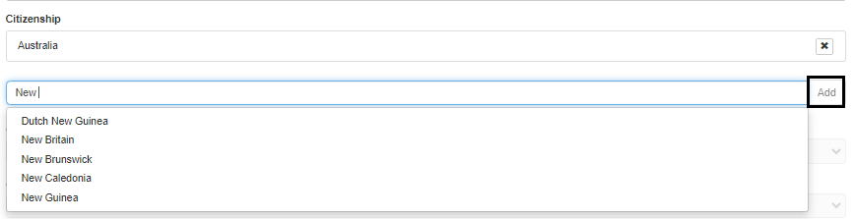
Figure 2.2- Set Citizenship Countries
    - If you are not an Australian citizen, please complete the residency questions. If you answer Yes to Permanent Resident, the following three fields are disabled.
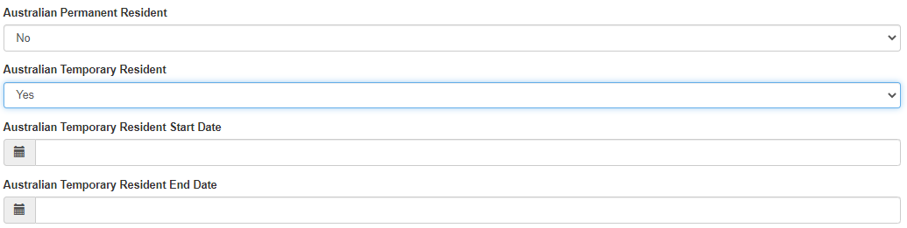
Figure 2.3- Residency Status

The final set of questions collects information regarding personal interest activities, conflicts of interest, and an acknowledgment that the personal information listed in your profile may be disclosed for the purposes of grant administration or legislative purposes.
Are you currently receiving any financial support (cash or in-kind) for research related activities from a country other than Australia?
Are you currently, or have you previously been, associated or affiliated with a talent recruitment program from a country other than Australia?
Are you currently associated or affiliated with a government, political party, government owned enterprise, military or police organisation in a country other than Australia?

For these three questions:
    - Multiple entries are allowed.
    - If you select Yes, you will be prompted to search/select and add the country, then provide details.
    - Start typing the country and select from the options provided, then click the “Add” button. This will prompt you to add the name of the organisation providing the funding and provide a summary of the type of financial support received.
    - Add additional countries as needed.
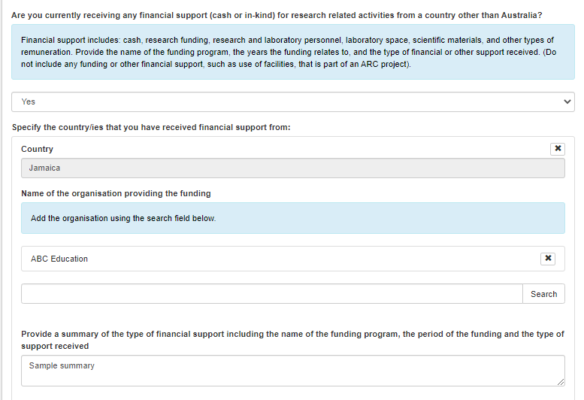
Figure 2.4 - Foreign financial Support example
    - Finally, complete the declaration.
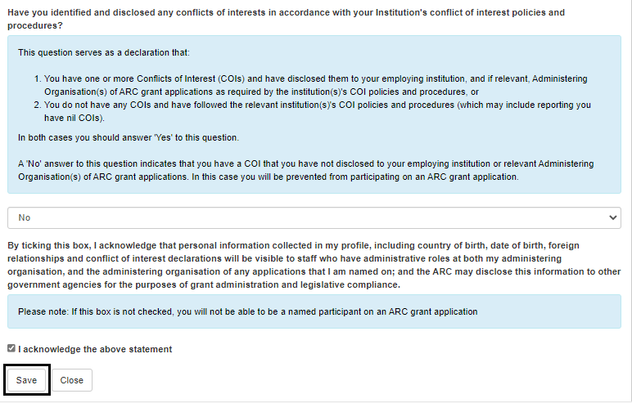
Figure 2.5 - Declaration
    - Save and close.

2.1.1 Transferring your RMS account to a different Organisation
    - You can transfer administration of your RMS account to a new Organisation by clicking on Personal Details under the Person Profile section of the Action Centre.
    - Under the Organisation section (Admin Organisation/Research Office/Lead Agent) of the Personal Details page, select a new Organisation to administer your account from the list.
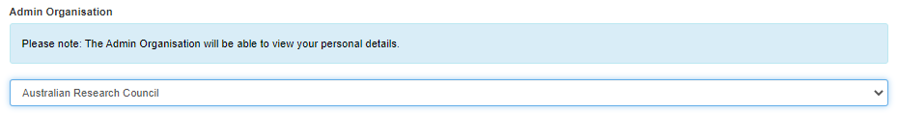
Figure 2.6 – Transfer of Administering Organisation
    - Once the new Organisation is selected, click Save at the top or bottom of the page. The account will automatically transfer to the new organisation.
Note: If updating your Admin Organisation, you should also update your email address

2.2 Expertise and Fields of Research
    - Your Expertise text and Fields of Research (FoR) codes are used to match assessors to applications and are also included in the application for research grants.
    - Select Expertise and Fields of Research from the Person Profile Menu
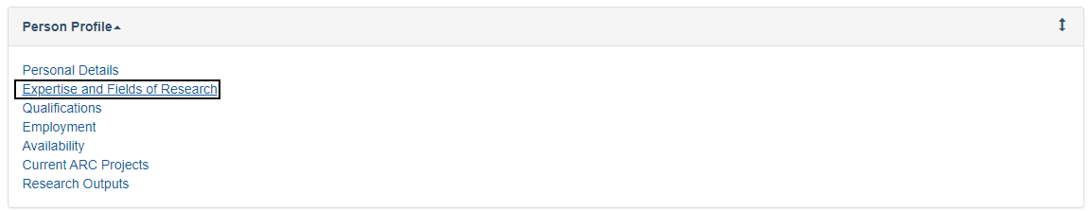
Figure 2.7 – Person Profile Expertise and Fields of Research
    - Complete the details by entering your Expertise text and FoR Codes.
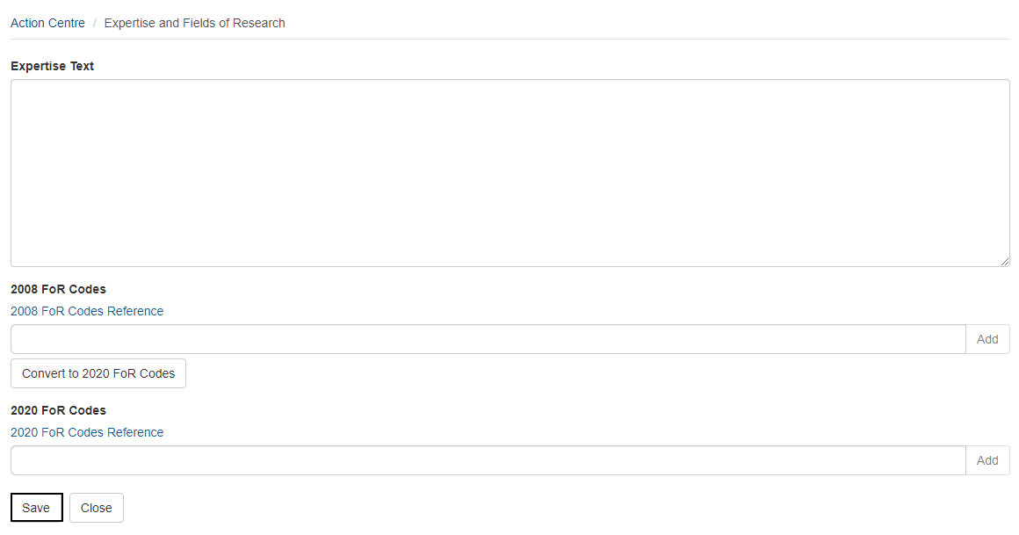
Figure 2.8 – Expertise and Fields of Research
    - Your expertise text should NOT be a list of academic positions held.
    - Align your expertise text with the following points:
- My major area of research expertise is in x, y, z…
- I also have experience in research a, b, c…
- I would also be able to assess in the areas of…….
    - FoR Codes: select between six and ten FoR codes
Note: 2008 FoR codes will continue to be utilised in applications and assessments until 2021. Please ensure that both 2008 and 2020 FoR codes are available within your profile.

    - Use the FOR Codes search to find the codes closest to your area of expertise.
- Start typing the text or the FoR code, select from the options that match your search, then click the “Add” button. Repeat to add more codes. 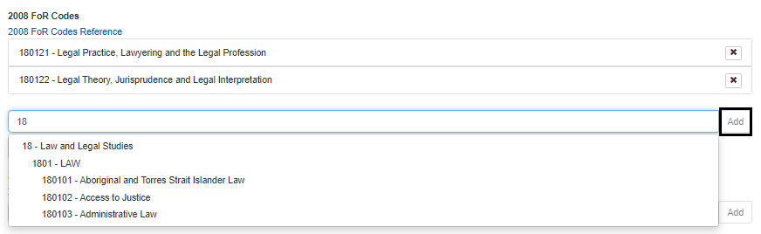
Figure 2.9 – Adding Fields of Research
Convert to 2020 FoR codes
    - If you add 2008 FoR codes, they can be converted to 2020 FoRs using this option.
- This screen shows you the mapping of 2008 FoRs to 2020 FoRs and you can either select to confirm only the direct one to one mappings or confirm all suggested mapping, adding them to your profile. Alternatively, you can select then confirm or remove codes one at a time.
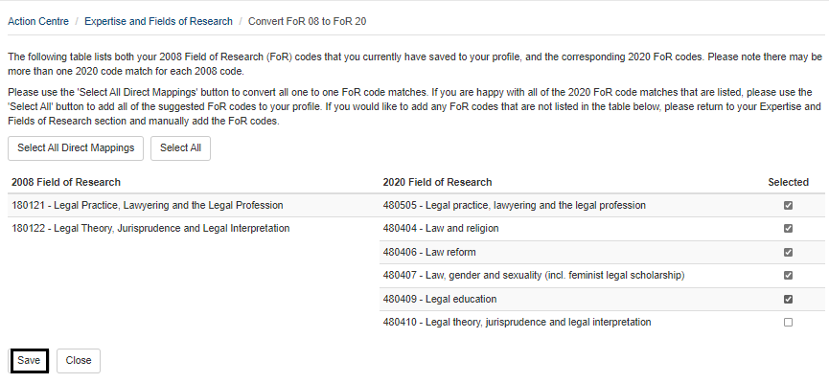
Figure 2.10 – Convert to 2020 Fields of Research
    - Click on Save after updating your details.

2.3 Qualifications
    - Click on the Qualifications link from the Person Profile menu.
    - To add qualifications, click on Add Qualification.
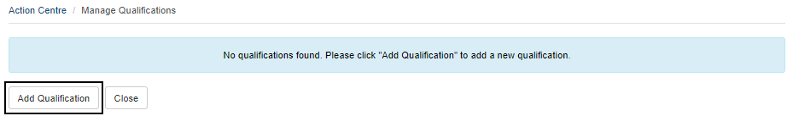
Figure 2.11 Adding a qualification
    - Enter in your qualification details using the following fields:
  - Conferral Date
  - Australian Qualifications Framework Level (Further information about Australian Qualifications Framework levels is available at www.aqf.edu.au)
  - Degree/Award Title
  - Discipline/Field
  - Awarding Organisation
  - Country of Award
- Click on Save after updating your details.
- To add more qualifications, click on the Close to return to the Manage Qualifications page, then click the Add Qualifications link.
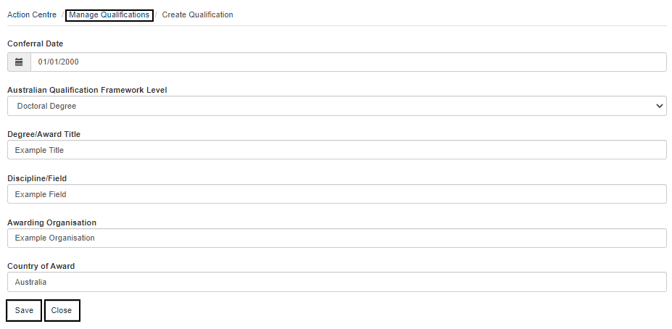
Figure 2.12 Entering in your qualifications
- The Manage Qualifications page lists each Qualification entry, and you can edit or delete as required.
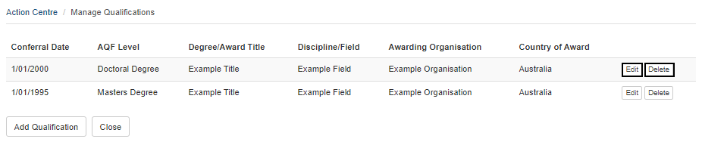
Figure 2.13 – Managing and viewing your qualifications

2.4 Employment History
    - Click on the Employment link from the Action Centre.
    - To add employment records, click on Add Employment.
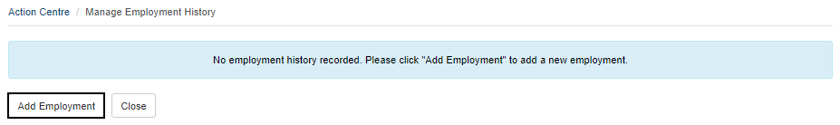Figure 2.14 – Managing your employment history
    - Enter in your employment details using the following fields:
- Description
- Department
- Contract Type
- Employment Type
- Start Date
- End Date (leave blank if employment is current/ongoing)
- Organisation: Enter your employers name in the available field, click search and select your organisation from the search results. You can also search for it by using the organisation’s ABN or entering part of the name (ABN search is more reliable). If your organisation is not listed in RMS, click the here link (see Figure 1.4) in the pop-up message to add the name of your organisation, or contact RMS Support and ask for it to be added to RMS.
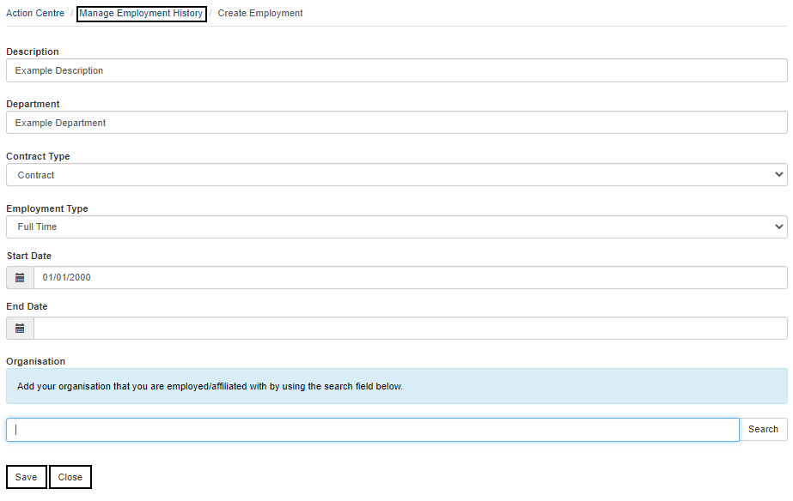
Figure 2.15 - Entering employment history

- Click on Save after updating your details.
- To add additional employment history, click Close to return to the Manage Employment History page, then click the Add Employment link.
- The Manage Employment History page lists each employment entry, and you can edit or delete as required.
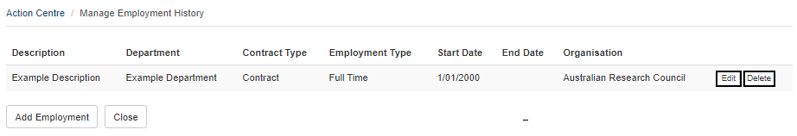
Figure 2.16 – Managing and viewing your employment history

2.5 Assessor Availability
    - Click on the Availability link of the Person Profile section of the Action Centre.
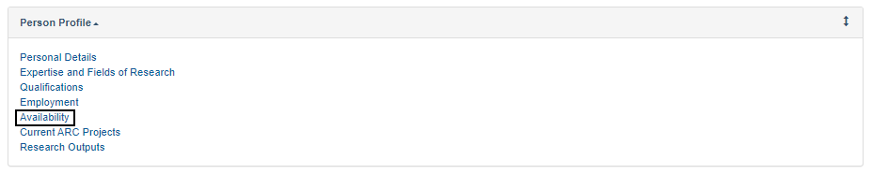
Figure 2.17– Select Unavailability from Person Profile menu
    - To add new periods of unavailability click Add New Item.
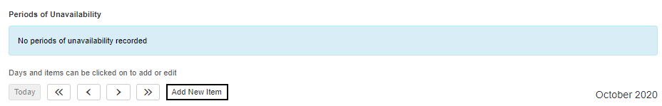
Figure 2.18 – Add New Item
    - Complete the details in the pop-up window – note that all fields are mandatory.
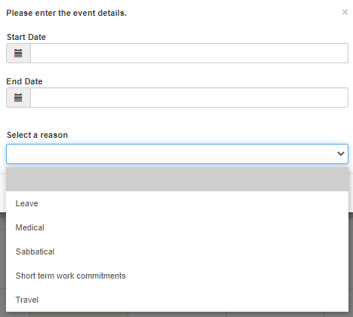
Figure 2.19 – Enter details of unavailability
    - Once you have entered all the details, you will be able to see the period of unavailability listed against your profile.
Figure 2.20 – Viewing entered Unavailability

2.6 Current ARC Projects
This section displays information on any current ARC projects that you are a participant on. This is populated from within RMS and you cannot update this page.

2.7 Research Outputs
Please see the separate guide: Research Outputs in RMS—Instructions for adding Research Outputs to your RMS Profile available on the RMS Information page of the ARC website.

PART 3 – Login, Navigation and Troubleshooting

3.1 Login to RMS
    - To login to RMS navigate to the relevant RMS Login page using the links as listed in the Key Points section of this document.
    - Enter the email address associated with your RMS account and your password. Click Login.
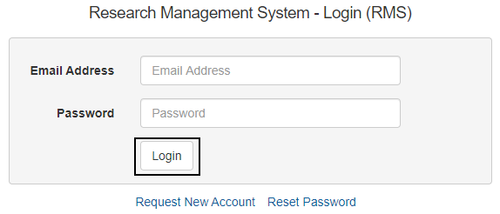
Figure 3.0 – RMS Login Page

3.2 Requesting a Password Reset
    - To reset your password, navigate to the relevant RMS instance Login page using the links as listed in the Key Points section of this document. Click on Reset Password.
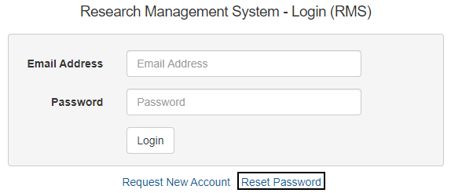
Figure 3.1 – Reset Password from Login Page

    - Enter the email address associated with your RMS account and click Request.
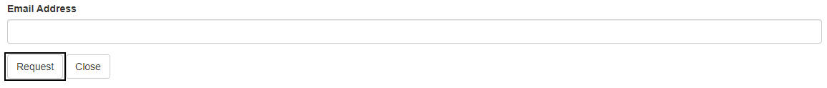
Figure 3.2 – Password reset – email address


Figure 3.4 – Password reset – request confirmation
    - If you cannot remember the email address associated with your RMS account, or you no longer have access to that email address, please contact RMS Support.
    - RMS will send an automated email containing a link Click here to reset your password which will open the password reset page.

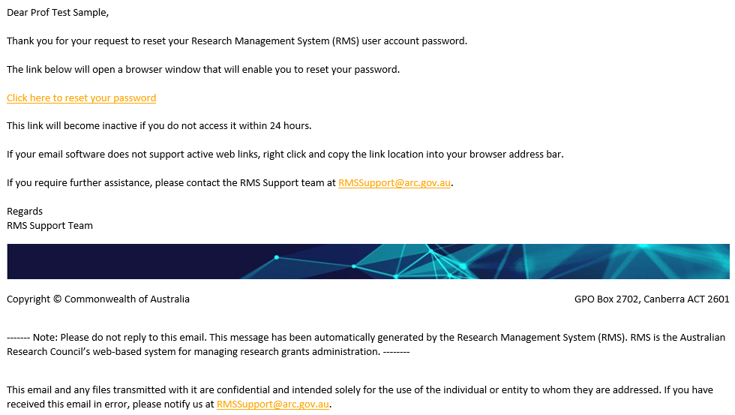
Figure 3.5 - Example of Password reset automated email
    - A password must not be one of your last 8 passwords and must be a minimum length of 14 characters and must contain at least three of the following character sets:
  - lowercase alphabetic characters (a-z)
  - uppercase alphabetic characters (A-Z)
  - numeric characters (0-9)
  - special characters (!@#$%&/=?_.,:;\-)
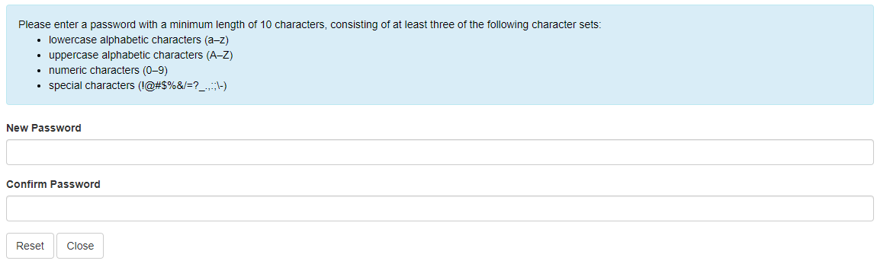
Figure 3.6 - Password Reset Page

Note: You can also change your password while logged into RMS by clicking on your name in the top right corner of RMS screen and selecting Change Password.
    - Enter in your new password, and then click the Change Password. Note that when updating your password from within your profile, the RMS will log you out and you will be prompted to enter your new password to access your account.
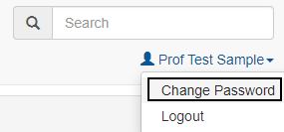
Figure 3.7 – Change Password Option
    - You can now login to RMS with your new password.
IMPORTANT NOTE:
You can only reset your password once every 24 hours. If you cannot remember the new password, you will have to wait 24 hours before trying again. However, RMS Support can override this if required
You must change your RMS Password every 12 months. If you do not change your password within the 12 months, RMS will lock your account.
Updating your password in one RMS instance will automatically update your password for all RMS instances.

3.3 Unlocking your account
    - RMS will lock your account if you enter the incorrect password 5 times, or you have not updated your password for 12 months.
    - You can unlock your account by requesting a Password Reset from the RMS Login Page (Section 2.2) or by contacting RMS Support.
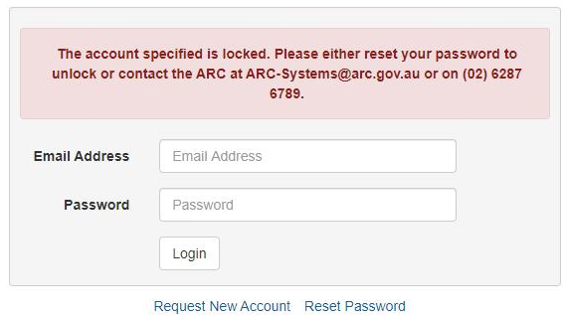
Figure 3.8 – Account Locked notification

3.3.1 Password troubleshooting
    - A password must be a minimum length of 14 characters and must contain at least three of the following character sets:
  - lowercase alphabetic characters (a-z)
  - uppercase alphabetic characters (A-Z)
  - numeric characters (0-9)
  - special characters (!@#$%&/=?_.,:;\-)
    - Please ensure that you are using the latest version of either Google Chrome or Microsoft Edge. Other browsers may have compatibility issues.
It may also be worthwhile clearing any saved passwords in your browser that may be auto filling the login details.

3.4 RMS navigation
    - On login you will see the main page called the Action Centre. The Action Centre will look different depending on the agency or program you have logged into, and what roles you have attached to your profile.
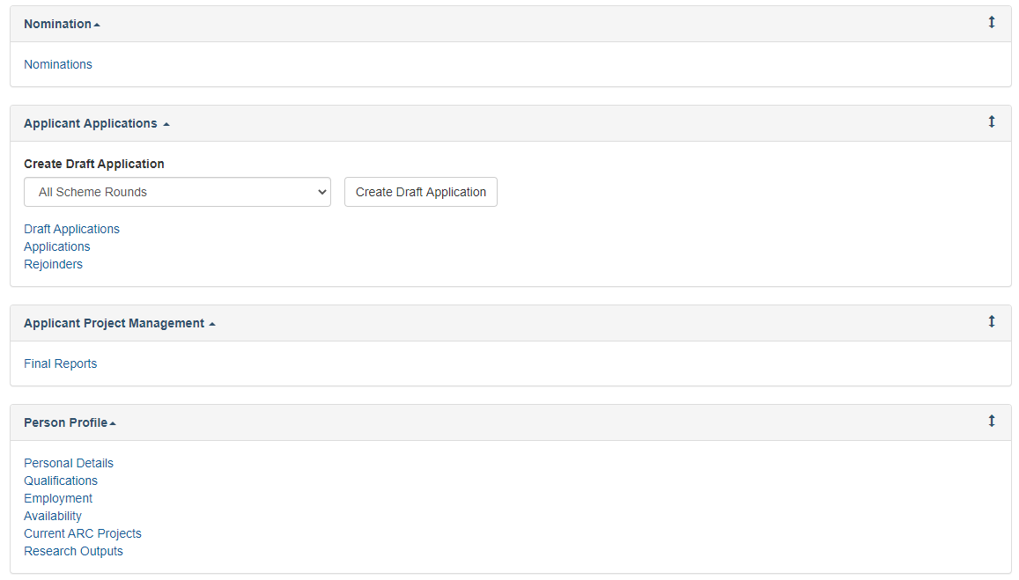
Figure 3.9 – Typical Action Centre for ARC-RMS

    - You can navigate to the required functions via the Action Centre.
    - You can tell where you are by the navigation path, also known as breadcrumbs, as shown in Figure 2.10. Navigate back to the Action Centre by clicking on the Action Centre link within the navigation path.
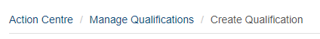
Figure 3.10 - Navigation Path – navigate back by the page links

3.5 Multi-factor Authentication
    - RMS security requirements must comply with the Australian Cyber Security Centre (ACSC) cyber security strategies and require Multi-factor Authentication (MFA).
    - This will be mandatory for ARC and Research Office Staff (privileged users) and optional for other users (non-privileged users). All RMS users will be able to set up MFA or opt out themselves.
    - Multi-factor authentication can be set up via ‘Personal Details’ from the Action Centre and then clicking on ‘MFA Settings’.
    - Any user with the mandatory roles (privileged users) will be required to set up MFA before they can access RMS or SEER.

3.5.1 MFA Settings using Mobile App
    - When a user with one of these roles enters their email address, password and then clicks ‘Login’; they will see the following screen (please note, this screen will not be displayed for mandatory users who have previously set up MFA on their account):
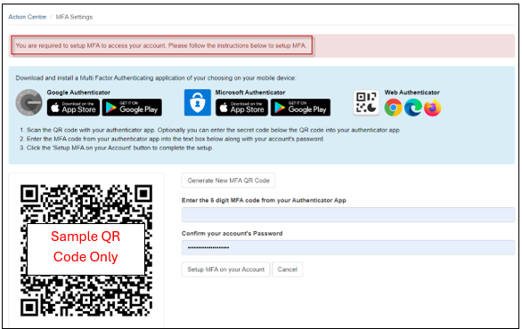
NB: these apps have security measures built into them that regenerates a new code every 30 seconds. If you try to re-use this code after the 30 seconds or enter the incorrect code, you will receive an error message.
    - Once MFA is set up, they will see the following message:
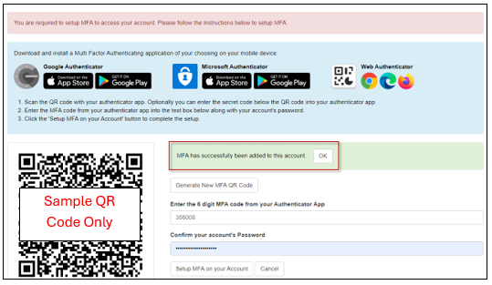
    - For all subsequent logons, users will need to enter their security code to access the system:
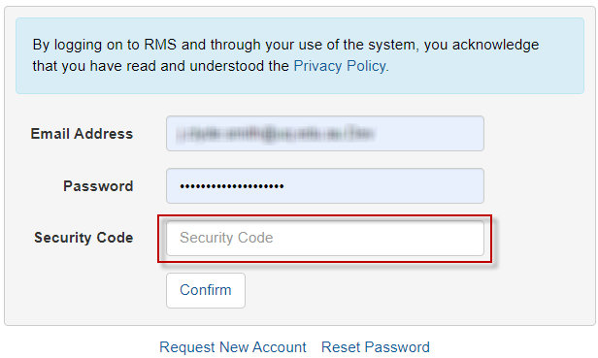
    - Users who are not in the mandatory category, can ‘opt out’ or choose to add MFA to their account. They will receive the following screen after clicking ‘Login’. (Please note, this screen will not be displayed for users that have previously set up MFA on their account or have opted out):
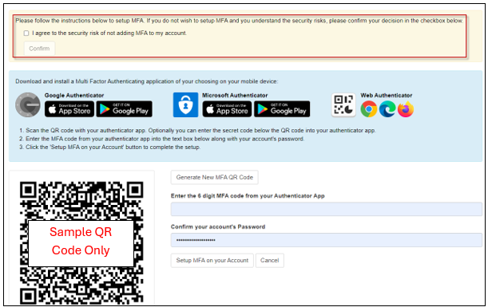

3.5.2 Setting up MFA in RMS using Desktop extension
    - Microsoft and Google add-ons or stores have the 2FA authenticator available. The examples below refer to Microsoft Edge. Once you have installed the app on your desktop, you will see an icon appear in the top right of your browser that resembles the 2FA logo. Clicking this icon will open the app.
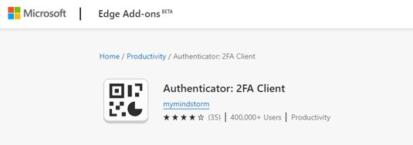
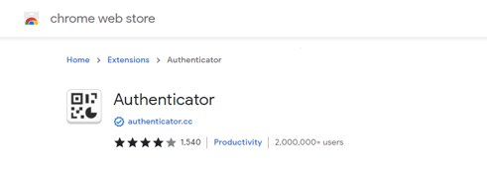
    - Authenticator Icon
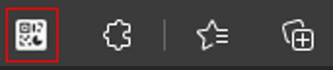
    - 2FA has the functionality to either scan or manual enter codes.
    - There are 3 steps to generate a code for the app. Step one is clicking the pencil icon in the top right.
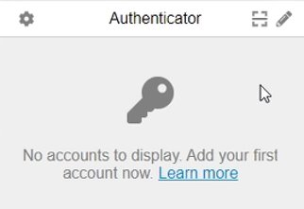
    - Step 2 shows a + or tick symbol. You will need to click the + symbol.

    - Step 3 will bring you the section that will prompt you to either to scan or manually enter a code.
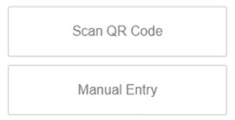

3.5.3 Manual Entry of MFA
    - Under the QR code, you will see a group of numbers and letters known as the “secret code”. This code is used in the manual entry section of the authenticator
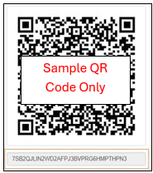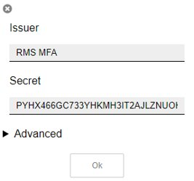
    - To assist in identifying which codes link to which system, you are able to give this code a unique identifier under “Issuer”.
    - Once you have renamed the “Issuer” and entered the code, click ok to generate the 6-digit code to be entered into in RMS.
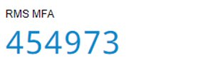

3.5.4 Scanning QR code for MFA
    - You can scan the QR code rather than manual entry by selecting the scan option. This brings up a scanning tool that can be used to highlight the QR code. The scanning option is a simpler process and automatically creates an “Issuer” name that is specific to the system you are using.

3.5.5 FAQs
Will MFA apply across other RMS platforms?
      - Yes. MFA will apply to all RMS instances. This includes NCGP, RGS and SEER.
Once MFA is set up on one RMS platform, will you have to do it separately for other RMS instances?
      - Yes. Each platform will require its own authentication process.
Will the current RMS default time out period be extended under this new system?
      - No. The time-out period is set by the Australian Cyber Security Centre. Session and screen locking prevents unauthorised access to a system which a user has already authenticated to.
If you set up with one type of authenticator, can you swap to another type at a later date?
      - Yes. However, if you use a new authenticator, please note that the previous authenticator will no longer work. We would recommend removing the older authenticator, before creating a new one.
Is it possible to use multiple MFA methods (e.g mobile app and desktop app)?
      - We suggest you use a single form of MFA authenticator. However, should it be necessary for you to swap between the mobile and desktop app, it will cancel out the former authenticator and you will need to set that up again next time you use it.
If non-privileged users opt out will they still have to update their password every 90 days?
      - No. Non-privileged users who reset their passwords to the 14 character requirements need only reset their password every 12 months. Refer to Password information at Key Points.

