End of Year Reporting:

RMS User Guide and Instructions for processing the 2025 EOYRs

Table of Contents
1. Information to note regarding submission of reports. 2
1.1 Accessing EOYR reports 2
1.2 Searching for and editing Reports 3
1.3 Mandatory fields 3
1.4 ARC Comments 3
1.5 Saving the Report 3
1.6 End of Year Report status 4
2. Completing EOYRs 4
2.1 Amending Start and End Dates 4
2.2 Project allocations table 5
2.3 Reporting the Amount Spent 6
2.4 Unspent Reason 7
2.5 Research Office Comments 9
2.6 Justification 9
2.7 Completing Progress Reporting section 9
3. Certification and submission of reports 10
3.1 Certification and accuracy of information 11
4. Submission to the ARC 12
Frequently Asked Questions 13

Information to note regarding submission of reports.
The Australian Research Council (ARC) requires that an End of Year Report (EOYR) be submitted for all active ARC projects.
The purpose of the EOYR is to collect information regarding the financial activity relating to ARC funding spent during the 2025 calendar year and reconcile it against ARC records. The purpose of this Report is also to collect information regarding any significant issues affecting the progress of a Project during the 2025 calendar year, from an administrative perspective.
EOYRs are completed and submitted to the ARC by the Administering Organisation (AO), via the ‘Research Office Project Management’ module in ARCs Research Management System (RMS). The EOYR must be certified by the ‘Research Office EOYR Delegate’ before it can be submitted to the ARC.
All 2025 reports must be submitted by 31 March 2026. Extensions must be requested from and approved by the ARC prior to this date and will only be considered under exceptional circumstances. All requests for extensions must be made by emailing arc-postaward@arc.gov.au.
It is the responsibility of each AO to ensure that the information contained in the Report is accurate and that all required fields are comprehensively completed.
Reports can be accessed in RMS by Research Office (RO) staff and ARC approved EOYR Delegates, relevant to their organisation.
For any RMS access issues, please contact the ARC RMS Helpdesk at ARCSystems@arc.gov.au.
All requests for AO EOYR Delegate access must be requested by emailing arc-postaward@arc.gov.au.
Note: RMS is compatible with the latest versions of Google Chrome and Microsoft Edge. Compatibility with different browsers or older versions of Google Chrome and Microsoft Edge is not guaranteed.

1.1 Accessing EOYR reports
- Login to RMS.
- In the Research Office Project Management section of the Action Centre, click on ‘Research Office Project Reports’.

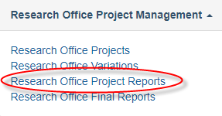

1.2 Searching for and editing Reports
In the Monitoring Reports tab, reports can be searched by selecting the relevant EOYR round from the ‘Report’ dropdown list. Reports can then be searched by:
- the ‘Program, Scheme and/or Scheme Round’ dropdown; or
- the status of the Report/s under the ‘Status’ dropdown list.
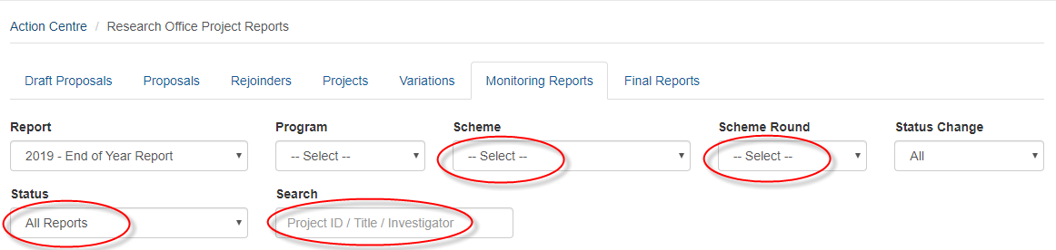
Once the relevant Report has been found it can be edited by selecting the ‘Form’ button, located on the furthest right for each Project’s row.
Reports can also be searched for by inputting the Project Title, Project leader name or status using the universal search field on the top right of the screen in RMS.


1.3 Mandatory fields
Several fields in the Report are mandatory and are required to be completed before the Report can be certified and submitted to the ARC. These fields will be highlighted in red and/or a warning will occur when there is information missing. The required fields are explained in detail at Part 2: Completing EOYRs.

1.4 ARC Comments
A field has been added for ‘ARC Comments’, to enable RO and ARC staff to query any issues and provide instruction on any corrections required to approve the EOYR. Should the EOYR be de-submitted and returned to the RO, please refer to this section for comments from the ARC.

1.5 Saving the Report
All changes to the Report must be saved. Should a user attempt to navigate away from the page with unsaved changes, a prompt will appear on the browser. The ‘Save’ button can be found at the top right of the page.
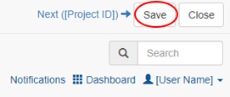

1.6 End of Year Report status
The progress of an EOYR can be tracked by status, which can be found on the Monitoring Reports tab, as described at 1.2 above.
ROs can also filter all reports based on these status’, by selecting the relevant ‘Status’ in the last drop down for of the Monitoring Reports tab, as described at 1.2 above.
The status and their meanings are as follows:
Status type | Explanation
Draft | Either nothing has been entered or not all mandatory fields have been completed
Ready to Submit | All mandatory information has been entered and the Report is ready to be submitted to the EOYR Delegate for certification
Returned to Research Office | The ARC has returned the Report to the RO to be amended
Submitted to RO EOYR Delegate | The Report has been submitted to the EOYR Delegate and is waiting to be certified
Certified | The RO EOYR Delegate has certified the Report and it is now ready to be submitted to the ARC
Resubmitted to ARC | The Report has been resubmitted to the ARC and is ready to be reassessed
Submitted to ARC | The Report has been submitted to the ARC and is ready to be assessed
Accepted | The ARC has assessed and accepted the Report
Waived | The ARC has waived the requirement for this Report

Completing EOYRs

2.1 Amending Start and End Dates
Noting that this can be done via the EOYR, it is the preference of the ARC that changes to the start and/or end dates are done via a variation. All requests for an extension to the End Date must comply with the relevant Grant Agreement and Guidelines.
Mandatory field
- Select ‘Yes’ or ‘No’ from the ‘Has the start/end date changed’ drop-down.
- If ‘Yes’ is selected, input the new date into the ‘Amended Start/End Date’ box.
- If ‘Yes' is selected for ‘Has the start date changed’, you must select ‘Yes’ for ‘Has the end date changed’ to maintain the project activity period.
IMPORTANT:
If the project Start Date is within the allowable timeframe (as outlined in the relevant Grant Agreement), updating the start date via the EOYR process is acceptable. However, if the start date is beyond this date, a Defer Commencement Variation will need to be submitted.
The Project End Date is the estimated date that ongoing Projects will conclude or if the Project has already been completed, it is the actual date that all ARC funds were expended.
Please note: Dates cannot be amended via the EOYR process for the following reasons:
- the start date
  - cannot be before the funding commencement date
  - cannot be changed into a future year, if spending has already commenced
- the end date cannot be
  - cannot be changed into a future year, if all funds have been spent and there are no future allocations, or if a recovery has been requested in the EOYR
  - cannot be in a previous year if there is either a carryover reported, there are future allocations, or if a recovery has been requested in the EOYR
  - cannot be changed if the project end date is not within the next 12 months
If any of these changes are made, a warning will be displayed, and the Report will not be able to be certified.
Please take care to ensure eligibility limits are not breached when adjusting End Dates. Although the ARC will consider all End Date requests, if it is found that End Dates are significantly changed to circumvent eligibility rules, the ARC will decline these requests.

2.2 Project allocations table
The following information is auto-populated from RMS records.
Field | Explanation
2025 Allocations | The net income received by the AO in 2025
2024 Carryover Amount | The approved EOYR carryover amount from 2024 to 2025. This will also include any approved variations processed in 2025 (if relevant)
Total Amount Available | This is the sum of the '2025 Allocations' + '2024 Carryover Amount'
Total Amount Unspent | This is the carryover request from 2025 to 2026

IMPORTANT: This table is accurate as at completion of Pay 12. Any variations completed after Pay 12 will not update this table. If the 2024 Carryover Amount or Total Amount Unspent does not match the AO’s financial acquittals, there may be a variation that was pending after Pay 12, or previous spending has been inaccurately reported. Please review the project’s finances in RMS and advise of discrepancies to arc-postaward@arc.gov.au.

2.3 Reporting the Amount Spent
Mandatory field
- Enter the total amount spent in 2025 for the entire Project, including funds spent at Participating Organisations.
- For Fellowship or Awards, Centre of Excellence and ITRP projects, please provide an expenditure breakdown (by completing either Table A or Table B) after the Total Amount Unspent, to assist in processing this EOYR.
Table A: Fellowship and Awards (FL, FT, DE, IL, IM, IE)
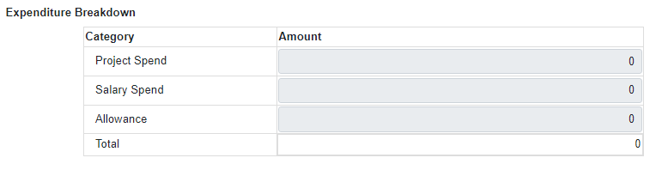
Table B: Centre of Excellence and Industry Transformation Research Program (CE, IC, IH)
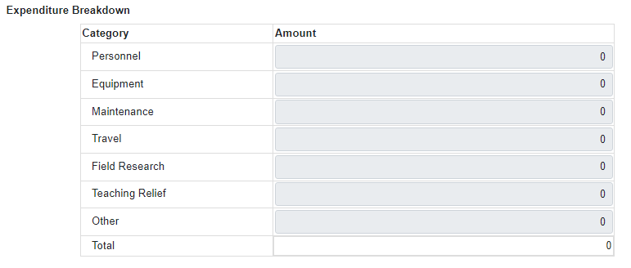
IMPORTANT: The AO is responsible for reporting all ARC funding for Projects, regardless of the location of funds. ARC funding is only to be reported as spent by the AO if the funds are spent, including the funds located at other Organisations. Funds are not to be 'written off' because they are located outside the AO. If this is done, it will be seen as committing a fraudulent act and may result in serious action taken by the ARC.
An amount that is less than $0 or greater than the ‘Total Allocations’ displayed for the Project cannot be entered into this field. The use of symbols such as $, or comma's must not be entered into this field. Only numbers may be entered into this field and a full stop to show the cents. For ARC Centres of Excellence, Industrial Transformation Research Hubs and Training Centres, and Special Research Initiatives that have received Establishment Funds but have not yet commenced, you should put $0 in the Amount Spent box and a comment in the RO Comment box that Establishment Funds used will be reflected in the next years’ EOYR.

2.4 Unspent Reason
Mandatory field
To add a reason code, select the most appropriate code from the list and click ‘Add’.
To remove a reason code, select the ‘x’ button associated with the appropriate code.
Please note: if the ‘Other’ reason code is selected, the RO Comments field will become mandatory, and a reason must be entered.
IMPORTANT: If there is any carryover requested (i.e. less than the full '2025 Total Allocations' have been spent), at least one ‘Unspent Reason’ Code must be selected (see table on below). More than one ‘Unspent Reason’ code may be selected from the list.
Reporting on issues that affected the academic progress of the Project during the 2025 calendar year should be reported in the Progress Reporting section of the Report.
If there are changes that need to be made to the Project, entering in a Reason Code does not replace the need for a submission of Variation.
The following unspent reasons can be found in RMS:
Reason code | Explanation
Late Project start | Project started late (e.g. due to late signing of agreement/s, ARC approved deferment, moved from overseas). Please do not use this for years 2 onwards unless the Project has not yet started (i.e. approved deferral)
Late Student Start | Late commencement of HDR/PGR Student funded directly from the grant
Late Staff Start | Late commencement of staff funded directly from the grant (that are not named participants or students)
Leave/suspension | Named participant/s on the project took a period of leave or suspension during the reporting period
Withdrawal of named Investigator | Withdrawal of named participants (CIs and PIs only)
Student resigned | Resignation of student funded by the Project
Work Hours Change (salary position only) | ARC approved change in work hours (% of FTE) for a position funded by the Project. A Variation should have been submitted to support this
Project Transfer | Project transferred during the reporting period
Investigator Organisation change | Delays due to movement of named investigators (CIs and PIs only)
Seasonal Fieldwork | Seasonal nature of fieldwork (e.g. wet season, migratory practices, remote community access, natural disaster etc.)
Equipment Issue/s | Equipment Issues (e.g. breakdown of Project equipment, unavailability of new equipment causing delays, delay in new equipment being available from supplier, delay in construction of equipment)
Late Invoicing | Late invoicing for services or equipment that were not paid in the reporting period
Task Rescheduling | Rescheduling of tasks, resulting in expenditure being moved into the following year
Other (must specify reason) | If Other is chosen, a mandatory reason must be submitted. (Please provide details in the RO Comment field – Part E)
Recovery | A recovery occurs when unspent ARC funding is repaid to the ARC. When funds have not been spent and there is no approved carryover, ARC funding will be recovered. Please make sure to only include this reason if there are funds to be recovered by the ARC. Please make a reference to variation if a recovery has already been entered into RMS.  ‘Recover’ reason code should only be selected if the project is to relinquish the remaining unspent amount and not when the project has transferred throughout the year.  IMPORTANT – The RO Comments section must confirm:  - The total expenditure by the AO on the project  - The total amount to be recovered by the ARC  For projects with salary funding, a breakdown of spending against Project Funds and Salary is required.
Transfer Correction | When a project has been transferred from the AO and there is a balance remaining, this Reason Code should be selected.  The total expenditure by the AO on the project should be confirmed including the balance to be sent to the new AO. A breakdown of spending against Project Funds and Salary is required for salary funded projects.  The ARC will contact the ROs of previous and current AOs for confirmation before accepting the EOYR.

2.5 Research Office Comments
This field is mandatory if the ‘Other’ reason code is selected. This field should be used to respond to ARC Comments and communicate any additional administrative issues with the ARC. For example, if the project financials have been amended after Pay 12 has closed, it will not be reflected in RMS, this should be noted in the ‘Research Office Comments’ field.

2.6 Justification
If the ‘Total Amount Unspent’ (carryover request) is more than 75% of the 2025 calendar year allocation or over 12 months (includes carryover from 2024) a mandatory ‘Justification’ must also be entered.

2.7 Completing Progress Reporting section
This part of the report enables Progress Reports to be submitted to the ARC.
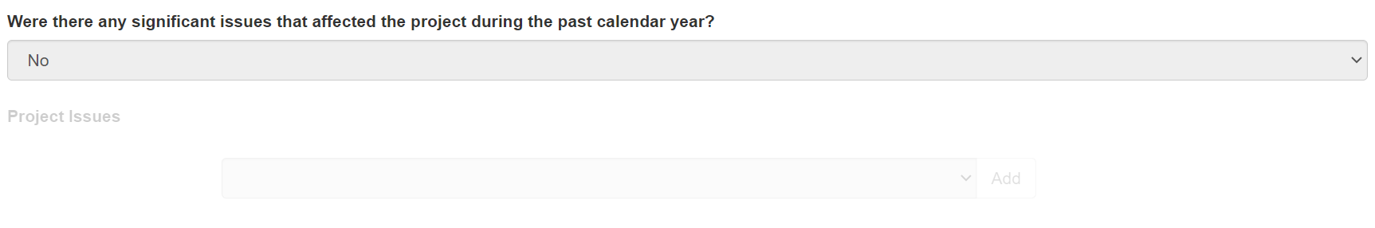
Mandatory field
This question will only have to be answered as ‘Yes’ if the Project’s progress was affected during the 2025 calendar year, and this was not already reported in a previous calendar year.
The Project issues selected should only relate to any research issues that affected the progress of the Project during the 2025 calendar year, this should not be a copy and paste from previous years. If the answer to this question is ‘Yes’, at least one ‘Project Issue’ must be selected from the dropdown menu provided.
To add a project issue reason code, select the most appropriate code from the list and click ‘Add’.
To remove a project issue reason code, select the ‘x’ button associated with the appropriate code.

The following Project Issues can be selected from in RMS:
Project Issues
Approved change to work hours (% of FTE) for a named Investigator on the Project resulted in changes to the end date
Issues with Partner Organisation such as: contributions not received, change in Partner investigator, change in Organisational structure, Organisation left the Project
The scope/budget of the Project was altered to include/exclude tasks listed in the Proposal
Equipment issues have delayed the Project during the reporting period
Fieldwork issues have caused a significant delay to the Project during the reporting period
Project was delayed as it was transferred during the reporting period, and this significantly impacted the Project
Due to personal reasons member/s of the research team had to take time off the Project to attend to personal health/carer matters (does not include support staff)
Changes within the research team such as Personnel left or joined the team (does not include support staff)

Certification and submission of reports
Once all required information has been entered, RO staff must submit reports to the EOYR Delegate for assessment and certification. The EOYR Delegate can then either de-submit the reports back to the RO staff to make changes or certify and submit the report to the ARC for assessment.
All reports can be Submitted/Certified via two options.
- Inside the report itself by selecting the button at the top left-hand side of the screen within the individual EOYR
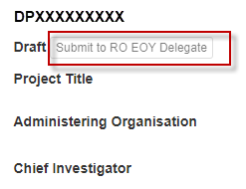

- Using the Monitoring tab using the bulk submission options


3.1 Certification and accuracy of information
EOYRs must be checked and certified by the RO EOYR Delegate before they can be submitted to the ARC. RO EOYR Delegates are required to certify that the Project has complied with the relevant schemes Grant Guidelines and Grant Agreements and that all information provided within the report is accurate and up to date. Submission of this report must only be done by a person who has the financial delegation to do so on behalf of the AO, as this is a legal document that is being supplied to the ARC.
The ‘Submitted to Research Office (Valid)’ status will appear against each Report which is ready to be certified. Once certified, the status of the report will appear as ‘Certified’ and may then be submitted to the ARC by RO staff.
Please note: The EOYR Delegate cannot make changes to the reported information unless they have ‘Research Office Staff’ access in RMS. Having both access levels will allow the EOYR Delegate to enter/edit details in the report and submit directly to the ARC, without the need for de-submission.
IMPORTANT: Only staff approved by the ARC to have EOYR Delegate access will be granted this access in RMS. The ARC Helpdesk is not authorised to make these changes in RMS. If anyone is found to have this access in RMS without the relevant approvals, they will have their EOYR Delegate access removed immediately.
The following prompt will appear once the ‘Certify’ button has been selected:
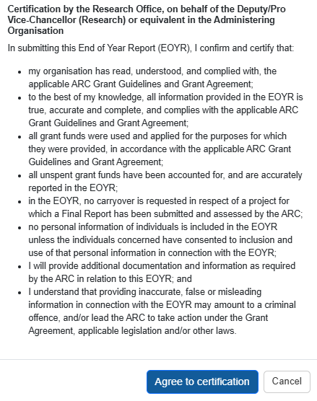
The EOYR Delegate must select the ‘Agree to certification’ for each EOYR before they can be submitted to the ARC.

Submission to the ARC
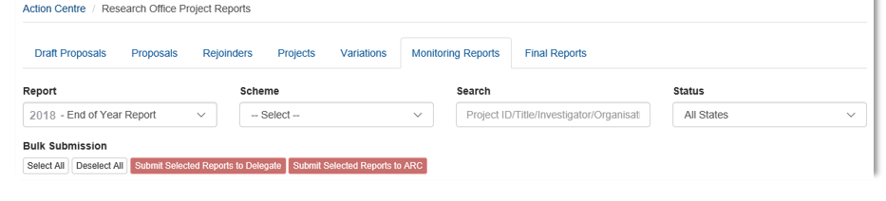
Submission of EOYRs to the ARC can be submitted by the EOYR Delegate or RO staff with RMS access once Certified by the EOYR Delegate, and can be done in two ways:
- To submit individual/blocks of reports to the ARC, select the Project/s that are required to be submitted to the ARC and select ‘Submit Selected Reports to ARC’.

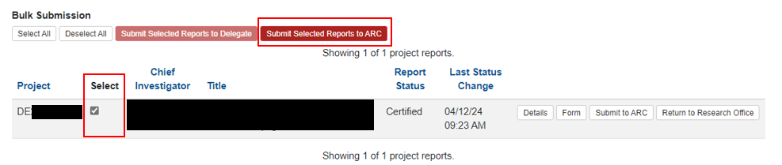
- To submit reports in bulk, click the ‘Select All’ button and then select ‘Submit Selected Reports to ARC’.

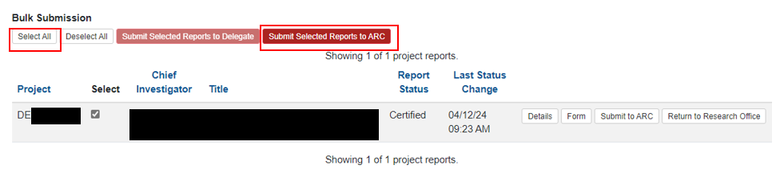
Please note that EOYRs can also be submitted to the EOYR Delegate and Certified within the Report itself.
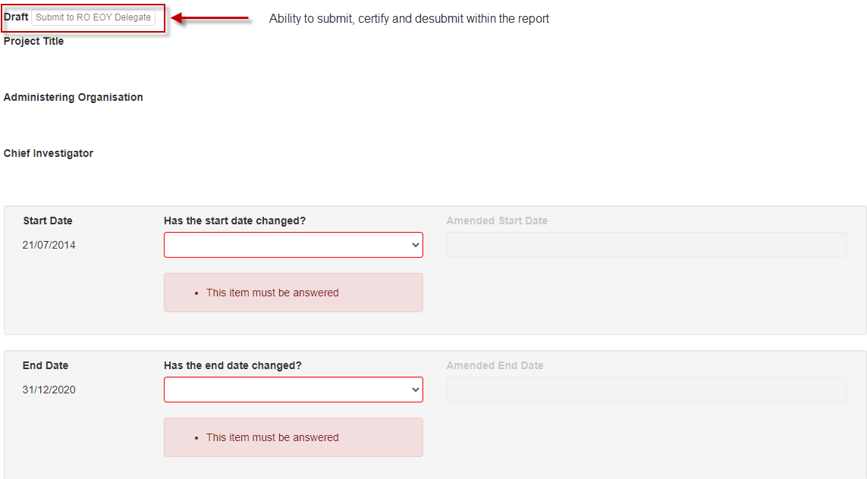

Frequently Asked Questions
Some information on screen maybe incorrect, how can this be adjusted?
For any queries regarding the information on screen, please contact the ARC at arc-postward@arc.gov.au. Make sure to include the Project ID and the details of the issue.
What is a carryover?
A carryover may occur when there is remaining ARC funding for a Project unspent in a calendar year. Funds may be made available to spend in the subsequent calendar year through the approval of a carryover request via the EOYR process. Funds not spent and not approved for a carryover may be recovered* by the ARC.
*A recovery occurs when unspent ARC funding is repaid to the ARC. When funds have not been spent and there is no approved carryover, ARC funding will be recovered.
Is the active project period as described in the Grant Agreement enforced by the ARC?
Yes. The ARC will check to see if the project has been undertaken in the number of years allowed as per the Grant Agreement, plus any period of leave or suspension approved by the ARC.
Does RMS show if an EOYR has been approved?
The status of the EOYR will appear as “Accepted” in RMS.
How will I know when an EOYR has been approved?
RMS allows RO staff to subscribe to notifications, including status changes, such as approvals, for EOYRs.
What circumstances might cause a carryover request to be rejected?
Projects that have been completed, terminated or relinquished cannot carryover any unspent funding. Funds can also not be carried over if the Final Report has been submitted (which certifies/confirms the completion of the project) or if the ARC has not approved an extension to the End Date.
Can carryover funds be spent before the ARC has approved it?
Yes. The ARC will allow funds to continue being spent, however it is the responsibility of the AO to ensure that by doing so, the Project has not gone beyond the allowable timeframe. If the ARC has already provided advice to say that the project must come to an end, any funds spent beyond this date is the responsibility of the AO.
What if the ARC approved a defer commencement? Does this change when the limits are calculated?
The number of active years is calculated based on the ARC approved start date in RMS. If there has been an ARC approved defer commencement, the ARC will calculate the number of years the project has been active from that date.
Can additional information be included in the EOYR?
There is an optional Research Office Comments field in every EOYR. This field is limited to 500 characters and should contain notes from the RO to ARC staff only. Variations cannot be submitted through this field, but the RO staff may indicate that a variation is to be or has been submitted.
What if there was an overspend on the Project?
The ARC will not reimburse overspends and the funding should be reported as fully expended in the EOYR. RMS will not accept negative figures.
Can the University salary contributions be charged to the ARC Project and then the University just pay the difference in the final years?
No. This is a breach of the ARC Agreement and will be treated as fraudulent activity if it is found that the AO has not acquitted the salary correctly. Any AO found to undertake this practise risks losing the funds for these projects.
When should salaries be acquitted?
Salaries should be acquitted each year. It is the responsibility of the AO to ensure funds are accurately expended and acquitted each year and this activity is not withheld until the end of the Fellowship/Award/Project.
When does a Progress Report by exception need to be submitted?
If no additional changes or administrative issues have affected the Project than those already reported to the ARC, then a report does not need to be submitted and ‘no’ should be selected. If changes are made to the project without the ARC approving a Variation, then a report will need to be submitted.
Example:
If a Project has been approved by the ARC to be transferred and the Project was able to be resumed at the new AO within the originated timeline expected, then the first question may be answered as ‘no’.
However, if the approved transfer resulted in unexpected delays that significantly affected the Project’s progress, then the first question should be answered ‘yes’.
Who can submit to the ARC?
Those with RO Staff role access in RMS can edit, save information and can submit EOYRs to the ARC once they have been certified by the EOYR Delegate. Only EOYR Delegates can certify EOYRs. If an EOYR Delegate has both access levels, they can enter details into RMS and submit directly to the ARC.
A maximum of two EOYR Delegates should have been nominated from each AO. Each EOYR Delegate must have the appropriate financial/legal delegation within their AO to certify the reports and cannot be granted to a lower level staff member. If the EOYR Delegates needs to be updated for the AO, please contact the ARC (arc-postaward@arc.gov.au). The ARC has the right to not accept a nomination for an EOYR Delegate if we believe that the person does not have the appropriate delegate authority.
What if a Project finished in 2025, does an EOYR still need to be completed?
An EOYR must be completed for any Projects that were completed in 2025 if any funds were spent in 2025 (including any carryover from 2024) or retained at the AO.
If the Project has any ARC funds to be recovered, select reason code ‘Recovery’ and include a comment providing the information listed under ‘Recovery’ in this document.
What if a Project was transferred in 2025, does an EOYR still need to be completed?
An EOYR must be completed if any funding was reported as spent in 2025 in the transfer documentation.
Enter the 2025 expenditure in the ‘Amount Spent’ field, select reason code ‘Project Transfer’ and include a comment noting that the Variation request has been approved by the ARC.
What if there is a mistake in the EOYR and it needs to be changed?
Email arc-postaward@arc.gov.au to request a report be de-submitted back to the RO. However, if the Report has been accepted by the ARC, the change will have to be made manually outside of the EOYR application. Any issues from previous years’ reports may also be able to be fixed manually but must be done by emailing the details of the required change to arc-postaward@arc.gov.au. ARC staff will create a Variation as per the RO request, and submit this to the ARC Delegate for consideration.

