
Progress Report Instructions
RMS user guide and Instructions

For rounds funded in the following schemes:
- Special Research Initiative Program for funding commencing in 2020 R1

Contents
Progress Reports: Information to note 4
When to submit a Progress Report to the ARC 4
Progress Report Extensions 4
Waiver requests 4
Administration of Progress Reports in RMS 4
Certification and accuracy of information 5
Updating of Progress Report once submitted to the ARC 5
Accessing Reports 6
Starting a Progress Report in RMS 6
Director or COO/BM 6
Research Office Staff 7
Mandatory fields 7
How to add multiple answers and remove answers within questions. 8
Adding and removing multiple answers 8
Adding and removing an option 8
Uploading a file 9
Completing the Progress Reports Form Parts 9
Saving the Report 10
ARC Comments fields 10
Submitting a Form 11
Director or COO/BM 11
Research Office Staff 13
Progress Report status 16
Return to Research Office 17
Part A – Project Themes 18
A1 Themes 18
Part B – Themes 19
B1 Theme 19
B2 Theme Review 19
B3 Theme Updates 23
Part C – Governance 24
C1 Governance Plans 24
C2 Personnel Demographics 26
What are gender demographics among Programs personnel? 26
What are gender demographics among student personnel? 26
Part D – Highlights / Case Studies 27
D1 Highlights 27
D2 Case Studies 28
Part E – Partner Contributions 29
Part F – Key Performance Indicators 31
Traditional and Non-traditional outputs 32
F2. Non-traditional Research Outputs 32
F3. Number of workshops/conferences held/offered by the Project 33
F4. Number of training held/offered by the Project 33
F5. Number of Postgraduate commenced and completed 33
F6. Number of additional researchers working on Project research 35
F7. Number of government, industry and business community briefings 35
F8. Number of new organisations collaborating with, or involved in, the Project 36
F9. Number of female research personnel 36
Part G – Outreach 37
G1 Describe the Project's Outreach Strategy 37
G2 Grant Outreach 37
G3 Provide a summary of Project’s Top 10 outreach and engagement activities 38
Part H – Lodgment of Publication 40
Part I – Annual Report 42

Progress Reports: Information to note
The Australian Research Council (ARC) requires a Progress Report be submitted for each ARC funded project through the Special Research Initiative Program 2020 Round 1 (SR20 R1).
These instructions provide information to assist Research Office (RO) staff and Project participants in the completion and submission of ARC Progress Reports in the Research Management System (RMS).
The Project Director with the assistance of the Chief Operating Officer (COO)/Business Manager (BM) are responsible for the completion of the Progress Report and its submission to the Administering Organisation’s (AO) Research Office. The Director, COO/BM and Research Office staff all have full edit access to the Progress Report. The Research Office Delegate is responsible for the certification of the form and submission of Progress Reports to the ARC.
If, after consulting this document, there are any queries regarding completing the Progress Report form in RMS, please contact the Administering Organisation’s Research Office.
Please note: Paper copies or any other electronic format of the Progress Report will not be accepted by the ARC.

When to submit a Progress Report to the ARC
Progress Reports are due by 31 March the year following the reporting period. For example, progress reports for the 2025 reporting period are due 31 March 2026.

Progress Report Extensions
Extensions for Progress Reports must be requested and approved by the ARC via the Administering Organisation’s Research Office. The request must note the Project ID and explain the extenuating circumstances. All requests for extensions must be made in writing to ARC Post Award by emailing ARC-Postaward@arc.gov.au before the due date.
Please note: the ARC will only accept requests for an extension to the Progress Report due date if received from the Research Office of the Administering Organisation. Requests from researchers or other Participating Organisations will not be accepted.

Waiver requests
If there is a Project that may be eligible for the Progress Report to be waived, email the Administering Organisation’s Research Office with the Project ID and a justification as to why the request is being made. All requests to waive a Progress Report must be made in writing to ARC Post Award by emailing ARC-Postaward@arc.gov.au before the due date.
Please note: The ARC will only consider a waiver request for a full Progress Report will be if the project is still within the establishment phase or within the final six (6) months of the project end date.

Administration of Progress Reports in RMS
Progress Reports can only be accessed and managed through RMS. For general instructions on how to use RMS, please refer to the RMS User Guide available on the ARC website.
All requests for RO Delegate access must be made in writing to ARC Post Award by emailing ARC-Postaward@arc.gov.au.
For any RMS access issues, please contact the ARC RMS Helpdesk at ARC-Systems@arc.gov.au.
Note: RMS is compatible with the latest versions of Google Chrome and Microsoft Edge. Compatibility with different browsers or older versions of Google Chrome and Microsoft Edge is not guaranteed.

Certification and accuracy of information
Progress Reports must be checked and certified by the Research Office Delegate, before they can be submitted to the ARC. The Research Office Delegates is required to certify that the report is complete and that all information provided within the Progress Report is accurate and up to date.
The ‘Submitted to Research Office (Valid)’ state will appear against each Report which is ready to be certified. Once certified, the state of Progress Reports will appear as ‘Research Office Certified’ and can then be submitted to the ARC by Research Office staff.
The following prompt will appear once the ‘Certify Progress Report’ button has been selected:
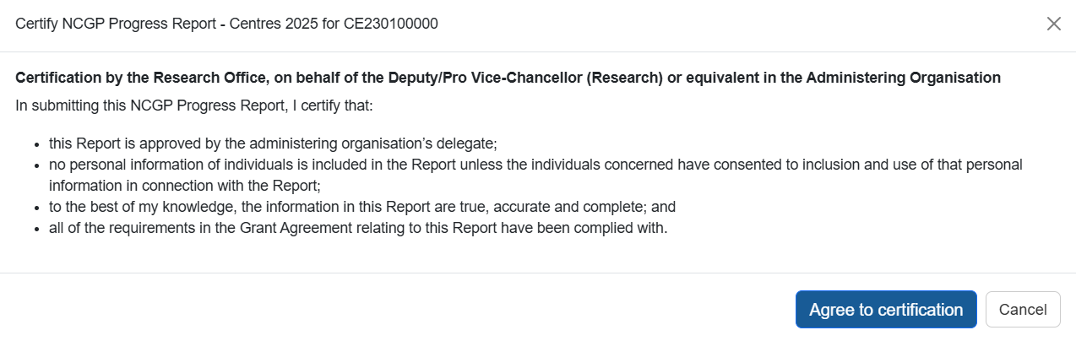

Please note: information collected in the Progress Report is used to determine whether the Project is progressing towards satisfactory completion. Statistical information collected in Progress Reports enables the ARC to account for public funding of research and to promote the value of research to the Australian community. As such, the ARC reserves the right to reject Progress Reports to seek further clarification on information submitted or the lack thereof.
Please check that all information contained in the Progress Report is accurate and that all required questions are completed as comprehensively as possible.

Updating of Progress Report once submitted to the ARC
If a Director and/or COO/BM needs to edit a Progress Report after submission, Research Offices can request that the Progress Report is de-submitted back to them up until it has been approved by the ARC. Once a report is assessed and approved by the ARC, the ARC will not allow edits to the report.

Accessing Reports
To access a Progress Report in RMS you must be Research Office (RO) Staff or have an approved role in a project.
Project roles with access to the Progress Report are:
- Project Director
- Chief Operating Officer (COO)
  - This role is a system title that captures roles such as Business Manager (BM) and COO

Starting a Progress Report in RMS

Director or COO/BM
- Login to RMS.
- In the ARC Applicant Project Management section of Action Centre, click on ‘Project Reports’.

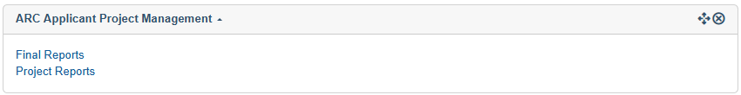

Searching for and editing Reports
- Click the ‘Report’ drop-down and select the relevant form ‘NCGP Progress Report – SRI’. The reporting year is indicated on the name of the form.

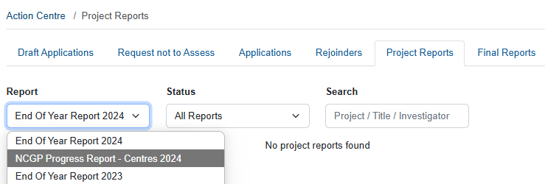

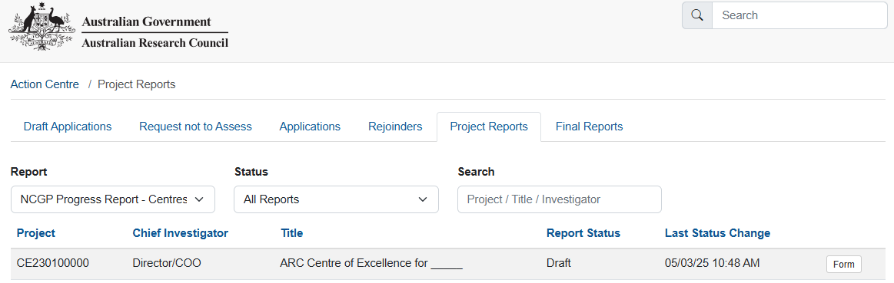
- In the filtered search results click ‘Form’ to edit the report for the desired project.

Research Office Staff
- Login to RMS.
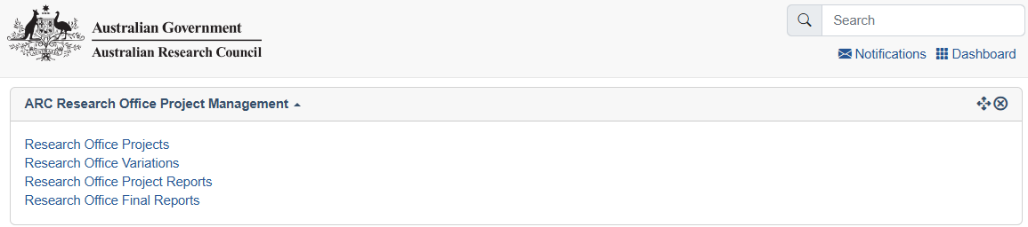
- In the ARC Research Office Project Management section of Action Centre, click on ‘Research Office Project Reports’

Searching for and editing Reports
- Click the ‘Report’ drop-down and select the relevant form ‘NCGP Progress Report – SRI’. The reporting year is indicated on the name of the form.
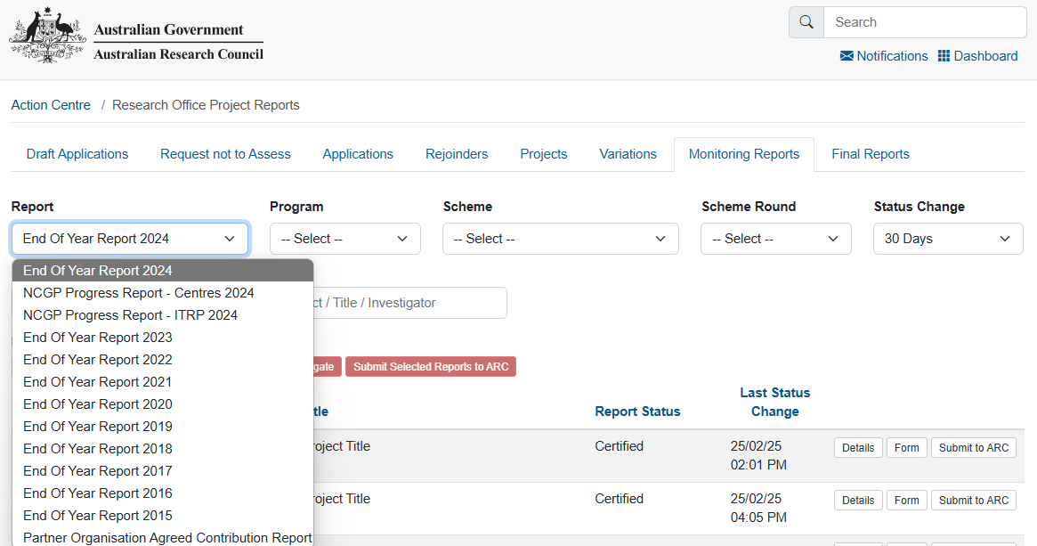
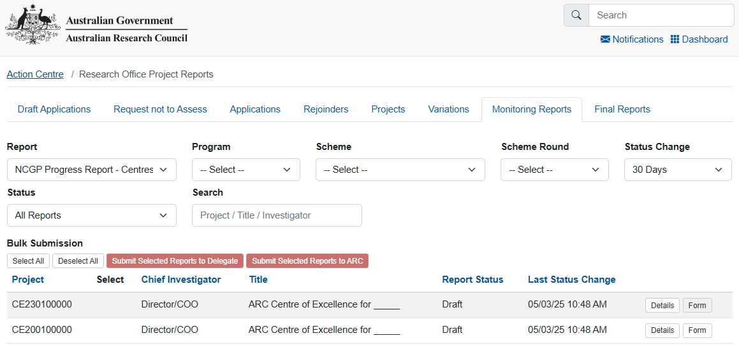
- In the filtered search results click ‘Form’ to edit the report for the desired project.

Mandatory fields
Several fields in the Report are mandatory and must be completed before the Progress Report can be certified and submitted to the ARC. The required fields are explained in detail, later in this document.
A mandatory question will be highlighted red, and the following banner will appear under the question indicating it must be answered: 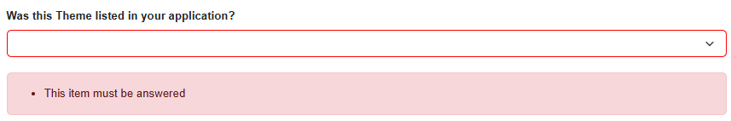

How to add multiple answers and remove answers within questions.

Adding and removing multiple answers
- To enter multiple answer panels for a given question, select ‘Add Answer’ at the bottom of the question or the questions answer panel.

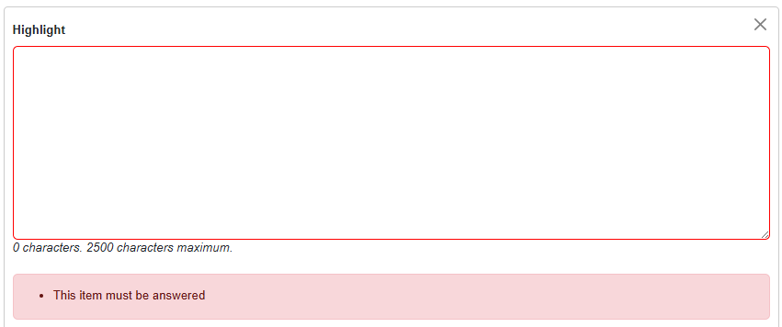
- To remove an answer panel, select the cross ‘X’ in the top right of the answer panel for the answer that needs to be removed.

Adding and removing an option
- To add, select the option from the drop-down menu or ‘search’ function and click ‘Add’.
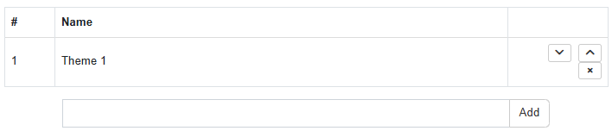
- To remove, select the ‘x’ beside the option that needs to be removed.

Please note: All options can only be added once. Click ‘Add’ otherwise the selection will be lost the next time ‘Save’ is hit.

Uploading a file
- Click ‘Choose File’ and select a file to upload 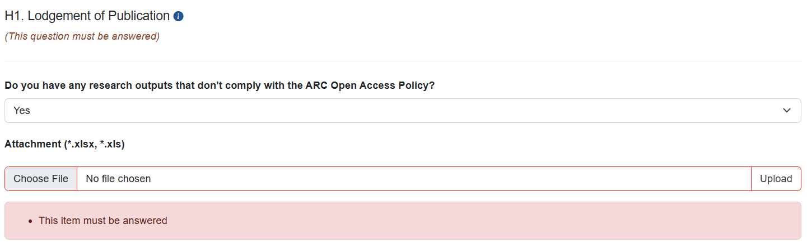

- Click ‘Upload’ to upload the file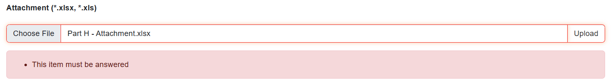

- Click ‘Save’ at the top right of the page to ensure this is uploaded. 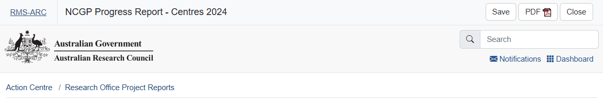

- When completed correctly the file will appear under the upload field as a downloadable hyperlink. 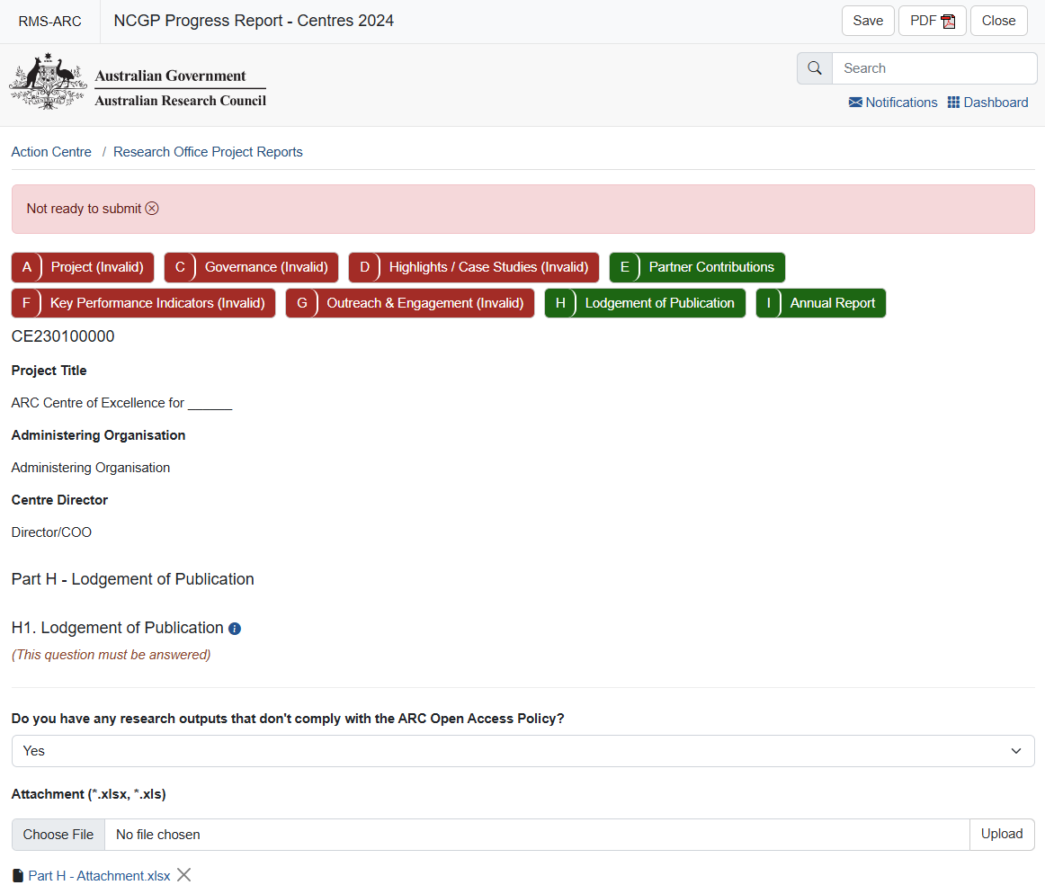
Removing an upload
a) Clicking the ‘X’ and saving removes an upload.
b) You may also replace an uploaded document by following the above steps from a) to d). Only one file may be uploaded.

Completing the Progress Reports Form Parts
To begin filling out the Progress Report, click on the relevant form part at the top of the screen to navigate between form parts, beginning with Part A.
Please note: Within the heading of the form, the colour of the parts will be indicated as either red – meaning that they are incomplete and therefore invalid; or green – meaning that they are completed and valid.
Please remember to save regularly as you complete the form, using the ‘Save’ button located at the top right of the page.
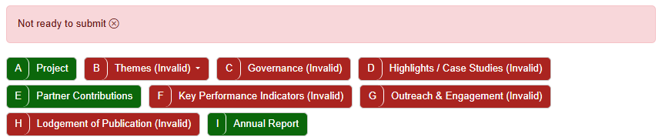

Saving the Report
All changes to the Report must be manually saved (no automatic saving). Should a user attempt to navigate away from the page with unsaved changes, a prompt will appear on the browser. The ‘Save’ button can be found at the top right of the page.



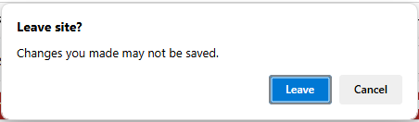
NOTE: Should your browser remain idle for an extended period, RMS will automatically log you out and your work will not be saved. Ensure you save your work on a regular basis.

ARC Comments fields
‘ARC Comments’ fields have been included in each Part of the Progress Report form to enable ARC staff to query any issues and provide instruction on any corrections required prior to approving the Progress Report. Should the Progress Report be returned to the RO, please refer to this section for comments from the ARC.
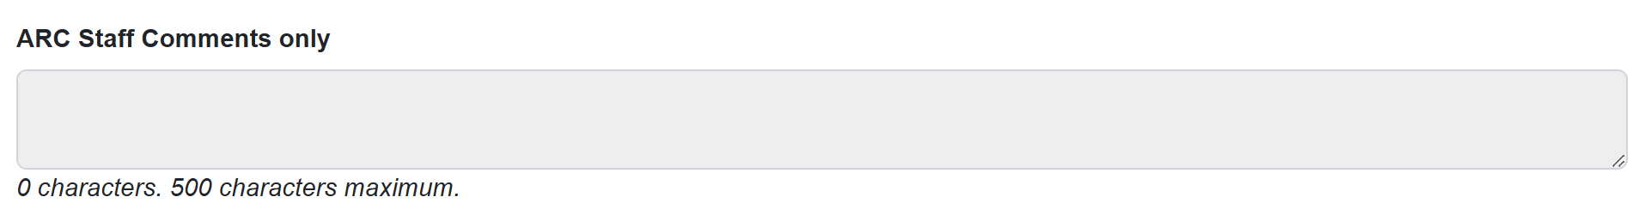

Submitting a Form
When all parts of the form are Green, the Report is ready to be submitted to the research office and its status will update to ‘Ready to Submit’.
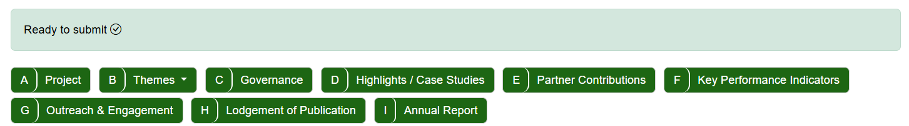

Director or COO/BM
- Login to RMS.
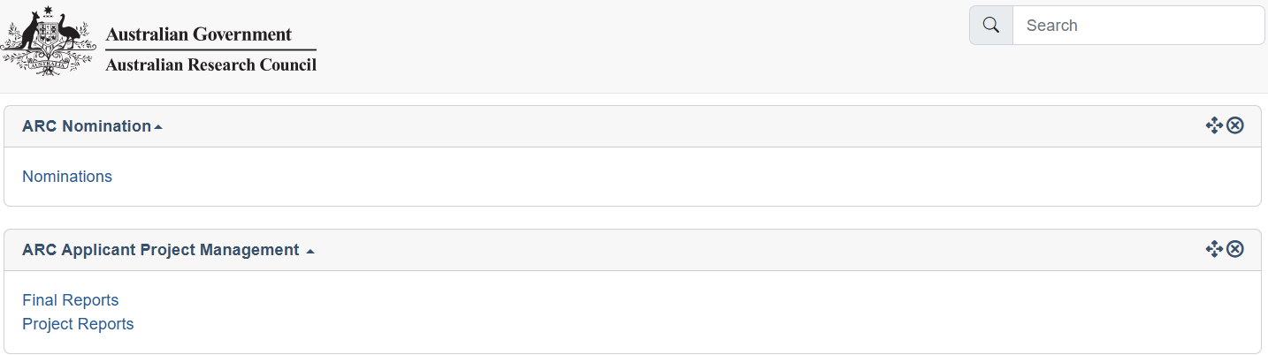
- In the ARC Applicant Project Management section of Action Centre, click on ‘Project Reports’.
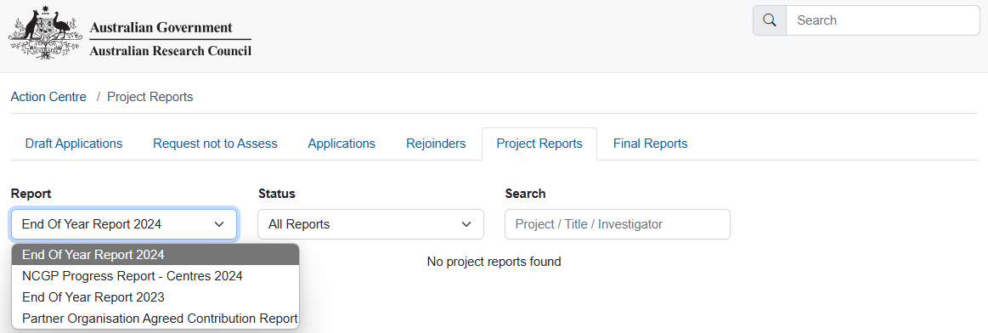
- Click the ‘Report’ drop-down and select the relevant form ‘NCGP Progress Report – SRI’. The reporting year is indicated on the name of the form.

- In the filtered search results click ‘Submit to RO’ to edit the report for the desired project.
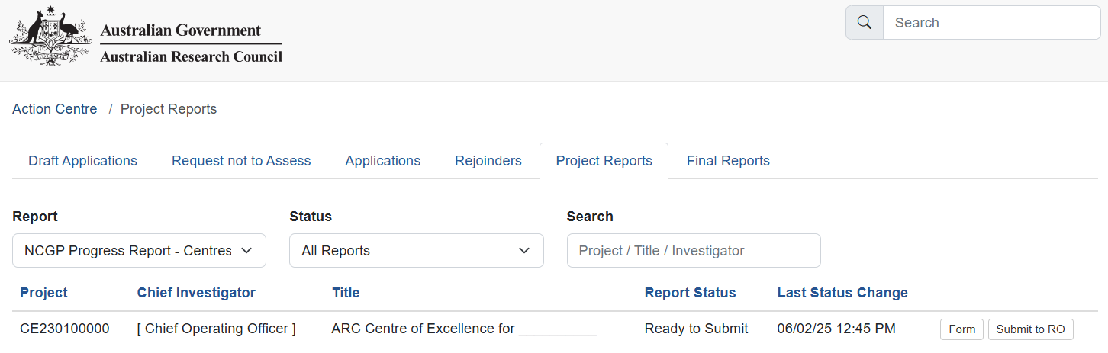

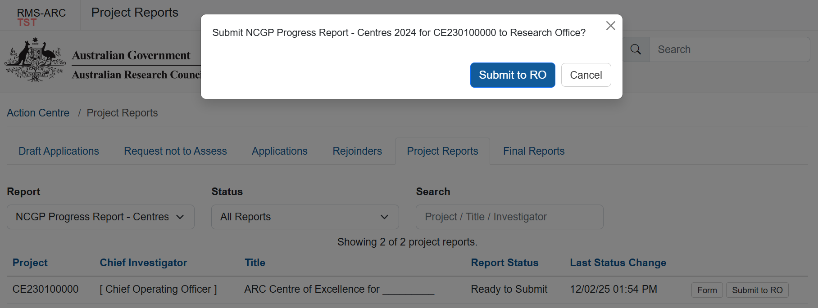
- Click ‘Submit to RO’ in the following prompt to submit the report to your Research Office

Once submitted to research office, the status will update to ‘Submitted to Research Office’.

Research Office Staff
- Login to RMS.
- In the ARC Research Office Project Management section of Action Centre, click on ‘Research Office Project Reports’

Searching for and editing Reports
- Click the ‘Report’ drop-down and select the relevant form ‘NCGP Progress Report – SRI’. The reporting year is indicated on the name of the form.
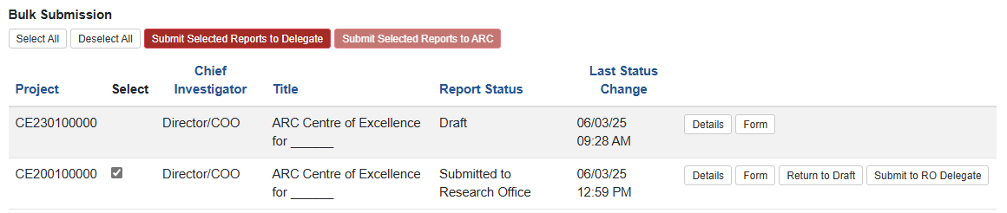
- In the filtered search results click ‘Submit to RO Delegate’ to send the report to the RO Delegate for Certification.

You may use the ‘Select All’ and ‘Submit Selected Reports to Delegate’ buttons to bulk submit forms that are ready to be certified by the RO Delegate. These forms will have a status of ‘Submitted to Research Office’
You may also select individually using the check box against the project code.

- Click through the prompts to send to the RO Delegate.
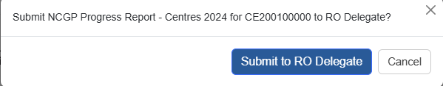
Prompt when submitting individually.

Prompt when submitting using the bulk submit function.
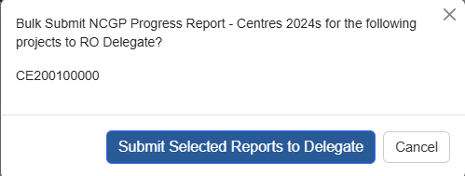

Certifying as RO Delegate
- Login to RMS.
- In the ARC Research Office Project Management section of Action Centre, click on ‘Research Office Project Reports’

Searching for and editing Reports
- Click the ‘Report’ drop-down and select the relevant form ‘NCGP Progress Report – SRI’. The reporting year is indicated on the name of the form)

- In the filtered search results click ‘Submit to RO Delegate’ to send the report to the RO Delegate for Certification. 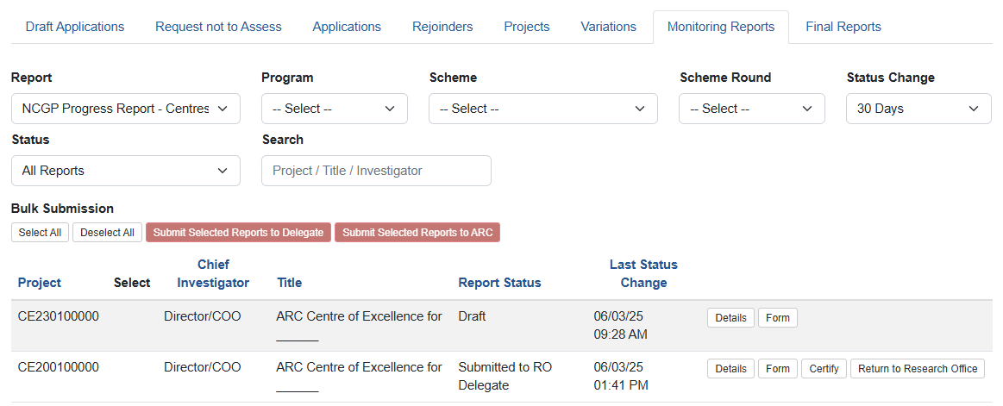

Bulk certification is unavailable.

- Click through the prompts to Agree to certification.

- Once certified, the Progress Report can be submitted to the ARC. Follow the prompts to submit the form to the ARC.
You may use the ‘Select All’ and ‘Submit Selected Reports to ARC’ buttons to bulk submit forms that have a status of ‘Certified’.
You may also select individually using the check box against the project code.
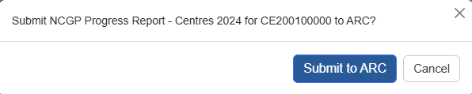
Prompt when submitting individually.

Prompt when submitting using the bulk submit function.
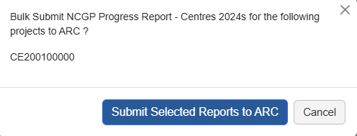

Once submitted to the ARC, the Report’s status will update to ‘Submitted to ARC’.

Progress Report status
The progress of a report through the approval process can be tracked by status, which can be found when accessing a form.
Your view can be filtered based on status, by choosing a status from the ‘Status’ drop-down.
The status and their meanings are as follows:
Status type | Explanation
Draft | Either nothing has been entered, or not all mandatory fields have been completed
Ready to Submit | All mandatory information has been entered, and the Progress Report is ready to be submitted to the RO
Returned to Research Office | The ARC has returned the Progress Report to the RO to be amended
Submitted to RO Delegate | The Progress Report has been submitted to the RO Delegate and is waiting to be certified
Certified | The RO Delegate has certified the Progress Report, and it is now ready to be submitted to the ARC
Resubmitted to ARC | The Progress Report has been resubmitted to the ARC and is ready to be reassessed
Submitted to ARC | The Progress Report has been submitted to the ARC and is ready to be assessed
Accepted | The ARC has assessed and accepted the Progress Report
Waived | The ARC has waived the requirement for this Progress Report

Return to Research Office
There is no notification or automated email system in RMS for these Progress Reports. ARC Post Award will email the project Director, COO/BM and RO advising of a Report’s desubmission and the resubmission due date. Notifications will be sent to the user’s nominated email address in RMS.

Part A – Project Themes
Enter the name of each Theme associated with this grant (as per your application and/or approved variation by ARC). Each Theme entered will create a new form part in Part B for this reporting period.
Theme names cannot be edited, ensure they are typed correctly when creating. A Theme will need to be deleted to update the name, therefore any information entered in Part B will be lost.
Your project application may have called a Theme a:
- Research Program
- Project
- Core Project
- Sub-project
- Workstream
For the purpose of completing this section of the Progress Report, these terms are interchangeable.

A1 Themes
- Add a Theme by entering the theme name in the text field and clicking the ‘Add’ button.


A minimum of 1 Theme is required
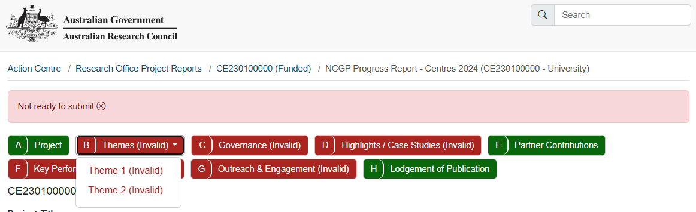
Once a Theme is added, it will be included in Part B drop-down selection at the top of the page.

Once all Themes are added, you may continue to Part B – Themes.

Part B – Themes
This section captures information related to the progress of Themes over the reporting period. New Themes may be reported and justified to meet scheme and funding objectives. For each entry in Part A, set questions in Part B will need to be answered. Use the drop-down to select a Theme and respond to the questions.

B1 Theme
Theme Name
This section is auto-populated from responses in Part A.
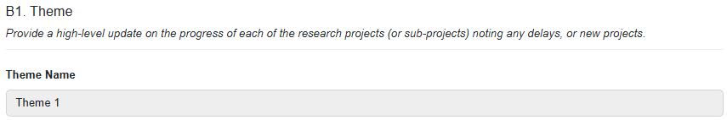

B2 Theme Review
Was this Theme listed in your application? (Mandatory)

- Select “Yes” or “No” from the drop-down box.
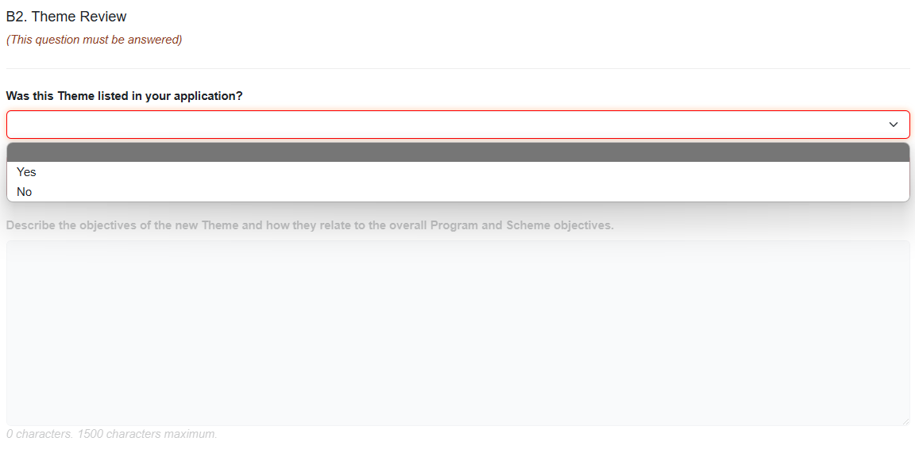
If ‘No’
  - Describe the objectives of the new Theme and how they relate to the overall Program and Scheme objectives.
A Theme that is not listed in the original application must describe its relation to Program and Scheme Objectives.

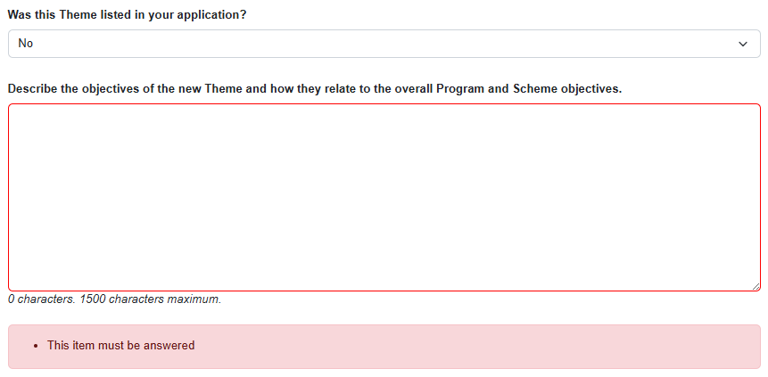

  - Select “Yes” or “No” from the drop-down menu of Has this theme been approved through a formal variation?

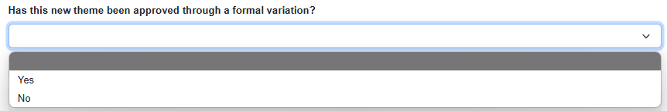

Please note: On acceptance of the Progress Report the ARC Comments section will advise if a variation will be required to be submitted, or if it has been accepted as part of the acceptance of the Progress Report.

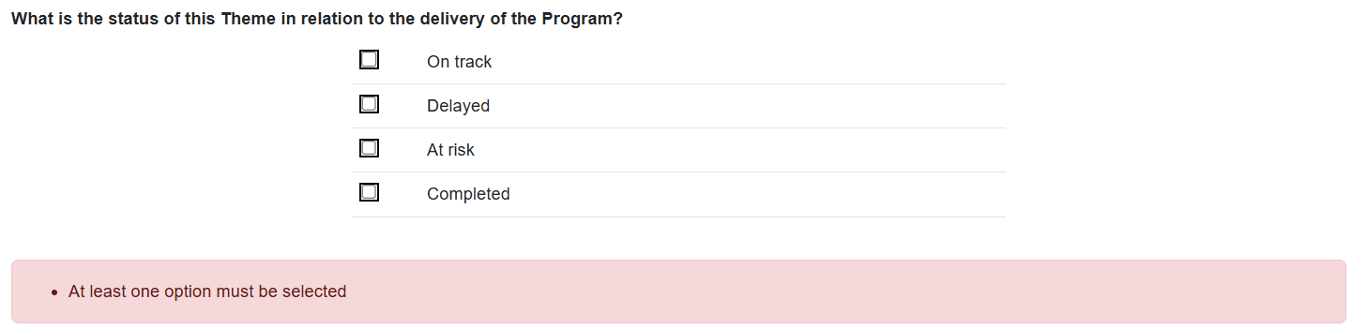
  - Indicate the status of the Theme in relation to the delivery of the Program.
The progress of delivery of a Theme is reported using a stop-light system:
Status | Stop light
On track | Green light
Delayed | Yellow light
At risk | Red light
Completed | n/a

Where a Theme is identified as ‘Delayed’ or ‘At risk’, further information is required to be provided in question B3.
A Theme that is identified as ‘On track’ or ‘Completed’ can save the progress on the form before continuing to Part C – Governance.

If ‘Yes’ to ‘Was this Theme listed in your application?’
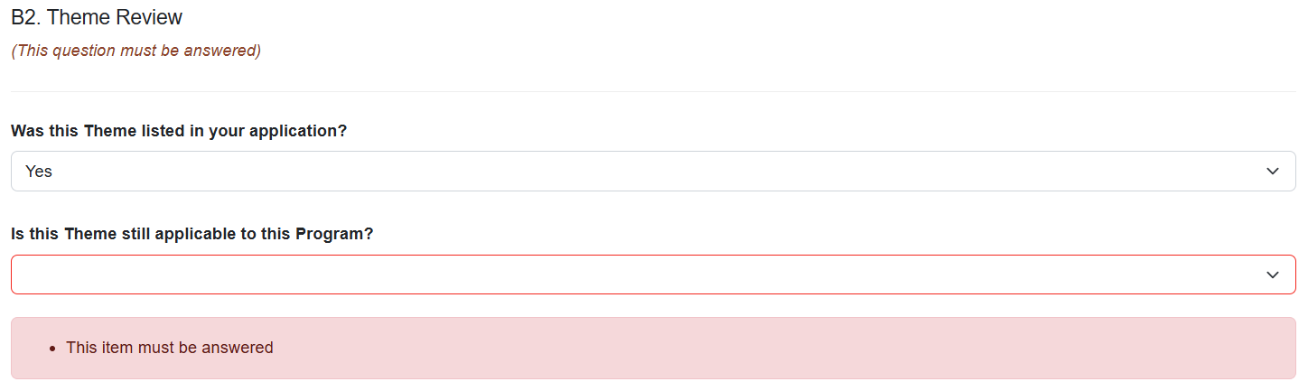
Click the drop-down and respond Yes or No to ‘Is this Theme still applicable to this grant?’
If ‘No’

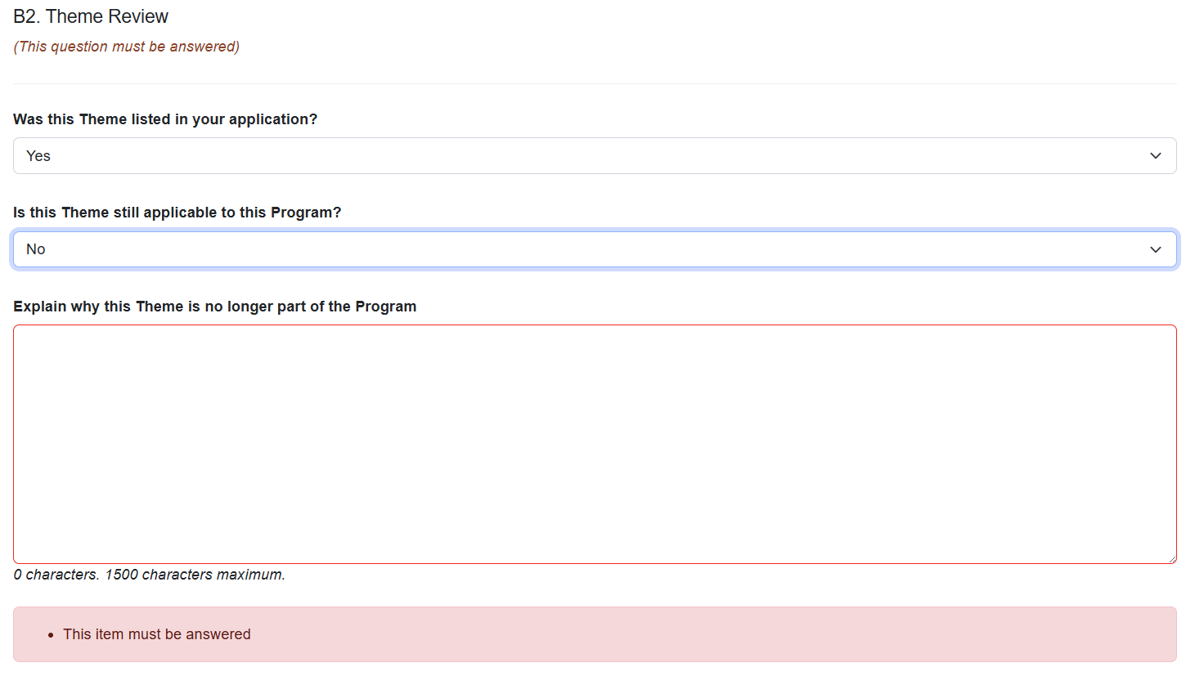
Explain why the Theme is no longer part of the Program in the following text box.
  - Save the progress on the report before proceeding to Part C – Governance.
If ‘Yes’ to ‘Is this Theme still applicable to this grant?’
  - Indicate the status of the Theme in relation to the delivery of the Program.

The progress of delivery of a Theme is reported using a stop-light system:
Status | Stop light
On track | Green light
Delayed | Yellow light
At risk | Red light
Completed | n/a

Where a Theme is identified as ‘Delayed’ or ‘At risk’, further information is required to be provided in question B3.
A Theme that is identified as ‘On track’ or ‘Completed’ can continue to other questions on the form. Ensure to save the progress on the report before continuing to Part C – Governance.

B3 Theme Updates
Describe the changes and/or issues. Why were they important to the Program?
This section is required if a Theme is ‘Delayed’ or ‘At risk’ in B2.
- Click ‘Add answer’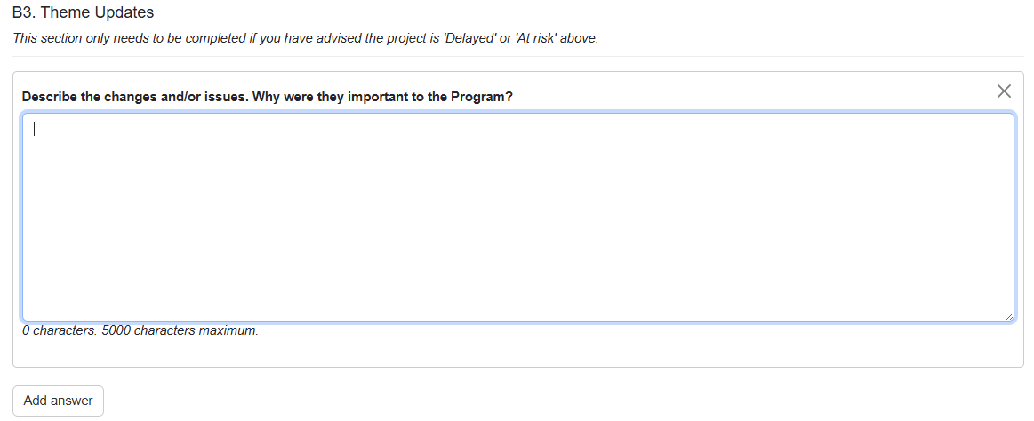

Describe the changes and/or issues. Why were they important to the Program

For issues and risks, include any mitigation strategies implemented and provide a self-assessment of the effectiveness of these strategies in managing the issue.
Multiple issues/changes may be identified for a single Theme and described individually using the ‘Add Answer’ button to add additional text boxes. Mitigation strategies and a self-assessment on effectiveness may be provided.
Where the status of a Theme is either ‘On track’ or ‘Completed’, the ARC does not need to be notified of any issues or risks, and this section will be greyed out.
Once this is completed, ensure you are save the form before continuing to Part C – Governance.

ARC Comment section
An ARC comment may be used to advise whether a scope change variation would be required for any ‘new’ Themes.
New themes that have not been requested in a formal variation will have a comment here from the ARC stating whether a formal variation is required.

Part C – Governance
Once a project has commenced, we expect that the governance, policies and procedures required by the grant agreement are in place. This section is used to notify the ARC of any reviews and changes. There is no requirement to provide copies of these documents as part of the Progress Report.
As part of the ARC Grant Agreement, all CE/ITRP Programs are required to have strong governance, policies and procedures in place from the commencement of the Program. These governance, policies and procedures are to be reviewed on a regular basis.
At any stage, the ARC may request to see any, or all of your governance, policies or procedure documents relating to the ARC Grant Agreement.

C1 Governance Plans
Have you completed any reviews of your governance, policies or procedures during the reporting period? 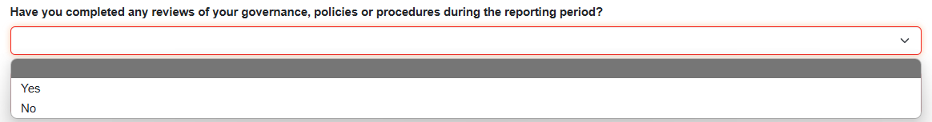
- Respond ‘Yes’ or ‘No’ from the drop-down box.

If ‘Yes’ 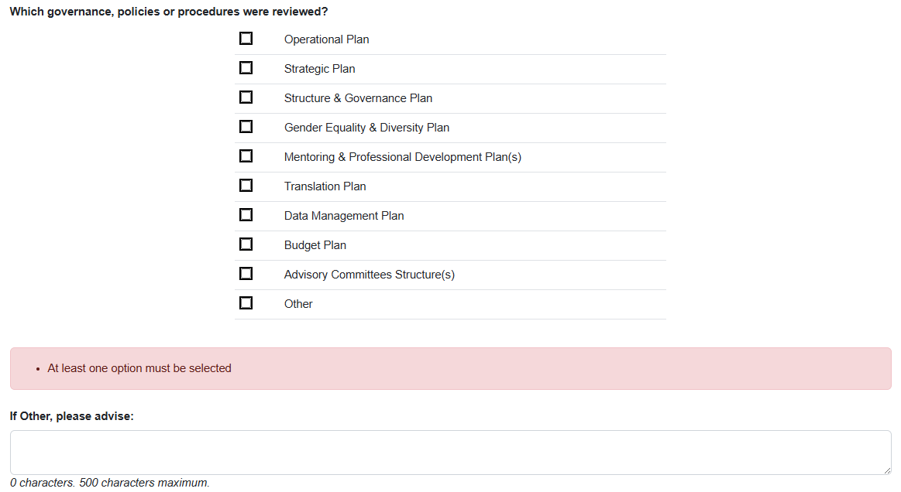

- Select which of the following have been reviewed by clicking on the adjacent checkbox:
- Operational Plan
- Strategic Plan
- Structure & Governance Plan
- Gender Equality & Diversity Plan
- Mentoring & Professional Development Plan(s)
- Translation Plan
- Data Management Plan
- Budget Plan
- Advisory Committees Structure(s)
- Other

When selecting ‘Other’ please state what governance, policy or procedure has been reviewed.
- Click the drop-down and respond Yes or No to “Have any governance, policies or procedures been updated?”

If ‘Yes’
  - Select which of the following have been updated by clicking on the adjacent checkbox:
  - Operational Plan
  - Strategic Plan
  - Structure & Governance Plan
  - Gender Equality & Diversity Plan
  - Mentoring & Professional Development Plan(s)
  - Translation Plan
  - Data Management Plan
  - Budget Plan
  - Advisory Committees Structure(s)
  - Other
  - When selecting ‘Other’ please state what governance, policy or procedure has been reviewed.

If ‘No’
There is no requirement to report updates to governance, policy or procedure.

For example, this may occur when a review has been undertaken for a policy however it was found that it is still applicable, and no updates were made.

If ‘No’ to “Have you completed any reviews of your governance, policies or procedures during the reporting period?”
When a project is already established and has commenced, we expect that plans and policies required by the agreements are in place. Where no reviews have taken place, there is no requirement to report an update implemented in the reporting period.
There is no requirement to provide copies of these documents as part of the Progress Report.

C2 Personnel Demographics
Since 2016*, the ARC has collected data on researchers who identify as Female, Male, Indeterminate/Intersex, or Unspecified.
The matrix should reflect the Full Time Equivalent program personnel across the reporting period.
Complete the table using FTE figures. Up to 2 decimal places may be entered. You may estimate the total FTE.

What are gender demographics among Programs personnel?
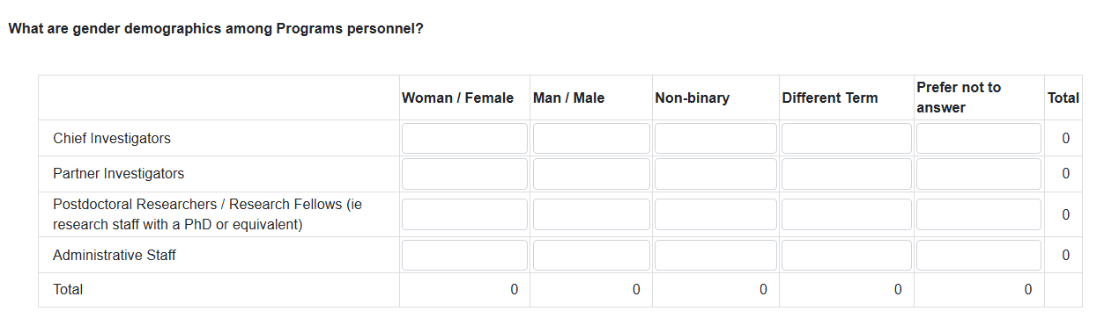
Programs personnel are personnel employed and working to support activity of the project including contractors, full and part time employees.
Where personnel have changed roles through the year, report them against the role they performed majority of their duties as during the reporting period. Please provide detail in the Additional Comments section.

What are gender demographics among student personnel?
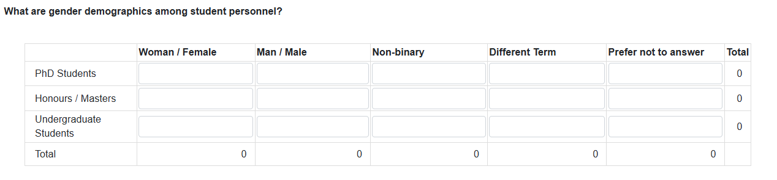
Where students have advanced their level of study (e.g. completed undergrad and commenced honours) through the year, report them against the highest degree during the reporting period.

How many of Program personnel, to your knowledge, would identify as Culturally or Linguistically Diverse?
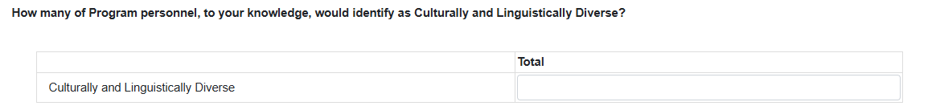
This question is not tied to an FTE. Please provide the head count of personnel who would identify as culturally or linguistically diverse.
Ensure to save your progress on this form before proceeding to Part D – Highlights / Case Studies.

Part D – Highlights / Case Studies
A highlight may be a story of a success or unintended positive impact by the Project. This could include anything from PhD completions, researcher promotion, research awards, project recognition, onboarding a new partner.
A case study is defined for this report as an example of the project having a demonstrable benefit. Anything from commercialising a product or process; making a significant scientific discovery; achieving a societal benefit; providing evidence to inform government policy; improving economic outcomes for industry; etc.
An Executive Summary must be provided for each case study provided to the ARC which may be used in the ARC Annual Report and/or media releases.
SRI projects are required to provide a highlight. Although a case study is not required, consider the option as an opportunity to present the impact of the research through the reporting period.
TIP: Ensure to save this form frequently so that your progress is not lost.

D1 Highlights
- Click ‘Add answer’ to show the text box needed to complete this section.
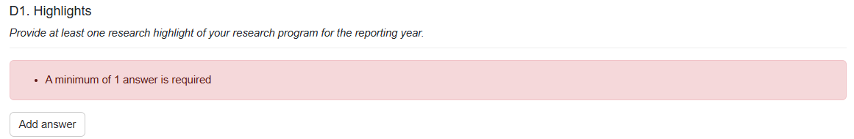
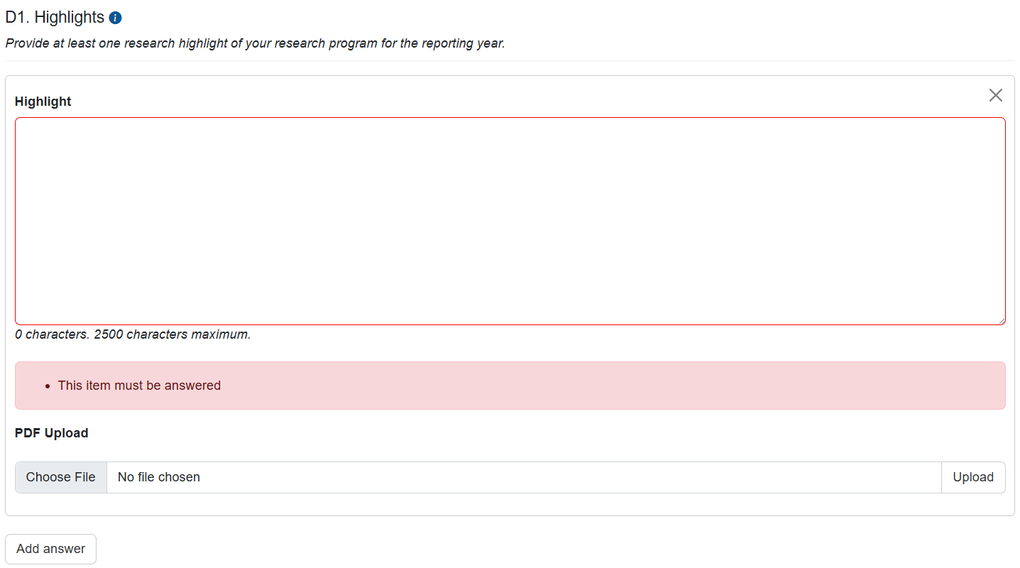
- A PDF may be uploaded as supporting documentation. See instructions for uploading above.

D2 Case Studies
- Click ‘Add answer’ to show the text boxes required to complete this section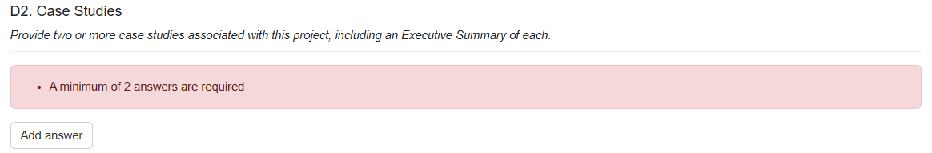

- A PDF of a case study may be provided as supporting documentation. See instructions for uploading above. 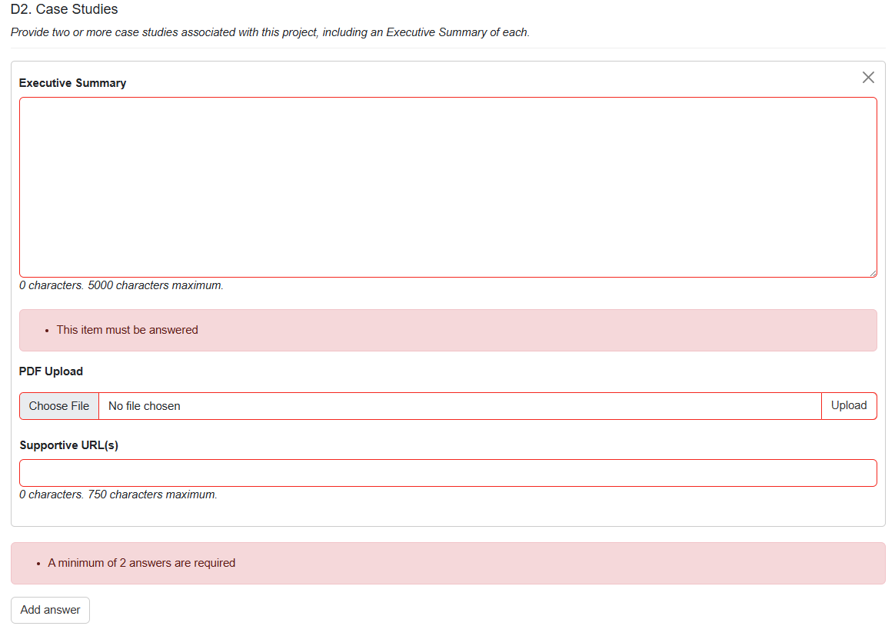

A full case study can be uploaded, or you can provide a URL link. See instructions for uploading above.
Describe how your project was involved in your examples.
The ‘Executive Summary’ should not be a copy paste of text from the attached case study.

Part E – Partner Contributions
Your RO will be familiar with a Partner Organisation Agreement Contribution Report (POACR), if you have any questions regarding this section, please contact your RO.
POACR’s refer to the original funded years rather than calendar year. Funds should be entered against the year the activity is intended to take place regardless of periods of deferred commencements or suspensions. Should additional contributions be provided after the original funding years, they may be entered into the last year of the table.
If your Partner Contributions require updating, please report in the ‘Updated Contributions’ table. Acceptance of the Progress Report will update the project POACR.
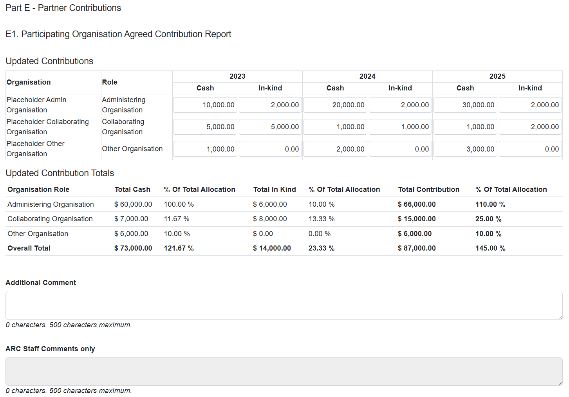

Current Organisational Contributions are displayed at the bottom of the page. 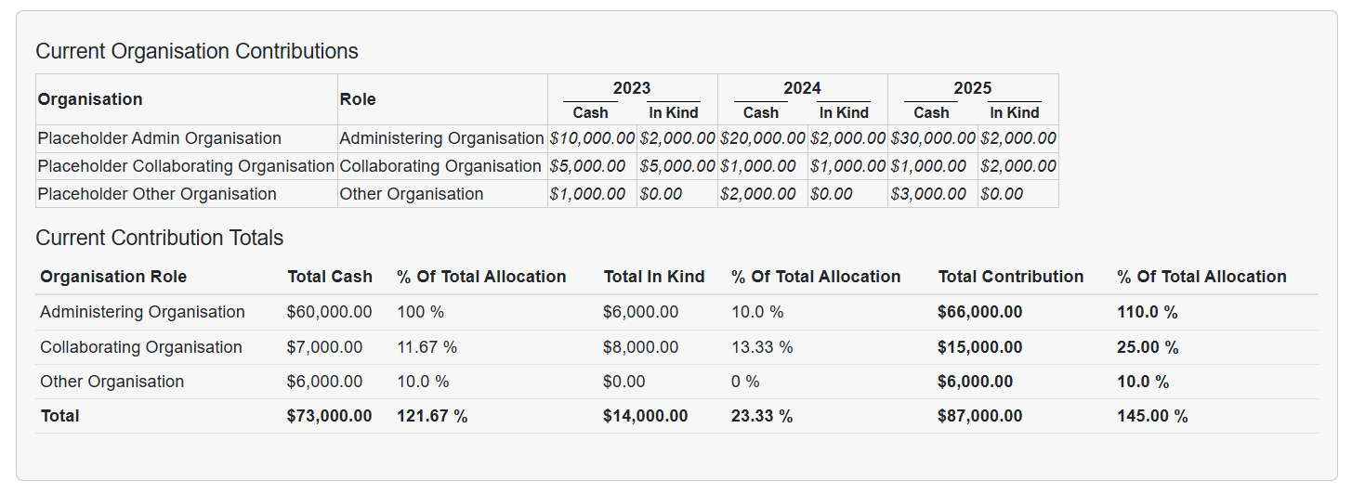
Ensure to save this form frequently so that your progress is not lost.
If there has been a change in Participating Organisations, a variation may be required to be submitted to the ARC. Please check with your RO if a variation is required, or has been submitted and is pending an outcome from the ARC.
Where a variation is pending an outcome from the ARC, or an outcome to a variation was not received (completed in RMS) until after the opening of this form; the Participating Organisation will not appear on this list.

Part F – Key Performance Indicators
Key Performance Indicators (KPIs) are a set of quantifiable measures that are used to monitor and provide indicative progress of research outcomes.
Common KPI measures have been identified and included in the Progress Report form.
Where KPI measures have previously been approved by the ARC:
- Approved KPIs that are not in Part F and included in the published Annual Report provided in Part I require an Additional Comment prompting ARC to check the published Annual Report.
- Approved KPIs that are not in Part F should be reported in the Additional Comment section.
- A target from an approved KPI that has not been met must be indicated in the Additional Comment section.
- A target from an approved KPI that has been exceeded does not require additional comment to indicate it has been met.
- Where a KPI is included in the form but not part of the Project’s approved KPIs, these are not assessed. You must enter a 0 and indicate these were not included in approved KPIs in the ‘Additional Comment’ section. See screenshots provided for each section for more information.
Qualitative measures should be provided in the Additional Comment section to provide context to quantitative measures in the category.
All tables are mandatory and only accept positive integers and will automatically remove characters that are not numbers (e.g. spaces, commas).
TIP: Ensure to save this form frequently so that your progress is not lost.
See below, screenshots for example responses.

Traditional and Non-traditional outputs
The number of outputs would be expected to increase over time and should reflect the body of work being developed. The types of outputs can be discipline and industry and/or other sector relevant and be of the highest quality.
The quality of research outputs may be quantified through a variety of measures including impact factors, peer review of outputs, citation analysis, and awards or prizes (if applicable).
Qualitative measures should be indicated in as an Additional Comment.
F1. Number of traditional outputs
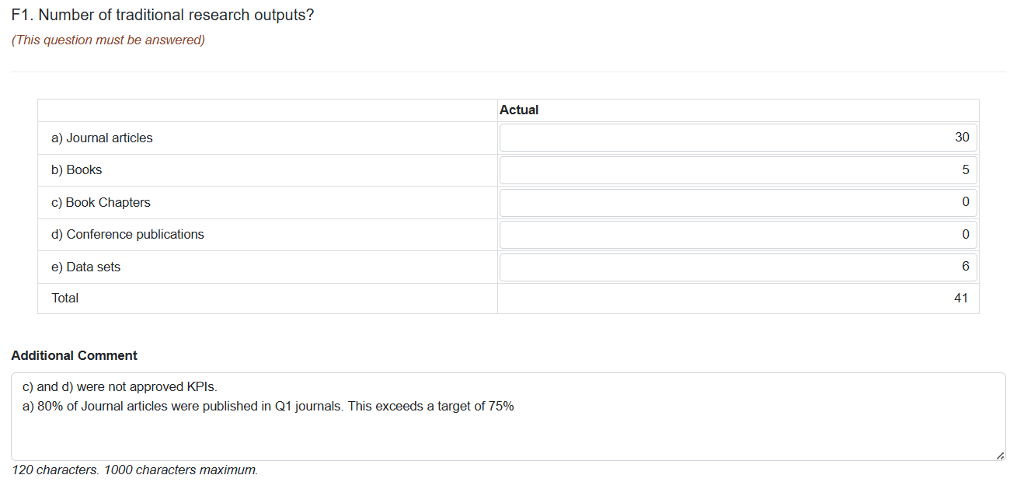

F2. Non-traditional Research Outputs
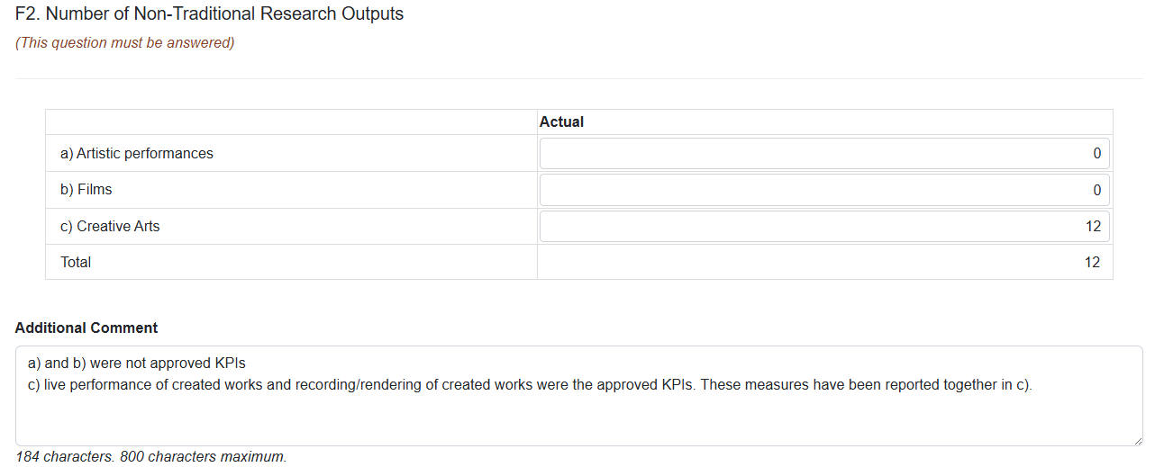

F3. Number of workshops/conferences held/offered by the Project
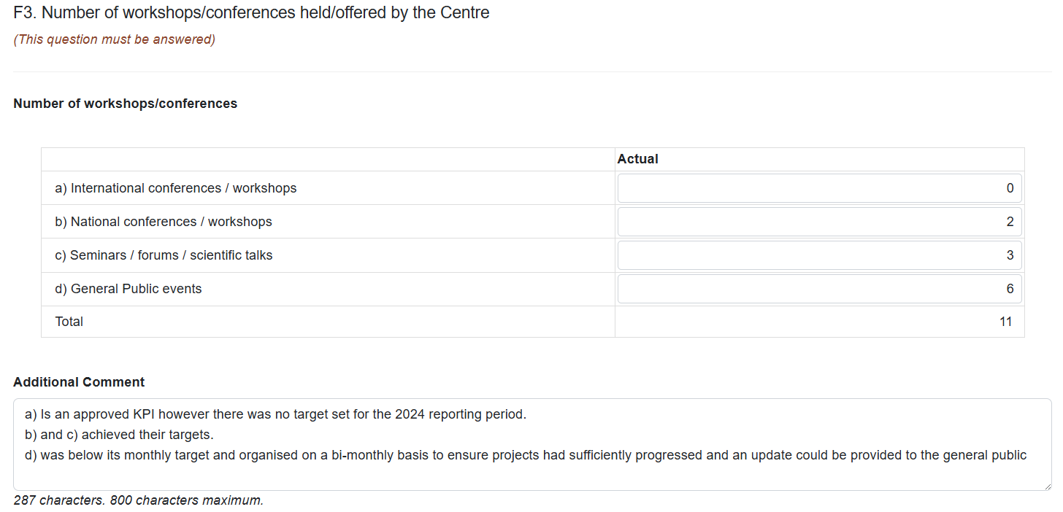

F4. Number of training held/offered by the Project
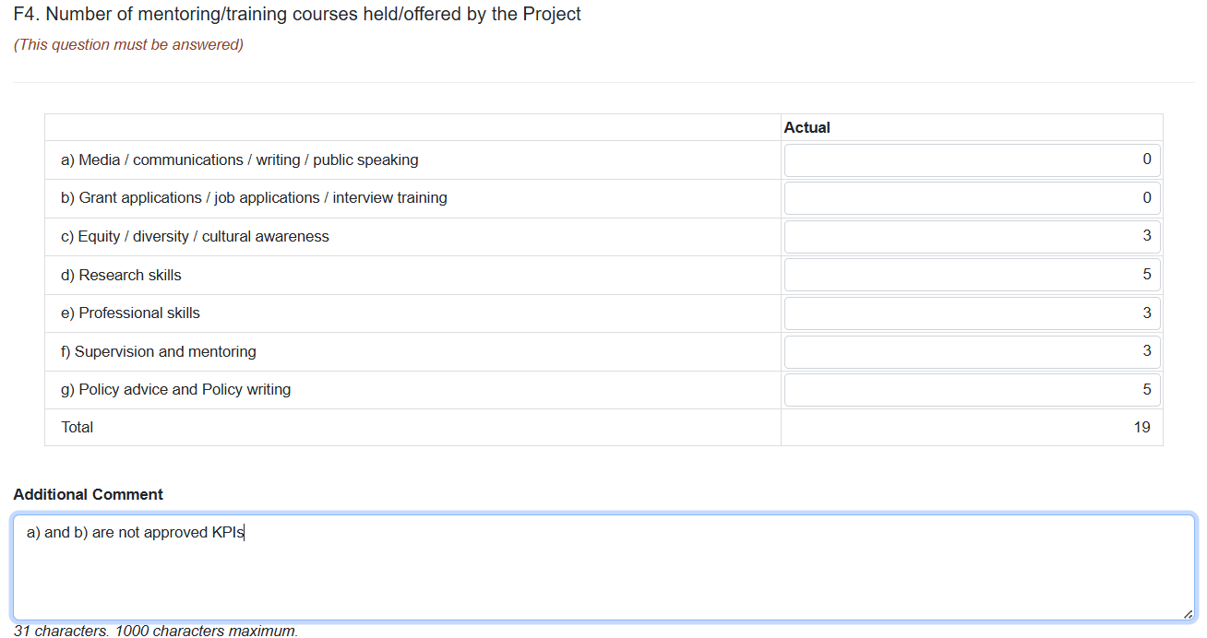
Training courses listed here should be over and above the standard professional development courses offered by participating institutions. The training should directly relate to the operation and objectives of the project and align with future workforce skills requirements.

F5. Number of Postgraduate commenced and completed
These measures should report commencements and completions in reporting period only.
All students are expected to complete within the duration of the project. Acknowledging a general timeframe of 3.5 years for completion of a PhD, completions are not normally anticipated in the first three years of the project.

- Number of Postgraduate commenced 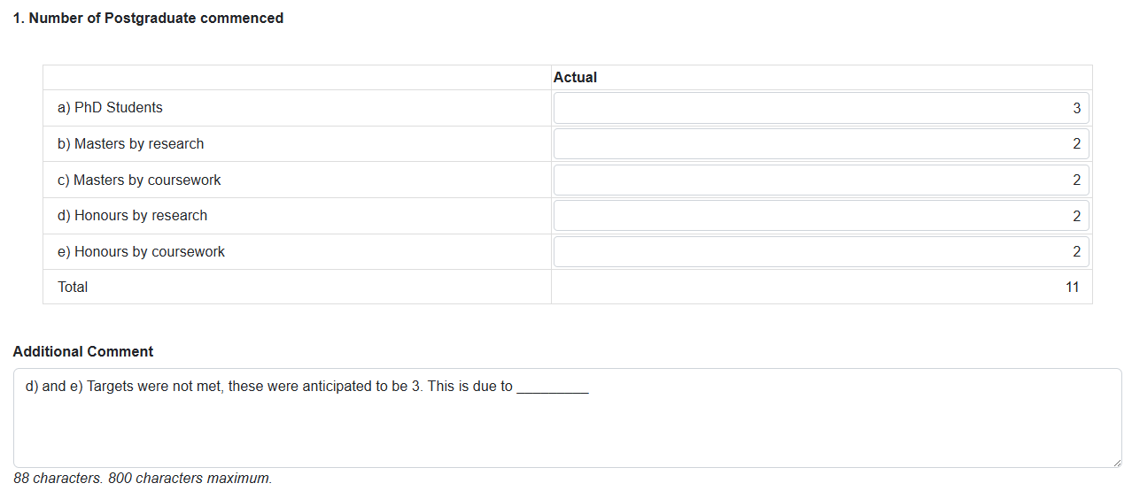
- Number of Postgraduate completed
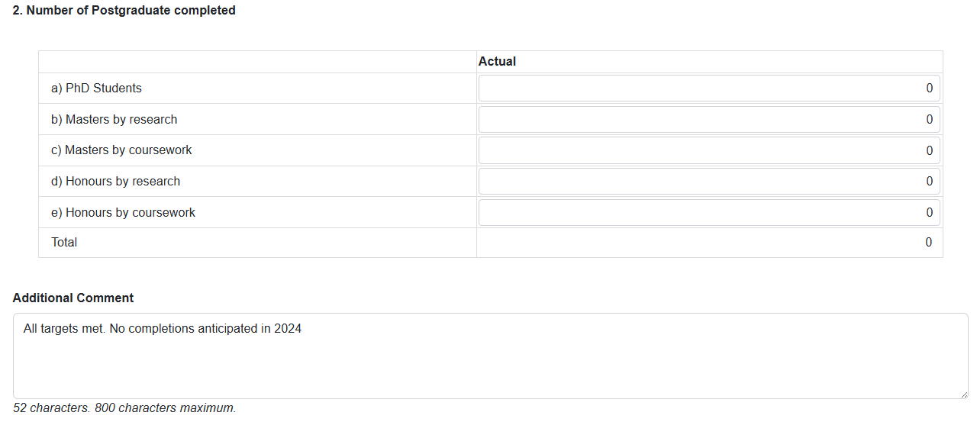

F6. Number of additional researchers working on Project research
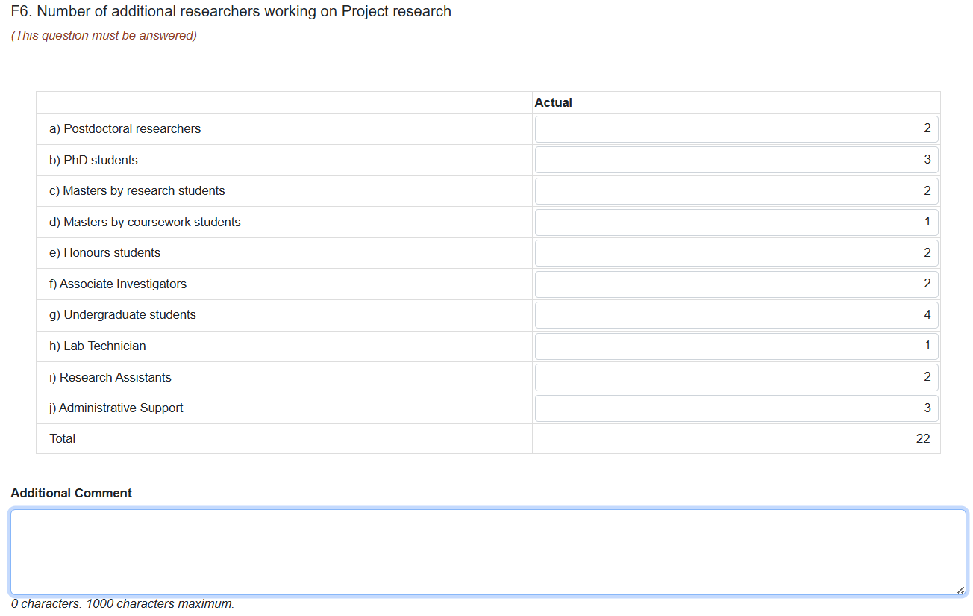
This refers to the number of research personnel recruited each year and should include all research personnel who are not participating as a CI or PI. Students listed should be supervised by project researchers.

F7. Number of government, industry and business community briefings
These targets demonstrate the project’s level of engagement with external stakeholders and the public, and ability to message the project’s research ideas. The ARC expects students/trainees to be involved in public talks. 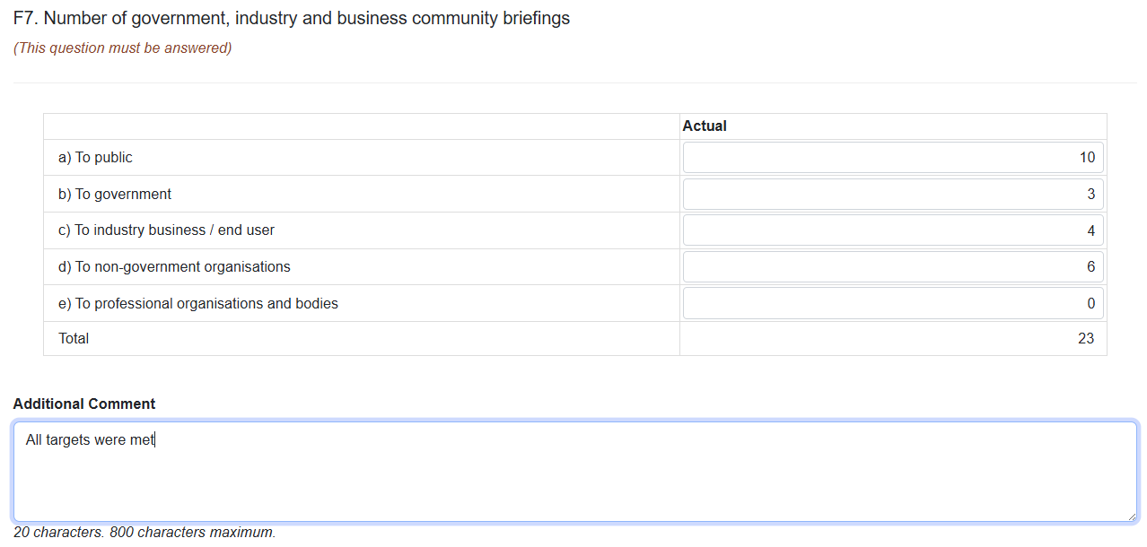

F8. Number of new organisations collaborating with, or involved in, the Project
Projects are expected to leverage new partnerships throughout the duration of the grant. Include the number of new Participating Organisations, as well as organisations with which the project establishes a new collaborative relationship.
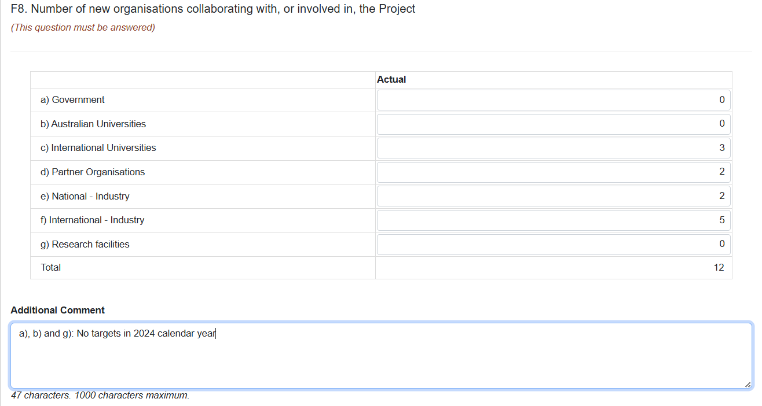

F9. Number of female research personnel
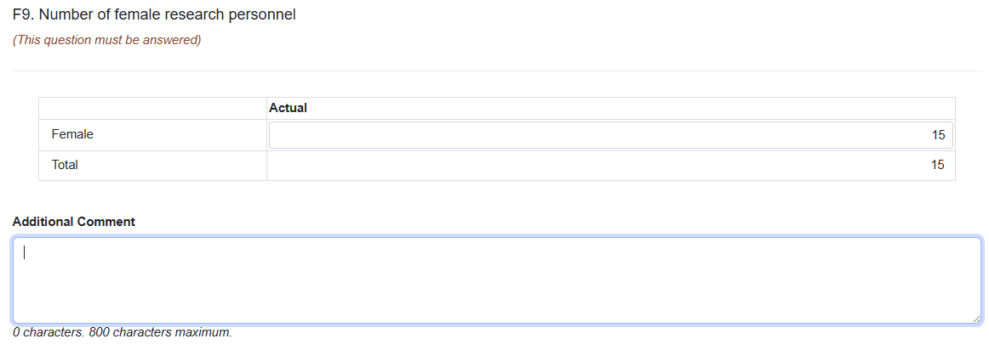
Provide the current number of female research personnel at the project.

Part G – Outreach

G1 Describe the Project's Outreach Strategy
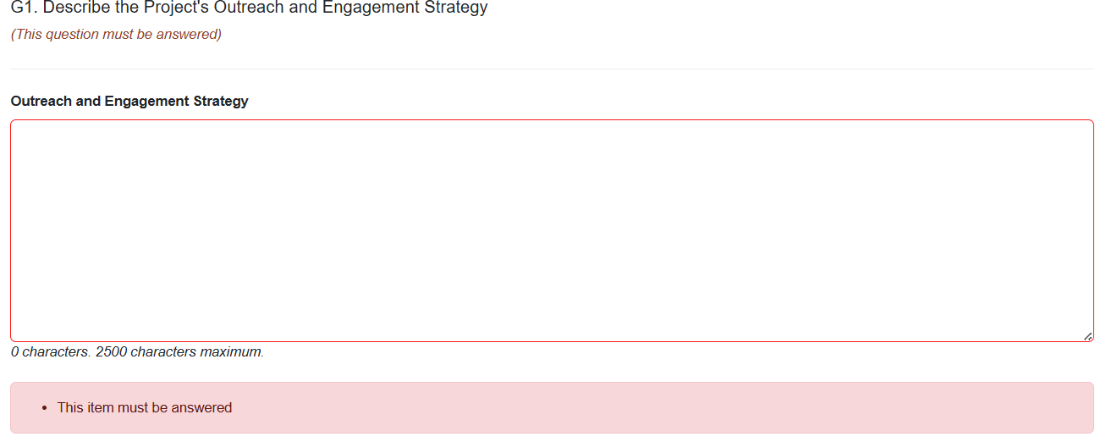
Where unchanged from previous years and/or has been previously provided to the ARC or stated as part of the ‘Glossy’ Annual Report, it may be copy/pasted here.

G2 Grant Outreach
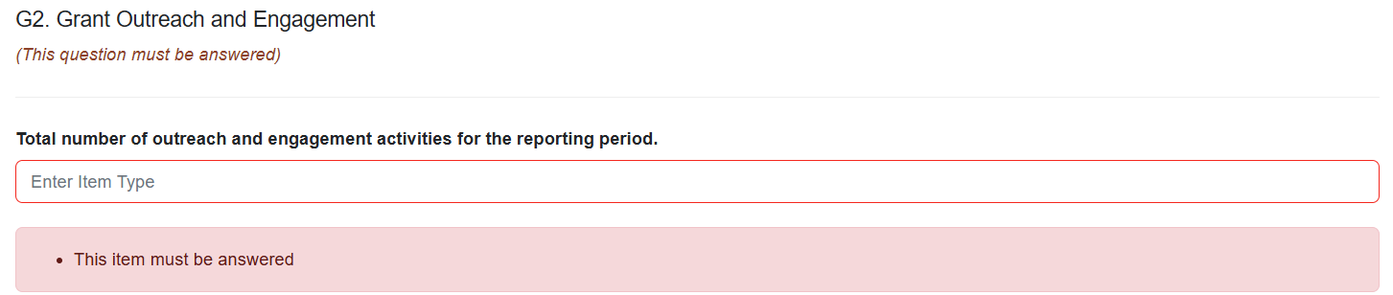
- Provide total number of outreach activities conducted by the project in reporting period.

G3 Provide a summary of Project’s Top 10 outreach and engagement activities
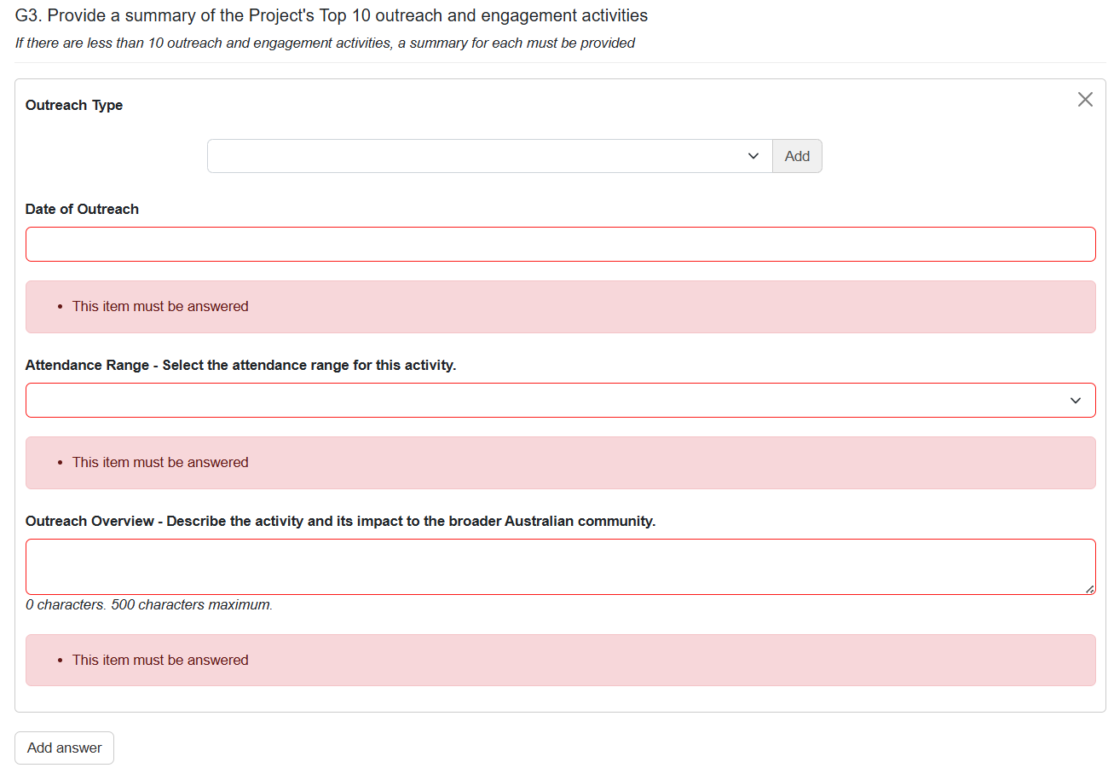
- Click ‘Add answer’ to add a response to an outreach activity. Click ‘Add answer’ multiple times to provide the required number of summaries.
When there are less than 10 outreach activities completed in the reporting period, all activities must complete a summary.
No more than 10 activities can be described in this section.
Outreach Type
Multiple types may be attributed to an activity. The following may be selected:
- Conference
- Congress
- Forum
- Mentoring
- Round Table
- Scientific talks
- Seminar
- Summit
- Symposium
- Training
- Visitors
- Workshop

- Select the activity type and click ‘Add’.
- Repeat as required, adding types where an activity has multiple types that are suitable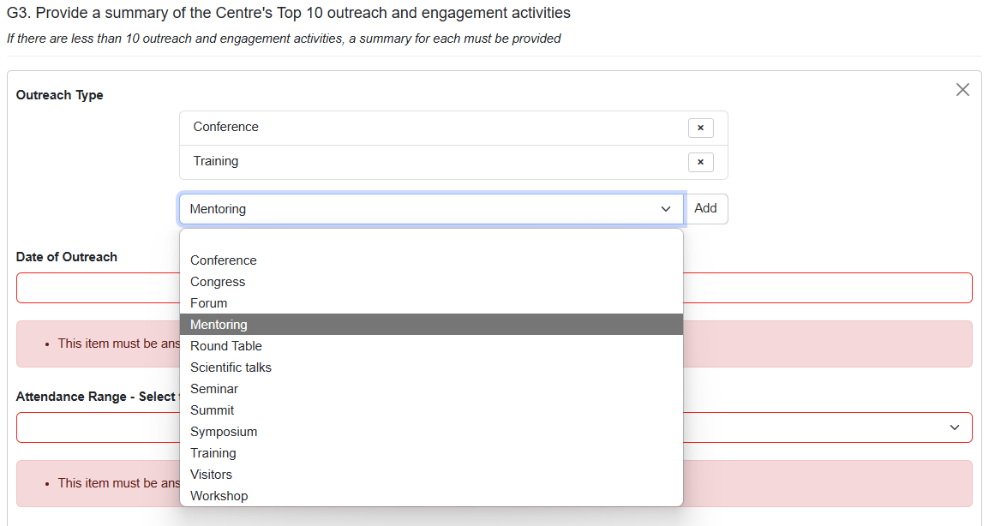
- Click ‘X’ to remove a type that is not required.
Date of Outreach
You may only select dates in the reporting period.
Attendance Range
The following ranges may be selected:
- <25
- 26-50
- 51-75
- 76-100
- 101-150
- 151-200
- 201-300
- >300
Outreach Overview
Describe the activity and its impact to the broader Australian community.

Part H – Lodgment of Publication
ARC Open Access Policy applies to all Research Outputs that result from ARC Funded Research, and their Metadata. Any Research Outputs arising from an ARC research project must be made accessible within 12 months from the date of publication.
Provide a list of publications (with justification) as to why they are not compliant with ARC Open Access Policy as an attachment below.
Note: The template for non-lodgement is provided on the ARC website and available here: Annual Reporting Responsibilities of the ARC Special Research Initiative in Excellence in Antarctic Science (SRIEAS).
You may also click the ‘i’ under the question header to reveal a link to the same webpage above. 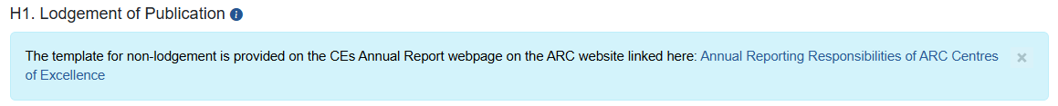
- Click the drop-down to respond Yes or No to “Do you have any research outputs that don’t comply with the ARC Open Access Policy?”

For a response of ‘Yes’
- Click ‘Choose File’ and select a file to upload

- Click ‘Upload’ to upload the file.
- Click ‘Save’ at the top right of the page to ensure this is uploaded.

- When done correctly the file will appear as a downloadable hyperlink.

Part I – Annual Report
ARC Grant Agreement requires each SRI to produce an Annual Report. Please provide a link or upload a copy of your Annual Report for this reporting period.
When the Annual Report is publicly available for example on your project’s website, a link to the Annual Report may be provided.
