

Evaluation of the implementation of the continuous Linkage Projects process  
  
Final report

Australian Research Council  
Program Evaluation Section

May 2019

**Contents**

Abbreviations and glossary 3

Executive summary 4

Background and context 5

The Linkage Projects scheme 5

The continuous Linkage Projects process 5

ARC implementation of the continuous process 6

Evaluation overview 7

Authorisation and management 7

Reasons for the evaluation 7

Purpose and scope 8

Terms of reference 8

Evaluation questions 8

Methodology 9

Analysis and findings 12

Evaluation question 1: Partner organisation involvement 12

Evaluation question 2: Applications and selection outcomes 18

Evaluation question 3: ARC administration 22

Evaluation question 4: Stakeholder views – collaboration and innovation 25

Evaluation question 5: Stakeholder views – processes 33

Evaluation question 6: Stakeholder views – assessors and SAC members 37

Recommendations 43

Recommendation 1: Application deadlines 43

Recommendation 2: Information on assessment process 44

Recommendation 3: Funding commencement 44

Recommendation 4: Guidance to SAC members 44

Recommendation 5: Data and monitoring 45

Appendix 1 46

Conclusion and opportunities (ACIL Allen Consulting) 46

# Abbreviations and glossary

| ARC | Australian Research Council |
| --- | --- |
| CEO | Chief Executive Officer |
| CI | Chief Investigator |
| Detailed assessor | Detailed Assessors provide scores and written comments addressing the relevant assessment criteria on applications for ARC grants |
| General assessor | General Assessors are selected to form a Selection Advisory Committee (SAC) to oversee the peer review process for ARC grant applications |
| NISA | National Innovation and Science Agenda |
| PI | Partner Investigator |
| Return rate | The amount of ARC funding awarded as a percentage of funding requested in successful applications |
| RMS | Research Management System |
| SAC | Selection Advisory Committee |
| SAC member | See ‘general assessor’ |
| Success rate | The number of funded projects as a percentage of applications submitted for ARC grants |
| Watt Review | 2015 Review of Research Policy and Funding Arrangements |

# Executive summary

The Australian Research Council (ARC) Linkage Projects scheme promotes research partnerships by providing funding to Australian higher education institutions for collaborative research with industry and other research end users. A continuous application and assessment process was introduced to the scheme on 1 July 2016, as an Australian Government initiative to facilitate timely collaboration and greater responsiveness to innovation opportunities. The process was designed to enable the submission of grant applications at any time and the announcement of grant outcomes within six months.

The ARC committed to undertake an evaluation of the continuous process within three years of its implementation. This evaluation assessed the effectiveness of the continuous process in supporting research collaboration and responsiveness to innovation opportunities, and the efficiency and effectiveness of the ARC’s implementation of the process. The evaluation drew upon ARC policy and program documents and program management data, as well as independent survey and interview research conducted with a range of Linkage Projects stakeholders by ACIL Allen Consulting Pty Ltd.

The evaluation found that the introduction of the continuous process coincided with a decline in total Linkage Projects applications, funded projects, partner organisation participation (especially business and industry organisations) and partner organisation contributions. Many stakeholders reported that without deadlines, Linkage Projects applications do not receive priority, and that planning and managing the workloads associated with Linkage Projects applications is challenging for researchers and their partners.

However, there have been increases in the average number of partner organisations per application and funded project, and indications of increasing average partner contribution value per project. Many stakeholders also perceived increased and improved collaboration in applications and funded projects under the continuous process, as well as more timely collaboration and greater responsiveness to innovation opportunities.

Most stakeholders expressed satisfaction with the ARC’s implementation of the continuous process. However, areas of concern included the transparency of the process and an inability to track applications, issues related to the provision of feedback on unsuccessful applications, difficulties in benchmarking and assessing the relative quality of applications, and assessment timeframes. There was also evidence of an increased administrative burden for the ARC.

The evaluation makes five recommendations to the ARC to improve the effectiveness and efficiency of its implementation of the continuous process:

1. Introduce three or four application deadlines and assessment rounds each year
2. Provide additional information on the ARC website and in the Research Management System (RMS) regarding assessment processes and announcements
3. Modify ARC financial systems to allow for more frequent releases of initial funding
4. Provide guidance to Linkage Projects Selection Advisory Committees (SACs) to ensure high quality applications that involve business partner organisations are given greater priority
5. Consider using metrics provided in this report as benchmarks to monitor future performance of the continuous process and inform improvements.

# Background and context

## The Linkage Projects scheme

The ARC Linkage Projects scheme promotes research partnerships by providing funding to Australian higher education institutions for collaborative research with industry and other research end users. The scheme’s objectives are to:

* support the initiation and/or development of long term strategic research alliances between higher education organisations and other organisations, including industry and other research end users, in order to apply advanced knowledge to problems and/or to provide opportunities to obtain national economic, commercial, social or cultural benefits
* provide opportunities for internationally competitive research projects to be conducted in collaboration with organisations outside the higher education sector, targeting those who have demonstrated a clear commitment to high-quality research
* encourage growth of a national pool of world-class researchers to meet the needs of the broader Australian innovation system
* build the scale and focus of research in the national Science and Research Priorities.[1]

## The continuous Linkage Projects process

Between 2013 and 2016, the Linkage Projects scheme was administered with an annual round of applications and associated assessment processes. As part of the Australian Government’s National Innovation and Science Agenda (NISA),[2] a continuous Linkage Projects application and assessment process was introduced on 1 July 2016 to facilitate timely, successful collaboration and greater responsiveness to innovation opportunities.

The introduction of the continuous process under NISA was informed by the 2015 *Review of Research Policy and Funding Arrangements* (Watt Review). The Watt Review found that annual timeframes undermined the ability of businesses and other research end users to respond to time critical market or innovation opportunities. The Watt Review also noted the government’s specific focus on increasing business engagement in research to strengthen innovation and commercial outcomes.

The implementation of the continuous process responded specifically to the Watt Review recommendations that:

* the Linkage Projects scheme moves from one round per year to a continuous application and peer assessment process from 1 July 2016, with strong applications to be progressed immediately for ministerial approval, and the remaining applications to be considered in one of three selection meetings per year (recommendation 6a)
* grant outcomes should be announced within a maximum of six months from the submission of applications (recommendation 6b)
* the ARC revises its guidance for selection advisory committees for the Linkage Projects scheme to ensure that high quality proposals that involve business partner organisations are given greater priority (recommendation 6c).[3]

## ARC implementation of the continuous process

The continuous process commenced on 1 July 2016. As part of the process, Linkage Projects applications for each round of the scheme (that is, approximately each year of the scheme) may be submitted to the ARC at any time. The opening and closing dates for each round are listed on the ARC website, as well as an indication that all proposal outcomes are recommended to the Minister for Education within six months of submission. The continuous nature of submissions within the scheme means it is not possible to publish dates for specific stages of the assessment process in the same way as the ARC does for other schemes.

To manage the continuous submission of applications and ensure recommendations are provided to the Minister within six months, the ARC generally processes applications in a number of ‘batches’ per round. Reflecting the sporadic nature of submissions, batches vary considerably in size. Batch timelines are set by the ARC when the first application in a round is received, and provide the basis for the ARC to manage the required assessment processes and meet the six month commitment.

Three Selection Advisory Committee (SAC) members (also known as general assessors) are assigned to each application. In common with other ARC schemes, one SAC member (‘Carriage 1’) on each application is required to assign detailed assessors to the application in the ARC’s Research Management System (RMS). Under the continuous process—unlike the annual process and other ARC schemes—SAC members and detailed assessors may be responsible for multiple applications with staggered timeframes simultaneously, and may be assigned applications at any time across a number of batches.

Detailed assessors generally have three weeks (less time than other ARC schemes) to provide scores and comments on the applications assigned to them within any given batch. Following this, applicants have one week to complete any rejoinders (half as long as other ARC schemes). SAC members then have around two weeks to submit their assessments. Under the continuous process, Carriage 1 is asked to provide—by email to the ARC, and with the agreement of the other SAC members assigned to each application—a one line budget recommendation for highly scored applications, and confirmation of whether an application should be ‘fast tracked’.

In practice, fast tracking refers to whether or not an application is considered in a Linkage Projects SAC meeting (one meeting is held for each batch of applications). Fast tracked applications are either those with high overall assessment scores that are recommended for funding, or low overall assessment scores that are not recommended for funding. If a SAC member raises an issue with a high or low scoring application, or if an application has received disparate assessment scores, it will be considered in a meeting.

To manage the increased frequency of SAC meetings under the continuous process, they are held via Zoom videoconference. All SAC members involved in the included applications are tentatively invited to the meeting as early as practicable, but after fast tracked applications have been confirmed, those SAC members who are no longer required to attend the meeting are notified by the ARC. SAC members are asked to review a sample of high and low marked applications provided by the ARC prior to the meeting to assist them in assessing the relative quality of the applications discussed at the meeting. At every SAC meeting, discussions on each application are led by the relevant Carriage 1, and if the meeting participants vote to recommend the application for funding, Carriage 1 must recommend a project budget for discussion and agreement.

Following each SAC meeting, and Chief Executive Officer (CEO) approval of the recommendations, the ARC finalises the relevant outcome documentation (including both applications that were considered at the meeting and those that were fast tracked) for approval and announcement by the Minister. Once the Minister has publicly announced the successful grants (unsuccessful applications are not announced publicly), applicants on all applications in the batch can see their outcomes in RMS. Feedback is also provided to unsuccessful applicants in RMS after the announcement, advising whether their application was considered at a selection meeting or fast tracked with low assessment scores. Unlike other schemes where all applications submitted in a round are considered in one SAC meeting, the ARC does not provide advice or feedback on the scoring bands in which unsuccessful applications fell under the continuous process.

A publicly available selection report providing statistics for each scheme round is provided on the ARC website at the end of the round,[4] not after each announcement under the continuous process.

# Evaluation overview

## Authorisation and management

This evaluation was authorised and undertaken in accordance with the ARC Evaluation Strategy and Strategic Evaluation Plan.[5]

The evaluation was managed and conducted by the ARC Program Evaluation Section, which sits within the Corporate Services Branch and is independent from policy and program functions within the ARC organisational structure.

The Program Evaluation Section consulted with relevant ARC line areas to identify the priorities and issues addressed in the evaluation, seek advice on policy and program matters, and access policy and program data, documents and information.

The Program Evaluation Section engaged ACIL Allen Consulting Pty Ltd to conduct independent survey and interview research with external and internal stakeholders as an input to the evaluation. ACIL Allen Consulting’s stakeholder engagement services were procured under the whole-of-government Research, Evaluation and Data panel arrangement, administered by the Department of Social Services.

## Reasons for the evaluation

As part of the development of the continuous Linkage Projects process, the ARC committed to undertake an evaluation within three years of its implementation. As the continuous process was a government initiative and is unique among ARC schemes, assessing its performance was a priority for the ARC.

## Purpose and scope

The purpose of the evaluation was to assess the effectiveness of the continuous process in supporting research collaboration with industry and other end-users, including in response to innovation opportunities, and the efficiency of the process and its implementation.

The evaluation did not assess the Linkage Projects scheme more broadly, or the outcomes and impacts of funded projects. Projects funded under the continuous process were still underway and it was too early to assess the ultimate success of the collaboration involved.

The primary intended use of this evaluation is to inform whether any changes and improvements should be made to the implementation of the continuous process by ARC policy and program areas. It may also provide useful information and advice for administering and partner organisations to consider when engaging in the process.

## Terms of reference

The evaluation’s terms of reference were to:

1. Assess the effectiveness of the continuous Linkage Projects process in supporting research collaboration, including:
   1. its influence on the participation of partner organisations, including industry and other research end-users
   2. its facilitation of support for research that responds to time critical innovation opportunities
2. Assess the efficiency and effectiveness of the continuous Linkage Projects process and its implementation, from the perspectives of the ARC, higher education institutions and partner organisations, including:
   1. application and assessment processes
   2. fast tracking processes
   3. announcement and commencement of funding.

## Evaluation questions

To address the terms of reference, the evaluation sought to answer the following questions:

1. What are the differences in partner organisation involvement in Linkage Projects grants awarded before and after the introduction of the continuous process? Specifically:
   1. How many partner organisations have been involved?
   2. What types of partner organisations have been involved?
   3. How frequently have partner organisations been involved (i.e. repeat participants)?
   4. In what disciplines have partner organisations been involved?
   5. How much and what kind of contributions (cash/in kind) have they provided?
2. What changes have there been in Linkage Projects applications and selection outcomes under the continuous process, including:
   1. the number of applications submitted
   2. the timing of application submissions
   3. success and return rates
   4. the quality of applications
   5. the timing of announcements?
3. What are the pros and cons for the ARC in administering the continuous process, including:
   1. efficiencies or burdens in terms of costs and resources
   2. managing the flow of applications and assessment (including ‘batching’ of applications)
   3. effectiveness of assessment processes (including virtual meetings, peer review, ensuring quality applications are funded)
   4. administrative risks (such as monitoring, fraud and legal issues)?
4. What are administering and partner organisations’ views on whether, and how, the continuous process:
   1. facilitates greater collaboration within the university sector and with partner organisations
   2. encourages partner organisations to participate in collaborative research
   3. influences the ways in which collaboration is initiated and managed, and by whom
   4. facilitates support for research that responds to time critical innovation opportunities
   5. influences administering and partner organisations’ approaches and responses to time critical innovation opportunities
   6. meets its objectives as outlined by NISA and the Watt Review?
5. How satisfied are administering and partner organisations with:
   1. the efficiency and effectiveness of the continuous Linkage Projects application and assessment processes, including fast-tracking
   2. the timeliness of announcements
   3. the administration and provision of awarded funding?
6. What are assessors and Selection Advisory Committee members’ views on the efficiency and effectiveness of the continuous process?

## Methodology

The evaluation involved analysis of the following sources of data and information:

* ARC policy and program documents
* ARC program management data
* stakeholder surveys and interviews conducted by ACIL Allen Consulting.

### ARC policy and program documents

A range of ARC policy and program documents and materials were used to inform the development of the evaluation and the analysis presented in this report. These included publicly available sources such as the ARC Linkage Projects webpage,[6] grant guidelines and funding rules,[7] as well as internal ARC policy documents and program management information such as scheme timelines, standard operating procedures, SAC meeting materials and previous feedback from stakeholders.

### ARC program management data

Program management data on the Linkage Projects scheme and the continuous process were sourced from RMS—including application, outcome, funding, partner organisation and other data.

Advice on interpretation, complexities and caveats associated with the data was provided by relevant policy and program owners and administrators within the ARC. Some of the analysis presented in this report also builds upon existing data analysis undertaken internally by the ARC, including as part of regular program review and monitoring processes.

The program management data analysed in this report is limited to Linkage Projects rounds from 2013 to 2017, and some application data for the 2018 round, for the following reasons:

* The Watt Review findings that informed the introduction of the continuous process were based on the annual application and assessment process that commenced in the 2013 round (prior to that, the scheme included two rounds per year).
* Application, assessment and announcement processes for the 2017 round were completed in mid-2018. At the time of this report’s preparation, the 2017 round was the latest for which complete data were available.
* While applications for the 2018 round closed at the end of 2018, assessment and announcement processes will continue until mid-2019. Complete data on grant outcomes from the 2018 round were therefore not available at the time of this report’s preparation, but application data have been included in the analysis where possible.

Linkage Projects rounds for each year have been identified in this report according to whether they were run under the annual process (signified by an ‘A’, in 2013 A, 2014 A, 2015 A and 2016 A) or the continuous process (signified by a ‘C’, in 2016 C, 2017 C and 2018 C).

The 2016 round included both an annual component (represented as 2016 A) and a continuous component (2016 C), and it is important to explain how this is reflected in the significantly lower values for 2016 C in the data. When the continuous process commenced on 1 July 2016 (in line with the NISA commitment), the full annual Linkage Projects round for 2016 had already been completed. To manage the transition to the new process, the ARC effectively ‘reopened’ the 2016 round to applications under the continuous process until the end of that year. This represented an application cycle of only six months, as opposed to the 12 month application cycles for earlier annual rounds and later continuous rounds.

### Stakeholder surveys and interviews

The stakeholder engagement undertaken by ACIL Allen Consulting included delivery of surveys and interviews, collection and analysis of quantitative and qualitative response data, and reporting to the ARC.

The surveys were released on 23 October 2018 and closed on 14 November 2018. They were tailored and delivered to four Linkage Projects stakeholder groups:

* Chief Investigators (CIs) on successful applications under the continuous process
* Partner Investigators (PIs) on successful applications under the continuous process (representing the perspectives of partner organisations)
* Detailed assessors who had assessed applications under the continuous process
* SAC members involved in selection processes and meetings under the continuous process.

Participants were asked whether they had also been involved in the Linkage Projects scheme in their respective roles prior to the introduction of the continuous process. This enabled the surveys to illuminate perspectives of relevant stakeholders on changes arising from the implementation of the continuous process.

Participants who had not been involved prior to the introduction of the continuous process were sometimes asked similar questions about changes or impacts associated with it. Their responses to some of these questions were difficult to interpret, as it was unclear what comparisons they were making in relation to the continuous process. Such instances are addressed in this report, and care has been taken throughout to indicate which stakeholders’ views have informed the discussion and analysis.

#### Table 1: Summary of survey participation

| Stakeholder group | Surveys sent | Surveys completed | Response rate (%) | Respondents involved prior to continuous process (%) |
| --- | --- | --- | --- | --- |
| Chief Investigators | 711 | 294 | 41 | 62 |
| Partner Investigators | 356 | 106 | 30 | 51 |
| Detailed assessors | 1864 | 576 | 31 | 74 |
| SAC members | 128 | 57 | 45 | 42 |

Source: ACIL Allen Consulting.

Ten interviews were also held between 25 October 2018 and 16 November 2018, with the following Linkage Projects stakeholder groups:

* A sample of eight research offices from universities that had been administering organisations on successful applications under the continuous process
* Two ARC officers involved in policy and program aspects of the implementation of the continuous process.

It is important to note that only CIs, PIs and administering organisations who had been successful under the continuous process were included in the surveys and interviews (although some of these stakeholders had also been involved in unsuccessful applications). This was largely due to the better availability of current contact details for successful stakeholders within RMS. Care has been taken in this report to address the potential implications of this limitation of the evaluation’s methodology where relevant.

Contact details for all stakeholder groups were provided confidentially to ACIL Allen Consulting by the ARC. ACIL Allen Consulting de-identified all survey and interview responses, including in the data, analysis and reporting provided back to the ARC, and destroyed all stakeholder contact details upon completion of the services.

The concluding findings and opportunities identified in ACIL Allen Consulting’s final report to the ARC are provided in Appendix 1.

# Analysis and findings

This section presents the evaluation analysis and findings in relation to each of the identified evaluation questions.

## Evaluation question 1: Partner organisation involvement

What are the differences in partner organisation involvement in Linkage Projects grants awarded before and after the introduction of the continuous process? Specifically:

1. How many partner organisations have been involved?
2. What types of partner organisations have been involved?
3. How frequently have partner organisations been involved (i.e. repeat participants)?
4. How much and what kind of contributions (cash/in kind) have they provided?
5. In which disciplines have partner organisations been involved?

### How many partner organisations have been involved?

The intention of the continuous Linkage Projects process was to incentivise greater collaboration between universities and businesses and other research end users. However, its introduction has coincided with a reduction in the total number of partner organisations on both applications and funded projects (successful applications), as shown in Figure 1.

The participation of fewer partner organisations is a reflection of the lower numbers of Linkage Projects applications and funded projects under the continuous process, as described under evaluation question 2 and shown in Figure 6, below. However, the number of partner organisations involved has been gradually increasing over the first three rounds of the continuous process, which may indicate that stakeholders are adjusting to the changes.

#### Figure 1: Number of partner organisations involved in applications and funded projects

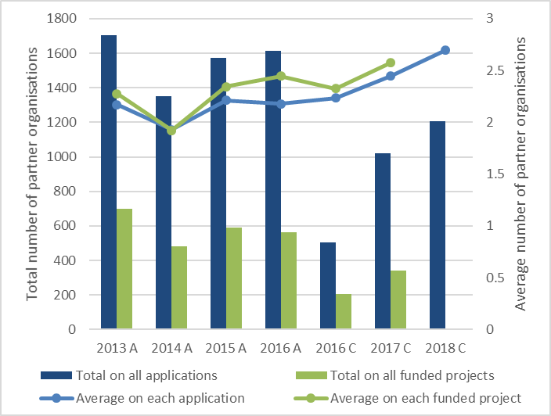

Source: ARC. *Note: complete data for 2018 C were not available at the time of this report’s preparation.*

It is also notable that the average numbers of partner organisations per application and funded project have maintained an overall upward trend through the introduction of the continuous process. This may indicate that while the introduction of the continuous process has not so far supported increased participation by partner organisations at the scheme level, it may have done so at the project level.

### What types of partner organisations have been involved?

In identifying opportunities to support increased research collaboration, the Watt Review noted the government’s specific focus on increasing business engagement and recommended that high quality proposals involving business partner organisations be given greater priority.[8]

As shown in Figure 2, business and industry (identified as ‘Australian Company Industry Body’ and ‘International Company Industry Body’) represented the largest proportion of partner organisations listed on Linkage Projects applications in all rounds from 2013 to 2017. However, under the continuous process, their presence has declined from 44 per cent of named partner organisations in 2016 to 35 per cent in 2017 and 32 per cent in 2018, with 2017 and 2018 being their weakest results over the period. In the 2018 round, government partner organisations (Commonwealth, State and Local, and International) represented the largest proportion of listed partner organisations (35 per cent) for the first time.

#### Figure 2: Types of partner organisations on applications (%)

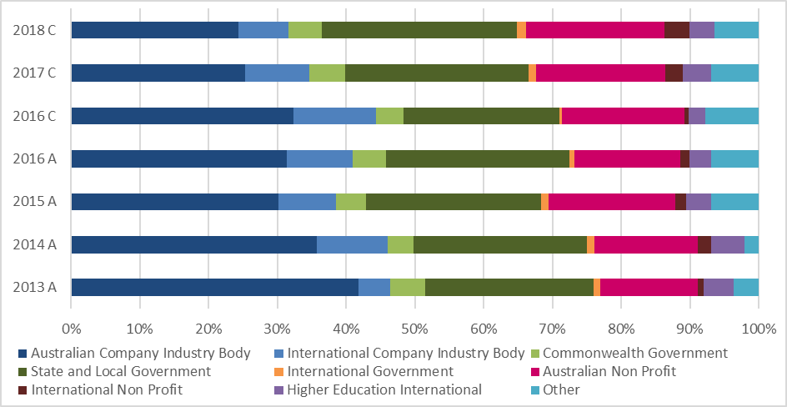

Source: ARC.

Figure 3 shows that the types of partner organisations involved in funded projects differ in small but important ways from those involved in applications. Government partner organisations outnumbered businesses and industry from 2015 to 2017, except in the first continuous round in 2016. In addition, while the proportion of business and industry partner organisations in that round was the highest it has been over the period (50 per cent), in the following, and most recently completed round in 2017, it fell to its lowest (31 per cent).

#### Figure 3: Types of partner organisations on funded projects (%)

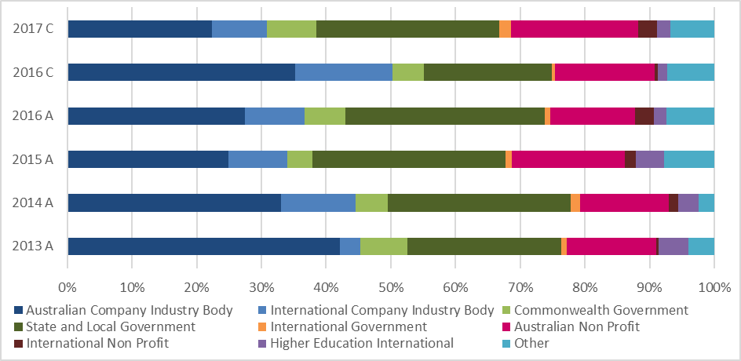

Source: ARC. *Note: data for 2018 C were not available at the time of this report’s preparation.*

While there appears to have been a somewhat more equal balance of partner organisation types participating in the scheme in recent rounds, these data suggest that the continuous process has not incentivised increased participation by business and industry partner organisations specifically. Further, the decline in their representation on funded projects appears at odds with the intended outcomes of the Watt Review recommendation to ensure applications involving business and industry partners are given greater priority.

### How frequently have partner organisations been involved?

The data presented in Table 2 appear to suggest that a smaller proportion of partner organisations have been repeat participants on Linkage Projects applications under the continuous process (22 per cent) than under the annual process (29 per cent). However, on average, those organisations that have participated in multiple applications appear to have done so more frequently under the continuous process (1.21 applications per year) than the annual process (0.79 per year).

The pattern is similar for funded projects, where 11 per cent of organisations involved in funded projects have been repeat participants under the continuous process, compared to 17 per cent under the annual process. However, on average, repeat participants under the continuous process appear to have been involved in more funded projects (1.71 per year) than those under the annual process (0.74 per year).

It is important to note that these comparisons are indicative only, as the continuous process has operated for a shorter period than the annual process and partner organisations have had less time (and, therefore, possibly fewer opportunities) for repeat participation.

In addition to repeat participation, the extent to which new partner organisations are attracted to the scheme may be another useful indicator of support for greater collaboration. This is addressed under evaluation question 4, in relation to stakeholder perceptions regarding the initiation of collaboration.

#### Table 2: Frequency of partner organisation involvement

| APPLICATIONS | | |
| --- | --- | --- |
|  | **Annual process (2013 A – 2016 A)** | **Continuous process (2016 C – 2018 C)** |
| Time period | 4 years | 2.5 years |
| Partner organisations listed on all applications | 6240 | 2731 |
| Unique partner organisations | 3830 | 1895 |
| Partner organisations involved in more than one application | 1119 (29%) | 412 (22%) |
| Average number of applications partner organisations were involved in over the period (if involved in more than one) | 3.15 | 3.03 |
| Average number of applications partner organisations were involved in per year (if involved in more than one) | 0.79 | 1.21 |
| FUNDED PROJECTS | | |
|  | **Annual process (2013 A – 2016 A)** | **Continuous process (2016 C – 2017 C)** |
| Time period | 4 years | 1.5 years |
| Partner organisations listed on all funded projects | 2335 | 547 |
| Unique partner organisations | 1740 | 469 |
| Partner organisations involved in more than one funded project | 304 (17%) | 50 (11%) |
| Average number of funded projects partner organisations were involved in over the period (if involved in more than one) | 2.96 | 2.56 |
| Average number of funded projects partner organisations were involved in per year (if involved in more than one) | 0.74 | 1.71 |

Source: ARC. *Note: the data presented in this table are approximate only. They have been calculated on the basis of partner organisation names recorded in RMS, which may have changed between rounds or entered inconsistently in different applications.*

### How much and what kind of contributions have partner organisations provided?

The continuous process has coincided with a lower value of total partner organisation contributions on funded projects, as shown in Figure 4. This is in line with the lower numbers of applications, funded projects and partner organisations noted previously.

However, over the period since 2013, there has been an overall upward trend in the average value of cash and in kind contributions each application and funded project has attracted, as Figure 5 shows. This has included some fluctuations, with in kind contributions jumping quite sharply in the 2017 round (due in part to two projects that attracted particularly large in kind contributions and together accounted for 15 per cent of the round’s total).[9] As the overall upward trend has continued through both the annual and continuous processes to date, it is difficult to draw conclusions on the role (if any) played by the continuous process. It may be possible to gain further insights after the 2018 round is complete and the data from another full year of the continuous process can be added to the analysis of partner organisation contributions.

#### Figure 4: Total partner organisation contributions (cash and in kind) on funded projects

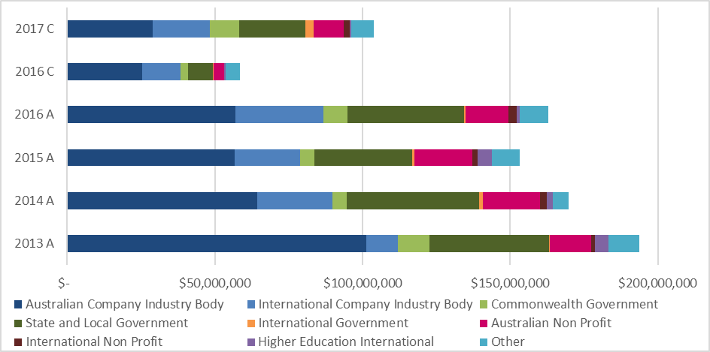

Source: ARC. *Note: data for 2018 C were not available at the time of this report’s preparation.*

#### Figure 5: Average partner organisation cash and in kind contributions per application and funded project

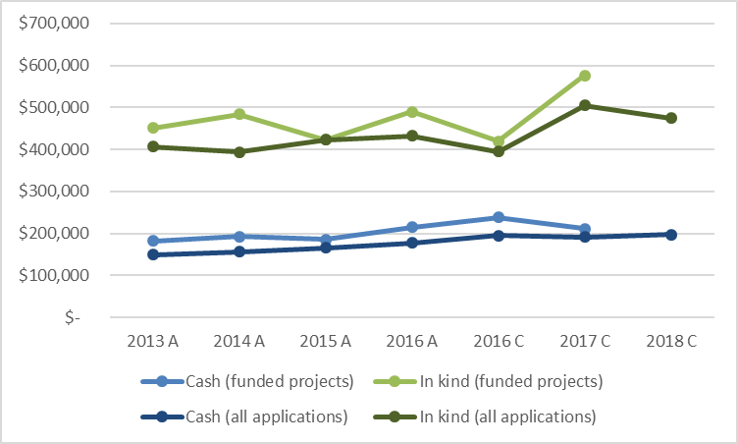

Source: ARC. *Note: complete data for 2018 C were not available at the time of this report’s preparation.*

Figure 4 also depicts the breakdown of total partner organisation contributions on funded projects by organisation type. Business and industry organisations have consistently accounted for largest proportion of partner contributions, even when outnumbered by government partner organisations (in 2015 A, 2016 A and 2017 C). Over the period from 2013 to 2017, they accounted for just under 54 per cent of all partner organisation contributions (54 per cent under the annual process and 53 per cent under the continuous process). Notably, both their highest (66 per cent in 2016 C) and lowest (47 per cent in 2017 C) shares of total contributions have occurred under the continuous process. Given these varied results in relation to the continuous process, further analysis following the completion of the 2018 round may help to provide a clearer picture of trends.

### In which disciplines have partner organisations been involved?

Table 3 provides an overview of the fields of research (FoR)—for applications and funded projects—in which the most Linkage Projects partner organisations have been involved under the annual and continuous processes.[10] In general, it shows that although there has been some movement, the application and project FoRs accounting for the largest proportions of partner organisations have remained quite consistent between the annual and continuous processes.

#### Table 3: Most common FoRs for partner organisation participation

| **APPLICATIONS** | | **FUNDED PROJECTS** | |
| --- | --- | --- | --- |
| **Annual process (2013 A – 2016 A)** | **Continuous process (2016 C – 2018 C)** | **Annual process**  **(2013 A – 2016 A)** | **Continuous process (2016 C – 2017 C)** |
| Engineering  (21%) | Engineering  (19%) | Engineering  (20%) | Engineering  (22%) |
| Studies in Human Society (10%) | Studies in Human Society (9%) | Studies in Human Society (11%) | Studies in Human Society (14%) |
| Environmental Sciences (9%) | Environmental Sciences (9%) | Environmental Sciences (9%) | Earth Sciences  (10%) |
| Biological Sciences (7%) | Medical and Health Sciences (8%) | Biological Sciences (8%) | Environmental Sciences (9%) |
| Medical and Health Sciences (7%) | Biological Sciences (7%) | Medical and Health Sciences (5%) | Biological Sciences (6%) |
| Information and Computing Sciences (6%) | Education  (5%) | Education  (5%) | Medical and Health Sciences (5%) |
| Education  (6%) | Agricultural and Veterinary Sciences (5%) | Information and Computing Sciences (4%) | Information and Computing Sciences (4%) |
| Built Environment and Design (5%) | Earth Sciences  (5%) | Earth Sciences  (4%) | History and Archaeology (4%) |
| Agricultural and Veterinary Sciences (5%) | Information and Computing Sciences (5%) | Built Environment and Design (4%) | Agricultural and Veterinary Sciences (4%) |
| Commerce, Management, Tourism and Services (4%) | Built Environment and Design (4%) | Agricultural and Veterinary Sciences (4%) | Psychology and Cognitive Sciences (3%) |

Source: ARC.

Engineering has clearly been the dominant FoR. It accounted for 21 per cent of all partner organisations on Linkage Projects applications under the annual process and 19 per cent under the continuous process. It also accounted for 20 percent of all partner organisations on funded projects under the annual process and 22 percent under the continuous process.

Engineering has led all other FoRs in these measures in every round since 2013, except in relation to funded projects in the most recently completed continuous round (2017 C). In that round, Studies in Human Society accounted for 20 per cent of all partner organisations on funded projects, while Engineering accounted for 14 per cent. It is important to note that the figures in the previous round (2016 C) were just 3 per cent for Studies in Human Society, as opposed to 36 per cent for Engineering.[11]

Overall, the introduction of the continuous process does not yet appear to have created any significant changes in relation to the FoRs in which partner organisations participate. However, there has been some variation within key FoRs across the first two continuous rounds, and further analysis following the completion of the 2018 round may help to provide a clearer picture of any changes.

### Key findings: Partner organisation involvement

1. The total number of partner organisations involved in each round of the Linkage Projects scheme has declined since the introduction of the continuous process, but has gradually increased with each continuous round.
2. The average number of partner organisations per application and funded project has increased under the continuous process.
3. Business and industry organisations have declined as a proportion of all partner organisations on applications and funded projects under the continuous process.
4. There are indications that a smaller proportion of partner organisations have been repeat participants in the continuous process than in the annual process, but that repeat participants in the continuous process have been involved more frequently.
5. The total value of partner organisation contributions has declined under the continuous process. Data indicate the average value per project is growing, but further analysis would be desirable when more data are available.
6. Business and industry organisations have continued to provide the highest proportion of partner organisation contributions under the continuous process.
7. The continuous process does not appear to be associated with a major change in the disciplines in which partner organisations have been involved, but further analysis would be desirable when more rounds have been completed.

## Evaluation question 2: Applications and selection outcomes

What changes have there been in Linkage Projects applications and selection outcomes under the continuous process, including:

1. the number of applications submitted
2. the timing of application submissions
3. success and return rates
4. the quality of applications
5. the timing of announcements?

### Number of applications submitted

As foreshadowed above, the number of Linkage Projects applications submitted and funded has declined since the introduction of the continuous process. Figure 6 shows that while these numbers appear to be gradually increasing with each round, they remain well below the totals for each round under the annual process.

Administering and partner organisation stakeholders expressed a view that the lack of deadlines under the continuous process has made Linkage Projects applications less of a priority.[12] This is discussed in more detail under evaluation questions 4 and 5.

#### Figure 6: Total number of applications submitted and funded

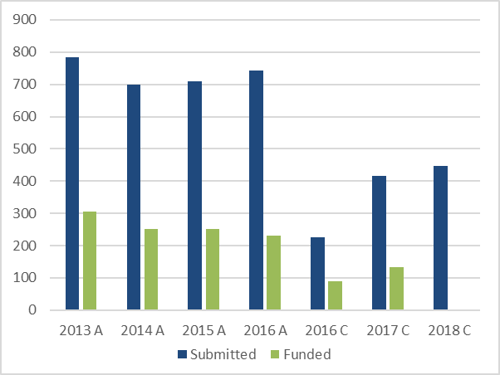

Source: ARC. *Note: complete data for 2018 C were not available at the time of this report’s preparation.*

Consistent with fewer funded projects, there has been less total funding awarded in continuous rounds than annual rounds, as shown in Figure 7. However, the average funding awarded per project has increased over the period from 2013 ($332,710 per project) to 2017 ($404,017 per project), with higher values and greater growth in the two completed continuous rounds.

#### Figure 7: Linkage Projects funding awarded

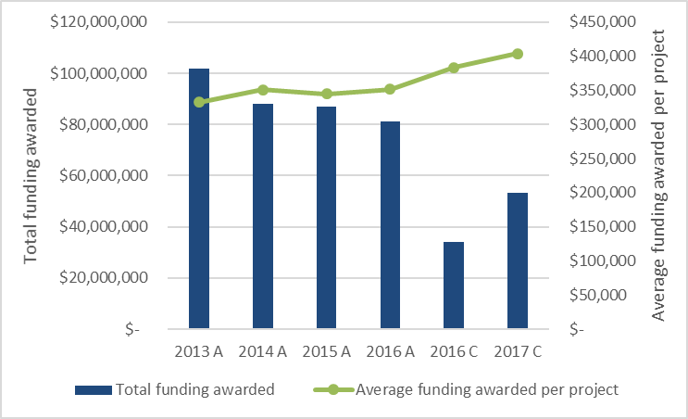

Source: ARC. *Note: data for 2018 C were not available at the time of this report’s preparation.*

### Timing of application submissions

To manage the continuous process and ensure all funding recommendations are provided to the Minister within six months of application submission, the ARC processes applications in batches. When the first application under a scheme round is received, the timelines for that round’s batches are set—usually at intervals ranging from around 3 weeks to 8 weeks—with the final batch collecting all applications received in the last interval up to a date in late December (for example, the final batch for the 2018 round consisted of applications received between 28 November and 20 December 2018).

The size of each batch gives a good indication of when applications have been submitted under the continuous process. As shown in Figure 8, they have not been submitted steadily throughout the year, and the final batch in each round has accounted for a disproportionate share—74 per cent in 2016 C, and around 47 per cent in both 2017 and 2018—approximately 53 per cent of all applications since the continuous process was introduced.

#### Figure 8: Number of applications by batch

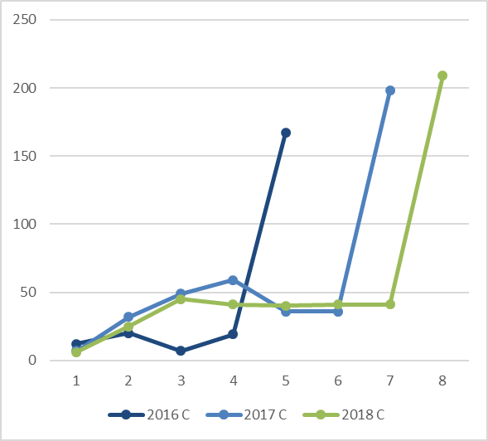

Source: ARC.

These data suggest that many researchers, universities, and possibly their partner organisations are not responding to the continuous process as the Watt Review and NISA envisaged, and are not using the continuous process to submit applications as opportunities for collaboration arise. Stakeholder perspectives on these issues are discussed in detail under evaluation questions 4 and 5.

### Success rates, return rates and quality of applications

As shown in Figure 9, there have been fluctuations in Linkage Projects success rates (the number of funded projects as a percentage of applications submitted) and return rates (the amount of ARC funding awarded as a percentage of funding requested in successful applications). The success rate fell from 39 per cent to 31 per cent under the annual process. It then jumped to 40 per cent in the first continuous round in 2016, before falling back to 32 per cent in the 2017 round. By contrast, the return rate increased slightly in the first three rounds of the annual process, before falling from 79 per cent in 2015 to 72 per cent in 2016 A. It then rose in the first two continuous rounds—to 77 per cent in 2016 C and 82 per cent in 2017.

Further analysis of success and return rates should be undertaken after completion of the 2018 round to investigate whether any clearer trends emerge in relation to the continuous process.

#### Figure 9: Linkage Projects success and return rates

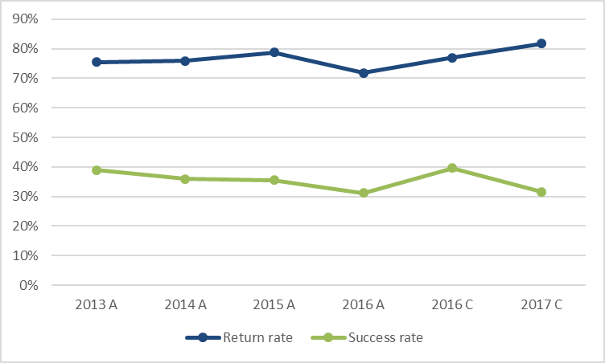

Source: ARC. *Note: data for 2018 C were not available at the time of this report’s preparation.*

Scheme success rates and return rates may provide some insights into the quality of applications. For example, higher success rates for a particular round may indicate that better quality applications have been submitted, and higher return rates may indicate better justified project budgets. However, other variables such as the number of applications submitted in a round and the amount of funding available must also be taken into account. Given the variations in these areas that have occurred with the change to the continuous process, it is difficult to draw clear conclusions from the data about changes in the quality of applications. However, some perceptions of detailed assessors and SAC members in relation to the quality of applications are discussed under evaluation question 6.

### Timing of announcements

The Watt Review recommended that grant announcements under the continuous process be made within six months of the submission of applications.[13] In accordance with the *Australian Research Council Act 2001*, ministerial approval is required for all ARC grants, with the ARC CEO to make recommendations to the relevant Minister on which grants should be approved and the funding amounts.[14] As with all ARC grant schemes, successful grants are announced publicly by the Minister, with unsuccessful outcomes made available to applicants via RMS. The timing of grant announcements is at the discretion of the Minister.

In the 2016 and 2017 continuous rounds, the ARC provided all funding recommendations to the Minister within six months. While all successful grants were announced publicly and unsuccessful outcomes made available in RMS within six months in the 2016 continuous round, this fell to 72 per cent in the 2017 round.[15]

### Key findings: Applications and selection outcomes

1. The total numbers of applications and funded projects have declined since the introduction of the continuous process, but have gradually increased with each continuous round.
2. Total grant funding has been lower under the continuous process, but average funding per project has been higher and has grown at a relatively fast rate.
3. Around half of all applications under the continuous process have been submitted in the final few weeks of each round, not steadily throughout the round.
4. It is too early to identify clear trends in success rates and return rates under the continuous process. Further analysis would be desirable when more rounds have been completed.
5. Not all grant outcomes have been announced within six months from the submission of applications.

## Evaluation question 3: ARC administration

What are the pros and cons for the ARC in administering the continuous process, including:

1. efficiencies or burdens in terms of costs and resources
2. managing the flow of applications and assessment (including ‘batching’ of applications)
3. effectiveness of assessment processes (including virtual meetings, peer review, ensuring quality applications are funded)
4. administrative risks (such as monitoring, fraud and legal issues)?

### Efficiencies and burdens in managing the continuous process

In response to the introduction of the continuous process, the ARC implemented a number of modifications to accommodate the continuous nature of the scheme.[16] For example, changes were required in RMS to allow applications to be received, processed and assessed throughout the year, rather than on set dates (like other ARC schemes).

Despite the overall decline in application numbers, the continuous process has been administratively demanding for the ARC. Compared with the annual process, greater manual processing is required to manage each application through RMS and more intervention is required to manage the assessment process and support assessors. There is also additional work associated with managing applications in multiple batches, including the administration of multiple SAC meetings each round (five in 2016 C, seven in 2017 C and eight in 2018 C), seeking ministerial approval of funding recommendations for each batch and the announcement of outcomes.[17]

This has encouraged the introduction of efficiencies such as conducting SAC meetings via Zoom videoconference, which has avoided many of the financial and time costs of in-person meetings for both the ARC and SAC members. Further, due to fast tracking and the ARC managing applications in batches, each SAC meeting involves the discussion of fewer applications and a lighter workload compared with an annual meeting that would address the entire round. Figure 10 shows that the majority of applications (58 per cent) were fast tracked in both the 2016 and 2017 continuous rounds.

#### Figure 10: Number of applications – fast tracked vs SAC meeting

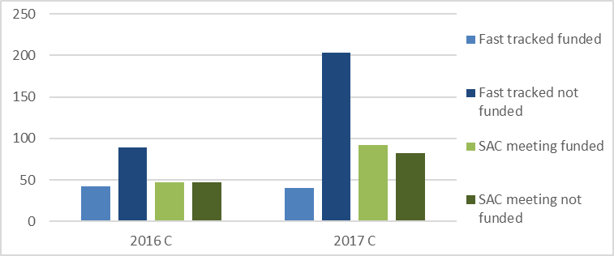

Source: ARC. *Note: complete data for 2018 C were not available at the time of this report’s preparation.*

### Effectiveness of assessment processes

Additional mechanisms have been required to ensure maintenance of a robust and consistent assessment process. ARC officers were confident that these have ensured that only quality proposals receive funding under the continuous process.[18]

For instance, while assessing a single annual round of applications allows for a ready comparison of their quality, assessing applications throughout the year in smaller batches makes relative assessments of quality more difficult. In addition, only those applications that have not been fast tracked are considered and discussed at a SAC meeting. To assist with benchmarking, SAC members have been provided with samples of high and low quality applications to review before considering newly received applications. In addition, SAC members have been selected to ensure that experienced members are retained every year in order to maintain knowledge and continuity in the assessment process.

A risk of the continuous process is that the increased number of SAC meetings may result in a decline in attendance at each meeting by SAC members. This could have implications for the effectiveness and robustness of the peer review process and potentially weaken the representation of relevant disciplinary expertise in the meetings. Out of an aggregate 189 member positions on the seven SAC meetings held under the 2017 continuous round, there were 23 total absences, with up to nine members absent from a single meeting.[19]

As absences continued to be a concern in the early SAC meetings for the 2018 round, the ARC conducted a range of outreach activities to stress the importance of SAC members’ participation, including as part of induction for new SAC members. There is some anecdotal evidence that attendance at SAC meetings has since improved, but to confirm whether the ARC’s response has been effective, further analysis would be beneficial after all meetings for the 2018 round have been completed.

### Administrative risks

Despite the changes allowing application submission and assessment to occur continuously throughout each round, ARC funding for successful Linkage Projects applications commences on either 1 January or 1 July each year. The Linkage Projects Grant Agreement also requires universities to commence projects within six months of the grant announcement, and to have a written agreement in place with each partner organisation before commencing the project.[20]

While these requirements are not unique to the Linkage Projects scheme, they may impact on the ability of the continuous process to support timely collaboration. Survey and interview responses from research office, CI and PI participants included that these requirements add to the time taken to commence projects and the ARC should ease the restriction and allow projects to commence before agreements are signed by partner organisations. Other comments included that universities do not control or know when partner organisations will sign and, consistent with a perception that tracking applications through the continuous process is difficult (discussed further under evaluation question 5), it is not easy to plan for agreements when the timeframes for grant announcements are uncertain.[21]

Table 4 shows the percentage of funded projects with formally deferred commencement dates in each Linkage Projects round under the annual and continuous processes. The predominant reason for these deferrals in all rounds has been delay in the conclusion of agreements with partner organisations. After a remarkable spike in the 2016 annual round (which, anecdotally, appears to have been due to external factors rather than any change in ARC processes), deferrals declined in the 2016 and 2017 continuous rounds, but have been more frequent than in earlier annual rounds. Given the fluctuations in the data, it is not possible to draw conclusions on whether the continuous process is associated with any changes in this area.

#### Table 4: Funded projects with deferred commencement

|  | 2013 A | 2014 A | 2015 A | 2016 A | 2016 C | 2017 C |
| --- | --- | --- | --- | --- | --- | --- |
| Total | 306 | 251 | 252 | 231 | 89 | 132 |
| Deferred | 36 | 17 | 21 | 228 | 61 | 31 |
| % | 12 | 7 | 8 | 99 | 69 | 23 |

Source: ARC. *Note: complete data for 2018 C were not available at the time of this report’s preparation.*

Nonetheless, in order to support better alignment between grant announcements and the commencement of funding under the continuous process, the ARC could consider potential modification of its financial systems to allow for the release of initial funding for frequently throughout the year (for example, quarterly). The ARC could also consider asking industry partners to provide their funding contributions first (that is, before ARC funding commences) to avoid delays in commencement, but noted this is likely to be challenging for projects where smaller partner organisations are not contributing cash or have limited cash resources.[22]

### Suggestions for improvement

As discussed throughout this report, the lack of deadlines in the continuous process was seen as an important issue in a number of respects by Linkage Projects stakeholders. As outlined under evaluation questions 5 and 6, many stakeholders felt that the introduction of application deadlines would improve the process.

An approach to modifying the ARC’s administration of the continuous process could be to continue to allow applications to be submitted at any time, and to publicly announce three or four application batch deadlines per year. Assessment would occur in three or four rounds, aligned with the application deadlines (it should be noted that the original Watt Review recommendation was for three selection meetings to be held per year). A move to published deadlines would require a change to the commitment to announce outcomes within six months, with the timeframe to begin from the application deadline.

### Key findings: ARC administration

1. Efficiencies have been achieved by holding SAC meetings via Zoom, and the fast tracking of applications has reduced SAC workloads.
2. The need for multiple SAC meetings in each round has increased the demands placed on SAC members and created risks relating to their meeting attendance. Further analysis of SAC attendance would be beneficial after the 2018 round is complete.
3. The implementation of the continuous process has increased the ARC’s administrative burden in managing application, assessment, approval and announcement processes throughout the year.
4. More frequent Linkage Projects funding commencement dates may help to support more timely project commencement.
5. The introduction of multiple application deadlines and assessment rounds per year may improve the continuous process.

## Evaluation question 4: Stakeholder views – collaboration and innovation

What are administering and partner organisations’ views on whether, and how, the continuous process:

1. facilitates greater collaboration within the university sector and with partner organisations
2. encourages partner organisations to participate in collaborative research
3. influences the ways in which collaboration is initiated and managed, and by whom
4. facilitates support for research that responds to time critical innovation opportunities
5. influences administering and partner organisations’ approaches and responses to time critical innovation opportunities
6. meets its objectives as outlined by NISA and the Watt Review?

### Collaboration within the university sector and with partner organisations

Consistent with the ARC data discussed under evaluation questions 1 and 2, all administering organisation research offices interviewed by ACIL Allen Consulting noted a decline in the number of applications submitted since the introduction of the continuous process. They viewed this as representing a decline in engagement with partner organisations and were unanimous on the reasons for the decline: both university applicants and partner organisations prioritise applications that have deadlines. They viewed deadlines as providing an incentive for university researchers to finalise their applications and organise and conclude arrangements with partner organisations, and as being central to partner organisations’ work planning, resource allocation and budgets.[23] As already noted, the lack of deadlines was a recurring theme in feedback from all stakeholder groups, although views on its impacts varied.

Despite the overall decline in collaboration, survey responses from CIs who had been involved in Linkage Projects both prior to and after the introduction of the continuous process suggest some positive impacts. As shown in Figure 11a, 36 per cent reported forming more collaborations, forming collaborations with a broader range of partner organisations and experiencing more successful collaborations—although the most frequent response in each of these areas was ‘no change’.

#### Figure 11a: CIs (involved prior) – impact of the continuous process on collaboration

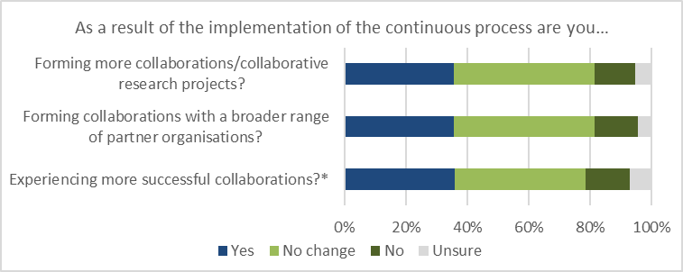

Source: ACIL Allen Consulting. *Note: n=183 (*n=181) CIs who had been involved prior to the continuous process.*

CIs who had not been involved in Linkage Projects prior to the introduction of the continuous process were asked the same question and, as shown in Figure 11b, their responses were clearly more positive. However, these findings are difficult to interpret. CIs who had been involved in the annual Linkage Projects process could compare their experiences from before and after the continuous process. For CIs who were not involved in Linkage Projects previously, it is unclear what prior experiences (if any) they were comparing.

#### Figure 11b: CIs (not involved prior) – impact of the continuous process on collaboration

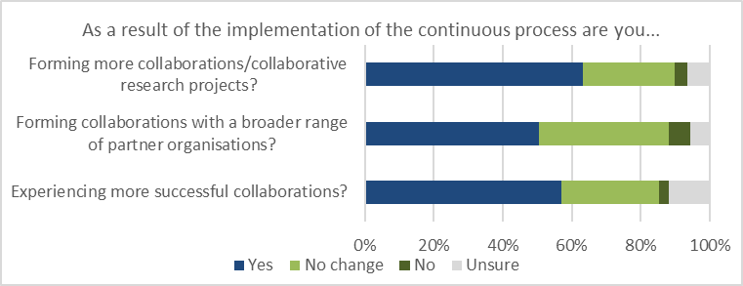

Source: ACIL Allen Consulting. *Note: n=109 CIs who had not been involved prior to the continuous process.*

PIs who had been involved prior to the introduction of the continuous process also perceived some benefits for collaboration, with a majority (55 per cent) responding that it had a positive or slightly positive impact in facilitating more successful, diverse research collaboration, as shown in Figure 12. The results were even more positive for PIs who had not been involved prior to the continuous process, but as with the CI responses, it is unclear what prior experiences (if any) they were comparing.

#### Figure 12: PIs (involved prior) – impact of the continuous process in facilitating more successful, diverse research collaboration

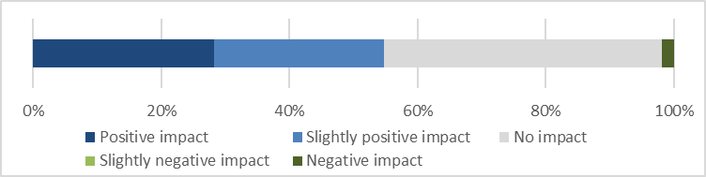

Source: ACIL Allen Consulting. *Note: n=53 PIs who had been involved prior to the continuous process.*

### Partner organisation participation

As discussed earlier, total partner organisation participation in Linkage Projects has decreased under the continuous process. However, stakeholder feedback suggests the continuous process may support improved engagement among a smaller number of participating partner organisations. For example, the majority (63 per cent) of PIs who had been involved prior to the change indicated that the continuous application process made it easier for them to participate in Linkage Projects grant applications.[24]

Figure 13 shows that 47 per cent of PIs who had been involved prior to the continuous process considered it to have a positive or slightly positive impact on increasing their engagement in collaborative research under the scheme (45 per cent perceived no impact and the remaining 8 per cent perceived a slightly negative impact).

#### Figure 13: PIs (involved prior) – impact of the continuous process in increasing participation in collaborative research under the Linkage Projects scheme

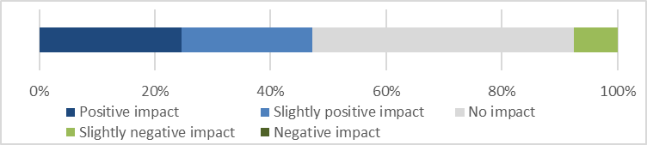

Source: ACIL Allen Consulting. *Note: n=53 PIs who had been involved prior to the continuous process.*

As shown in Figure 14, two thirds (67 per cent) of CIs who had been involved prior to the continuous process perceived a positive or slightly positive impact on PI engagement and retention for the duration of the application process. However, the perception of this issue among PIs themselves was somewhat different, with 40 per cent responding that it had a positive or slightly positive impact, and 58 per cent perceiving no impact.

#### Figure 14: Impact of the continuous process on engagement and retention of partner investigators for the duration of the application process

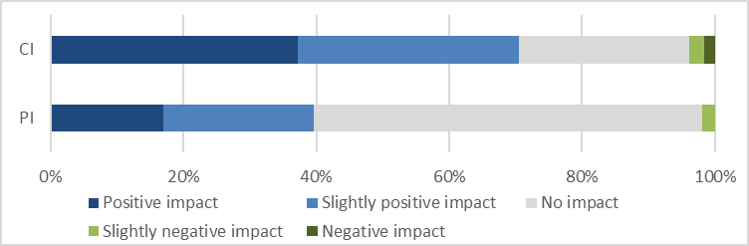

Source: ACIL Allen Consulting. *Note: n=183 CIs and n=53 PIs who had been involved prior to the continuous process.*

An important aspect of encouraging partner organisations to collaborate is facilitating their access to relevant research. As Figure 15 shows, 43 per cent of PIs who had been involved in Linkage Projects prior to the continuous process considered the change had improved their access to research, (compared to 31 per cent who said it had not and 26 per cent who were unsure). By contrast, responses from PIs who had not been involved previously were markedly more positive, with 60 per cent reporting improved access to research. Again, this result is difficult to interpret because the reference point for this comparison is unclear.

#### Figure 15: PI views on whether the continuous process has improved their access to research

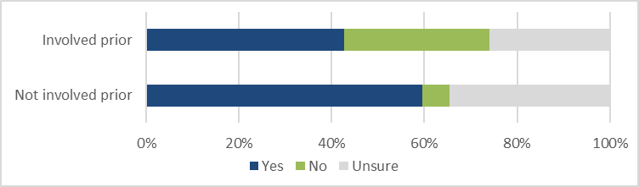

Source: ACIL Allen Consulting. *Note: n=54 PIs who had been involved prior to continuous process and n=52 PIs who had not.*

### Initiation and management of collaboration

As shown in Figure 16, around half (49 per cent) of CI respondents who had been involved prior to the continuous process indicated they were initiating and managing collaboration in a different way as a result of its introduction. Most PIs who had been involved prior to the continuous process (63 per cent) perceived it to have a positive or slightly positive impact on changing the initiation and management of collaboration, as shown in Figure 17.

#### Figure 16: CIs (involved prior) – initiating and managing collaborations in a different way

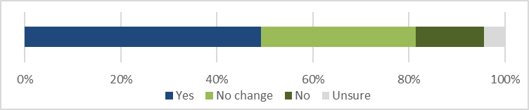

Source: ACIL Allen Consulting. *Note: n=183 CIs who had been involved prior to the continuous process.*

#### Figure 17: PIs (involved prior) – impact of the continuous process on changing the way in which collaborations are initiated and managed

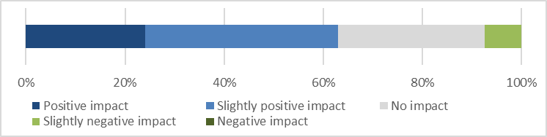

Source: ACIL Allen Consulting. *Note: n=54 PIs who had been involved prior to the continuous process.*

The perceptions of CIs and PIs shown in Figures 18 and 19 give an indication of how the initiation of Linkage Projects applications may have changed. Each group was asked, ‘On average, how were your Linkage Projects application/s initiated?’ and given a set of response options. CIs were most likely to report developing applications from existing collaboration. Those who had only been involved after the introduction of the continuous process were less likely to report approaching a business than those who had also been involved before its introduction. This may bolster the finding that the continuous process may not be facilitating business and industry organisation participation as intended by NISA and the Watt Review.

#### Figure 18: CI reporting on initiation of Linkage Projects applications

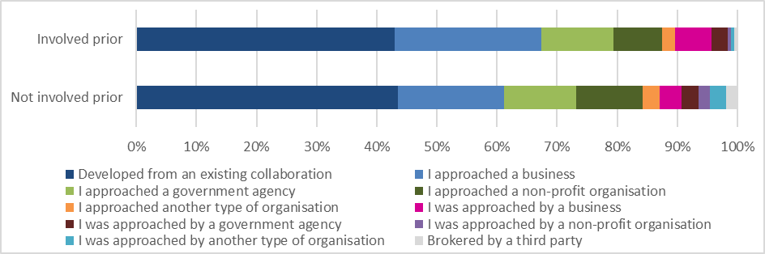

Source: ACIL Allen Consulting. *Note: n=184 CIs who had been involved prior to the continuous process and n=108 CIs who had not.*

#### Figure 19: PI reporting on initiation of Linkage Projects applications

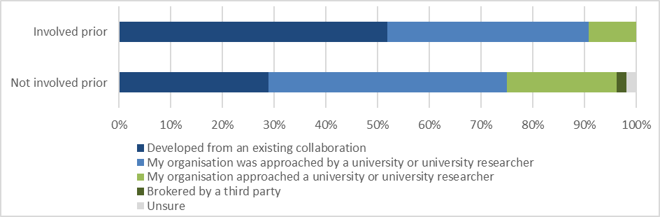

Source: ACIL Allen Consulting. *Note: n=54 PIs who had been involved prior to the continuous process and n=52 PIs who had not.*

Among PIs involved prior to the continuous process, 52 per cent reported applications developing from existing collaboration and 39 per cent reported that they were approached by a university or researcher. For PIs who were not involved prior to the continuous process, these figures were 29 per cent and 46 per cent, respectively, and this group was also more likely to report that their organisation had approached a university or researcher. These responses appear to indicate that the continuous process may provide increased encouragement for partner organisations to enter new collaborations and to seek out collaboration.

It is important to note that the survey participants only included CIs and PIs who have been successful under the continuous process. Thus, these findings cannot support firm conclusions about the impact of the continuous process on the initiation of research collaboration and the development of applications across the scheme. Further survey research in future may help to illuminate broader stakeholder perspectives on these issues.

In addition, university research office participants noted that the way collaboration is initiated varies between institutions, with some adopting university-wide policies, some specialising in research areas that are currently popular with industry, and some providing seed funding to develop collaborations as a stepping stone to Linkage Projects applications. They therefore found it difficult to identify causal links between the continuous process and changes in the initiation of collaboration.[25]

### Support for research that responds to time critical innovation opportunities

The majority of all CI (81 per cent) and PI (59 per cent) participants responded that the continuous application process provided a sufficiently timely response to meet their needs, as shown in Figure 20a. While a larger proportion of CIs than PIs responded positively on this issue, those PIs that did respond positively were slightly more likely to see this as beneficial to their organisation than CIs were, as shown in Figure 20b.

#### Figure 20a: CI and PI views on whether the continuous application process provides a sufficiently timely response to meet their needs

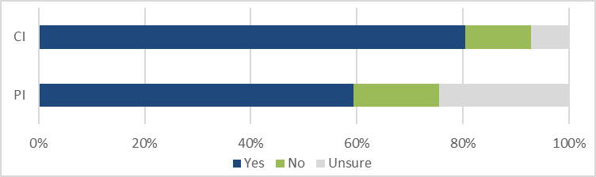

Source: ACIL Allen Consulting. *Note: n=293 CIs and n=106 PIs.*

#### Figure 20b: CI and PI views on how beneficial this has been to their university/organisation

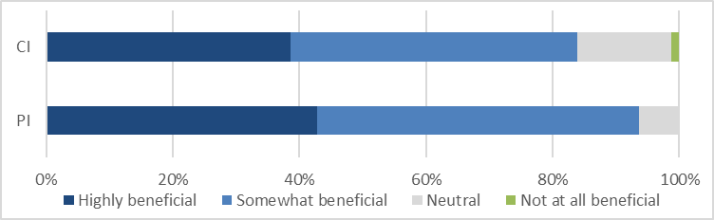

Source: ACIL Allen Consulting. *Note: n=236 CIs and 63 PIs.*

### Responses to time critical innovation opportunities

CI and PI survey results provide some positive indications that the continuous process may influence administering and partner organisations’ behaviour in response to innovation opportunities. For instance, Figure 21 shows that the majority (56 per cent) of CIs who had been involved prior to the continuous process reported forming collaborations in a more timely manner as a result of its implementation.

#### Figure 21: CIs (involved prior) – forming collaborations in a more timely manner as a result of the implementation of the continuous application process

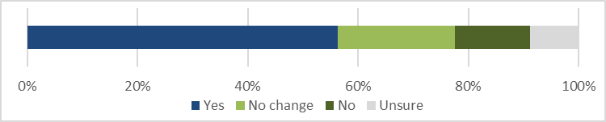

Source: ACIL Allen Consulting. *Note: n=183 CIs who had been involved prior to the continuous process.*

Figure 22 shows that CIs and PIs who had been involved prior to the continuous process overwhelmingly perceived it to have a positive or slightly positive impact in facilitating greater responsiveness to innovation opportunities. The perceptions of PIs in relation to facilitating greater responsiveness to time critical market opportunities were less positive, as shown in Figure 23, although more than half (58 per cent) still considered the continuous process to have a positive or slightly positive impact.

#### Figure 22: Impact of the continuous process in facilitating greater responsiveness to innovation opportunities

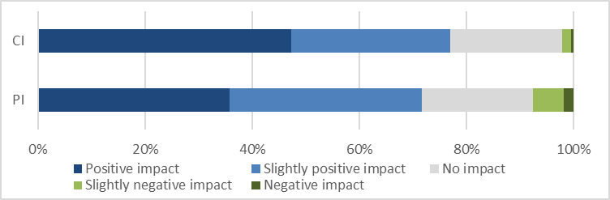

Source: ACIL Allen Consulting. *Note: n=182 CIs and n=53 PIs who had been involved prior to the continuous process.*

#### Figure 23: PIs (involved prior) – impact of the continuous process in facilitating greater responsiveness to time critical market opportunities

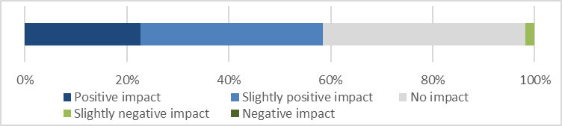

Source: ACIL Allen Consulting. *Note: n=53 PIs who had been involved prior to the continuous process.*

Again, it is important to reiterate that all surveyed CIs and PIs had been involved in successful applications under the continuous process. Research office participants provided a contrasting view, and were not confident that the continuous process has improved responsiveness to time critical innovation opportunities. Several research office participants suggested that industry partners are likely to apply to other grant programs or draw on personal networks if they have time critical opportunities they wish to pursue.[26]

### NISA and Watt Review objectives

As outlined above, there is a range of areas relevant to the objectives of NISA and the Watt Review in which successful CIs and PIs most commonly had positive, or at least neutral perceptions of the change to the continuous process.

Stakeholders were also asked the question, ‘On balance, does the change to a continuous application process achieve the objectives of facilitating timely collaboration and greater responsiveness to innovation opportunities?’ As shown in Figure 24, the different CI and PI groups all responded overwhelmingly positively, although PIs who had been involved prior to the continuous process were the least positive, with 23 per cent responding that it did not achieve those objectives.

#### Figure 24: CI and PI views on whether the continuous process achieves its objectives

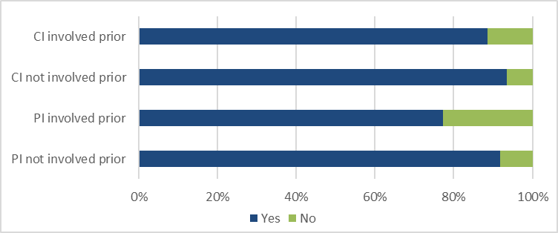

Source: ACIL Allen Consulting. *Note: n=183 CIs and n=53 PIs who had been involved prior to the continuous process and n=109 CIs and n=49 PIs who had not.*

Research office participants considered that the continuous process is a deterrent to applicants and has not facilitated timely collaboration or responsiveness to innovation opportunities.[27] The perspectives of CIs and PIs who have been successful under the continuous process must therefore be considered against the backdrop of the lower total numbers of applications and partner organisations involved.

### Key findings: Stakeholder views – collaboration and innovation

1. University research offices see the decline in applications as representing a decline in collaboration. They consider that without deadlines, there are fewer incentives for researchers and partner organisations to prioritise Linkage Projects applications.
2. Many successful CIs and most successful PIs perceive the continuous process to support increased and improved collaboration within their projects.
3. There are some indications that the continuous process may provide increased encouragement for partner organisations to seek out and enter new research collaborations, but further survey research is needed.
4. Among successful CIs and PIs, the majority considered the continuous process to facilitate timely collaboration and greater responsiveness to innovation opportunities.

## Evaluation question 5: Stakeholder views – processes

How satisfied are administering and partner organisations with:

1. the efficiency and effectiveness of the continuous Linkage Projects application and assessment processes, including fast-tracking
2. the timeliness of announcements
3. the administration and provision of awarded funding?

### Efficiency and effectiveness of the continuous process

As Figure 25 shows, the majority (77 per cent) of CIs who had been involved prior to the continuous process perceived that the change has made it easier to apply for a Linkage Projects grant. Among the same group, 63 per cent reported that they were more likely to submit applications as a result of the implementation of the continuous process (this figure was 74 per cent for CIs who had not been involved prior to the continuous process).[28] However, given the decline in total Linkage Projects applications, it is likely that other stakeholders who have not been successful under the continuous process and who were not included in the surveys may have very different views.

#### Figure 25: CI (involved prior) views on whether the continuous process has made it easier to apply for a Linkage Projects grant

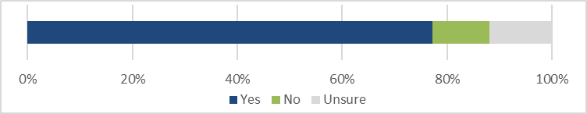

Source: ACIL Allen Consulting. *Note: n=184 CIs who had been involved prior to the continuous process.*

CIs who reported they had resubmitted a similar Linkage Projects application multiple times were asked about the timeframe between receiving advice that the original application had been unsuccessful and resubmission. Around 17 per cent of CIs said they had resubmitted—including 44 CIs who had been involved before the continuous process and five CIs who had not.[29] Respondents gave a wide range of timeframes and it is not possible to discern from the responses whether the former group resubmitted before or after the continuous process was introduced, so no clear conclusions can be drawn on the effect of the continuous process in this regard.

Stakeholder views were sought on burdens associated with the changes. A small minority of CIs (6 per cent) and PIs (9 per cent) associated the continuous process with additional costs, as shown in Figure 26, though these were not generally financial costs. For CIs, costs included additional time spent preparing applications where there were no deadlines, and developing and managing relationships with partners. For PIs, costs included managing ad hoc requests to collaborate throughout the year and chasing university partners to submit applications.[30]

Despite submitting fewer applications, research office participants reported a need to assign more resources to administer and follow up Linkage Projects applications throughout the year (rather than at one time)—including to encourage CIs to develop relationships and complete and submit applications. While there is a peak in applications at the end of the year, research offices reported finding it difficult to predict the volume and precise timeframes for which additional resources will be required.[31]

#### Figure 26: CI and PI (involved prior) – additional costs created by continuous process

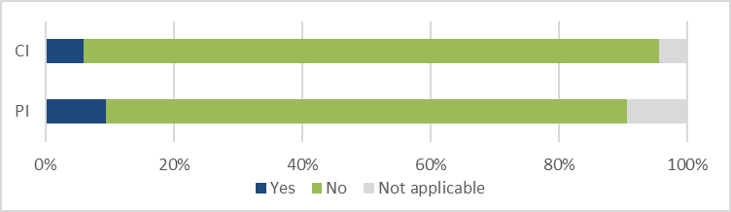

Source: ACIL Allen Consulting. *Note: n=184 CIs and n=53 PIs who had been involved prior to the continuous process.*

Participants were asked if their university or organisation’s internal and quality control processes for research applications have been affected by the continuous process. Only five PIs responded that they had. By contrast, 36 per cent of CIs perceived a change in university processes, 31 percent perceived no change and the remainder (33 per cent) were unsure.[32] Among CIs who provided additional comments, the most commonly perceived changes were the introduction of ‘batching’ of applications and altered timeframes for internal processing and review of applications. ‘Batching’ here refers to the creation of a series of internal university deadlines that aim to improve the administration of Linkage Projects applications and apply pressure to researchers (CIs) to complete their applications.

Some research office participants reported that their universities have trialled batching to manage the continuous process, but that researchers tend to overlook these internally generated deadlines, as opposed to deadlines imposed externally by the ARC. Other comments from research office participants regarding changes in their processes varied, but included the following perspectives:

* the processes of working with researchers to ensure high quality applications has not changed, but researchers need to be educated about the requirements of the Linkage Projects process more frequently
* Linkage Projects applications are disadvantaged because, without hard deadlines, they are not prioritised when there are many other deadlines to contend with.[33]

At a more general level, when asked about the consequences of moving to the continuous process, 67 per cent of CIs and 61 per cent of PIs reported encountering positive consequences, while only 13 per cent of CIs and 15 per cent of PIs reported encountering challenges or negative consequences.[34]

The positive consequences identified by CIs included the additional flexibility to spend more time on applications, manage workloads associated with writing different grant applications, develop relationships with partners and respond to partners’ timelines. Challenges identified by CIs related to the lack of deadlines—including applications taking longer to complete, fewer applications being completed, and difficulties in keeping other investigators, partners and research offices focused on timeframes—as well as concerns about the quality and consistency of assessment processes and the lack (or delay) of feedback provided on the rating of unsuccessful applications.

Comments from PIs also emphasised the benefits of additional flexibility, ability to align applications with industry timeframes (including planning and budget), time to develop better partnerships and applications, and the ability to develop more applications. Challenges identified by PIs related to assessing and prioritising opportunities (with continual approaches from academics), lack of alignment with their internal processes and timelines, difficulty maintaining interest and engagement without deadlines, and the length of the ARC process.

While Research office participants, CIs and PIs provided views on the timeliness of the continuous process (as outlined below), they were not specifically asked about the effectiveness and efficiency of the process for fast tracking applications. This was a focus in the detailed assessor and SAC member surveys discussed under evaluation question 6.

### Timeliness of announcements and administration of funding

In general, the majority of stakeholders expressed satisfaction with the ARC’s administration of the continuous process. For example, when CIs were asked about their satisfaction with the ARC’s communication during the application process, 78 per cent reported that they were ‘satisfied’, ‘very satisfied’ or ‘extremely satisfied’,[35] although as Figure 27 shows, there was greater satisfaction among CIs who had not been involved prior to the continuous process.

#### Figure 27: CI satisfaction with ARC communication during the application process

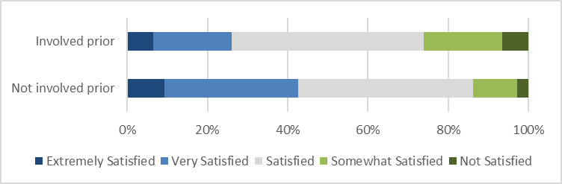

Source: ACIL Allen Consulting. *Note: n=184 CIs who had been involved prior to the continuous process and n=108 CIs who had not.*

Both CIs and PIs were asked about their satisfaction with the timeliness of grant announcements under the continuous process. PIs expressed slightly greater satisfaction than CIs, with 80 percent responding that they were ‘satisfied’, ‘very satisfied’ or ‘extremely satisfied’, as compared to 74 per cent of CIs.[36] Among CIs, those who had not been involved prior to the continuous process again reported greater satisfaction than those who had, as shown in Figure 28. In this area the views of PIs who had been involved prior to the continuous process appear to be rather polarised, providing responses of both ‘extremely satisfied’ and ‘not satisfied’ more frequently than PIs who had not been involved prior to the continuous process.

#### Figure 28: CI and PI satisfaction with the ARC’s administration of the continuous process, including timeliness of announcements

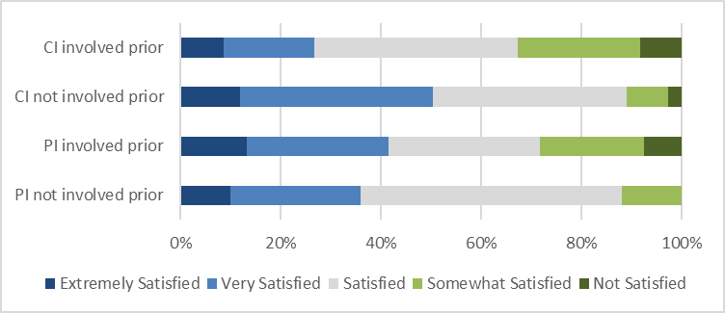

Source: ACIL Allen Consulting. *Note: n=183 CIs and n=53 PIs who had been involved prior to the continuous process and n=109 CIs and n=50 PIs who had not.*

Despite these predominantly positive responses, other comments provided by stakeholders highlighted a number of particular concerns regarding the ARC’s administration of the continuous process. For instance, CI comments included that it is difficult to track applications through the process, and that there appeared to be little change in the timeline for announcements under the continuous process.[37]

The provision of feedback on applications was another common theme in comments from research office participants and CIs. Their concerns included that feedback on the ranking of unsuccessful applications has not been provided under the continuous process, which makes it difficult to consider improvements in applications, and that the announcement of unsuccessful applications through RMS was unclear. Research offices commented that the approach to announcements and selection reports made it difficult for universities to benchmark their relative performance. CIs expressed a view that more timely feedback should be provided on unsuccessful applications that have been fast tracked (with low assessment scores) to allow for quicker resubmission.[38]

### Suggestions for improvement

In responses to the open question, ‘What could be done to improve the implementation of the continuous process?’ themes that emerged most commonly among both CIs and PIs included:

* increasing the speed of the ARC assessment process and announcing grant outcomes more quickly (including to better meet partner organisations’ needs)
* providing more information on the progress of applications (including whether they have been fast tracked or not) and expected timeframes for the announcement of outcomes
* introducing multiple application submission deadlines—between two and four per year.[39]

Research office participants were also asked for their views on how the implementation of the continuous process could be improved. Consistent with their comments elsewhere, their responses focused on reintroducing multiple application submission deadlines, most commonly suggesting two or three deadlines per year. They also suggested that the assessment process should be faster to support time critical opportunities.[40]

### Key findings: Stakeholder views – processes

1. The continuous process has not created significant additional financial costs for research offices, CIs and PIs, but it has required additional time and work to manage collaboration and applications throughout the year.
2. Stakeholders have mixed views regarding the flexibility of the continuous process—for some it supports better collaboration and applications, for others the lack of deadlines makes it difficult to maintain engagement and prioritise applications.
3. Successful CIs and PIs perceive the positive consequences of the continuous process to outweigh the negative consequences, and the majority are satisfied with the ARC’s implementation of the continuous process.
4. To improve the continuous process, research offices, CIs and PIs commonly suggested the introduction of multiple application deadlines, faster assessment processes, more information on the progress of applications and improved feedback on unsuccessful applications.

## Evaluation question 6: Stakeholder views – assessors and SAC members

What are assessors and Selection Advisory Committee members’ views on the efficiency and effectiveness of the continuous process?

### Collaboration and innovation

Detailed assessors and SAC members were asked about their perceptions in relation to the effectiveness of the continuous process in supporting collaboration and innovation. Those who had been involved in assessing Linkage Projects applications prior to the introduction of the continuous process provided useful perspectives on particular changes. For example, as Figure 29 shows, the majority of those detailed assessors (67 per cent) and SAC members (58 per cent) considered the continuous process to have a positive or slightly positive impact on the quality of research collaboration in Linkage Projects applications.

#### Figure 29: Detailed assessors and SAC members (involved prior) – impact of the continuous process on the quality of research collaboration

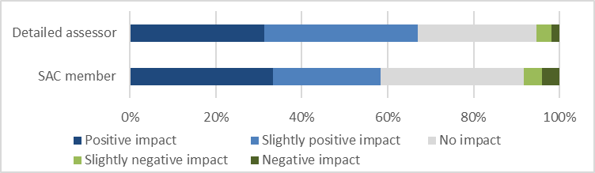

Source: ACIL Allen Consulting. *Note: n=424 detailed assessors and n=24 SAC members who had been involved prior to the continuous process.*

In contrast, these detailed assessors and SAC members were much less positive about whether the continuous process supported a greater focus on innovation. As shown in Figure 30, the most common perception among detailed assessors (44 per cent) and SAC members (54 per cent) was that responsiveness to innovation or market opportunities had not increased since the introduction of the continuous process. Moreover, 50 per cent of detailed assessors and 58 per cent of SAC members perceived no increase in the inclusion of innovation in the content of Linkage Projects applications.

#### Figure 30: Detailed assessors and SAC members (involved prior) – perceived changes in Linkage Projects applications

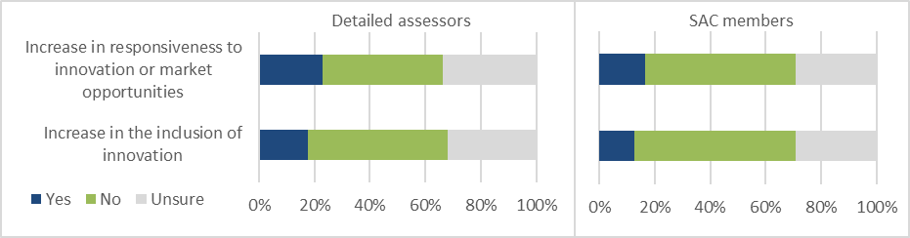Source: ACIL Allen Consulting. *Note: n=426 detailed assessors and n=24 SAC members who had been involved prior to the continuous process.*

When asked the more general question, ‘On balance, does the change to a continuous application process achieve the objectives of facilitating timely collaboration and greater responsiveness to innovation opportunities?’ the majority of detailed assessors and SAC members answered ‘yes’. As shown in Figure 31, this also included those who had not been involved in the scheme prior to the introduction of the continuous process. While the results were reasonably similar for all groups, SAC members who had not been involved prior to the continuous process were the least likely to respond positively.

#### Figure 31: Detailed assessor and SAC member views on whether the continuous process achieves its objectives

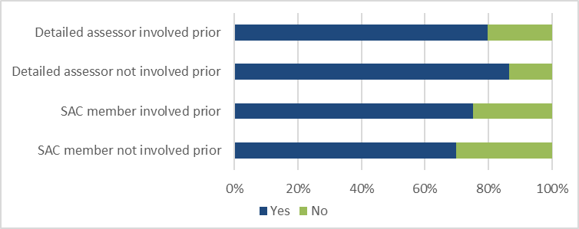

Source: ACIL Allen Consulting. *Note: n=418 detailed assessors and n=24 SAC members who had been involved prior to the continuous process and n=149 detailed assessors and n=33 SAC members who had not.*

### Processes

Figure 32 shows that a clear majority (71 per cent) of SAC members who had been involved prior to the continuous process perceived an increase in the speed of approving applications, compared to only 26 per cent of detailed assessors (36 percent of detailed assessors perceived no increase and 37 per cent were unsure). These differing perceptions may be a reflection of the different roles these stakeholders play. For instance, detailed assessors are involved in just one part of the assessment process, often for a relatively small number of applications. By contrast, SAC members are involved in multiple stages of the assessment process and a larger number of applications. SAC members therefore have a broader view of the changes implemented to facilitate the provision of recommendations to the Minister within six months.

#### Figure 32: Detailed assessors and SAC members (involved prior) – perceived increase in the speed of approving applications

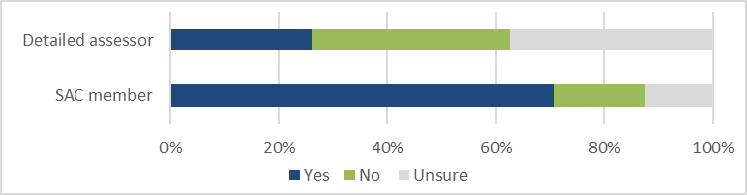

Source: ACIL Allen Consulting. *Note: n=425 detailed assessors and n=24 SAC members who had been involved prior to the continuous process.*

Further evidence that the introduction of the continuous process has had a relatively small impact on detailed assessors is depicted in Figure 33. When those who had been involved prior to the continuous process were asked how its introduction had changed different aspects of assessing Linkage Projects applications, the majority responded that there had been no change. The ability to manage workloads was the change most commonly identified as positive (considered ‘positive’ or ‘slightly positive’ by 35 per cent of respondents). However, it was also the change most commonly identified as negative, along with the timeframes to complete assessments (both were considered ‘negative’ or ‘slightly negative’ by 10 per cent of respondents).

#### Figure 33: Detailed assessor views on changes in assessing Linkage Projects applications

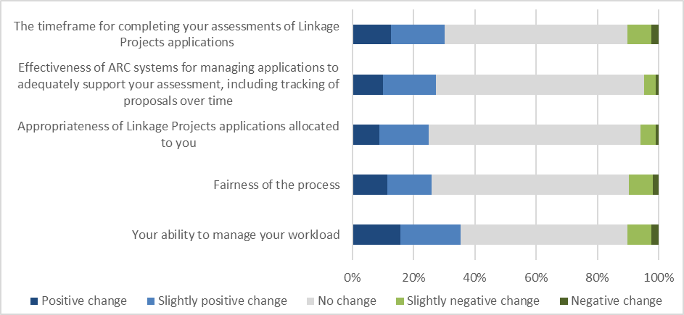Source: ACIL Allen Consulting. *Note: n=426 detailed assessors who had been involved prior to the continuous process.*

Detailed assessors and SAC members who had been involved prior to the continuous process were asked about the consequences of its introduction. Like CIs and PIs, more reported that they had encountered positive consequences (38 per cent of detailed assessors and 67 per cent of SAC members) than challenges or negative consequences (12 per cent of detailed assessors and 54 per cent of SAC members).[41]

Detailed assessors’ open text comments on positive consequences frequently referred to having a more flexible, balanced assessment workload with applications spread over the year rather than being received all at once. However, some expressed the contrary view that the spread of applications over the year was a negative consequence that made it more difficult to plan and prioritise their workloads. Some detailed assessors perceived an increase in the quality of applications being submitted, while others noted that fewer applications being submitted made it difficult to compare and rank them, which impacted on the fairness of the process.

The difficulty in benchmarking, comparing and ranking applications was also repeatedly identified as a challenge in SAC members’ open text comments on consequences. Other negative consequences identified by SAC members included a decline in the number of applications and less engagement in the scheme (including by industry partners). In line with their perception that the speed of approving applications had increased, positive consequences cited by SAC members included faster turnaround times, better time management and smaller SAC workloads (enabling more in depth assessment). Some SAC members also suggested that the continuous process may give applicants more time to engage partners.

As with detailed assessors, SAC members were asked for their views on changes in different aspects of their role in reviewing and assessing Linkage Projects applications under the continuous process. As shown in Figure 34, there were a number of changes that most respondents saw as ‘positive’ or ‘slightly positive’, including the capacity to make fast tracking and budget recommendations by email (75 per cent) and assess application quality and detailed assessor reports within timeframes (58 per cent). Conducting SAC meetings via Zoom (54 per cent) and the efficiency of the process for determining funding recommendations (54 per cent) were also viewed favourably.

The strongest response from SAC members was unfavourable and related to their capacity to asses and rank relative application quality, which 79 per cent considered to be a ‘negative or ‘slightly negative’ change. While only a minority (33 per cent) considered the related issue of the fairness of the process to represent a ‘negative’ or ‘slightly negative’ change, this represented the second most negative response. These two results appear to reinforce the concerns raised in open text comments, above. The same proportion of SAC members (33 per cent) perceived a ‘negative’ or ‘slightly negative’ change in their capacity to plan and schedule their workload, although views on this aspect appear to be somewhat polarised, with 46 per cent considering it to be a ‘positive’ or ‘slightly positive’ change.

#### Figure 34: SAC member views on changes in reviewing and assessing Linkage Projects applications

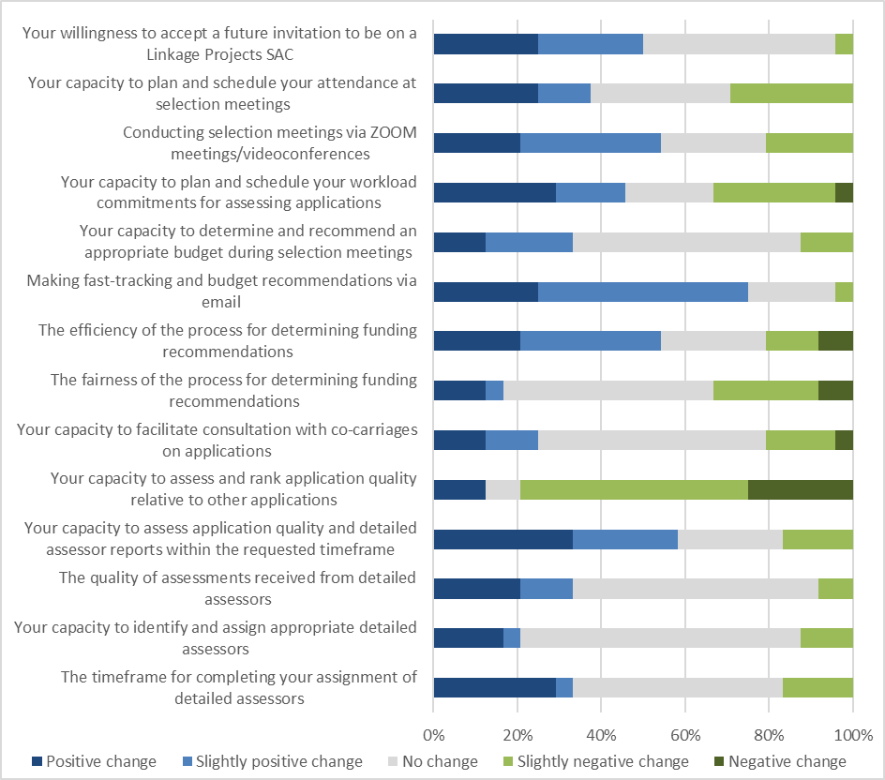Source: ACIL Allen Consulting. *Note: n=24 SAC members who had been involved prior to the continuous process.*

SAC members (including those who had not been involved before the continuous process) were asked for their views on the fast tracking process. As shown in Figure 35, a clear majority perceived it to foster time saving efficiencies (88 per cent), a fair and equitable process (70 per cent) and funding of the highest quality research (72 per cent). Overall, those who had been involved prior to the continuous process gave slightly more positive responses than those who had not.

#### Figure 35: SAC member views – fast tracking process

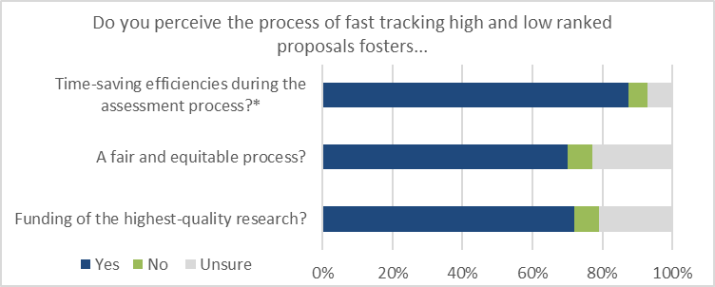

Source: ACIL Allen Consulting. *Note: n=57 (*n=56) SAC members.*

As shown in Figure 36, the majority (58 per cent) of SAC members who had been involved prior to the continuous process had a neutral view of the effectiveness of ARC systems for managing workloads and tracking proposals under the continuous process. In relation to supporting assessment and ranking tasks, half considered ARC systems to have adapted well.

#### Figure 36: SAC member (involved prior) views on how well ARC systems have adapted to the continuous process

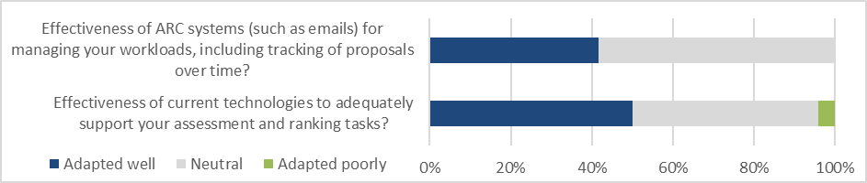

Source: ACIL Allen Consulting. *Note: n=24 SAC members who had been involved prior to the continuous process.*

### Suggestions for improvement

Detailed assessors and SAC members were also asked, ‘What could be done to improve the implementation of the continuous process?’ Consistent with other stakeholder groups, their responses included:

* implementing multiple application deadlines per year, with clearer deadlines for assessment and SAC meetings held on a regular basis
* allowing for assessment of a greater number of applications at once to better compare quality
* quicker assessment and announcement of outcomes to better meet industry needs
* more transparency and information about the assessment process.[42]

### Key findings: Stakeholder views – assessors and SAC members

1. Detailed assessors and SAC members predominantly consider that the continuous process has had a positive impact on the quality of research collaboration in applications, but has not increased the focus on innovation in applications.
2. Most detailed assessors and SAC members consider the continuous process to facilitate timely collaboration and greater responsiveness to innovation opportunities.
3. Most SAC members perceived an increase in the speed of approving applications, but detailed assessors did not. This may be due to their different roles in the process.
4. Both detailed assessors and SAC members expressed concern with the difficulty of assessing the relative quality of applications under the continuous process.
5. The majority of SAC members had positive perceptions of the fast tracking process, and neutral or positive views on how ARC systems have adapted to the continuous process.
6. To improve the continuous process, detailed assessors and SAC members suggested the introduction of multiple application deadlines, better processes for comparing assessment quality, faster and more transparent assessment processes.

# Recommendations

This section provides recommendations, based on the analysis and findings outlined above, for the ARC to consider to improve the effectiveness and efficiency of its implementation of the continuous Linkage Projects process.

## Recommendation 1: Application deadlines

To address the decline in total partner organisation participation, the value of partner organisation contributions, total applications, funded projects, and overall collaboration in the Linkage Projects scheme since the introduction of the continuous process (findings 1, 5, 8, 9 and 18), the ARC should **introduce three or four application deadlines and assessment rounds each year**. The introduction of deadlines would respond directly to feedback from key Linkage Projects stakeholders (findings 17, 25 and 31).

A series of regular application deadlines would help the ARC to address a range of issues associated with the implementation of the continuous process by:

* providing greater incentives for researchers and partner organisations to prioritise and complete Linkage Projects applications (finding 23)
* supporting improved planning and workload management for universities, researchers and partner organisations (finding 22)
* providing incentives for more even submission of applications throughout the year (finding 11)
* reducing the administrative burden on SAC members and the ARC associated with the management of assessment processes and SAC meetings throughout the year (findings 14 and 15)
* reinforcing the capacity of SACs to benchmark and assess relative application quality through fewer, larger batches of applications (finding 29).

There are positive changes and benefits arising from the introduction of the continuous process that the ARC should seek to protect as part of the implementation of any application deadlines and assessment rounds. These include:

* an increased average number of partner organisations participating per application and funded project (finding 2), indications of more frequent involvement by partner organisations who are repeat participants (finding 4), and indications of increasing value of partner organisation contributions per project (finding 5)
* stakeholders reporting increased and improved collaboration within applications and funded projects (findings 19 and 26), and facilitation of more timely collaboration and greater responsiveness to innovation opportunities (findings 21 and 27)
* efficiencies in assessment and SAC processes (findings 13 and 28), and satisfaction among successful stakeholders with ARC implementation of the process (findings 24 and 30).

The introduction of three or four assessment rounds per year should be accompanied by an undertaking to provide applicants with an outcome within six months from each application deadline. This will represent a shift from the current undertaking to provide outcomes within six months from the submission of applications (as intended by NISA and the Watt Review) (finding 12). Given that stakeholders expressed a desire for faster assessment processes (findings 25 and 31), the ARC should consider the number and dates of deadlines carefully to minimise the potential time taken for applicants and their partners to receive advice of their outcomes.

## Recommendation 2: Information on assessment process

To address stakeholders’ concerns about a lack of transparency, difficulty in tracking applications through the continuous process, and the quality of feedback on unsuccessful applications (findings 25 and 31), the ARC should **provide additional information on the ARC website and in RMS regarding assessment processes and announcements**.

The introduction of three or four assessment rounds per year would support this recommendation by enabling the ARC to manage and communicate the following information:

* expected timeframes for the different stages of the assessment process for each assessment round—published on the ARC website
* a selection report for each completed assessment round—published on the ARC website
* provision of feedback on the scoring bands in which unsuccessful applications fell (within the relevant assessment round)—available to applicants through RMS.

The provision of this additional information will support improved planning, workload management and prioritisation for universities, researchers and partner organisations (finding 22).

## Recommendation 3: Funding commencement

To better align grant announcements and the commencement of ARC funding for successful projects, the ARC should **modify ARC financial systems to allow for more frequent releases of initial funding** (finding 16).

It may be possible to coordinate these releases with the expected timeframes for assessment and announcement of grants. This would help to address stakeholder concerns about potential delays in commencing projects.

## Recommendation 4: Guidance to SAC members

To address the decline in business and industry organisation participation as a proportion of all partner organisations under the continuous process (finding 3), the ARC should revisit the Watt Review recommendation to **provide guidance to Linkage Projects SACs to ensure high quality applications that involve business partner organisations are given greater priority**.

Increasing business and industry organisations’ collaboration (and investment) in research was a specific focus of government under NISA, and an intended outcome of the continuous process. The evaluation notes that business and industry organisations have provided the largest proportion of partner contributions under the continuous process (finding 6).

## Recommendation 5: Data and monitoring

The ARC should **consider using metrics provided in this report as benchmarks to monitor future performance of the continuous process and inform improvements**.

Additional insights may also be gained from revisiting areas where sufficient data and information were not available to identify clear trends or draw firm conclusions at the time of this report’s preparation. The completion of the 2018 continuous round will offer numerous opportunities to build upon this report’s analysis. Among others, areas where further research and analysis may be useful include:

* the average value of partner organisation contributions per project (finding 5)
* partner organisation involvement by discipline (finding 7)
* total funded projects, success rates and return rates (finding 11)
* analysis of SAC member participation in meetings (finding 14)
* partner organisations entering new collaborations (finding 20).

# Appendix 1

*From the final report by ACIL Allen Consulting Pty Ltd to the ARC on stakeholder engagement services conducted as an input to the evaluation.*

## Conclusion and opportunities

There is a diversity of perspectives about the continuous process and its consequences. Stakeholders generally support its intent but have mixed views on whether it has had a positive impact on collaboration and responsiveness to time-critical innovation opportunities, as the Watt Review had intended.

The perceptions of the stakeholder groups should be considered in the context of two variables: involvement with the process before (and after) the continuous arrangements were introduced, and roles and responsibilities in relation to Linkage Projects applications. Differences and inconsistencies between stakeholders’ responses may be explained by varied exposure to different stages of the application process. For example, a university researcher may perceive the application assessment process as unreasonably long, yet a Detailed Assessor may believe it has improved under the continuous processing arrangements.

While acknowledging these dimensions, the following section highlights the common themes in stakeholders’ responses to the evaluation topics, before concluding with highlights for improvement.

### Findings on effectiveness

The effectiveness of the continuous process was examined through stakeholders’ perceptions of the impact of the continuous process on the level, responsiveness and diversity of collaboration between universities and partners, including how these opportunities are initiated and managed.

On whether the new process increases collaboration, the views are mixed. Detailed Assessors and SAC members do not associate the continuous process with an increase in collaboration and note that the overall number of CIs per application has increased slightly and the number of PIs per application has decreased slightly. PIs, however, believe the continuous process has had a positive impact on the success and diversity of research collaborations. Research Offices note a decline in applications submitted by their institutions since the introduction of the continuous process (mainly due to the lack of a deadline) and believe this has led to a decline in collaboration.

Most CIs reported that they initiate applications by leveraging existing collaborations, whereas PIs reported that they are most commonly approached by a university or researcher (if they were not involved prior to the new process) or leverage an existing collaboration (if they were involved since the new process). PIs and CIs believe that the continuous process has improved the participation and retention of partners and supported them to form collaborations in a timelier manner, while Research Offices argue that collaboration is closely related to the institutional history, specialities and strategic aims and any changes are therefore difficult to attribute to the new ARC processes.

All four surveys show that on average, those not involved with the processes before the introduction of the continuous process perceive the continuous process to be more positive at achieving most metrics/objectives, than those involved prior to the implementation of the continuous process.

There are mixed views on whether the application processing is timelier. On average, partners believe the continuous process has had a positive or neutral impact on facilitating responsiveness to innovation opportunities and contributing to competitiveness. However, Research Offices do not believe there has been an improvement in the turn-around time, and only a quarter of Detailed Assessors (that have experience with prior arrangements) perceive an increase in the speed of approving applications. In contrast, SAC members largely perceive an increase in the speed of application approvals. Further examination of decision making at different stages of the overall process may help to explain these differences.

On whether the continuous process has fostered time-critical innovation and collaboration, consistent with expectations arising from the Watt Review, there are mixed views. CIs and PIs believe the continuous process has had a positive impact, although PIs who were involved with the prior arrangements do not. Research Offices on the other hand strongly believe that the decline in application numbers, and decline in turn in collaborations, are inconsistent with the overall aims of the continuous process.

### Findings on efficiency

The efficiency of the continuous process was assessed in terms of its administration, the resource implications for participants and the positive and negative consequences for stakeholders.

Reactions from stakeholders involved in the administration of the process, namely Research Offices and ARC officers, support the continuous process in principle but note that it has generated administrative challenges, including administration throughout the year rather than at established and predictable times. Perceptions of the implementation of the continuous process are positive, however it is noted that the quality of feedback has declined, thereby making it more difficult for stakeholders to decide whether to invest in reapplying.

The continuous process has not generated additional financial costs. However, stakeholders noted that it has redirected work and is associated therefore with the cost of additional time, described by some as time spent developing CI-PI relationships and encouraging and ‘chasing’ CIs to submit applications. For most, this is an additional burden, although some note that it has led to better relationships with partners and more considered and possibly higher quality applications. The burden on the ARC in managing the assessment processes throughout the year, despite the decline in overall application numbers, is also considerable.

The positive consequences of the continuous process are perceived to be greater flexibility for CIs and PIs to manage their workload, and more responsive and timely engagement with industry because there are no time pressures, as reported by Research Offices and CIs. Conversely, while stakeholders noted fewer negative consequences, those cited are significant to the reputation of Linkage Program. They include a decline in the number of applications (all stakeholders), processing of applications taking too long (Research Offices, CIs and PIs), difficulty benchmarking relative quality during assessment (Detailed Assessors and SAC members), a lack of quality feedback (Research Offices, CIs and PIs) and the need to adjust internal processes to accommodate the more fluid (less structured) processing arrangements (all stakeholders). While CIs perceive that PIs were more likely to be retained, engaged and participate in Linkage Projects applications as a result of the continuous process, it was also noted that applicants increasingly look to other sources of funding if they have a time-critical opportunity to pursue.

Consistent with the perception that the continuous process has been positive, SAC members believe that fast-tracking has produced time-saving efficiencies and support the funding of the highest-quality research. Research Offices, however, believe Linkage Projects are less effective because grants that have firm deadlines and faster processing times are better at motivating researchers, and in turn encourage more collaborative initiatives.

Support for the intent of the continuous process and satisfaction with the ARC’s administration with the new process is generally high, especially among stakeholders that were not involved with previous arrangements. The improvements that have been proposed centre on reintroducing fixed deadlines for multiple assessment rounds per year, faster processing of applications, simplifying the application paperwork, improved communication about the process and outcomes of the assessment decisions.

### Opportunities

Satisfaction with the ARC’s administration with the new process is generally high, especially among stakeholders that were not involved with prior arrangements and unable therefore to compare them.

The clear preference of stakeholders is the retention of a continuous application process, while reintroducing a series of fixed assessment deadlines, for preferably three assessment rounds per year. This would assist university administrators to manage workloads and give CIs and partner organisations the impetus to submit applications, and to plan and manage resources around this accordingly. It would also reduce the burden of managing continuous processing on the ARC. Assuming that application numbers and timeliness would increase overall as a result, this approach would be consistent with the underlying objectives of the Watt Review.

1. www.arc.gov.au > Grants > Linkage Program > [Linkage Projects](https://www.arc.gov.au/grants/linkage-program/linkage-projects).
2. www.industry.gov.au > Data and Publications > [National innovation and Science Agenda Report](https://www.industry.gov.au/data-and-publications/national-innovation-and-science-agenda-report).
3. www.education.gov.au > Higher Education Research > [Review of Research Policy and Funding Arrangements](https://www.education.gov.au/review-research-policy-and-funding-arrangements-0).
4. For example, www.arc.gov.au > Grants > Grant Outcomes > Selection Outcome Reports > [Selection Report: Linkage Projects 2017 for proposals submitted 23 December 2016 to 19 December 2017](https://www.arc.gov.au/grants-and-funding/funding-outcomes/selection-outcome-reports/selection-report-linkage-projects-2017-proposals-submitted-23-december-2016-19-december-2017).
5. www.arc.gov.au > Policies & Strategies > Strategy > Evaluation > [ARC Evaluation Strategy](https://www.arc.gov.au/policies-strategies/strategy/evaluation/arc-evaluation-strategy).
6. www.arc.gov.au > Grants > Linkage Program > [Linkage Projects](https://www.arc.gov.au/grants/linkage-program/linkage-projects).
7. www.arc.gov.au > Grants > Grant application > Funding Rules/Grant Guidelines > [Linkage Program Funding Rules/Grant Guidelines](https://www.arc.gov.au/grants/grant-application/funding-rulesgrant-guidelines/linkage-program-funding-rulesgrant-guidelines).
8. www.education.gov.au > Higher Education Research > [Review of Research Policy and Funding Arrangements](https://www.education.gov.au/review-research-policy-and-funding-arrangements-0).
9. ARC data.
10. ‘Field of research’ refers to the primary Australian and New Zealand Standard Research Classification (ANZSRC) two digit Field of Research (FoR) code recorded in RMS for each Linkage Projects application. There are 22 ANZSRC two digit FoRs.
11. ARC data.
12. ACIL Allen Consulting.
13. www.education.gov.au > Higher Education Research > [Review of Research Policy and Funding Arrangements](https://www.education.gov.au/review-research-policy-and-funding-arrangements-0).
14. See www.legislation.gov.au > Acts > In Force > [Series/C2004A00773](https://www.legislation.gov.au/Series/C2004A00773).
15. ARC data. *Note: complete data for 2018 C were not available at the time of this report’s preparation.*
16. ACIL Allen Consulting.
17. ACIL Allen Consulting.
18. ACIL Allen Consulting.
19. ARC data.
20. See *Draft Grant Agreement regarding funding for* *schemes under the Linkage Program (2018) –* Linkage Projects *funding applied for in 2019*, available at [www.grants.gov.au](http://www.grants.gov.au) > [Forecast Opportunity View - LP2019](https://www.grants.gov.au/?event=public.FO.show&FOUUID=6D4D8C00-B6BF-D2BA-B01F274BF297245D).
21. ACIL Allen Consulting.
22. ACIL Allen Consulting.
23. ACIL Allen Consulting.
24. ACIL Allen Consulting. *Note: n=34 out of 54 PIs who had been involved prior to the continuous process.*
25. ACIL Allen Consulting.
26. ACIL Allen Consulting.
27. ACIL Allen Consulting.
28. ACIL Allen Consulting. *Note: n=116 out of 184 CIs who had been involved prior to the continuous process and n=81 out of 109 who had not.*
29. ACIL Allen Consulting. *Note: n=184 CIs who had been involved prior to the continuous process and n=109 CIs who had not.*
30. ACIL Allen Consulting. *Note: only n=10 CIs and n=4 PIs provided examples of costs.*
31. ACIL Allen Consulting.
32. ACIL Allen Consulting. *Note: n=183 CIs and n=54 PIs who had been involved prior to the continuous process.*
33. ACIL Allen Consulting.
34. ACIL Allen Consulting. *Note: n=184 CIs and n=54 PIs who had been involved prior to the continuous process.*
35. ACIL Allen Consulting. *Note: n=292 CIs.*
36. ACIL Allen Consulting. *Note: n=292 CIs and n=103 PIs.*
37. ACIL Allen Consulting.
38. ACIL Allen Consulting.
39. ACIL Allen Consulting.
40. ACIL Allen Consulting.
41. ACIL Allen Consulting. *Note: n=424 detailed assessors and n=24 SAC members who had been involved prior to the continuous process.*
42. ACIL Allen Consulting.