|  |
| --- |
| Survey and Interviews for the Evaluation of the Industrial Transformation Research Program |
|  |
| Australian Research Council |
| Findings Report |
| 2 April 2019 |

Acknowledgments

This work was completed with the assistance of the Australian Research Council’s Program Evaluation section.

We would also like to thank the many key informants from the Australian Research Council, Department of Industry, Innovation and Science, Industry Growth Centres, and all the members of universities and partner organisations who were interviewed and surveyed as part of this research, and those members of the Australian Research Council who participated in the design and findings workshops. We thank them for their time and insights and trust that their views are adequately represented in this report.

**ARTD consultancy team**

Gerard Atkinson

Wendy Hodge

Brad Astbury

Klas Johansson

Kerry Hart

David Wakelin

Jack Cassidy

Lia Oliver

Jack Rutherford

Pravin Siriwardena

Contents

Executive summary v

Project v

Key findings v

1. Introduction 6

1.1 The project 6

1.2 Scope and focus of project 6

2. Methodology 7

2.1 Surveys and interviews 7

3. Summary of responses 9

3.1 Support for industry focused research collaboration 9

3.2 Support for industry focused research training 13

3.3 Engagement with Industry Growth Centres (IGCs) 18

3.4 ITRP fit with other Australian Government programs that support industry focused research and innovation 24

3.5 Process implementation and advice to stakeholders 28

3.6 Overall objectives 35

3.7 General feedback 36

Appendix 1. Technical summary 38

Survey 38

IGC Survey 40

Appendix 2. Participant summary 41

Survey 41

Interviews 42

Abbreviations and acronyms

|  |  |
| --- | --- |
| ARC | Australian Research Council |
| CI | Chief investigator |
| CRC | Cooperative Research Centres |
| CRC-P | Cooperative Research Centres Projects |
| DIIS | Department of Industry, Innovation and Science |
| Dir | Director |
| ERA | Excellence in Research Australia |
| HDR | Higher degree by research (e.g. Honours, Masters or PhD) student |
| IGC | Industry Growth Centre |
| IP | Intellectual Property (e.g. patents, trademarks, copyright) |
| ITTC | Industrial Transformation Training Centre |
| ITRH | Industrial Transformation Research Hub |
| ITRP | Industrial Transformation Research Program |
| Mgr | Manager |
| PI | Partner investigator |
| PDR | Post-doctoral researcher |
| R&D | Research and development |
| RO | Research Office |
| SME | Small to medium enterprise |
|  |  |
|  |  |

Executive summary

Project

This report presents the findings of a survey and interview process with stakeholders of the Industrial Transformation Research Program (ITRP). These findings are being used to support the ARC’s broader project to evaluate the alignment of the ITRP with government priorities, and the efficiency and effectiveness of ITRP in supporting collaborations to deliver research and research training. ARTD delivered two surveys and a series of 33 interviews with key stakeholders of the ITRP. The survey and interviews targeted a subset of the evaluation questions for the broader ITRP evaluation. The surveys received a total of 707 complete responses.

Key findings

* Overall, respondents feel that the ITRP effectively supports industry focused research collaboration. Collaborations for ITRP projects have mostly been initiated through existing relationships. In terms of the role of partner organisations in the ITRP application and design process, there appears to be differences in views from stakeholders on the level of consultation activities.
* Stakeholders feel that the ITRP does well in supporting research training, and they feel it is of high academic quality and relevance. That being said, students and post-doctoral researchers expressed a desire to see more training opportunities.
* Industry Growth Centres (IGCs) are generally seen as beneficial in identifying and enabling partnerships; however, many stakeholders were unclear as to the role that they play in the application and assessment process. Some stakeholders also found IGCs difficult to engage with in a timely manner.
* The ITRP is perceived by stakeholders to be unique in its scope and focus on research training, and a good complement to other Australian Government programs. However, there is some perceived overlap with the CRC and CRC-P programs.
* For most stakeholders the ITRP process is considered both effective and efficient. The major issues raised were around the timeframes for preparation of applications, the amount of information required for applications, and negotiating and establishing collaborations with partners.
* In general, respondents agreed that the ITRP both fosters important research partnerships and supports research trainees to gain skills in industry priority areas.

# Introduction

## The project

### Purpose

The purpose of this work is to support the ARC’s broader project to evaluate the alignment of the ITRP with government priorities, and the efficiency and effectiveness of ITRP in supporting collaborations to deliver research and research training. The evaluation as a whole will focus primarily on the design, implementation and administration of the ITRP. The findings will be used to inform changes and improvements in the administration of future ITRP rounds.

## Scope and focus of project

To support the broader evaluation, ARTD delivered a survey instrument and a series of interviews with key stakeholders of the ITRP. The survey and interviews targeted a subset of the evaluation questions.

The stakeholder groups targeted as part of these activities were:

* Research offices at universities involved with successful applications for ITRP funding
* ITRH and ITTC directors and managers involved with successful applications for ITRP funding
* Chief investigators involved with successful applications for ITRP funding
* Partner investigators involved with successful applications for ITRP funding
* Higher degree by research students (HDRs) and post-doctoral researchers (PDRs) who had undertaken research training within a Research Hub or Training Centre
* Industry Growth Centre (IGCs) representatives
* Department of Industry, Innovation and Science (DIIS) representatives
* ARC policy and program owners.

The scope of this work did not extend to a broader evaluation of the scheme, or the outcomes and impacts of research projects supported under the scheme.

# Methodology

## Surveys and interviews

### Survey and interview development

To develop the surveys and interviews, ARTD facilitated a half-day workshop with key ARC stakeholders in Canberra to:

* prepare and confirm a survey framework covering the key areas of investigation
* further develop question themes and language for the survey and interviews
* align questions and survey logics with stakeholder groups[1]
* ensure that language reflected ARC communication styles, tone and program policy
* obtain relevant stakeholder information and contact details, and discuss engagement strategies for stakeholders as part of the survey and interview process
* finalise questions proposed for inclusion in the survey instrument and interview guides
* confirm the sampling frame and approach to be taken in communicating with stakeholders.

This workshop enabled the development of survey instruments and interview guides in collaboration with the ARC Program Evaluation section.

### Surveys

A survey was delivered across members of the following stakeholder groups (where contact details were available):

* Research offices at universities involved with successful applications for ITRP funding
* ITRH and ITRC directors and managers involved with successful applications for ITRP funding
* Chief investigators involved with successful applications for ITRP funding
* Partner investigators involved with successful applications for ITRP funding
* HDR students and PDRs who had undertaken research training within a Research Hub or Training Centre

Survey questions were tailored to ensure that respondents were presented with questions relevant to their role and experience with the ITRP. A separate survey (IGC Survey) was also developed and delivered to IGC representatives, which focused on their interactions with Research Hub and Training Centre applicants.

#### Survey response

The survey was delivered between 6 February 2019 and 28 February 2019 to a distribution list of 2,177 stakeholders. Reminder emails were sent on a weekly basis and 24 hours prior to closure of the survey.

A total of 702 complete responses to the survey were received, representing a response rate of 32.3 per cent. A further 302 partial responses were received which have not been included in the analysis or final data set. More detail on the survey delivery and response rates are provided at Appendix 1. Breakdowns of survey respondents by demographic are provided at Appendix 2.

The IGC survey was delivered between 11 February 2019 and 28 February 2019 to six representatives from IGCs. Reminder emails were sent one week after launch, followed by phone calls to remaining representatives. Five of the six representatives provided a response to the survey.

### Interviews

A total of 33 interviews were delivered alongside the survey to members of the following stakeholder groups (numbers of interviews in brackets):

* University Research Office representatives (seven)
* Hub and Centre directors and managers (20 interviews, representing ten Research Hubs and ten Training Centres)
* ARC representatives (two)
* DIIS representatives (two, from the policy and IGC management areas).

The interviews were designed to probe topics from the survey in greater depth. For Research Office, Research Hub and Training Centre interviews a purposive sampling approach was used to provide a balance across factors such as geography, university type, number of Research Hubs and Training Centres at a university, and rounds of the program.

# Summary of responses

## Support for industry focused research collaboration

#### Effectiveness of ITRP support for industry focused research collaboration

Figure 1 shows responses for Directors (Dirs) and Partner Investigators (PIs) on the effectiveness of the research programs in their Research Hubs and Training Centres in supporting collaboration to meet industry needs in a range of areas. Respondents felt that industry access to research expertise was the most effective area, with intelligence on research and industry trends being less effective. Broken down by group, however, there are differences with higher ratings from respondents from Research Hubs across all factors except providing research candidates with skills and knowledge needed for industry employment (which may reflect the differing objectives of Research Hubs and Training Centres). Dirs also provided higher ratings than PIs across all factors.

1. Effectiveness of research program and projects in supporting collaboration

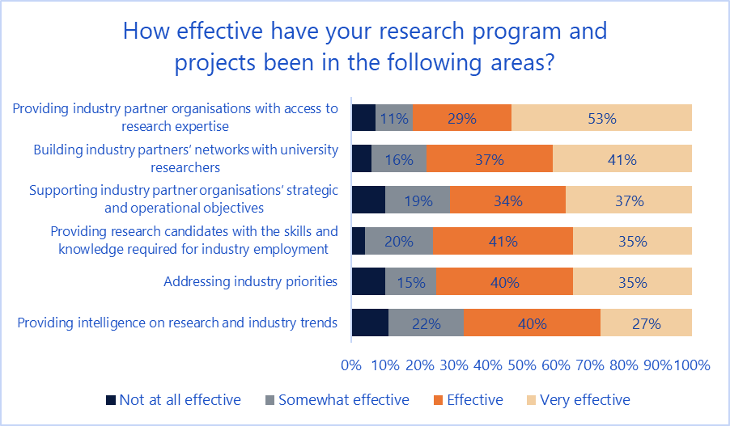

Figure 2 shows the effectiveness of partner organisation contributions in helping to achieve different aspects of university researchers’ needs and goals in undertaking collaborative research, as reported by Dirs and Chief Investigators (CIs). Advice on industry needs was seen as most effective, while supervision and mentoring were seen as least effective. Research hub respondents found contributions to be more effective than for Training Centres in all but the areas of expert input, supervision and mentoring, and building networks. Notably, Dirs saw partner organisation contributions as more effective on each dimension as compared to CIs.

1. Effectiveness of partner contributions in supporting collaboration

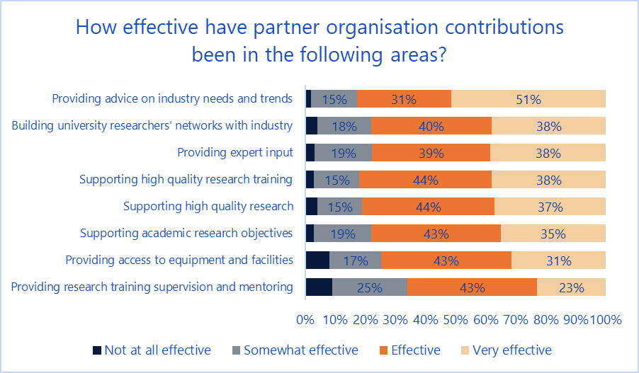

Research Offices (ROs), Dirs, Managers (Mgrs), CIs and PIs were asked for their views on the quality and reliability of partnerships; these were generally rated as good or excellent (Figure 3). However, broken down by group there were large differences in whether these partnerships were rated “good” or “excellent”, with ROs more likely to rate the quality and reliability as “good” and Dirs more likely to rate quality and reliability as “excellent”.

1. Quality and reliability of partnerships

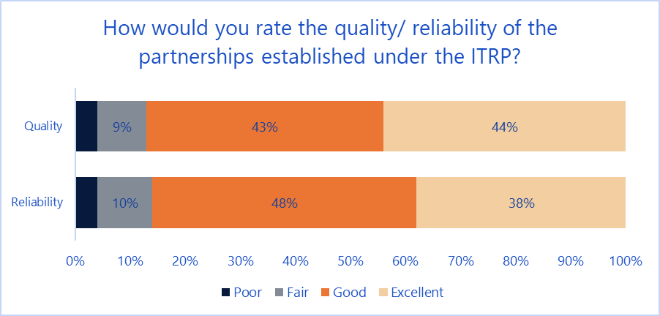

Of 73 verbatim comments from ROs, Dirs, Mgrs, CIs and PIs on research collaboration, 39 per cent related to the quality and nature of partnerships (with mixed views within these comments). Other topics raised were processes for managing collaboration (nine per cent), knowledge sharing arrangements (five per cent) and alignment of academic and industry priorities and needs (five per cent). Twenty-three per cent of comments were generally positive about research collaboration, compared to 18 per cent which were generally negative in nature about their experiences.

Interviews with Dirs and with ARC and DIIS stakeholders found generally positive views on collaboration, and a view that the ITRP acted as a vehicle for bringing partners together that would not have otherwise collaborated.

[The ITRP] enables researchers to build long term relationships with multiple industrial partners at once on more than one project and often manages to bring together different partners that would never have seen each other. That I see as its key strength.

- ARC representative

Interviewees also felt that the ITRP allows long term collaborative relationships to develop between academia and industry. It also enables research collaboration between academia and industrial organisations that are of different sizes. One Training Centre Dir mentioned that industry sometimes does not have the internal means to conduct research, so universities can provide their capital to develop an R&D group, a situation ideally suited for small to medium enterprises.

#### Number of new versus existing collaborations facilitated through ITRP

Existing research collaborations with partner organisations were the most common way that collaborations have been initiated for Research Hubs and Training Centres, with 63 per cent of Dir and CIs listing this as the most common method. The next most common way was through approaches by respondents to potential partners (26 per cent) and then approaches by potential partners to respondents (7 per cent).

The perspective of PIs was similar for this question, with 57 per cent of respondents listing existing collaborations as the most common channel for initiation. Dirs and CIs reported on average that ten partner organisations came from existing research collaborations, though with a median of four organisations, suggesting large variations in numbers of partners. Dirs and CIs reported on average that six partner organisations came from new research collaborations, with a median of two organisations. However, new collaborators were more common for Training Centres, which had an average of eight new collaborations as compared to four for Research Hubs.

In terms of new partners joining after establishment, 57 per cent of respondents (Dirs, Mgrs and CIs) stated that this had occurred. This response was similar across both Research Hubs and Training Centres. On average, three new partner organisations have joined Research Hubs and Training Centres since establishment (with a median of two organisations).

In terms of partners dropping out after establishment, 50 per cent of respondents (Dirs, Mgrs and CIs) stated that this had occurred. The predominant reason for organisations dropping out was due to changes in business conditions or strategy (49 per cent), followed by financial constraints on partners (37 per cent).

#### Ways industry partners are involved in the development of ITRP applications and the design of programs and projects

ROs, Dirs, CIs and PIs were asked questions on the ways in which industry partners were consulted in the application and design process. Eighty-five per cent of university respondents reported that partner organisations were consulted in the development of their Research Hubs and Training Centres’ entire research programs. However, only 60 per cent of PIs reported that they or their organisations were consulted, which is a statistically significant difference. This may represent different perceptions on what constitutes consultation activities by both groups, and/ or that different partners play different roles in different projects.

Ninety-five per cent of university respondents reported that partner organisations were consulted on the development of sub-projects. Ninety per cent of PIs reported that they were consulted. This difference was not statistically significant.

Regarding whether partner organisations consulted with IGCs, 71 per cent of university respondents reported that this occurred. However, only 38 per cent of PIs responded that this had occurred. Again, this difference is statistically significant.

Dirs and CIs also listed in more detail the ways that partners were involved in the development and design process, with 32 per cent stating that partners had provided design advice, 25 per cent had engaged in or facilitated meetings with key stakeholders, ten per cent had provided market advice, and a further ten per cent had enabled linkages with other potential partners.

Of 50 verbatim comments from PIs on ways in which they were involved in the application process, 40 per cent related to the provision of expertise on industry. A further 40 per cent related to partnership activities and advice.

## Support for industry focused research training

#### Effectiveness of ITRP support for industry focused research training

CIs and PIs both reported delivering a range of research training activities to HDRs and PDRs (Figure 4). CIs were most likely to report delivering mentoring and supervision activities.

1. Involvement in research training

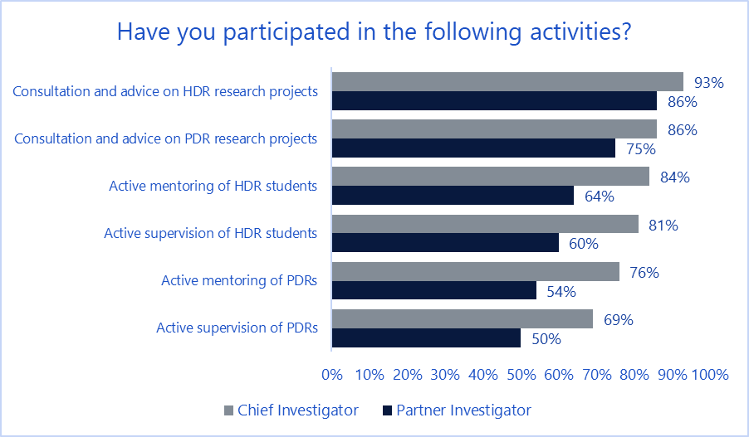

ROs, Dirs, CIs and PIs were asked how well the ITRP supports the delivery of research training across a range of dimensions (Figure 5). Over 80 per cent responded “well” or “very well” in respect of each dimension. By group, ROs tended to provide more “very well” responses, with PIs providing more “well” responses.

Analysis of 64 verbatim comments from CIs and PIs on other activities provided as part of HDR and PDR research training apart from the above found the most common activity to be providing direct support on research activities (e.g. through access to facilities and systems) which made up 29 per cent of comments. The next most common activity was administration of students (recruitment, probation, submission of theses) which made up 24 per cent of responses. Other activities mentioned were providing professional development opportunities (19 per cent) and managing relationships between HDRs/ PDRs and other stakeholders (14 per cent).

1. ITRP support of research training delivery

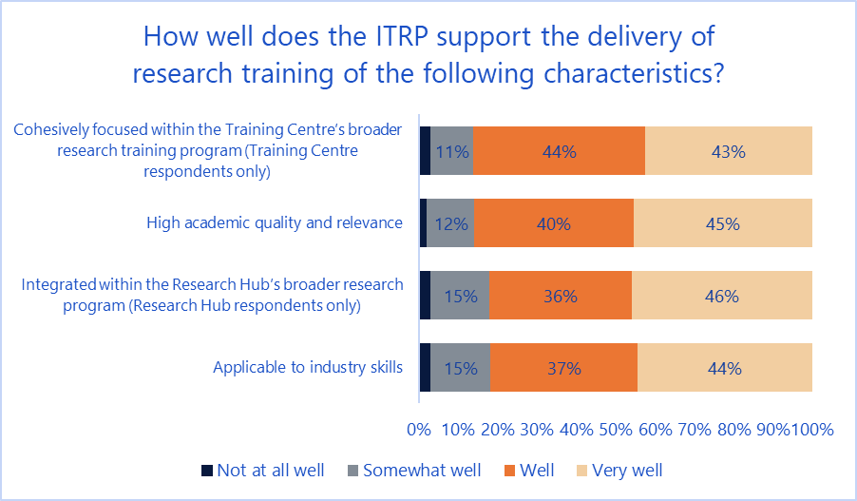

In terms of specific benefits of the ITRP for supporting collaboration in research training, half of the respondents (comprising ROs, Dirs, Mgrs, CIs and PIs) felt that work experience for HDRs and PDRs was the greatest benefit, followed by networking opportunities (18 per cent) and aligning HDR and PDR training with industry outcomes (12 per cent).

In terms of issues encountered in the delivery of placements, the two most common issues reported were timing of placements, and recruitment of HDR students and PDRs (18 per cent each). Other common issues noted were the placement design (14 per cent), IP arrangements (8 per cent), distance of placements from home universities (7 per cent) and logistics of arranging placements (7 per cent).

Analysis of 108 comments from HDRs and PDRs on how the ARC can improve research training found that most common topic respondents discussed was the need for more and higher quality training opportunities through industry placements and skills development courses (43 per cent of comments) – this was particularly strong for HDRs, with 54 per cent of their comments addressing this topic. Other topics discussed included greater funding support (18 per cent) and improved communications between stakeholders (and between HDRs and PDRs from different Research Hubs and Training Centres), which made up 13 per cent of comments.

The most common topics in the 43 general feedback comments provided by Dirs, Mgrs, CIs and PIs on research training were access to training opportunities (18 per cent), alignment of training activities with industry needs (15 per cent), recruitment, logistics and timelines for placements (ten per cent each). Thirteen per cent of comments were generally positive remarks as compared to three percent generally negative remarks.

HDR and PDR respondents were also asked to provide general feedback on their experiences of research training through the ITRP. Among 73 comments, the most common type was general positive remarks, which made up 35 per cent of all comments (28 per cent of comments from PDRs and 41 per cent of comments from HDRs). This compared to 12 per cent of comments being generally negative in nature (14 per cent of comments from PDRs and 11 per cent of comments from HDRs). The remaining comments covered topics such as the process for completing placements as part of their engagement (14 per cent), research collaboration (nine per cent), and networking opportunities (nine per cent).

Interviews with Dirs were consistent with the above findings, with interviewees giving generally positive responses in terms of the delivery of training, with the alignment of student training with industry needs seen as a strong feature, and the development of capabilities in research methods, particularly for HDR students.

As a PhD training opportunity, I think it’s fantastic – I think I’m confident that the people who graduate at the Centre will be able to find jobs in the industry or be in a position to think about doing something on their own. I think they’ll be well qualified in that respect.

- Training Centre Dir

However, interviewees noted challenges in arranging and securing industry placements, as well as recruiting high quality local students in a competitive market.

#### Number of Higher Degree by Research (HDR) students and post-doctoral researchers (PDR) involved

Dirs and Mgrs of Research Hubs reported that an average of five HDR placements (median of two) and four PDR placements (median of two) have been undertaken in their Research Hubs.

For Training Centres, the average number of HDR placements reported was six (median of five) and the average number of PDR placements was two (median of two).

In terms of the 176 HDRs and 97 PDRs who reported that they have completed or are completing placements, they reported an average placement length of ten months (median three months – this suggests a minority of placements are quite long in duration). By comparison, Dirs and Mgrs of Research Hubs and Training Centres reported an average placement length of three months (median of two months) for HDRs, and four months for PDRs (median of two months).

Dirs and Mgrs reported that on average two non-university organisations are involved in placements (median of one organisation).

In terms of outcomes for HDRs and PDRs who had completed their training as part of the ITRP, 41 per cent were in some form of study (63 per cent of HDR students and ten per cent of PDRs), and 68 per cent were working full time (57 per cent of HDR students and 84 per cent of PDRs). A further nine per cent were working part time, and 16 per cent were not employed (six per cent were not employed and not looking for work).

For those respondents who are in work, 79 per cent are employed by universities, 15 per cent by industry, and six per cent by government.

#### HDR students and PDRs roles in ITRP projects including types of industry placements

HDRs and PDRs reported playing a variety of roles in ITRP projects (Figure 6), including leading projects and subprojects as part of their engagement. Respondents from Training Centres were more likely to report having led research projects or supervised training as compared to respondents from Research Hubs.

1. HDR and PDR roles

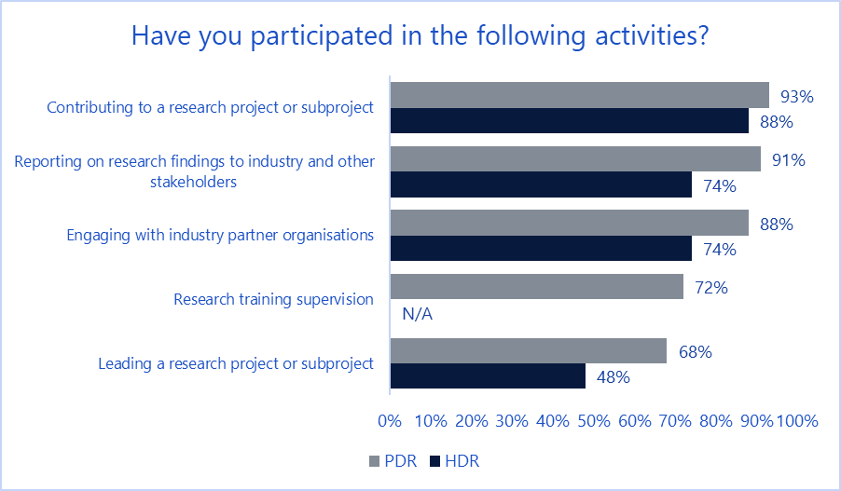

Forty five per cent of HDRs and PDRs who provided open text responses on other activities as part of their industry placements reported undertaking some form of research or experimental activities, with 22 per cent involved in conferences and workshops, nine per cent completing site visits with industry, and eight per cent involved in business management activities relating to Research Hubs and Training Centres.

#### Reasons HDR students and PDRs choose to be involved in the ITRP (as opposed to other opportunities for industry experience)

This evaluation question was not directly addressed through the survey; however, HDRs and PDRs were asked about their views on their involvement in Training Centres and Research Hubs. Both groups had similar views with respect to career development, professional development and personal interest all rating strongly (Figure 7). PDRs tended to agree more strongly than HDRs in relation to all areas.

1. HDR and PDR views on involvement

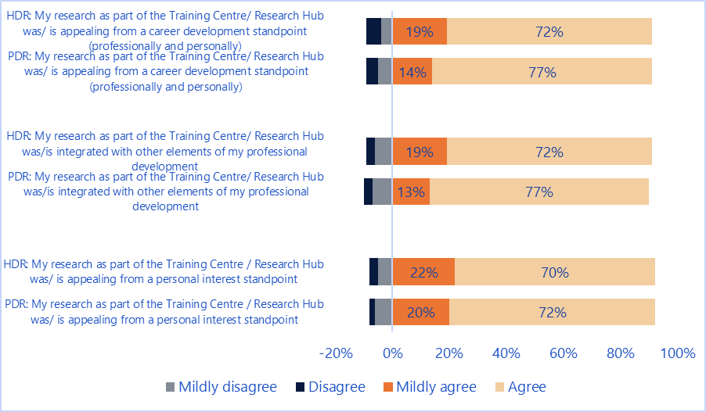

#### Nature of partner organisations involvement in the development of and design of ITRP placements

Eighty-five per cent of university survey respondents (ROs, Dirs and CIs) reported that partner organisations were involved in the development and design of research training placements (for Training Centres this was 92 per cent as compared to 79 per cent for Research Hubs). However, only 64 per cent of PIs reported that they or their organisations were involved, which is a statistically significant difference. This may represent different perceptions on what involvement meant for each group, or the different roles that PIs have had in Research Hubs and Training Centres.

## Engagement with Industry Growth Centres (IGCs)

#### Effectiveness of engagement with Industry Growth Centres as part of ITRP processes

Analysis of 104 comments from ROs, Dirs, Mgrs, CIs and PIs found that the most benefit seen from engagement with the IGCs was in the area of identifying and enabling partnerships (28 per cent), followed by support in the design and application process (22 per cent), and the provision of market advice (21 per cent). Notably, 12 per cent of comments were negative about their experiences with IGCs, saying that they were not at all beneficial.

Most ROs, Dirs, Mgrs, CIs and PIs found the IGCs both easy to reach and responsive to enquiries (Figure 8). By group, Mgrs reported the most positive results on these dimensions, while ROs were more negative. There did not appear to be a pattern of variation in responses based on program round. Note that although IGCs were only introduced in 2015, responses were received from participants from all ITRP rounds.

1. IGC ease of contact and responsiveness

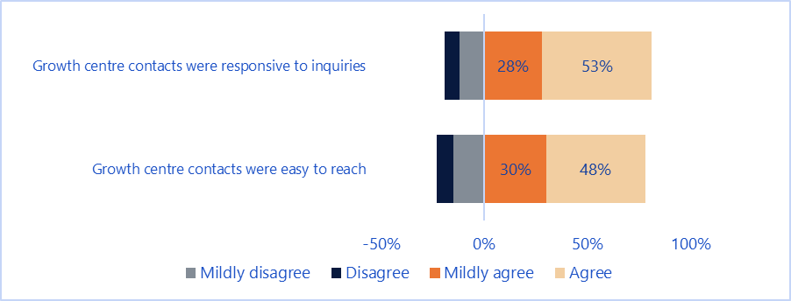

Analysis of 38 verbatim comments from ROs, Dirs, Mgrs, CIs and PIs presented more mixed views on engagement, with 31 per cent of comments being generally negative around engagement with IGCs as compared to generally positive comments which made up 26 per cent. Some respondents indicated that they were unclear about the role of IGCs within the ITRP:

How this is meant to work could be better articulated. It feels like a gatekeeper role, but it could be a much better engagement. I’m a big supporter of the Growth Centres but my engagement outside of ITRP has been the good engagement with them.

* *Research Hub CI*

In terms of issues relating to engagement with IGCs, the primary issue noted in survey comments was difficulty in contacting and engaging with IGCs (36 per cent):

Not responsive to telephone calls – no answer. Not responsive to emails – no reply.

- RO respondent

Eighty-four verbatim responses were provided on the main issues faced when engaging with IGCs, with 36 per cent of responses discussing issues with contacting IGCs (timeliness, ease of contact). A further 16 per cent discussed issues around the alignment of IGCs with the ITRP, and the quality of their links with industry (12 per cent).

Interviews with Research Hubs and Training Centre Dirs and Mgrs also corroborated these viewpoints, expressing uncertainty around aspects of the role of IGCs and the need for clarity, particularly in relation to their role at the application stage. Dirs and Mgrs felt unclear as to whether IGCs are advocates (i.e. their support can influence the success of applications) or involved in assessing applications (making decisions).

Interviews with DIIS found that engagements with the IGCs are seen as a way of reinforcing the industry focus of the program:

…it’s actually solving an industry problem, it’s not maybe a solution in search of a problem. [For the ITRP] it’s research led so we are trying to bring that industry focus.

- DIIS representative

The IGC survey found that for the most part, engagement was driven by universities reaching out to IGCs either through ROs or from CIs; only one IGC reported being proactive in promoting the ITRP to universities and industry.

IGCs also felt that this engagement was meaningful, with three of the five IGCs feeling that engagement was “very meaningful”, one respondent stating that engagement was “meaningful”, and the remaining respondent stating that engagement was “somewhat meaningful”. Respondents stated that the ability to provide feedback and have discussions with applicants not only benefited the quality of applications but improved knowledge sharing, collaboration and understanding of industry needs and directions.

IGCs were unanimous in their view that interaction between the ITRP and IGCs supports both programs in achieving their objectives, predominantly by enabling collaboration between industry and academia and through knowledge transfer.

#### Perceived usefulness and value of the advice provided by Growth Centres to universities, researchers and partner organisations

ROs, Dirs, CIs and PIs had mixed views on the usefulness of advice provided by IGCs (Figure 9). The most positive area was identifying university research partners, (about which only PI respondents were asked) and the most negative area was the ability of IGCs to identify industry partners and enable collaboration (about which only ROs, Dirs and CIs were asked). For questions answered by ROs, Dirs, CIs and PIs ongoing engagement after establishment received the most positive responses, while identifying gaps in existing research produced the least positive responses. By respondent group, PIs tended to be more positive in their views of IGCs, while ROs were less positive.

1. Usefulness of IGC engagement

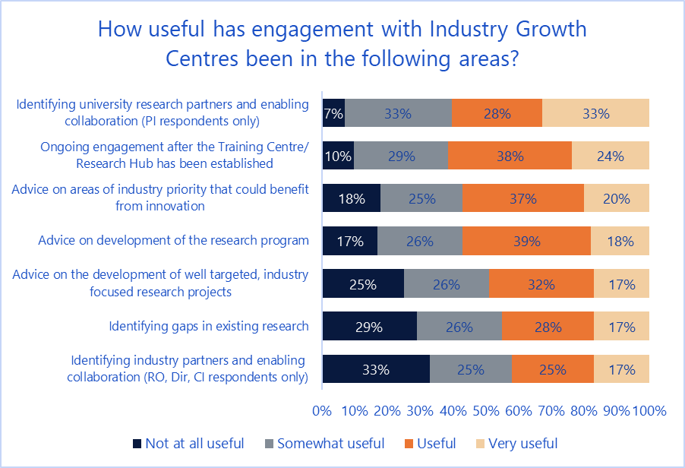

Interviewees from the ARC and DIIS felt that engagement with IGCs are a way of gaining valuable advice about industry—particularly insights on market trends, emerging technologies and on ARC and government priorities. Dirs from Research Hubs and Training Centres valued the advice on research projects while a few talked about adapting/ restructuring projects as a result of advice given.

All five IGC survey participants reported providing advice on industry priorities and on identifying industry partners. Four IGCs also reported providing advice on identifying research gaps and on developing research programs to applicants. Other advice was also provided by IGCs on commercialisation, mentoring, and communications plans for Research Hubs and Training Centres.

Three of the five IGCs felt that applicants were very receptive to the advice they provided, with one respondent feeling that applicants were “receptive”, and the remaining respondent feeling that applicants were “somewhat receptive”. Respondents noted that this receptiveness was evidenced through a willingness by applicants to incorporate advice into applications, and in some cases, meet further with the IGC to gain a better understanding. The respondent who stated that in their experience applicants were only “somewhat receptive” noted a mixed reception by applicants:

Some Training Centres see input as a dilution of the idea and without ongoing value, others do not.

- IGC representative

This questioning of the value of IGCs was also articulated by a small number of Research Hub Dirs (though these interviewees were involved with Research Hubs that existed prior to the formation of IGCs, so they had not had direct interaction with the IGCs).

#### Extent Industry Growth Centres support opportunities for collaboration that may not otherwise occur, or that add to existing collaborations and nature of value-add

The majority of respondents (comprising ROs, Dirs, Mgrs, CIs and PIs) together felt that engagement with IGCs had supported collaborations in a number of ways (Figure 10). ROs tended to be most positive, while Dirs and CIs were less positive.

1. IGC support for collaborations

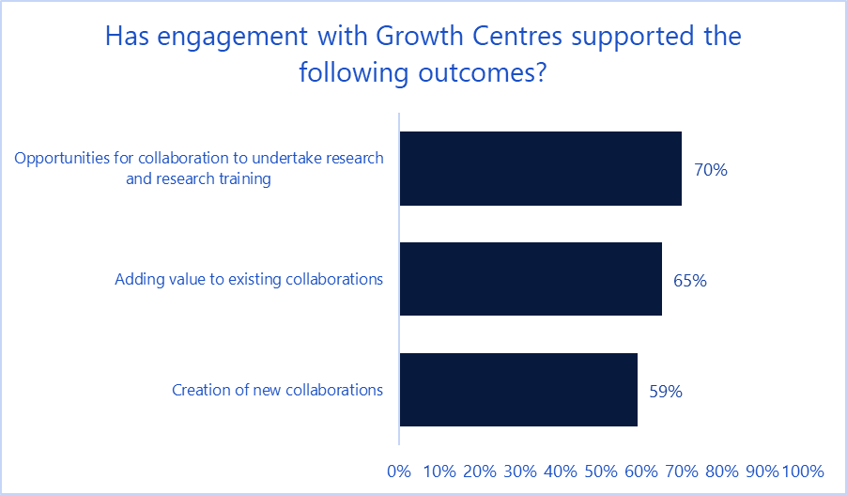

Comments on the benefits of IGCs supported this result. Among 118 comments provided, 27 per cent addressed the role of the IGC in promoting partnerships. A further 21 per cent discussed the role of the IGCs in providing market advice, and 15 per cent described their involvement in the design process as beneficial.

Dir and Mgr interviewees from Research Hubs and Training Centres were also positive in this regard. As examples, one Training Centre Dir reported that an IGC identified potential small to medium enterprise (SME) partners for a research project, which they would not have otherwise known about or collaborated with. Two Research Hub Dirs said that IGC presentations about successful collaborative partnerships between the research and industry sector highlighted opportunities for other partnerships.

Three of the five IGCs surveyed agreed that their involvement in the ITRP supports opportunities for collaboration that may not otherwise occur. One IGC noted that this collaboration also improves efficiency through the reduction of duplicated activities:

We have been able to point researchers towards new industry partners as well as towards research collaborators. We are not keen to see research duplicated across Australia.

- IGC representative

#### Views on the extent Industry Growth Centres support innovative research and the development of well targeted, industry focused research and research training

There was limited information from interviews with Dirs and Mgrs in relation to this area, though most interviewees assumed this was the case. Only two of the five IGCs surveyed though felt that their engagement supports innovative research collaboration and the development of well-targeted projects. In relation to this, one IGC noted mixed results depending on the mindset of the applicant:

Some bids come with partners and defined goals that are relatively set. Other bids are looking for support in defining the goals.

- IGC representative

From the perspective of the ARC, there was a concern that the limited priorities of the IGCs limited the scope of the ITRP:

[The ARC should] consider whether the ITRP should be based on just the Growth Centres or whether it should be based upon whatever priority list the ARC itself actually builds up because by default that leaves us somewhat beholden to another organisation for what the priorities are… is the intent just to support the other agency in which case the other agency may as well run the program or is it there to support academics and could it be engaging with industry in which case their priority should inform our priorities but perhaps not be our priorities to give us a little bit of flexibility.

- ARC representative

#### Engagement with Industry Growth Centres beyond the proposal stage

The majority of RO, Dir, Mgr, CI and PI respondents to the survey reported engagement with IGCs at all stages of the Training Centre and Research Hub life-cycle (Figure 11). The strongest levels of engagement were reported by ROs. Respondents from Training Centres reported more engagement occurring than those from Research Hubs.

1. IGC engagement

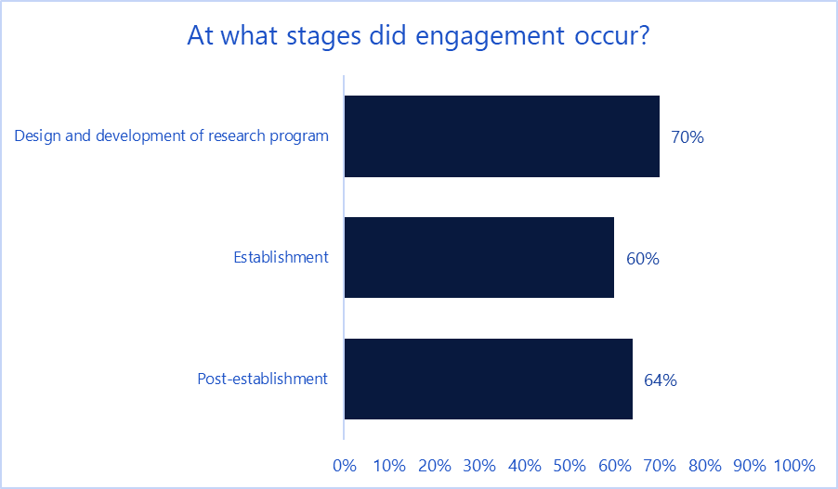

On average, Dirs, Mgrs, CIs and PIs engaged with a single IGC, while ROs reported engagement with an average of three IGCs, reflecting their broader role in overseeing research at universities, which may have multiple Research Hubs and Training Centres.

All five IGCs that participated reported that they had been engaged during the proposal phase. Only two reported involvement during the establishment phase, and four reported involvement after establishment.

## ITRP fit with other Australian Government programs that support industry focused research and innovation

#### Effectiveness of fit with Growth Centres, CRC, CRC-P and the Global Innovation Linkages Program

ROs, Dirs, CIs and PIs were asked to rate the uniqueness of the ITRP on five dimensions as part of the survey (Figure 12). Across all dimensions, respondents generally agreed in their perception that the ITRP is unique, with the strongest response seen in support for collaborative research training, and the least strong response being in the area of flexibility for establishing and managing research collaboration. Among respondent groups, Dirs had the strongest agreement on all dimensions.

1. ITRP uniqueness

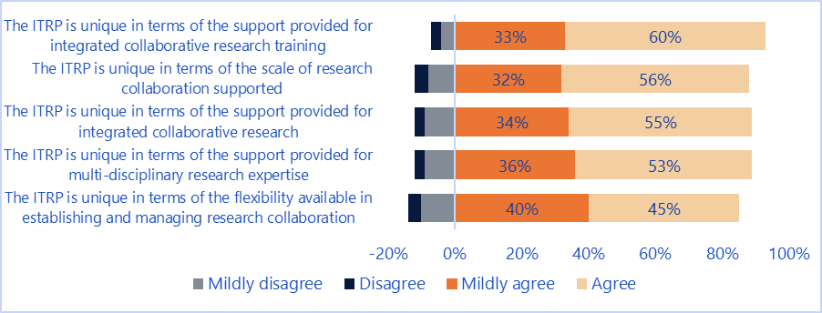

Sixty-three per cent of survey respondents agreed in their perception that the ITRP effectively complements other Australian Government programs, and a further 28 per cent mildly agreed with this statement (Figure 13). Again, Dirs agreed most strongly with this statement relative to other groups.

1. ITRP complementarity with other Australian Government programs

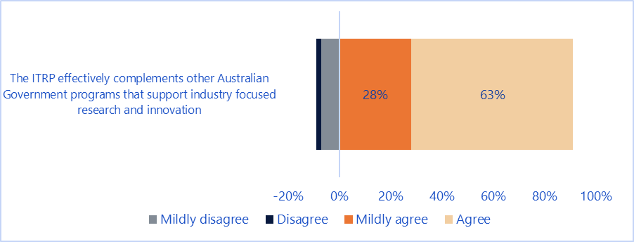

IGC survey respondents generally agreed in their perception that the ITRP effectively complements other Australian Government programs, though one respondent felt there was a lack of alignment with CRCs. Among the five IGC respondents, four agreed the ITRP was unique amongst government programs in providing support for integrated collaborative research training. Fewer agreed on its uniqueness in other areas.

Interviews with both ARC and DIIS representatives indicated that the ITRP is seen as a complement to other industry focused schemes:

We have the Linkage projects, which are smaller, then we go into our industrial transformation research programs, and then we’ve got our own ARC centres. They’re sort of equivalent with the CRC. Because ours are initiated by academics they, in my mind, sit quite neatly against the CRCs and the industry-focused ones, which can often have industry as the administering body for the money.

- ARC representative

#### Reasons administering organisations and their partners seek support under the ITRP rather than other industry focused research schemes

Interviews with ROs and Dirs found that the primary reason for seeking support under the ITRP was that larger scale projects can be funded, compared with other industry funded research schemes:

What the Hub represented was … a conglomeration of a number of these ARC Linkages - in other words, a much more efficient way of trying to apply and then ultimately a more efficient way of trying to deliver a number of these ARC Linkages that have all been sort of brought together.

* *Research Hub Dir*

The larger scale also enables less pressure to seek large contributions from industry towards research projects:

There is not a big onus for us to get huge amounts of cash from industry because you cannot always find it, and if they have a huge amount of cash they [industry] tend to run their own project, which is a bit more confidential.

* Training Centre Dir

Other reasons for seeking support highlighted by ROs and Dirs include:

* a focus on student training
* extended placements in industry
* broad scope
* early stage research focus
* alignment with university goals for developing industry ready degrees

CRC-Ps and ARC Linkage Projects were most commonly mentioned by ROs and Dirs as other schemes they had applied for. Interviewees felt that by comparison, ITRP is more early stage research focussed than CRC-Ps. Linkage Projects grants were seen as smaller and less connected with industry. The broader CRC program was also mentioned as a comparison, with the primary differentiator being that ITRPs were university-led and less complex to establish and run.

Interviews with the ARC also found that the early stage research focus was an attractor for applicants, as well as the ability to work with SMEs:

[The ITRP] allows them to do a lot more lower development level work, taking the idea to see if we can actually make something work out of it and the fact that it doesn’t have as much industry fund matching requirements enables them to work with a lot smaller companies.

- ARC representative

#### The role of the Industrial Transformation Priorities (which match the areas of focus for the Industry Growth Centres) in focusing applications on key industry priority areas

ROs and Dirs felt that the Industrial Transformation Priorities effectively focus applications on key industry priority areas. There was consensus that the priorities reflect many of Australia’s transformational areas of need. Some identified perceived gaps but there was no common view of what those gaps were. Two interviewees made the point that while aligning IGC priorities with ITRP is useful, IGC priority areas are relatively narrow and do not cover the whole economy.

From the perspective of the IGCs, there was general agreement that the Industrial Transformation Priorities focus applications on priority areas, though one IGC felt that their area had not received as much focus from the program:

I don't think there has been a fair spread of ITRP funding across the six priority sectors. Is this because of a clear interest in particular sectors for the ITRP assessors and decision-makers or a variable quality of applications across sectors? It would be good to know either way so that we can address for our sector.

- IGC representative

#### Potential overlaps or inconsistencies between the ITRP and other industry focused research schemes

Survey respondents from ROs, Dirs, CIs and PIs were asked if they felt that the ITRP overlaps with other programs that support industry focused research and innovation (Figure 14). Fifty-four per cent of respondents agreed to some extent with this statement, suggesting that there is a perception of overlap with other programs.

1. ITRP overlap

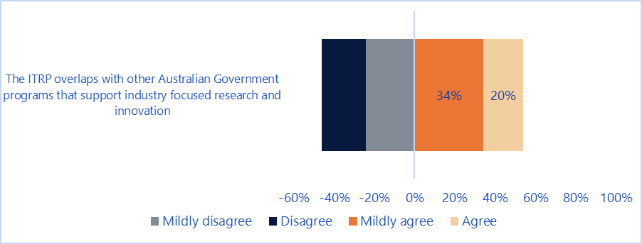

ROs, Dirs and Mgrs were more inclined to view the ITRP as having a niche and complementary place in relation to other programs in terms of scale and focus. The unique elements of the ITRP were listed by interviewees as:

* offering student training placements in industry settings
* a focus on more fundamental/ basic research. One Research Hub respondent commented that ITRP has the reputation of attracting the best scientists and doing the best research.
* broader research and industry collaborations compared to Linkage Projects and better supports commercialisation of the research results, and
* intensive partnerships and greater opportunities for multi-disciplinary research.

Three of the five IGC survey respondents felt that the ITRP overlaps with other programs, particularly the CRCs and CRC-Ps where these have an industry focus.

Interviews with DIIS indicated that there was little perception of overlap with other programs; one ARC interviewee indicated that in their view the Global Innovation Linkages appeared to be very similar in scope (with the exception of the requirements around international partners).

## Process implementation and advice to stakeholders

#### The effectiveness and efficiency of ITRP implementation processes and satisfaction with the associated advice provided by the ARC to ITRP applicants and other stakeholders

Overall, responses to interviews and the survey indicated that for most stakeholders the ITRP process is considered both effective and efficient. The major issues raised were around the timeframes for preparation of applications, the amount of information required for applications (especially from industry partners), and issues relating to negotiating and establishing collaborations with partners. Advice provided by the ARC has been received largely positively by stakeholders. These topics are covered in further detail in the below sections.

Regarding the establishment of collaborations, ROs, Dirs and Mgrs reported a few issues from their experiences. The predominant issue related to getting partnership agreements in place once the application was approved. Respondents found it a slow process to get letters of intent from industry signed, with one respondent saying that it can take 12 months (the expectation is six months). Some of the specific challenges encountered were around negotiating finances, IP arrangements, commercialisation arrangements, and the need to sign certification, which was considered to be duplicative.

The grant funding structure was also seen as an impediment to establishing collaborations, particularly the five-year timeframe for funding commitment, and the Research Hub requirement for 75 per cent of funding to be supplied by partners once an employee threshold was reached.

A perceived lack of awareness of the program by industry was also noted in the interviews, which respondents felt was impacting the understanding of partners around the program and how they can be involved.

…because the ITRH wants to engage with the small-medium enterprises, they are where you probably don’t have that awareness very high and the opportunities that might come with that to lead to those industry academia collaborations.

*- Research Hub Dir*

This indicates that a potential opportunity exists for the program to be promoted to industry.

#### Effectiveness and efficiency of application and assessment processes

In terms of ARC advice in the application process, respondents to the survey (ROs, Dirs and CIs) were generally positive about the usefulness of ARC information (Figure 15). Respondents felt that guidelines and application form requirements were most useful, while there are opportunities for improvement in outreach activities. Between respondent groups, CIs found forums and outreach activities to be less useful, while ROs found application forms and guidelines to be less useful as compared to other groups.

1. Usefulness of ARC information (application)

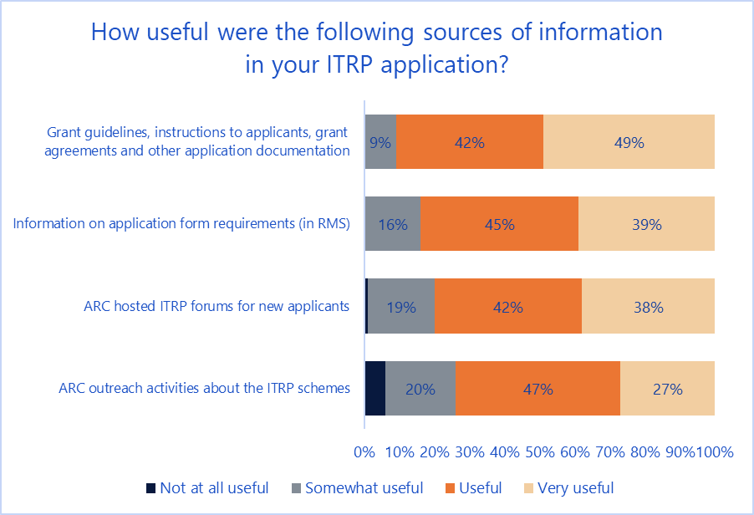

Respondents to the survey (ROs, Dirs, CIs and PIs) were asked about their views in relation to the application and assessment process (Figure 16). Respondents felt that their participation was appropriate and that the process was clear. However, there were less positive results in relation to timelines for the application process, as well as the transparency of the process. Broken down by group Dirs were the most positive across all areas. ROs were least in agreement with other groups around the appropriateness of timelines, being less positive.

Dir and RO respondents added that the size of the applications was a challenge (both to prepare, and for Dirs that had been involved in the assessment process, the size made it difficult to efficiently review applications). Timeframes were also raised as an issue, with respondents noting that they had a short lead time, and that the closure date for applications comes at a busy period for research institutions. One respondent suggested that an Expression of Interest process followed by a more detailed assessment process may reduce the administrative burden and allow them to better manage timeframes.

1. ITRP application and assessment processes

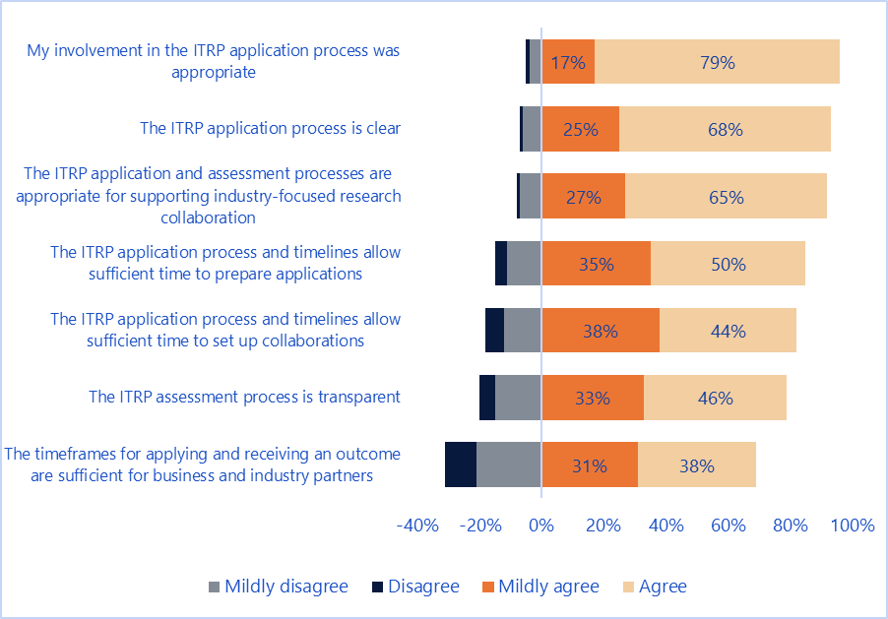

ROs, Dirs, CIs and PIs were also asked about challenges in the application process (Figure 17). Negotiating IP and commercialisation arrangements was reported as the largest challenge, followed by managing partner organisations’ expectations (PIs were not asked this question). In terms of least challenging factors, these were establishing collaboration with other universities (PIs were not asked this question) and negotiating the research program. By group, PIs generally found the process less challenging as compared to other groups, particularly for negotiations.

1. Challenges in the application process

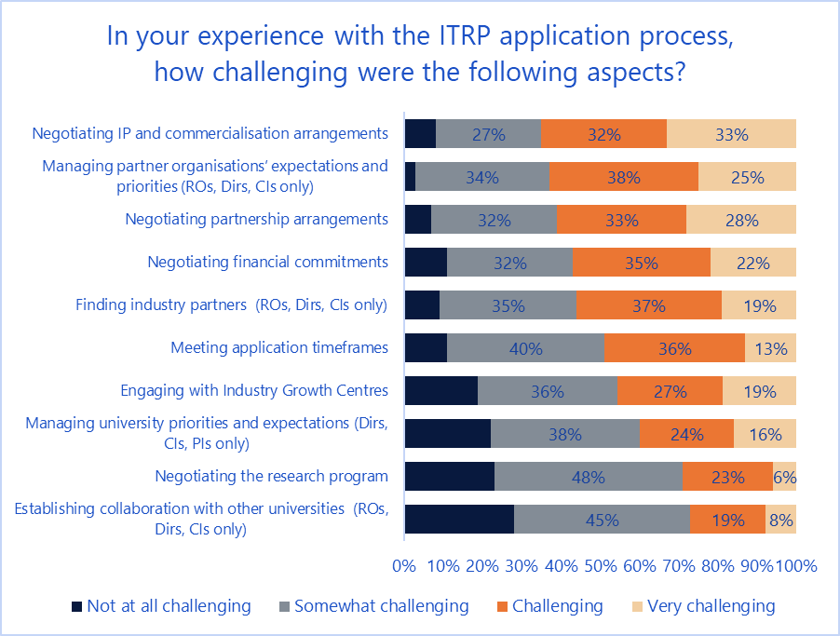

Of 81 comments provided by ROs, Dirs, and CIs on other significant issues in the application process, 25 per cent related to difficulties with the timelines for applications and the time required to prepare the application, a further 15 per cent related to achieving financial commitment from partners to being involved in the program, and a further 14 per cent related to managing relationships with partner organisations and getting them to work together (comments on this topic came primarily from CIs).

In terms of key learnings from the application process, analysis of 169 comments from ROs, Dirs and CIs found that the biggest learning was to begin as early as possible in developing the program and establishing partnerships (34 per cent of comments). A further 28 per cent stressed the importance of establishing and managing partnerships, and 14 per cent of comments discussed the value of building engagement across the collaboration.

Ninety-one general feedback comments relating to the application and assessment process included an emphasis on timelines (21 per cent), and suggestions for improvement around the assessment process (20 per cent) and the application process (15 per cent). General positive comments about the process accounted for a further 10 per cent, and general negative comments accounted for 4 per cent.

#### Effectiveness and efficiency of processes and associated advice on project implementation issues such as establishment, contracts, recruitment, intellectual property and commercialisation arrangements

Respondents to the survey (ROs, Dirs, Mgrs and CIs) were generally positive about the usefulness of ARC information and advice (Figure 18)[2]. Respondents felt that induction days and the Major Investments Forum were most useful, while there may be opportunities for improvement in progress reporting and ad-hoc reviews. Between respondent groups, Dirs tended to find activities more useful as compared to other groups; however, many CIs chose not to respond to these questions, suggesting that they had not interacted with these sources of information throughout their engagement.

Dirs reported finding the yearly meeting with other Dirs useful for sharing experiences. However, they also felt that KPIs were less useful as they were not descriptive enough.

1. Usefulness of ARC information (establishment and post establishment)

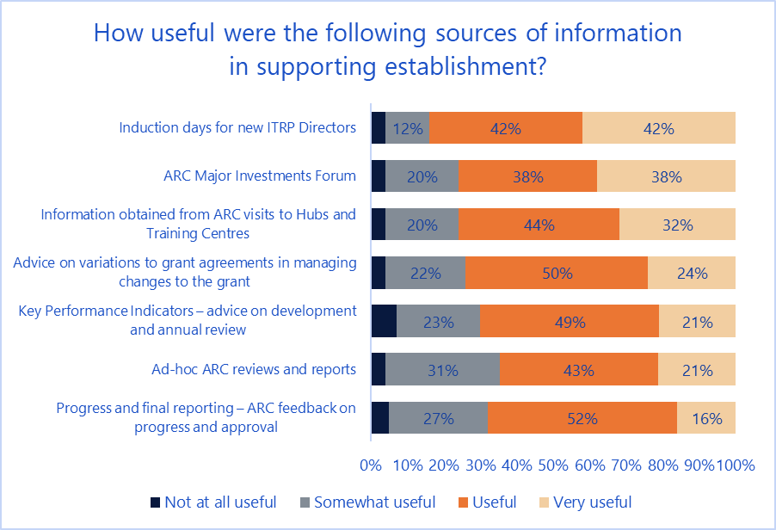

ROs, Dirs, Mgrs, CIs and PIs were also asked about challenges in the establishment process (Figure 19). Domestic student recruitment was reported as the largest challenge, followed by negotiating partnership arrangements and IP arrangements. In terms of least challenging factors, these were managing collaboration with other universities, budget management and negotiating the research program. By group, Mgrs and PIs generally reported the process to be less challenging than other groups.

1. Challenges in the establishment process

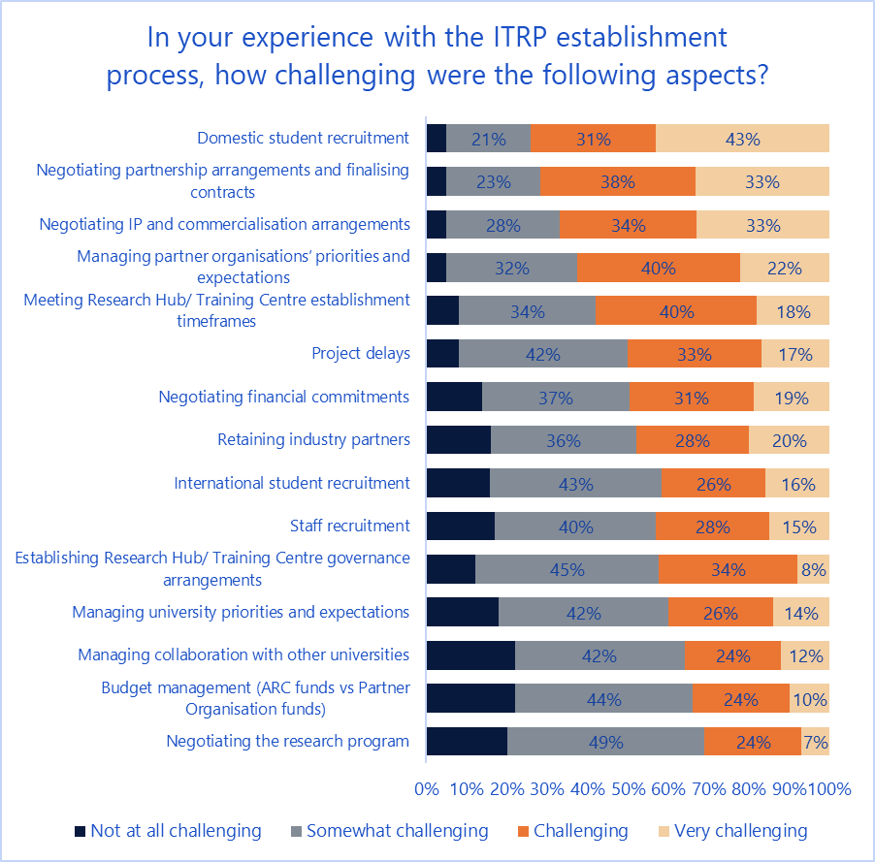

Of 99 comments provided on other significant issues in the establishment process, 18 per cent related to difficulties with managing agreements, 13 per cent related to HDR and PDR recruitment and management, and a further ten per cent related to dealing with changes in industry trends and the business environment.

In terms of key learnings from the establishment process, analysis of 190 comments from ROs, Dirs, Mgrs and Chief and PIs found that the biggest learning was to maintain good communications across stakeholders (26 per cent of comments). A further 22 per cent stressed the importance of cultivating partnerships (and within this, having a diversity of partnerships). Ten per cent of comments discussed the importance of a good governance model and a strong management team.

Dirs and Mgrs were asked about the importance of particular governance structures for enabling and managing research collaboration (Figure 20). Note that Research Hubs and Training Centres may not have all these structures in place. For those that responded for each type of structure, business manager was seen as the most important role, followed by management committees and independent advisory committees. Mgrs considered that all of the governance structures were more important as compared to Dirs.

1. Importance of governance structures (Dirs and Mgrs)

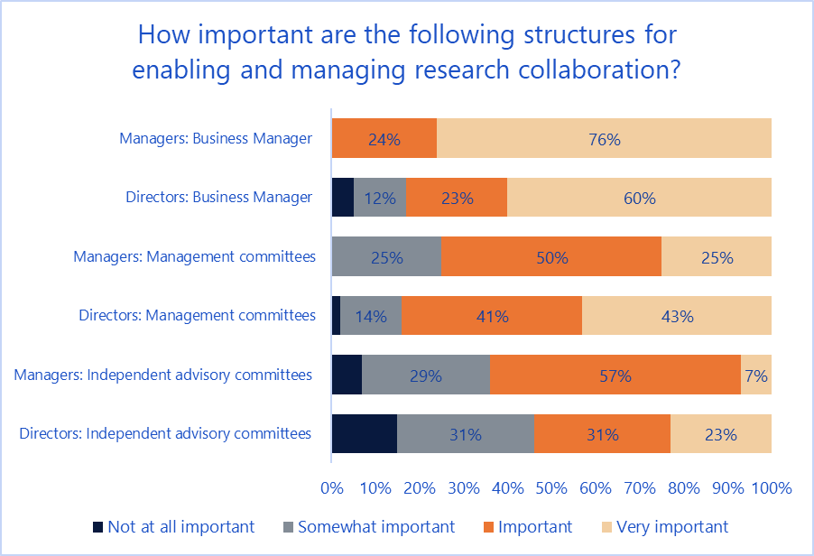

Other important governance arrangements identified in 25 comments from Dirs and Mgrs were executive meetings (17 per cent), research committees and general committees (13 per cent each), student committees (nine per cent), and industry agreements (nine per cent).

Forty-eight general feedback comments relating to the establishment process discussed difficulties in applying guidelines (13 per cent), the value of collaborations (11 per cent), and the role of individual people in the process (nine per cent). Fifteen per cent were general positive comments and nine per cent were general negative comments.

## Overall objectives

All respondents to the survey were asked about their views on the effectiveness of the ITRP in meeting its objectives (Figure 21) and, depending on their experience, the effectiveness of Research Hubs (Figure 22) and Training Centres (Figure 23) in meeting their objectives. In general, respondents agreed that the ITRP both fosters important research partnerships and supports research trainees to gain skills in industry priority areas.

1. ITRP objectives (General)

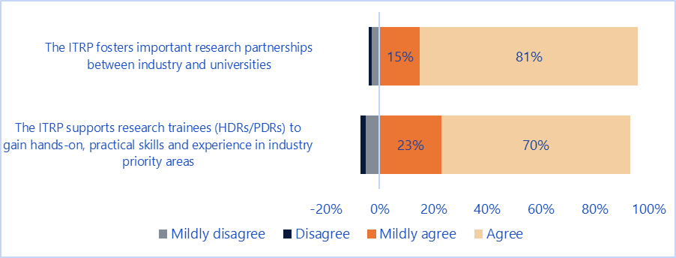

Respondents generally agreed that Research Hubs’ objectives are being achieved, though there was less agreement in relation to their ability to attract investment in targeted industry sectors.

1. ITRP objectives (Research Hubs)

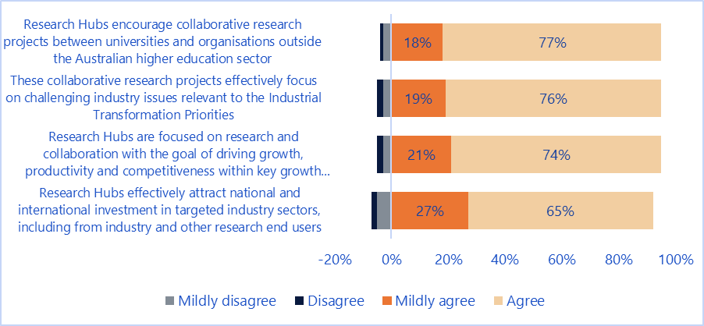

Respondents also generally agreed that Training Centres’ objectives being achieved, with the strongest agreement seen in enhancing research training collaboration.

1. ITRP objectives (Training Centres)

In terms of encouraging and supporting industry focused collaborative research and research training, IGCs were unanimously positive in terms of their support for the ITRP:

The program provides an avenue for collaboration between research organisations (as the engines of innovation) and industry (the commercialisation vehicle). This interaction and collaboration is critical for better understanding of expectations and relevant knowledge exchange between industry and academia, providing an effective path for the commercialisation of new products or services to transform industry.

- IGC representative

## General feedback

Dirs, Mgrs and ROs were asked to provide suggestions on ways the ARC can assist Research Hubs and Training Centres in the future. Across the 59 comments provided, funding changes (primarily increasing the size and length of funding) was the most common topic (24 per cent), followed by suggestions for improved communications and reporting processes (20 per cent). Feedback from IGCs on areas of improvement included:

* stronger communications and knowledge sharing plans
* having ITRPs based in industry with a free flow of academics/researchers
* specific funding/rounds for each priority sector
* support awareness that IGC engagement can occur after the grant has been awarded
* requiring local business school input on applications, in relation to likely demand for the ITRP outcomes and commercial pathway options.

Survey respondents were also asked to provide general feedback on the program. A broad sentiment analysis of 199 comments received found that around 60 per cent were positive in tone, with 31 per cent neutral in tone and nine per cent being negative. Further topical analysis of these comments found that the three most common topics of discussion (aside from simple positive or negative statements about the program) were:

* a desire to see greater monitoring and evaluation of Research Hubs and Training Centres (9 per cent)
* changes to the funding structure for the program – this included the size of funding as well as ensuring an appropriate balance in the distribution of funding between activities and partners (8 per cent)
* and changes to the timeframes for application and assessment (8 per cent).

Other notable topics raised by particular stakeholder groups included improving access to and timing of placements (HDRs) and increasing the timeframes for application preparation (ROs).

Interviews with ARC representatives indicated that there was a need to ensure that in the application process there is an understanding by reviewers of the capability and experience of proposed Dirs in running similar types of programs (as opposed to research projects):

… in many ways [the ITRP is] almost a training for you to run a bigger centre like the Centres of Excellence or the CRC’s but at a slightly smaller scale ipso facto should we actually be doing more assessment than just your research ability, because we’re actually looking at your ability to run an organisation. I’m not sure you can read that off [the application] or perhaps the selection criteria aren’t quite right … because you’re not really asking them to write about that capability.

- ARC representative

Feedback from interviews with DIIS representatives focused on ensuring that researchers are aligning their work with industry and business needs, and on evaluating the outcomes of collaborations, particularly from a commercial standpoint.

1. Technical summary

Survey

The survey was delivered between 6 February 2019 and 28 February 2019 to a distribution list of 2,177 stakeholders. Reminder emails were sent on a weekly basis and 24 hours prior to closure of the survey.

A total of 702 complete responses to the survey were received, representing a response rate of 32.3 per cent. This is higher than expected for surveys of this type (typically a response rate of 20 per cent would be normal) and exceeded initial predictions for expected total responses.

A further 302 partial responses were received which have not been included in the analysis or final data set. This represents a completion rate of 69.9 per cent for those who started the survey, indicating a high degree of uptake for a survey of this length.

Twenty-four members of the contact list opted out from receiving further communications about the survey, representing 1.1 per cent of the contact list. Analysis of this showed that these were predominantly PIs.

Figure 24 shows a breakdown of completed survey responses over time between launch and closure of the survey. Spikes in the number of responses correspond to the transmission of reminder emails. The lower spike relating to the final reminder indicates that the length of the survey in the field was optimal, and that few further responses would have been received had the survey remained in field longer.

1. Survey responses by day

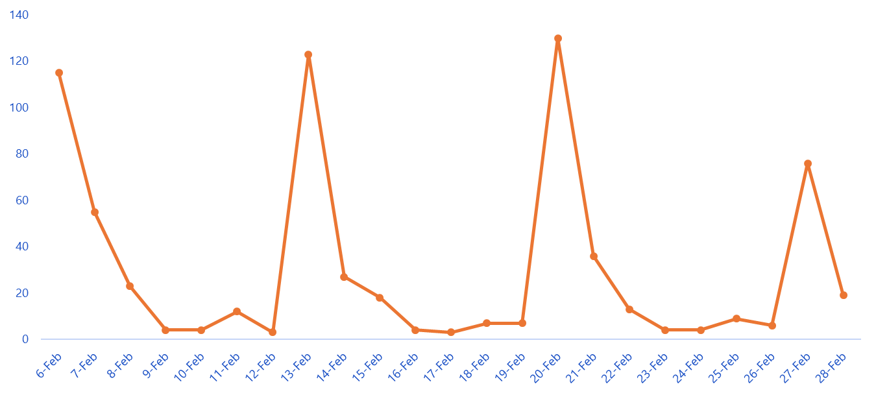

Figure 25 presents the response totals by group, and Figure 26 presents the response rate by respondent group. Response rates were calculated in comparison to the total contact list.

1. Responses by group

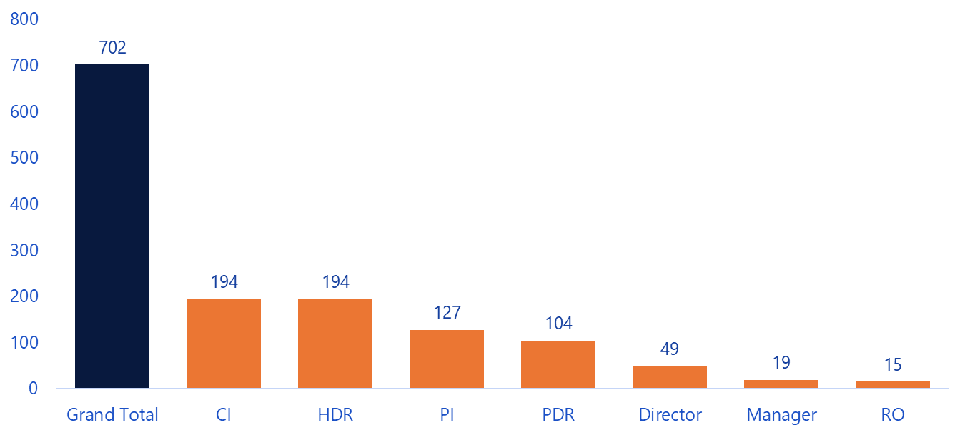

1. Response rate by group

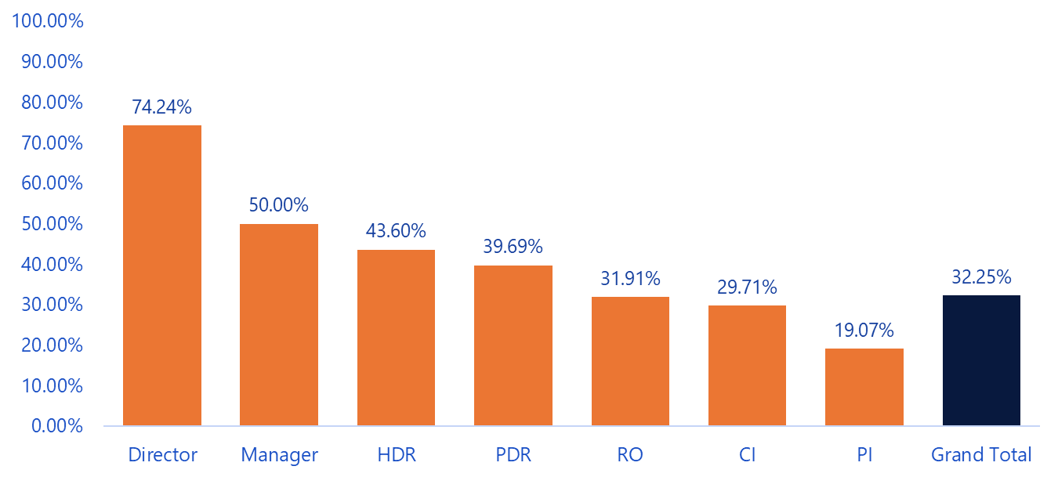

Table 1 and Table 2 present the breakdown of survey responses by response group (number and percentage respectively). Each of the groups provided a reasonable sample of the population, though ROs were slightly low. PIs had a low relative response rate, but this was offset by the large number of responses.

1. Survey responses by response group (number)

|  |  |  |  |
| --- | --- | --- | --- |
| Role | Complete | Partial | Not started |
| RO | 15 | 8 | 24 |
| Dirs | 49 | 3 | 14 |
| Mgr | 19 | 9 | 10 |
| CI | 194 | 96 | 363 |
| PI | 127 | 80 | 459 |
| PDR | 104 | 37 | 121 |
| HDR | 194 | 68 | 183 |
| **Grand Total** | **702** | **301** | **1174** |

1. Survey responses by response group (percentage)

|  |  |  |  |
| --- | --- | --- | --- |
| Role | Complete | Partial | Not started |
| RO | 31.91% | 17.02% | 51.06% |
| Dirs | 74.24% | 4.55% | 21.21% |
| Mgr | 50.00% | 23.68% | 26.32% |
| CI | 29.71% | 14.70% | 55.59% |
| PI | 19.07% | 12.01% | 68.92% |
| PDR | 39.69% | 14.12% | 46.18% |
| HDR | 43.60% | 15.28% | 41.12% |
| **Grand Total** | **32.25%** | **13.83%** | **53.93%** |

IGC Survey

The IGC survey was delivered between 11 February 2019 and 28 February 2019 to six representatives from Industry Growth Centres. Reminder emails were sent one week after launch, followed by phone calls to remaining representatives. Five of the six representatives provided a response to the survey.

1. Participant summary

Survey

1. Survey responses by role and type

|  |  |  |  |  |
| --- | --- | --- | --- | --- |
|  | RO | Research Hub | Training Centre | Total |
| RO | 15 |  |  | 15 |
| Dirs |  | 22 | 27 | 49 |
| Mgr |  | 7 | 12 | 19 |
| CI |  | 101 | 93 | 194 |
| PI |  | 51 | 76 | 127 |
| PDR |  | 72 | 32 | 104 |
| HDR |  | 129 | 65 | 194 |
| **Grand Total** | **15** | **382** | **305** | **702** |

1. Survey responses by role and round

|  |  |  |  |  |  |  |  |  |  |  |
| --- | --- | --- | --- | --- | --- | --- | --- | --- | --- | --- |
|  | RO | 2012 Round 1 | 2013 Round 1 | 2013 Round 2 | 2014 Round 1 | 2015 Round 1 | 2016 Round 1 | 2017 Round 1 | 2018 Round 1 | Grand Total |
| RO | 15 |  |  |  |  |  |  |  |  | 15 |
| Dirs |  | 1 | 4 | 6 | 7 | 7 | 5 | 8 | 11 | 49 |
| Mgr |  |  |  | 2 | 4 | 4 | 3 | 6 |  | 19 |
| CI |  | 7 | 17 | 14 | 42 | 20 | 13 | 45 | 36 | 194 |
| PI |  | 1 | 10 | 7 | 15 | 16 | 18 | 32 | 28 | 127 |
| PDR |  | 2 | 12 | 18 | 20 | 30 | 9 | 13 |  | 104 |
| HDR |  | 6 | 30 | 29 | 40 | 58 | 15 | 16 |  | 194 |
| **Grand Total** | **15** | **17** | **73** | **76** | **128** | **135** | **63** | **120** | **75** | **702** |

1. Survey responses by type and round

|  |  |  |  |  |  |  |  |  |  |  |
| --- | --- | --- | --- | --- | --- | --- | --- | --- | --- | --- |
|  | RO | 2012 Round 1 | 2013 Round 1 | 2013 Round 2 | 2014 Round 1 | 2015 Round 1 | 2016 Round 1 | 2017 Round 1 | 2018 Round 1 | Grand Total |
| RO | 15 |  |  |  |  |  |  |  |  | 15 |
| Research Hub |  | 17 | 43 | 76 | 99 | 77 |  | 39 | 31 | 382 |
| Training Centre |  |  | 30 |  | 29 | 58 | 63 | 81 | 44 | 305 |
| **Grand Total** | **15** | **17** | **73** | **76** | **128** | **135** | **63** | **120** | **75** | **702** |

Interviews

1. Interviews by role and type

|  |  |  |  |  |
| --- | --- | --- | --- | --- |
|  | RO/ARC/DIIS | Research Hub | Training Centre | Total |
| RO | 9 |  |  | 9 |
| ARC | 2 |  |  | 2 |
| DIIS | 2 |  |  | 2 |
| Dir/Mgr |  | 10 | 10 | 20 |
| **Grand Total** | **13** | **10** | **10** | **33** |

1. Interviews by role and round

|  |  |  |  |  |  |  |  |  |  |  |
| --- | --- | --- | --- | --- | --- | --- | --- | --- | --- | --- |
|  | RO/ARC/DIIS | 2012 Round 1 | 2013 Round 1 | 2013 Round 2 | 2014 Round 1 | 2015 Round 1 | 2016 Round 1 | 2017 Round 1 | 2018 Round 1 | Grand Total |
| RO | 9 |  |  |  |  |  |  |  |  | 9 |
| ARC | 2 |  |  |  |  |  |  |  |  | 2 |
| DIIS | 2 |  |  |  |  |  |  |  |  | 2 |
| Dir/Mgr |  | 0 | 2 | 3 | 3 | 3 | 1 | 4 | 4 | 20 |
| **Grand Total** | **13** | **0** | **2** | **3** | **3** | **3** | **1** | **4** | **4** | **33** |

1. Interviews by type and round

|  |  |  |  |  |  |  |  |  |  |  |
| --- | --- | --- | --- | --- | --- | --- | --- | --- | --- | --- |
|  | RO/ARC/DIIS | 2012 Round 1 | 2013 Round 1 | 2013 Round 2 | 2014 Round 1 | 2015 Round 1 | 2016 Round 1 | 2017 Round 1 | 2018 Round 1 | Grand Total |
| RO | 9 |  |  |  |  |  |  |  |  | 9 |
| ARC | 2 |  |  |  |  |  |  |  |  | 2 |
| DIIS | 2 |  |  |  |  |  |  |  |  | 2 |
| Research Hub |  | 0 | 1 | 3 | 1 | 2 | 0 | 2 | 1 | 10 |
| Training Centre |  | 0 | 1 | 0 | 2 | 1 | 1 | 2 | 3 | 10 |
| **Grand Total** | **13** | **0** | **2** | **3** | **3** | **3** | **1** | **4** | **4** | **33** |



1. With the exception of questions aimed at ARC and Industry Growth Centre stakeholders which were separately vetted by the Program Evaluation section at the ARC.
2. The question language was: “How useful were the following ARC sources of information and advice in supporting the establishment of your [Hub/Centre]” – while there was a prefacing statement that stated that questions related to the establishment and post-establishment phases, it is possible that respondents limited their views to the role of information and advice in the establishment phase only.