

Research Management System

**API Management in RMS**

(User Guide)

Target Audience – Research Office Staff

Updated May 2021

Contents

Introduction 3

Key Points 3

Overview 4

PART 1 – API Key Configuration 4

1.1 – API Key Management 4

1.2 – Generating a new API Key 5

1.3 - How to set an API Key for display 6

1.4 – Security of API Keys 8

PART 2 – Allowed IP Addresses for using API 9

2.1 - How to enter an allowed IP address for using API calls 9

PART 3 – Frequently Asked Questions 11

PART 4 – Contacting the ARC for additional help 11

# Introduction

The Research Management System (RMS) is a web-based application developed by the Australian Research Council (ARC) and now used by multiple agencies to manage their Grant Programs. Each agency can utilise functions such as: submissions, request not to assess, assignment and assessment, rejoinders, announcement, grant offers/acceptance, and post-award activities such as grant variations and project reporting.

More detailed information on the agencies utilising RMS is available on the [Research Grant Services](https://www.arc.gov.au/research-grants-services) page of the ARC Website.

RMS Access

The web address to access RMS is dependent on the agency or program that you are needing to interact with.

* ARC (NCGP) RMS instance - [https://rms.arc.gov.au](https://dese.researchgrants.gov.au/)
* DESE (NCRIS) RMS instance - [https://dese.researchgrants.gov.au](https://rmsoni.researchgrants.gov.au)
* ONI (NISDRG) RMS instance - [https://rmsoni.researchgrants.gov.au](https://defence.researchgrants.gov.au)
* Defence (NISDRG) RMS Instance - [https://defence.researchgrants.gov.au](https://www.arc.gov.au/research-grants-services)

**NOTE:** - You only need one account to access RMS, regardless of agency or program you are accessing, however you will require specific roles for each version/instance of RMS.

All screenshots provided within this document have been sourced from the NCGP instance of RMS and images and processes may differ slightly dependent on the instance you are using.

# Key Points

* + - The target audience for this user guide is Research Office staff.
    - RMS is compatible with the latest versions of Google Chrome and Microsoft Edge. The ARC cannot guarantee compatibility with other browsers or older versions of Google Chrome or Microsoft Edge.
    - Research Office staff will need to copy their current API Key prior to the **27 May 2021** as the key will no longer be visible in the API examples after that date.
    - Research Office staff will be responsible for API Key security.
    - Research Office staff will have the ability to generate **up to 10 concurrent API valid keys** at any point in time.
    - Research Office staff now have access to identify and record the IP addresses they require to continue to use API functionality.
    - These measures enhance and improve security provisions for RMS APIs.

# Overview

The Application Programming Interface (API) functionality provides Research Offices with the ability to extract data stored within RMS using an organisation specific key. This information can be extracted in JSON or CSV format and in some instances, organisations have linked the API to internal organisation systems for data review. Functionality has been implemented to enhance the security of RMS data which has introduced two new links to allow Research Office staff to manage access to data for their organisation:

* Research Office API Key Config
* Research Office Allowed IP Addresses

# PART 1 – API Key Configuration

A Research Office requires the organisation specific API Key to enable them to access their RMS data. On the **27 May 2021** visibility of this key within RMS will be removed, and a limit of **10 concurrent API keys per organisation** will be imposed.

## 1.1 – API Key Management

Click the ‘Research Office API Key Config’ link under **Reports** on the Action Centre to access the API Key Management screen in RMS.

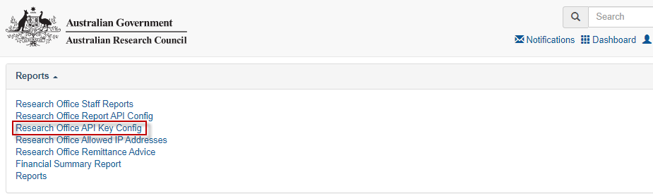

**Figure 1 – Research Office API Key Config link from within the Action Centre**

The Research Office API Key Config screen will display as:

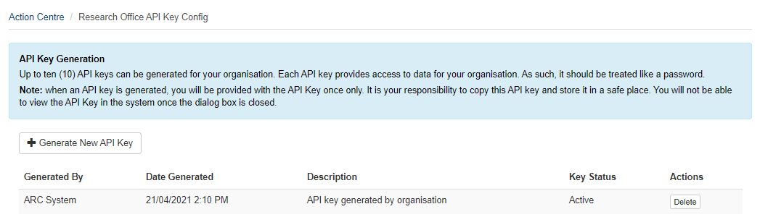  
**Figure 2 – Research Office API Key Config**

## 1.2 – Generating a new API Key

The Research Office can generate a new API Key by selecting the ‘Generate New API Key’ action button:

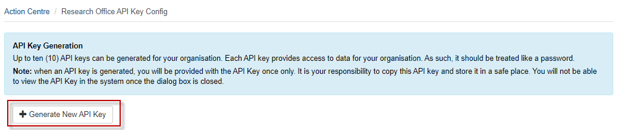  
**Figure 3 – Generate New API Key Action button**

A pop-up box will display prompting a description of what the API Key will be used for:

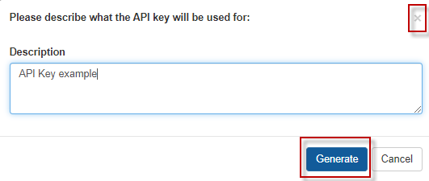

**Figure 4 – Generate New API Key Description**

* The pop-up box can be closed by selecting the **X** in the top right corner or by selecting the **Cancel** button. If either of these actions are completed the API will not be generated
* The **Generate** button will become available once a description has been entered

On generation of a new API Key, a pop-up box will display with the key and a prompt to copy the API Key:

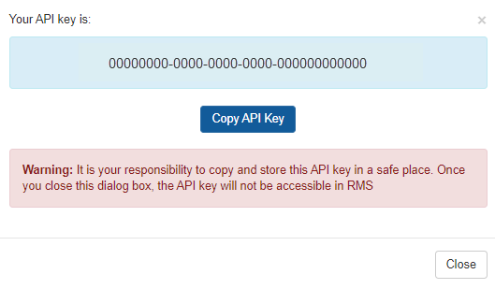

**Figure 5 – Copy API Key**

The Research Office is responsible for selecting the ‘Copy API Key’ at this point for use in any information requests.

***Note:*** *When an API Key is generated,* ***you will only see it once.*** *Ensure you always ‘Copy API Key’ once it has been generated. Once this screen is closed, you will not be able to view that API Key again. If the key is lost a new API Key will need to be generated.*

On closing the pop-up box, a record is added to the ‘API Key Management’ list as a log of the API Keys created:

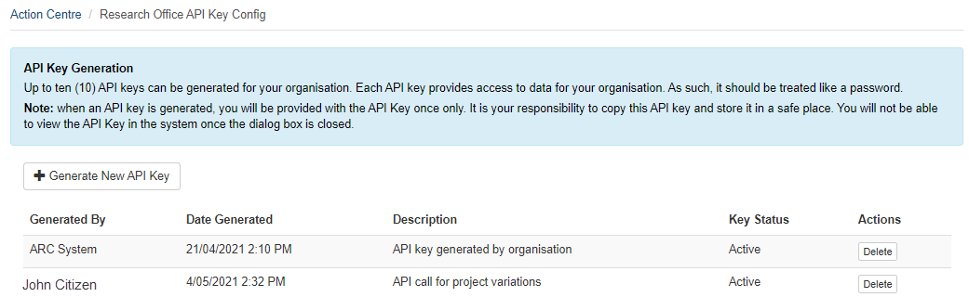

**Figure 6 – Summary details of generated API Keys**

## 1.3 - How to set an API Key for display

To assist Research Offices in using the API, RMS has examples displayed within the ‘Research Office Report API Config’ link. To ensure that the examples within the link display useable information the ‘Set Displayed API key’ button should be selected.

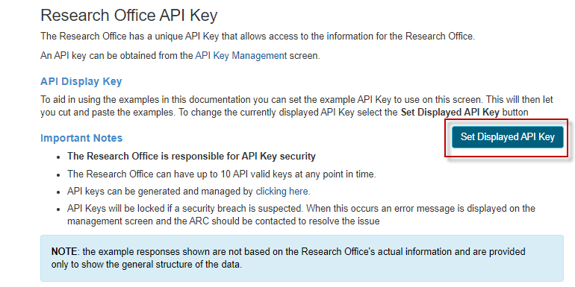

**Figure 7 – Setting displayed API Key within the ‘Research Office Report API Config’ link**

A pop-up box will display which will allow the Research Office to:

* paste the copied API Key (see Figure 5)
* selecting the **X** in the right top corner or the ‘Cancel’ button will close the pop-up window
* selecting the ‘OK’ button will save the API Key and populate the key in the API call examples

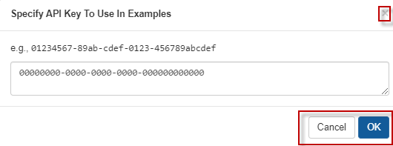

**Figure 8 – Specifying API Key to display in examples**

## 1.4 – Security of API Keys

As part of the overall management of API Keys, the Research Office is responsible for the security of their API Key. The Research Office can have **up to 10 concurrent API valid keys** at any point in time.

An API Key will be locked if a security breach is suspected. When this occurs, an error message will display on the API Key Management screen and the Research Office will need to contact the RMS Support Team to have the issue resolved (see Part 4).

# PART 2 – Allowed IP Addresses for using API

RMS is now configured for the Research Office to enter the list of accepted IP addresses that will have access to API information. For security purposes, the ARC strongly recommends that Research Offices:

* identify the IP addresses
* enter the IP addresses in RMS

## 2.1 - How to enter an allowed IP address for using API calls

To access the IP address configuration screen, select the ‘Research Office Allowed IP Addresses’ link under **Reports** on the Action Centre.

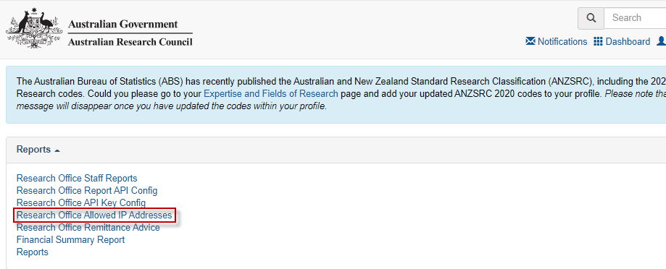  
**Figure 9 – Research Office Allowed IP Addresses link from Action Centre**

The first-time for an IP address to be entered, the screen will display with only the ‘Add’ button:

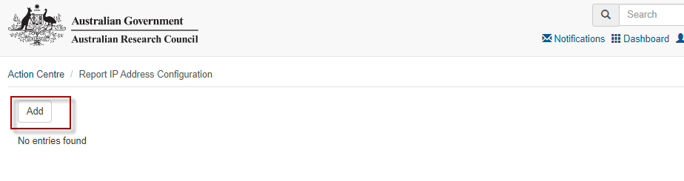   
**Figure 10 – Report IP Address Configuration**

Selecting the ‘Add’ button will result in a pop-up box for the Research Office to complete:

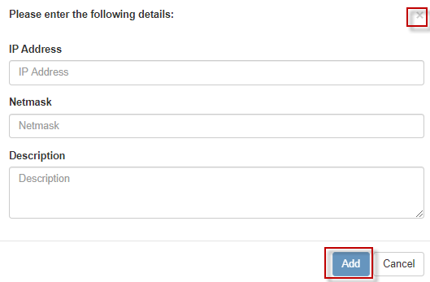

**Figure 11 – IP Address entry dialog**

The IT areas in the Research Office will be able to provide the relevant details for:

* **IP Address**: is the internet protocol address and is a numerical label assigned to each device connected to a computer network
* **IP Address**: should be entered in IPv4 format
* **Netmask**: used in conjunction with the IP address to signify what range of IP addresses in a network can be accessed

The ‘description’ is a free text field and should be relevant to the Research Office. For example, could be the range of IP addresses included.

Once the IP address details have been added, the details will display on the ‘Report IP Address Configuration’ screen:

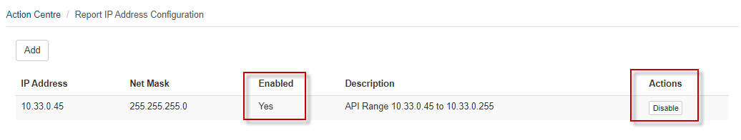

**Figure 12 – IP Address entry**

The entry will default to enabled and should be managed by the Research Office. IP addresses can be disabled if no longer required and can be re-enabled as needed.

There is no limit to the number of IP addresses added on this screen.

# PART 3 – Frequently Asked Questions

**What should I do before the release on 27 May 2021?**You should copy the existing API Key being used by your Research Office and store the information in a safe place.

**How do I set my API Key in the RMS examples?**

Use the ‘Set Display API Key’ button (see Figure 7) to have your API Key added to the RMS API examples.

**Can I generate a new API Key?**Yes, by using the ‘Generate New API Key’ on the ‘Research Office API Key Config’ screen. Your Research Office can have up to 10 valid concurrent API Keys to use.

**What do I do when an error message displays stating the API Key has been locked?**You can contact the RMS Support team at the ARC (see PART 4).

**Can the one API Key be used in each of the RMS instances my Research Office has users in? For example: my Research Office has users in the ARC, Defence and ONI RMS instances.**

No, different API Keys will need to be generated for each of the instances your Research Office has access to.

**Do I have to provide IP Addresses to the ARC?**

No. However, the ARC strongly recommends that you enter allowed IP addresses to increase the security around API Key use. An allowed IP address can be entered in RMS on the ‘Research Office Allowed IP Addresses’ screen.

**How do I find out what IP Address to enter in RMS?**

Contact the IT area in your Research Office.

**How do I find out what Netmask to enter in RMS?**

Contact the IT area in your Research Office.

**Do I have to enter the allowed IP Addresses in all of the RMS instances I have user accounts in?**

Yes, your Research Office will have to enter the allowed IP Addresses in every RMS instance they have user accounts in.

# PART 4 – Contacting the ARC for additional help

If you are experiencing any technical issues or require help with navigating RMS please contact the RMS Support team at [rmssupport@arc.gov.au](mailto:rmssupport@arc.gov.au).