Variations of ARC Agreement:Research Office instructions for completing and submitting a Variation and/or POACR

**Table of contents**

**Submission of Variations: Information to note** 4

**Processing variations in RMS** 4

Who can create variations in RMS 4

Submitting a variation in RMS 5

Starting a variation in RMS 5

Add a variation request line 6

Remove a variation request line 7

Re-order multiple request lines 7

Deleting a variation request 7

Justification field 8

Mandatory fields 8

Supporting documentation 8

Retrospective requests 8

External Feedback Comments and Special Conditions 8

Project Status in RMS 9

Finding a variation request 9

**Variation Request types** 10

Allowance Variations 10

Allowance - Maternity/Parental leave 10

Budget Variations 11

Budget Change notifications 11

Organisation Variations 13

Organisations - Add/update 13

Organisations - Withdraw 14

Personnel Variations 15

Person - Add/update 15

Person - Additional Appointments 17

Person - Defer commencement 18

Person - Suspension 19

Person - Withdraw 20

Project Variations 21

Project - Asset Relocation 21

Project - Defer Commencement 22

Project - End date 23

Project - Full Relinquishment 24

Project - Partial Relinquishment 25

Project - Salary Conversion 26

Project - Salary Relinquishment 27

Project - Scope Change 28

Project - Suspension 29

Project - Transfer 30

Variations submitted outside of RMS 32

Project - Transfer Corrections 32

Project - EOYR Corrections 33

Person - Add/update (that cannot be done in RMS) 34

**Partner/Participating Organisation Agreed Contribution Report (POACR)** 35

Creating a POACR in RMS 35

Search for a POACR in RMS 37

**Appendix A – ARC Variations - Supporting Documentation** 38

Supporting documents for variations submitted via RMS 38

Supporting documents for variations submitted outside of RMS 39

**Appendix B – ARC Variations - How to's** 40

Allowance Variations 40

Budget Variations 41

Organisation Variations 42

Personnel Variations 44

Project Variations 50

# **Submission of Variations: Information to note**

The Australian Research Council (ARC) requires that a variation to an ARC Agreement be submitted for all major changes that occur on ARC funded Projects. Variations are submitted to the ARC in RMS by the Administering Organisation that owns the grant.

Depending on the type of change/s requested in the variation, there are various personnel and/or organisations that will need to agree to the request. A list of the documentation/approvals required for variation’s can be found in Appendix A. It is the responsibility of the Administering Organisation to ensure the appropriate approvals are included with the supporting documentation when submitting variation requests.

For a variation to be assessed, the following conditions must be met:

1. The variation must be submitted by the Administering Organisation via RMS, unless ARC has instructed otherwise. Direct requests from researchers or other organisations (even if listed on the Project) will not be accepted.
2. The Administering Organisation that is responsible for the Project must retain approvals but also be able to provide a copy of the relevant participant’s approval or confirmation that all relevant participants have been notified of the change, if requested to by the ARC.
3. Collaborating or Other Eligible Organisation agreements must be from an authorised delegate such as the Research Office or other University staff member that has the appropriate authority to do so.
4. A Partner or Other Organisation agreement may be submitted by the Partner Investigator (PI) on behalf of their organisation, provided the PI has the appropriate internal approval agreeing to the change. It is up to the Administering Organisation to ensure the PI has this authority.
5. A Host Organisation agreement may be submitted by the principle contact on behalf of their organisation, provided they have the appropriate internal delegation for approval.

# **Processing variations in RMS**

## Who can create variations in RMS

Only Research Office staff that have the ‘Research Office Staff’ role in RMS can create a variation in RMS. All variations can be created by RO staff excluding the following:

* Transfer Corrections
* EOYR Corrections
* Title Changes, and
* the addition of new investigator (if their RMS account is not administered by the Research Office)

For these variations, Research Offices must email the relevant details/documentation to the Post Award mailbox for processing. Please refer to Appendix A for further instructions.

## Submitting a variation in RMS

* A variation must only be created in RMS when there is certainty that one is required
* If you are dealing with a complex situation, please contact the ARC Post-award team prior to submitting a variation
* Once a variation has been submitted to the ARC, the Research Office will not be able to make edits until the variation has been de-submitted.
* If edits need to be made, a request to de-submit the variation must be made to the ARC Post-award team
* A variation can only be de-submitted prior to the ARC delegate’s assessment
* Once the variation has been assessed by the ARC delegate, no further edits may be made and a new variation needs to be submitted for any additional changes.

**Tip:** Please remember to save regularly as you complete the form, by using the 'Save' button located at the bottom left of the page.

## Starting a variation in RMS

1. Login to [RMS](https://rms.arc.gov.au/RMS/ActionCentre/Account/Login?ReturnUrl=%2fRMS%2fActionCentre%2f).
2. In the Action Centre, select ARC Project Management Section and click on 'ARC Projects'.

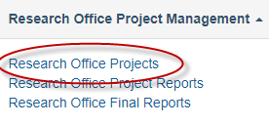

1. Search for the relevant Project by filtering on the Scheme, Scheme Round or Status drop down lists. Alternatively, the Search bar above can be used to search on the Project ID, Project Title or First Investigator.

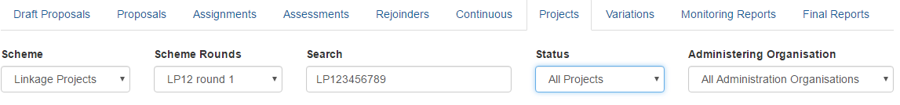

**Tip:** When entering project IDs or variation numbers in the search field of RMS, you must ensure that there are no spaces before or after the number or the search will return no results.

1. Once you have found the relevant project, click on the 'Details' button.

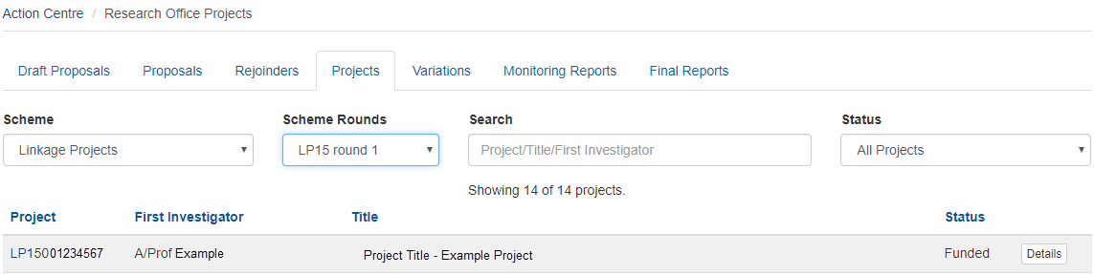

1. Once in the project select the 'Variations' tab and click on the 'Create Variation' button.

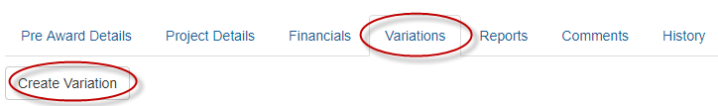

**Tip:** Once created, each variation is assigned an individual seven-digit code, which can be viewed under the 'Code' column. The assigned code is based on the year it was created and the order it was created. For example, a variation created in 2018 would have an 18 pre-fix followed by five digits, for example: **18**12345.

## Add a variation request line

1. Select the appropriate variation type from the 'Add Project Variation' drop-down menu, as shown below.

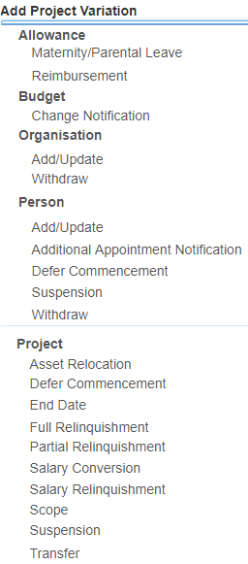

1. Fill in all of the mandatory fields, as required (referring to the individual variation instructions later in this document).
2. Click 'Add'.
3. Repeat steps a and c to add in additional lines for each variation line as required, saving as you go.
4. Justification for the request must be entered in the justification field. Please note this is a text box only and will not accommodate attachments or graphics.
5. Select the ‘Choose File’ button and upload the relevant supporting documentation for the request if relevant.
6. Save and Close the request.

**Tip:** Once a request line is added, not all of them can be edited. If an edit is required, then the line may be removed and recreated.

## Remove a variation request line

1. If the request line needs to be removed, select the request line and click the 'Remove' button, located on the right side of the relevant line

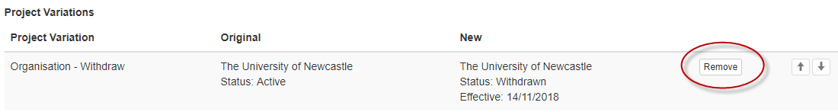

1. A confirmation box will appear asking you whether you are sure you wish to remove this project variation. Click 'OK'.
2. Repeat as necessary for any lines to be removed.
3. Once completed Save and Close the variation

## Re-order multiple request lines

1. Within the variation request, select the request line to be moved and click the up or down arrows, located on the right side of the relevant line. This will allow you to re-order the request lines, which may be important for some of the variation types

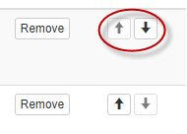

1. Repeat as necessary for any lines to be moved
2. Once completed Save and Close the variation.

## Deleting a variation request

If you create a variation in error, it may be deleted.

1. Open the variation that you want to delete
2. Select the 'Remove' button located within each request line (the justification does not need to be deleted)

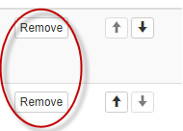

1. Save and Close the variation
2. Once in the variation tab of the Project, select the variation and click the 'Delete' button on the far right hand side of the screen

Snapshot of RMS button

1. A warning will then pop up, confirm that you are happy to delete the variation by selecting 'Yes'.

**IMPORTANT: this cannot be undone once you have selected yes.**

## Justification field

The justification field is mandatory and should be completed with all variations. This field should be used to provide detail of the changes/actions proposed and to provide adequate justification for the request. The information provided here should be clear, concise, and include:

* what the requested changes/actions are
* the personnel/organisations involved
* the justification for the changes/actions taking place.

If the request includes confidential information, it may be excluded from this field and should only be included within the justification documents, if appropriate.

**Tip:** To avoid duplication, the justification should not be an exact copy of the request but a clear reason as to why the request is being asked.

## Mandatory fields

Several fields within each individual variation type are mandatory, meaning that you are required to complete these fields before the variation type can be added to the variation request. These fields will be highlighted in red and/or a warning will occur when there is information missing.

## Supporting documentation

The ARC requires that all variations are submitted with supporting documentation, as specified in Appendix A. Although all document types and sizes are accepted in RMS, only one file can be attached to the request in RMS.

**Tip:** Multiple files can be attached by saving them to a ‘zipped’ file. This zipped file can then be attached to the Variation.

## Retrospective requests

All variations are expected to be submitted to the ARC in a timely manner. If the ARC was not notified of changes as they occurred, then a retrospective variation may be sought from the Administering Organisations Research Office. Failure to notify the ARC of changes to Projects is a breach of the ARC Agreement and may result in a full or partial recovery of funds.

## External Feedback Comments and Special Conditions

If a variation has been de-submitted back to the Research Office by the ARC, there will be an external feedback comment. This comment will include details of why the variation was de-submitted and/or declined and should outline the reason.

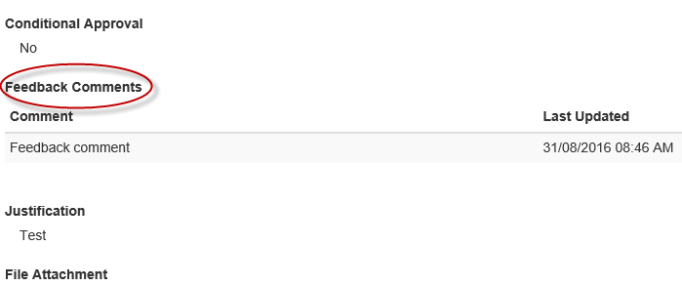

External feedback comments may also be included to outline any special conditions the ARC may have placed on the approval. Special conditions are identified by the 'Conditional' column being populated with a 'Yes'.



## Project Status in RMS

In the search bar, the Project Status is classified as follows:

| **Status** | **Classification** |
| --- | --- |
| **Funded** | ARC funding have been received and funds are available to spend. They are considered Active Projects |
| **Project Complete** | Funds are not yet fully acquitted but the Final Report has been approved (usually conditional) |
| **Fund Complete** | All funds have been acquitted via the End of Year reporting, the Project is complete but the Final Report is not yet approved |
| **Terminated** | The ARC has terminated the project and all funds have been recovered by the ARC |
| **Relinquished** | The project has been relinquished and all unspent funds have been returned to the ARC |
| **File Closed** | All funds have been spent/relinquished and all ARC reporting requirements have been met. The file has been closed in RMS |

## Finding a variation request

Variations can be found by looking up the Project ID and searching in the 'Variations' tab or by looking up the individual variation 'Code'. For variations which have been completed, you may view its details by clicking on the 'View' button. For variations which have been created, but have not yet been completed, you may view its details and edit it, by selecting the 'Edit' button, as shown below.

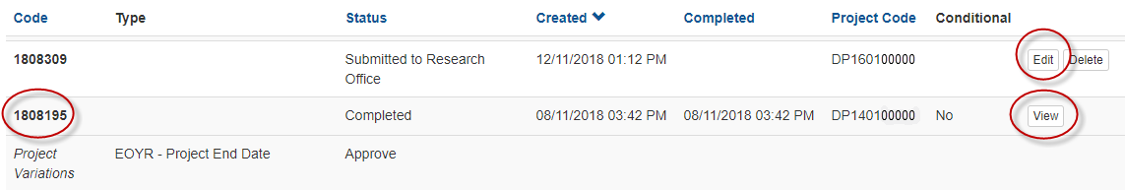

# **Variation Request types**

## Allowance Variations

### Allowance - Maternity/Parental leave

For selected scheme rounds, ARC-funded personnel have access to apply for additional ARC funding for periods of up to 14 weeks of paid maternity leave or two weeks of paid parental leave, where such leave is taken during the course of the project. If there is no provision for paid maternity/parental leave in the ARC Agreement, the participant will not be eligible for paid leave from the ARC.

*To submit a Maternity/Parental leave variation the ARC will require the following:*

1. The variation should include the following lines:

**Allowance – Maternity/Parental Leave**

This request line will show the name of the person claiming the leave, the dates of leave being claimed and an empty field for ARC staff to enter the allowance amount (Research Offices cannot populate this field). The ARC will provide funding of either two or 14 weeks to the Administering Organisation (as per the relevant ARC Agreement) and it will be up to the organisation HR’s department to adjust the FTE payments accordingly.

**Project – Suspension or Person - Suspension (if relevant)**

Although it is not mandatory to have a suspension when taking leave, this line is usually required when the total period of leave is greater than the two or 14 weeks available for Maternity/Paternal leave. The start date of suspensions should be from the first date after the Maternity/Parental leave ends and continue until the Fellow/Awardee has returned back to work. If additional time is being taken, a *Project - Suspension* or *Person - Suspension* line should be added. Please refer the relevant instructions for details on the differences.

**Project – End Date**

End dates should always be adjusted to accommodate the length of leave/suspension.

**Tip:** Although extending the end date is allowed, it should only be done for the equivalent length of time that the leave and suspension is asked for and/or any conversion of part-time FTE. This is because there are limits as to how long projects can go for, including those projects that are undertaken on a part-time basis.

**Person – Add/Update (if relevant)**

Although it is not mandatory, if the person is returning to work with a different FTE than previously held (i.e. they were working 1.0 FTE before and return to work part-time at 0.5 FTE), then they should also create a *Person – Add/Update* variation line.

1. Up to 500 words should be entered into the justification outlining details of the leave request. This should be the ‘**WHY**’ for the request.
2. Check that the required documentation is attached as per Appendix A, ensuring the dates match what has been entered into the variation and those dates are within the projects start and end dates.

## Budget Variations

### Budget Change notifications

A *Budget Change* variation is requested when some funding is being moved across line items for the purpose of completing the Project.

**Some examples of acceptable budget changes**

* + moving some funding between personnel, travel, maintenance, equipment, other, workshops

(as allowable within the relevant ARC Agreement)

* + from domestic to international travel
  + reduction of project aims due to reduced budget (this may also involve a *Project - Scope Change*)
  + movement of funds between years if they have been received (i.e. same funding year or carryover)

**When would a variation not be required**

If funding is being spent differently from what was outlined in the original proposal but the intention of the expenditure is the same, a variation is not required. For example:

* + a Research Associate was planned to be hired but now a Research Assistant or PhD/HDR will undertake those tasks
  + a conference in Melbourne has been replaced by a conference in Perth
  + a type of software was initially intended to be purchased but now a better/updated version is available so that version will be purchased instead
  + budget changes in timing with field work, due to natural disasters or change of environmental circumstances

**When would a variation not be approved**

A *Budget Change* variation will not be approved if funding is being spent differently from what was outlined in the original proposal and the request is:

* + asking for items that are not allowed (as per the ARC Agreements)
  + approving the change would push the allowable item over the limits (i.e. travel or teaching relief)
  + the request is asking to purchase an item at the end of the project, not for the benefit of the project, but for another project, or just so the university doesn’t lose the funds (for example – buying $50,000 worth of computers with only 1 month to go to the end of the project)
  + asking for future years funding (that have not been paid yet) to be brought forward (i.e. funds to be brought forward from year 3 to year 1, in the first year of funding).

**Special Conditions**

Changes to funds linked to special conditions, such as International Collaboration Awards or Discovery International Awards (ICA’s or DIA’s) or Teaching Relief may be requested, however they are still required to abide by the conditions as outlined in the ARC Agreement. If the request is not in line with the original intention of the funding or will push the funding amounts over the allowable limits, or is requesting the use of non-allowable items (i.e. converting ICA/DIA’s to travel funding for non-collaboration), then the request will be declined.

**Travel – economy to business class**

Travel may also be upgraded from economy to economy business/business class if a medical certificate covering the travel period is provided to the HR area and certified as the Administering Organisation. Medical certificates that are dated far in advance of the travel are normally not acceptable, unless the condition is on-going or lifelong (i.e. a disability or chronic illness). Medical certificates for a specific period of time in the past to cover a specific injury (a medical certificate for 6 weeks for a broken arm) would not be acceptable.

**Salary Conversions**

If a salary is funded from project funds only (i.e. student stipends in a DP), then a *Budget Change* variation type should be submitted. If salary funds are paid from a salary line or named position (Fellowship/Award), then a *Project - Salary Conversion* variation type should be submitted instead. If a *Budget Change* variation is submitted for these type of requests incorrectly, they will be desubmitted for correction.

**Tip:** If you are unsure if a position is funded from salary or project funds, try entering in a *Project - Salary Conversion* line. If the dropdown menu does not allow you to select the person/position, then it is funded through project funds.

*To submit a Budget Change variation, the ARC will require the following:*

1. The variation should include the following lines:

**Budget Change**

The *Budget Change* should outline what is being changed, where it is going to and the amount being changed. For example, transferring $15,000 from Year 3 maintenance to Year 3 travel. For multiple changes, across different years and items, there should be different lines for each item. This should clearly explain ‘**WHAT**’ is the change.

**Project - Scope Change (if relevant)**

If a *Project -* *Scope Change* is required, details on what is being removed or added to the project and how funds will be changed to cover the change needs to be listed. It should refer to the original project so scope changes can be easily identified. This should clearly explain ‘**WHAT**’ is the change. Please see instructions for *Project – Scope Changes* for examples of when this is needed.

1. Up to 500 words should be entered into the justification outlining the budget changes and any additional changes. This should be the ‘**WHY**’ for the request.

Supporting documentation should only be attached if requested by the ARC. The details of the request must be listed within the justification.

## Organisation Variations

### Organisations - Add/update

All changes to participating organisations must be reported to the ARC via a variation. All organisations must meet the eligibility criteria specified in the relevant ARC Agreement and should benefit the project.

This variation type is commonly used to:

* add a new organisation to a project, possibly due to the movement or addition of investigators
* change the role of the organisation on the project (used during a transfer)
* add an organisation due to a name change (this is combined with an organisation removal).

*To submit an Organisation – Add/Update variation the ARC will require the following:*

1. The variation should include the following lines:

**Organisation – Add/Update**

The organisation line should list the organisation name, the role of the organisation while they are on the project (this will change depending on the scheme requirements), the effective date at which the organisation was added/updated (this date should match the request or approvals). If the project is being transferred but the current Administering Organisation is remaining on the project, their role will have to be changed using the *Organisation – Add/Update* line.

**Person – Add/Update (if relevant)**

If the organisation is being added/updated due to personnel movement, a *Person – Add/Update* line will have to be added to update the relevant personnel’s affiliated organisation. The effective dates should match the dates the organisation is being added/updated.

1. Up to 500 words should be entered into the justification outlining the reason for adding/updating the organisation and any additional changes. This should be the ‘**WHY**’ for the request.
2. Check that the required documentation is attached as per Appendix A of these Instructions and that the dates match the ‘Effective Date’ entered.

Once assessed a revised Participating/Partner Organisation Agreed Contribution Report (POACR) must be submitted within three months of the variation being approved in RMS. Note – this is only mandatory for Linkage schemes, however POACRs must be submitted to update the Final Report form.

**Please note:** If an organisation cannot be found in RMS, the RO will need to collect the relevant information from the Organisation and provide it to ARC helpdesk. To contact ARC helpdesk please email [ARC-Systems@arc.gov.au](mailto:ARC-Systems@arc.gov.au)

For **Australian Organisations** the following information will need to be provided: Organisation full name; ABN; Organisation Type (i.e. Private Organisation, Public Organisation, Government Organisation).

For **International Organisations** the following information will need to be provided: Name (Legal or trading name in English); Abbreviated Name; Country; Organisation Type (Must pick **one** of the following - Higher Education International, International Company, Industry Body, International Company Government, International Company Non Profit).

### Organisations - Withdraw

All changes to participating organisations must be reported to the ARC via a variation. If an organisation is to be withdrawn from a project, this must be reported to the ARC via a variation. Organisations are commonly withdrawn due to the movement of investigators as well as changes in contributions and research direction.

This variation type is commonly used to:

* remove an existing organisation from a project, possibly due to the movement/withdrawal of investigators or transfer of project or the organisation no longer wants to participate
* remove an organisation due to a name change (this is combined with an organisation add/update).

*To submit an Organisation Withdrawal variation, the ARC will require the following:*

1. The variation should include the following lines:

**Organisation – Withdraw**

The organisation line should list the organisation name, the role of the organisation while they are on the project (this will change depending on the scheme requirements), the effective date at which the organisation was being removed (this date should match the request or approvals). If the project is being transferred and the current Administering Organisation is leaving the project, they will need an *Organisation – Withdraw* line to be added, as the transfer line alone will not remove them from the project.

**Tip:** For schemes under the Linkage Program, the minimum eligibility requirements must still be maintained (i.e.: minimum cash and or in-kind contributions percentage is maintained; that there is still one Partner Organisation; and if there is an Australian Partner Organisation on the grant.

**Person – Add/Update (or) Person - Withdraw (if relevant)**

If the organisation is being removed due to personnel movement, a *Person – Add/Update* line will have to be added to update the relevant personnel’s new affiliated organisation. If the person is being removed from the project a *Person – Withdraw* line will need to be added. The effective dates should match the dates the organisation is being added/updated or removed.

1. Up to 500 words should be entered into the justification outlining the reason for removing the organisation and any additional changes. This should be the ‘**WHY**’ for the request.
2. Check that the required documentation is attached as per Appendix A of these Instructions and that the dates match the ‘Effective Date’ entered.

Once assessed a revised Participating/Partner Organisation Agreed Contribution Report (POACR) must be submitted within three months of the variation being approved in RMS. Note – this is only mandatory for Linkage schemes, however POACRs must be submitted to update the Final Report form.

## Personnel Variations

### Person - Add/update

All changes to named participants must be reported to the ARC. All existing and new participants must meet the eligibility criteria as specified in the relevant ARC Agreement. RMS profiles should be updated by Investigators to ensure all their details are correct. New Investigators cannot be added to a project until the ARC is notified of their RMS login details.

**Tip:** The ARC will be required to add participants whose RMS account are not administered by the Administering Organisation. If you are trying to add a participant whose account is not administered by your organisation, you will have to submit a variation to the ARC via email at[**ARC-Postaward@arc.gov.au**](mailto:ARC-Postaward@arc.gov.au)**.** Please refer to Appendix A for full details.

Each request must include their updated and relevant affiliated organisation, relevant to the project. Noting that it not all occasions will this organisation be the same as the organisation that administers their RMS. For example: an investigator maybe employed at two universities and their RMS account administered by one, however they are participating on the project as it’s connected to the second university.

This variation type is commonly used to:

* add a new investigator to a project
* change the role of the investigator on the project (from a Chief Investigator to Partner Investigator)
* change the FTE of an investigator (commonly used in Fellowships)
* change the organisation affiliation for an investigator on the project

*To submit a Person – Add/Update variation the ARC will require the following:*

1. The variation should include the following lines:

**Person – Add/Update**

If the person is being added or updated, the following lines will need to be populated for each investigator – full name, role, affiliated organisation on the project, FTE the investigator is working on the project and the effective date the addition/change happened. The effective dates should match the dates the organisation is being added/updated (if relevant).

**Organisation – Add/Update (or) Organisation - Withdraw (if relevant)**

If a person is joining the project with their organisation or changing organisations and a new one has to be added to the project, an *Organisation – Add/Update* should be added or an *Organisation - Withdraw* line needs to be used if the organisation is being removed. The organisation line should list the organisation name, the role of the organisation while they are on the project (this will change depending on the scheme requirements), the effective date at which the organisation was added/withdrawn (this date should match the request or approvals). Although not mandatory to add /withdraw an organisation if a person is being updated, if the justification states that there are changes then the relevant line should be added to the variation.

**Project – End Date (if relevant)**

If a Fellow/Awardee is adjusting their FTE, a *Project - End date* line should always be included to accommodate the change. **Note** - there are limits as to how long a Fellowship/Award can go for, including if its part-time. Please consult the relevant ARC Agreement for the limit.

1. Up to 500 words should be entered into the justification outlining the reason for adding/updating the person and any additional changes. This should be the ‘**WHY**’ for the request.
2. Check that the required documentation is attached as per Appendix A of these Instructions and that the dates match the ‘Effective Date’ entered. **Note** - Documentation is not required for adding on a student such as a PDRA or PGR.

**Tip:** The ARC is reluctant to add new investigators to DP projects as they are often held by a sole CI or a very small team and no PI. ARC Agreements also state that there must be one original CI on the project at all times. It is important to note that unless fully justified, the request will be declined.

**Updating an Affiliated Organisation**

When adding a person to a project or updating their organisation, if the Affiliated Organisation is not appearing, you will have to update their employment history in their RMS profile.

If the organisation is appearing in the profile but cannot be chosen when entering in a variation, this maybe because of the way the organisation’s name was originally added to the profile (i.e. it was typed in and not selected from a drop down list, or entered in a previous version of RMS). Refer to Appendix B for instructions on how to update a person's affiliated organisation in their RMS profile.

**FTE changes/Part-time requests to existing Investigators**

Although FTE changes and part-time requests can be requested in most schemes, it is important to be aware of the conditions that are outlined in the ARC Agreements.

For example: The Fellowship/Award may be awarded on a full-time basis, or a part-time basis if the Fellowship/Award Recipient is required to fulfil family and/or carer responsibilities. The Fellowship/Award may be converted to (or from) part-time at any time to enable the Fellowship/Award Recipient to fulfil family and/or carer responsibilities, or with the prior approval of the ARC to pursue exceptional research opportunities, provided that the Fellowship/Award Recipient does not exceed the number of years from the date of commencement (excluding any approved periods of suspension and/or maternity and/or partner/parental leave) specified in the ARC Agreement.

**IMPORTANT: The ARC defines Part-time as less than five full working days per week.**

If requesting part-time or FTE change, the ARC will accept that the researcher is working less than 5 days per week. If the researcher is working full time for 6 months a years and then working elsewhere full time 6 months a year, then this does not equal a part-time arrangement and in the cases of Fellowships/Awards, a suspension should be requested.

### Person - Additional Appointments

Submitting an additional appointment notification is only possible for participants who hold ARC Fellowships or Awards. As Fellowships/Awards are research intensive positions, any additional appointments should be justified and significantly benefit the Fellow/Awardees career. Requests for appointments must also comply with the relevant scheme specific ARC Agreements.

If the appointment is for an administration appointment at the University (i.e. Dean or Head of School), it would be expected that their salary is relinquished to match the FTE amount spent on the position, unless it was deemed to be a short term emergency appointment (i.e. four weeks due to a death or sudden illness of the person who holds the position) and approved by the ARC Post-award Delegate. The ARC will not accept requests to convert the Fellowship/Award to part time and extend the end date for the purposes of holding an Administrative position at the Administration Organisation.

Each request should include a description of the additional appointment, ensuring that the additional information is provided, where possible:

* what organisation the additional appointment will be located at
* what activities the participant will engage in
* how will this additional appointment enhance the project
* how much the participant will be remunerated
* what is the FTE of the appointment.

*To submit an Additional Appointment notification variation, the ARC, require the following:*

1. The variation should include the following lines:

**Person - Additional Appointment**

All additional appointments should be fully justified and outline the position, FTE, if it’s remunerated and the length of the appointment. It should clearly explain ‘**WHAT**’ the appointment is. The additional appointment start and end dates cannot be outside of the start and end dates of the Project.

**Person – Add/Update (if relevant)**

If the person is changing their FTE due to the appointment, then a *Person - Add/Update* line should be added to capture the change in FTE. The effective dates should match the dates of the appointment.

**Project - Salary Relinquishment (if relevant)**

If the appointment is an administrative position or the ARC has determined that some of the salary will have to be returned to the ARC, a *Project - Salary Relinquishment* line will have to be added to return these funds to the ARC.

**Project - Suspension (if relevant)**

If the appointment is being undertaken full time, then a *Project - Suspension* line will have to be added to ensure funds are not being spent during the appointment, unless approved by the ARC.

1. Up to 500 words should be entered into the justification outlining how the appointment will benefit the Fellow/Award and the Project. This should be the ‘**WHY**’ for the request.

Supporting documentation should only be attached requested by the ARC. The details of the request must be listed within the justification text box.

### Person - Defer commencement

The commencement of some non-named salaried participants (i.e. Post Graduate Researcher/Post-Doctoral Research Associate/Higher Degree by Research) can be deferred beyond the start date of the project. Although it is allowed, there are strict limits on when and for how long a deferment maybe requested. The request can also only be requested for named participants. Please refer to the relevant ARC Agreement for guidance on whether the start date falls within the allowable period or the limit on when a request maybe submitted.

This variation type is commonly used when:

* a PDRA/PGR/HDR position (named and funded) on an ARC grant is moving to Australia or is on approved leave (i.e. maternity/personal leave) and they cannot commence by the commencement date, as defined in the ARC Agreement.

**Tip:** If a sole investigator wishes to defer the commencement of a project, then a *Project - Defer Commencement* should be requested, not a *Person - Defer Commencement*.

*To submit a Person - Defer Commencement variation the ARC will require the following:*

1. The variation should include the following lines:

**Person - Defer Commencement**

A request must name the participant/award, as displayed in the drop down menu provided. A new commencement date must then be selected indicating when the person will commence on the project.

1. Up to 500 words should be entered into the justification outlining how the deferment will benefit the Fellow/Awardee and/or project. This should be the ‘**WHY**’ for the request.

Supporting documentation should only be attached requested by the ARC. The details of the request must be listed within the justification.

**Tip:** as a result of the deferred start date, the term of a PGR, named on Australian Laureate Fellowships, may be extended beyond the completion date of the project, for the purpose of meeting PhD requirements. However, a PGR can only receive funding for a maximum period of up to four years as the ARC will not provide additional funding to cover any extension to the study period of the award and the final end date of the project cannot be more than 8 years from the project commencement.

### Person - Suspension

If a salaried participant (Fellow/Awardee) is required to step away from the project for a period of time (usually more than four weeks), for exceptional circumstances, but the project will continue in their absence, they may request a *Person – Suspension*.

This variation type is commonly used when a Fellow/Awardee takes leave for:

* Maternity/Paternity leave
* to take care of a family member
* to undertake an exceptional career opportunity
* medical reasons.

**Tip:** The ARC Agreements have different requirements and limits on suspensions for each scheme. It is advised that participants make themselves aware of these limits when requesting long or multiple suspension requests.

A *Person - Suspensions* request will only be considered if it meets the following criteria:

* the project will continue in their absence by other named participants
* the suspension is for a salaried position only (Fellow/Award), or named student position (PDRA/PGR)
* the suspension is allowable, as per the ARC Agreements (*noting that there are limits on how long suspensions may be requested for – please see the relevant ARC Agreement for limits*)
* the suspension has been fully justified, including the exceptional circumstances to approve the suspension.

*To submit a Person - Suspension variation the ARC will require the following:*

1. The variation should include the following lines:

**Person – Suspension**

The start and end date must be supplied for the suspension period. It would be expected that the participant will be working on the project until the start of the suspension and would resume after the suspension period.

**Person – Add/Update (if relevant)**

If the person is changing their FTE due to the suspension, (possibly on their return) then a *Person - Add/Update* line should be added to capture the change in FTE. The effective dates should match the dates of the change.

1. Up to 500 words should be entered into the justification outlining why the suspension is required and how it will benefit the Fellow/Awardee and the project. This should be the ‘**WHY**’ for the request.

Supporting documentation should only be attached requested by the ARC. The details of the request must be listed within the justification.

### Person - Withdraw

All changes to participating investigators must be reported to the ARC via a variation. If an investigator is to be withdrawn from a project, this must be reported to the ARC via a variation. Investigators are commonly withdrawn due to, for example, withdrawals of organisations (such as PIs) as well as changes in contributions and research direction.

This variation type is commonly used to remove an existing person from a project possibly:

* due to the withdrawal of organisations, transfer of project or investigator no longer wants to participate
* due to eligibility limits

*To submit a Person - Withdrawal variation the ARC will require the following*

1. The Variation should include the following lines

**Person – Withdraw**

If the person is being removed from the project a *Person – Withdraw* line will need to be added. The effective dates should match the dates the person is being removed.

**Organisation - Withdraw (if relevant)**

Although not mandatory, if the organisation is being removed due to personnel leaving, an *Organisation - Withdraw* line will have to be added. The effective dates should match the dates the person is being removed.

1. Up to 500 words should be entered into the justification outlining the reason for removing the person and any additional changes. This should be the ‘**WHY**’ for the request.
2. Check that the required documentation is attached as per Appendix A of these Instructions and that the dates match the ‘Effective Date’ entered.

## Project Variations

### Project - Asset Relocation

Assets purchased with ARC Funding must be purchased for the exclusive purposes of the project for the duration of the 'Project Activity Period'. It is expected that unless otherwise approved by the ARC, the ownership of any Asset purchased wholly or partly with the funding shall be vested in the Administering Organisation, located on its campus and listed in its assets register unless:

* it was specified in the original proposal as being located at another organisation
* the project is terminated or
* the project is transferred to another organisation.

If an organisation would like to locate an asset at another location, such as another university on the grant, and the project is not transferring, a variation must be submitted to the ARC for approval.

This variation type is commonly used when the distribution of ARC funded equipment is being relocated to another organisation listed on the project.

*To submit an Asset - Relocation variation the ARC will require the following*

1. The variation should include the following lines

**Asset Relocation**

The request will need to include the asset name (as per the proposal or approved variation), the value of the asset being moved, the organisation that will be moved to and the date it will be moved. This should clearly explain ‘**WHAT**’ is the change.

**Budget Change (if relevant)**

Although not mandatory, if the asset relocation is being made due to a change in budget, a *Budget Change* variation may have to be done. The *Budget Change* should list what is being change, where it is going to and the amount being changed. For example, transferring $15,000 from Year 3 maintenance to Year 3 travel. For multiple changes, across different years and items, there should be different lines for each item. This should clearly explain ‘**WHAT**’ is the change.

1. Up to 500 words should be entered into the justification outlining the reason for the asset relocation and any additional changes. This should be the ‘**WHY**’ for the request.
2. Check that the required documentation is attached as per Appendix A of these Instructions and that the dates match the ‘Effective Date’ entered.

### Project - Defer Commencement

If a project is requested to be deferred, this must occur before the final date of commencement, as per the relevant ARC Agreement. Although it is allowed, there are strict limits on when and for how long a deferment may be requested. The request means that no funds will be spent on the project until the new commencement date. Please refer to the relevant ARC Agreement for guidance on whether the start date falls within the allowable period or the limit on when a request maybe submitted.

This variation type is commonly used when:

* contracts have not yet been signed by all named organisations
* a Fellow/Awardee is on maternity leave or other approved leave
* eligibility limits will be breached if the Project commences (noting there are limits on how long projects can be extended for, for this reason)
* the project was transferred before it commenced, delaying the start date.

*To submit a Project - Defer Commencement variation the ARC will require the following:*

1. The variation should include the following lines:

**Project - Defer Commencement**

The request must list the new commencement date and also provide the new end date, as a result of the commencement. The ARC would expect that unless an FTE change is also being requested, the length of the project will remain the same length of time, as per the original funded project.

**Tip**: A *Project - End date* is NOT required for this type of request as it is already included in the *Project - Defer Commencement* line.

1. Up to 500 words should be entered into the justification outlining how the deferment will benefit the Fellow/Awardee and/or project. This should be the ‘**WHY**’ for the request.

Supporting documentation should only be attached requested by the ARC. The details of the request must be listed within the justification.

### Project - End date

End dates are defined as when an ARC funded project has concluded and all ARC funds for that project have been expended. Once ARC funds are fully expended, the ARC considers the project to be completed and the end date should match this activity. Requests to extend the end date beyond this time will not be approved.

End dates are normally revised via the End of Year Reporting (EOYR) process. However, if an end date is required to be changed before or after this time, it may be requested as long as it meets the conditions listed below.

**Conditions for changing and End date:**

* The request directly relates to a change e.g. maternity/paternity leave, suspension, part-time conversion, deferred commencement or to meet an eligibility requirement (if allowed in the relevant ARC Agreement).
* If the end date needs to be changed to be eligible for a grant application, the ARC will only approve the change on the condition that no additional extensions or carryovers will be approved in the future to allow the project to go beyond the new end date and any unspent funds will have to be relinquished, if changing the end date will breach the eligibility limits.
* If the end date needs to be changed for the purposes of submitting a Final Report, written confirmation must be provided, confirming that the project has ended (including the actual end date) and that all of the ARC funds have been expended. This action will confirm that if any carryovers are requested after this time, all remaining funds from the change of the end date will be recovered by the ARC.

This variation type is commonly used to:

* extend an end date due to a change in a FTE, approved leave or suspension
* reduce the length of a project due to all funds being spent
* to ensure eligibility is adhered to
* comply with ARC eligibility requirements.

*To submit a Project - End date variation the ARC will require the following:*

1. The variation should include the following lines:

**Project - End date**

The new end date will have to be entered, based on the request. There are limits on how far an end date can be extended and requests should be limited to be within the allowable timeframes for each scheme.

**Tip:** The ARC generally allows up to three years’ carryover on the majority of schemes (excluding any approved extensions). End dates requested beyond this are not approved without suitable justification.

1. Up to 500 words should be entered into the justification outlining the reason for changing the end date. This should be the ‘**WHY**’ for the request.

Supporting documentation should only be attached requested by the ARC. The details of the request must be listed within the justification.

### Project - Full Relinquishment

If a project has come to an end and there are residual funds that have to be returned to the ARC, or a project has not commenced and the Administering Organisation is now relinquishing the grant, a *Project -* *Full Relinquishment* variation will have to be submitted to return all funds to the ARC.

For a project to be relinquished, full expenditure figures (to date) must be included within the request. Universities are not to include commitments after the project has been agreed to be relinquished as expenditure, but they may include expected costs (i.e. outstanding invoices).

Future years’ allocations may also not be claimed as expenditure after the relinquishment effective date. Administering Organisations should also ensure that they have acquitted all funds prior to submitting a *Project - Full Relinquishment* request, as the ARC will not reimburse the recovered funds.

**Tip:** If the request for relinquishment is only for a specific amount but the project is still ongoing, a *Project -* *Partial Relinquishment* variation should be requested. A *Project - Full Relinquishment* variation should only be requested where the project is returning all remaining funds to the ARC and the project will end.

This variation type is commonly used when:

* a Fellow/Awardee does not take up the grant or leaves before completion
* the investigators do not meet the eligibility criteria to hold the grant
* contract negotiations fail and the project is not eligible to commence (Linkage Program)
* there is a serious breach or integrity misconduct issue and ARC recovers all funding.

**Considerations of the Agreement when submitting a Full Relinquishment**

* do not include salary commitments after the project has been relinquished as expenditure
* all figures reported to the ARC must include **ALL** spent and unspent funds, regardless of their location. This includes funds that are not located at the Administering Organisation, and/or funds that are currently credited to another account code such as salaries, instead of the project itself.
* The ‘Indexed Amount’ column will not appear for all future years.

*To submit a Project - Full Relinquishment variation the ARC will require the following:*

1. The variation should include the following lines

**Project - Full Relinquishment**

The full amount to be kept for the project (i.e. not to be recovered) will have to be entered into the request line. The difference between the two amounts will be the amount recovered by the ARC.

The amounts should be entered so that all funds being relinquished match up with the original years funded. The effective date of the relinquishment also needs to be entered. This is the date the ARC will consider this the date the funds to be recovered from.

1. Up to 500 words should be entered into the justification outlining the reason for relinquishing the grant. This should be the ‘**WHY**’ for the request.

Supporting documentation should only be attached requested by the ARC. The details of the request must be listed within the justification.

**Tip:** Final Reports for relinquished projects are still required to be submitted to the ARC for all projects that have been active for at least 12 months or have spent up to 12 months of expenditure, prior to the relinquishment, unless otherwise approved by the ARC.

### Project - Partial Relinquishment

There are occasions where the funds have to be returned to the ARC, however the project is still ongoing (i.e. has not come to an end). If this happens, a *Project -* *Partial Relinquishment* variation will have to be completed.

For a project to be partially relinquished, only the years that funding is being relinquished has to be completed. To relinquish the funds, you must enter the amount that is to remain on the project only and the ARC will recover the difference.

**Tip:** If the request for the full amount or the Project has come to an end, a *Project -* *Full Relinquishment* variation should only be requested. If the amount to be recovered is only for the salary component of a Fellowship/Award, a *Project - Salary Relinquishment* variation should be used. A *Project - Partial Relinquishment* should only be requested when a partial amount is being recovered and the project is ongoing.

This variation type is commonly used:

* when funds allocated for a special condition cannot be used for their original purpose and are not approved to be used for another purpose by the ARC
* there is a serious breach or misconduct and ARC recovers partial funding.

**Considerations to observe when submitting a Partial Relinquishment**

* Is this the correct type of relinquishment to be used?
* The ‘Indexed Amount’ column will not appear for all future years.

*To submit a Project - Partial Relinquishment variation the ARC will require the following*

1. The variation should include the following lines

**Project - Partial Relinquishment**

The full amount to be kept on the project (i.e. not to be recovered) will have to be entered into the request line. The difference between the two amounts will be the amount recovered by the ARC.

The amounts should be entered so that all funds being relinquished match up with the original years funded. The effective date of the relinquishment also needs to be entered. This is the date the ARC will consider this the date the funds to be recovered from.

1. Up to 500 words should be entered into the justification outlining the reason for relinquishing the funds. This should be the ‘**WHY**’ for the request.

Supporting documentation should only be attached requested by the ARC. The details of the request must be listed within the justification.

.

### Project - Salary Conversion

There are occasions where the ARC will allow the conversion of identified salary funds for a Fellowship/Award to be converted to project funds to be used for other purposes.

For salary funds to be converted, the full amount to be converted must be included within the request, however for this variation, to convert the funds you must confirm the amount that is to remain on the salary - not the amount to be converted to project funds.

**Tip:** When entering in the amount to convert, you will see the amount listed under the project funds adjusting. This will represent the new split between the salary and project funds.

**Considerations when submitting a Salary Conversion**

* Is this the correct type of variation to be used? If the salary is already funded through project funds, then a *Budget Change* variation should be requested.
* The ‘Indexed Amount’ column will not appear for all future years.

This variation type is commonly used:

* when a salary is being converted by a Fellow/Award, due to an additional appointment
* a salary was awarded to a named position (i.e. PDRA/PGR) and the position is not filled and it's been converted to project funds.

*To submit a Project - Salary Conversion variation the ARC will require the following*

1. The variation should include the following lines

**Project - Salary Conversion**

The participants whose salary is being converted needs to be selected from the drop down list. Enter in the salary amount that is to remain as salary. The difference will automatically be converted to project funds on the project funds line.

The amounts should be entered so that all funds being converted match up with the original years funded. The effective date of the conversion also needs to be entered. This is the date the ARC will consider the conversion taking place.

1. Up to 500 words should be entered into the justification outlining the reason for converting the salary funds. This should be the ‘**WHY**’ for the request.

Supporting documentation should only be attached requested by the ARC. The details of the request must be listed within the justification.

### Project - Salary Relinquishment

There are occasions where the salary funds have to be returned to the ARC, however the project is still ongoing (i.e. has not come to an end). If this happens, a *Project - Salary Relinquishment* variation will have to be completed.

For salary funds to be relinquished, the full amount to be relinquished must be included within the request, however for this variation, to relinquish the funds you must confirm the amount that is to remain on the project - not the amount to be recovered by the ARC.

**Tip:** If the request is for the full amount or the project has come to an end, a *Project - Full Relinquishment* variation should be requested. If the amount to be recovered is not for the salary component of a Fellowship/Award, a *Project - Partial Relinquishment* variation should be used. A *Project - Salary Relinquishment* should only be requested when a salary amount for a Fellowship/Award is being recovered and the project is ongoing.

**Considerations to observe when submitting a Salary Relinquishment**

* Is this the correct type of relinquishment to be used? If there are projects to be relinquished, then this is not the correct Variation to use.
* The ‘Indexed Amount’ column will not appear for all future years.

This variation type is commonly used:

* when a salary is being relinquished by a Fellow/Award, due to an additional appointment
* a salary was awarded to a named position (i.e. PDRA/PGR) and the position is not filled and it has been relinquished

*To submit a Project - Salary Relinquishment variation the ARC will require the following*

1. The variation should include the following lines

**Project - Salary Relinquishment**

The participants whose salary is being relinquished needs to be selected from the drop down list. The full amount to be kept on the project (i.e. not to be recovered) will have to be entered into the request line. The difference between the two amounts, will be the amount recovered by the ARC

The amounts should be entered so that all funds being relinquished match up with the original years funded. The effective date of the relinquishment also needs to be entered. This is the date the ARC will consider this the date the funds to be recovered from.

1. Up to 500 words should be entered into the justification outlining the reason for relinquishing the salary funds. This should be the ‘**WHY**’ for the request.

Supporting documentation should only be attached requested by the ARC. The details of the request must be listed within the justification.

### Project - Scope Change

A *Project - Scope Change* variation is used if there is a significant change in the projects scope, e.g. the direction of the project is changing significantly from the original proposal. This can be from the result of budget restraints, changes in methodology, to avoid duplication of funding, fieldwork affected by natural disasters, political/civil unrest in another country or an opportunity arises to expand the existing project.

As the ARC Agreements have strict guidelines as to how the ARC will allow its funds to be used, it is important to consider if the changes will impact on how the originally funded project will be affected and if the scope change will drastically change the project moving forward. For schemes such as ARC Centres of Excellence, ARC Industrial Transformation Research Program or Special Research Initiatives, it is imperative that consultation is sort from the ARC Major Investments team, prior to submitting a request.

This variation type is commonly used:

* major changes are made because the current project budget does not allow for all aims to be completed with the project funding with the removal of some funded activities, the researchers can seek other funds, but must avoid Commonwealth overlap
* events such as natural disasters inhibit a component of the research from being undertaken by the current project

**Tip:** the ARC will not approve *Project - Scope Changes* if they are being requested in order to meet a Partner Organisations requirements (i.e. contract research).

*To submit a Project - Scope Change variation the ARC will require the following:*

1. The variation should include the following lines:

**Project - Scope Change**

If a *Project - Scope Change* is required, details on what is being removed or added to the project and how funds will be changed to cover the change needs to be listed. It should refer to the original project so scope changes can be easily identified. This should clearly explain ‘**WHAT**’ is the change.

**Budget Change (if relevant)**

The *Budget Change* should outline what is being change, where it is going to and the amount being changed. For example, transferring $15,000 from Year 3 maintenance to Year 3 travel. For multiple changes, across different years and items, there should be different lines for each item. This should clearly explain ‘**WHAT**’ is the change. For examples of when Budget Changes are needed, please review the *Budget – Change Notification* instructions.

1. Up to 500 words should be entered into the justification outlining the scope changes and any additional changes. This should be the ‘**WHY**’ for the request.

Supporting documentation should only be attached requested by the ARC. The details of the request must be listed within the justification.

### Project - Suspension

A *Project - Suspension* is normally requested when, for example due to exceptional circumstances and no one is able to work on the project (usually for 4 weeks or more), a *Project - Suspension* may be requested.

This variation type is commonly used for:

* serious illness, care for family member or maternity leave (usually for a sole CI)
* exceptional career opportunity arises (usually for a sole CI)
* delays in transferring an ARC grant
* restrictions in fieldwork resulting in ability to access the site or would result in danger to the researcher, such as natural disaster or political unrest
* default of Partner Organisations.

**Tip:** The ARC Agreement may have different requirements and limits on suspensions for each scheme. It is advised that participants make themselves aware of these limits when requesting long or multiple suspension requests.

When suspending a project (as opposed to the person) ARC funding cannot be spent on a project while a project is suspended. If funding is planned to be spent while a Fellowship is suspended (for example, a student hired on the Project intends to continue to work while the DECRA recipient is on maternity leave), a *Person - Suspension* must be requested.

**Tip:** *Project - Suspensions* cannot be requested to delay the commencement of a project. If a project has not commenced, a *Defer Project Commencement* variation must be submitted.

*To submit a Project - Suspension variation the ARC will require the following:*

1. The variation should include the following lines:

**Project – Suspension**

The start and end date must be supplied for the suspension period. It would be expected that participants will be working on the project until the start of the suspension and would resume after the suspension period.

**Project - End date**

The new end date will have to be entered, based on the request. There are limits on how far an end date can be extended and requests should be limited to be within the allowable timeframes for each scheme.

1. Up to 500 words should be entered into the justification outlining why the suspension is required and how it will benefit the Project. This should be the ‘**WHY**’ for the request.

Supporting documentation should only be attached requested by the ARC. The details of the request must be listed within the justification.

### Project - Transfer

A *Project - Transfer* may be requested if the project is still active and there are ARC funds still available for expenditure and if all parties agree to the transfer.

This variation type is commonly used when:

* the Project Leader changes institutions and wants to take the grant with them, or
* there is a change in Project leader and the Project moves to the new leader’s employing institution.

For a project to be transferred, the new organisation must be listed as an Eligible Organisation as specified in the relevant ARC Agreement. If they are not listed, they will not be able to become the Administering Organisation for the project.

**Tip:** An ARC Agreement will also have to be accepted in RMS, prior to the organisation being able to become the new Administering Organisation. If the receiving organisation does not yet have an accepted ARC Agreement in RMS for the relevant scheme round, (indicated by a validation error when processing the transfer request) the Research Office will have to contact the ARC Post-award team at ARC-Postaward@arc.gov.au and request that an ARC Agreement be made available in RMS. Once an Agreement has been accepted by ARC and the new organisation, the transfer request can be submitted.

Transfer requests must always be fully justified and outline the reason for the transfer, how it will benefit the project and what (if any) affect it will have on any students or employees involved in the project. Transfer requests are also expected to have the agreement of all parties listed on the project.

Requests for Fellowship/Awardee transfers will also require additional justification from the DVCR from the receiving Administering Organisation. This justification should outline the exceptional reasons for the transfer, how the new research environment will benefit the Fellow/Awardee.

*To submit a Project - Transfer variation the ARC will require the following*

1. The variation should include the following lines

**Project - Transfer request**

The transfer request should include the name of the new Administering Organisation, the amount to be transferred and the effective date of the transfer.

All ARC funds must be declared before the transfer. By not declaring all ARC funds as the Administering Organisation, will be a breach of the ARC Agreement and may be considered as fraudulent activity.

When calculating the transfer amount the following MUST be adhered to:

* the total amount that the project was allocated for the all years up to and including the current year must be included, not just the amount that the organisation has received so far
* future years’ allocation will not appear in the ‘Total Allocated’ column as this will be transferred automatically and the relinquishing Administering Organisation cannot claim this funding as expenditure
* if the project had previously been transferred, only the amount paid to the relinquishing Administering Organisation will appear in the ‘Total Allocated’ column
* full expenditure figures (to date) must be included within the request. Do not include salary commitments after the project has been transferred as expenditure
* all figures reported to the ARC must include ALL spent and unspent funds, regardless of their location. This includes funds that are not located at the Administering Organisation, and/or funds that are currently credited to another account code such as salaries, instead of the project itself
* only leave accumulated during the Fellowship/Awardee, can be paid out from the on-costs. Leave accumulated before or outside the Fellowship/Award (i.e. in another appointment) cannot be charged to the project
* the last year’s EOYR should be confirmed with the transfer amount, so that the transfer amount is not less than the amount previously reported as spent in the EOYRs
* transfers cannot be requested if all ARC funds have been spent.

**Organisation - Withdraw (or) Organisation - Add/Update**

The current Administering Organisation on the grant must either be withdrawn from the project (mandatory if the grant is for a Fellowship/Award), or change its affiliation to the project to another status. The effective date for the change must be the same as the transfer date.

**Person - Add/Update**

Transfer requests must also be accompanied by a *Person - Add/Update* request, in order to change any moving investigators affiliated organisation on the project.

**Project Defer Commencement (if relevant)**

If the transfer request has been requested to happen prior to the project commencing, then a *Project - Deferred Commencement* may be requested, as long as it is within the allowable limits, as per the ARC Agreements. The deferred commencement date and new end date will have to be entered into the line, ensuring that the new dates match the originally funded length of time (i.e. number of years funded).

**Project Suspension / End date (if relevant)**

If the transfer request has been requested to happen during the project and it encountered long delays, then a *Project - Suspension* and *Project - End Date* may be requested, as long as it is within the allowable limits, as per the ARC Agreements. The project suspension dates and new end date will have to be entered into their relevant lines, ensuring that the new dates match the originally funded length of time (i.e. number of years funded).

1. Up to 500 words should be entered into the justification outlining why the transfer is required and how it will benefit the project. This should be the ‘**WHY**’ for the request.
2. Check that the required documentation is attached as per Appendix A of these Instructions and that the dates match the ‘Effective Date’ entered.

## Variations submitted outside of RMS

### Project - Transfer Corrections

If the amount previously reported during a transfer was incorrect, a *Project - Transfer Correction* may be requested.

This variation type is commonly used when:

* there are additional funds to be transferred to the new Administering Organisation, that were not included in the original transfer (i.e. funds located at another organisation on the grant)
* there are funds to be returned to the previous Administering Organisation as costs associated with the project were not identified at time of transfer

**Tip:** if the previous Administering Organisation is requesting that funds be returned to them, they must first communicate with the new Administering Organisation and seek their agreement. The ARC will not process this type of request unless both organisations have agreed to the request in writing and itis provided to the ARC.

*To submit a Project - Transfer Correction the ARC will require the following*

1. The variation should include

**Agreement from the Administering Organisation/s**

The ARC requires agreement from both organisations if funds are to be moved from the current organisation to the previous organisation. If the previous Administering Organisation wishes to provide additional funds to the new Administering Organisation, then an email from the older Administering Organisation will suffice.

**Details of the correct transfer amount to be transferred**

Details of the exact amount that should have been reported as spent in total.

1. Up to 500 words should be provided into the justification outlining why the transfer correction is required.

For these variations, Research Offices must email the relevant details/documentation to the Post Award mailbox for processing as outlined in Appendix A of these instructions.

### Project - EOYR Corrections

If the amount previously reported during an EOYR was incorrect, a EOYR Correction may be requested.

This variation type is commonly used when funds were incorrectly reported during a previous EOYR, resulting in carryover figures being incorrect

*To submit a Project - EOYR Correction the ARC will require the following*

1. The variation should include

**Details of the correct expenditure amount**

Details of the exact amount that should have been reported as spent in each year and a reason for the change. Example table below:

**Example of EOYR correction table:**

| **Reporting Year** | **Indexed amount funded** | **Original Expenditure reported to ARC** | **Revised Expenditure** | **Revised Carryover balance** | **RO Comments** |
| --- | --- | --- | --- | --- | --- |
| **2016** | $100,000 | $80,000 | $80,000 | $20,000 | Amount correctly reported – no changes |
| **2017** | $100,000 | $60,000 | $50,000 | $70,000 | Salary incorrectly charged, amount adjusted |
| **2018** | $100,000 | $30,000 | $20,000 | $150,000 | Salary incorrectly charged, amount adjusted |
| **TOTAL** | **$300,000** | **$170,000** | **$150,000** |  |  |

1. Up to 500 words should be provided into the justification outlining why the EOYR correction is required.

For these variations, Research Offices must email the relevant details/documentation to the Post Award mailbox for processing as outlined in Appendix A of these instructions.

### Person - Add/update (that cannot be done in RMS)

New Investigators cannot be added to a project until the ARC is notified of their RMS login details.

All changes to named participants must be reported to the ARC. All existing and new participants must meet the eligibility criteria as specified in the relevant ARC Agreement. RMS profiles should be updated by Investigators to ensure all their details are correct.

Each request must include their updated and relevant affiliated organisation, relevant to the project. Noting that it not all occasions the Administering Organisation for the project may not be the same Administering Organisation on the researcher’s profile. For example: an investigator maybe employed at two universities and their RMS account administered by one, however they are participating on the project as it is connected to the second university.

This variation type is commonly used to:

* add a new investigator to a project
* change the role of the investigator on the project (from a Chief Investigator to Partner Investigator)
* change the FTE of an investigator (commonly used in Fellowships)
* change the organisation affiliation for an investigator on the project

*To submit a Person - Add/Update the ARC will require the following:*

1. The variation should include:

**Person – Add/Update**

If the person is being added, the request needs to list their full name, role, affiliated organisation on the project, FTE the investigator is working on the project and the effective date the addition/change happened. The effective dates should match the dates the organisation is being added/updated (if relevant).

To add them the ARC will also need to know their email address as per their RMS account so they can be added.

1. Up to 500 words should be provided into the justification outlining why the person is requested to the added to the project.

For these variations, Research Offices must email the relevant details/documentation to the Post Award mailbox for processing as outlined in Appendix A of these instructions.

# **Partner/Participating Organisation Agreed Contribution Report (POACR)**

All Administering Organisations are required to enter agreed Cash and In-Kind Contribution in RMS after it has signed a written agreement with all named Organisations listed on the Project. Before entering the contribution, please refer to the ARC Agreements for each year’s organisation contribution requirements. Information drawn from the most recently approved POACRs are then used to confirm the contributions amounts for the Project, which are used to ensure that eligibility is being adhered to (only for the Linkage Program).

The information is then also used in assessing the ARC Final Reports. For the older forms (known as first release forms), contributions will need to be manually checked to ensure that the POACR information matches what has been reported. For the newer forms (known as the second release) this POACR information will be auto-populated.

### Creating a POACR in RMS

**IMPORTANT:** Please **do not** create a POACR for a new organisations contribution, until the ARC has **approved the addition of the new organisation**. The POACR will **only** populate with the organisations listed on the Project. If the POACR has been created in error (i.e. before a new organisation was approved to be added), please email the ARC Post-award mailbox [ARC-Postaward@arc.gov.au](mailto:ARC-Postaward@arc.gov.au) to inform them of the issue. In most cases, the ARC will advise to make no changes to the report and submit it so it matches what was previously approved. This is because the report will not update even if the organisation has been approved to be added in RMS. A new POACR can then be created after the organisations have been added.

To create a POACR in RMS, you must do the following:

1. Search for the Project in RMS that a POACR needs to be created for.
2. Select the ‘Reports’ tab within the Project and press the *Create New Partner Organisations Agreed Contribution Report* button.



1. Click *Create Report* when ‘Create a new Partner Organisation Agreed Contribution report appears.

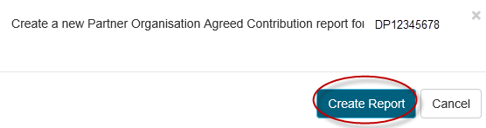

1. Once selected, a DRAFT report will appear on the list.
2. Click the *Form* located next to the report that you want to update.



1. Enter each Organisation’s cash and in-kind contributions in the Updated Contributions section in the lower half of the screen (in white). As information is populated, the Updated Contribution Totals will then automatically update the totals.

**Please Note:** Only the original funded years will appear in the table. Funds should be entered against the years as they were awarded, regardless if there was a deferred commencement. If contributions were provided after the original funded years, they may be entered into the last year of the table.

1. Click *Save* when all contributions have been entered and *Close* the screen.
2. The POACR is now ready to be certified. Click the Certify button on the right of the report.



1. A new Certify Partner Organisation Agreed Contribution Report for the Project ID pop-up window will appear, asking to certify the Partner Organisation Contributions.
2. Click *Agree to certification* to certify the contributions or *Cancel* to go back to the form.

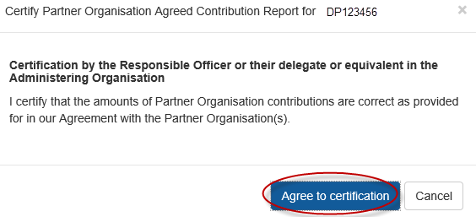

1. Following certification there will be option on the Reports page *Submit to ARC* or *Decertify* the contributions, to edit the form.
2. Click *Submit to ARC* to submit POACR to the ARC



Once a POACR has been submitted to the ARC in RMS, the ARC will then review the report. If the ARC identifies an error or the Research Office requests that the POACR be desubmitted, the status of the POACR will revert back to the ‘Ready to Submit’ status.

Once the report has been returned to the Administering Organisation, the POACR can then be adjusted accordingly and resubmitted back to the ARC (following steps h-l above). Once approved by the ARC the status will appear as ‘Accepted’.

### Search for a POACR in RMS

Once a POACR has been created in RMS, it can be located via the following methods:

**Via the Monitoring Reports tab:**

1. In the Research Office Project Management section of the Action Centre, click on Research Office Project Reports.

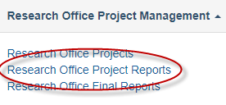

1. Search for the relevant Project by selecting the ‘Partner Organisation Agreed Contribution Report (POACR)’ from the *Report* drop down list.
2. Then filter on the *Scheme, Scheme Round or Status* drop down lists*.* Alternatively, the *Search* bar can be used to search on the Project ID, Project Title or First Investigator.

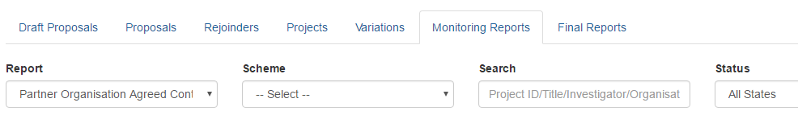

1. Upon finding the Project, click on ‘Form’ under Research Office Projects

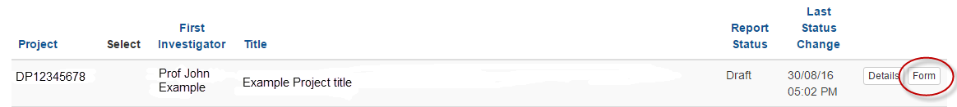

**To search via the individual Project:**

1. Login to [RMS.](https://rms.arc.gov.au/RMS/ActionCentre/Account/Login?ReturnUrl=%2fRMS%2fActionCentre%2f)
2. In the ‘Research Office Project Management’ section of the Action Centre, click on ‘Research Office Projects’.
3. Search for the relevant Project by filtering on the *Scheme, Scheme Round or Status* drop down lists*.* Alternatively, the *Search* bar can be used to search on the Project ID, Project Title or First Investigator.
4. Select the Report tab and select the ‘Form’ button for the relevant POACR.

# **Appendix A – ARC Variations - Supporting Documentation**

Some variations submitted to the ARC may also require additional evidence/agreements from participants on the project. If these are required, they will be listed below. The ARC will consider all variations that are submitted to the ARC, as approved and certified by the Administering Organisation and Project Leader. Additional approvals are not required unless requested by the ARC.

### Supporting documents for variations submitted via RMS

Unless requested by the ARC, justifications for variations must be listed within the justification field in the request and not just in the attachments. Supporting documents should only be attached to variations if required by the ARC, as outlined in these instructions.

**New Chief Investigator added to the Project**

* CV of new personnel (up to 2 pages)

**New Partner Investigator added to the Project**

* Agreement from the new Partner Investigator’s Organisation *(if named on the Project)*
* CV of new personnel (up to 2 pages)

**New Centre Director / Hub Director / Chief Operating Officer / Manager**

* CV of new personnel (up to 2 pages)
* Agreement from ALL parties (for Directors only)

**Named Personnel removed from the Project**

* Agreement from the personnel to be removed

**Personnel role change (e.g. Partner Investigator to Chief Investigator)**

* Agreement from the personnel changing
* Agreement from the relevant Partner Organisation *(if named on the Project)*

**Personnel changes to Affiliated Organisation** *(no Organisation added/removed to the Project)*

* Agreement from person changing organisations

**Organisation changes - added/removed/updated**

* Agreement from Organisation being added/removed/updated

**Project Transfer**

* Agreement from receiving Administering Organisation
* Agreement from all named Organisations (excluding Host Organisations)

***For Fellowship (FL, FT) and Award (DECRA) transfers only:***

* Justification and research environment statement from receiving Admin Org’s DVC(R)

**Maternity/Parental Leave**

* Certification from Administering Organisations Human Resource department
* Confirmation from Project Leader (if not taking the leave)

**Asset Relocation**

* Confirmation from all named Organisations

### Supporting documents for variations submitted outside of RMS

Some variations are not able to be submitted to the ARC via RMS. These include:

* Transfer Corrections
* EOYR Corrections
* Title Changes, and
* the addition of new investigator (if their RMS account is not administered by the RO)

For these variations, Research Offices must email the relevant details/documentation to the Post Award mailbox for processing as outlined below.

The ARC will also consider all variations that are submitted to the ARC, as approved and certified by the Administering Organisation and Project Leader. Additional approvals are not required unless requested by the ARC.

**Transfer Correction**

* Agreement from the new Administering Organisation that they agree to the new amount
* Details of the correct transfer amount to be transferred
* A statement as to why the information was reported incorrectly

**EOYR Correction**

* Details of the correct expenditure amount for each year of the Project using the table below
* A statement as to why the information was reported incorrectly

**Example of EOYR correction table:**

| **Reporting Year** | **Indexed amount funded** | **Original Expenditure reported to ARC** | **Revised Expenditure** | **Revised Carryover balance** | **RO Comments** |
| --- | --- | --- | --- | --- | --- |
| **2016** | $100,000 | $80,000 | $80,000 | $20,000 | Amount correctly reported – no changes |
| **2017** | $100,000 | $60,000 | $50,000 | $70,000 | Salary incorrectly charged, amount adjusted |
| **2018** | $100,000 | $30,000 | $20,000 | $150,000 | Salary incorrectly charged, amount adjusted |
| **TOTAL** | **$300,000** | **$170,000** | **$150,000** |  |  |

**Project Title Change**

*Only to be used if previously approved by the ARC*

* Details of the requested change, proposed title and justification for the change

**New Chief Investigator added to the Project**

*Only to be used for when an investigators RMS account is not administered by the Administering Organisation*

* CV of new personnel (up to 2 pages)

# **Appendix B – ARC Variations - How to's**

## Allowance Variations

**Allowance - Maternity/Parental leave:**

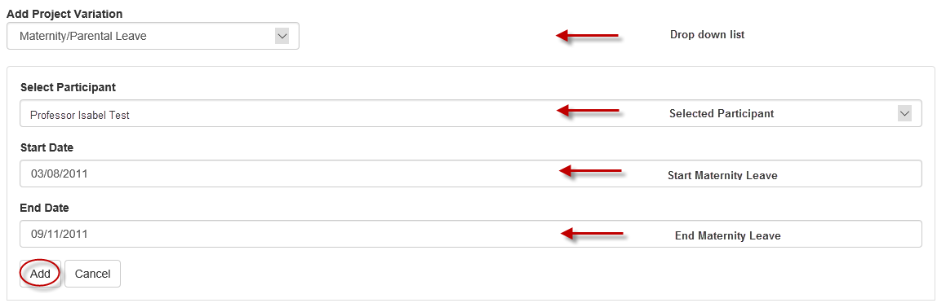

1. Select *Maternity/Parental Leave* from the ‘Add Project Variation’ drop-down menu.
2. Select the participant which the maternity/parental leave is being applied for, from the ‘Select Participant’ drop-down.
3. Enter the intended maternity/parental leave start and end dates into the appropriate fields.
4. Select ‘Add’
5. Provide details of the leave in the Justification box.
6. Select the ‘Choose File’ button and then press ‘**Upload’** to attach the relevant documentation for the entire request, noting that it can only be one attachment.
7. ‘Save’ and ‘Close’ the request

## Budget Variations

**Budget - Change Notification:**

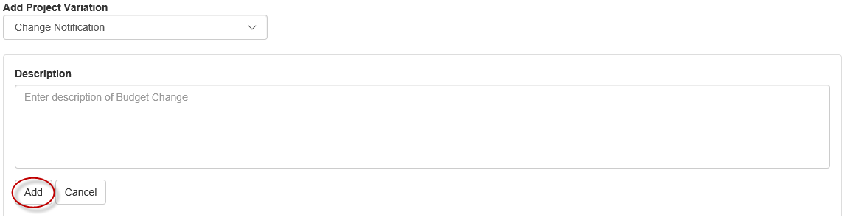

1. Select *Change Notification* from the ‘Add Project Variation’ drop-down.
2. Enter a description of the proposed budget item changes, including amounts and location/years.
3. Select ‘Add’
4. Provide details of the budget changes in the Justification box.
5. Documentation is not required for this type of variation, unless requested by the ARC.
6. ‘Save’ and ‘Close’ the request.

## Organisation Variations

**Organisation - Add/Update:**

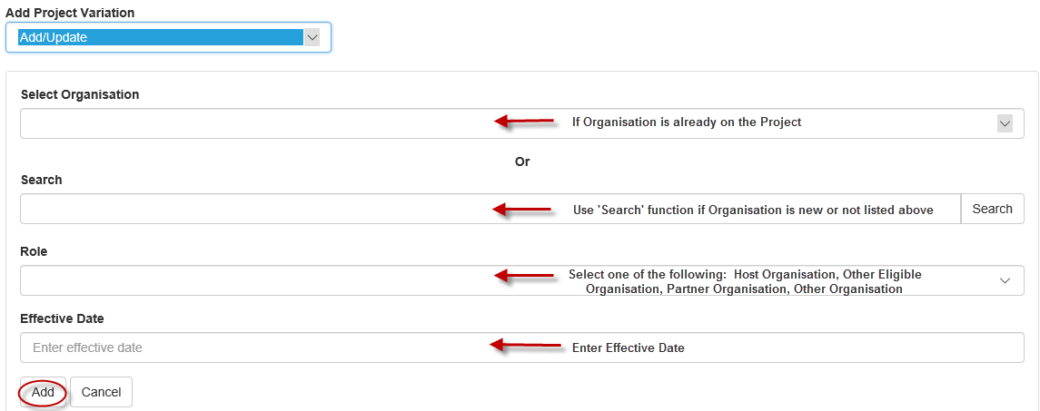

1. Select *Add/Update* from the ‘Organisation’ category within the ‘Add Project Variation’ drop-down.
2. Using the ‘Select Organisation’ drop-down, select the organisation that you intend on updating on the project. Alternatively, if the organisation is not already on the project, you may search for the organisation’s name using the search functions.
3. Select the organisation role from the ‘Role’ drop-down.

**Please note:** Universities which are considered eligible organisations can only be added to projects as an ‘Other Eligible Organisation’. Please refer to the general eligibility requirements for organisations as defined in the relevant ARC Agreement.

1. Provide the date that this is to take effect in the ‘Effective Date’ box as per the Agreement by the New Organisation.
2. Select ‘Add’
3. Provide details of why the new organisation is to be added in the Justification box.
4. Select the ‘Choose File’ button and then press ‘**Upload’** to attach the relevant documentation for the entire request, noting that it can only be one attachment.
5. ‘Save’ and ‘Close’ the request.

**Organisation - Withdraw:**

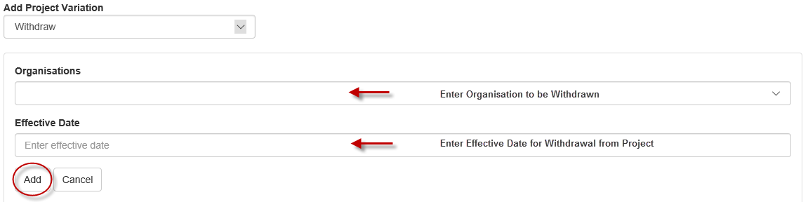

1. Select *Withdraw* from the ‘Organisation’ category within the ‘Add Project Variation’ drop-down.
2. Using the ‘Organisations’ drop-down, select the organisation that you intend to withdraw from the Project.
3. Provide the date that this is to take effect in the ‘Effective Date’ field as per the agreement by the organisation.
4. Select ‘Add’
5. Provide details of why the organisation is being removed in the Justification box.
6. Select the ‘Choose File’ button and then press ‘**Upload’** to attach the relevant documentation for the entire request, noting that it can only be one attachment.
7. ‘Save’ and ‘Close’ the request.

## Personnel Variations

**Person - Add/Update:**

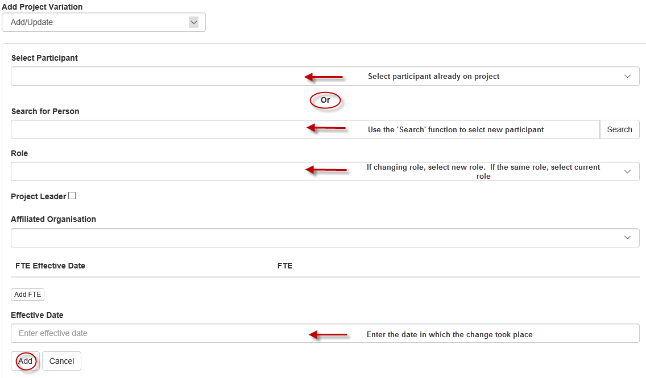

1. Select *Add/Update* from the ‘Person’ category within the ‘Add Project Variation’ drop-down
2. Using the ‘Select Participant drop-down, select the organisation that you intend on updating on the project. Alternatively, if the person is not already on the project, you may search for their name using the search functions.
3. Select the Participant role from the ‘Role’ drop-down menu.
4. Select the Affiliated Organisation from the ‘Role’ drop-down, relevant to this person’s role on the Project. If the Organisation does not appear, please refer to the ‘Updating Affiliated Organisation’ instructions.
5. Select ‘Add FTE’ and enter the FTE fraction and effective date. Noting that multiple dates may be entered in this field by selecting the ‘Add FTE’ button each time to add in a new FTE fraction, if required.
6. Provide the date that this is to take effect in the ‘Effective Date’ box. This should reflect the date in which the change took place.
7. Select ‘Add’
8. Provide details on why the person is being added to the project in the Justification box.
9. Select the ‘Choose File’ button and then press ‘**Upload’** to attach the relevant documentation for the entire request, noting that it can only be one attachment. (Note - documentation is not required for notifying a PDRA/PGR placement)
10. ‘Save’ and ‘Close’ the request.

**Updating an Affiliated Organisation in an investigators RMS profile:**

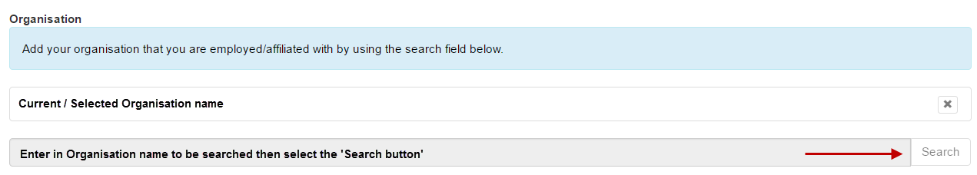

1. Look up the person's profile in RMS, by searching their name under the Mange Users link in the RMS Activity Centre.
2. Once you have selected the person, select the link to Employment History.
3. Select the relevant organisation that you want to edit.
4. Scroll to the bottom of the page and remove the Organisation name from the base of the screen by using the ‘x’ button.
5. Search for the Organisation’s name by typing in the Organisation’s name in the last row and selecting the ‘Search’ button.
6. Once the correct name is found, it can be selected by using the ‘Select’ button.
7. ‘Save’ and ‘Close’ the record. The profile will then be updated and the name will appear in the dropdown menu in the Variation.

**Tip:** If you cannot see the person’s profile, please contact either the researcher or ARC Helpdesk to fix this issue.

**Person - Additional Appointments:**

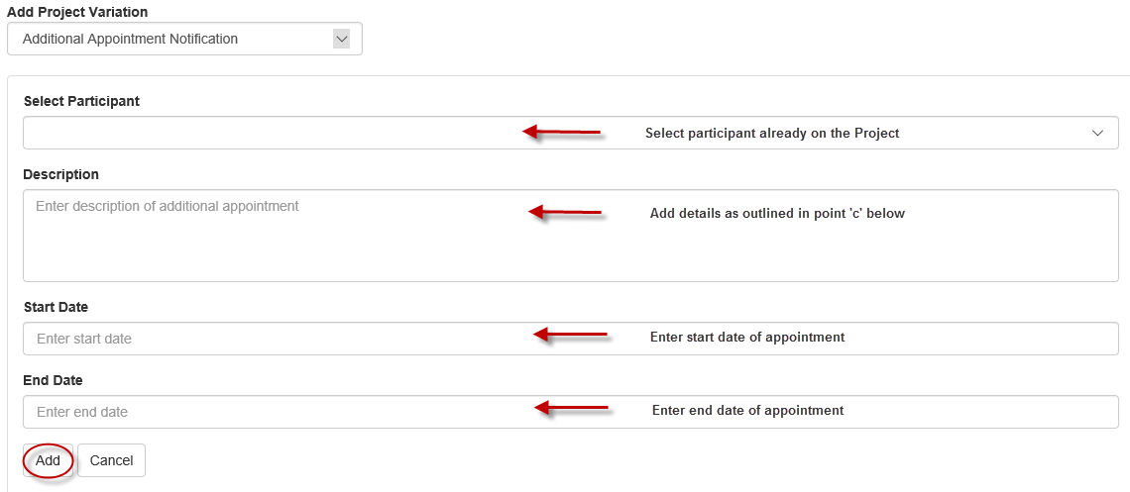

1. Select *Additional Appointment Notification* from the ‘Add Project Variation’ drop-down.
2. Using the ‘Select Participant’ drop-down select the participant for whom is requesting the additional appointment notification.
3. Provide a description of the additional appointment, ensuring that the additional information is provided, where possible:

* What organisation the additional appointment will be located at
* What activities the participant will engage in
* How much the participant will be remunerated
* The new FTE for the Project and Appointment

1. Enter the intended appointment start and end dates into the appropriate fields.
2. Select ‘Add’
3. Provide details on how this additional appointment will enhance the project in the Justification box.
4. Documentation is not required for this type of variation, unless requested by the ARC.
5. ‘Save’ and ‘Close’ the request.

**Please note:** the additional appointment start and end dates cannot be entered in RMS outside of the start and end dates of the Project.

**Person - Defer Commencement:**

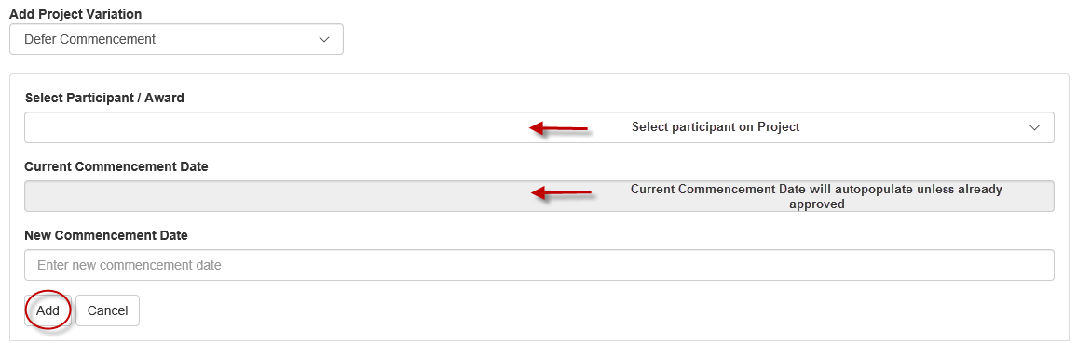

1. Select *Defer Commencement* from the ‘Person’ category within the ‘Add Project Variation’ drop-down.
2. Using the ‘Select Participant/Award’ drop-down select the participant/role for whom you need to defer the commencement of.
3. Provide the revised commencement date into the ‘New Commencement Date’ field.
4. Select ‘Add’
5. Provide details of the deferment in the Justification box.
6. Documentation is not required for this type of variation, unless requested by the ARC.
7. ‘Save’ and ‘Close’ the request.

**Person – Suspension:**

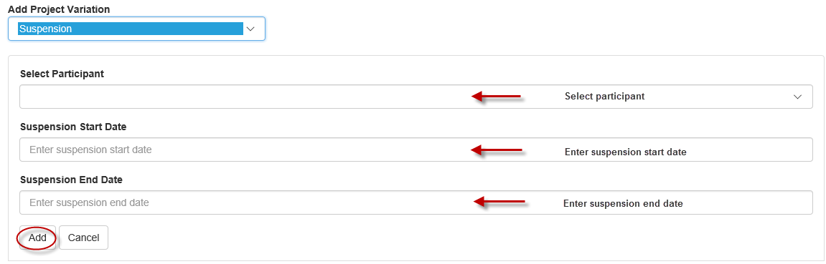

1. Select *Suspension* from the ‘Person’ category within the ‘Add Project Variation’ drop-down.
2. Select the relevant participant from the drop down menu.
3. Enter the intended suspension start and end dates into the appropriate fields.
4. Select ‘Add’
5. Provide details of the suspension in the Justification box.
6. Documentation is not required for this type of variation, unless requested by the ARC.
7. ‘Save’ and ‘Close’ the request.

**Person – Withdraw:**

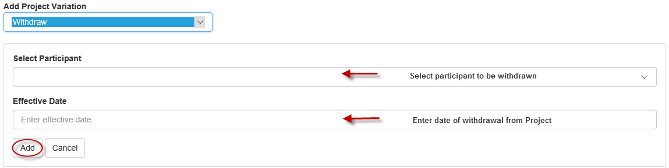

1. Select *Withdraw* from the ‘Person’ category within the ‘Add Project Variation’ drop-down.
2. Using the ‘Select Participant’ drop-down, select the participants that you intend to withdraw from the Project.
3. Provide the date that this is to take effect in the ‘Effective Date’ field.
4. Select ‘Add’
5. Provide details of why the person is being withdrawn in the Justification box.
6. Select the ‘Choose File’ button and then press ‘**Upload’** to attach the relevant documentation for the entire request, noting that it can only be one attachment.
7. ‘Save’ and ‘Close’ the request.

## Project Variations

**Project - Asset relocation:**

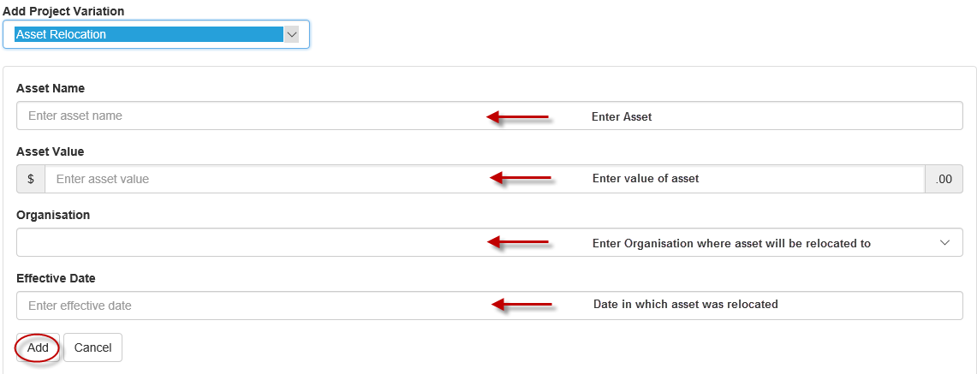

1. Select *Asset relocation* from the ‘Add Project Variation’ drop-down.
2. Provide the name of the Asset to be relocated
3. The value of the Asset
4. The organisation/location that the asset will be located (must be an organisation listed on the grant)
5. Provide the date that this is to take effect in the ‘Effective Date’ field.
6. Select ‘Add’
7. Provide details of the asset relocation in the Justification box.
8. Select the ‘Choose File’ button and then press ‘**Upload’** to attach the relevant documentation for the entire request, noting that it can only be one attachment.
9. ‘Save’ and ‘Close’ the request.

**Project - Defer Commencement:**

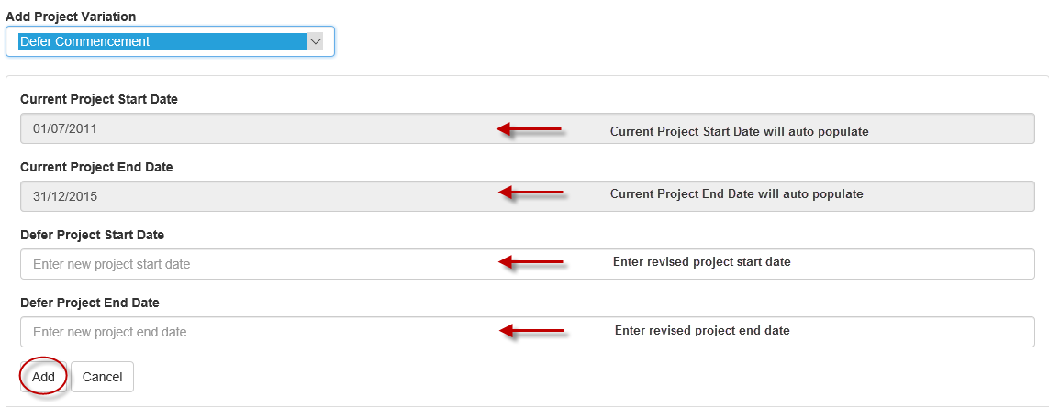

1. Select *Defer Commencement* from the ‘Project’ category of the ‘Add Project Variation’ drop-down.
2. Provide the new start date in the ‘Defer Project Start Date’ field. Provide the new end date in the ‘Defer Project End Date’ field.
3. Select ‘Add’
4. Provide details on why the project is to be deferred in the Justification box.
5. Documentation is not required for this type of variation, unless requested by the ARC.
6. ‘Save’ and ‘Close’ the request.

**Please note:** the deferred start date must not be before the intended date of funding commencement, as indicated in the warning text which appears if the dates are entered incorrectly.

**Project – End date:**

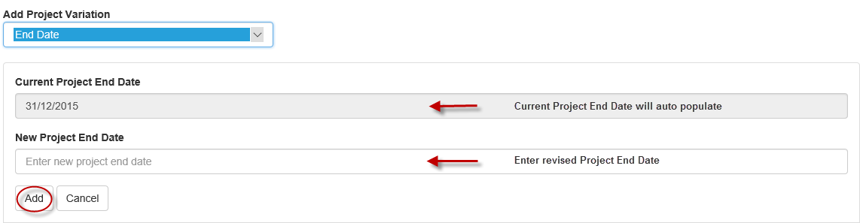

1. Select *End Date* from the ‘Add Project Variation’ drop-down.
2. Provide a revised Project end date in the field provided.
3. Select ‘Add’
4. Provide details on why the project date is to be changed in the Justification box.

**If this is for an eligibility reasons, please state this in the justification**.

1. Documentation is not required for this type of variation, unless requested by the ARC.
2. ‘Save’ and ‘Close’ the request.

**Project - Full Relinquishment:**

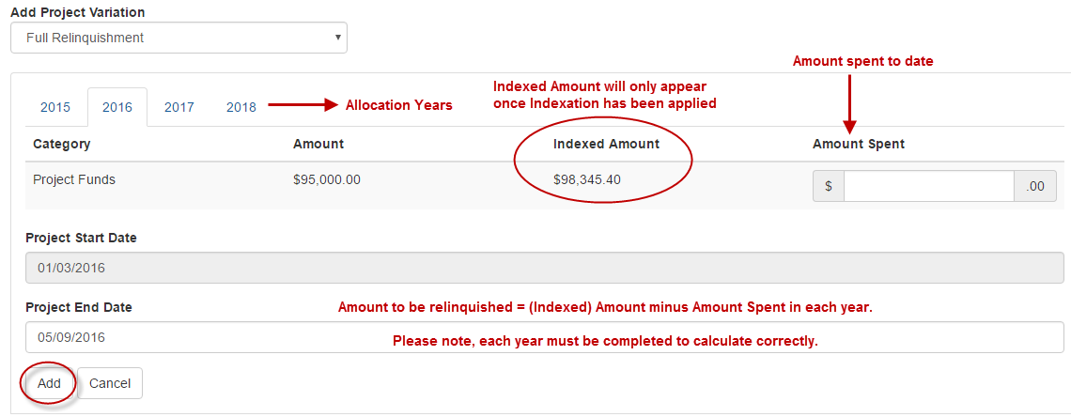

1. Select *Full Relinquishment* from the ‘Add Project Variation’ drop-down.
2. For each year of original allocation, enter the full amount of Project and Salary (if applicable) funding that has been spent to date in the ‘New Amount’ column provided. This Variation type requires that an amount be entered into all ‘New Amount’ fields, for each year.
3. Provide a revised Project end date in the field provided.
4. Select ‘Add’
5. Provide details on the relinquishment in the Justification box.
6. Documentation is not required for this type of variation, unless requested by the ARC.
7. ‘Save’ and ‘Close’ the request.

**Project - Partial Relinquishment:**

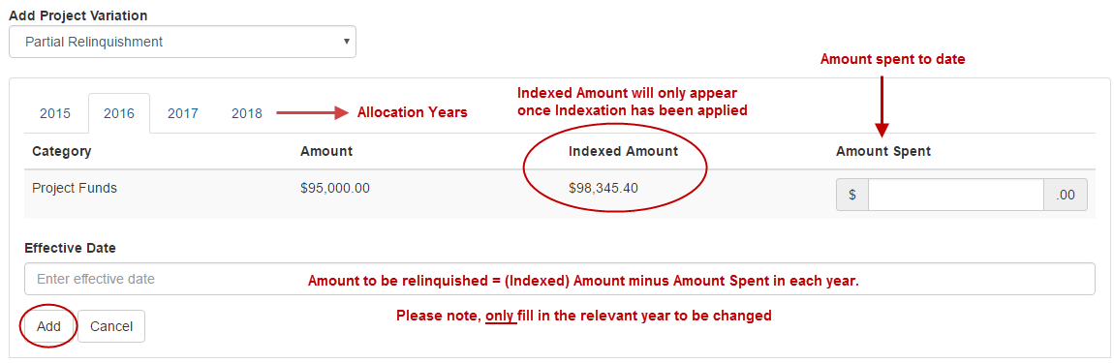

1. Select *Partial* *Relinquishment* from the ‘Add Project Variation’ drop-down.
2. For each year, enter the amount of Project and/or Salary funding that has been spent to date in the ‘New Amount’ column provided.
3. Provide the date that this is to take effect in the ‘Effective Date’ box.
4. Select ‘Add’
5. Provide details on the relinquishment in the Justification box.
6. Documentation is not required for this type of variation, unless requested by the ARC.
7. Save and Close the request’

**Project – Salary Conversion:**

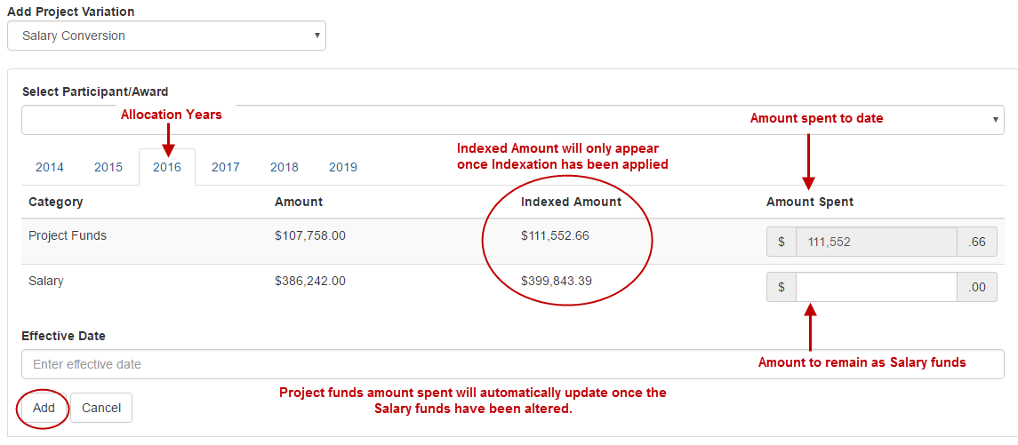

1. Select *Salary Conversion* from the ‘Add Project Variation’ drop-down.
2. Select the participant for which the salary is being converted, from the ‘Select Participant/Award’ drop-down.
3. For each year, calculate the remaining funds that are to be held as Salary, by subtracting the amount to be converted from the Salary ‘Indexed Amount’, as shown in the above example. This will automatically calculate the new ‘Project Funds’ as shown in the above example.
4. Provide the date that this is to take effect in the ‘Effective Date’ box.
5. Select ‘Add’
6. Provide details on the conversion in the Justification box.
7. Documentation is not required for this type of variation, unless requested by the ARC.
8. ‘Save’ and ‘Close’ the request.

**Project - Salary Relinquishment:**

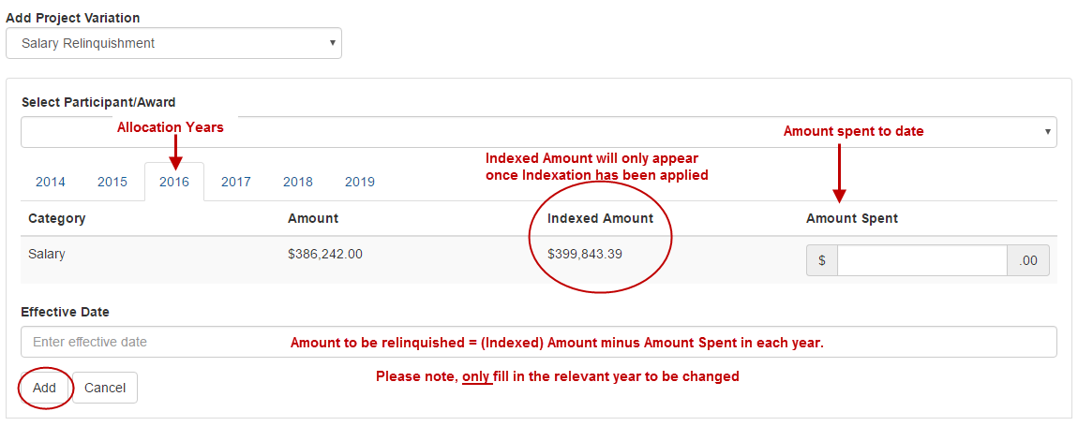

1. Select *Salary Relinquishment* from the ‘Add Project Variation’ drop-down.
2. Select the participant for which the salary is being relinquished, from the ‘Select Participant/Award’ drop-down.
3. For each year, enter the amount of salary funding that is to be relinquished in the ‘New Amount’ column provided.
4. Provide the date that this is to take effect in the ‘Effective Date’ box.
5. Select ‘Add’
6. Provide details of the relinquishment in the Justification box.
7. Documentation is not required for this type of variation, unless requested by the ARC.
8. ‘Save’ and ‘Close’ the request.

**Please note:** the effective date must not fall outside of the start and end dates of the Project.

**Project - Scope Change:**

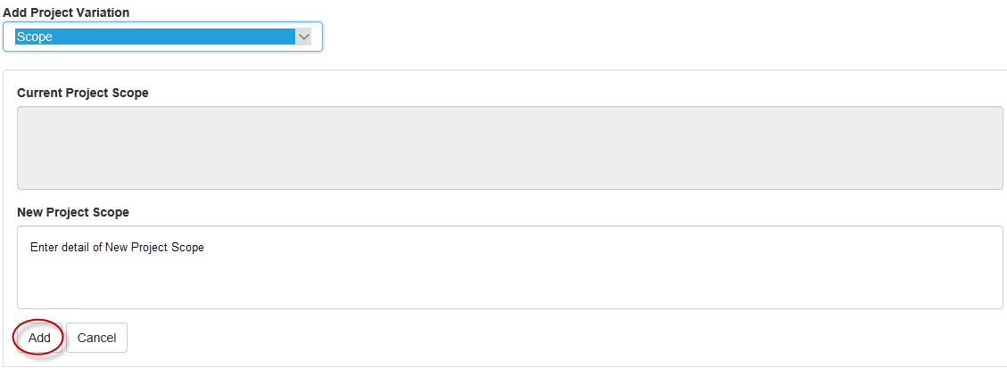

1. Select *Scope* from the ‘Add Project Variation’ drop-down.
2. Provide a revised scope in the ‘New Project Scope’ field provided.
3. Select ‘Add’
4. Provide details of the scope change in the Justification box.
5. Documentation is not required for this type of variation, unless requested by the ARC.
6. ‘Save’ and ‘Close’ the request.

**Please note:** Currently the scope changes will not appear anywhere on the project details tab. You will only know if the scope has changed is when you are entering in a new Variation.

**Project – Suspension:**

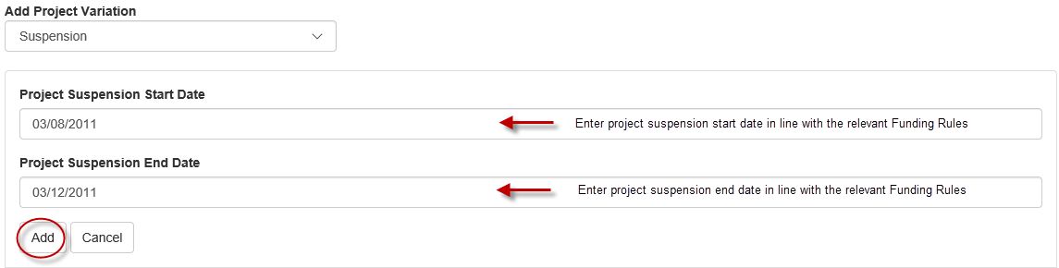

1. Select *Suspension* from the ‘Add Project Variation’ drop-down.
2. Enter the intended suspension start and end dates into the appropriate fields.
3. Select ‘Add’
4. Provide details of the suspension in the Justification box.
5. Documentation is not required for this type of variation, unless requested by the ARC.
6. ‘Save’ and ‘Close’ the request.

**Please note:** the suspension start date entered must not be outside the start and end dates of the Project. If the suspension results in the Project end date being changed, this will also have to be either added to the Variation request, or requested separately via another Variation.

**Project – Transfer:**

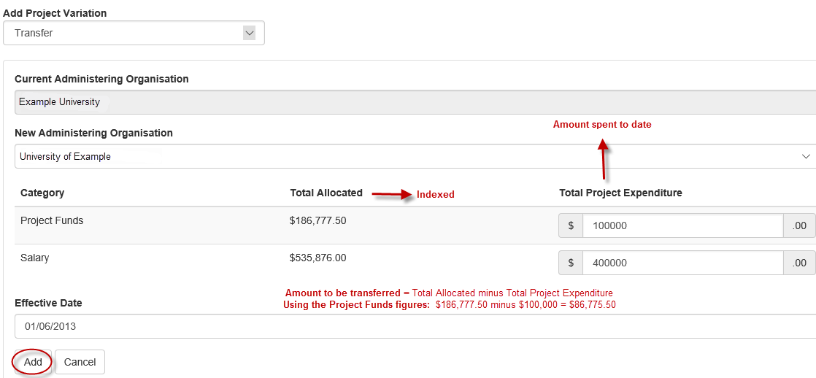

1. Select *Transfer* from the ‘Add Project Variation’ drop-down.
2. Select the Organisation which the Project is being transferred to in the ‘New Administering Organisation’ drop-down.
3. Update or Withdraw the original Administering Organisation, by changing its role or withdrawn it from the Project.
4. Provide the **total Project and/or Salary expenditure to date**, via the ‘Total Project Expenditure’ column. Note, the transfer amount will be calculated by subtracting the reported expenditure from the allocated amount.
5. Provide the date that this is to take effect in the ‘Effective Date’ box.
6. Select ‘Add’
7. Provide details of the transfer in the Justification box.
8. Select the ‘Choose File’ button and then press ‘**Upload’** to attach the relevant documentation for the entire request, noting that it can only be one attachment.
9. ‘Save’ and ‘Close’ the request.

**Please note:** the ‘transfer’ variation should be listed as the first request and the ‘Add/update Organisation’ or ‘Withdraw Organisation’ variation should be listed second. The arrows on the right side of the screen can be used to change the order of the requests.