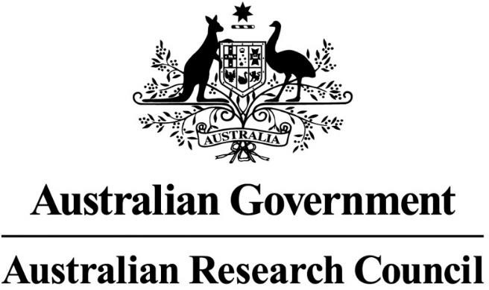

Policy on Use of Generative Artificial Intelligence in the

ARC’s grants programs

Version: 2023.1
Issued: 7 July 2023
Owner: Research Policy Branch

The Policy on Use of Generative Artificial Intelligence in the ARC’s grants programs provides guidance for researchers, Administering Organisations, and peer reviewers including all Detailed and General Assessors engaged in the Australian Research Council’s (ARC) National Competitive Grants Program in relation to the use of generative Artificial Intelligence (generative AI) tools.
1. Purpose

2. Background
Generative AI can be easily used to create content, including audio, code, text, images and videos, and has transformative potential across a wide range of uses within society and the economy. Its use presents enormous opportunities, as well as many risks and challenges.
Use of generative AI in the context of research similarly has benefits as well as risks. Benefits may include assistance with summarising or refining text to increase readability. Risks include IT security, intellectual integrity and property protection, and the loss of confidential information. When information is entered into generative AI tools it enters the public domain and can be accessed by unspecified third parties. The content is therefore not reliable and can lead to disputes about the true authorship of what is generated.
Generative AI technologies and the applications of these technologies will continue to rapidly evolve and give rise to new considerations – both positive and challenging. The ARC will continue to engage actively with domestic and international counterparts on this issue and will maintain a watching brief on the uses of generative AI and update this policy as required.

3. Use of generative AI or similar technologies within the National Competitive Grants Program

Advice to applicants (researchers and Administering Organisations)

The use of generative AI tools in grant writing presents an opportunity to assist researchers in the crafting of grants proposals, but this may raise issues around authorship and intellectual property including copyright. Content produced by generative AI may be based on the intellectual property of others or may also be factually incorrect.
The ARC advises applicants to use caution in relation to the use of generative AI tools in developing their grant applications.
The DVC-R or their equivalent at an Administering Organisation is required to certify applications on submission to the ARC. This includes certification that all participants are responsible for the authorship and intellectual content of the application.
Administering Organisations, as the applicant, are responsible for ensuring that: applications submitted to the ARC are complete and all details in the application are accurate and current at the time of submission; and that applications do not contain false or misleading information, or otherwise breach the Australian Code for the Responsible Conduct of Research, 2018 (the Code).

Advice to individuals providing assessments (including all General and Detailed Assessors) within ARC peer review processes
The Code sets out that individuals are to participate in peer review in a way that is fair, rigorous, and timely and maintains the confidentiality of the content.
The ARC Conflict of Interest and Confidentiality Policy (2020) requires that all officials and individuals carrying out ARC business, including assessors and peer reviewers, are required to preserve the principles of confidentiality outlined in the policy. Release of material into generative AI tools constitutes a breach of confidentiality and peer reviewers, including all Detailed and General Assessors, must not use generative AI as part of their assessment activities.
Assessors are asked to provide detailed high quality, constructive assessments that assist the Selection Advisory Committees to assess the merits of an application. The use of generative AI may compromise the integrity of the ARC’s peer review process by, for example, producing text that contains inappropriate content, such as generic comments and restatements of the application.
If there are concerns with how confidentiality and integrity have been managed during a review, the ARC has robust processes to manage these concerns. These are set out in the ARC’s Research Integrity Policy.
The Research Integrity Policy also allows for the ARC to take precautionary actions to protect the assessment process. Specifically, in cases where the use of generative AI by assessors is suspected, the ARC will remove that assessment from its assessment process.
This Policy on Use of Generative Artificial Intelligence in the ARC’s grants programs adds to existing policies and processes for reviewing inappropriate assessments such as Rejoinders.
If, following an investigation, an assessor is found to have breached the Code during ARC assessment, the ARC may impose consequential actions in addition to any imposed by the employing institution.

