

RMS User Guide for Assessors

2 April 2024

Table of Contents
Table of Contents
Table of Contents 2
RMS Instructions for Assessors – Overview 4
PART 1 – Access RMS 4
RMS Recommended Browser 4
Accessing RMS 4
Ensure your RMS Profile is up to date 5
Entering Unavailability in RMS 5
PART 2 – Detailed Assessors 6
Assignment Notice 6
Access Assignments 6
Policy Compliance Agreement 6
Review and Accept or Reject Assignments 7
Review Application Details and check for Conflicts of Interest (COI) 7
Reject 7
Accept 8
New Assignments 9
View Assessments list 9
View Important Assessor Information 9
Assessor Material 10
Rating Scale 10
Application Details 10
Navigating between Applications and Assessments 12
Return to Assessment List 12
Enter Assessments 12
Rank Applications 14
Submit Assessments in Bulk 15
PART 3 – General Assessors 16
Assignment Notice 16
Access Assignments 16
Policy Compliance Agreement 16
Review and Accept or Reject Assignments 17
Review Application Details and check for Conflicts of Interest (COI) 17
Reject 17
Accept 18
New Assignments 19
Assign Detailed Assessors (if required) 19
Application Assignment Screen 20
Determine Best Detailed Assessor Match 21
Search for Detailed Assessors 23
Assign Detailed Assessors 23
Announcing Assignments 24
Access Panel Member Reports 24
View Assessments list 25
View Important Assessor Information 25
Assessor Material 26
Rating Scale 26
Application Details 26
Navigating between Applications and Assessments 28
Return to Assessment List 28
Enter Assessments 28
Rank Applications 30
Submit Assessments in Bulk 31

RMS Instructions for Assessors – Overview
The RMS User Guide for Assessors is a document to provide guidance to both General and Detailed Assessors on system navigation throughout the assessment process.
Further details regarding what constitutes a quality assessment can be located on the Peer Review page of the ARC Website. In addition, further scheme specific details are available in the Assessor Handbook relative to the scheme, within RMS.
Need more help?
Contact the RMS Support team for RMS technical difficulties on (02) 6287 6789 or via email RMSSupport@arc.gov.au.
Alternatively, contact details for scheme specific questions can be located within the relevant Assessor Handbook.

PART 1 – Access RMS

RMS Recommended Browser
RMS is compatible with the latest versions of Google Chrome and Microsoft Edge. The Australian Research Council (ARC) cannot guarantee compatibility with other browsers or older versions of Google Chrome or Microsoft Edge.
It is advisable to not have several tabs opened within the browser at one time, as inactivity in one-tab leads to system log out, resulting in all unsaved changes being lost.

Accessing RMS
The web address to access RMS is dependent on the agency or program that you are needing to complete an assessment for.
- ARC (NCGP) RMS instance - https://rms.arc.gov.au
- ONI (NISDRG) RMS instance - https://rmsoni.researchgrants.gov.au
- Defence (NISDRG) RMS Instance - https://defence.researchgrants.gov.au
NOTE: you only need one account to access RMS, regardless of agency or program you are accessing, however you will require specific roles for each version/instance of RMS.
General information regarding RMS, including a user guide for the creation and management of accounts, can be found at http://www.arc.gov.au/rms-information.

Ensure your RMS Profile is up to date
Please ensure that your Expertise text, Fields of Research (FoR) Codes and Employment History are up to date in your RMS profile.
IMPORTANT NOTE: All RMS Users must update their RMS profile with their current employment and any previous employment within the past two years to assist with the identification and management of organisational conflicts of interest.
Expertise Text
Check that your Expertise Text does not require updating. This text assists with matching assessors to appropriate applications.
Expertise Text should be a description that explains your expertise; it should not be a list of academic positions held.
Expertise Text sample: ‘I carry out research on alpine crustaceans, with a particular focus on their evolution and adaptability to contemporary environmental effects. I have investigated alpine crustaceans in Australia, New Zealand and Canada, and compared the geographical effects of predators, altitude and extreme physical conditions. My work also involves the theoretical modelling of crustacean populations, scenario evaluation, and the development of protocols for effective habitat management.’
FoR Codes
Check that your FoR codes are correct and are within the recommended limit or enter new codes. We strongly recommend that you limit the codes to no more than 10. This assists with matching assessors to appropriate applications. Please avoid using codes that have a description stating ‘not elsewhere classified’ as this may lead to assignment of applications not within your area of expertise.
Employment History
Check that you have your current organisation listed by entering in your employment details. All RMS Users must update their RMS profile with their current employment and any previous employment within the past two years to assist with the identification and management of organisational conflicts of interest.
Conflicts of Interest
Ensure that information on your conflicts of interest and/or non-Australian funding, talent programs and affiliations/associations is current and complete. You will be required to certify that this information is current when accepting assignments for assessment.

Entering Unavailability in RMS
If you are unavailable to complete assessments, please enter these periods into RMS. Entering periods of unavailability ensures that only individuals with capacity are contacted within an assessment period.
You may still be assigned an assessment during a period of unavailability, on the basis that that ARC will have allowed sufficient time for the assessment to be completed following the unavailable period.
To enter a period of unavailability, click the ‘Availability’ link under your ‘Person Profile’ heading. Click on the ‘Add New Item’ button and complete the event details in the pop up (Note: all fields are mandatory). Further information and relevant screenshots are available within the RMS User Guide located on the RMS Information page of the ARC website.
Note: If you are a current recipient of ARC funding, please ensure that you are aware of your Grant Agreement obligations for ARC Assessments. Extended lengths of unavailability that are entered into RMS, will be monitored by the ARC.

PART 2 – Detailed Assessors

Assignment Notice
You will receive an automated email from do-not-reply@arc.gov.au to let you know you have been assigned one or more applications to assess. These applications could be across different ARC schemes and Government entities supported by the ARC.
It is highly recommended to add do-not-reply@arc.gov.au to your safe senders list in your email settings to ensure your assignment notices do not get sent to your junk mail folder.

Access Assignments
To access assignments, log in to RMS using the relevant RMS link as listed in the Accessing RMS section of this document. From the RMS Action Centre, under the ‘Assignment’ heading, you will see a list of ‘Pending’ assignments. Click on the ‘View’ or ‘Assignments’ link to open the list of applications assigned to you.
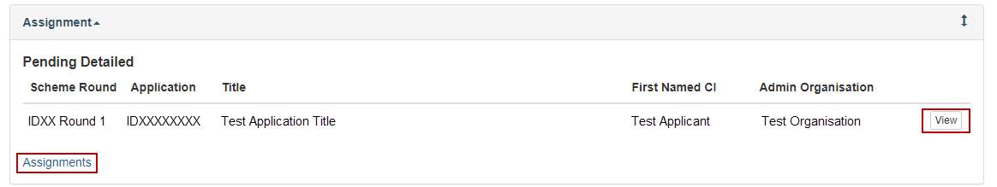
Figure 1 – Pending assignments view
Once accepted, the pending details will no longer be available, and your assignments list can be accessed by clicking on the ‘Assignments’ link from your Action Centre.

Policy Compliance Agreement
All ARC assessors will receive an automatic prompt in RMS that reminds them of their obligations relating to Conflict of Interest (CoI), Foreign Interest Disclosures and compliance with ARC policy statements
Assessors are required to complete this declaration once per scheme round. If an assessor is assigned to multiple rounds, they must confirm their declaration for each round, as prompted by RMS. The text for this declaration is provided below for your information.

Identifying and Handling a Conflict of Interest in NCGP processes explains the timeframes for conflicts of interest when assessing ARC proposals. An Assessor must comply with the:
- ARC Conflict of Interest and Confidentiality Policy,
- ARC Research Integrity Policy,
- Australian Privacy Principles (APPs) (as outlined in the Privacy Act 1988 (Cth)), and
- codes and guidelines available on the ARC website.
Assessors must ensure their RMS profile is complete and current. All conflicts of interest, including relevant non-Australian interests, must be declared in RMS in accordance with (not exhaustive) section 3 of the ARC Conflict of Interest and Confidentiality Policy, which outlines what interests an individual must disclose to the ARC, when undertaking business with the ARC.
Assessors must also be familiar with and comply with all elements of the ARC Research Integrity Policy. This includes section 4, which outlines requirements for individuals engaged in ARC business to report to the ARC when they are implicated in research integrity matters; and section 5, which outlines requirements for reporting to the ARC when any concerns about potential research integrity breaches are identified in the conduct of ARC business.
You clicking the ‘Accept button’ confirms your compliance with these requirements.
NOTE: By agreeing to complete a peer review assessment for the ARC, you confirm your RMS profile and all conflicts of interest reported to the ARC are current. Once accepted you can see your individual assignments. If you then have concerns about an application assigned to you, you must reject that specific assignment.
- By ticking the box, you are confirming that your RMS profile is up to date, and all conflicts of interest and/or non-Australian funding, talent programs, affiliations/associations reported to the ARC are current.

Review and Accept or Reject Assignments
Note: A list of applications assigned to you will be displayed in the Action Centre with the status ‘Announced’ indicating that you have not yet accepted the assignment.

Review Application Details and check for Conflicts of Interest (COI)
Click on the ‘View’ button for an application to view the details, including the title, summary and list of participating Investigators and Organisations.
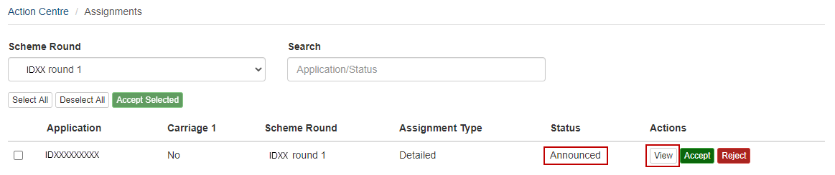
Figure 3 – Assigned application list view
Check for any potential COIs as soon as possible so that any applications you are conflicted with can be rejected and assigned to an alternative Assessor. Please review the timeframes for COIs that are set out on the Identifying and Handling a Conflict of Interest page available on the ARC website. Assessors who have identified a conflict of interest must reject the application in RMS to assist the ARC in the management of conflicts of interest (see below).
If, at any stage, you become aware of a COI with an application that you have agreed to assess, you should immediately reject the application using the reject button available in either the Assessments page or by returning to your Assignments page.

Reject
If you are unable to participate in the assessment of an application due to a Conflict of Interest, or another reason listed below, select the ‘Reject’ button and choose a rejection reason from the drop-down list. Applications you have ‘rejected’ will be removed from your assignments list after saving the selection.
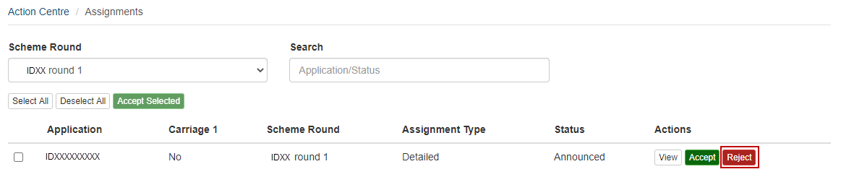
Figure 4 – Reject assignment button
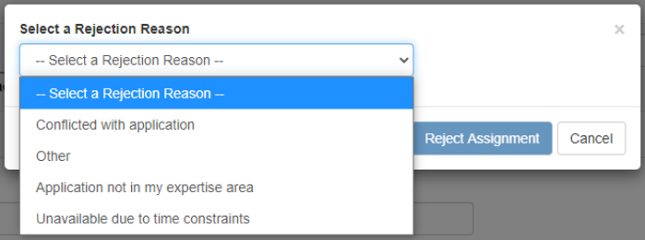
Figure 5 – Reject assignment reason dropdown
If ‘Conflicted with application’ is selected, you are then required to provide details regarding the conflict of interest to ensure that RMS is updated with the conflict details.
IMPORTANT NOTE: It is critical that RMS captures Conflict of Interests correctly, therefore please do not use the ‘Other’ option for a Conflict.
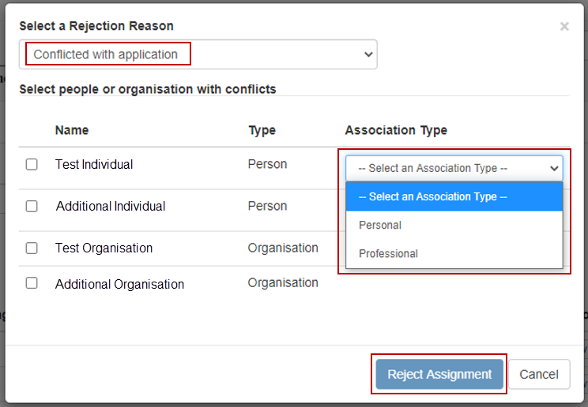
Figure 6 – Conflict of Interest association entry

Accept
If you intend on completing the assessment, accept the assignment by selecting the ‘Accept’ button. Once accepted the status of the application will change to ‘Accepted’, the application will move to the bottom of your Assignments list and a button will appear to allow the completion of assessments.
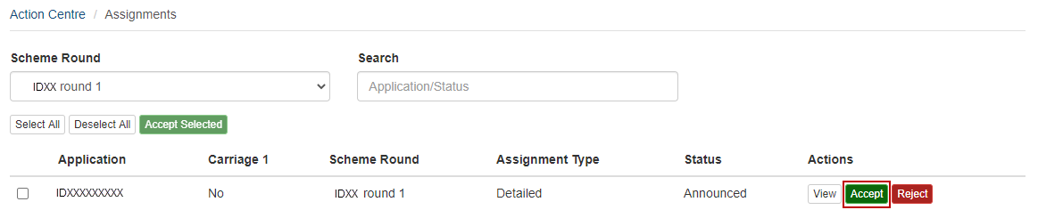
Figure 7 – Accept assignment button
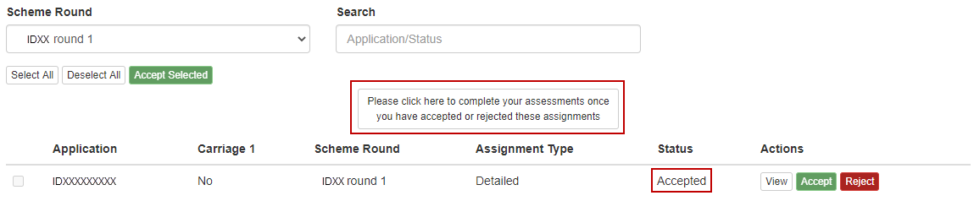
Figure 8 – Complete assessment button

New Assignments
If any additional applications are assigned to you after the initial announcement, you will receive a notification email and the new assignments will appear in the ‘Pending Assignments’ list on your RMS Action Centre.
Note: You may receive additional applications at any stage during the assessment period due to other assessors rejecting assignments.

View Assessments list
Once you have accepted your assignments, click on the ‘Please click here to complete your assessments’ button at the top or bottom of the screen to open your assessments list (Figure 8). Alternatively, you can click on the ‘Assessments’ link from your RMS Action Centre.
Figure 9 – Assessments link within the Action Centre

View Important Assessor Information
Important messages will appear at the top of the screen within a blue box. This information will always be visible upon opening the assessment screen. Below is an example of the information you may receive.
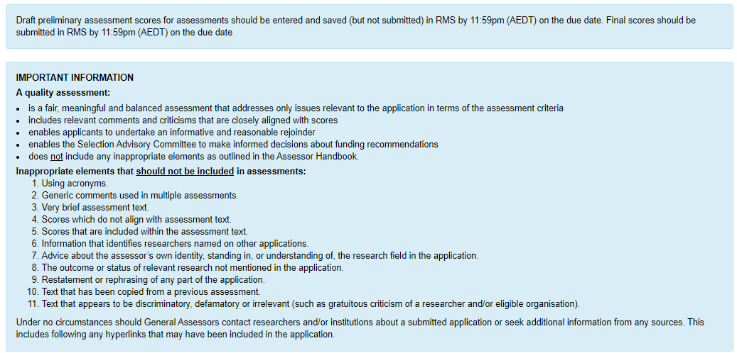
Figure 10 – Important information message example

Assessor Material
Additional Assessor material can be accessed using the ‘Assessor Material’ button in the top right of the screen.
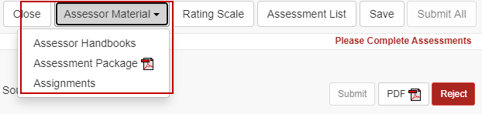
Figure 11 – Assessor material dropdown menu
Assessor Handbooks – provides a link to the webpage containing scheme specific assessment information
Assessment Package – downloads a single zip file containing a PDF copy of each accepted assessment application form
Assignments – returns the assessor to the Assignment screen within RMS

Rating Scale
The rating scale specific to the applications you are assessing can be located using the ‘Rating Scale’ button. This button can be selected from the assessment list screen, or while an assessment is being completed. To minimise the information once it has been opened select the ‘Rating Scale’ button again.
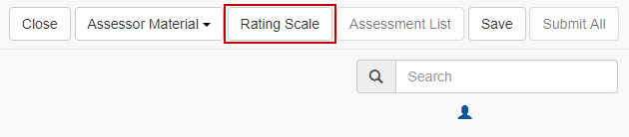
Figure 12 – Rating Scale button

Application Details
The ‘Detailed Assessments’ list will display the list of applications you have agreed to assess.
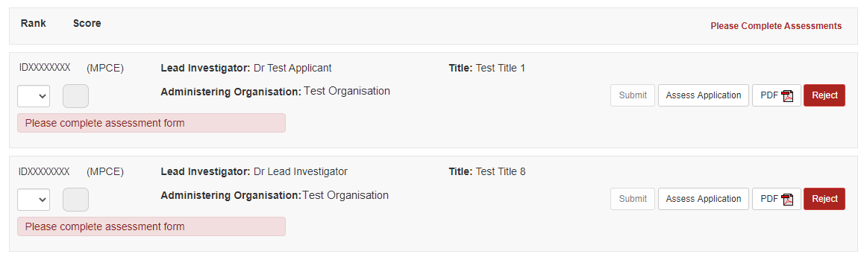
Figure 13 – Assessment List screen
Application information can be reviewed by either opening the PDF of the application form, or reviewing the application form details within RMS.
To view the application PDF, click on the ‘PDF’ button:
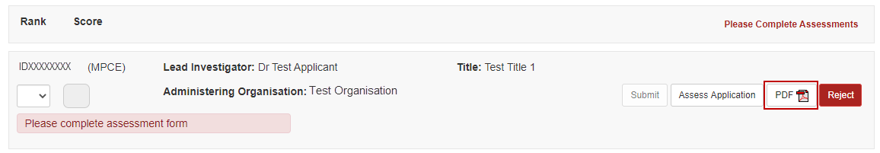
Figure 14 – Application PDF button
Alternatively, to view the application form completed by applicants select ‘Assess Application’ and then the ‘Application’ tab. Please note that selecting the ‘Assess Application’ button will navigate the user away from the assessment list and only details of the selected application will display. Further details on navigating between applications or returning to the assessment list are outlined in the next sections of this document.
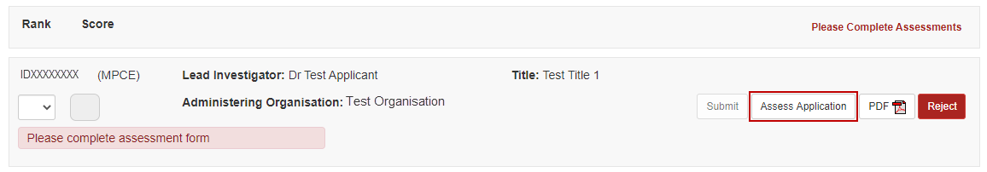
Figure 15 – Assess Application button
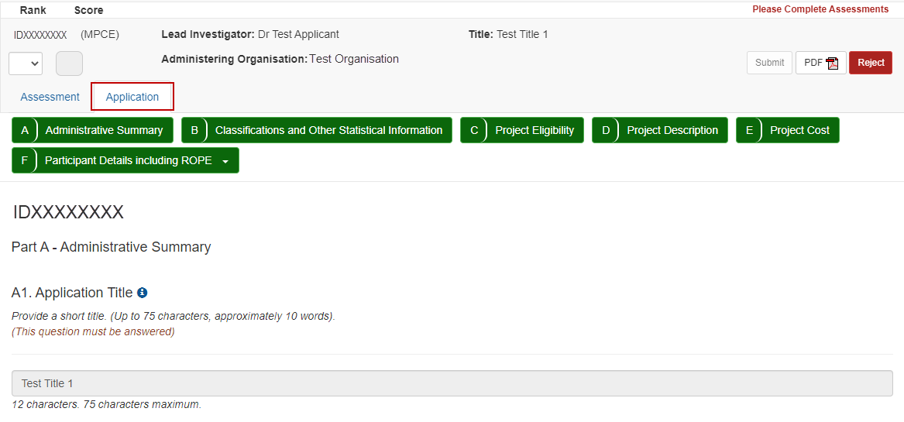
Figure 16 – Application form details
If upon review you identify that you cannot complete an assessment, you must reject the assignment using the ‘Reject’ button and entering the rejection reasons as outlined in the Reject Assignment section of this document.
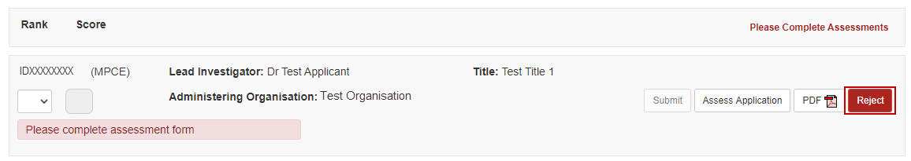
Figure 17 – Reject assessment button

Navigating between Applications and Assessments
Once the ‘Assess Application’ button is selected RMS will only display information and assessment details regarding the selected application. To review details or enter assessment for another accepted application a ‘Next’ and ‘Previous’ button becomes available at the top of the screen. This button will display the application ID of the next or previous application within the assessment list.
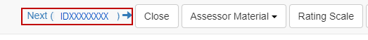
Figure 18 – Next application button

Return to Assessment List
At the top of the page is an ‘Assessment List’ button which activates once the ‘Assess Application’ has been selected. This button returns the assessor to the full list of accepted assessments and reopens the key assessment information and due date messages. Please note this button is not available if the user is currently within the assessment list screen.
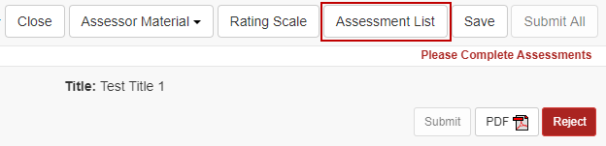
Figure 19 – Assessment List button

Enter Assessments
Assessment Criteria and weightings will differ between schemes. Information regarding the scheme specific assessment criteria can be found within the ‘Assessor Handbooks’ link found under the ‘Assessor Resources’ button in the top right of the screen.
To enter assessment details, click the ‘Assess Application’ button for the relevant application to open the Assessment Form:
Figure 20 – Assess Application button
Enter your assessment text, noting the minimum and maximum character limit, against each assessment criterion. It is mandatory that assessment text is provided for each assessment criterion. Enter your Score for each assessment criterion in the box provided
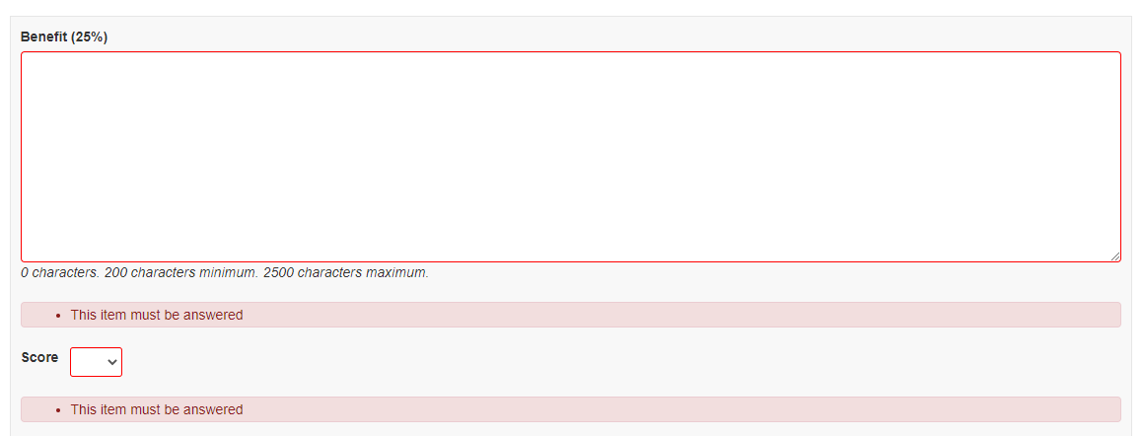
Figure 21 – Assessment details screen
If you do not understand any of the criteria against which applications are assessed, do not leave the text or score blank, as you will be unable to submit your assessment. Either refer to the relevant Grant Guidelines or the Assessor Handbook for information about assessment criteria.
Click on the ‘Save’ button at the top right of screen regularly to save your assessment. It is recommended that you also save your assessment text in a separate document to minimise the risk of losing data at any stage. This information must be destroyed at the completion of the assessment process.
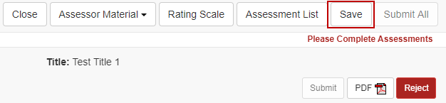
Figure 22 – Save assessment button
Once your assessment of the application has been entered, RMS will automatically calculate/recalculate the overall Application ‘Rank’ and ‘Score’. This calculation is based on the assessment criteria score weightings. If a rank matches an already assessed application an error message will appear, and the assessment cannot be submitted until all rankings have been applied. Rankings can be assigned to each application by selecting the ‘Rank’ dropdown from the assessment screen or through the assessment list screen (further information is available in the Rank Applications section of this document).
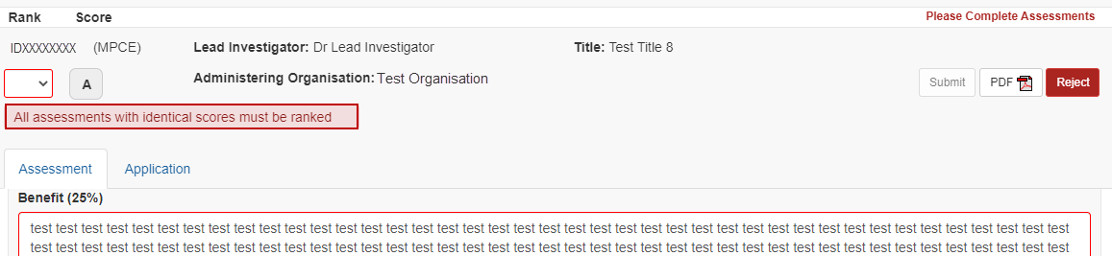
Figure 23 – Duplicate rank error message
Once the assessment details are complete the assessment can be submitted. To submit an individual assessment, select the ‘Submit’ button. If you wish to undo the submit action of an individual assessment select the ‘Undo Submit’ button that appears under the Administering Organisation detail. To proceed with submission, confirm the submission by selecting ‘Save’ at the top right of the screen.
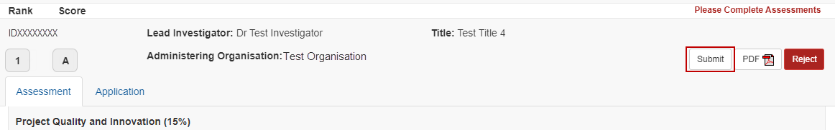
Figure 24 – Submit assessment button
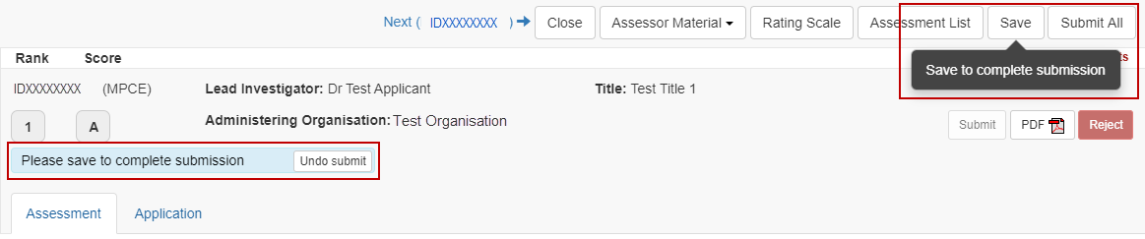
Figure 25 – Confirm assessment submission message
NOTE: Once you have selected ‘Save’ to complete the submission you will be unable to de-submit the assessment and you must email the relevant contact details provided within the Assessor handbook to have the assessment returned to you.
Alternatively, you can ‘Save’ the assessment and continue to complete all assessments prior to bulk submission as outlined in the Submit Assessments in Bulk section of this document.

Rank Applications
To submit all assessments, you must establish a ranked list if you have accepted more than 1 assessment.
RMS will use the Overall Application Scores to automatically rank your assessments in order.
If you have multiple applications with the same overall Application score the Assessment list will flag applications that must be given a unique rank. Note that since the Assessment Criteria are weighted, it is possible for applications with different criteria scores to have the same overall score. You will not be able to submit your assessments until each application has a unique rank.
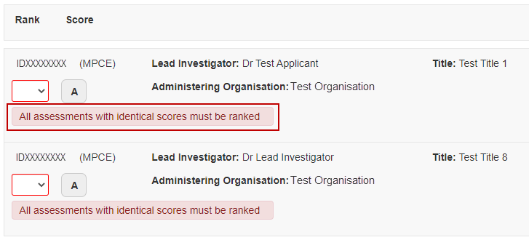
Figure 26 – Duplicate rank error message
Once the unique rank is assigned the error message will disappear and the assessments can be submitted.
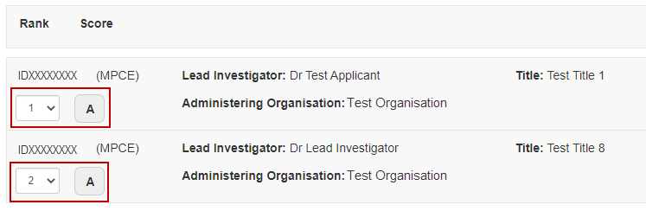
Figure 27 – Entered rank to clear duplicate rank error message

Submit Assessments in Bulk
If assessments have not been submitted individually the ‘Submit All’ button will activate at the top right of the screen once all unsubmitted assessments have reached the minimum system requirements.
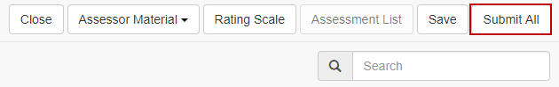
Figure 28 – Submit All assessments button
To submit all complete assessments, select ‘Submit All’ and then ‘Save’ to complete submission.
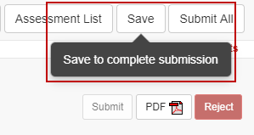
Figure 29 – Confirm assessment submission message
Once your assessments have been submitted you will not be able to amend the details, and the ‘Submit’ button will be greyed out. If you need to change an assessment, please email the relevant contact details provided within the Assessor Handbook before the assessment closing date to have the assessment 'de-submitted'.

PART 3 – General Assessors

Assignment Notice
You will receive an automated email from do-not-reply@arc.gov.au to let you know you have been assigned one or more applications to assess. These applications could be across different ARC schemes and Government entities supported by the ARC.
It is highly recommended to add do-not-reply@arc.gov.au to your safe senders list in your email settings to ensure your assignment notices do not get sent to your junk mail folder.

Access Assignments
To access assignments, log in to RMS using the correct RMS link as listed in Accessing RMS section of this document. From the RMS Action Centre, under the ‘Assignment’ heading, you will see a list of ‘Pending’ assignments. Click on the ‘View’ or ‘Assignments’ link to open the list of applications assigned to you.
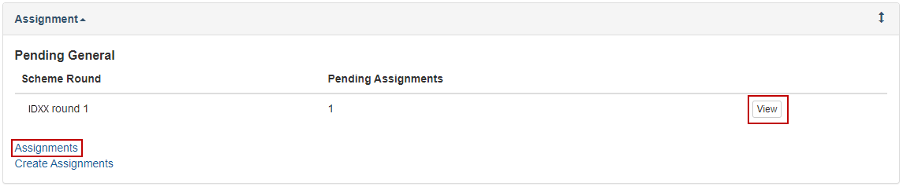
Figure 30 – Pending assignments view
Once accepted, the pending details will no longer be available, and your assignments list can be accessed by clicking on the ‘Assignments’ link from your Action Centre.

Policy Compliance Agreement
All ARC assessors will receive an automatic prompt in RMS that reminds them of their obligations relating to Conflict of Interest (CoI), Foreign Interest Disclosures and compliance with ARC policy statements
Assessors are required to complete this declaration once per scheme round. If an assessor is assigned to multiple rounds, they must confirm their declaration for each round, as prompted by RMS. The text for this declaration is provided below for your information.

Identifying and Handling a Conflict of Interest in NCGP processes explains the timeframes for conflicts of interest when assessing ARC proposals. An Assessor must comply with the:
- ARC Conflict of Interest and Confidentiality Policy,
- ARC Research Integrity Policy,
- Australian Privacy Principles (APPs) (as outlined in the Privacy Act 1988 (Cth)), and
- codes and guidelines available on the ARC website.
Assessors must:
- ensure their RMS profile is current (e.g., current Foreign Interest Disclosures must be identified within your RMS profile)
- complete a Conflict-of-Interest Declaration (e.g., (not exhaustive) see section 3 of the ARC Conflict of Interest and Confidentiality Policy which outlines what interests an individual must disclose to the ARC, when undertaking business with the ARC; section 4 of the ARC Research Integrity Policy which outlines requirements for individuals engaged in ARC business to report to the ARC when they are implicated in research integrity matters; and, section 5, which outlines requirements for reporting to the ARC when any concerns about potential research integrity breaches are identified in the conduct of ARC business), and
- complete a Foreign Interest Disclosure Declaration.

You clicking the ‘Accept button’ confirms your compliance with these requirements.
NOTE: By agreeing to complete a peer review assessment for the ARC, you confirm your RMS profile and all COIs reported to the ARC are current. Once accepted you can see your individual assignments. If you then have concerns about an application assigned to you, you must reject that specific assignment.
- By ticking the box, you are confirming that your RMS profile is up to date, and all conflicts of interest and/or non-Australian funding, talent programs, affiliations/associations reported to the ARC are current.

To indicate that your RMS profile is up to date, and that CoIs reported to the ARC are current, tick the relevant box. You will then need to click the ‘Confirm and Accept’ button.
You will be prevented from completing this declaration if you have not answered the questions on CoIs and/or non-Australian funding sources, talent programs and affiliations in the Personal Details section of your RMS profile.

Review and Accept or Reject Assignments
Note: A list of applications assigned to you will be displayed in the Action Centre with the status ‘Announced’ indicating that you have not yet accepted the assignment.

Review Application Details and check for Conflicts of Interest (COI)
Click on the ‘View’ button for an application to view the details, including the title, summary and list of participating Investigators and Organisations.
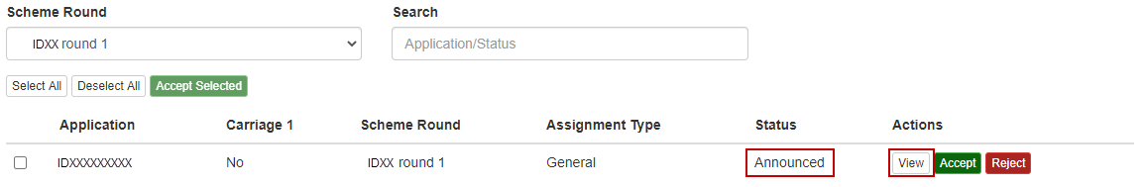
Figure 32 – Assigned application list view
Check for any potential COIs as soon as possible so that any applications you are conflicted with can be rejected and assigned to an alternative Assessor. Please review the timeframes for COIs that are set out on the Identifying and Handling a Conflict of Interest page available on the ARC website. Assessors who have identified a conflict of interest must reject the application in RMS to assist the ARC in the management of conflicts of interest (see below).
If, at any stage, you become aware of a COI with an application that you have agreed to assess, you should immediately reject the application using the reject button available in either the Assessments page or by returning to your Assignments page.

Reject
If you are unable to participate in the assessment of an application due to a Conflict of Interest, or another reason listed below, select the ‘Reject’ button and choose a rejection reason from the drop-down list. Applications you have ‘rejected’ will be removed from your assignments list after saving the selection.
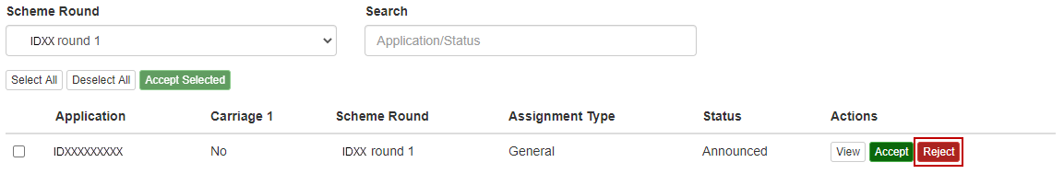
Figure 33 – Reject assignment button
Figure 34 – Reject assignment reason dropdown
If ‘Conflicted with application’ is selected, you are then required to provide details regarding the conflict of interest to ensure that RMS is updated with the conflict details.
IMPORTANT NOTE: It is critical that RMS captures Conflict of Interests correctly, therefore please do not use the ‘Other’ option for a Conflict.
Figure 35 – Conflict of Interest association entry
Application outside an Assessor’s Area of Expertise
As a General Assessor we will sometimes need to call upon you to assess applications outside your area of expertise. Unless you have a personal or institutional conflict of interest, please accept the assignment and assess the application based on your general knowledge of what makes a strong application. There are numerous reasons why you may have been assigned the application, however, if after careful consideration you still feel it is not possible to assess, then please contact the relevant contact details within the Assessor Handbook as soon as possible.

Accept
If you intend on completing the assessment, accept the assignment by selecting the ‘Accept’ button. Once accepted the status of the application will change to ‘Accepted’, the application will move to the bottom of your Assignments list and a button will appear to allow the completion of assessments.
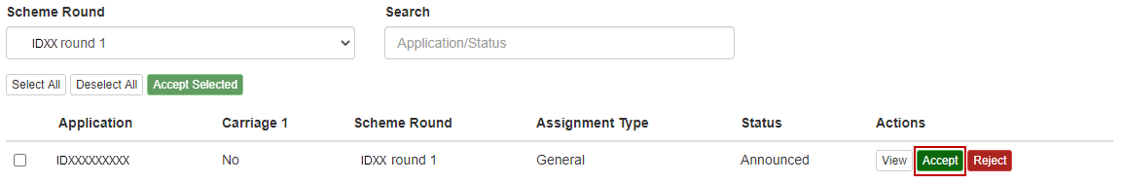
Figure 36 – Accept assignment button
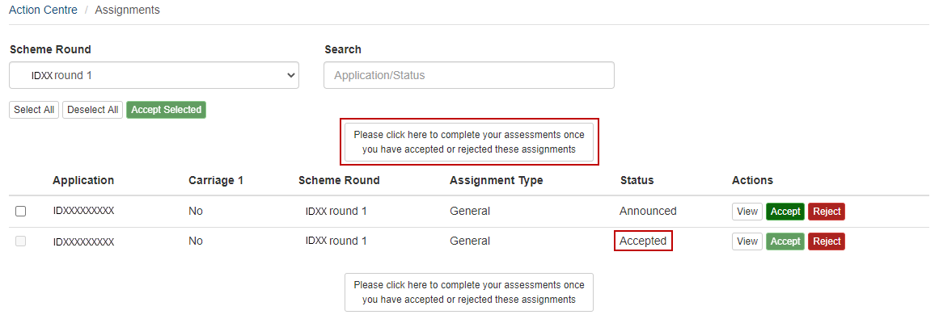
Figure 37 – Complete assessment button

New Assignments
If any additional applications are assigned to you after the initial announcement, you will receive a notification email and the new assignment will appear in the ‘Pending Assignments’ list on your RMS Action Centre.
Note: You may receive additional applications at any stage during the assessment period due to other assessors rejecting assignments.

Assign Detailed Assessors (if required)
The number of Detailed Assessors required varies from scheme to scheme and you will be advised how many you should assign once you are selected for a panel. If you are assigned as a Carriage 1 to any applications a link called ‘Create Assignments’ will appear on your RMS Action Page once you have accepted your assignments.
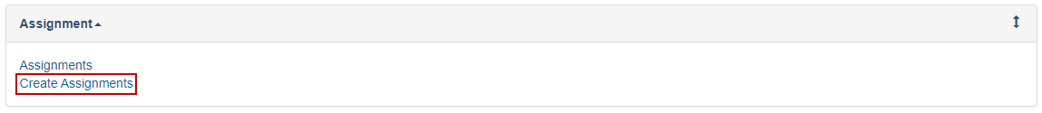
Figure 38 – Create Assignments link from Action Centre
Click the ‘Create Assignments’ link to access the list of your Carriage 1 applications. Click on the ‘Assign’ button to open the ‘Create Assignments’ page for the specific application.
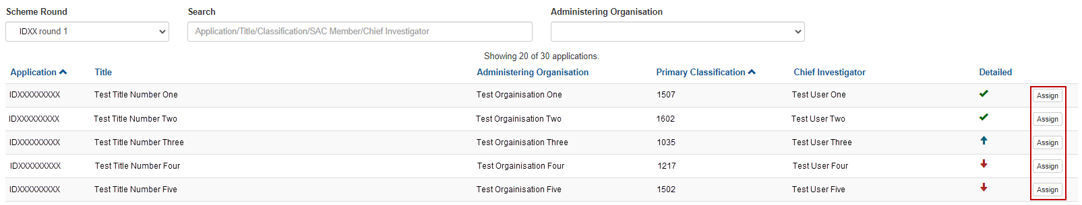
Figure 39 – Create Assignment button from Assignment Page
Flag indicators (flags do not take into account Reserves):

A green tick indicates that enough Detailed Assessors have been assigned to the application.
A red arrow indicates that not enough Detailed Assessors have been assigned to the application.
A blue arrow indicates that more than the required number of Detailed Assessors have been assigned to the application.
Figure 40 – Definition of Flag Indicators

Application Assignment Screen
Once you have selected the ‘Assign’ button the Application Assign Screen will open and display relevant application and assessor information including:

Application details: including the Title, Administering Organisation, Investigators, Classifications and Summary.

Application word cloud: a visual summary of the words used in the application summary, the FoR and Socio-Economic Objective (SEO) descriptions. Also included are the FoR code numbers. The greater the size of the word within the word cloud, the more frequently the word has been used within the application. This information is provided to assist General Assessors in choosing the best matching Detailed Assessors for this application. It also provides interactive ways of changing the search parameters.

Assessor contact cards: shows relevant assessor information including current allocated assignment numbers, and an individual word cloud. The word cloud will only display information overlap between the current application and the information contained within RMS about the potential assessor (drawn from their FoR codes, expertise text, current grants, and submitted applications.)

Below is an example demonstrating Detailed Assessor contact cards (at the bottom) that are well-matched with the application cloud (in top right corner).
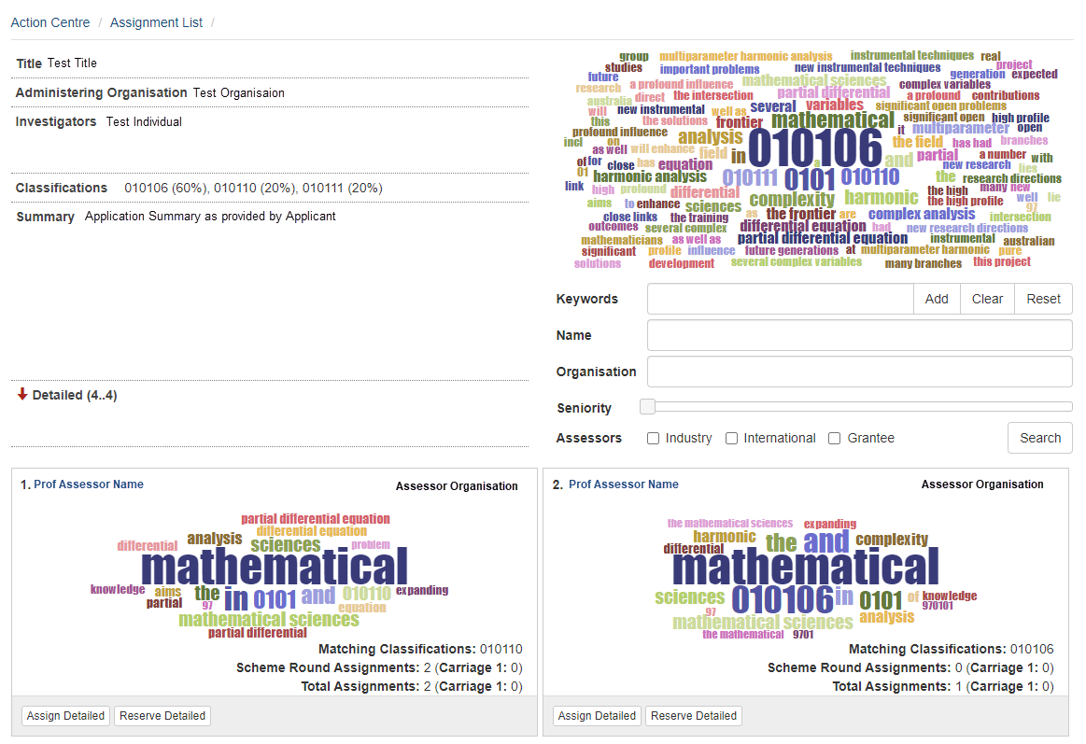
Figure 41 – Assessor Contact Card and Application Word Cloud example

Determine Best Detailed Assessor Match
The role of the Carriage 1 is to select the best possible matches from the potential Assessor list for the application. The Word Cloud is a very powerful tool to assist you in assigning Detailed Assessors. However, assigning is a complex task and there is no routine way to achieve the optimum result. The Carriage 1 for an application is expected to interrogate the information in RMS and assign the best assessors, not simply assign the suggested matches.

Potential Detailed Assessors are listed in descending order of match to the application based on how closely an Assessors’ word cloud matches that of the application, i.e. the best matches appear at the top of the list. The list of potential Assessors appears in ranked order.

Change Word Cloud Search Parameters:
Text in the Title, Classifications and Summary fields are all active links. Clicking on a word in any of these fields will automatically update the application word cloud and will alter the assessor contact cards presented
In addition, the importance of a term within the word cloud can be amended by selecting the term and sliding the toggle found under the word cloud to increase its size.

Keywords can also be added to the word cloud by entering the term into the ‘Keywords’ field and then selecting ‘Add’. To remove any terms added by the General Assessor select the ‘Clear’ button.

To reset the word cloud to the original generated cloud, select the ‘Reset’ button.
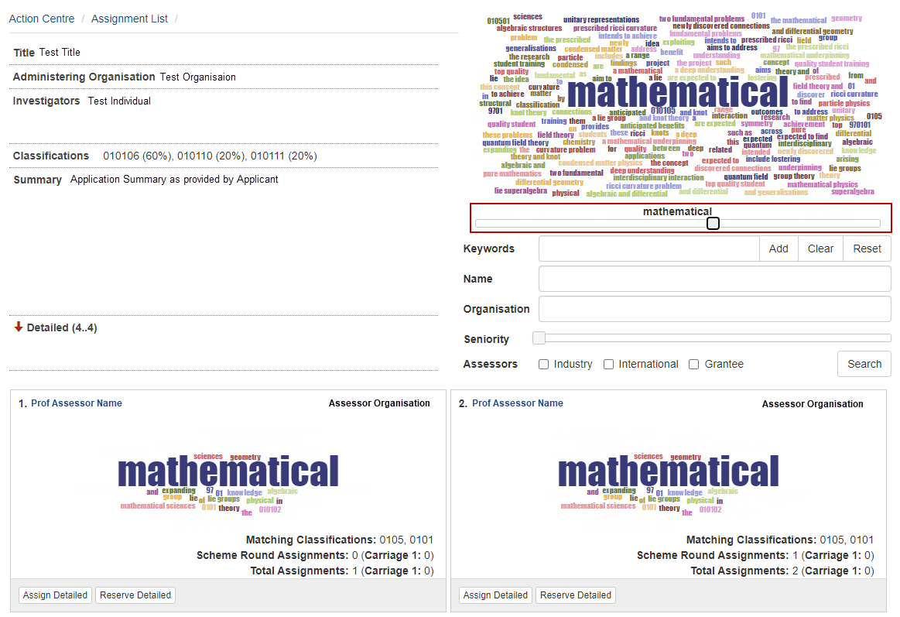
Figure 42 – Toggle to increase importance of word within word cloud
Assignment Details of Potential Assessors: Click on the name of a potential Assessor to access a new window with details of their expertise text and classifications.

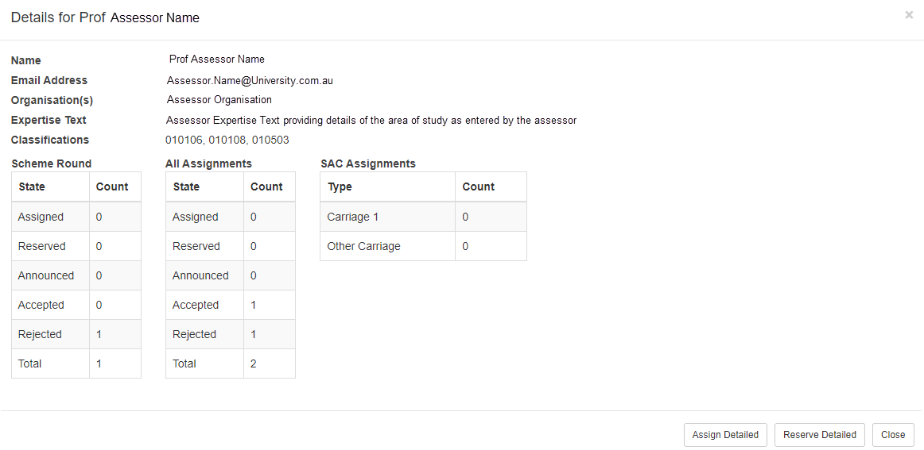
Figure 43 – Assessor detail screen
This window also shows the Assessor’s Assignment History for both the scheme round you are assigning and open scheme rounds:

Assigned: shows the number of applications assigned to this Assessor
Reserved: shows the number of applications assigned to this Assessor as Reserve
Announced: shows the number of applications assigned to this Assessor that have not yet been accepted or rejected
Accepted: shows the number of assignments accepted by this Assessor
Rejected: shows the number of assignments rejected by this Assessor

Search for Detailed Assessors
Detailed Assessors can be searched by entering details into the ‘Name’ and ‘Organisation’ fields below the application word cloud. Please note that if the searched individual has an active RMS account although is conflicted with the application or is unavailable to assess a contact card will not appear.

Assign Detailed Assessors
To assign a Detailed Assessor, click ‘Assign Detailed’ in either the Assessor Detail Screen or the Assessor contact card. The name of the Assessor will appear in the Detailed Assessor List under the application details.
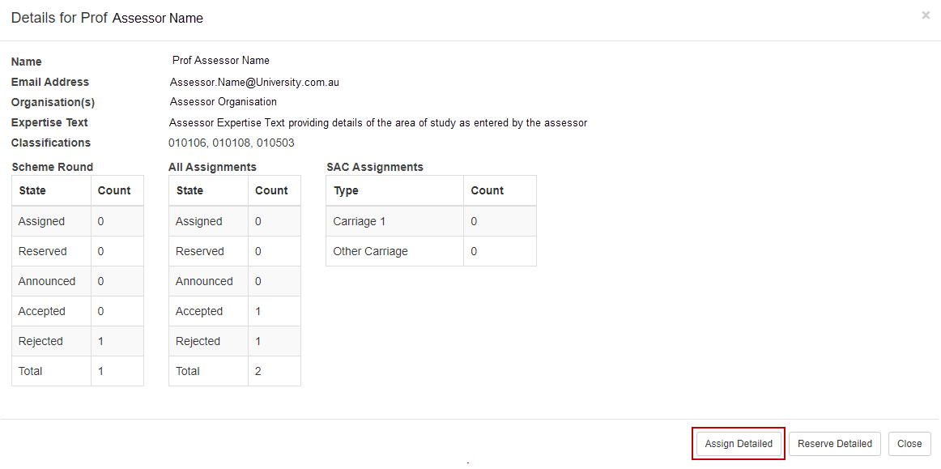
Figure 44 – Assign Detailed assessor button on the assessor detail screen
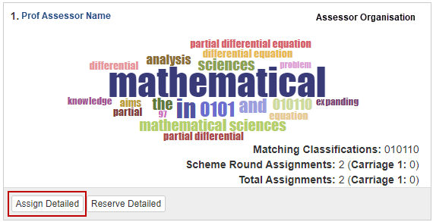
Figure 45 – Assign Detailed assessor button on the assessor contact card
To reserve a Detailed Assessor, click ‘Reserve Detailed’ in the Assessor detail screen or the Assessor Contact Card. The names of Reserved Assessors will appear in square brackets […] in blue text in the Detailed Assessor List. Reserved Assessors are used if any of the other Detailed Assessors reject or do not respond to the assignment.

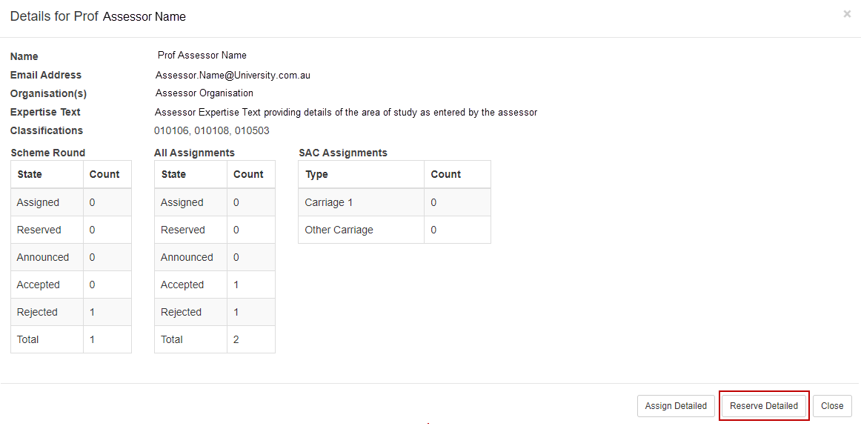
Figure 46 – Reserve Detailed assessor button on the assessor detail screen
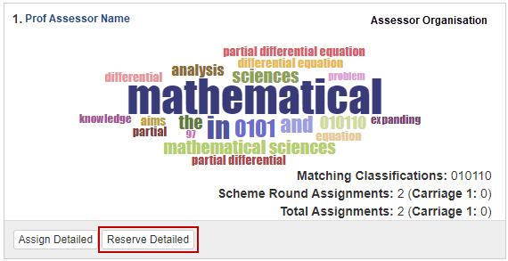
Figure 47 – Reserve Detailed assessor button on the assessor contact card
To remove a Detailed Assessor click on the Assessor’s name in the Detailed Assignments List and select ‘Remove’ from the assessor detail screen. The Assessor will then be removed from the current assignments.

Announcing Assignments
After you have completed your initial assignments, you are not required to notify assessors of assignments or monitor acceptance and submission. This process will be managed by the Government agency administering the application scheme round.

Access Panel Member Reports
Once the rejoinder period for a scheme round has closed, General Assessors are able to access reports for their accepted applications in RMS. To access the reports, click on the ‘Selection Advisory Committee Member Reports’ link under the Reports heading in the Action Centre.

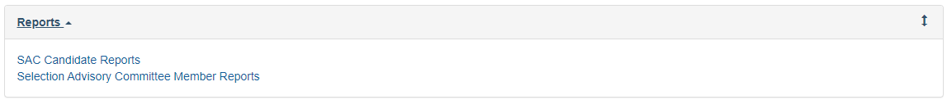
Figure 48 – SAC report links from Action Centre
There are two reports available:
Assessments by Scheme Round – This is an Excel report containing all application that you agreed to assess. When available, this report also contains the scores submitted by Detailed Assessors, and the scores provided by other General Assessors assigned to the applications in your list.

Panel Member Assessment Summary – This is a PDF report containing the scores and text submitted by Detailed Assessors for your applications. This report also includes the Rejoinder provided by Applicants.

View Assessments list
Once you have reviewed the detailed assessment and the applicant’s rejoinder response the list of accepted assignments can be accessed by selecting the ‘Assessments’ link from your RMS Action Centre.
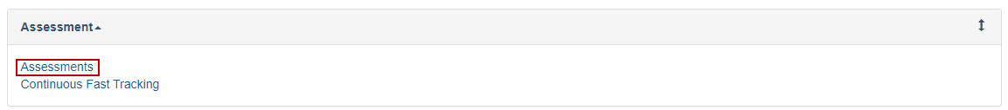
Figure 49 – Assessments Link within Action Centre

View Important Assessor Information
Important messages will appear at the top of the screen within a blue box. This information will always be visible upon opening the assessment screen. Below is an example of the information you may receive.
Figure 50 – Important information message example

Assessor Material
Additional Assessor material can be accessed using the ‘Assessor Material’ button in the top right of the screen.
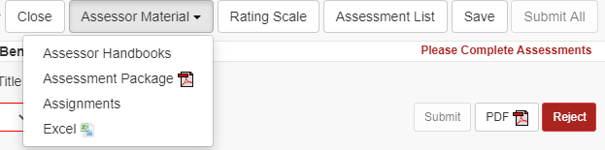
Figure 51 – Assessor material dropdown menu
Assessor Handbooks – provides a link to the webpage containing scheme specific assessment information
Assessment Package – downloads a single zip file containing a PDF copy of each accepted assessment application form
Assignments – returns the assessor to the Assignment screen within RMS
Excel – provides an excel data extract of current assessment details

Rating Scale
The rating scale specific to the applications you are assessing can be located using the ‘Rating Scale’ button. This button can be selected from the assessment list screen, or while an assessment is being completed. To minimise the information once it has been opened select the ‘Rating Scale’ button again.
Figure 52 – Rating Scale button

Application Details
The ‘General Assessments’ list will display the list of applications you have agreed to assess.
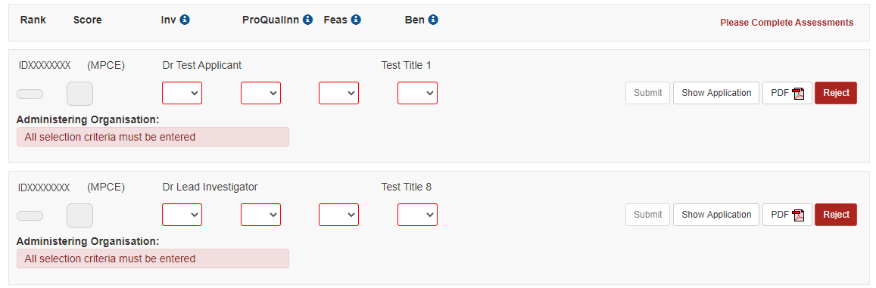
Figure 53 – Assessment list screen
Application information can be reviewed by either opening the PDF of the application form, or reviewing the application form details within RMS.
To view the application PDF, click on the ‘PDF’ button:
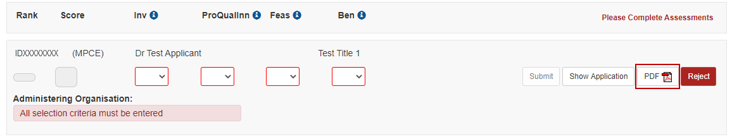
Figure 54 – Application PDF button
Alternatively, to view the application form completed by applicants select ‘Show Application’, this will display the application form within the ‘Application’ tab. Please note that selecting the ‘Show Application’ button will navigate the user away from the assessment list and only details of the selected application will display. Further details on navigating between applications or returning to the assessment list are outlined in the next sections of this document.
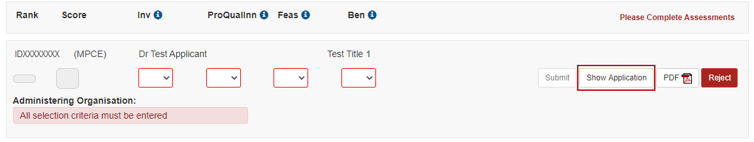
Figure 55 – Show Application button
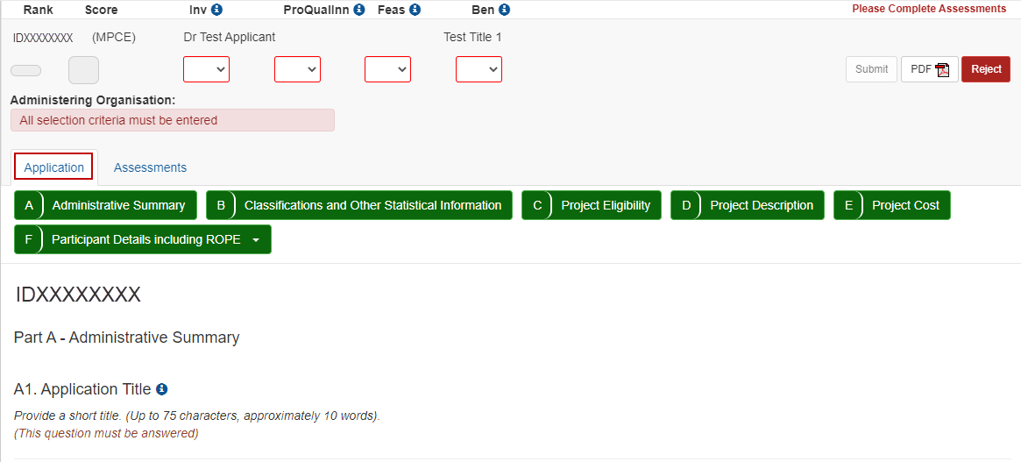
Figure 56 – Application form details
If upon review you identify that you cannot complete an assessment, you must reject the assignment using the ‘Reject’ button and entering the rejection reasons as outlined in the Reject assignment section of this document.
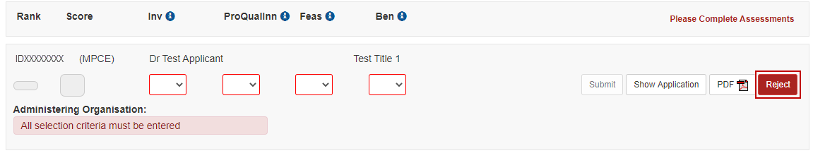
Figure 57 – Reject assessment button

Navigating between Applications and Assessments
Once the ‘Show Application’ button is selected RMS will only display information and assessment details regarding the selected application. To review details for another accepted application a ‘Next’ and ‘Previous’ button becomes available at the top of the screen. This button will display the application ID of the next or previous application within the assessment list.
Figure 58 – Next application button

Return to Assessment List
At the top of the page is an ‘Assessment List’ button which activates once ‘Show Application’ has been selected. This button returns the assessor to the full list of accepted assessments and reopens the key assessment information and due date messages. Please note this button is not available if the user is currently within the assessment list screen.
Figure 59 – Assessment list button

Enter Assessments
Assessment Criteria and weightings will differ between schemes. Information regarding the scheme specific assessment criteria can be found within the ‘Assessor Handbooks’ link found under the ‘Assessor Resources’ button in the top right of the screen.
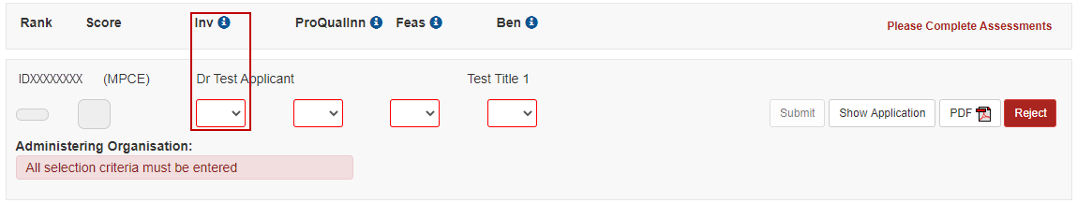
Figure 60 – Assessment score entry
Enter your Score for each assessment criteria in the box provided ensuring that the score entered relates to the criteria listed above the score box.
More information including the full criterion name and the weighting can be located by selecting the ‘information’ button.
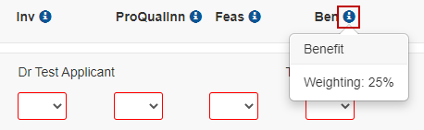
Figure 61 – Additional criterion information
If you do not understand any of the criteria against which applications are assessed, do not leave the score blank, as you will be unable to submit your assessment. Either refer to the relevant Grant Guidelines or the Assessor Handbook for information about assessment criteria.
Click on the ‘Save’ button at the top right of screen regularly to save your assessment. It is recommended that you also save your assessment text in a separate document to minimise the risk of losing data at any stage. This information must be destroyed at the completion of the assessment process.
Figure 62 – Save assessment button
Once your application assessment has been entered, RMS will automatically calculate/recalculate the overall Application ‘Rank’ and ‘Score’. This calculation is based on the assessment criteria score weightings. If a rank matches an already assessed application an error message will appear, and the assessment cannot be submitted until all rankings have been applied.
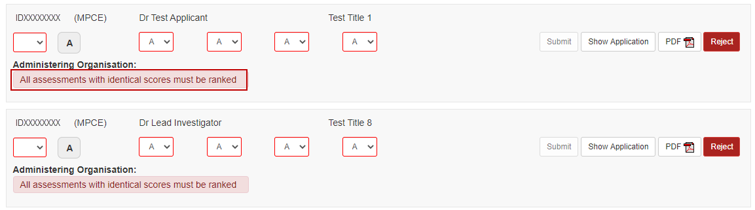
Figure 63 – Duplicate rank error message
Once the assessment details are complete the assessment can be submitted. To submit an individual assessment, select the ‘Submit’ button. If you wish to undo the submit action, select the ‘Undo Submit’ button that appears under the Administering Organisation detail. To proceed with submission, confirm the submission by selecting ‘Save’ at the top right of the screen.
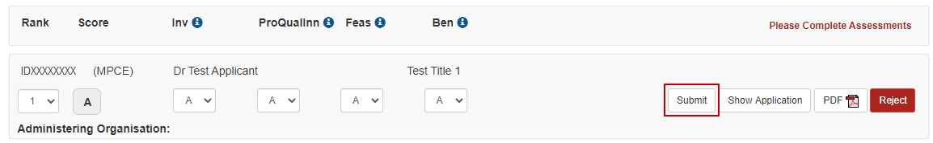
Figure 64 – Submit assessment button
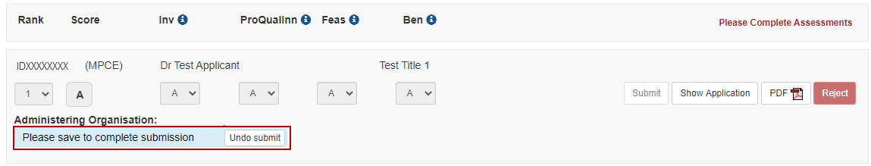
Figure 65 – Undo submit prior to saving submission
Figure 66 – Confirm assessment submission message
NOTE: Once you have selected ‘Save’ to complete the submission you will be unable to de-submit the assessment and you must email the relevant contact details provided within the Assessor handbook to have the assessment returned to you.
Alternatively, you can ‘Save’ the assessment and continue to complete all assessments prior to bulk submission (further information is available in the Submit Assessments in Bulk section of this document).

Rank Applications
To submit all assessments, you must establish a ranked list if you have accepted more than 1 assessment. RMS will use the overall application scores to automatically rank your assessments in order.
If you have multiple applications with the same overall Application score the Assessment list will flag applications that must be given a unique rank. Note that since the Assessment Criteria are weighted, it is possible for applications with different criteria scores to have the same overall score. You will not be able to submit your assessments until each application has a unique rank.
Figure 67 – Duplicate rank error message
Once the unique rank is assigned the error message will disappear and the assessments can be submitted.
Figure 68 – Entered rank to clear duplicate rank error message
To ensure that all the assessments are saved, click ‘Save’.

Submit Assessments in Bulk
If assessments have not been submitted individually the ‘Submit All’ button will activate at the top right of the screen once all unsubmitted assessments have reached the minimum system requirements.
Figure 69 – Submit All assessments button
To submit all complete assessments, select ‘Submit All’ and then ‘Save’ to complete submission.
Figure 70 – Confirm assessment submission message
Once your assessments have been submitted you will not be able to amend the details, and the ‘Submit’ button will be greyed out. If you need to change an assessment, please email the relevant contact details provided within the Assessor Handbook before the assessment closing date to have the assessment 'de-submitted'.

